Supplementary Materials for

Ferroelectric domain-wall logic units

Jing Wang^{1,2#}, Jing Ma^{2#}, Houbing Huang^{1*}, Ji Ma^{2,3}, Hasnain Mehdi Jafri¹, Mingfeng Chen², Di Liu¹, Yuanyuan Fan¹, Jinxing Zhang⁴, Yuan-Hua Lin², Long-Qing Chen⁵, Di Yi², Ce-Wen Nan^{2*}

#These authors contributed equally to this work.
Correspondence to: hbhuang@bit.edu.cn; cwnan@mail.tsinghua.edu.cn

This PDF file includes:

Supplementary Text
Figs. S1 to S6
Tables S1
Captions for Movies S1, S2

Other Supplementary Materials for this manuscript include the following:

Movies S1, S2

Supplementary Text

Creation of an in-plane trailing field by biased scanning probe.
As shown in Fig. S4, the spatial distribution of the static electric field from the nanoscale probe is isotropic and spherical. When the negative biased probe moves along upward or downward direction on the surface of the nano-island, a net in-plane trailing field (indicated by purple arrows) along upward or downward direction is produced [13, 31].

The definition of CDWs and neutral DWs.
To illustrate the microscopic mechanism of the various conductance of DWs with distinct DW morphology, we analyzed the distribution of the polarization vectors and the bound charge density around the local DWs. As shown in Fig. 2D and 2F, when the DW oriented along $[1\overline{1}0]$ or $[\overline{1}\overline{1}0]$ direction respectively, there are a large number of bound charges accumulated on the DW, which is defined as CDW. While in Fig.2E, the DW oriented almost along [100] direction, which results in a continuous transition of the polarization vectors and dramatically reduction of the bound charge density at such a DW. Hence, such kind of DW is defined as neutral DWs. And the above discussions are also well consistent with the high- and low-conductance of the respective DWs, as indicated by the c-AFM snapshots in Fig. 1 and Fig. 3 and Fig. 4. Therefore, the above results show clearly that the conducting DW network can be well determined by the DW morphology.

Supplementary Figures:

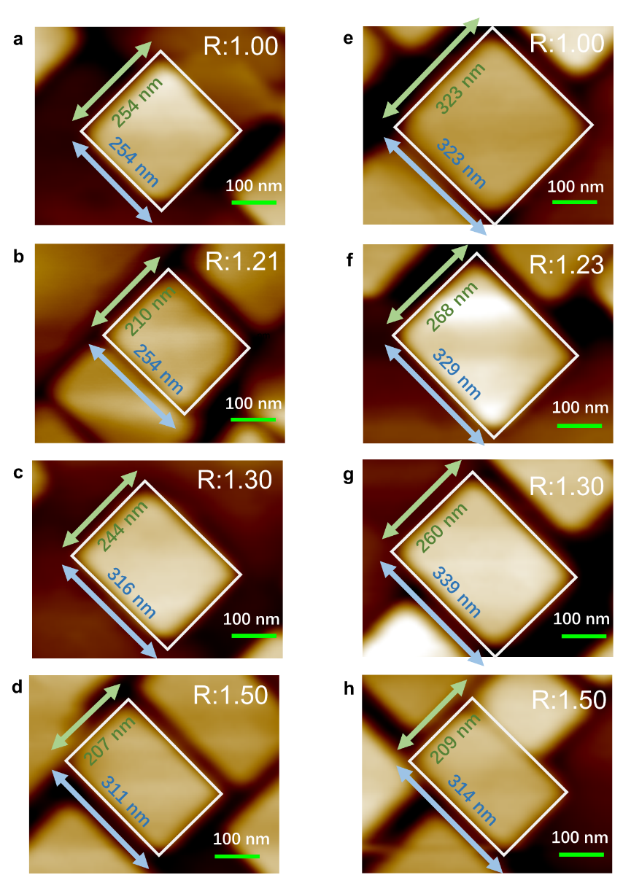
Fig. S1. Self-assembled BFO nano-islands with various size and AR.

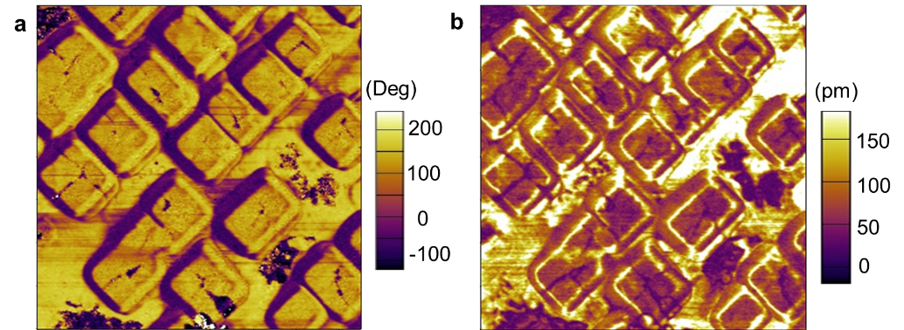
Fig. S2. Cross-shaped CDW network confined in BFO nano-islands with different R. a, Out-of-plane PFM phase image. b, Out-of-plane PFM amplitude image.

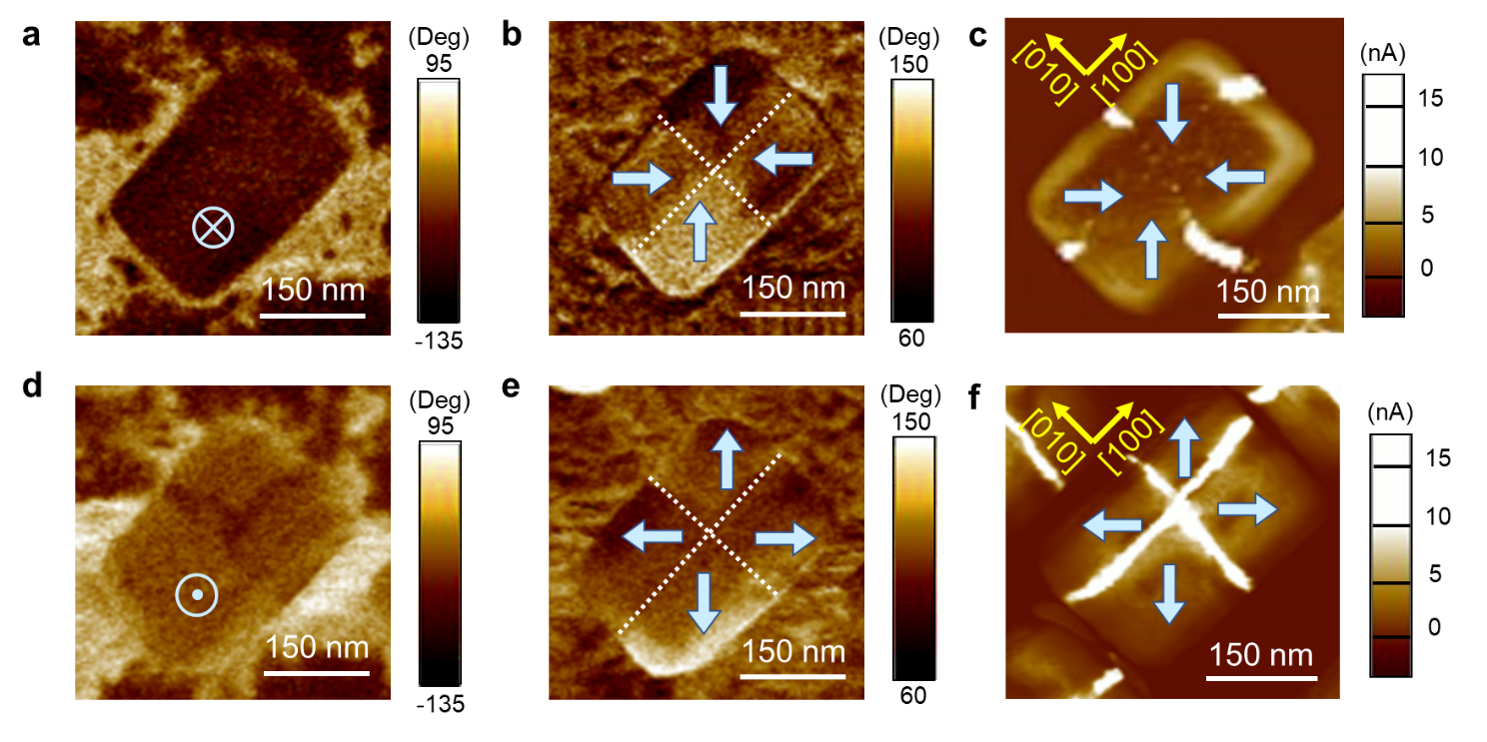
Fig. S3. Polarization-dependent CDW conduction in a BiFeO₃ nano-island. a-c, Out-of-plane (a), in-plane (b) PFM phase image and c-AFM image (c) for a BiFeO₃ nano-island with downward and center-convergent domain pattern. d-f Out-of-plane (d), in-plane (e) PFM phase image and c-AFM image (f) for the BiFeO₃ nano-island with upward and center-divergent domain pattern.

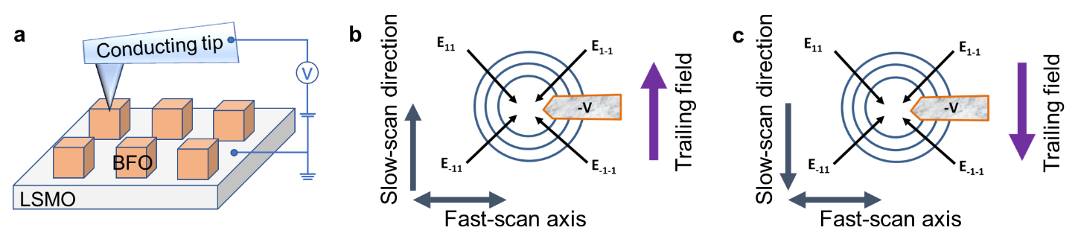
Fig. S4. Schematic illustration for an trailing field from the negative biased scanning probe. a Schematic diagram of experimental setup for electric-field control of DW networks. b, c In-plane electric-field distribution for the moving probe from down to top and top to down, respectively. The black center-convergent arrows indicate an in-plane radial electric-field distribution for the negative biased probe. The blue contour hints the equipotential lines. The purple arrows indicate the direction of the trailing field.

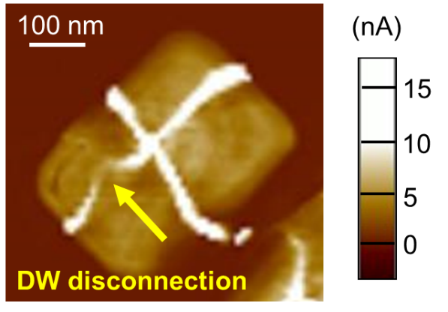
Fig. S5. Repeatable c-AFM snapshot showing the good retention characteristic of the disrupted CDW. Compared with the initially disconnected CDW by a [$\overline{1}\overline{1}0$]-oriented trailing field in Fig. 1e, this c-AFM image is re-captured several hours later, before the re-connection of the CDW by [$110$]-oriented trailing field (Fig. 1f). This c-AFM image indicates the disconnected CDW well maintains until the [$110$]-oriented trailing field is applied to reconnect it.

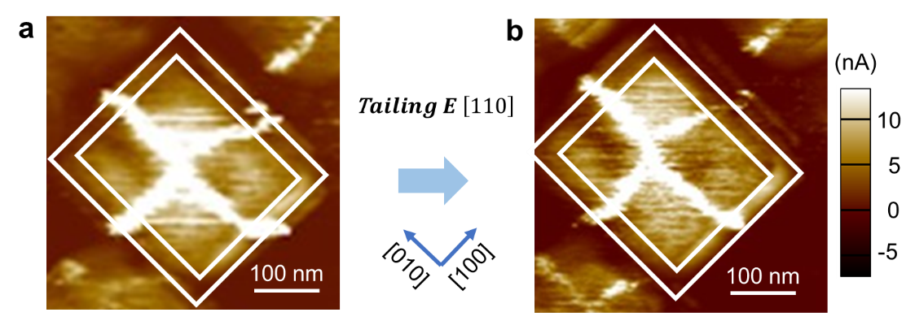
Fig. S6. Virtually unchanged cross-shaped CDW network under a trailing field in a nano-island with AR around 1.0.

Table S1.
List of coefficients used in the present work [37].
Coefficients | Values
$$α_{1}$$ | 4.64385×(T-1103)×105 C-2m2N
$$α_{11}$$ | 2.29047×108 C-4m6N
$$α_{12}$$ | 3.06361×108 C-4m6N
$$α_{111}$$ | 5.99186×109 C-6m10N
$$α_{112}$$ | -3.33980×108 C-6m10N
$$α_{123}$$ | -1.77754×109 C-6m10N
$$Q_{11}$$ | 3.2×10-2 C-2m4
$$Q_{12}$$ | -1.6×10-2C-2m4
$$Q_{44}$$ | 2.0×10-2 C-2m4
$$C_{11}$$ | 302 GPa
$$C_{12}$$ | 162 GPa
$$C_{44}$$ | 68 GPa

Movie S1.
Disruption of one CDW by [$\overline{1}\overline{1}0$]-oriented electric field.
Movie S2.
Connection of the disrupted CDW by [$110$]-oriented electric field.

