Recovery in stroke patients treated with fluoxetine versus placebo: A pooled analysis of 7,165 patients

Journal name: European Journal of Clinical Pharmacology
Authors:
Ahmed Elsnhory^{1, 5, 6}, Mohammed Tarek Hasan^{1, 5, 7}, Abdulrahman Ibrahim Hagrass^{1, 5, 8}, Ahmed Hanbal^{1, 5, 8}, Anas fathy^{1, 5, 9}, Eslam Ahmed^{1, 5, 10}, Yassamine Ouerdane^{2, 5, 11}, Khaled Mohamed Ragab^{3, 5, 12}, Mohamed Fahmy Doheim^{4, 5, 13}.
Affiliation:
1. Faculty of Medicine for boys, Al-Azhar University, Cairo, Egypt.
2. Faculty of Medicine, Saad Dahlab University, Blida, Algeria.
3. Faculty of Medicine, Minia University, Minia, Egypt.
4. Faculty of Medicine, Alexandria University, El-Shatby, 22 El-Guish Road, Alexandria, 21526, Egypt.
5. International Medical Research Association (IMedRA)

Corresponding author:
Mohamed Fahmy Doheim
Email: fahmydoheim@alumni.harvard.edu
Orchid number: https://orcid.org/0000-0001-8279-5078
Affiliation: Faculty of Medicine, Alexandria University, El-Shatby, 22 El-Guish Road, Alexandria, 21526, Egypt.
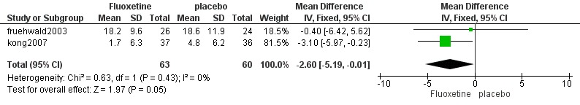
Fig.7: The pooled mean difference of the Hamilton Depression Scale (HDS).

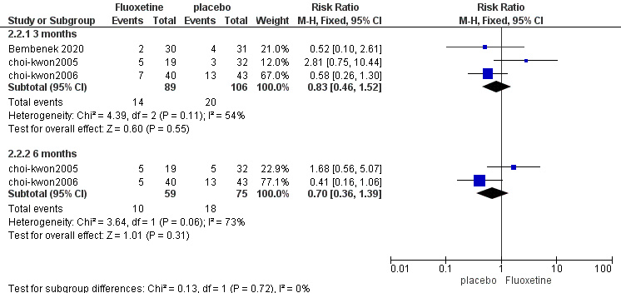
Fig.8: The pooled risk ratio of Poststroke depression.

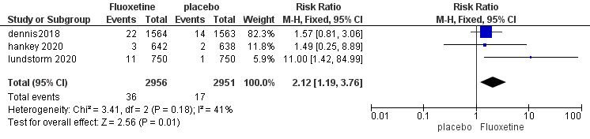
Fig.9: The pooled risk ratio of Hyponatremia.
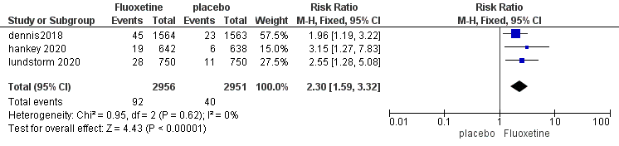
Fig.10: The pooled risk ratio of the Fractured bone.
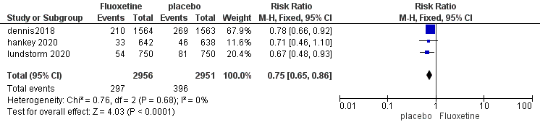
Fig.11: The pooled risk ratio of the new depression.

Table 3: Efficacy outcomes
Efficacy outcomes: | MD [95% CI] | P value
Poststroke depression | 0.85 [0.42, 1.72] | 0.66
Excessive/inappropriate crying | 1.16 [0.47, 2.89] | 0.74
Excessive/inappropriate laughing | 1.75 [1.09, 2.80] | 0.02
Post-stroke anger proneness | 1.03 [0.67, 1.58] | 0.9
Modified Rankin Scale (MRS) at 3 months | 1.04 [0.86, 1.25] | 0.69
Modified Rankin Scale (MRS) at 6 months | 0.99 [0.95, 1.04] | 0.78
MADRS | 0.39 [-7.30, 8.08] | 0.92

Table 4: Safety outcomes
Safety outcomes: | RR [95% CI] | P value
Insomnia | 1.00 [0.61, 1.62] | 0.99
Nausea | 4.95 [0.89, 27.62] | 0.07
Diarrhoea | 1.34 [0.49, 3.66] | 0.57
Any recurrent stroke | 0.93 [0.72, 1.20] | 0.58
Acute coronary events | 0.68 [0.39, 1.17] | 0.17
Ischemic stroke | 0.92 [0.69, 1.23] | 0.59
Other major bleeds | 1.00 [0.54, 1.85] | 1
Upper gastrointestinal bleed | 1.30 [0.73, 2.32] | 0.38
Hemorrhagic stroke | 1.00 [0.42, 2.39] | 1
Epileptic seizures | 1.44 [0.67, 3.10] | 0.34
Fall with injury | 1.71 [0.80, 3.64] | 0.16
Death | 1.01 [0.82, 1.24] | 0.91

Table 5: The Cochrane Collaboration’s tool for assessing the risk of bias

Study ID | Random sequence generation (selection bias) |  | Allocation concealment (selection bias) |  | Blinding of participants and personnel (performance bias) |  | Detection bias |  | Attrition bias |  | Reporting bias |  | Other Bias
Study ID | Risk of bias | Reason | Risk of bias | Reason | Risk of bias | Reason | Risk of bias | Reason | Risk of bias | Reason | Risk of bias | Reason | Risk of bias | Reason
Asadollahi 2018 | low | Block randomization was applied to place patients into one of three groups according to a computer-generated schedule. | low | The allocation is completely computer-generated. | low | double-blinded | low | A third-party evaluator was hired who was blinded to the interventions. | low | Four participants lost due to being too far away to get healthcare. | low | Every one of the predetermined outcomes was published. | unclear
Bembenek 2020 | low | Every participant in the study was randomly enrolled to receive either fluoxetine or placebo using a computer program. | low | The allocation is completely computer-generated. | low | double-blinded | low | Each patient, family member, and clinician involved in the intervention was masked to prevent any of them from knowing the therapy allocation. The placebo pills were indistinguishable from the fluoxetine. | high | five patients didn't continue the therapy because of an unclear cause. | low | Every one of the predetermined outcomes was published. | high | Funded
boninpinto2019 | low | They used a web-based randomization sequence developed by a study participant who was not taking part in the study protocol. | low | Secrecy of allocation was maintained by sequentially labeled opaque envelopes. | low | double-blinded | low | All assessments were completed by an assessor who was blinded to rTMS and medication. The rTMS operator was not blinded to rTMS allocation, but she or he was blinded to fluoxetine allocation and did not gather outcome data. | low | We applied intention to treat analysis with regression imputation to solve the significant proportion of missing data, but we also added a full case analysis. | low | Every one of the predetermined outcomes was published. | unclear
choi-kwon2005 | low | Treatment distribution was based on a list sorted by a computer. | low | The allocation is completely computer-generated. | low | double-blinded | unclear |  | high | The dropouts' causes varied. 4 participants in the fluoxetine arm and 6 participants in the placebo arm did not comply with the protocol. For the fluoxetine arm, 10 patients sought to terminate the treatment because of unpleasant symptoms, while only 2 did for the placebo arm. In the fluoxetine arm, one patient had hospital readmission due to another illness, while in the placebo arm, two patients did. | low | Every one of the predetermined outcomes was published. | high | funded
choi-kwon2006 | low | Treatment distribution was based on a list sorted by a computer. | low | The allocation is completely computer-generated. | low | double-blinded | unclear |  | high | Two patients in the placebo group and three in the fluoxetine group discontinued the treatment before the completion of the 3-month treatment course. | low | Every one of the predetermined outcomes was published. | high | funded
chollet2011 | low | Randomization was established via a computer random-number generator, which the pharmacist in charge of the coordinating center has applied. | low | Secrecy of allocation was maintained by sequentially labeled opaque envelopes. | low | double-blinded | low | To protect against bias, clinicians examining the findings were blinded to group assignment. | high | Three patients suffered from neurological diseases and dropped out and one person died owing to fluoxetine's adverse effects. | low | Every one of the predetermined outcomes was published. | high | funded
dam 1998 | unclear | The method of randomization isn't mentioned. | unclear | The method of randomization isn't mentioned. | unclear | It isn't mentioned. | unclear | It isn't mentioned. | low | There were few losses to follow-up | unclear | Protocol not found | low
dennis2018 | low | Every participant in the study was randomized through a centralized randomization system. | low | The allocation is completely computer-generated. | low | double-blinded | low | To protect against bias, clinicians examining the findings were blinded to group assignment. | low | There were only a few missed follow-ups, and prespecified intention-to-treat analyses were performed. | low | Every one of the predetermined outcomes was published. | high | funded
fruehwald2003 | low | Computer software used a random permuted block design for each site to build the randomization code list. | low | The allocation is completely computer-generated. | low | Double-blinded, but continued open-label after the initial assessment for 18 months | low |  | low | A patient on placebo experienced an intercurrent dermatological condition, hence the patient had to withdraw from the study. | low | Every one of the predetermined outcomes was published. | unclear
gong2020 | low | We assigned randomly patients into one of four groups by using a computer-generated schedule. | low | The allocation is completely computer-generated. | low | double-blinded | low |  | high | five patients dropped out | low | Every one of the predetermined outcomes was published. | high | supported by a grant from The National Natural Science Foundation of China
hankey 2020 | low | They used an automated technique for running a randomized trial using web-based randomization to create a unique study identification number and treatment pack number. | low | The allocation is completely computer-generated. | low | Each patient, family member, and clinician involved in the intervention was masked to prevent any of them from knowing the therapy allocation. | low | Each patient, family member, and clinician involved in the intervention was masked to prevent any of them from knowing the therapy allocation. The placebo pills were indistinguishable from the fluoxetine. | low | adjusted for variables in the minimization algorithm, was similar in both groups | low | Every one of the predetermined outcomes was published. | high | funded
he 2016 | low | Randomization codes were generated by a person who was not participating in the treatment or the follow-up | unclear | Staff not involved in therapy or follow-up handled the allocation. | high | In our trial, we used a single-blind assessor. | high | They employed the single-blind evaluator. | low | dropped patients died | low | Every one of the predetermined outcomes was published. | high | funded
kong2007 | low | A computer-generated list of therapy codes served as the basis for treatment allocation. | low | Staff not involved in therapy or follow-up handled the allocation. | high | No blinding | high | No blinding | low | A total of 11 patients dropped out. | low | Every one of the predetermined outcomes was published. | unclear
li2008 | low | An unbiased physician performed the randomization by a computer algorithm that was not participating in the treatment protocol. | low | Staff not involved in therapy or follow-up handled the allocation. | low | double-blinded | unclear |  | low | No patients dropped out | low | Every one of the predetermined outcomes was published. | unclear
lundstorm 2020 | low | The randomization process was carried out using a web-based randomization engine that featured a minimization algorithm. | low | Staff not involved in therapy or follow-up handled the allocation. | low | double-blinded | low | Each patient, family member, clinician involved in the intervention as well as personnel from the coordinating center and the pharmacy was masked to prevent any of them from knowing the therapy allocation. | low | The modified intention-to-treat approach is used in the analysis. | low | Every one of the predetermined outcomes was published. | high | funded
marquez-romero2020 | low | The randomization list was developed via a web-based randomization tool. | low | Staff not involved in therapy or follow-up handled the allocation. | low | double-blinded | unclear |  | low | mild and no patient discontinued the study medication | low | Every one of the predetermined outcomes was published. | unclear
Wiart2001 | unclear | The method of randomization Isn't mentioned. | unclear | not mentioned | low | double-blinded | unclear |  | low | mild for non-related compliance | low | Every one of the predetermined outcomes was published. | unclear

