Supplemental figure 1: McGill Réseau Universitaire Intégré de Santé et Services Sociaux (RUISSS)
Center of Expertise Low Back Pain (LBP) Model of Care

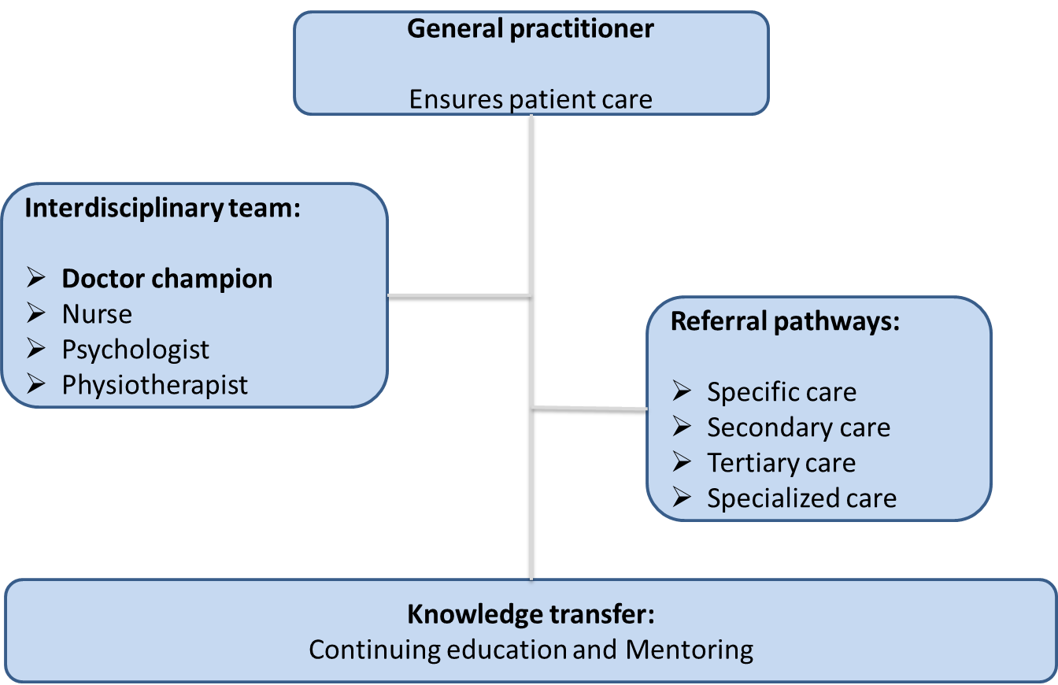

Supplemental figure 2: McGill Réseau Universitaire Intégré de Santé et Services Sociaux (RUISSS)
Center of Expertise Clinical Process and trajectories to other services
Clinical trajectory for low back pain

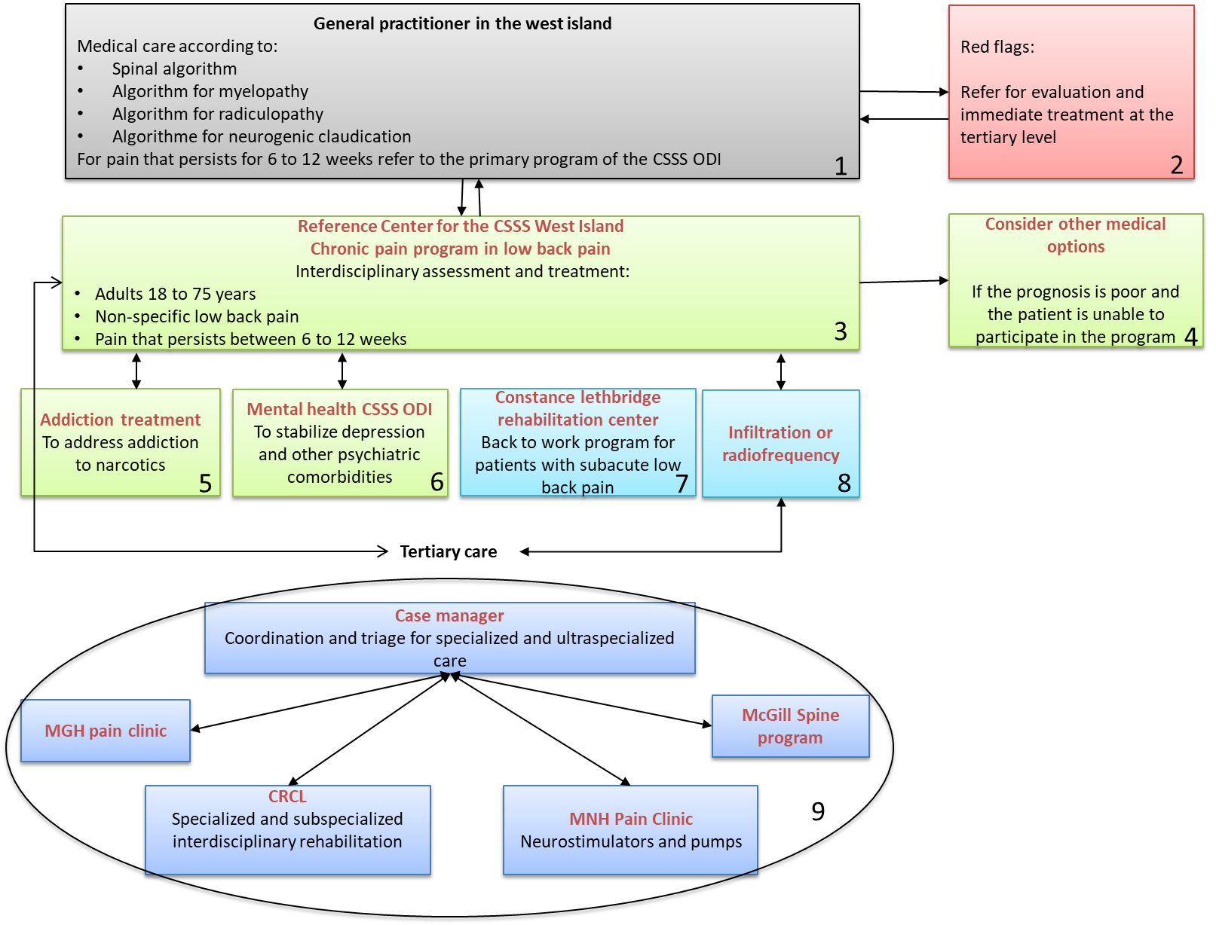

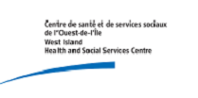
Supplemental figure 3: Treatment of non-specific subacute low back pain. McGill Réseau Universitaire Intégré de Santé et Services Sociaux (RUISSS) Center of Expertise Clinical Chronic Pain Program
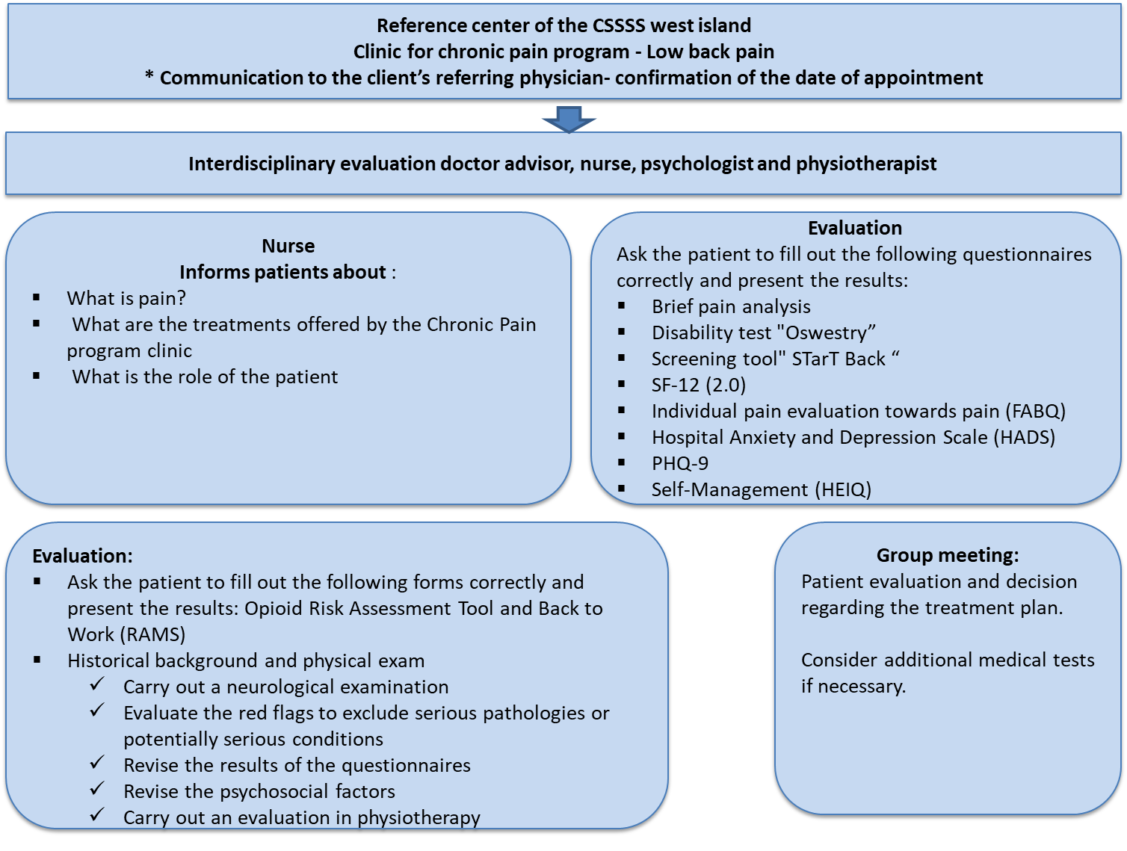
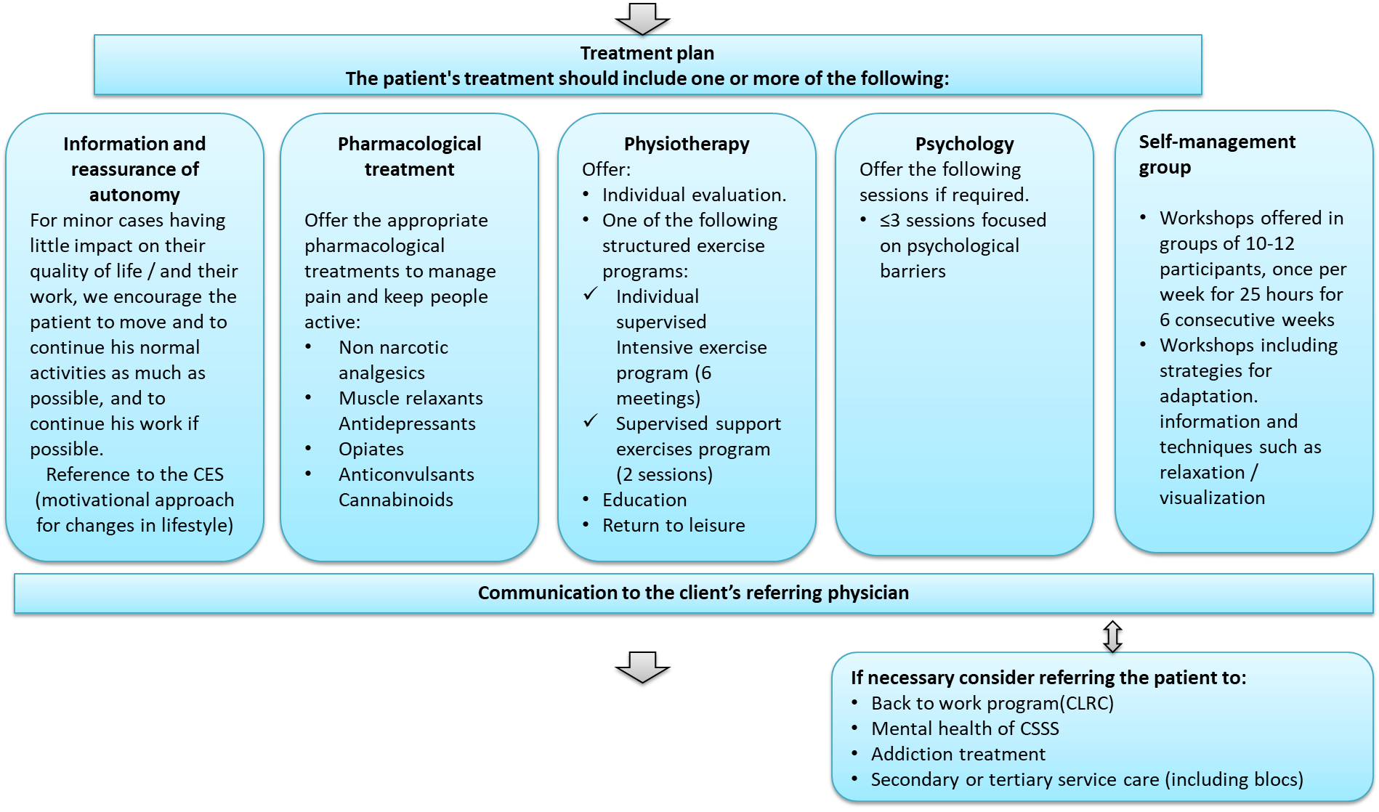

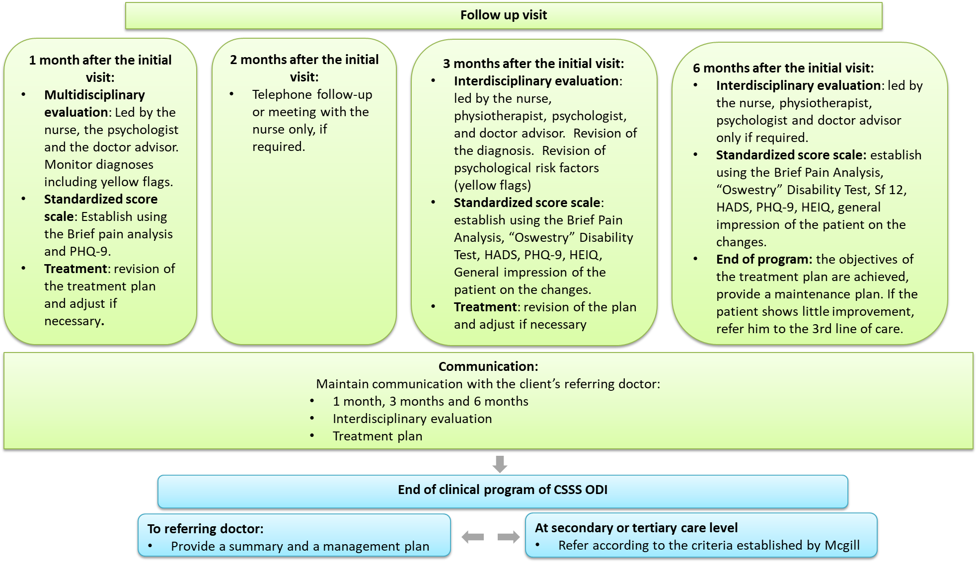

Supplemental figure 4: Number of visits to each clinician according to level of risk of chronicity

Supplemental figure 5: Minimal Clinical Important Difference (MCID) for Depression and Anxiety
MCID = (Depression = 2.1, Anxiety = 1.9)
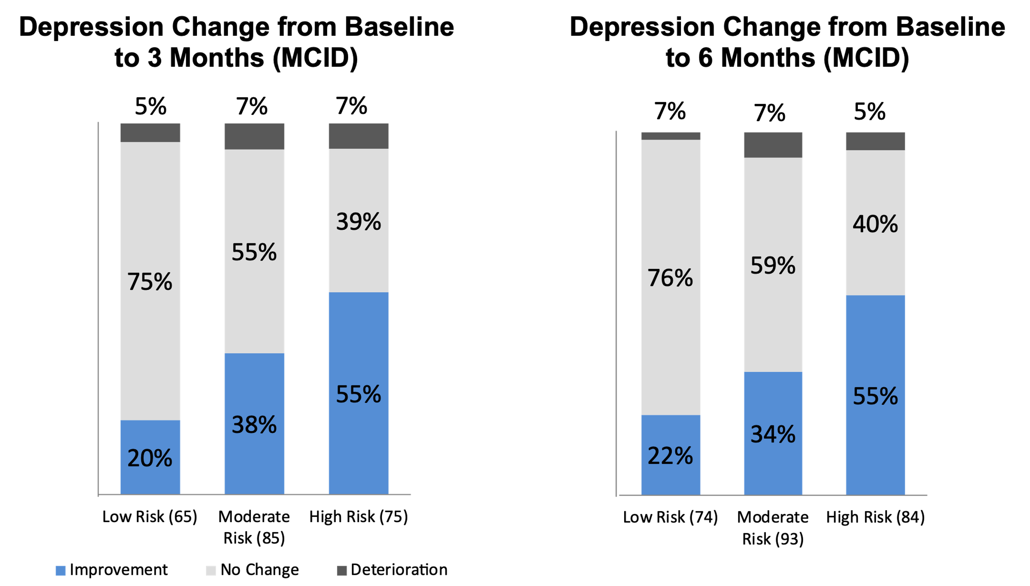
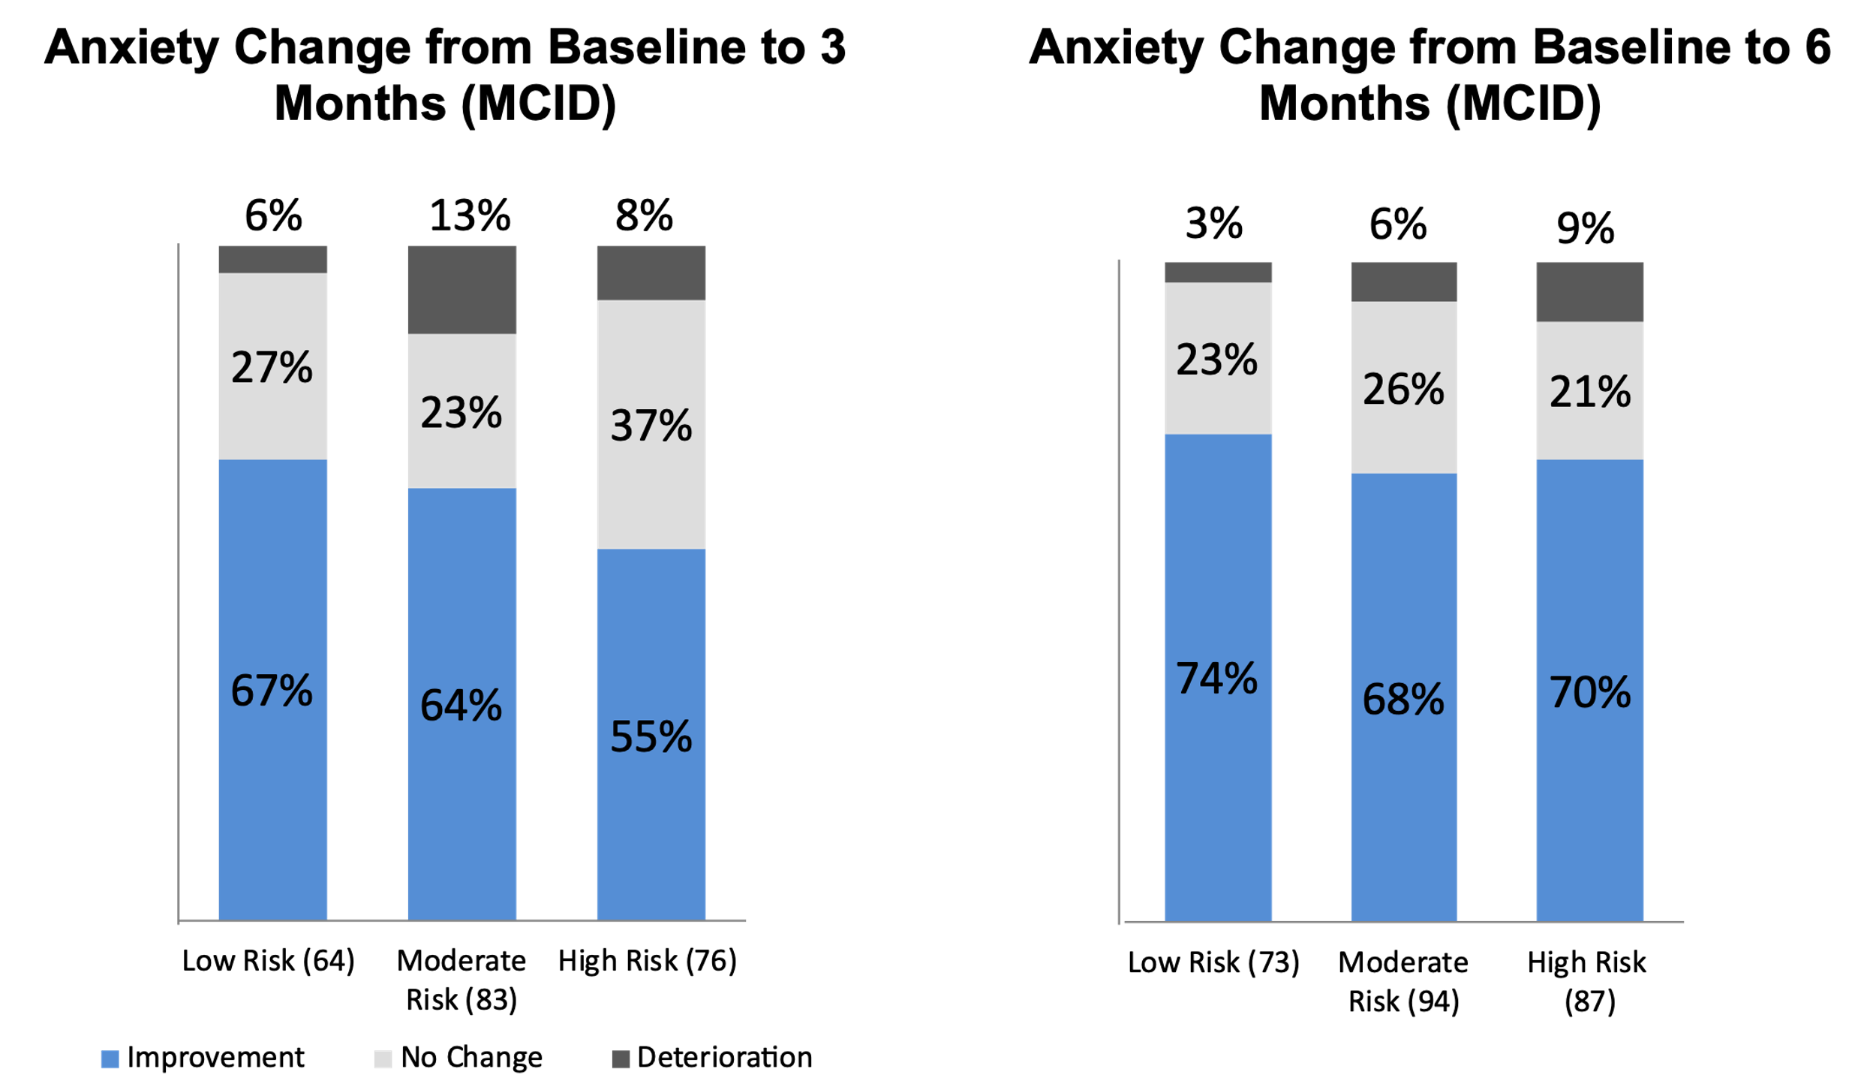

Supplemental figure 6 Minimal Clinical Important Difference (MCID) for Self-Efficacy
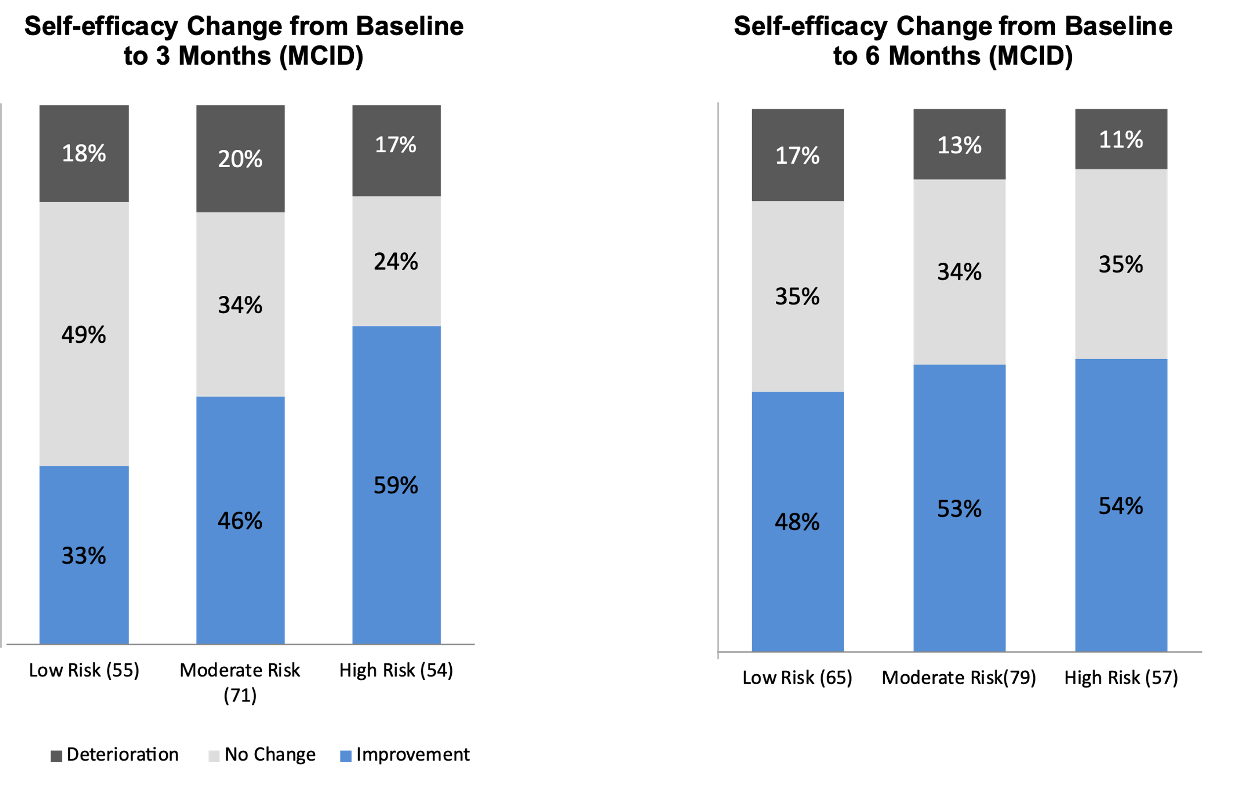

Supplemental table 1: Committees established to develop the LBP Program
Committee | Co-chairs | Mandate
Inter regional working committee | Physiatrist, McGill University Health Centre Pain Clinic  General practitioner, McGill University Health Center pain clinic | - develop and evaluate regional programming on evidence and guidelines;  - develop reference to target clientele towards the 2nd and 3rd line of care;  - develop and evaluate an algorithm (medical);  - develop and evaluate a clinical process, i.e. the sequence of interventions planned for the interdisciplinary team.
Clinical | General practitioner, McGill University Health Center pain clinic  Physiatrist McGill University Health Center pain clinic, and rehabilitation center | - promote clinical discussions between the different members;  - develop or update clinical tools;  - develop reference mechanisms between the first line, the second line and the third line of care;  - develop if required, a system of collective prescriptions for all stakeholders in the area.
Education | Anesthesiologist, McGill University Health Center pain clinic  General practitioner, McGill University Health Center pain clinic | - promote clinical discussions between the various members of the interdisciplinary team and general practitioners in the CSSS territory;  - organize continuing professional development activities for general practitioners and members of the interdisciplinary team.
Quality and evaluation | Director of Rehabilitation  Services | - develop or update clinical indicators;  - develop reference mechanisms between the first line and the second line of care;  - develop, if required, a system of collective prescriptions for all stakeholders in the area.
Local Coordination Committee (LCC) | General practitioner of the health region  Director of corporate services of the health region | - develop a partnership between medical specialists, general practitioners and all stakeholders;  - determine and approve target clienteles and clinical processes;  - promote a hierarchy of services;  - determine service corridors and propose agreements with partners;  - establish a clinical committee to review and harmonize clinical content;  - support the implementation and smooth operation of the local project in chronic disease;  - set up an evaluation process in partnership with the agency;  - review the referral / feedback process (doctors and healthcare teams);  - ensure a communication plan for general practitioners in the area;  - provide clinical training for stakeholders;  - support the development of expertise and accreditation of different professionals

Supplemental table 2: Reason for refusing to remain in the program
Reason | Frequency
stroke | 1
No interest in the program | 5
No reason mentioned | 8
Not available because of work | 7
Needs do not correspond to project | 4
No more pain | 4
No more pain and no longer available | 1
Moved out of town | 6
Not available | 5
Very hard for her to come ecause she works at night and lives far away | 1
File closed by the team | 1
The patient fell and has a broken arm. She suspends her participation in the program | 1
No longer available and no motivation, end of follow-up, MD has been notified | 1
Follows the recommendation of physician, physician says program not adequate for her | 1
Could not reach | 15
Very hard for her to come because she works at night and lives far away | 1
See note | 14
Had a surgery and is followed individually | 1
Cancelled by patient | 1
Cannot come, secondary other medical issues | 1
Hip surgery | 1
Client in remission from cancer, has many appointments, can`t attend 6 months follow up | 1
Not interested and not available | 1
Postural deficit | 1
Depression (will resume when he feels better) | 1
Says wasting her time | 1
Given that her pain is not a nonspecific low back pain, we do not plan to continue to see her here | 1
Dissatisfaction | 1
Language barrier | 2
Lack of time, motivation | 1
Lack of time, motivation and return to school. | 1
Didn’t adhere to self-management principles, self-management care to be discussed, family physician has been notified, consultation with ortho | 1
No longer feels clinic is helping | 1
Non-adherence to the entire program | 1
Not able to continue with exercise program | 1
Vascular problem | 1
Redirected to pain clinic and conventional physiotherapy | 1
Neurosurgery reference | 1
Sent to emergency on May 18th | 1
She is discontinuing program as she feels confident she can exercise on own | 1
She is unable to continue in the program | 1
Followed by physio only, lack of motivation | 1
Suspend his program until his emotional state gets better | 1
Absenteeism rate too high | 1
Too much for her (depression?) | 1
Too much back pain | 1
Wife is in the hospital | 1
Note : Patient left program, he would be followed in chiropractic | 1
Too far | 2

