Table S1. Summary of statistics for gas exchange parameters using anova test in R for effect of cultivar, elevated CO₂ and heat stress (HS) on gas exchange parameters measured at 25°C leaf temperature at three-time points. T1 did not have HS treatment. T2 includes only HS1 at the vegetative stage, with two HS levels: Control and HS1. T3 included HS1 at the vegetative stage and HS2 at the reproductive stage with four HS levels: Control, HS1, HS2 and HS1+2. Both aCO₂ and eCO₂ grown plants were measured at 400 and 650 μl L⁻¹. Growth CO₂ measurements refer to measurement of ambient CO₂ grown plants at 400 (μl L⁻¹) and elevated CO₂ grown plants at (650 μl L⁻¹). Significance levels are: *** = p < 0.001; ** = p < 0.01; * = p < 0.05; ns p > 1.
Time Point | Parameter | Meas CO₂ (μlL⁻¹) | Main Effects |  |  |  |  | Interactions
Time Point | Parameter | Meas CO₂ (μlL⁻¹) | Cultivar |  | CO₂ |  | HS | Cultivar*CO₂ | CO₂* HS | Cultivar*HS | Cultivar*CO₂ * HS
Common and Growth CO₂
T1 | A_{sat}  (µmol m⁻² s⁻¹) | 400 | ns |  | ** |  |  | ns
T1 | A_{sat}  (µmol m⁻² s⁻¹) | 650 | ns |  | ** |  |  | *
T1 | g_{s}  (mol m⁻²s⁻¹) | 400 | ns |  | *** |  |  | ns
T1 | g_{s}  (mol m⁻²s⁻¹) | 650 | ns |  | *** |  |  | ns
T1 | PWUE (A_{sat}/g_{s})  (µmol mol⁻¹) | 400 | ns |  | ** |  |  | ns
T1 | PWUE (A_{sat}/g_{s})  (µmol mol⁻¹) | 650 | ns |  | ** |  |  | ns
T1 | Fv/Fm | 400 | ns |  | ns |  |  | ns
T1 | Fv'/Fm' | 400 | *** |  | ns |  |  | ns
T1 | Rd (µmol m⁻² s⁻¹)  (µmol m⁻²s⁻¹) | 400 | ns |  | ns |  |  | ns
T2 | A_{sat}  (µmol m⁻² s⁻¹) | 400 | * |  | ** |  | ns | ns | ns | ns | ns
T2 | A_{sat}  (µmol m⁻² s⁻¹) | 650 | ** |  | * |  | ns | ns | ns | ns | ns
T2 | g_{s}  (mol m⁻²s⁻¹) | 400 | ns |  | ns |  | ns | ns | ns | ns | ns
T2 | g_{s}  (mol m⁻²s⁻¹) | 650 | ns |  | ns |  | ns | ns | ns | ns | ns
T2 | PWUE (A_{sat}/g_{s})  (µmol mol⁻¹) | 400 | ns |  | ns |  | ns | ns | ns | ns | ns
T2 | PWUE (A_{sat}/g_{s})  (µmol mol⁻¹) | 650 | ** |  | ns |  | ns | ns | ns | ns | ns
T2 | Fv/Fm | 400 | ** |  | ns |  | ns | ns | ** | ns | ns
T2 | Fv'/Fm' | 400 | * |  | * |  | ns | ns | ns | ns | ns
T2 | Rd (µmol m⁻² s⁻¹)  (µmol m⁻²s⁻¹) | 400 | *** |  | ns |  | ns | ns | ns | ns | ns
T3 | A_{sat}  (µmol m⁻² s⁻¹) | 400 | * |  | *** |  | * | ns | ns | ns | ns
T3 | A_{sat}  (µmol m⁻² s⁻¹) | 650 | *** |  | * |  | ** | ns | ns | ns | ns
T3 | g_{s}  (mol m⁻²s⁻¹) | 400 | * |  | *** |  | *** | ns | ns | *** | ns
T3 | g_{s}  (mol m⁻²s⁻¹) | 650 | *** |  | ** |  | *** | ns | ns | *** | ns
T3 | PWUE (A_{sat}/g_{s})  (µmol mol⁻¹) | 400 | ns |  | ns |  | ** | * | ns | *** | **
T3 | PWUE (A_{sat}/g_{s})  (µmol mol⁻¹) | 650 | ns |  | ns |  | ** | ns | ns | *** | ns
T3 | PNUE (A_{sat}/)  (µmol mol⁻¹) | 400
T3 | Fv/Fm | 400 | *** |  | ns |  | ns | *** | * | ns | *
T3 | Fv'/Fm' | 400 | ns |  | ns |  | ns | ns | ns | ns | ns
T3 | Rd (µmol m⁻² s⁻¹)  (µmol m⁻²s⁻¹) | 400 | *** |  | ns |  | ns | * | ** | * | ns
T3 | V_{cmax} | 400 | ns |  | *** |  | ns | ns | ns | ns | ns
T3 | J_{max} | 400 | * |  | ns |  | ns | ns | ns | ns | ns
T3 | V_{cmax} / J_{max} | 400 | ** |  | *** |  | ns | * | ns | ns | ns
Growth CO₂
T3 | A_{sat}  (µmol m⁻² s⁻¹) | Growth CO₂ | ** | *** |  | * |  | ns | ns | ns | ns
T3 | g_{s}  (mol m⁻²s⁻¹) | Growth CO₂ | ** | *** |  | *** |  | ns | ns | ** | ns
T3 | PWUE (A_{sat}/g_{s})  (µmol mol⁻¹) | Growth CO₂ | ns | *** |  | * |  | ns | ns | *** | **
T3 | PNUE (A_{sat}/) | Growth CO₂ | ns | ns |  | ns |  | ns | ns | ns | ns
T3 | Rd (µmol m⁻² s⁻¹)  (µmol m⁻²s⁻¹) | Growth CO₂ | **** |  | *** |  | ns | ns | ** | *** | ns

Table S2. Response of Scout gas exchange parameters to elevated CO₂ and heat stress. Summary of leaf gas exchange measured at two CO₂ (400 and 650 μl L⁻¹) partial pressures and 25ºC leaf temperature for Scout grown at ambient CO₂ (aCO₂) or elevated CO₂ (eCO₂) and exposed to 1 and/or 2 heat stresses. Values are means ± SE (n= 9-10). Heat stress treatments include plants not exposed to any heat stress (control), plants exposed to heat stress 1 (HS1), heat stress 2 (HS2) and both heat stresses (HS1+2).
Scout  Parameters | Time  Point | Growth CO₂ | Ambient |  |  |  | Elevated
Scout  Parameters | Time  Point | Meas CO₂ / Heat Stress | Control | HS1 | HS2 | HS1+2 | Control | HS1 | HS2 | HS1+2
A  (µmol m⁻² s⁻¹) | T1 | 400 | 24.6 ± 0.99 |  |  |  | 22.9 ± 0.49
A  (µmol m⁻² s⁻¹) | T1 | 650 | 31.4 ± 1.2 |  |  |  | 30.8 ± 0.67
A  (µmol m⁻² s⁻¹) | T2 | 400 | 24.4 ± 0.99 | 22.8 ± 0.84 |  |  | 21.6 ± 0.99 | 21.8 ± 1.02
A  (µmol m⁻² s⁻¹) | T2 | 650 | 32.4 ± 1.40 | 30.1 ± 1.51 |  |  | 29.2 ± 1.19 | 29 ± 1.09
A  (µmol m⁻² s⁻¹) | T3 | 400 | 17.6 ± 0.59 | 19.5 ± 0.64 | 18.6 ± 1.04 | 14.8 ± 1.12 | 17.1 ± 1.14 | 19.1 ± 0.96 | 14.8 ± 1.12 | 17 ± 1.29
A  (µmol m⁻² s⁻¹) | T3 | 650 | 22.5 ± 0.74 | 26.1 ± 0.97 | 25 ± 1.51 | 20.8 ± 1.47 | 22.8 ± 1.55 | 25.5 ± 1.47 | 20.8 ± 1.47 | 23.2 ± 1.9
g_{s}  (mol m⁻²s⁻¹) | T1 | 400 | 0.35 ± 0.02 |  |  |  | 0.28 ± 0.01
g_{s}  (mol m⁻²s⁻¹) | T1 | 650 | 0.36 ± 0.04 |  |  |  | 0.25 ± 0.01
g_{s}  (mol m⁻²s⁻¹) | T2 | 400 | 0.36 ± 0.02 | 0.36 ± 0.02 |  |  | 0.33 ± 0.01 | 0.33 ± 0.02
g_{s}  (mol m⁻²s⁻¹) | T2 | 650 | 0.31 ± 0.01 | 0.33 ± 0.01 |  |  | 0.33 ± 0.01 | 0.33 ± 0.01
g_{s}  (mol m⁻²s⁻¹) | T3 | 400 | 0.29 ± 0.01 | 0.35 ± 0.01 | 0.31 ± 0.02 | 0.20 ± 0.02 | 0.23 ± 0.01 | 0.34 ± 0.02 | 0.20 ± 0.02 | 0.31 ± 0.02
g_{s}  (mol m⁻²s⁻¹) | T3 | 650 | 0.26 ± 0.01 | 0.34 ± 0.01 | 0.27 ± 0.01 | 0.20 ± 0.02 | 0.23 ± 0.01 | 0.31 ± 0.02 | 0.20 ± 0.02 | 0.30 ± 0.02
PWUE (A_{sat}/g_{s})  (µmol mol⁻¹) | T1 | 400 | 71.9 ± 3.3 |  |  |  | 83.2 ± 4.6
PWUE (A_{sat}/g_{s})  (µmol mol⁻¹) | T1 | 650 | 95.9 ± 10 |  |  |  | 123.5 ± 6.2
PWUE (A_{sat}/g_{s})  (µmol mol⁻¹) | T2 | 400 | 67.6 ± 3.7 | 65.2 ± 3.9 |  |  | 65.3 ± 2.2 | 66.6 ± 3.2
PWUE (A_{sat}/g_{s})  (µmol mol⁻¹) | T2 | 650 | 106 ± 9.5 | 90.6 ± 5.4 |  |  | 89.7 ± 4.0 | 86.9 ± 2.3
PWUE (A_{sat}/g_{s})  (µmol mol⁻¹) | T3 | 400 | 60.2 ± 2.3 | 56.0 ± 2.6 | 61.7 ± 3.6 | 81.0 ± 8.1 | 72.7 ± 3.4 | 56.6 ± 2.9 | 81.0 ± 8.1 | 55.3 ± 2.7
PWUE (A_{sat}/g_{s})  (µmol mol⁻¹) | T3 | 650 | 90.5 ± 6.3 | 77.4 ± 5.2 | 92.9 ± 4.3 | 125 ± 23.0 | 98.6 ± 4.2 | 82.4 ± 3.9 | 125 ± 23.0 | 75.3 ± 3.6
Rd  (µmol m⁻² s⁻¹) | T1 | 400 | -1.11 ± 0.09 |  |  |  | -1.19 ± 0.08
Rd  (µmol m⁻² s⁻¹) | T2 | 400 | -0.54 ± 0.16 | -0.65 ± 0.16 |  |  | -0.76 ± 0.09 | -0.76 ± 0.14
Rd  (µmol m⁻² s⁻¹) | T3 | 400 | -1.04 ± 0.09 | -0.96 ± 0.08 | -1.08 ± 0.09 | -0.71 ± 0.15 | -1.06 ± 0.09 | -0.99 ± 0.16 | -0.71 ± 0.15 | -0.70 ± 0.05
Fv/Fm | T1 | 400 | 0.81 ± 0.00 |  |  |  | 0.81 ± 0.00
Fv/Fm | T2 | 400 | 0.81 ± 0.01 | 0.80 ± 0.01 |  |  | 0.80 ± 0.01 | 0.82 ± 0.00
Fv/Fm | T3 | 400 | 0.79 ± 0.01 | 0.79 ± 0.01 | 0.79 ± 0.01 | 0.78 ± 0.01 | 0.76 ± 0.01 | 0.79 ± 0.01 | 0.78 ± 0.01 | 0.75 ± 0.02
Fv'/Fm' | T1 | 400 | 0.48 ± 0.01 |  |  |  | 0.49 ± 0.01
Fv'/Fm' | T2 | 400 | 0.48 ± 0.01 | 0.48 ± 0.00 |  | 0.45 ± 0.02 | 0.50 ± 0.01 | 0.50 ± 0.00
Fv'/Fm' | T3 | 400 | 0.50 ± 0.01 | 0.50 ± 0.01 | 0.49 ± 0.01 | 0.52 ± 0.01 | 0.52 ± 0.02 | 0.50 ± 0.01 | 0.45 ± 0.02 | 0.48 ± 0.02
PNUE | T3 | Growth CO₂ | 317 ± 52 |  |  | 270 ± 32 | 247 ± 25 |  |  | 280 ± 50
V_{cmax} | T3 | NA | 84.2 ± 2.7 |  |  | 82.2 ± 5.3 | 73.9 ± 3.6 |  |  | 72.8 ± 5.6
J_{max} | T3 | NA | 134 ± 5 |  |  | 137 ± 9 | 133 ± 7 |  |  | 138 ± 8
V_{cmax}/ J_{max} | T3 | NA | 0.63 ± 0.01 |  |  | 0.60 ± 0.01 | 0.55 ± 0.01 |  |  | 0.52 ± 0.02

Table S3. Response of Yitpi gas exchange parameters to growth at elevated CO₂ and heat stress. Summary of leaf gas exchange measured at two CO₂ (400 and 650 μl L⁻¹) partial pressures and 25ºC leaf temperature for Yitpi grown at ambient CO₂ (aCO₂) or elevated CO₂ (eCO₂) and exposed to 1 and/or 2 heat stresses. Values are means ± SE (n= 9-10). Heat stress treatments include plants not exposed to any heat stress (control), plants exposed to heat stress 1 (HS1), heat stress 2 (HS2) and both heat stresses (HS1+2).
Yitpi  Parameters | Time Point | Growth CO2 | Ambient |  |  |  | Elevated
Yitpi  Parameters | Time Point | Meas CO_{2 /} Heat Stress | Control | HS1 | HS2 | HS1+2 | Control | HS1 | HS2 | HS1+2
A  (µmol m⁻² s⁻¹) | T1 | 400 | 24.8 ± 0.77 |  |  |  | 21 ± 0.63
A  (µmol m⁻² s⁻¹) | T1 | 650 | 33.9 ± 0.93 |  |  |  | 29.5 ± 0.57
A  (µmol m⁻² s⁻¹) | T2 | 400 | 26 ± 0.63 | 24.2 ± 1.01 |  |  | 23.4 ± 1.12 | 22.9 ± 1.49
A  (µmol m⁻² s⁻¹) | T2 | 650 | 36.2 ± 0.84 | 34 ± 1.30 |  |  | 31.9 ± 1.99 | 32.5 ± 2.18
A  (µmol m⁻² s⁻¹) | T3 | 400 | 20 ± 1.09 | 20.9 ± 1.13 | 20.1 ± 0.69 | 18.3 ± 0.81 | 16.3 ± 0.91 | 20.2 ± 1.20 | 18.3 ± 0.81 | 18.4 ± 0.81
A  (µmol m⁻² s⁻¹) | T3 | 650 | 27.6 ± 1.64 | 29.2 ± 1.46 | 27.7 ± 0.92 | 25.9 ± 1.36 | 23.3 ± 1.22 | 28.6 ± 1.49 | 25.9 ± 1.36 | 26.7 ± 1.14
g_{s}  (mol m⁻²s⁻¹) | T1 | 400 | 0.35 ± 0.02 |  |  |  | 0.25 ± 0.01
g_{s}  (mol m⁻²s⁻¹) | T1 | 650 | 0.37 ± 0.02 |  |  |  | 0.27 ± 0.01
g_{s}  (mol m⁻²s⁻¹) | T2 | 400 | 0.38 ± 0.02 | 0.33 ± 0.02 |  |  | 0.34 ± 0.01 | 0.31 ± 0.01
g_{s}  (mol m⁻²s⁻¹) | T2 | 650 | 0.35 ± 0.01 | 0.31 ± 0.01 |  |  | 0.29 ± 0.01 | 0.30 ± 0.02
g_{s}  (mol m⁻²s⁻¹) | T3 | 400 | 0.30 ± 0.02 | 0.34 ± 0.02 | 0.37 ±0.01 | 0.35 ± 0.01 | 0.27 ± 0.01 | 0.33 ± 0.02 | 0.35 ± 0.01 | 0.29 ± 0.01
g_{s}  (mol m⁻²s⁻¹) | T3 | 650 | 0.29 ± 0.02 | 0.34 ± 0.01 | 0.38 ±0.01 | 0.35 ± 0.01 | 0.27 ± 0.01 | 0.32 ± 0.02 | 0.35 ± 0.01 | 0.30 ± 0.01
PWUE (A_{sat}/g_{s})  (µmol mol⁻¹) | T1 | 400 | 72.4 ± 3.8 |  |  |  | 84.1 ± 5.1
PWUE (A_{sat}/g_{s})  (µmol mol⁻¹) | T1 | 650 | 93.1 ± 5.6 |  |  |  | 110 ± 3.6
PWUE (A_{sat}/g_{s})  (µmol mol⁻¹) | T2 | 400 | 68.3 ± 3.0 | 75.7 ± 4.4 |  |  | 68.3 ± 3.5 | 71.9 ± 3.9
PWUE (A_{sat}/g_{s})  (µmol mol⁻¹) | T2 | 650 | 103 ± 5.9 | 110 ± 6.1 |  |  | 108 ± 7.0 | 109 ± 6.3
PWUE (A_{sat}/g_{s})  (µmol mol⁻¹) | T3 | 400 | 66.1 ± 2.3 | 60.5 ± 2.2 | 54.8 ± 1.9 | 52.0 ± 1.8 | 61.1 ± 2.3 | 61.1 ± 2.5 | 52.0 ± 1.8 | 62.7 ± 2.9
PWUE (A_{sat}/g_{s})  (µmol mol⁻¹) | T3 | 650 | 94.1 ± 4.6 | 85.9 ± 2.6 | 73.3 ± 2.7 | 73.8 ± 3.3 | 88.7 ± 6.1 | 89.7 ± 4.2 | 73.8 ± 3.3 | 88.5 ± 2.9
Rd  (µmol m⁻² s⁻¹) | T1 | 400 | -1.15 ± 0.59 |  |  |  | -1.19 ± 0.10
Rd  (µmol m⁻² s⁻¹) | T2 | 400 | -0.69 ± 0.10 | -1.24 ± 0.14 |  |  | -1.06 ± 0.12 | -1.06 ± 0.08
Rd  (µmol m⁻² s⁻¹) | T3 | 400 | -0.23 ± 0.28 | -0.30 ± 0.15 | -1.16 ± 0.13 | -0.61 ± 0.06 | -0.63 ± 0.09 | -0.70 ± 0.05 | -0.61 ± 0.06 | -0.83 ± 0.24
Fv/Fm | T1 | 400 | 0.81 ± 0.00 |  |  |  | 0.81 ± 0.00
Fv/Fm | T2 | 400 | 0.82 ± 0.00 | 0.81 ± 0.00 |  |  | 0.81 ± 0.00 | 0.82 ± 0.00
Fv/Fm | T3 | 400 | 0.81 ± 0.00 | 0.77 ± 0.01 | 0.81 ± 0.00 | 0.81 ± 0.01 | 0.80 ± 0.00 | 0.81 ± 0.00 | 0.81 ± 0.01 | 0.81 ± 0.00
Fv'/Fm' | T1 | 400 | 0.46 ± 0.00 |  |  |  | 0.45 ± 0.00
Fv'/Fm' | T2 | 400 | 0.48 ± 0.00 | 0.47 ± 0.01 |  | 0.50 ± 0.01 | 0.48 ± 0.01 | 0.48 ± 0.01
Fv'/Fm' | T3 | 400 | 0.50 ± 0.01 | 0.50 ± 0.01 | 0.51 ± 0.00 | 0.51 ± 0.01 | 0.50 ± 0.01 | 0.48 ± 0.01 | 0.50 ± 0.01 | 0.49 ± 0.01
PNUE | T3 | Growth CO₂ | 283 ± 16 |  |  | 284 ± 15 | 267 ± 26 |  |  | 280 ± 14
V_{cmax} | T3 | NA | 81.5 ± 2.9 |  |  | 90.3 ± 4.2 | 70.8 ± 4.9 |  |  | 80.1 ± 3.4
J_{max} | T3 | NA | 144 ± 6 |  |  | 161 ± 10 | 134 ± 9 |  |  | 148 ± 5
V_{cmax}/ J_{max} | T3 | NA | 0.56 ± 0.01 |  |  | 0.56 ± 0.01 | 0.52 ± 0.01 |  |  | 0.54 ± 0.01

Table S4. Summary of statistics for biomass parameters using anova test in R for effect of cultivar, elevated CO₂ and heat stress (HS) on plant dry mass (DM) and morphological parameters measured at four-time points. Significance levels are: *** = p < 0.001; ** = p < 0.01; * = p < 0.05; ns p > 1.
Time Point | Parameter  (Mean plant⁻¹) | Main Effects |  |  |  |  | Interactions
Time Point | Parameter  (Mean plant⁻¹) | Cultivar | CO₂ |  | HS |  | Cultivar × CO₂ | CO₂ × HS |  | Cultivar × HS |  | Cultivar × CO₂ × HS
T1 | Leaf number (n) | *** |  | ns |  |  | ns
T1 | Leaf area (cm²) | ns |  | ns |  |  | ns
T1 | Leaf DM (g) | * |  | * |  |  | ns
T1 | Stem DM (g) | ** |  | ns |  |  | ns
T1 | Root DM (g) | ns |  | ns |  |  | ns
T1 | Shoot DM (g) | ** |  | * |  |  | ns
T1 | Total DM (g) | ns |  | ns |  |  | ns
T2 | Height (cm) | *** |  | ns |  | ns | ns | ns | ** |  | ns
T2 | Tiller number | *** |  | ns |  | ns | ns | ns | ns |  | ns
T2 | Leaf number | *** |  | ns |  | ns | ns | ns | ns |  | ns
T2 | Leaf area (cm²) | *** |  | ns |  | ns | ns | ns | ns |  | ns
T2 | Leaf DM (g) | *** |  | ns |  | ns | ns | ns | ns |  | ns
T2 | Stem DM (g) | ns |  | ** |  | ns | ns | ns | ns |  | ns
T2 | Root DM (g) | *** |  | ns |  | ns | ns | ns | ns |  | ns
T2 | Shoot DM (g) | *** |  | ** |  | ns | ns | ns | ns |  | ns
T2 | Total DM (g) | *** |  | * |  | ns | ns | ns | ns |  | ns
 | Height (cm) | *** |  | *** |  | ns | ns | ns | ** |  | ns
T3 | Tiller number | *** |  | ns |  | ns | * | ns | ns |  | ns
T3 | Leaf number | *** |  | * |  | ns | ns | ns | ns |  | ns
T3 | Leaf area (cm²) | *** |  | ns |  | ns | ns | ns | ns |  | ns
T3 | Leaf DM (g) | *** |  | * |  | ns | ns | ns | ns |  | ns
T3 | Stem DM (g) | *** |  | *** |  | ns | ns | ns | ns |  | ns
T3 | Root DM (g) | *** |  | * |  | ns | ns | ns | ns |  | ns
T3 | Shoot DM (g) | *** |  | *** |  | ns | ns | ns | ns |  | ns
T3 | Total DM (g) | *** |  | *** |  | ns | ns | ns | ns |  | ns
T3 | Total N uptake (g plant⁻¹) | *** |  | ns |  | ** | ns | ns | ns |  | ns
T4 | Tiller number | *** |  | ns |  | ns | * | ns | ns |  | ns
T4 | Ear no/tiller no (ratio) | ** |  | ns |  | ns | ns | ns | ns |  | ns
T4 | Root DM (g) | *** |  | ns |  | ns | ns | ns | ns |  | ns
T4 | Shoot DM (g) | *** |  | * |  | ns | ns | ** | ns |  | ns
T4 | Total DM (g) | *** |  | * |  | ns | ns | ** | ns |  | ns
T4 | Grain yield (g) | ns |  | ** |  | ns | ns | ** | ns |  | ns
T4 | Grain number | *** |  | ns |  | ns | ns | ns | ** |  | ns
T4 | Grain size (mg grain⁻¹) | *** |  | ** |  | ns | ** | ns | ns |  | ***
 | Harvest index | *** |  | * |  | ns | * | ns | ns |  | ns
 | Grain protein (%) | *** |  | * |  | ns | ** | * | ns |  | *
 | Total N uptake (g plant⁻¹) | *** |  | ns |  | ns | ns | *** | ns |  | ns
 | N utilization efficiency  (g yield (g N uptake)⁻¹) | *** |  | ns |  | ns | ns | ns | ns |  | ns

Table S5. Response of plant morphological parameters, dry mass and yield to elevated CO₂ and HS. Summary of plant dry mass (DM) and morphological parameters measured at different time points for Scout and Yitpi grown at ambient CO₂ (aCO₂) or elevated CO₂ (eCO₂) and exposed to 1 and /or 2 heat stresses. Values are means ± SE (n= 9-10). Heat stress levels include plants not exposed to any heat stress (control), plants exposed to heat stress 1 (HS1), heat stress 2 (HS2) and both heat stresses (HS1+2).
Parameter | Time Point | CO₂ / Heat Stress | Scout |  |  |  | Yitpi
Parameter | Time Point | CO₂ / Heat Stress | Control | HS1 | HS2 | HS1+2 | Control | HS1 | HS2 | HS1+2
Height  (cm plant⁻¹) | T2 | aCO₂ | 74 ± 1 | 69 ± 1 |  |  | 42 ± 3 | 52 ± 2
Height  (cm plant⁻¹) | T2 | eCO₂ | 73 ± 1 | 68 ± 1 |  |  | 50 ± 3 | 52 ± 3
Height  (cm plant⁻¹) | T3 | aCO₂ | 74 ± 2 | 71 ± 1 | 73 ± 1 | 73 ± 1 | 75 ± 2 | 82 ± 1 | 81 ± 1 | 76 ± 1
Height  (cm plant⁻¹) | T3 | eCO₂ | 79 ± 1 | 76 ± 1 | 76 ± 1 | 76 ± 2 | 86 ± 1 | 85 ± 2 | 87 ± 1 | 81 ± 1
Leaf DM  (g plant⁻¹) | T1 | aCO₂ | 0.21 ± 0.03 |  |  |  | 0.34 ± 0.04
Leaf DM  (g plant⁻¹) |  | eCO₂ | 0.34 ± 0.03 |  |  |  | 0.40 ± 0.04
Leaf DM  (g plant⁻¹) | T2 | aCO₂ | 1.6 ± 0.2 | 1.3 ± 0.2 |  |  | 4.3 ± 0.2 | 4.3 ± 0.4
Leaf DM  (g plant⁻¹) |  | eCO₂ | 1.6 ± 0.1 | 1.7 ± 0.1 |  |  | 4.5 ± 0.1 | 4.7 ± 0.2
Leaf DM  (g plant⁻¹) | T3 | aCO₂ | 1.4 ± 0.2 | 1.1 ± 0.1 | 1.2 ± 0.2 | 1.5 ± 0.2 | 4.3 ± 0.3 | 4.8 ± 0.3 | 3.9 ± 0.4 | 4.4 ± 0.3
 |  | eCO₂ | 1.5 ± 0.1 | 2.0 ± 0.2 | 1.6 ± 0.2 | 1.8 ± 0.2 | 4.7 ± 0.5 | 4.7 ± 0.4 | 5.4 ± 0.3 | 4.9 ± 0.2
Stem DM  (g plant⁻¹) | T1 | aCO₂ | 0.21 ± 0.03 |  |  |  | 0.34 ± 0.04
Stem DM  (g plant⁻¹) |  | eCO₂ | 0.13 ± 0.02 |  |  |  | 0.18 ± 0.01
Stem DM  (g plant⁻¹) | T2 | aCO₂ | 7.2 ± 0.6 | 5.8 ± 0.5 |  |  | 5.8 ± 0.5 | 6.6 ± 0.7
Stem DM  (g plant⁻¹) | T2 | eCO₂ | 8.0 ± 0.4 | 7.1 ± 0.2 |  |  | 8.0 ± 0.4 | 7.4 ± 0.7
Stem DM  (g plant⁻¹) | T3 | aCO₂ | 14.5 ± 1.5 | 10.6 ± 0.9 | 12.2 ± 1.8 | 13.9 ± 1.6 | 17.8 ± 1.2 | 19.0 ± 1.1 | 18.9 ± 1.2 | 16.7 ± 1.3
Stem DM  (g plant⁻¹) | T3 | eCO₂ | 16.0 ± 1.1 | 18.1 ± 1.1 | 15.6 ± 1.6 | 17.3 ± 1.7 | 24.3 ± 1.6 | 23.7 ± 1.2 | 24.1 ± 0.7 | 21.1 ± 1.4
Shoot DM  (g plant⁻¹) | T1 | aCO₂ | 0.31 ± 0.03 |  |  |  | 0.50 ± 0.05
Shoot DM  (g plant⁻¹) | T1 | eCO₂ | 0.48 ± 0.04 |  |  |  | 0.59 ± 0.06
Shoot DM  (g plant⁻¹) | T2 | aCO₂ | 8.8 ± 0.9 | 7.1 ± 0.7 |  |  | 10.2 ± 0.7 | 11.0 ± 0.8
Shoot DM  (g plant⁻¹) | T2 | eCO₂ | 9.7 ± 0.4 | 8.8 ± 0.3 |  |  | 12.5 ± 0.9 | 12.1 ± 0.9
Shoot DM  (g plant⁻¹) | T3 | aCO₂ | 15.9 ± 1.7 | 11.7 ± 1.0 | 13.4 ± 2.0 | 15.4 ± 1.9 | 22.2 ± 1.2 | 21.5 ± 2.5 | 22.8 ± 1.1 | 21.1 ± 1.0
Shoot DM  (g plant⁻¹) | T3 | eCO₂ | 17.6 ± 1.2 | 20.1 ± 1.3 | 17.2 ± 1. | 19.1 ± 1.9 | 29.0 ± 1.9 | 28.5 ± 1.2 | 29.5 ± 0.7 | 26.1 ± 1.5
Shoot DM  (g plant⁻¹) | T4 | aCO₂ | 14.5 ± 1.1 |  | 21.8 ± 3.4 | 18.7 ± 2.6 | 28.8 ± 2.9 |  | 37.6 ± 2.8 | 34.2 ± 1.5
Shoot DM  (g plant⁻¹) | T4 | eCO₂ | 24.3 ± 0.8 |  | 22.1 ± 1.1 | 16.7 ± 0.7 | 37.1 ± 2.3 |  | 42.8 ± 2.0 | 34.7 ± 3.2
Root DM  (g plant⁻¹) | T1 | aCO₂ | 0.5 ± 0.1 |  |  |  | 0.6 ± 0.1
Root DM  (g plant⁻¹) | T1 | eCO₂ | 0.6 ± 0.1 |  |  |  | 0.7 ± 0.1
Root DM  (g plant⁻¹) | T2 | aCO₂ | 1.1 ± 0.23 | 0.7 ± 0.12 |  |  | 2.5 ± 0.37 | 2.5 ± 0.19
Root DM  (g plant⁻¹) | T2 | eCO₂ | 0.9 ± 0.09 | 0.9 ± 0.06 |  |  | 2.2 ± 0.24 | 2.7 ± 0.39
Root DM  (g plant⁻¹) | T3 | aCO₂ | 0.8 ± 0.18 | 0.5 ± 0.07 | 0.6 ± 0.16 | 0.6 ± 0.14 | 1.7 ± 0.13 | 2.1 ± 0.32 | 1.5 ± 0.13 | 1.9 ± 0.24
Root DM  (g plant⁻¹) | T3 | eCO₂ | 0.7 ± 0.09 | 0.9 ± 0.13 | 0.8 ± 0.22 | 0.8 ± 0.16 | 1.8 ± 0.12 | 2.6 ± 0.39 | 2.1 ± 0.23 | 2.8 ± 0.44
Root DM  (g plant⁻¹) | T4 | aCO₂ | 0.3 ± 0.07 |  | 0.4 ± 0.08 | 0.5 ± 0.13 | 1 ± 0.32 |  | 1.0 ± 0.17 | 1.4 ± 0.28
Root DM  (g plant⁻¹) | T4 | eCO₂ | 0.4 ± 0.09 |  | 0.4 ± 0.10 | 0.3 ± 0.12 | 1.0 ± 0.19 |  | 1.2 ± 0.29 | 1.3 ± 0.29
Leaf Area  (cm² plant⁻¹) | T1 | aCO₂ | 9.8± 2.4 |  |  |  | 24.9 ± 6.6
Leaf Area  (cm² plant⁻¹) | T1 | eCO₂ | 18.6 ± 3.8 |  |  |  | 24.9 ± 6.5
Leaf Area  (cm² plant⁻¹) | T2 | aCO₂ | 291 ± 51 | 159 ± 24 |  |  | 630 ± 96 | 560 ± 18
Leaf Area  (cm² plant⁻¹) | T2 | eCO₂ | 237 ± 28 | 204 ± 20 |  |  | 693 ± 81 | 648 ± 25
Leaf Area  (cm² plant⁻¹) | T3 | aCO₂ | 231 ± 39 | 170 ± 29 | 184 ± 47 | 240 ± 51 | 820 ± 89 | 981 ± 98 | 754 ± 114 | 902 ± 89
Leaf Area  (cm² plant⁻¹) | T3 | eCO₂ | 258 ± 26 | 321 ± 44 | 248 ± 52 | 287 ± 45 | 754 ± 63 | 870 ± 96 | 1015 ± 51 | 910 ± 50
Leaf Mass Area  (g m⁻²) | T1 | aCO₂ | 333 ± 98 |  |  |  | 239 ± 62
Leaf Mass Area  (g m⁻²) | T1 | eCO₂ | 316 ± 87 |  |  |  | 269 ± 56
Leaf Mass Area  (g m⁻²) | T2 | aCO₂ | 47 ± 12 | 130 ± 61 |  |  | 81 ± 1 | 79 ± 9
Leaf Mass Area  (g m⁻²) | T2 | eCO₂ | 75 ± 7 | 96 ± 17 |  |  | 73 ± 7 | 72 ± 3
Leaf Mass Area  (g m⁻²) | T3 | aCO₂ | 64 ± 2 | 68 ± 3 | 76 ± 06 | 79 ± 10 | 54 ± 2 | 51 ± 2 | 54 ± 2 | 50 ± 1
Leaf Mass Area  (g m⁻²) |  | eCO2 | 62 ± 2 | 64 ± 2 | 75 ± 11 | 69 ± 03 | 62 ± 0.3 | 56 ± 3 | 53 ± 1 | 55 ± 1
Leaf Size  (cm² plant⁻¹) | T1 | aCO₂ | 0.9 ± 0.2 |  |  |  | 1.5 ± 0.3
Leaf Size  (cm² plant⁻¹) | T1 | eCO₂ | 1.6 ± 0.3 |  |  |  | 1.6 ± 0.3
Leaf Size  (cm² plant⁻¹) | T2 | aCO₂ | 9.2 ± 1.3 | 7.0 ± 1.0 |  |  | 15.0 ± 2.0 | 12.3 ± 0.7
Leaf Size  (cm² plant⁻¹) | T2 | eCO₂ | 8.1 ± 0.8 | 7.2 ± 0.8 |  |  | 14.7 ± 1.7 | 14.0 ± 0.8
Leaf Size  (cm² plant⁻¹) | T3 | aCO₂ | 9.4 ± 0.9 | 7.6 ± 0.6 | 8.1 ± 1.3 | 8.2 ± 1.1 | 15.2 ± 0.6 | 16.0 ± 1.2 | 13.9 ± 1.0 | 16.4 ± 1.2
Leaf Size  (cm² plant⁻¹) | T3 | eCO₂ | 10.2 ± 1.0 | 8.3 ± 0.5 | 9.5 ± 1.2 | 8. ± 1.0 | 14.1 ± 1.1 | 15.3 ± 0.8 | 16.3 ± 0.7 | 16.2 ± 1.3
Leaf Number  (plant⁻¹) | T1 | aCO₂ | 10.4 ± 0.9 |  |  |  | 15.9 ± 0.5
Leaf Number  (plant⁻¹) | T1 | eCO₂ | 12.1 ± 0.9 |  |  |  | 14.7 ± 0.9
Leaf Number  (plant⁻¹) | T2 | aCO₂ | 28.8 ± 3.5 | 25.8 ± 3.4 |  |  | 43.6 ± 2.0 | 46.3 ± 2.4
Leaf Number  (plant⁻¹) | T2 | eCO₂ | 29.5 ± 1.7 | 29.3 ± 2.4 |  |  | 47.2 ± 2.1 | 47.6 ± 3.1
Leaf Number  (plant⁻¹) | T3 | aCO₂ | 23.5 ± 2.1 | 21.3 ± 1.9 | 20.2 ± 1.7 | 26.0 ± 2.9 | 53.7 ± 5.5 | 60.8 ± 3.6 | 53.6 ± 6.5 | 54.4 ± 3.0
Leaf Number  (plant⁻¹) | T3 | eCO₂ | 25.8 ± 1.6 | 37.4 ± 3.43 | 24.1 ± 2.6 | 31.8 ± 2.4 | 55.8 ± 5.0 | 57.5 ± 5.9 | 62.5 ± 3.1 | 58.1 ± 3.9
Tiller Number  (plant⁻¹) | T2 | aCO₂ | 6.7 ± 0.7 | 6.8 ± 0.7 |  |  | 10.8 ± 0.6 | 11.0 ± 0.6
Tiller Number  (plant⁻¹) | T2 | eCO₂ | 7.1 ± 0.4 | 8.1 ± 0.3 |  |  | 11.3 ± 0.6 | 11.5 ± 0.4
Tiller Number  (plant⁻¹) | T3 | aCO₂ | 8.2 ± 0.3 | 6.9 ± 0.5 | 7.2 ± 0.5 | 7.7 ± 1.1 | 18.9 ± 1.7 | 20.2 ± 0.9 | 20.1 ± 1.5 | 19.3 ± 1.3
Tiller Number  (plant⁻¹) | T3 | eCO₂ | 8.0 ± 0.5 | 11.5 ± 1.0 | 7.5 ± 0.5 | 10.5 ± 0.8 | 18.8 ± 1.7 | 19.6 ± 1.0 | 20.0 ± 1.0 | 18.8 ± 1.2
Tiller Number  (plant⁻¹) | T4 | aCO₂ | 7.2 ± 0.4 |  | 8.8 ± 0.8 | 8.4 ± 0.5 | 16.8 ± 1.8 |  | 16.2 ± 1.1 | 18.2 ± 2.4
Tiller Number  (plant⁻¹) | T4 | eCO₂ | 8.6 ± 0.9 |  | 8.4 ± 0.6 | 9.2 ± 0.3 | 15.8 ± 0.9 |  | 17.6 ± 0.7 | 13.6 ± 0.9
Ear Number  (plant⁻¹) | T2 | aCO₂ | 3.2 ± 0.2 | 3.7 ± 0.2 |  |  | 0.6 ± 0.1 | 1.7 ± 0.3
Ear Number  (plant⁻¹) | T2 | eCO₂ | 3 ± 0.1 | 3.5 ± 0.2 |  |  | 1.7 ± 0.3 | 2 ± 0.2
Ear Number  (plant⁻¹) | T3 | aCO₂ | 8.2 ± 0.3 | 6.9 ± 0.5 | 7.2 ± 0.5 | 8.5 ± 0.8 | 10.2 ± 0.7 | 10.3 ± 0.4 | 11.6 ± 0.7 | 10.9 ± 0.7
Ear Number  (plant⁻¹) | T3 | eCO₂ | 7.9 ± 0.5 | 11.5 ± 1.0 | 8 ± 0.6 | 10.3 ± 0.8 | 12.8 ± 0.6 | 12.3 ± 0.9 | 12.5 ± 0.5 | 11.4 ± 0.7
Ear Number  (plant⁻¹) | T4 | aCO₂ | 7.7 ± 0.2 |  | 8.8 ± 0.8 | 8.4 ± 0.6 | 14.8 ± 1.2 |  | 15.8 ± 1 | 15.2 ± 1
Ear Number  (plant⁻¹) | T4 | eCO₂ | 9.2 ± 0.8 |  | 9 ± 0.7 | 9 ± 0.3 | 15 ± 1 |  | 16.6 ± 1.1 | 13.4 ± 1
Ear No /  Tiller No  (ratio) | T2 | aCO₂ | 0.50 ± 0.04 | 0.59 ± 0.05 |  |  | 0.07 ± 0.02 | 0.16 ± 0.03
Ear No /  Tiller No  (ratio) | T2 | eCO₂ | 0.44 ± 0.04 | 0.43 ± 0.02 |  |  | 0.16 ± 0.04 | 0.17 ± 0.03
Ear No /  Tiller No  (ratio) | T3 | aCO₂ | 1 ± 0 | 1 ± 0 | 1 ± 0 | 1 ± 0 | 0.58 ± 0.06 | 0.52 ± 0.03 | 0.56 ± 0.04 | 0.58 ± 0.05
Ear No /  Tiller No  (ratio) | T3 | eCO₂ | 0.99 ± 0.01 | 1 ± 0 | 1 ± 0 | 0.98 ± 0.02 | 0.72 ± 0.05 | 0.63 ± 0.04 | 0.63 ± 0.03 | 0.62 ± 0.04
Ear No /  Tiller No  (ratio) | T4 | aCO₂ | 1 ± 0 |  | 1 ± 0 | 1 ± 0.04 | 0.89 ± 0.05 |  | 0.98 ± 0.01 | 0.86 ± 0.06
Ear No /  Tiller No  (ratio) | T4 | eCO₂ | 1 ± 0 |  | 1 ± 0.04 | 0.98 ± 0.02 | 0.95 ± 0.03 |  | 0.94 ± 0.03 | 0.98 ± 0.02
 | T0 | aCO₂ | 0.04 ± 0.001 |  |  |  | 0.04 ± 0.003
 | T1 | aCO₂ | 0.82 ± 0.18 |  |  |  | 1.16 ± 0.15
Total Plant DM  (g plant⁻¹) | T1 | eCO₂ | 1.17 ± 0.17 |  |  |  | 1.32 ± 0.15
Total Plant DM  (g plant⁻¹) | T2 | aCO₂ | 9.9 ± 1.0 | 7.8 ± 0.8 |  |  | 12.8 ± 0.8 | 13.6 ± 0.9
Total Plant DM  (g plant⁻¹) | T2 | eCO₂ | 10.6 ± 0.5 | 9.7 ± 0.3 |  |  | 14.8 ± 1.1 | 14.9 ± 1.3
Total Plant DM  (g plant⁻¹) | T3 | aCO₂ | 16.8 ± 1.8 | 12.2 ± 1.1 | 14.0 ± 2.2 | 16.1 ± 2.0 | 23.9 ± 1.1 | 26.1 ± 0.7 | 24.4 ± 1.2 | 23.1 ± 1.0
Total Plant DM  (g plant⁻¹) | T3 | eCO₂ | 18.3 ± 1.3 | 21.0 ± 1.4 | 18.1 ± 2.0 | 20.0 ± 2.1 | 30.8 ± 1.9 | 31.1 ± 1.2 | 31.6 ± 0.7 | 28.9 ± 1.8
Total Plant DM  (g plant⁻¹) | T4 | aCO₂ | 14.9 ± 1.8 |  | 22.3 ± 3.4 | 19.2 ± 2.7 | 29.8 ± 3.1 |  | 38.6 ± 2.9 | 35.7 ± 1.7
 | T4 | eCO₂ | 24.9 ± 0.8 |  | 20.0 ± 1.1 | 17.1 ± 0.6 | 38.1 ± 2.5 |  | 44.1 ± 2.3 | 36.0 ± 3.4
Grains Per Ear  (plant⁻¹) | T4 | aCO₂ | 29 ± 2 |  | 31 ± 3 | 29 ± 3 | 22 ± 2 |  | 30 ± 2 | 27 ± 2
Grains Per Ear  (plant⁻¹) |  | eCO₂ | 36 ± 4 |  | 32 ± 1 | 26 ± 1 | 29 ± 1 |  | 28 ± 2 | 27 ± 2
Total Grain Number (plant⁻¹) | T4 | aCO₂ | 230 ± 15 |  | 273 ± 34 | 247 ± 36 | 328 ± 32 |  | 471 ± 41 | 405 ± 7
Total Grain Number (plant⁻¹) |  | eCO₂ | 326 ± 11 |  | 287 ± 19 | 237 ± 8 | 433 ± 37 |  | 458 ± 27 | 364 ± 38
Mean Grain Size  (mg grain⁻¹) | T4 | aCO₂ | 37 ± 1 |  | 38 ± 1 | 43 ± 1 | 28 ± 1 |  | 28 ± 1 | 27 ± 1
Mean Grain Size  (mg grain⁻¹) |  | eCO₂ | 42 ± 2 |  | 40 ± 2 | 38 ± 1 | 32 ± 1 |  | 32 ± 1 | 35 ± 2
Grain yield  (g plant⁻¹) | T4 | aCO₂ | 8.5 ± 0.6 |  | 10.9 ± 2.0 | 10.7 ± 1.7 | 9.1 ± 1.0 |  | 13.2 ± 1.0 | 11.1 ± 0.4
Grain yield  (g plant⁻¹) |  | eCO₂ | 14.0 ± 0.6 |  | 11.6 ± 0.9 | 9.0 ± 0.5 | 13.7 ± 1.0 |  | 14.8 ± 0.8 | 12.8 ± 1.3
Harvest Index | T4 | aCO₂ | 0.58 ±0.01 |  | 0.49 ±0.03 | 0.56 ±0.01 | 0.31 ±0.01 |  | 0.35 ±0.01 | 0.32 ±0.01
Harvest Index |  | eCO₂ | 0.57 ±0.01 |  | 0.52 ±0.01 | 0.53 ±0.01 | 0.36 ±0.01 |  | 0.35 ±0.03 | 0.37 ±0.02
Total N uptake  (g N plant⁻¹) | T3 | aCO₂ | 0.21 ± 0.02 |  |  | 0.19 ± 0.04 | 0.41 ± 0.06 |  |  | 0.53 ± 0.04
Total N uptake  (g N plant⁻¹) |  | eCO₂ | 0.21 ± 0.02 |  |  | 0.32 ± 0.06 | 0.37 ± 0.02 |  |  | 0.57 ± 0.06
Total N uptake  (g N plant⁻¹) | T4 | aCO₂ | 0.31 ± 0.02 |  |  | 0.47 ± 0.04 | 0. 50 ± 0.04 |  |  | 0.70 ± 0.1
Total N uptake  (g N plant⁻¹) |  | eCO₂ | 0.54 ± 0.03 |  |  | 0.31 ± 0.01 | 0.77 ± 0.06 |  |  | 0.60 ± 0.07
Grain Protein  (%) | T4 | aCO₂ | 18 ± 0.6 |  |  | 18.1 ± 0.1 | 22.5 ± 0.2 |  |  | 20.3 ± 0.6
Grain Protein  (%) |  | eCO₂ | 18 ± 1 |  |  | 18 ± 0.6 | 18.7 ± 0.3 |  |  | 20.1 ± 0.8
N utilization efficiency  (g yield (g N uptake) ⁻¹) | T4 | aCO₂ | 28.1 ± 1.1 |  |  | 25.7 ± 2 | 18.1 ± 0.8 |  |  | 16.9 ± 2
N utilization efficiency  (g yield (g N uptake) ⁻¹) |  | eCO₂ | 26.0 ± 1 |  |  | 26.6 ± 1.2 | 17.9 ± 0.2 |  |  | 21.8 ± 2.1
Table S6. Summary of plant nitrogen content parameters. Summary of nitrogen content determined from flag leaf measured for gas exchange from Scout and Yitpi grown at ambient or elevated CO₂ and exposed to 1 and /or 2 heat stresses (HS). Values are means ± SE (n= 9-10). Heat stress levels include plants not exposed to any heat stress (control), plants exposed to only HS1, HS2 or both HS (HS1+2).
Parameter | Time Point | Cultivar | Scout |  |  |  | Yitpi
Parameter | Time Point | Heat Stress | Control | HS1 | HS2 | HS1+2 | Control | HS1 | HS2 | HS1+2
Parameter | Time Point | CO₂
Grain N (mg g⁻¹) | T4 | aCO₂ | 31 ± 1 |  |  | 31 ± 0 | 39 ± 0 |  |  | 35 ± 1
Grain N (mg g⁻¹) | T4 | eCO₂ | 31 ± 1 |  |  | 32 ± 0 | 32 ± 0 |  |  | 35 ± 1
Flag Leaf LMA  (g m⁻²) | T2 | aCO₂ | 32 ± 6 | 40 ± 1 |  |  | 42 ± 2 | 43 ± 3
Flag Leaf LMA  (g m⁻²) | T2 | eCO₂ | 42 ± 2 | 41 ± 1 |  |  | 42 ± 2 | 42 ± 2
Flag Leaf LMA  (g m⁻²) | T3 | aCO₂ | 33 ± 1 | 47 ± 4 | 37 ± 4 | 35 ± 3 | 34 ± 1 | 39 ± 9 | 29 ± 6 | 37 ± 2
Flag Leaf LMA  (g m⁻²) | T3 | eCO₂ | 32 ± 1 | 37 ± 2 | 36 ± 3 | 32 ± 4 | 34 ± 1 | 38 ± 2 | 37 ± 1 | 37 ± 2
Flag Leaf N  (mg g⁻¹) | T2 | aCO₂ | 42 ± 1 | 37 ± 1 |  |  | 41 ± 2 | 37 ± 2
Flag Leaf N  (mg g⁻¹) | T2 | eCO₂ | 39 ± 1 | 37 ± 1 |  |  | 37 ± 2 | 36 ± 1
Flag Leaf N  (mg g⁻¹) | T3 | aCO₂ | 29 ± 2 | 31 ± 1 | 33 ± 2 | 32 ± 2 | 30 ± 1 | 27 ± 1 | 32 ± 2 | 30 ±1
Flag Leaf N  (mg g⁻¹) | T3 | eCO₂ | 33 ± 2 | 35 ± 1 | 30 ± 2 | 32 ± 1 | 26 ± 2 | 29 ± 1 | 30 ± 1 | 27 ± 1
Flag Leaf N_{area}  (mmol m⁻²) | T2 | aCO₂ | 97 ± 20 | 108 ± 4 |  |  | 125 ± 7 | 114 ± 3
Flag Leaf N_{area}  (mmol m⁻²) | T2 | eCO₂ | 121 ± 8 | 112 ± 4 |  |  | 113 ± 7 | 109 ± 5
Flag Leaf N_{area}  (mmol m⁻²) | T3 | aCO₂ | 70 ± 7 | 104 ± 5 | 87 ± 12 | 82 ± 12 | 74 ± 4 | 71 ± 16 | 63 ± 13 | 81 ± 6
Flag Leaf N_{area}  (mmol m⁻²) | T3 | eCO₂ | 76 ± 6 | 92 ± 5 | 79 ± 11 | 73 ± 6 | 65 ± 8 | 80 ± 5 | 79 ± 3 | 71 ± 5
Leaf N  (mg g⁻¹) | T1 | aCO₂ | 48 ± 2 |  |  |  | 49 ± 1
Leaf N  (mg g⁻¹) | T1 | eCO₂ | 53 ± 1 |  |  |  | 53 ± 1
Leaf N  (mg g⁻¹) | T3 | aCO₂ | 35 ± 1 |  |  | 31 ± 3 | 34 ± 1 |  |  | 33 ± 1
Leaf N  (mg g⁻¹) | T3 | eCO₂ | 36 ± 1 |  |  | 36 ± 2 | 28 ± 1 |  |  | 30 ± 1
Leaf N  (mg g⁻¹) | T4 | aCO₂ | 9.6 ± 1 |  |  | 10 ± 1 | 7.4 ± 0.5 |  |  | 8 ± 0.4
Leaf N  (mg g⁻¹) | T4 | eCO₂ | 12 ± 1 |  |  | 11 ± 1 | 7.5 ± 0.7 |  |  | 6 ± 0.1
Stem N  (mg g⁻¹) | T1 | aCO₂ | 31 ± 2 |  |  |  | 39 ± 2
Stem N  (mg g⁻¹) | T1 | eCO₂ | 38 ± 4 |  |  |  | 39 ± 1
Stem N  (mg g⁻¹) | T3 | aCO₂ | 11 ± 1 |  |  | 13 ± 1 | 14 ± 3 |  |  | 23 ± 1
Stem N  (mg g⁻¹) | T3 | eCO₂ | 11 ± 1 |  |  | 16 ± 1 | 11 ± 1 |  |  | 16 ± 1
Stem N  (mg g⁻¹) | T4 | aCO₂ | 9.7 ± 1.3 |  |  | 6.8 ± 1.6 | 6 ± 1 |  |  | 5.6 ± 2
Stem N  (mg g⁻¹) | T4 | eCO₂ | 10.1 ± 1 |  |  | 11 ± 2 | 3 ± 0.3 |  |  | 6.7 ± 2
Root N  (mg g⁻¹) | T1 | aCO₂ | 12 ± 1 |  |  |  | 15 ± 1
Root N  (mg g⁻¹) | T1 | eCO₂ | 14 ± 1 |  |  |  | 12 ± 0
Root N  (mg g⁻¹) | T3 | aCO₂ | 15 ± 0 |  |  | 14 ± 0 | 14 ± 1 |  |  | 17 ± 1
Root N  (mg g⁻¹) | T3 | eCO₂ | 17 ± 2 |  |  | 16 ± 0 | 12 ± 1 |  |  | 11 ± 0
Root N  (mg g⁻¹) | T4 | aCO₂ | 11 ± 1 |  |  | 14 ± 0 | 15 ± 0 |  |  | 13 ± 1
Root N  (mg g⁻¹) | T4 | eCO₂ | 13 ± 1 |  |  | 14 ± 1 | 10 ± 1 |  |  | 11 ± 1

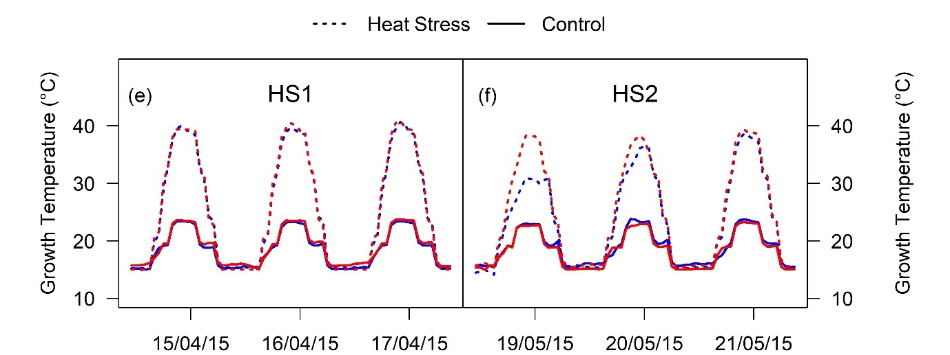
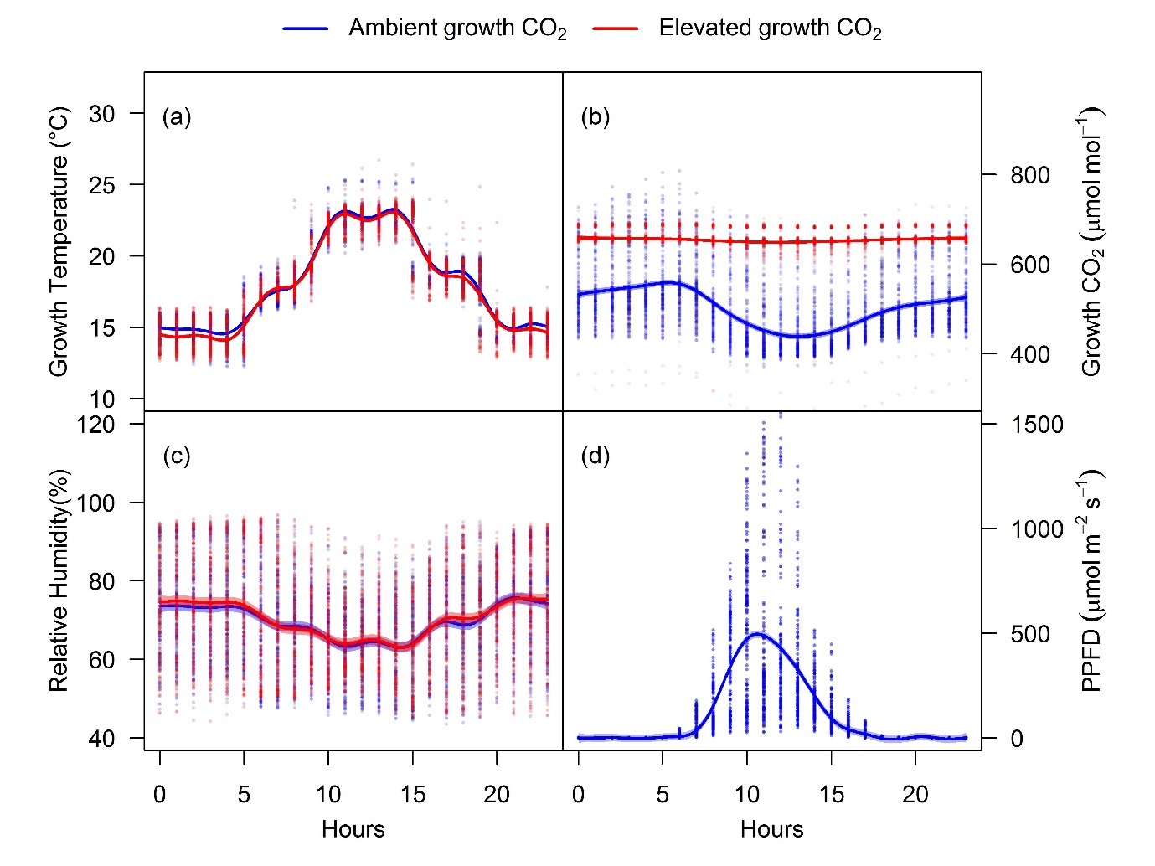
Figure S1. Glasshouse growth conditions. Glasshouse conditions during the experimental growth period; growth temperature (a), growth CO₂ (b), relative humidity (c) and PPFD (d). In panels a, b, c and d, the solid cultivars represent the growth averages, while the faint data points show all collected values. For HS1 (e) and HS2 (f), the solid cultivars represent control temperature and dotted cultivars represent the heat stress temperature. Ambient and elevated CO₂ are depicted in blue and red color, respectively.

Time point  (at the end of week period) | Weeks After Planting (WAP) | Zadoks Growth Scale | Growth Period/Stage
T0  (W₀ - W₂) | 2 | DC12 | Transplanting: 2 leaves unfolded
T1  (W₂ – W₇) | 7 | DC28 | Tillering: Main shoot and 6/8 tillers, 6/8 leaves unfolded
HS1 | 10 | DC32 | Vegetative stage
T2  (W₇ – W₁₂) | 12 | DC35 | Pre-anthesis: 4th node detectable
HS2 | 15 | DC63 | Flowering stage
T3  (W₁₂ – W₁₇) | 17 | DC65 | Anthesis: 50 % flowering
T4  (W₁₇ – W₂₅) | 25 | DC90 | Grain filling: Maturity
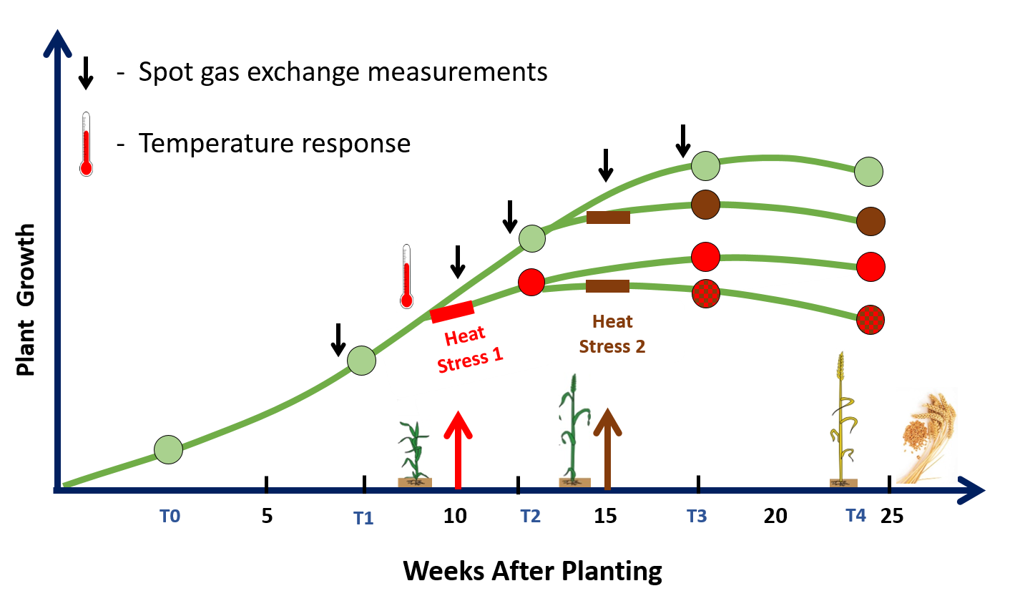
Figure S2. Experimental design. depicting plant growth plotted over 5-time points (T0, T1, T2, T3 and T4) across the wheat life cycle till maturity. The circles represent harvest of 10 plants at each time point. Green circles represent control plants grown at ambient or elevated CO_{2.} Upward directed red and brown arrows point to timing and duration of two heat stresses (HS), HS1 (vegetative stage) and HS2 (flowering stage) respectively. The red circles represent plants subjected to HS1 and brown circles represent plants subjected to HS2. Red and brown dotted circles represent plants subjected to both heat stresses. Downward small black arrows represent timing of single point gas exchange measurements. Thermometer symbol represents timing of temperature response measurements.
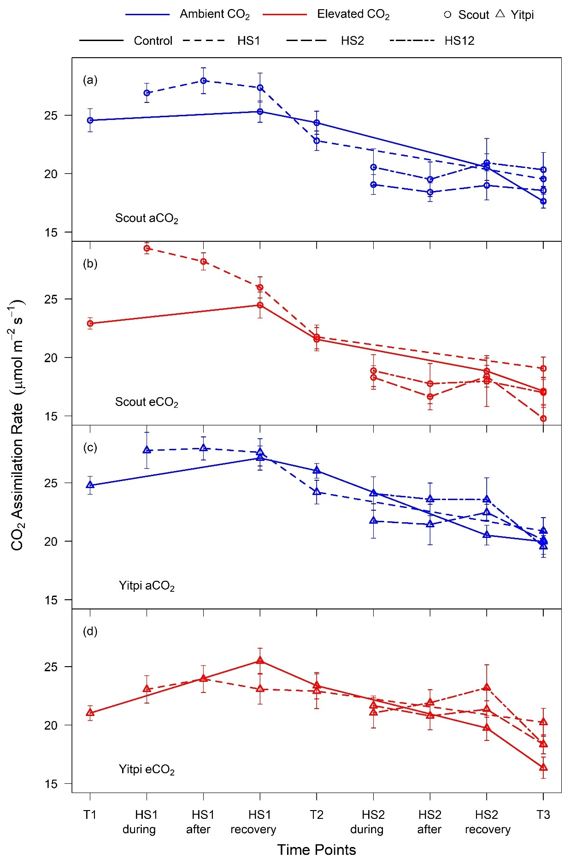

Figure S3. Photosynthetic response to growth at eCO₂ and heat stresses (HS1 and HS2). CO₂ assimilation rates measured at common CO₂ (400 μl L⁻¹) and 25°C in aCO₂ grown Scout (a), eCO₂ grown Scout (b), aCO₂ grown Yitpi and eCO₂ grown Yitpi (d). Ambient and eCO₂ CO₂ grown plants are depicted in blue and red, respectively. Measurements were performed during, after, at recovery stage of heat stress and at time points T1, T2 and T3.

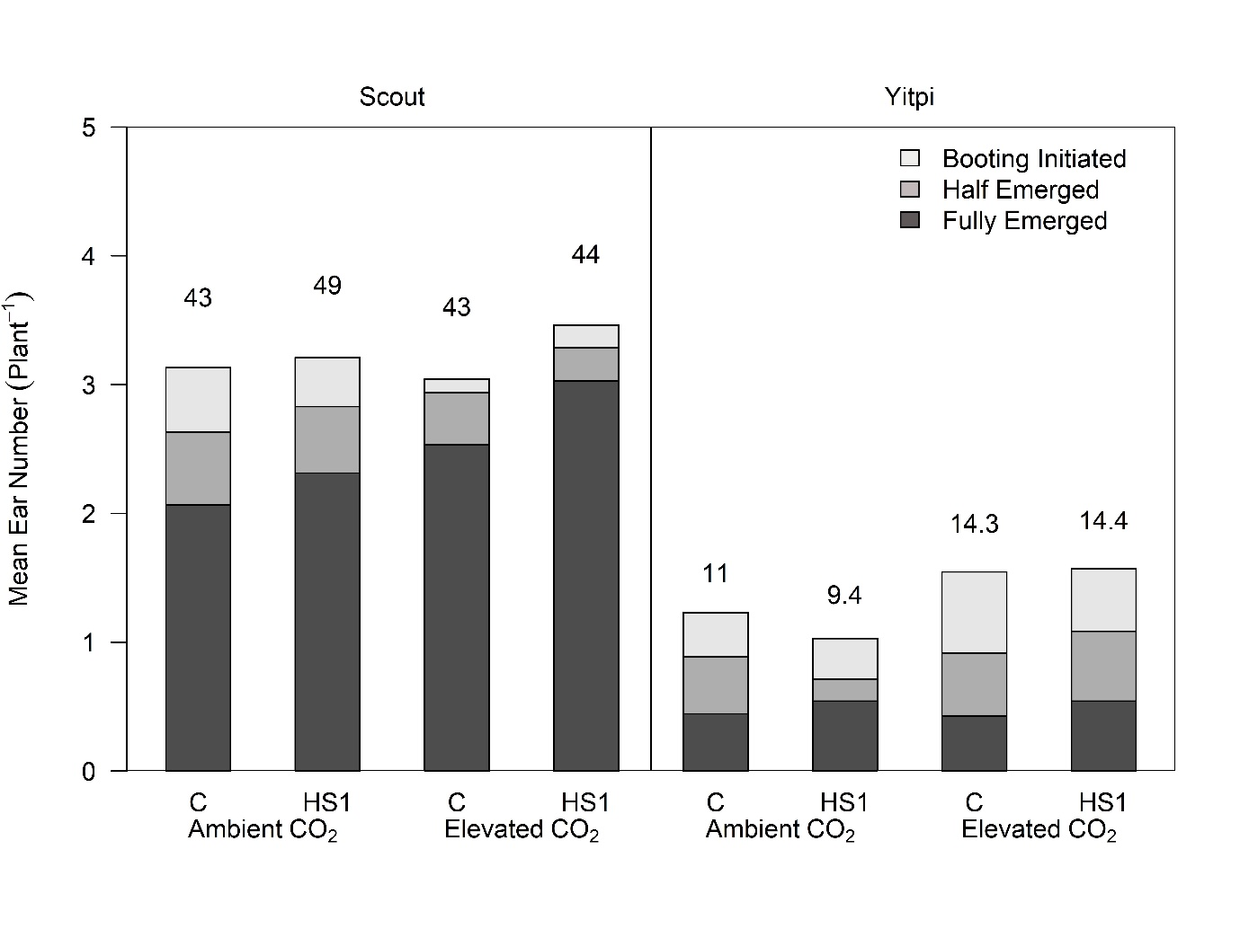
Figure S4. Response of ear development in Scout and Yitpi to eCO₂ and HS at the booting stage (T2). Data includes plants grown at ambient or elevated CO₂ and exposed to heat stress 1 (HS1). Numbers above each bar denote the percentage of ears relative to the total number of tillers.

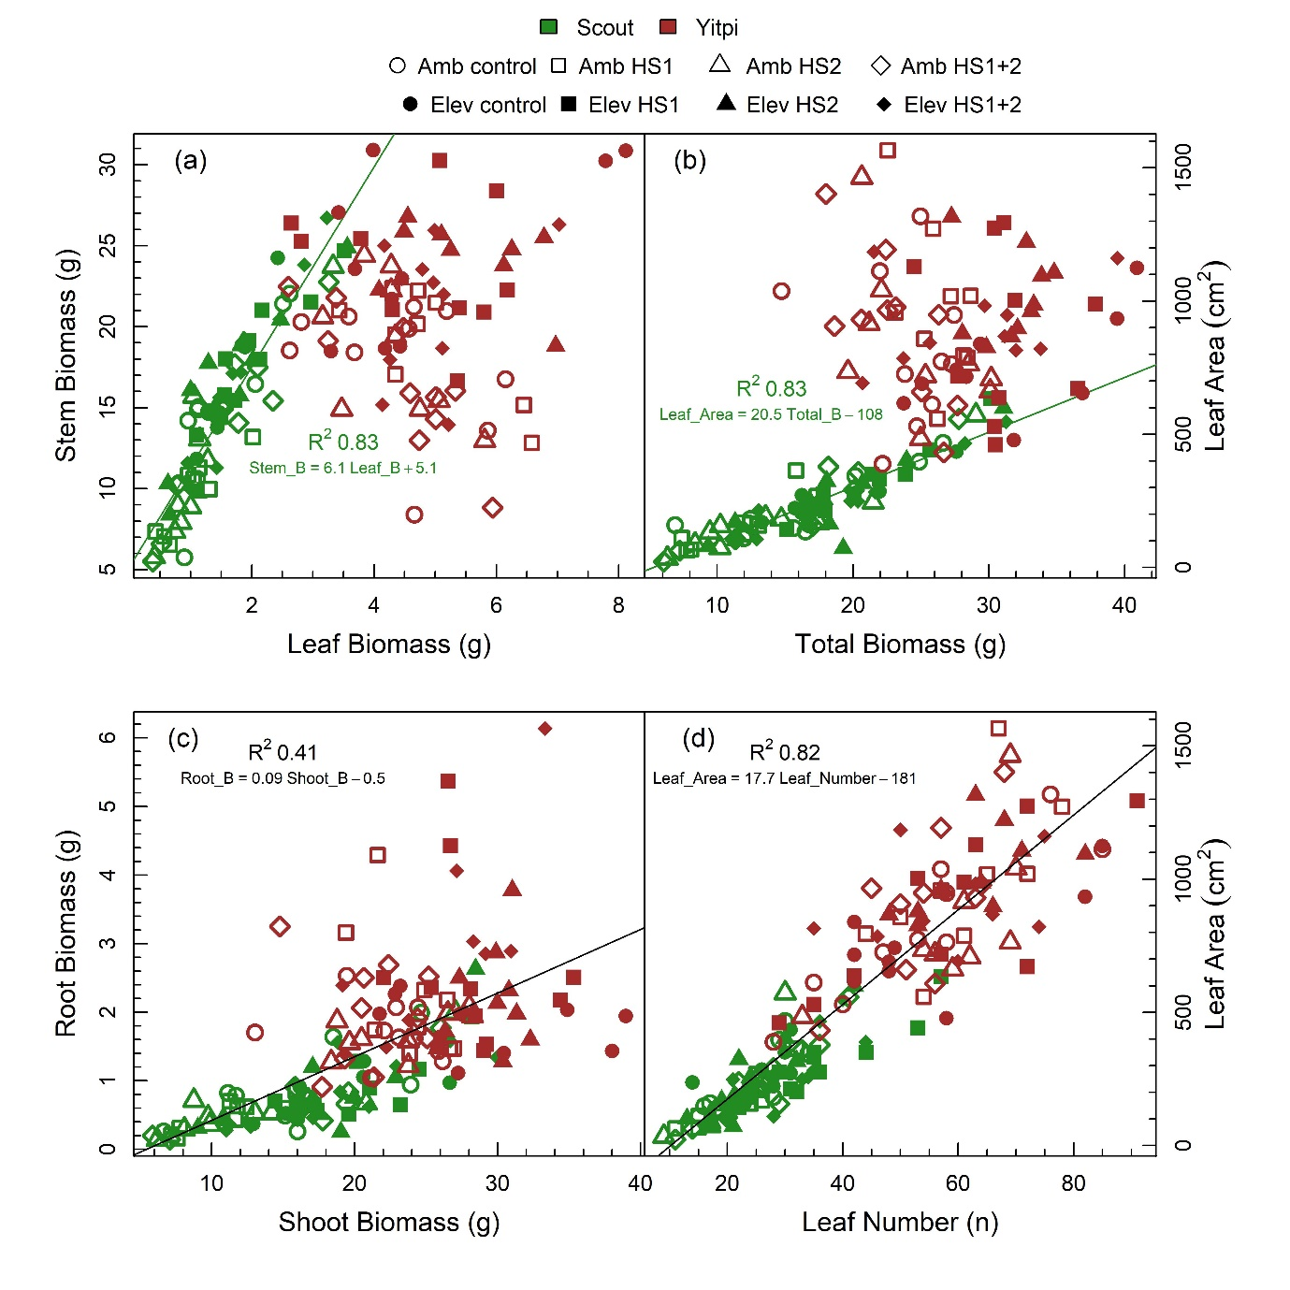
Figure S5. Relationship between dry mass and morphological parameters measured at anthesis (T3). Linear regression plotted for relationships between stem dry mass and leaf dry mass (a), total dry mass and leaf area (b), root dry mass and shoot (stem + leaf) dry mass (c) and leaf number and leaf area (d). Scout and Yitpi are depicted using green and brown color respectively. Ambient CO₂ and eCO₂ grown plants are depicted with open closed symbols, respectively. Heat stress (HS) levels are depicted in different shapes and include plants not exposed to any heat stress (control), plants exposed to heat stress 1 (HS1), plants exposed to heat stress 2 (HS2) and plants exposed to both the heat stresses (HS1+2).

