Energy reduction with application of Shaft in Water Supply Systems
Anujkumar Ghorpade¹, Abhishek Kumar Sinha², Pradip Kalbar³
¹Ph.D. Student, Centre for Urban Science and Engineering, Indian Institute of Technology Bombay, Powai, Mumbai, 400076, India. Email: anuj_32@iitb.ac.in
²Ph.D. Student, Centre for Urban Science and Engineering, Indian Institute of Technology Bombay, Powai, Mumbai, 400076, India. Email: aksinha.cuse@iitb.ac.in
³Assistant Professor, Centre for Urban Science and Engineering, Indian Institute of Technology Bombay, Powai, Mumbai, 400076, India (corresponding author). Email: kalbar@iitb.ac.in

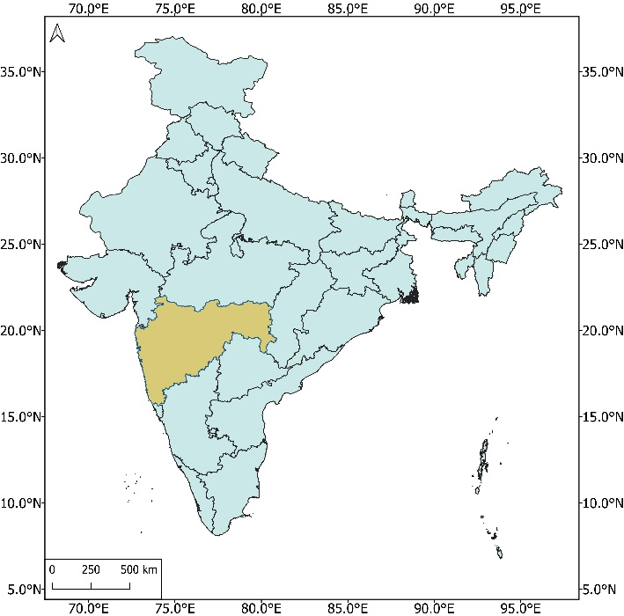 | 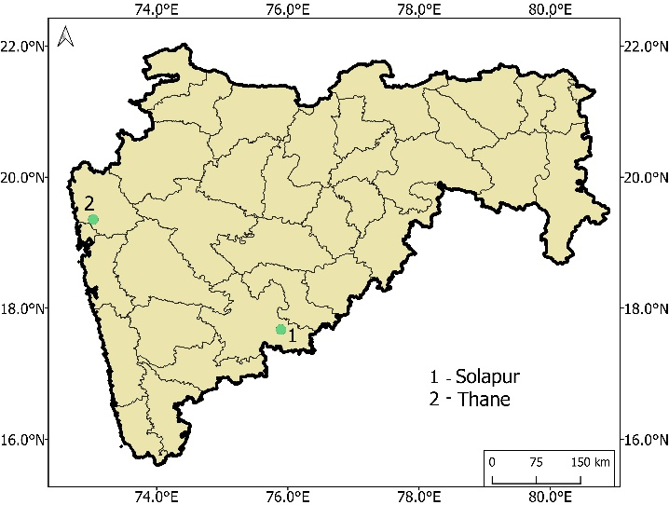

Fig. S1: Location of case studies
- Theory of Bernoulli’s theorem
Energies per unit weight of the fluid
$$Pressure energy= \frac{P}{ρg}$$
$$Kinetic energy= \frac{v^{2}}{2g}$$
$$Datum energy=z$$
Mathematically, the Bernoulli’s theorem is written as,
$$\frac{P}{ρg}+\frac{v^{2}}{2g}+z=constant (1)$$
(1)
(2)
$$z_{1}$$
$$z_{2}$$
$$\frac{P_{1}}{ρg}$$
$$\frac{P_{2}}{ρg}$$
$$\frac{v_{1}^{2}}{2g}$$
$$\frac{v_{2}^{2}}{2g}$$
$$h_{L}$$
$$Hydraulic Grade Line$$
$$Total Energy Line$$
Fig. S2: Total Energy Line (TEL) and Hydraulic Grade Line (HGL) for real fluid moving from point (1) to (2).
- Mathematical formulations for determination of operational energy

$$P=\frac{Q*H*g*ρ}{Pump efficiency} (2)$$
Where, Q is discharge in m³/sec, and H is pump head in meter.

$$h_{f}=\frac{10.7 L}{C^{1.85}d^{4.87}}Q^{1.85} (3)$$
Where, L in length of pipe in meter, d is diameter in meter, Q is discharge in m³/sec, and C is Hazen Williams coefficient of roughness.
$$SEC= \frac{E_{p}}{Q_{v}} (4)$$
Where, E_{p} in pump energy in kWh, and Q_{v} is discharge volume in m³.

$$P_{inf}=\left[\frac{{\left(1+w\right)}^{n}-1}{{w\left(1+w\right)}^{n}}\right] (5)$$
Where,
$$w=\frac{\left(1+i_{r}\right)}{\left(1+i_{f}\right)}-1 (6)$$
Where,
i_{r} is rate of interest on capital investment, which is considered as 10% per annum.
i_{f} is rate of inflation for replacement cost, which is considered as 6% per annum.
n is design period, which is considered as 30 years.
Unit rate of power is considered as 0.067 USD/unit.
$$A$$
$$A\left(1+i_{f}\right)$$
$$A{\left(1+i_{f}\right)}^{2}$$
$$A{\left(1+i_{f}\right)}^{3}$$
$$A{\left(1+i_{f}\right)}^{n}$$
$$P_{inf}$$
$$1$$
$$3$$
$$2$$
$$4$$
$$N$$
$$. . . . .$$
Fig. S3: Cash flow diagram for present worth calculation with inflation rate

- Site visit to the study area
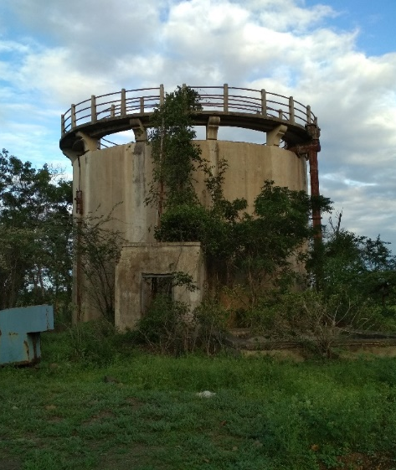  (a) | 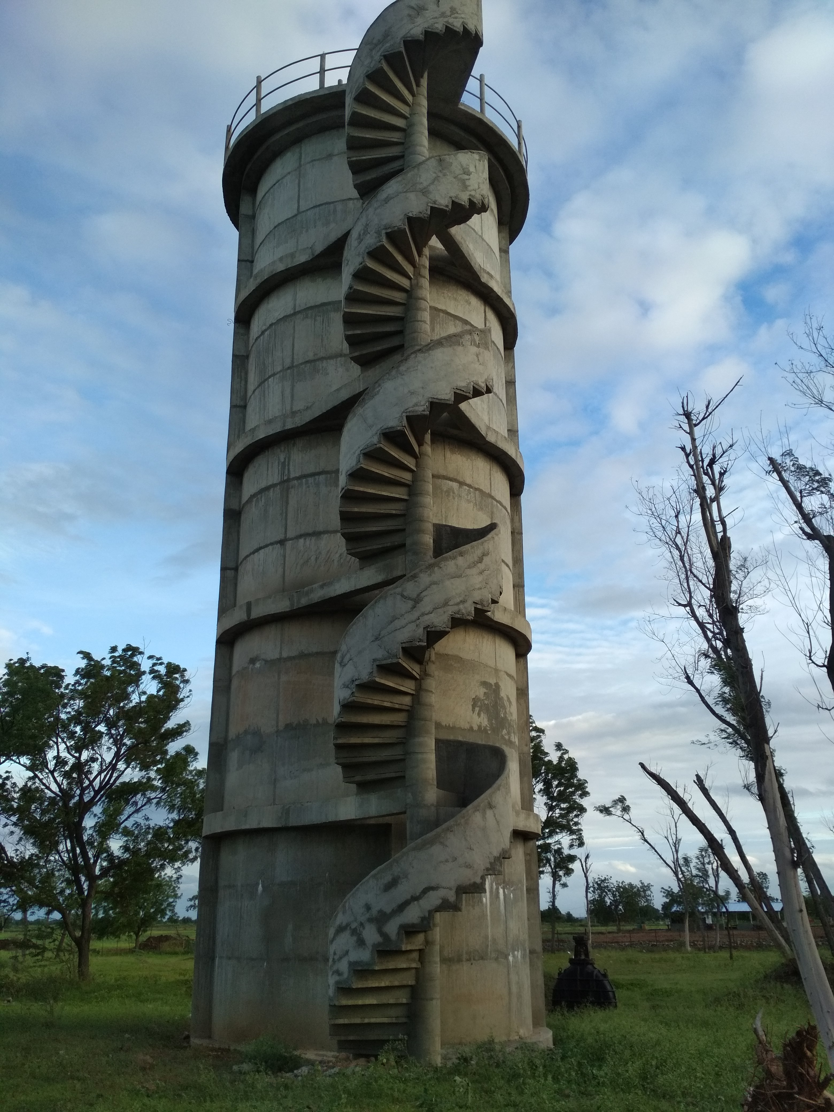  (b)
Fig. S4: Shaft at Bhima river WSS, Solapur, Maharashtra. (a) Old shaft (before 1984), (b) New shaft (post 2015).
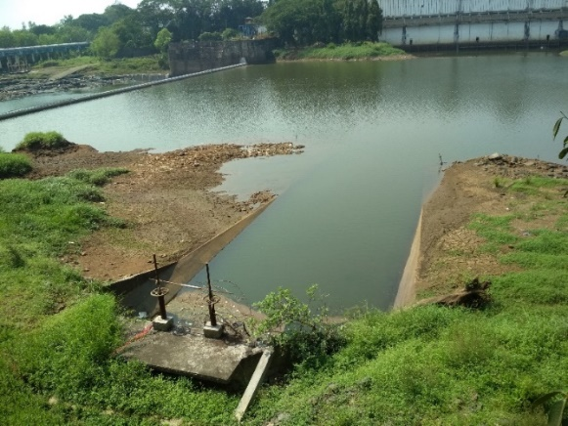  (a) | 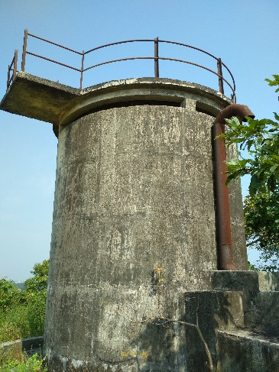  (c)
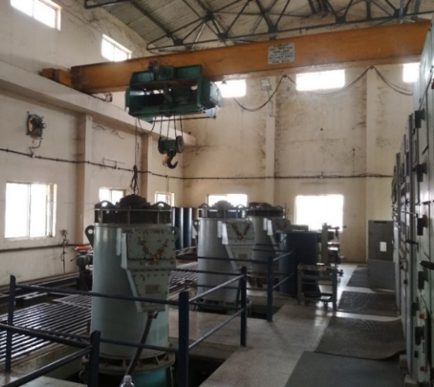  (b) | 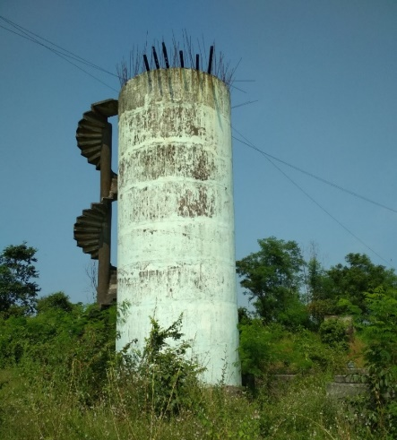  (d)
Fig. S5: Shaft at Pise weir WSS, Thane, Maharashtra. (a)- Pise weir, (b)- Pump house, (c)- Old Shaft and (d)- New shaft.
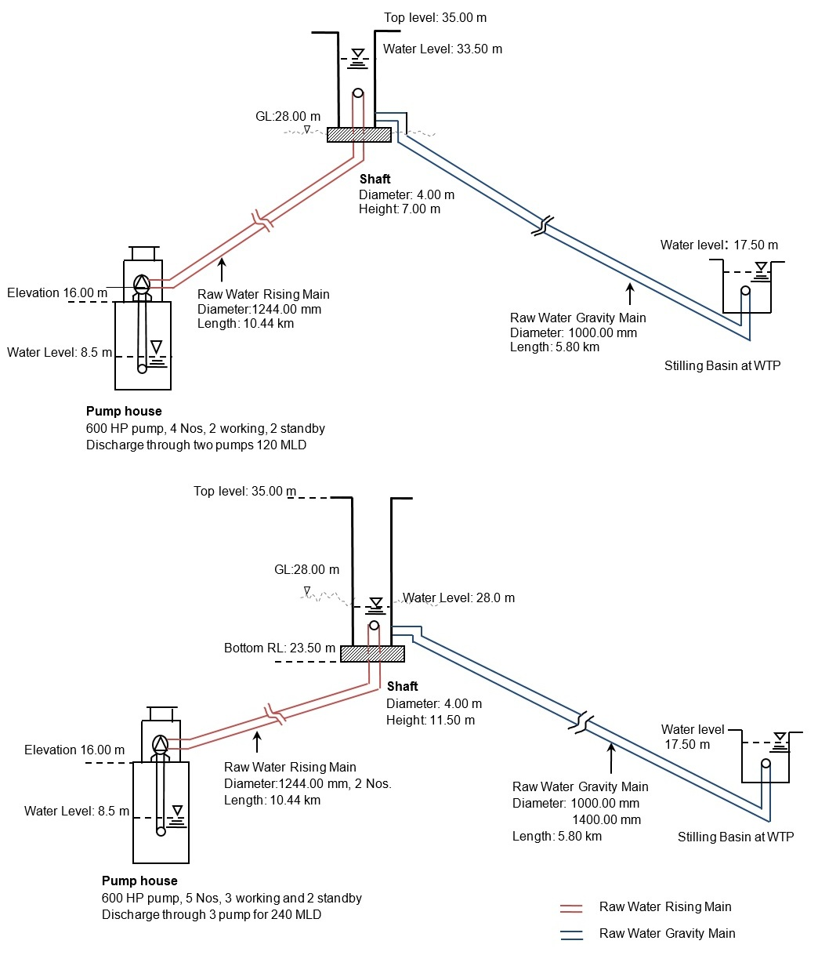
(a)
(b)
Fig. S6: Schematic of transmission network between pump house to WTP of Pise weir WSS, Thane, Maharashtra, India. (a) From 1998 to 2009, and (b) From 2009 onwards.

Exchange rate of currency 1 INR=0.013 USD on 24th July 2021

