Supplementary Material:

Suppl Figure 1:
Immunocytochemistry of astrocyte cell lines using specific astrocytic markers.

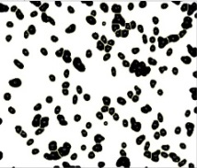
a.
DAPI
EAAT1/DAPI

C1

20x
20x
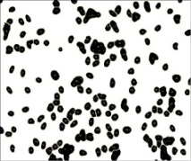
EAAT1/DAPI
DAPI

S1

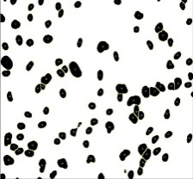
DAPI
GFAP/DAPI

C1

20x
GFAP/DAPI
20x
DAPI
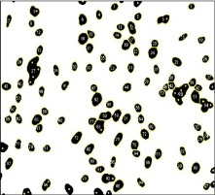

S1

b.

C1 C2 C3 S1 S2
C1 C2 C3 S1 S2

Suppl Figure 2:
The calcium signaling stimulation in astrocytes in culture (control sample).

- Average

- Individual cells

Suppl Figure 3:
Immunocytochemistry (ICC) of total tau in cortical neurons and astrocytes cell lines.

- 140 DIV Astrocytes
DAPI
T. TAU / DAPI
T. TAU

Control

T. TAU
DAPI
T. TAU / DAPI

Subject

- 140 DIV Neurons

DAPI
T. TAU / DAPI
T. TAU

Control
10+16 carrier

T. TAU / DAPI
T. TAU
DAPI

Subject

c. 300 DIV Astrocytes

T. TAU / DAPI
T. TAU
DAPI
DAPI
T. TAU
T. TAU / DAPI

Control

Subject

Suppl Figure 4:

The 3R- and 4R-tau expression using FAM primers to discard possible heteroduplex.

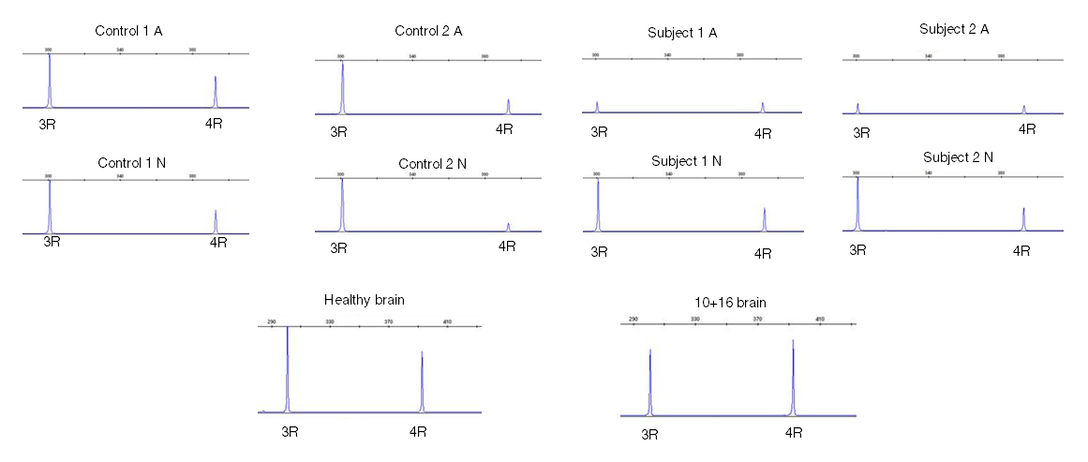

Suppl Figure 5:

Western blot and quantification analysis of tau protein in astrocytes
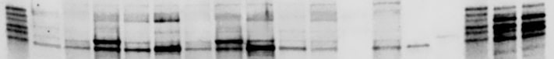
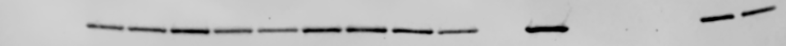
Tau Ladder
C1.1
C2.1
S1.1
S2.1
C1.2
C2.2
S1.2
S2.2
C1.3
C2.3
S1.3
S2.3
3R C+
4R C+
Tau Ladder
Control Brian
Ex10+ Brain

300 DIV Astrocytes
T.TAU

a.

GAPDH

b.

Suppl Table 1:

Shapiro-Wilk statistics to assess normality distribution in 3R/4R-tau mRNA analysis at different time points.

two-way mixed design ANOVA
Variable | F | P value
Group (subject vs control) | 25.64 | 0.001
Time (140, 200, 300) | 3.85 | 0.0675
Group-Time interaction | 0.60 | 0.5730
two-way mixed repeated measures ANOVA
Variable | F | P value
Group (subject vs control) | 71.97 | 0.0034
Time (140, 200, 300) | 2.51 | 0.1758
Group-Time interaction | 0.33 | 0.7327

Suppl Table 2:

Two-way mixed ANOVA statistical analysis for 3R-tau mRNA expression in cultured astrocytes.

two-way mixed design ANOVA
Variable | F | P value
Group (subject vs control) | 1.52 | 0.2519
Time (140, 200, 300) | 4.07 | 0.0604
Group-Time interaction | 2.22 | 0.1708
two-way mixed repeated measures ANOVA
Variable | F | P value
Group (subject vs control) | 2.11 | 0.2427
Time (140, 200, 300) | 3.06 | 0.1358
Group-Time interaction | 1.77 | 0.2621

Suppl Table 3:

Tukey’s multiple comparison test for statistical analysis of the Suppl. Figure 5 b.

