Supporting Information for “Half-Life Modeling of Basic Fibroblast Growth Factor and its Media Concentration from Growth Factor-Eluting Polyelectrolyte Multilayers”
Authors: Ivan Ding and Amy M. Peterson

Contents

Figure S.1 Original release data adjusted with half life value and Power Law fit
Figure S.2 Scaled Power Law data compared to actual cell culture concentration
Equation S.1 Higuchi Equation
Figure S.3 FGF2 cell culture concentration using Higuchi data

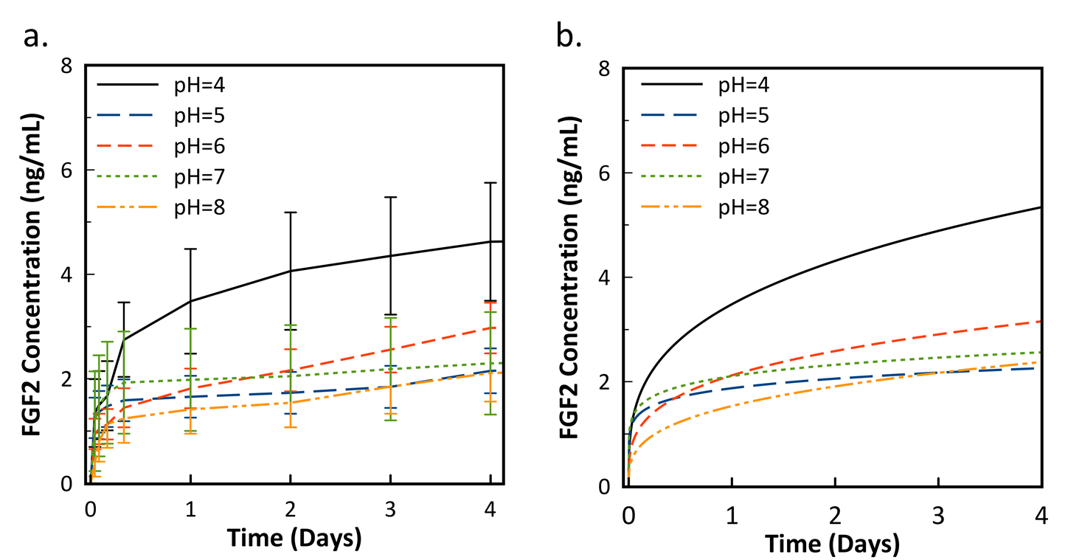
Figure S1: a. Raw experimental data (data identical to Figure 2 in main text of paper) b. Power Law fit of experimental data with degradation during release factored into the calculation. Factoring in half-life results in a higher predicted release more notable at the daily time steps. Error bars represent standard deviation (n=5).

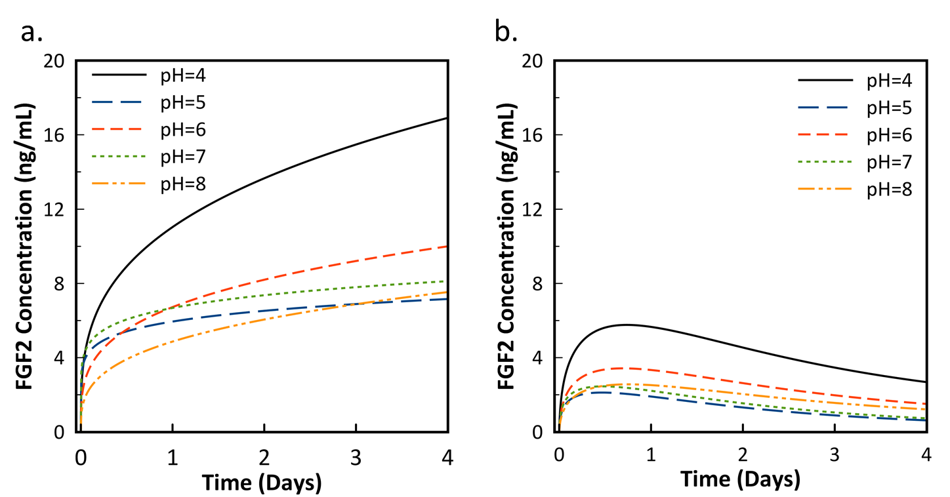
Figure S.2: a. Power Law fit of experimental data adjusted to dimensions and volumes of a 1.9 cm² well plate. b. Release curve on same scale (data identical to Figure 4a in main text of paper)

Equation S.1: Higuchi Equation. Serves as a general drug release model and was the first attempted model. The power law is more appropriate due to swelling of the PEM. M_{t} is the cumulative release up to a specific time t, M∞ is the total amount of drug released at an infinite time period and K is a constant representing diffusivity, drug solubility and release area.

$$\frac{M_{t}}{M_{∞}}=K\sqrt{t}$$

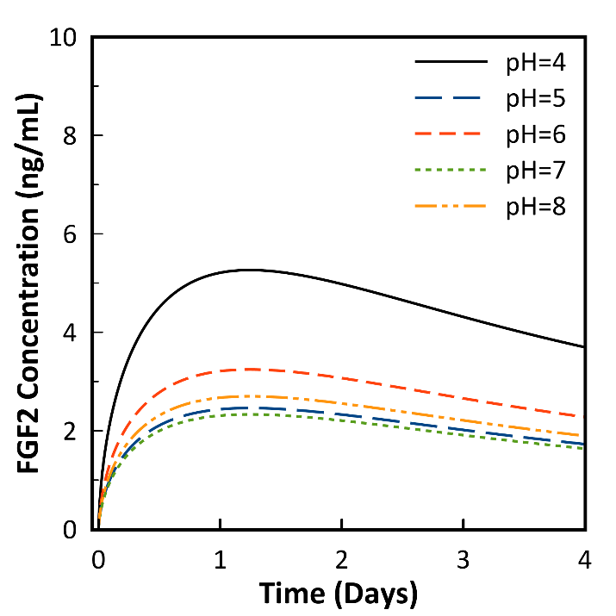
Figure S.3: Release curve data fit to the Higuchi equation. As the Higuchi equation less effectively predicts burst release, peak concentration predicted is lower, but concentration range is also reduced.

