Supplementary Information

A novel live imaging-based assay for visualising species-specific interactions in gametic adhesion molecules

Kohdai P. Nakajima¹, Clari Valansi², Daisuke Kurihara^{3,4}, Narie Sasaki^{1,5}, Benjamin Podbilewicz², Tetsuya Higashiyama^{1,4,6}

1Division of Biological Science, Graduate School of Science, Nagoya University, Furo-cho, Chikusa-ku, Nagoya, Aichi 464-8602, Japan
²Department of Biology, Technion- Israel Institute of Technology, Haifa 32000, Israel
³JST, PRESTO, Nagoya, Japan
4Institute of Transformative Bio-Molecules (WPI-ITbM), Nagoya University, Furo-cho, Chikusa-ku, Nagoya, Aichi 464-8601, Japan
5Institute for Human Life Innovation, Ochanomizu University, 2-1-1 Ohtsuka, Bukyo-ku, Tokyo 112-8610, Japan
⁶Department of Biological Sciences, Graduate School of Science, the University of Tokyo, 7-3-1 Hongo, Bunkyo-ku, Tokyo 113-0033, Japan
Supplementary Methods

Molecular phylogenetic analysis
Phylogenetic trees for IZUMO and JUNO of mouse, human, hamster, and pig were constructed using the neighbour-joining method in the MEGA X program⁴². Amino acid sequences for entire IZUMO proteins were used as follows: mouse, Mus musculus (Uniprot accession no. Q9D9J7); human, Homo sapiens (Q8IYV9); golden hamster, Mesocricetus auratus (A0A1U7QS27); pig, Sus scrofa (A0A287BMD8), and opossum, Monodelphis domestica (H9H653). Amino acid sequences for entire JUNO proteins were used as follows: mouse, M. musculus (Q9EQF4); human, H. sapiens (A6ND01); golden hamster, M. auratus (A0A1U7RC80); pig, S. scrofa (F1STK4), and opossum, M. domestica (F7AHC3).

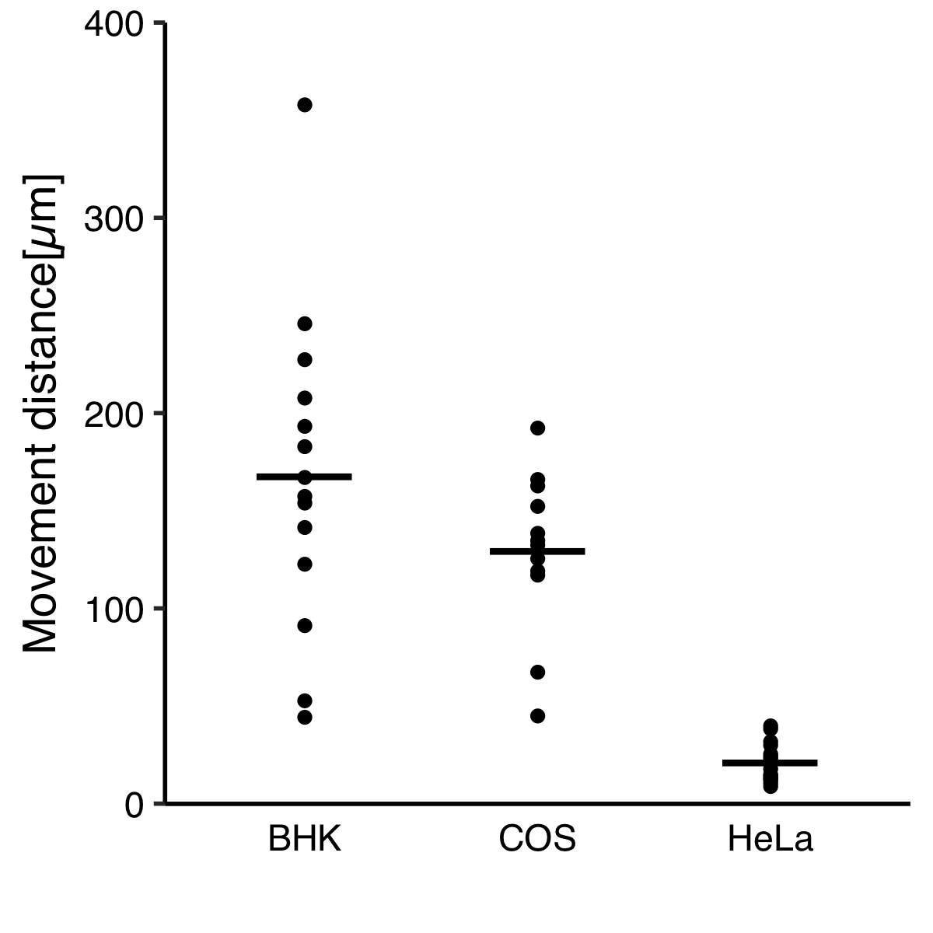
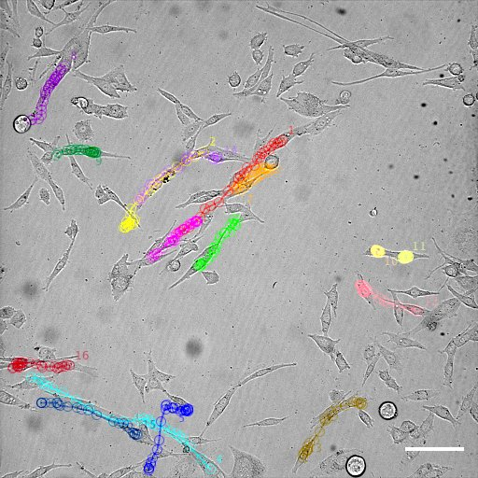
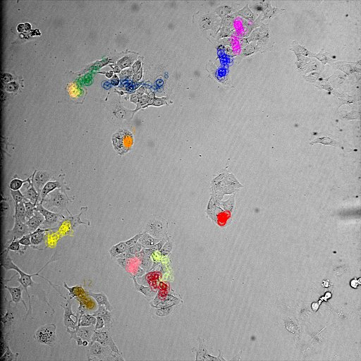
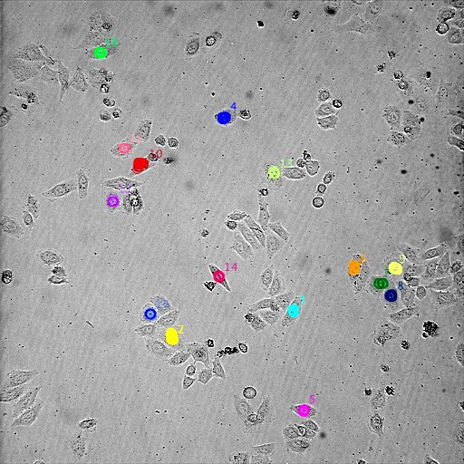
B
BHK
HeLa
COS-7
Movement distance (µm)
0
100
200
300
400
A
BHK
COS-7
HeLa
Figure S1 | Tracking of cultured cells
B

(A) Tracking of individual cultured baby hamster kidney (BHK), Cos-7, and HeLa cells using the Fiji software plugin MTrackJ. Bars: 50 µm. (B) Movement distance of cultured cells. Dots indicate the distance travelled by each cultured cell; bars indicate their averages.
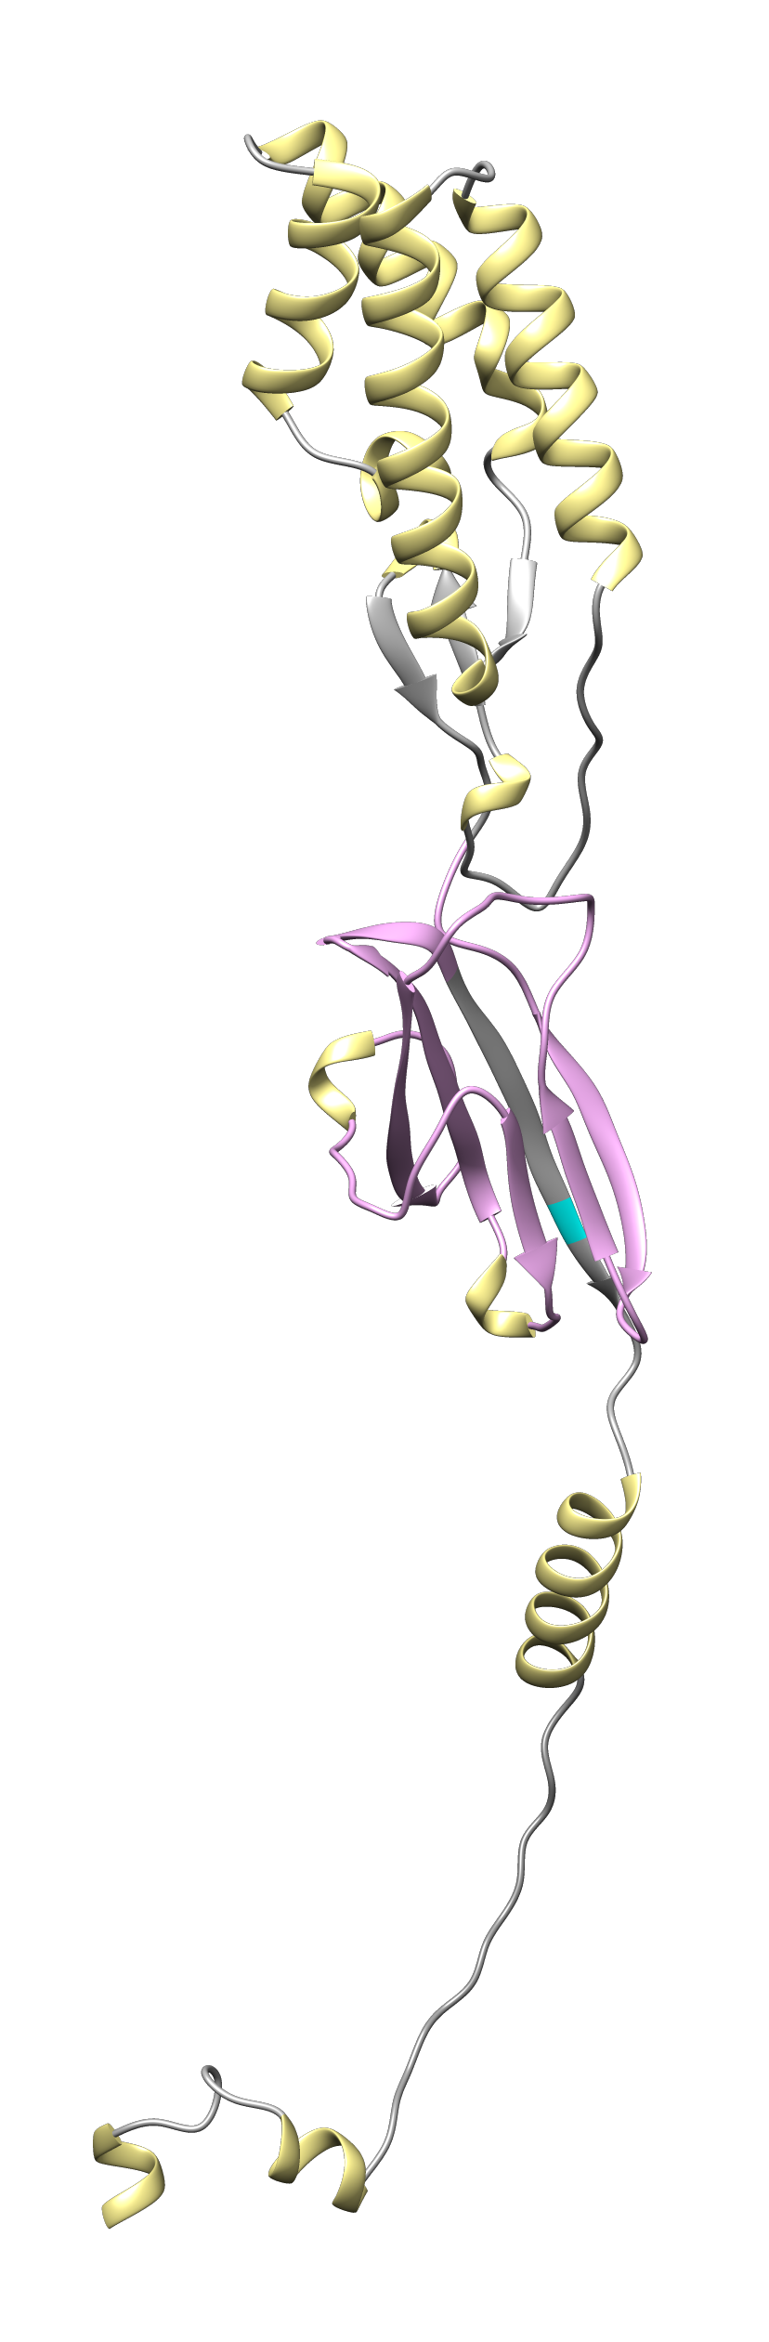
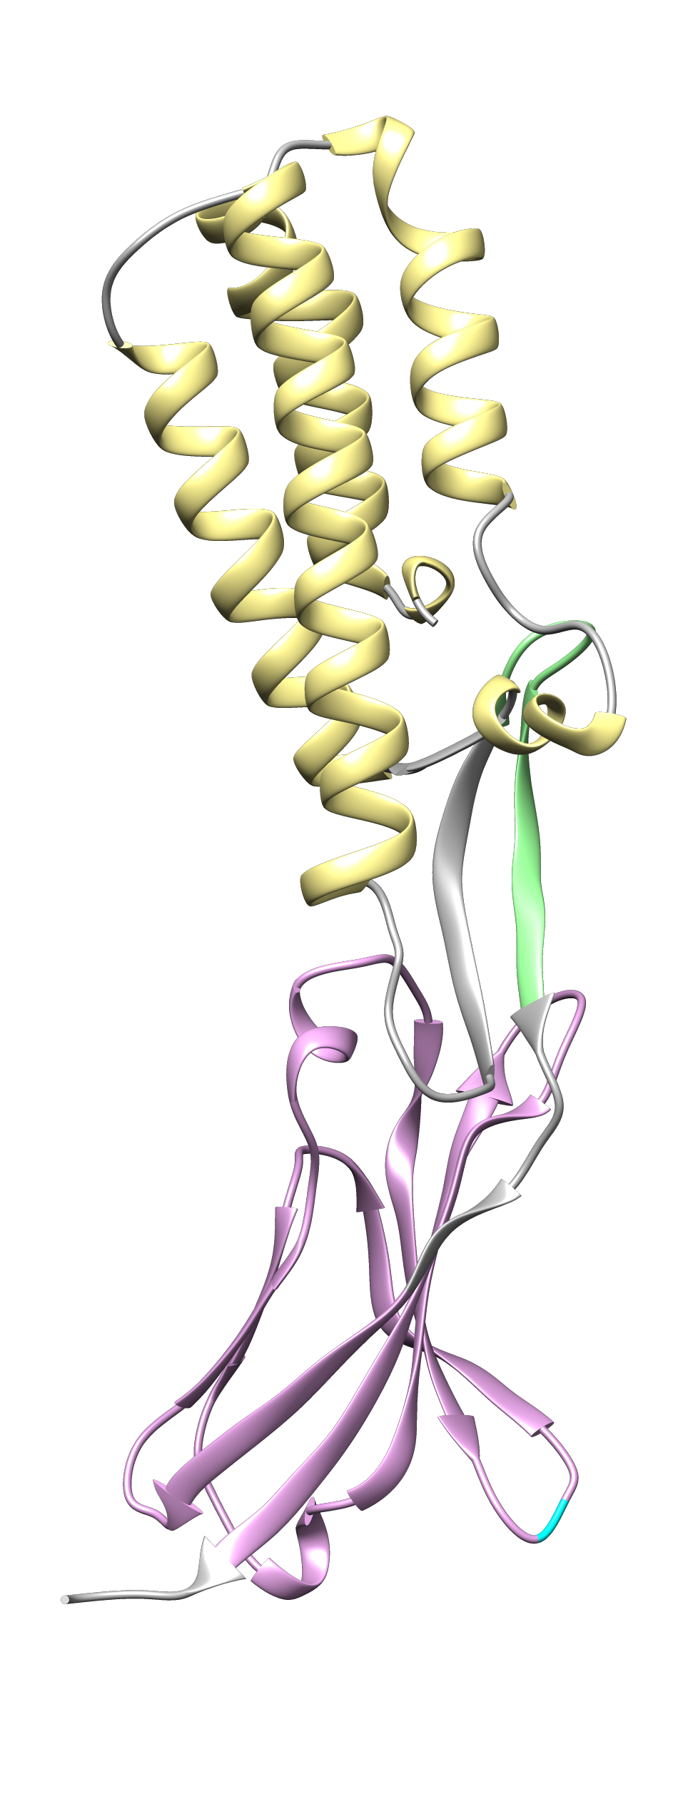
SPACA6
IZUMO

Figure S2 | IZUMO and SPACA6 structures
IZUMO was modelled using Chimera software based on amino acid sequence (Uniprot accession no. Q9D9J7). SPACA6 was modelled by AlphaFold. Both IZUMO and SAPCA6 encode a signal peptide, Ig-like domain (magenta), N-linked glycosylation sites (cyan), and type-I transmembrane domain^{6,} SPACA6 is localized on the acrosomal cap of the sperm head^{6,7} and has similar domain structures to IZUMO including four α-helix bundle.

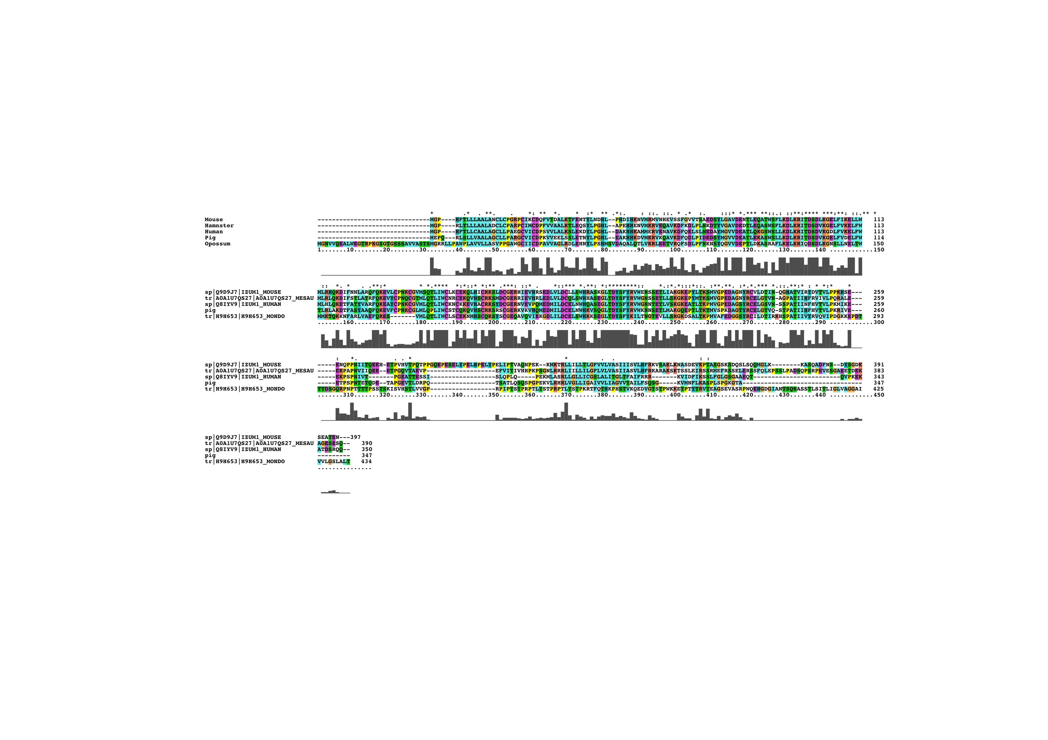
Figure S3 | Comparison of IZUMO amino acid sequence
Sequences were aligned using the Clustal X program. Parameters and colour codes were based on the Clustal X scheme. Amino acid sequences for entire IZUMO proteins were used as follows: mouse, Mus musculus (Uniprot accession no. Q9D9J7); human, Homo sapiens (Q8IYV9); golden hamster, Mesocricetus auratus (A0A1U7QS27); pig, Sus scrofa (A0A287BMD8), and opossum, Monodelphis domestica (H9H653).

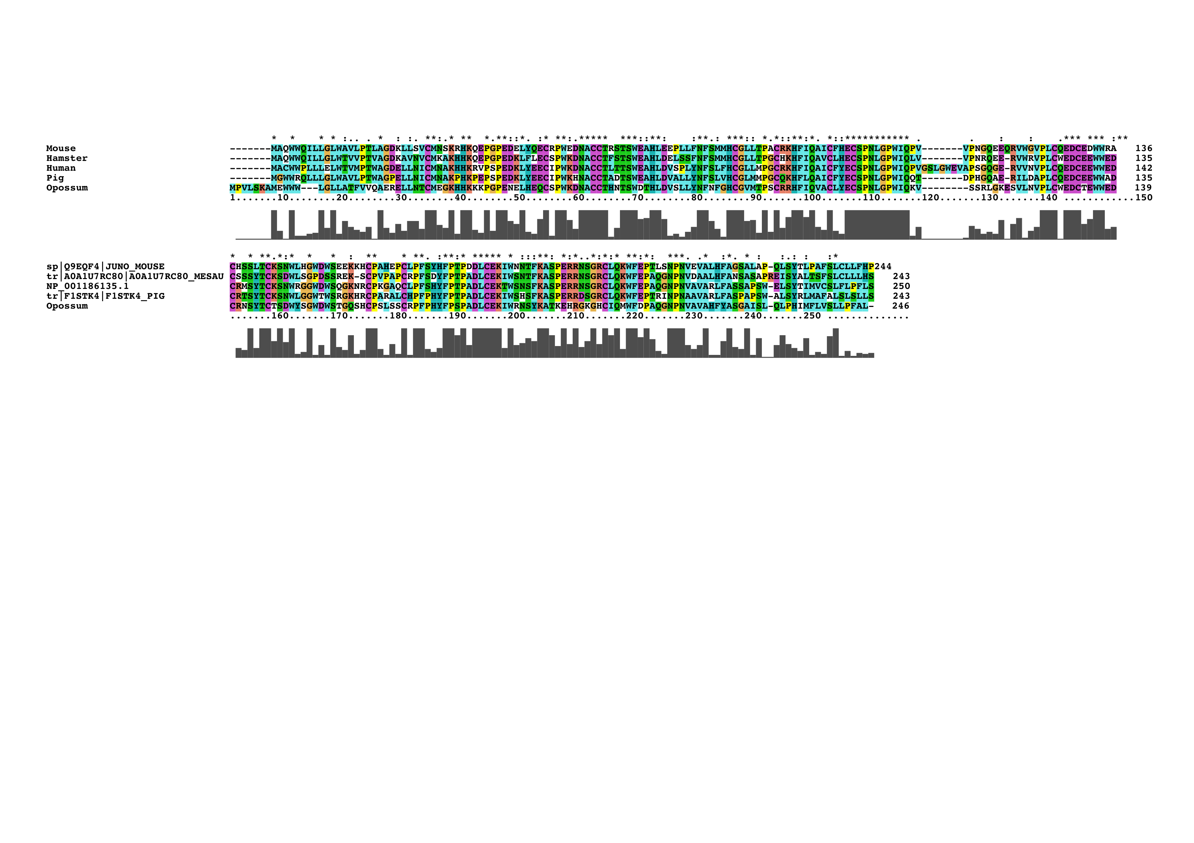
Figure S4 | Comparison of JUNO amino acid sequence
Sequences were aligned using the Clustal X program. Parameters and colour codes were based on the Clustal X scheme. Amino acid sequences for entire JUNO proteins were used as follows: mouse, M. musculus (Q9EQF4); human, H. sapiens (A6ND01); golden hamster, M. auratus (A0A1U7RC80); pig, S. scrofa (F1STK4), and opossum, M. domestica (F7AHC3).

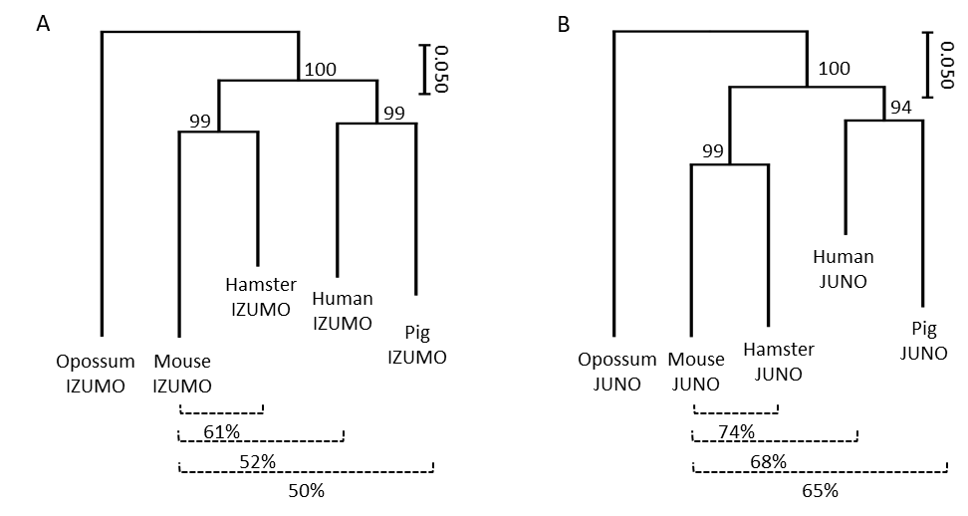
Figure S5 | Phylogenetic trees of IZUMO and JUNO
Neighbour-joining phylogenetic trees of IZUMO (A) and JUNO (B) were constructed using the MEGA X program. Bootstrap analysis was performed with 1,000 replicates. %: percent identity compared with mouse.

Table S1 | Sequences of oligonucleotide primers
Primer name | Sequence (5'-> 3')
GCS1_F | TCACAGGCCACCAAGCTTGGTACCATGGTGAACGCGATTTTAATGGCT
GCS1_R | GTGACCTCGAGCGGCCGCTTAACTCTCACGTAGTCTTTGTTTCCTCTG
GCS1∆_F | AAGGCAAATACCGCGCATTG
GCS1∆_R | AGGCATTCTTCGTTGCGGT
GEX2_F | TCACAGGCCACCAAGCTTGGTACCATGGCGATTAAATTCGTTTCAC
GEX2_R | GCTGCCCCCTCCACCTGACTGCTTATTCTGGTTGCCGGAAG
FUS1_F | TCACAGGCCACCAAGCTTGGTACCATGCCCATCTTTTTAATTTTAGTGCTGCTGGCCGC
FUS1_R | GCTGCCCCCTCCACCTGAAGGCTTATGTCTCAACATTCTGAAAGAC
CD9_F | TCACAGGCCACCAAGCTTGGTACCATGCCGGTCAAAGGAGGTAG
CD9_R | GCTGCCCCCTCCACCTGAGACCATTTCTCGGCTCCTGC
mouseIZUMO_F | TCACAGGCCACCAAGCTTGGTACCATGGGGCCGCATTTTACACTC
mouseIZUMO_R | GCTGCCCCCTCCACCTGAGTTTTCTGTTGCCTCGCTCTTATCT
mouseJUNO_F | TCACAGGCCACCAAGCTTGGTACCATGGCACAGTGGTGGCAGA
mouseJUNO_R | GCTGCCCCCTCCACCTGAGGGATGGAACAACAGGCACAGA
mouseIZUMO∆_F | GATTGTGGAGAGCGCCACATAG
mouseIZUMO∆_R | AAGAACTTCCTTTTGGAACTGTCTAGC
humanIZUMO_F | GATCTCGAGCTCAAGCTTGGTACCATGGGGCCGCATTTTACCC
humanIZUMO_R | GCTGCCCCCTCCACCTGATTGTTGCCTCGAATCTGTGGC
humanJUNO_F | GATCTCGAGCTCAAGCTTGGTACCATGGCATGCTGGTGGCC
humanJUNO_R | TGATCTAGAGTCGCGGCCGCTTATCAGGAAAGGAACGGCAGGAAC
humanJUNO_F2 | CCTCGCCCTTGCTCACCATAGCCCAGGTGGGCATG
humanJUNO_R2 | GTGGATCTGGAGGTGGTGGAGGGGACGAGCTGCTCAACA
hamsterIZUMO_F | GATCTCGAGCTCAAGCTTGGTACCATGGGGCCGCGTCTTAC
hamsterIZUMO_R | GCTGCCCCCTCCACCTGATTGGCTTTCTGATTCCCCTGC
hamsterJUNO_F | GATCTCGAGCTCAAGCTTGGTACCATGGCACAGTGGTGGCAG
hamsterJUNO_R | TGATCTAGAGTCGCGGCCGCTTATCAGGAATGGAGCAGCAGGC
hamsterJUNO_F2 | TCCTCGCCCTTGCTCACCATTCCTGCCACAGTGGGCAC
hamsterJUNO_R2 | GTGGATCTGGAGGTGGTGGAGACAAGGCGGTCAACGTCTG
pigIZUMO_F | GATCTCGAGCTCAAGCTTGGTACCATGGAGCCGCAGCGG
pigIZUMO_R | GCTGCCCCCTCCACCTGAAGCAGTGCCTTTGCCAGG
pigJUNO_F | GATCTCGAGCTCAAGCTTGGTACCATGGGATGGTGGAGGCAGC
pigJUNO_R | TGATCTAGAGTCGCGGCCGCTTAGGACAACAAGCTCAGTGAAAGAGC
pigJUNO_F2 | TCCTCGCCCTTGCTCACCATGGCCCAGGTAGGCAGCA
pigJUNO_R2 | GTGGATCTGGAGGTGGTGGAGGTCCAGAACTCTTGAACATCTGTATG
Venus/mCherry/mTurquoise2_F | TCAGGTGGAGGGGGCAGCGGGGGGGGAGGTATGGTGAGCAAGGGCGAG
Venus/mCherry/mTurquoise2_R | GTGACCTCGAGCGGCCGCTTACTTGTACAGCTCGTCCATGCC
mCherry for JUNO_F | ATGGTGAGCAAGGGCGAGG
mCherry for JUNO_R | TCCACCACCTCCAGATCCACCACCTCCAGACTTGTACAGCTCGTCCATGCC

