Additional file 1 for
All-in-One Approaches for Triple-negative Breast Cancer Therapy: Metal-phenolic Nanoplatform for MR Imaging-guided Combinational Therapy

Qi Xie¹, Shichao Li², Xingxing Feng¹, Jingyu Shi³, Yang Li¹, Guanjie Yuan², Conglian Yang¹, Yaqi Shen²*, Li Kong¹* and Zhiping Zhang^{1,4,5}*
E-mail: yqshen@hust.edu.cn; kongl@hust.edu.cn; zhipingzhang@mail.hust.edu.cn
¹Tongji School of Pharmacy, Huazhong University of Science and Technology, Wuhan 430030, China
²Department of radiology, Tongji Hospital of Tongji Medical College of Huazhong University of Science and Technology, Wuhan 430030, China
³Liyuan Hospital of Tongji Medical College of Huazhong University of Science and Technology, Wuhan 430030, China
⁴National Engineering Research Center for Nanomedicine, Huazhong University of Science and Technology, Wuhan, 430030, China
⁵Hubei Engineering Research Center for Novel Drug Delivery System, Huazhong University of Science and Technology, Wuhan, 430030, China

Figure S1: The chemical structure of BLM and EGCG. Bleomycin usually consists of two components differing in the positively charged tail —— bleomycin A2 and bleomycin B2.

Figure S2: The photograph of BFE NPs at different molar ratios of EGCG (A) and Fe³⁺ (B). The nanoparticles were presented in the form of resuspension and collected precipitation, respectively.

Figure S3: The particle size and PDI of BFE NPs in various media. There was also a lot of salt in the DMEM (cell culture medium).
Figure S4: The long-term stability of BFE NPs and BFE NPs@BSA.

Figure S5: The TEM images of BFE NPs (A) and BFE NPs@BSA (B). Scale bars were 500 nm.

Table S1: The drug encapsulation efficiency (EE) of BLM and Fe³⁺ in BFE NPs and BFE NPs@BSA.
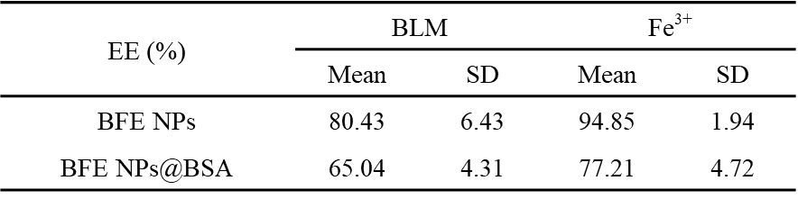
The EE was calculated as follows: EE (%) = (Mass of drug in nanoparticles/Mass of drug added) × 100%. (n = 5 independent samples)
Figure S6: The temperature elevation of BFE NPs@BSA under laser irradiation (808 nm, (A) 2.0 and (B) 3.0 W/cm²) for 10 min at different Fe³⁺ concentrations.
Figure S7: The linear fitting of 1/T₂ of BFE NPs@BSA at different Fe³⁺ concentrations.
Figure S8: The quantitative results of relative fluorescent ratio of tumor/liver. (n = 3)
Figure S9: (A) The 4T1 tumor inhibition rate after different treatments (n = 5). (B) H&E staining of the lung sections from the mice after different treatments.

Figure S10: The 4T1 tumor of the mice after different treatments.

