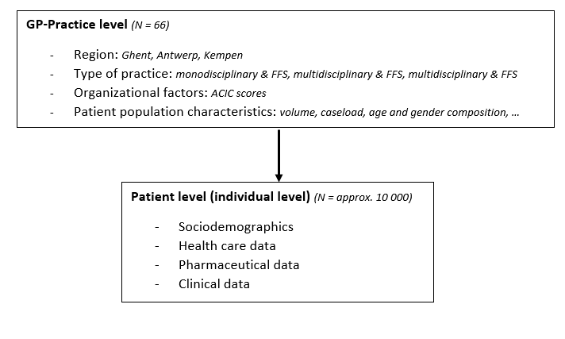
S4. Figure: Multilevel design of the Integrated diabetes database

