Supplemental
Fig. S1. Gating strategy for assessing expression of DAMPs on the surface of OGJ cells by flow cytometry. Gate 1 included all cells in the FSC versus SSCA plot, doublet cells were then excluded using FSC-H versus FSC-A plot, dead cells were excluded using zombie aqua viability marker. The surface expression of calreticulin, HMGB1, MIC-A/B and HLA-DR on OGJ cells was then assessed on this live, doublet excluded population. Representative dot plots are shown for veh and FLOT treated OE33 cells in vitro.

B
A

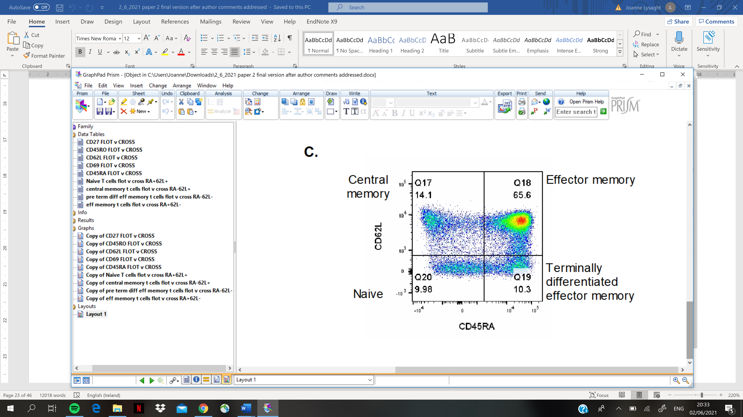
Fig. S2. Gating strategy for assessing expression of activation markers on T cells surfaces and T cell differentiation states by flow cytometry. Gate 1 included all cells in the FSC versus SSCA plot, doublet cells were then excluded using FSC-H versus FSC-A plot, dead cells were excluded using zombie aqua viability marker. The surface expression of CD62L, CD69, CD27 and CD45RA was assessed on CD3⁺CD4⁺ cells and CD3⁺CD8⁺ cells. The percentage of CD3⁺CD4⁺ cells and CD3⁺CD8⁺ cells co-expressing CD45RA⁺CD62L⁺ (naïve T cells), CD45RA⁻CD62L⁺, (central memory T cells), CD45RA⁻CD62L⁻ (effector memory T cells) and CD45RA⁺CD62L⁻ (terminally differentiated effector memory T cells) was also assessed by flow cytometry (A). Representative dot plots are shown for each marker. Representative dot plot showing the characterisation of naïve, central memory, effector memory and terminally differentiated T cells following treatment with TCM (B).
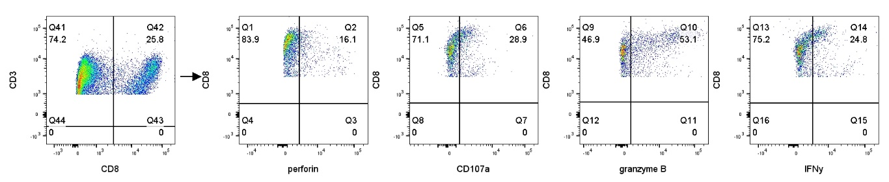

Fig. S3. Gating strategy for assessing cytokine production by T cells by flow cytometry. Gate 1 included all cells in the FSC versus SSCA plot, doublet cells were then excluded using FSC-H versus FSC-A plot, dead cells were excluded using zombie aqua viability marker. The intracellular surface expression of IL-17A, IL-10, IL-4 and TNF-α was assessed in CD3⁺CD4⁺ cells and CD3⁺CD8⁺ cells. Intracellular perforin expression, extracellular CD107a expression and intracellular granzyme B and IFN-γ was assessed on CD3⁺CD8⁺ cells by flow cytometry. Representative dot plots are shown for each marker.

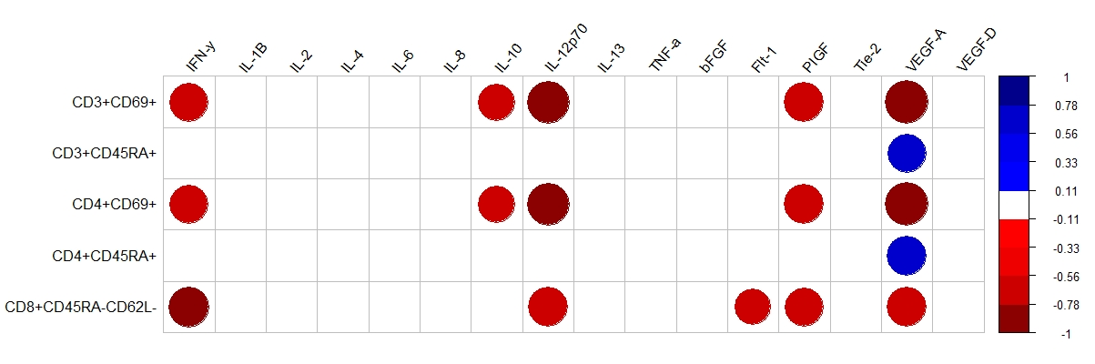
Fig. S4. Corogram demonstrating the correlation values between T cell activation status following 24h treatment with post-FLOT or post-CROSS CRT conditioned media with the levels of pro-inflammatory and pro-angiogenic analytes in the TCM. Only significant correlations shown. Spearman r 0.4-0.59 moderate, 0.6-0.79 strong and 0.8-1 very strong. Blue and red refer to positive and negative correlations, respectively. *p<0.05, **p<0.01.
Fig. S5. Patients who had a poor pathologic response to neoadjuvant treatment had significantly higher levels of tumour-infiltrating terminally differentiated T cells compared with good responders. CD3⁺CD4⁺ and CD3⁺CD8⁺ cells in circulating peripheral blood and infiltrating tumour tissue of OGJ patients in the treatment-naïve setting and post-treatment setting at surgical resection were assessed for CD27, CD69, CD62L and CD45RA expression based on pathologic response to neoadjuvant treatment (A). The percentage of naïve (CD45RA⁺CD62L⁺), central memory (CD45RA⁻CD62L⁺), effector memory (CD45RA⁻CD62L⁻) and terminally differentiated effector memory (CD45RA⁺CD62L⁻) cells was also determined by flow cytometry and graphed based on pathologic response to neoadjuvant treatment. Good pathologic response: tumour regression grade 1-2 and poor pathologic response: tumour regression grade: 3-5. Treatment-naïve blood: good responders (n=5) and poor responders (n=4), treatment-naïve tumour tissue: good responders (n=3) and poor responders (n=3). Post-treatment blood: good responders (n=6) and poor responders (n=3), post-treatment tumour tissue: good responders (n=4) and poor responders (n=5). Mann-Whitney test, *p<0.05.

Table S1. Correlation of peripheral blood and tumour-infiltrating T cell activation status with clinical characteristics in the treatment-naïve tissue. Only significant correlations shown. Spearman r 0.4-0.59 moderate, 0.6-0.79 strong and 0.8-1 very strong. CROSS CRT=0, FLOT=1, OGJ=0, OGJ=1, female=0, male=1. *p<0.05, **p<0.01.
T cell population | Correlated variable | Spearman r | p value
Peripheral blood
CD3⁺CD45RA⁺ | Increased age | 0.8333 | 0.0053
CD3⁺CD4⁺CD45RA⁺ | Increased age | 0.7857 | 0.0208
CD3⁺CD8⁺CD27⁺ | Increased age | 0.6795 | 0.0151
CD3⁺CD8⁺CD45RA⁺ | Increased age | 0.9167 | 0.0005
Effector memory CD8⁺ | Increased age | -0.8368 | 0.0049
Terminally differentiated effector memory CD3⁺ | Increased age | 0.8000 | 0.0096
Naïve CD3⁺ | Improved trx responseª | 0.9747 | 0.0048
Naïve CD4⁺ | Improved trx responseª | 0.9747 | 0.0048
CD3⁺CD8⁺CD27⁺ | Improved trx responseª | 0.8444 | 0.0168
CD3⁺CD45RA⁺ | Nodal metastasisª | -0.8233 | 0.0229
Terminally differentiated effector memory CD4⁺ | Nodal metastasisª | -0.8533 | 0.0307
CD3⁺CD8⁺CD45RA⁺ | Nodal metastasisª | -0.8233 | 0.0229
Terminally differentiated effector memory CD8⁺ | Nodal metastasisª | -0.8608 | 0.0129
Tumour
CD3⁺CD27⁺ | Increased BMI | -0.6667 | 0.0499
CD3⁺CD4⁺CD27⁺ | Increased BMI | -0.6696 | 0.0208
CD3⁺CD8⁺CD69⁺ | Increased BMI | -0.7167 | 0.0298
ªdetermined by PET/CT. Abbreviations: trx; treatment.

Table S2. Correlation of peripheral blood and tumour-infiltrating T cell activation status with clinical characteristics in the post-treatment tissue. Only significant correlations shown. Spearman r 0.4-0.59 moderate, 0.6-0.79 strong and 0.8-1 very strong. CROSS CRT=0, FLOT=1, OGJ=0, OGJ=1, female=0, male=1. *p<0.05, **p<0.01.
T cell population | Correlated variable | Spearman r | P value
Peripheral blood
CD3⁺CD8⁺CD45RA⁺ | Increased age | -0.93 | 0.0007
Effector memory CD8⁺ | Increased age | 0.92 | 0.0011
CD3⁺CD8⁺CD45RA⁺ | Diagnosis | -0.76 | 0.03
Effector memory CD8⁺ | Diagnosis | 0.76 | 0.03
CD3⁺CD4⁺CD45RA⁺ | Neo-adjuvant trx | 0.64 | 0.0464
CD3⁺CD27⁺ | Improved trx responseª | 0.69 | 0.0399
CD3⁺CD62L⁺ | Improved trx responseª | 0.75 | 0.0202
Terminally differentiated effector memory CD3⁺ | Improved trx responseª | -0.75 | 0.0202
CD3⁺CD4⁺CD62L⁺ | Improved trx responseª | 0.83 | 0.0061
Central memory CD8⁺ cells | Improved trx responseª | 0.8 | 0.0291
Terminally differentiated effector memory CD8⁺ | Advanced tumour stageª | -0.76 | 0.03
CD3⁺CD4⁺CD45RA⁺ | Advanced tumour stage^{b} | 0.82 | 0.0067
Terminally differentiated effector memory CD4⁺ | Advanced tumour stage^{b} | 0.69 | 0.0387
CD3⁺CD4⁺CD45RA⁺ | Nodal metastasis^{b} | 0.67 | 0.0479
Effector memory CD4⁺ | Nodal metastasis^{b} | -0.73 | 0.0266
Tumour
Central memory CD4⁺ cells | Increased age | 0.68 | 0.0305
CD3⁺CD8⁺CD69⁺ | Neo-adjuvant trx | -0.78 | 0.0133
CD3⁺CD8⁺CD27⁺ | Improved trx responseª | -0.72 | 0.0276
CD3⁺CD8⁺CD45RA⁺ | Improved trx responseª | -0.68 | 0.0434
Terminally differentiated effector memory CD8⁺ | Improved trx responseª | -0.68 | 0.0434
Terminally differentiated effector memory CD3⁺ | Nodal metastasis^{b} | -0.75 | 0.0204
CD3⁺CD62L⁺ | Advanced tumour stage^{b} | 0.74 | 0.0213
CD3⁺CD4⁺CD62L⁺ | Advanced tumour stage^{b} | 0.7 | 0.0345
CD3⁺CD4⁺CD45RA⁺ | Advanced tumour stage^{b} | 0.71 | 0.0313
Effector memory CD4⁺ | Advanced tumour stage^{b} | -0.8 | 0.0099
Terminally differentiated effector memory CD4⁺ | Advanced tumour stage^{b} | 0.85 | 0.0036
Central memory CD4⁺ cells | Increased BMI | -0.71 | 0.0227
ªdetermined by PET/CT; ^{b} determined pathologically. Abbreviations: trx; treatment.

