Supporting Data
An alternative model of gravitational forces in nature using the combined effects of repulsion and attraction forces on gaseous molecules
C.K. Gamini Piyadasa*
File 1. File Type: MS Excel. Note: Original empirical data given in the British Imperial System of Units have been converted to SI Units for the calculations.
File 2. File Type: PDF. Program text written in Wolfram Mathematica 11.2 to calculate parameters x, G_{R}, G_{A}, F_{R} and F_{A} with respect to T and y.
File 3. File type: Wolfram Mathematica 11.2 note book file
Note: Double click on the documents .xlsx, .PDF and .nb to open
Fig. S1 - Graphical representation of t_{f} (in Table I) through a metal tube of water droplets of masses 4 and 9 mg against temperature.
Fig. S2 - F_{R} vs. T - Extrapolation of graph F_{R} vs. T crosses (0,0) when y ≈ 0.5
Fig. S3 - F_{A} vs. T - Negative F_{A} tends to become positive as T approaches 0 K when y ≈ 0.5
File 1. File Type: MS Excel. Note: Original empirical data given in British Imperial Units have been converted to SI Units for the calculations.
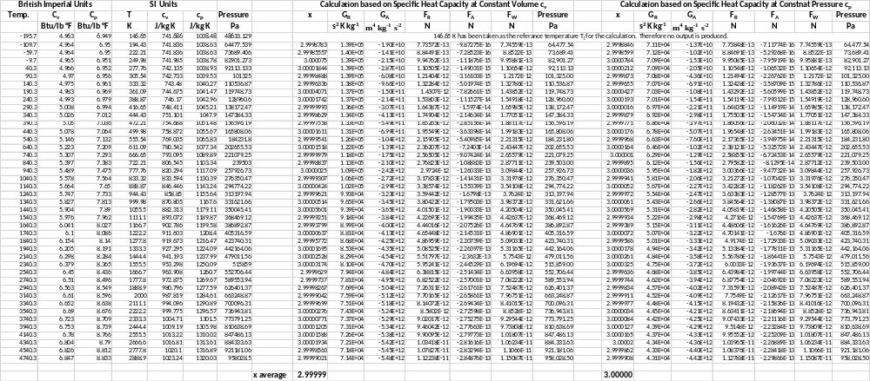
File 2. File Type: PDF. Program text written in Wolfram Mathematica 11.2 to calculate parameters x, G_{R}, G_{A}, F_{R} and F_{A} with respect to T and y.
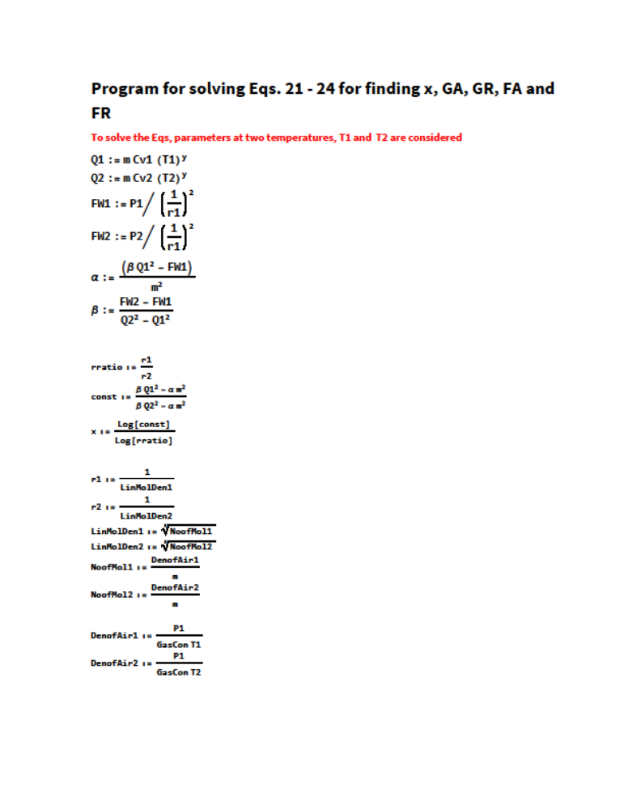
File 3. File type: Wolfram Mathematica 11.2 note book file



Fig. S1. Time of fall (t_{f}) of water droplets of 4 and 9 mg in air at temperatures 10, 30 and 60⁰C
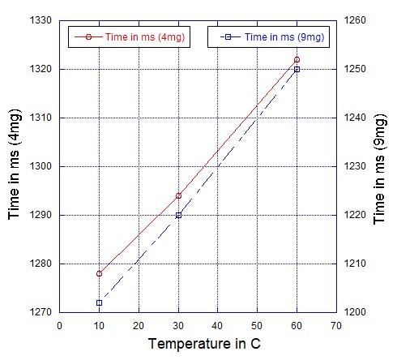
Investigating the time of fall (t_{f}) of water droplets under varying droplet temperatures:
A water-droplet of mass 4 mg and temperature 10⁰C was dropped through a metal tube of height 5.913 m, and the time of fall (t_{f}) was measured. Drop was repeated 25 times, and the readings were averaged. The experiment was repeated for droplets at temperatures 30 and 60⁰C.
The entire experiment was repeated with water droplets of mass 9 mg.
Results are given in TABLE I, and graphically presented in Fig. A.

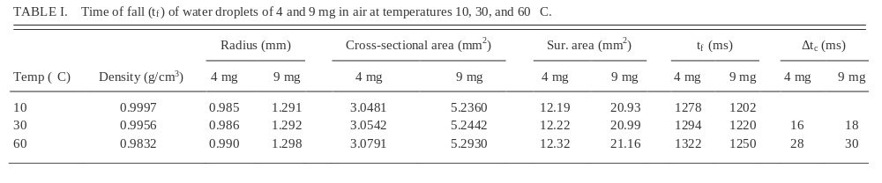
For further details please refer [2].
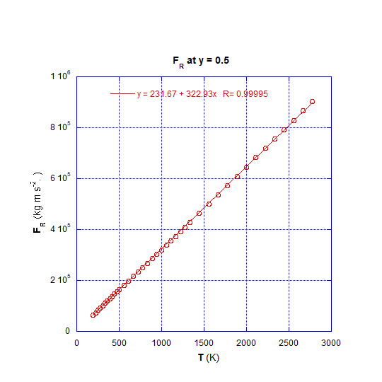
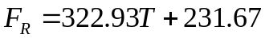

Fig. S2. F_{R} vs. T; when extrapolated crosses (0,0) when y ≈ 0.5
F_{R} is linearly proportionate to T at any given value of y (Fig. 7(d)); thus, vindicating the mathematical model Eq. 5.
A significant finding is that, in the linear relationship F_{R} vs. T extrapolated graph intercept ≈ 0 when y ≈ 0.5, while intercept > 0 when y < 0.5, and intercept < 0 when y > 0.5.
Significantly, this result confirms the findings presented in a previous paper [2] of the series of publications emanating from this research program (See Fig. A)
Fig. S3. F_{A} vs. T; F_{A} tends to become positive as T approaches 0 K when y ≈ 0.5
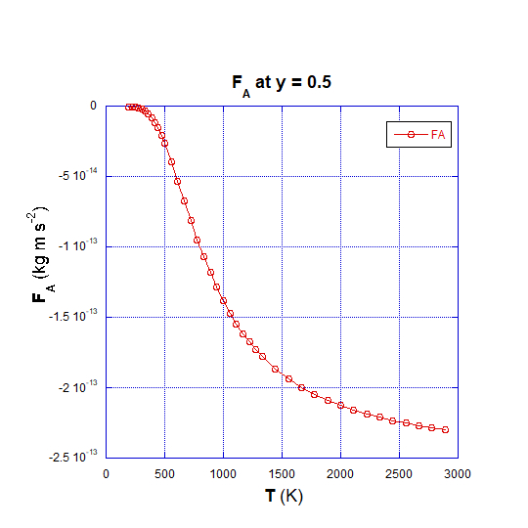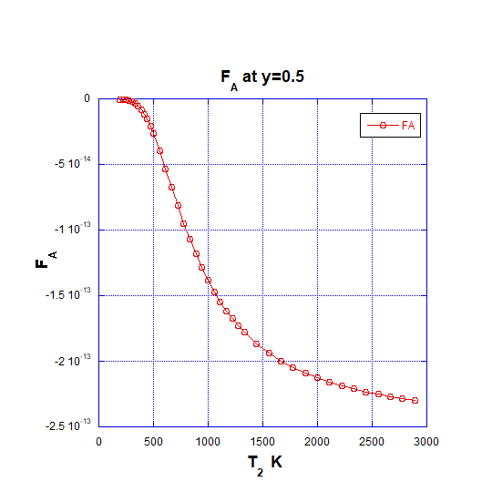
Applying empirical data to Eq. 24 has unearthed that F_{A}, (the attraction force among gas molecules) is negative at elevated temperatures, implying that it acts as a repulsive force together with F_{R}. This negative F_{A} tends to becomes positive at lower temperatures where gases are expected to condense.

