Design and synthesis of some new derivatives of chlorobenzyl-oxy-phenyl-ethyl-thio-1H-tetrazole and study their antibacterial and antifungal activity
Ajay N. Ambhore*
*Padmabhushan Dr. Vasantraodada Patil Mahavidyalaya, Tasgaon. Dist. Sangli (MS) India
Email: ambhoreajay@gmail.com
Fig 1. Graphical representation of antibacterial screening of chlorobenzyl-oxy-phenyl-ethyl-thio-1H-tetrazole derivatives (6a-p)

Fig 2. Graphical representation of antifungal screening of chlorobenzyl-oxy-phenyl-ethyl-thio-1H-tetrazole (6a-p)
Fig. 3 IR of Compound 2a
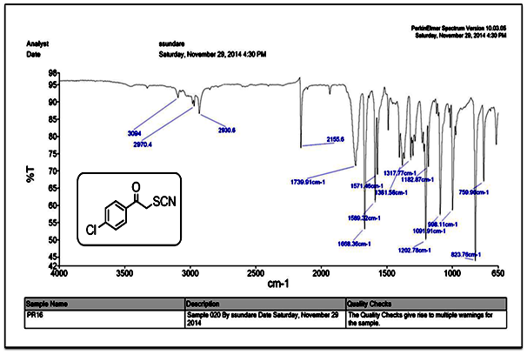
Fig. 4 IR of Compound 3a
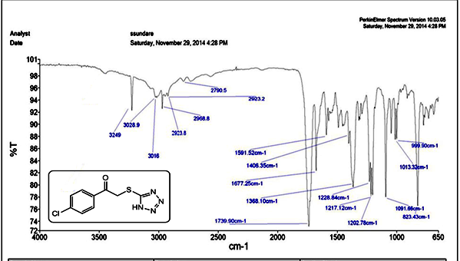
Fig. 5 ¹H NMR of Compound 3a
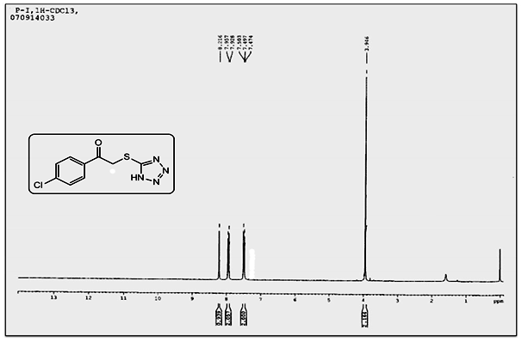
Fig. 6 Mass of Compound 3a
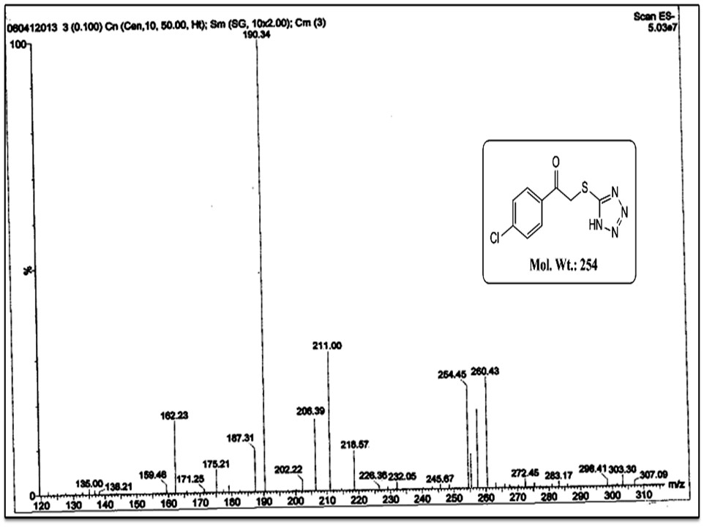
Fig. 7 IR of Compound 4a
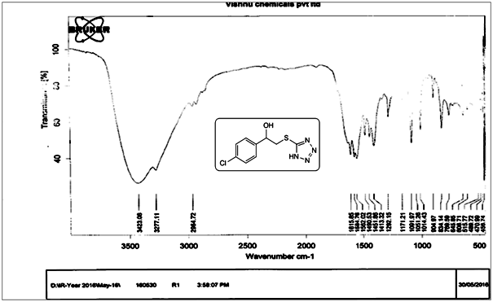
Fig. 8 ¹H NMR of Compound 4a
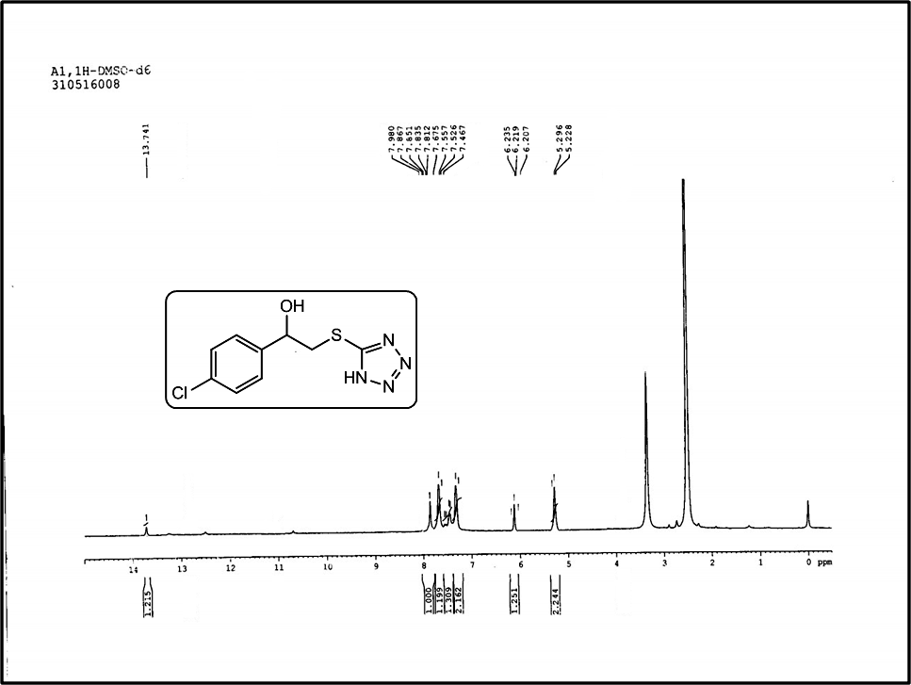
Fig. 9 IR of Compound 6a
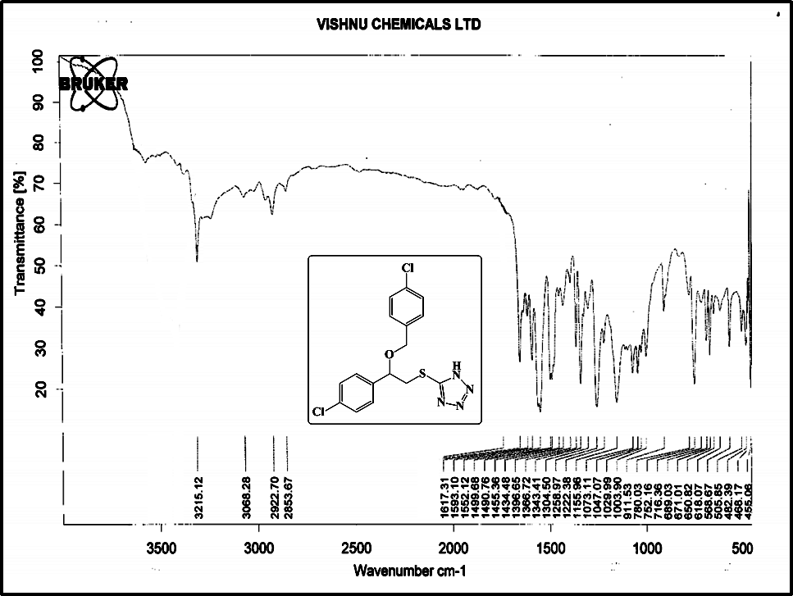
Fig. 10 ¹H NMR of Compound 6a
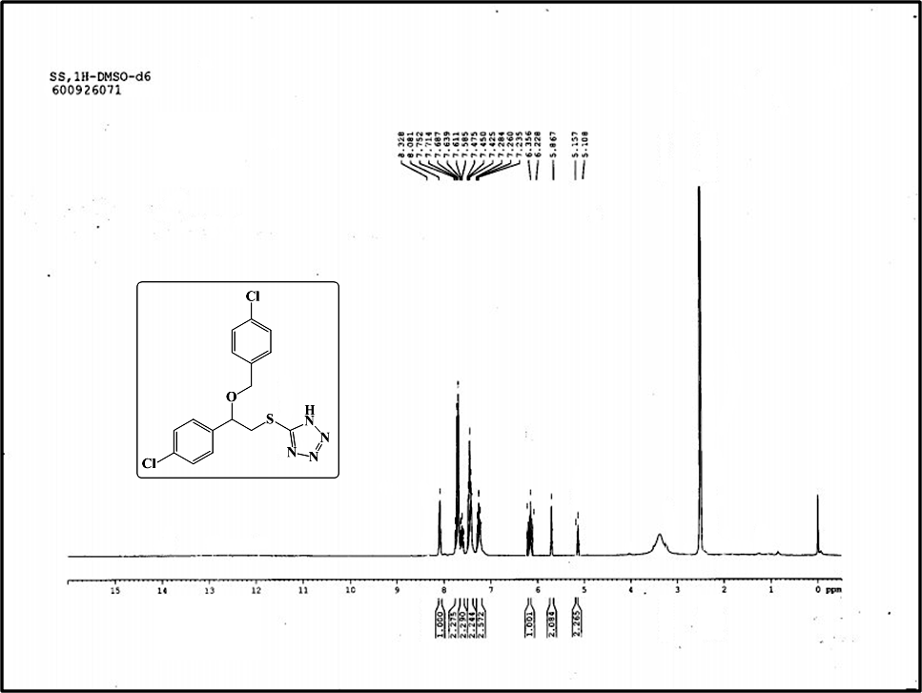
Fig. 11 ¹³C NMR of Compound 6a
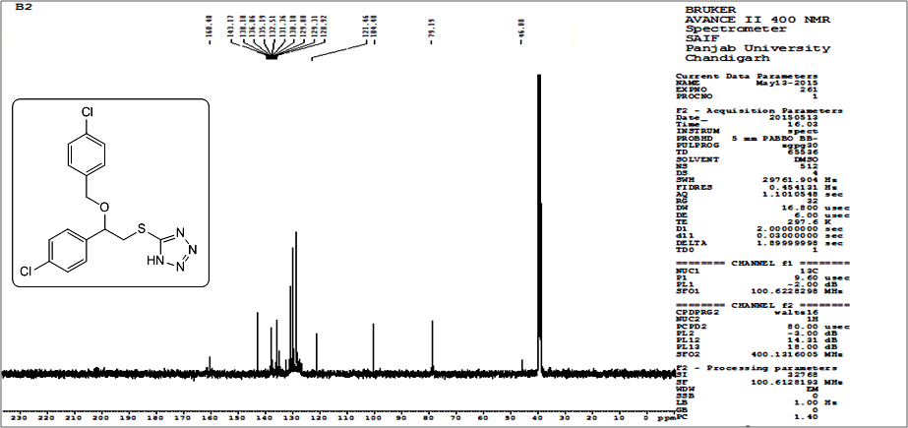
Fig. 12 Mass of Compound 6a
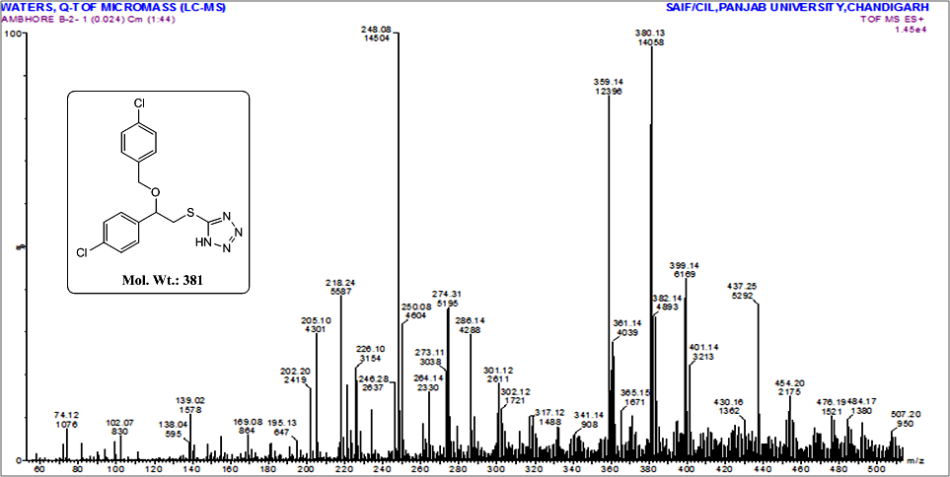
Fig. 13 IR of Compound 6d
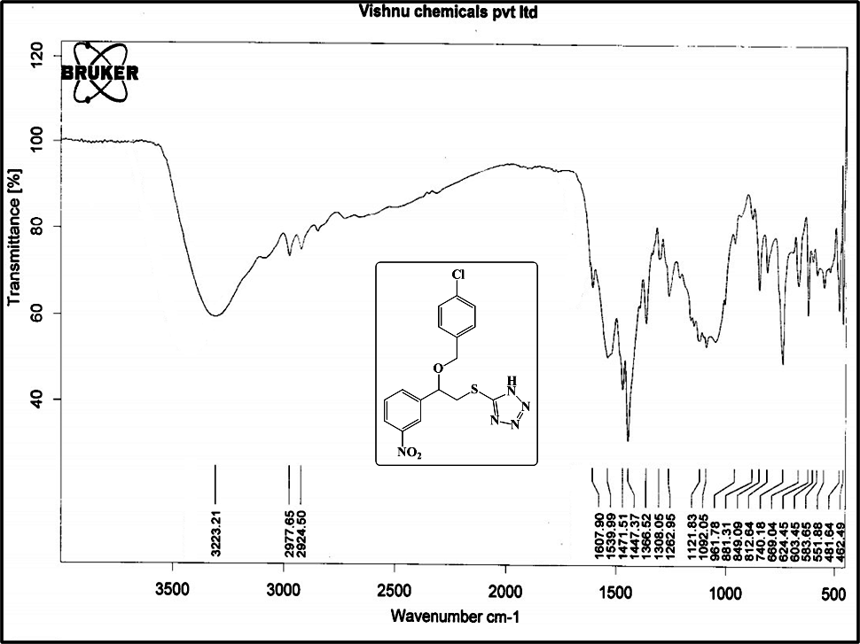
Fig. 14 ¹H NMR of Compound 6d
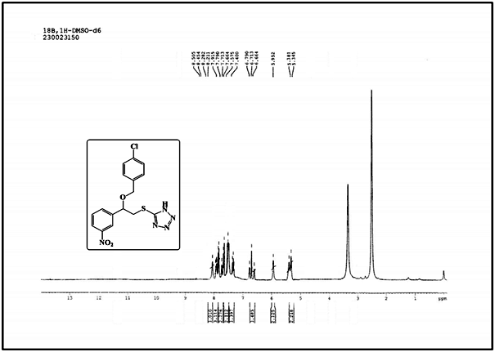

Fig. 15 ¹³C NMR of Compound 6d
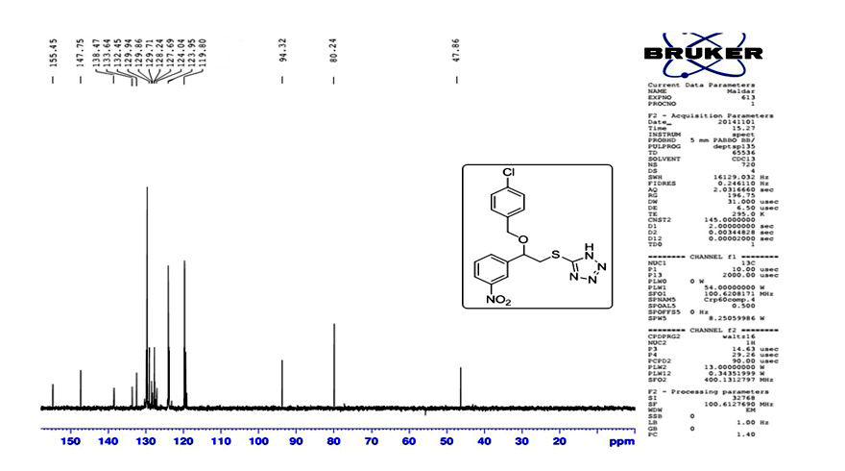
Fig. 16 MASS of Compound 6d
