Supporting information:

Highly aligned bacterial nanocellulose films obtained during natural biosynthesis

Nerea Murugarrenª, Soledad Roig-Sanchezª, Irene Antón-Salesª, Nanthilde Malandainª, Kai Xuª, Eduardo Solano^{b}, Juan Sebastian Reparazª, Anna Laromaineª

a. Institut Ciencia de Materials de Barcelona (ICMAB-CSIC), Campus UAB, 08193 Bellaterra, Spain.
b. NCD-SWEET beamline, ALBA Synchrotron Light Source, Carrer de la Llum 2−26, 08290 Cerdanyola del Vallès, Barcelona, Spain.

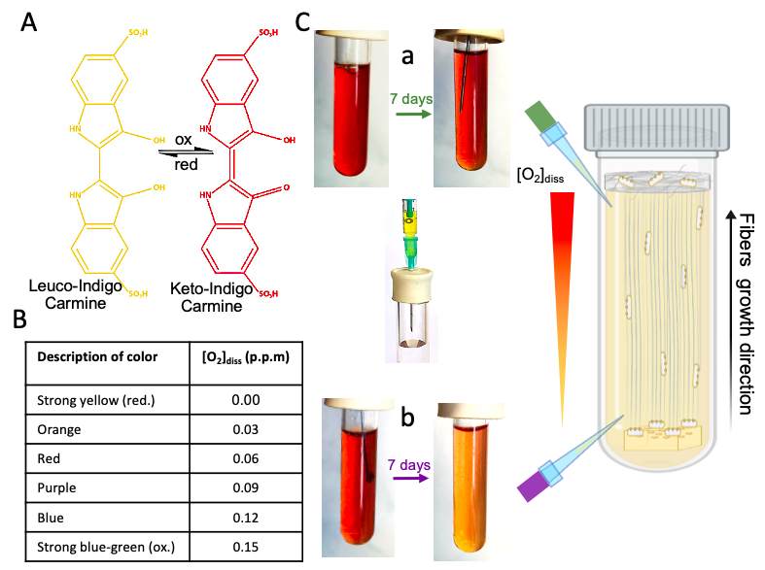

Figure S1. Dissolved Oxygen (DO) colorimetry assay. A Leuco- indigo carmine reagent oxidizes under the presence of oxygen to keto-indigo carmine, which causes a color change from yellow to red upon oxidation. B A color-DO chart allows to qualitatively estimate the DO concentration. C The initial DO concentration at the top (a) and bottom (b) part of a non-oxygen permeable tube was ≈0.06 ppm, seen as a red solution. After 7 days of culture, the DO concentration at the top was maintained at 0.06 ppm (a), while, at the bottom, it decreased to 0.03 ppm (b), noticeable as the color changed.

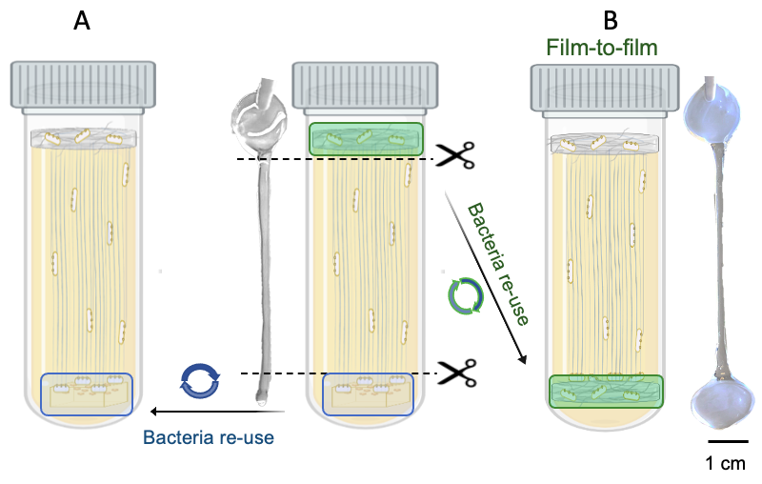
Figure S2. Methodology to re-use BNC films to produce A-BNC: film-to-film. A The initial bacteria substrate, agar with colonies, can be re-used after producing one film of A-BNC+BNC. The agar, containing bacteria, is placed at the bottom of a tube with bacteria-free culture media and a new A-BNC and BNC film are formed from the bottom of the tube to the liquid surface. B The produced BNC film at the liquid-air interface contains live and active bacteria. This section of non-aligned BNC can be easily detached from A-BNC by pulling off with Teflon tweezers and cutting with sterile scissors. Resembling A, this process can be repeated multiple times to achieve new A-BNC and BNC films.

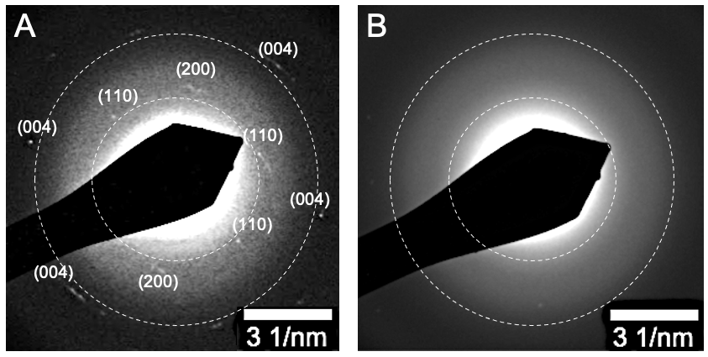
Figure S3. Selected area electron diffraction (SAED) of A A-BNC and B BNC. The cellulose crystalline lattice planes are only seen and indexed in A.

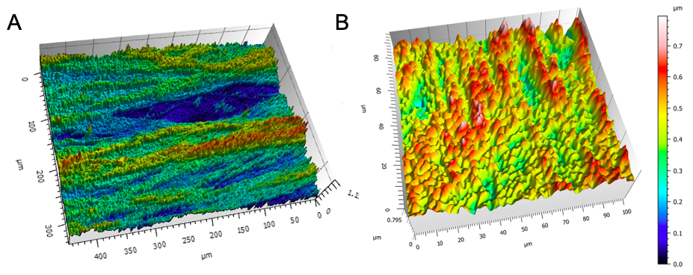
Figure S4. 3D Micro-structuration of BNC and A-BNC. Interferometry images of A A-BNC (350 x 450 µm²) and B BNC (85 x 100 µm²) sample sections. Color map showing the height of the section.
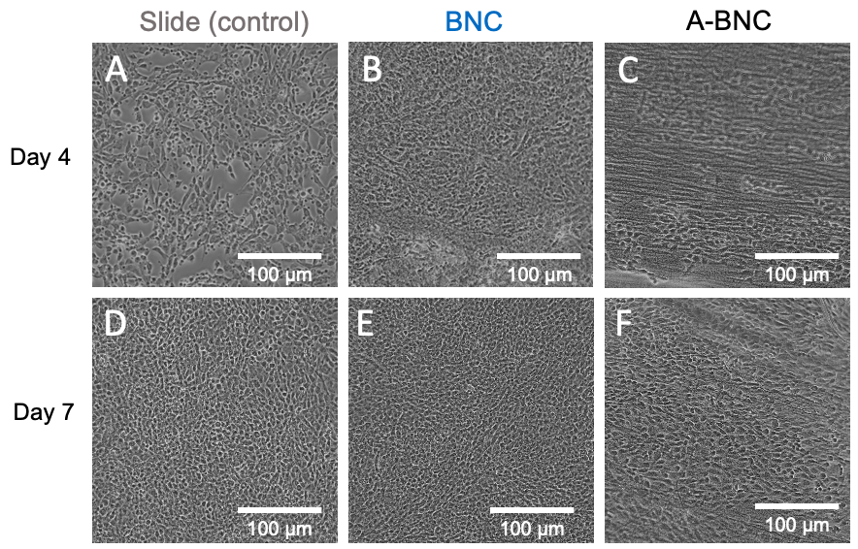
Figure S5. Optical images of cell culture for slide (control), BNC and A-BNC. Top row shows day 4 images of A slide, B BNC and C A-BNC. Bottom row shows day 7 images of D slide, E BNC and F A-BNC.

