Appendix

Kinematic of the two cylinders in the swing
As shown in Figure 1, ignoring manufacturing tolerances, when ,. Assume that and when an object is being carried

(1)
(2)
The length of the hydraulic cylinder can be determined by the law of cosines
(3)
(4)
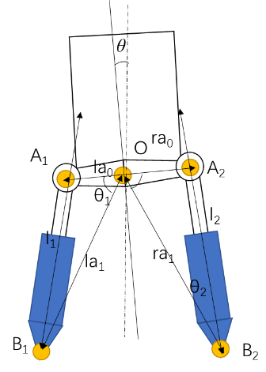
Figure 1 Schematic of the swing

