SYT1 gene-wide analysis on white matter microstructure in adulthood ADHD

Renata Basso Cupertino¹, ORCID - 0000-0002-3452-0632
Bruna Santos da Silva², ORCID - 0000-0002-5916-4638
Jaqueline Bohrer Schuch^{3.4}, ORCID - 0000-0002-2195-4407
Cibele Edom Bandeira², ORCID - 0000-0002-3964-1708
Maria Eduarda Tavares², ORCID - 0000-0002-2594-066x
Pamela Ferreira da Cunha², ORCID - 0000-0003-4624-7028
Felipe Almeida Picon⁴, ORCID - 0000-0002-2508-7961
Eduardo Schneider Vitola⁴, ORCID - 0000-0002-6053-1132
Diego Luiz Rovaris⁶, ORCID - 0000-0002-8910-4927
Eugenio Horácio Grevet^{4.5}, ORCID - 0000-0002-6898-7126
Claiton Dotto Henrique Bau^{2,5}, ORCID - 0000-0001-5644-3845

Affiliations:
¹ Department of Psychiatry, University of Vermont, Vermont, United States.
² Department of Genetics, Instituto de Biociências, Universidade Federal do Rio Grande do Sul, Porto Alegre, RS, Brazil
³ Graduate Program in Psychiatry and Behavioral Sciences, Universidade Federal do Rio Grande do Sul, Porto Alegre, RS, Brazil
⁴ Department of Psychiatry, Faculdade de Medicina, Universidade Federal do Rio Grande do Sul, Porto Alegre, RS, Brazil
⁵ ADHD Outpatient Program, Hospital de Clínicas de Porto Alegre, Porto Alegre, RS, Brazil
⁶ Universidade de São Paulo Instituto de Ciências Biomédicas Departamento de Fisiologia e Biofísica, São Paulo, Brazil

Supplementary Figure S1. Specific tracts evaluated
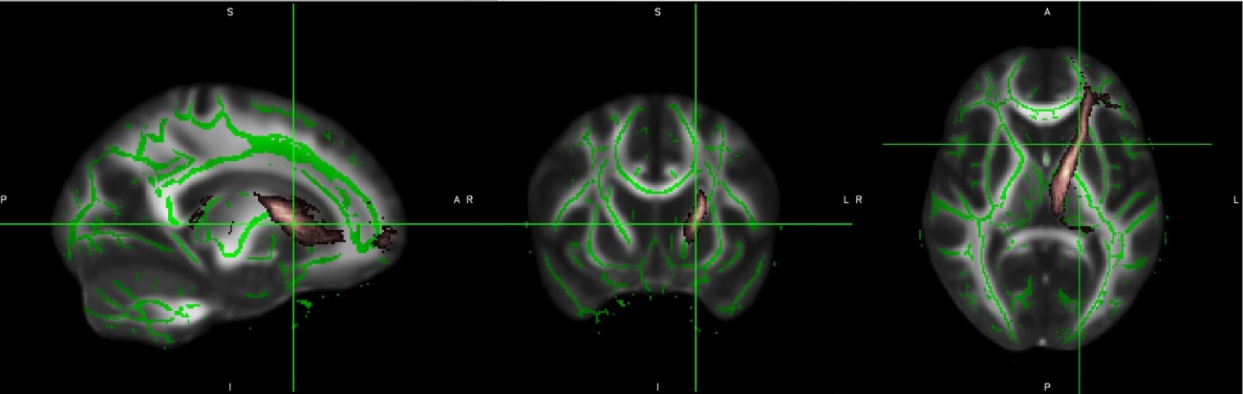
A
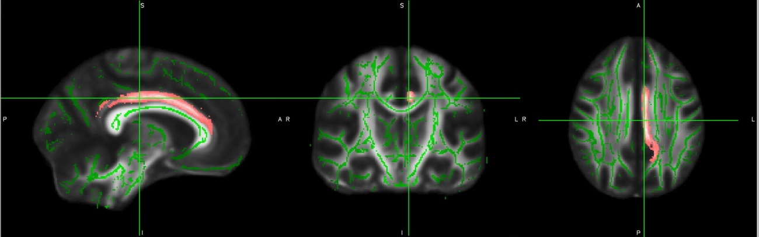
B

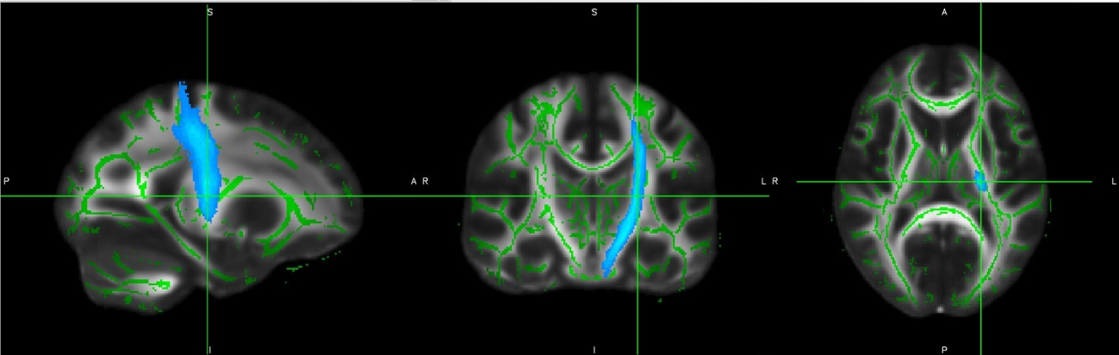
C

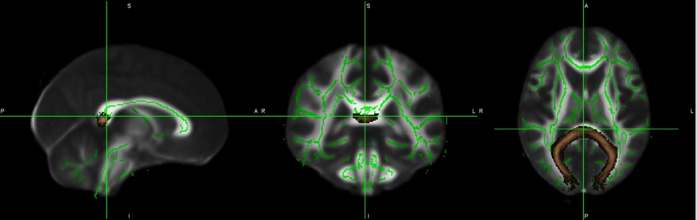
D

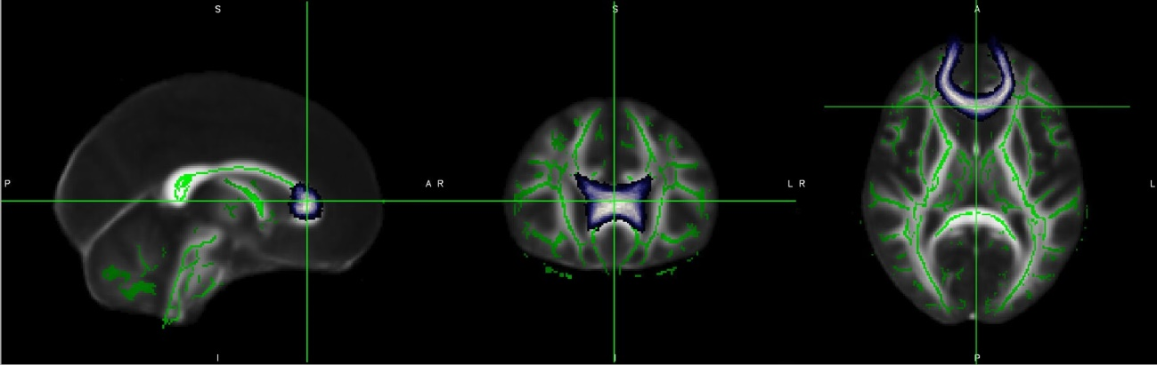
E

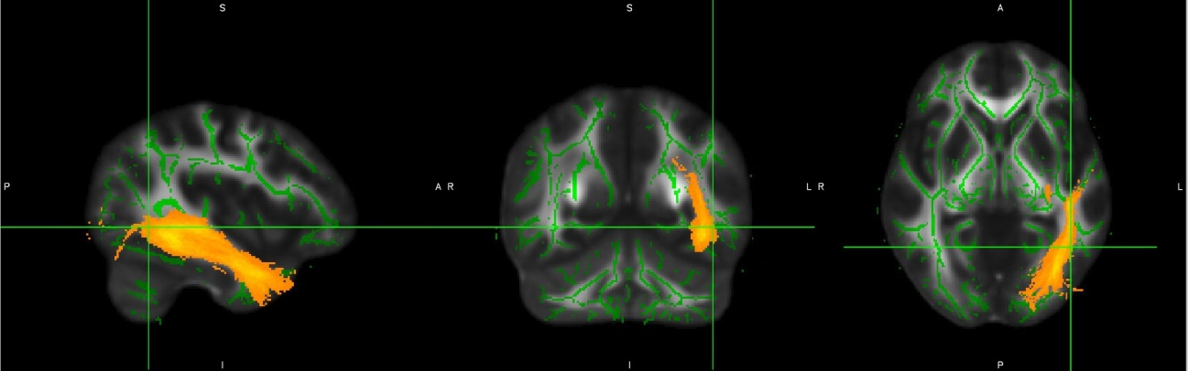
F

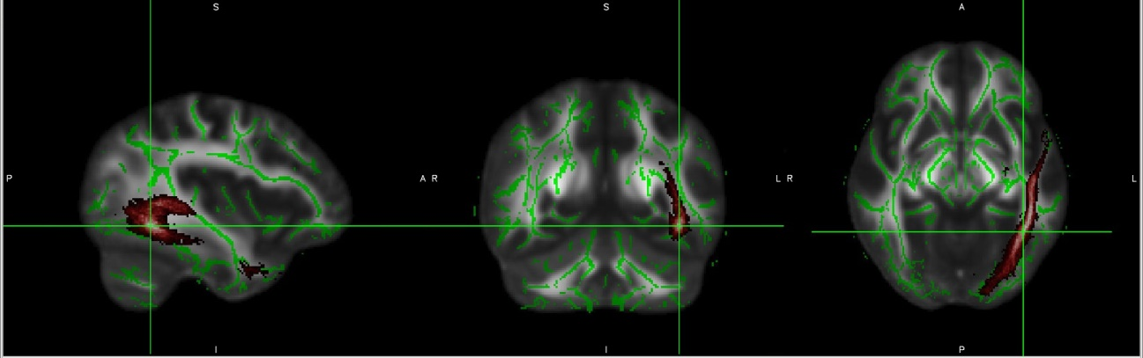
G

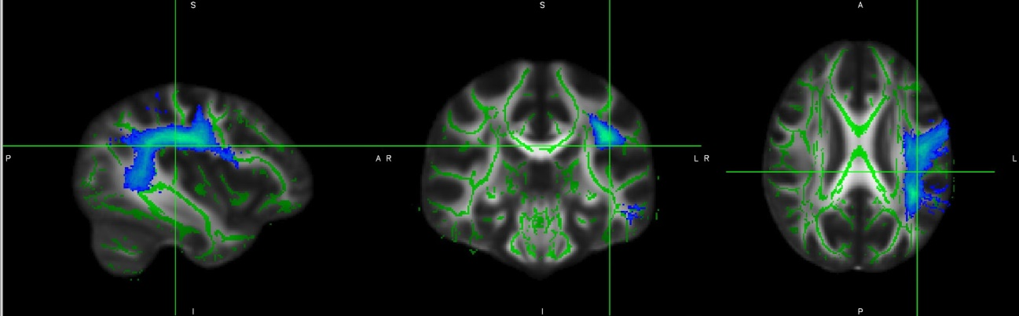
H

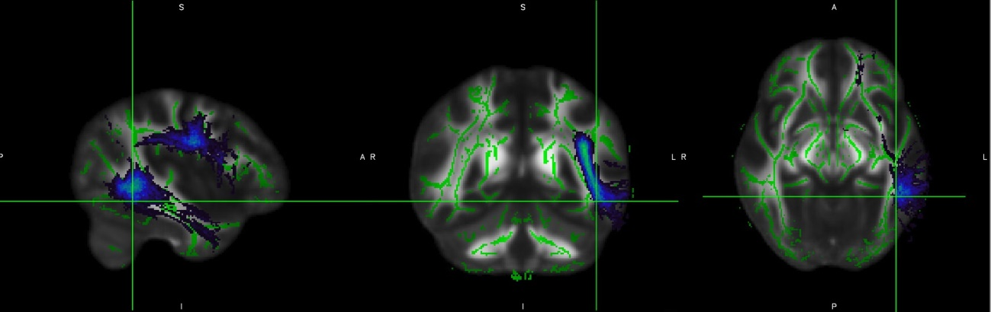
I

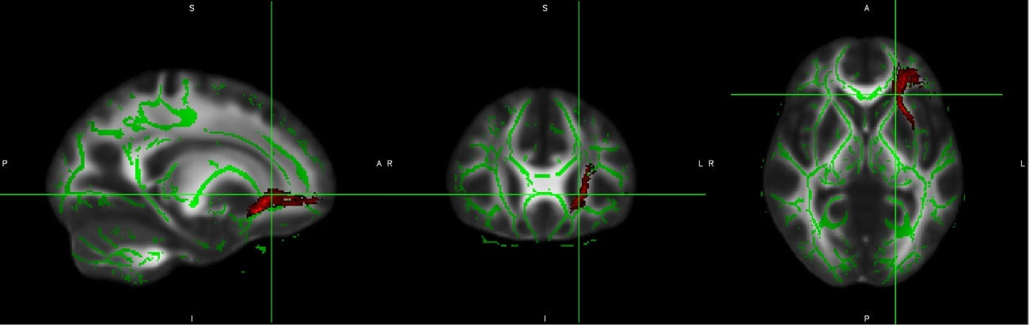
J

Representation of the evaluated tracts in sagittal (left), coronal (middle) and axial (right) views and the mean fractional anisotropy (skeleton) on top of MNI152 background image. A. Anterior thalamic radiation; B. Cingulate gyrus (analyzed in ventral and dorsal); C. Corticospinal tract; D. Forceps major; E. Forceps minor; F. Inferior fronto-occipital fasciculus; G. Inferior longitudinal fasciculus; H. Superior longitudinal fasciculus; I. Uncinate fasciculus; J. Temporal portion of the superior longitudinal fasciculus.

Supplementary Figure S2. LD heatmap of SYT1 gene and the haplotypic blocks identified
C
B
A
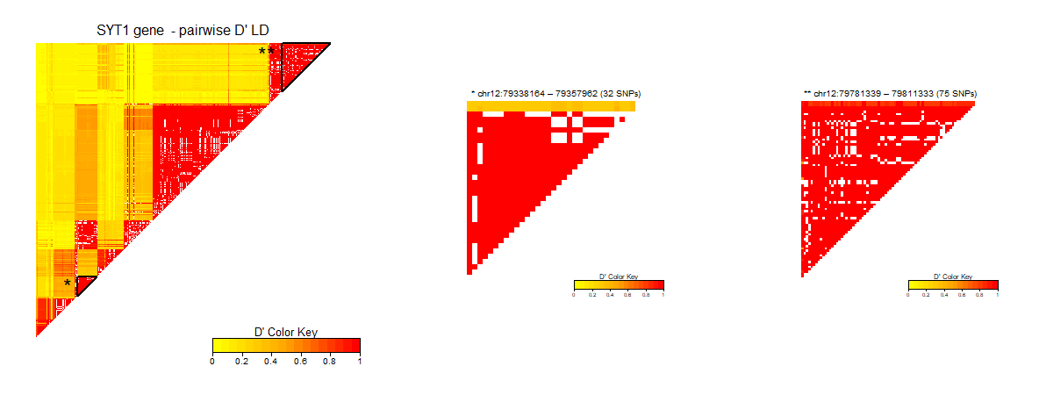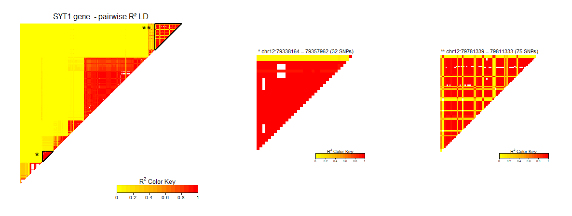
F
E
D
Linkage disequilibrium map of the SNPs comprised in SYT1 gene. The color in the bottom bars represents D’ (A, B and C) or R² (D, E and F), where warmer colors indicate stronger LD or correlation between the SNP pairs. A and D. All SNPs included, ranging from chr12: 79259039- 79832584. B and E. First independent region identified, comprising 32 polymorphisms located in chr12:79338164– 79357962. C and F. Second independent region identified, comprising 75 polymorphisms between the range chr12:79781339 – 79811333.

Supplementary Figure S3. Region plots of the SYT1 gene with the evaluated areas.
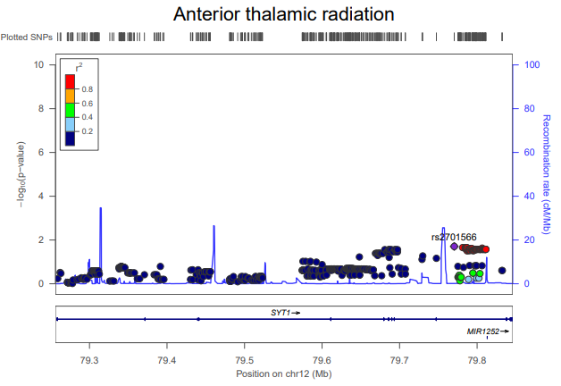
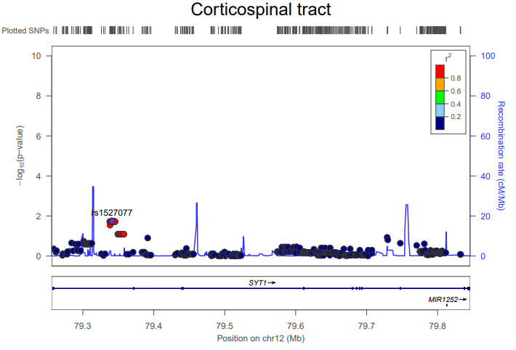
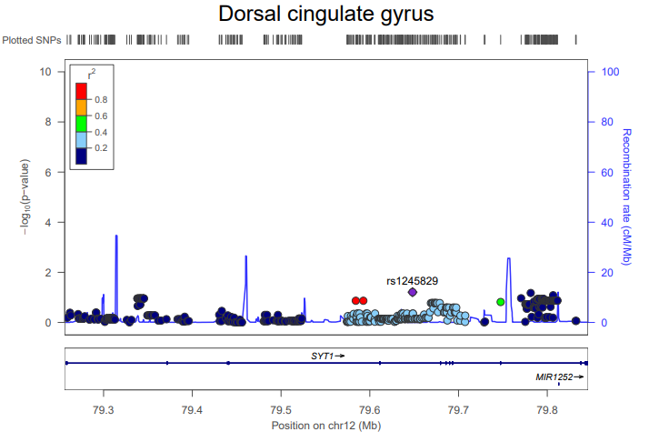
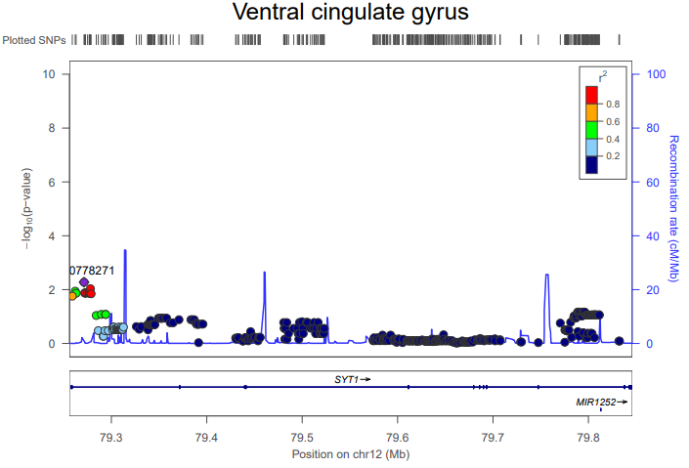

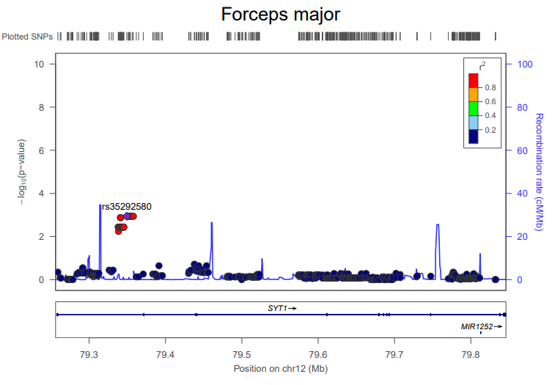

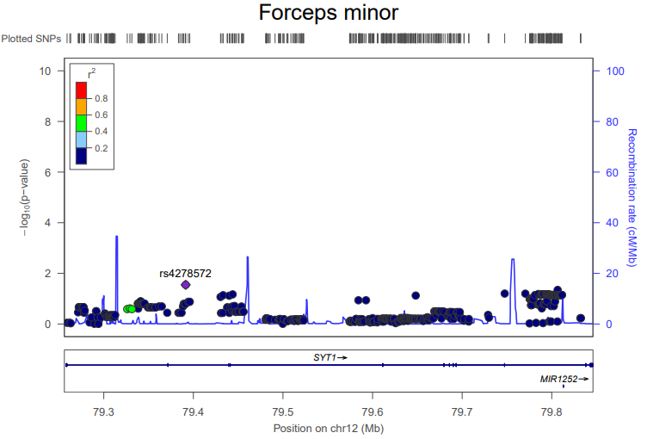

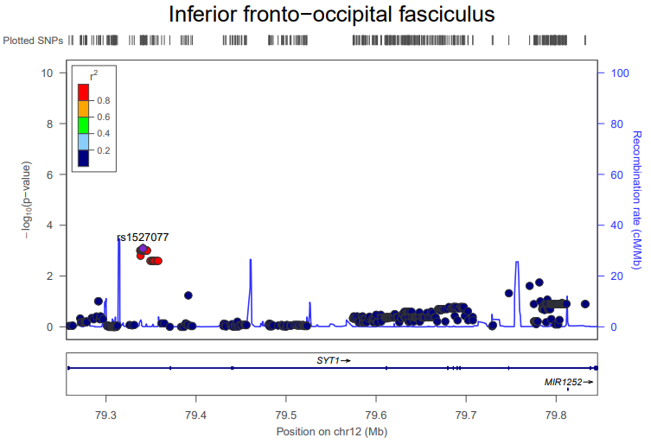
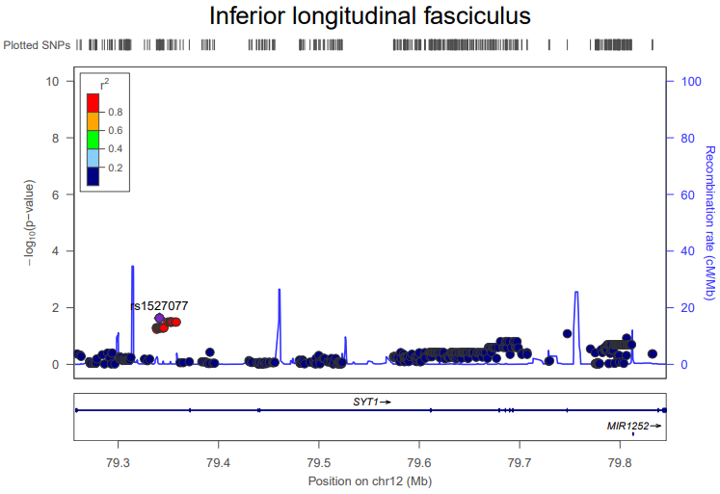
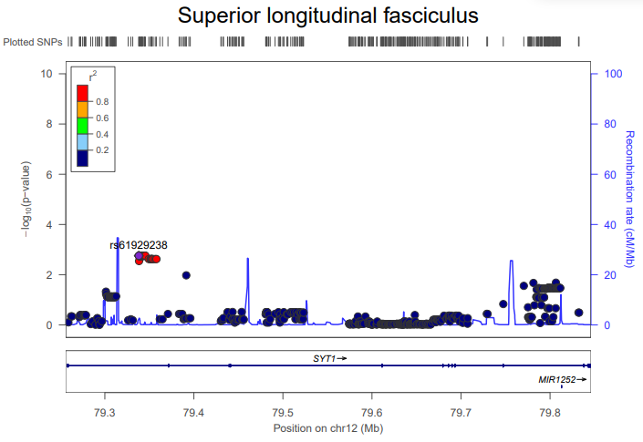

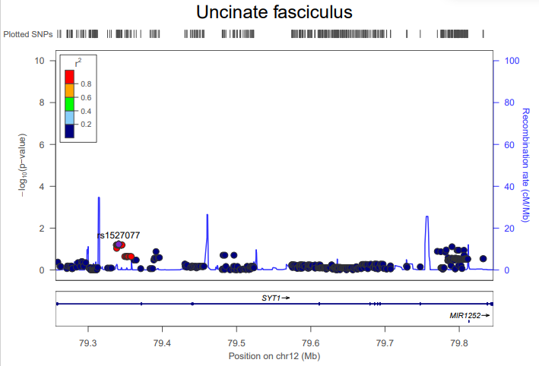

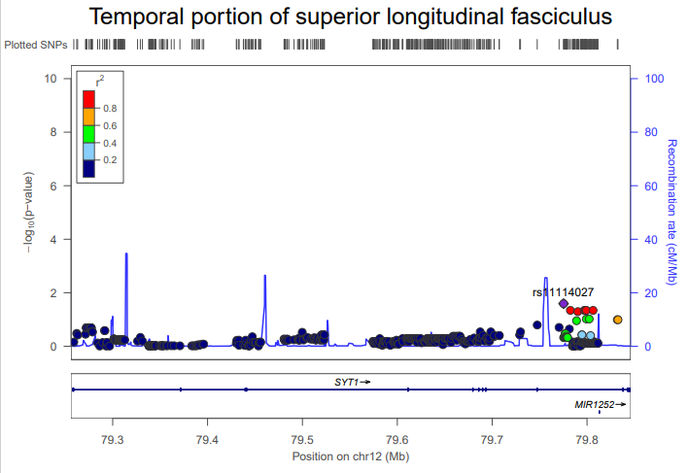

Regional visualization of SYT1 results for each outcome. SNP with the lowest P-value is represented in purple, of which linkage disequilibrium with other SNPs are depicted according to R².

