Extended data

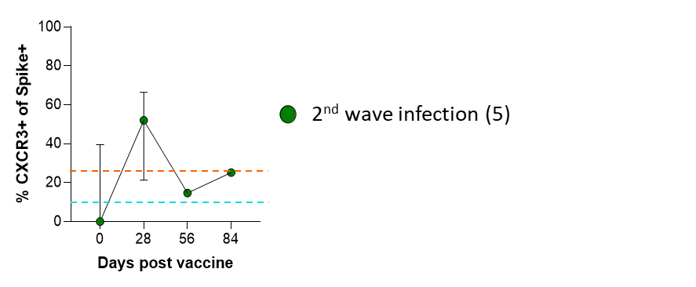

Extended Data Fig. 3: Median longitudinal B cell CXCR3 homing responses following vaccination for the second wave (Beta variant) infected group. The median (+/- 95% CI) of the Spike+ CXCR3+ B cell memory response is shown for participants infected with the Beta variant. The dashed lines represent the starting median response for the naïve (blue) and previously infected (orange) groups.

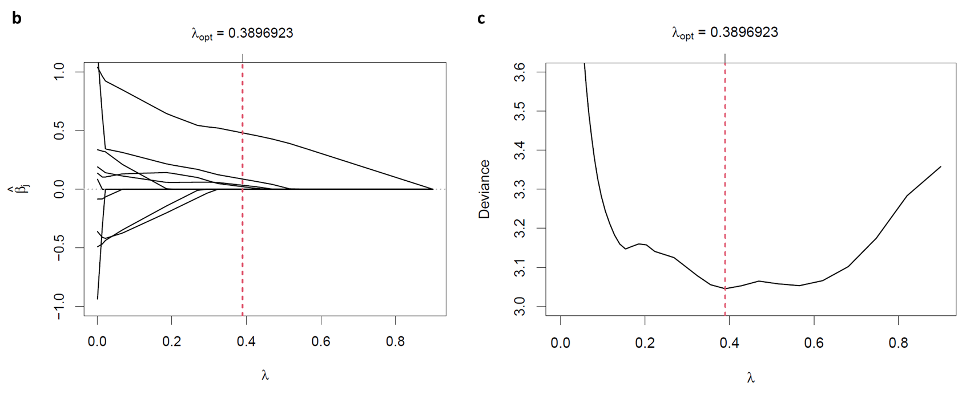
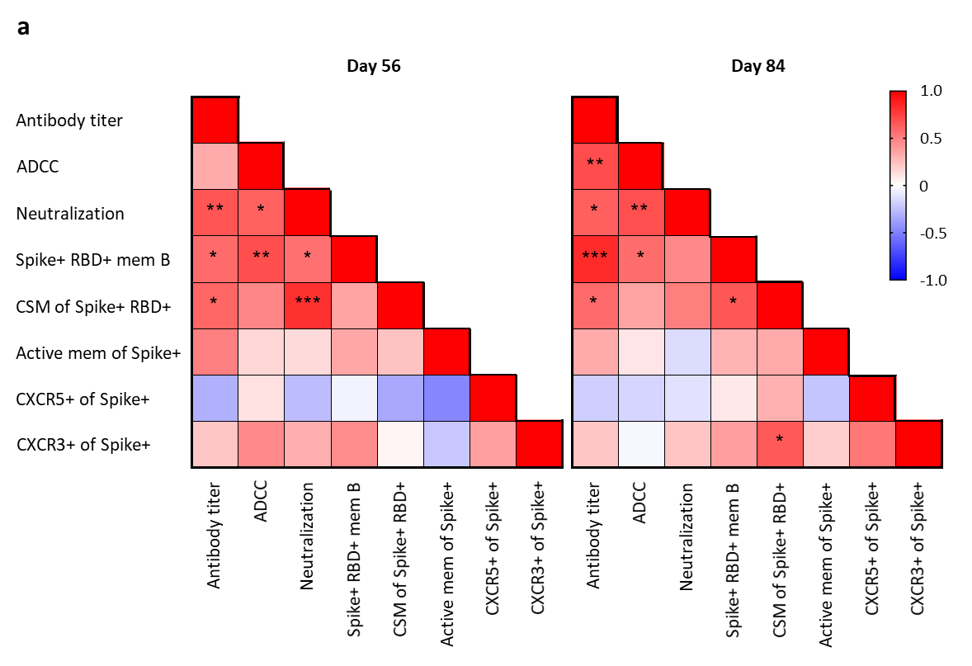

Extended Data Fig. 6: Correlations of the antibody, B and T cell responses following vaccination and the LASSO analysis coefficient paths and optimal penalty parameter. a, The Spearman rank correlation values (r) per comparison are presented as red (1.0) to blue (-1.0) for day 56 and 84 comparisons. The respective P values denoted by * ≤ 0.05; ** < 0.01; *** < 0.001 and **** < 0.0001. b, The LASSO regression analysis coefficient path plot resulting after antibody dependent SARS-CoV-2 neutralization was selected as the outcome and the Spike+ memory B cell parameters were included as covariates (intercept estimate was 4.338). c, The plot for determination of the optimal LASSO penalty parameter, showing the course of the error versus penalty strength lambda in a 10-fold cross validation approach.
Extended Data Table 1: Participant demographic and clinical data
 | No previous infection | 1st wave infection | 2nd wave infection | Unconfirmed wave infection | TOTAL
N | 10 | 9 | 5 | 6 | 30
Demographic
Age (years) | 36 [28-51] | 39 [29-47] | 41 [26-45] | 39 [34-49] | 39 [30-47]
Gender M:F | 6M:4F | 1M:8F | 2M:3F | 1M:5F | 10M:20F
Ethnicity
Black | 1 (10%) | 5 (56%) | 1 (20) | 6 (100%) | 13 (43%)
White | 2 (20%) | 0 (0%) | 2 (40%) | 0 (0%) | 4 (13%)
Mixed | 6 (60%) | 4 (44%) | 2 (40%) | 0 (0%) | 12 (40%)
Other | 1 (10%) | 0 (0%) | 0 (0%) | 0 (0%) | 1 (3%)
Clinical
PCR SARS-CoV-2+ | 0 (0%) | 8 (89%) | 0 (0%) | 0 (0%) | 8 (40%)*
Serology SARS-CoV-2+ | 0 (0%) | 9 (100%) | 5 (100%) | 6 (100%) | 20 (100%)*
Days after vaccination
28 | 31 [26-34] | 29 [28-31] | 30 [0] | 30 [24-33] | 30 [28-33]
56 | 67 [61-68] | 60 [59-66] | 56 [0] | 58 [54-61] | 60 [58-67]
84 | 92 [87-95] | 88 [84-93] | 84 [0] | 84 [81-86] | 87 [84-93]
Comorbidities
Asthma | 2 (20%) | 1 (11%) | 0 (0%) | 0 (0%) | 3 (10%)
Hypertension | 2 (20%) | 3 (33%) | 0 (0%) | 1 (17%) | 6 (20%)
Obesity | 1 (10%) | 0 (0%) | 0 (0%) | 1 (17%) | 2 (7%)
Diabetes mellitus | 1 (10%) | 0 (0%) | 0 (0%) | 0 (0%) | 1 (3%)
HIV | 0 (0%) | 0 (0%) | 0 (0%) | 2 (33%) | 2 (7%)
Other | 1 (10%) | 0 (0%) | 0 (0%) | 0 (0%) | 1 (3%)
None | 6 (60%) | 6 (67%) | 5 (100%) | 3 (50%) | 20 (67%)
>1 comorbidity | 2 (20%) | 1 (11%) | 0 (0%) | 1 (17%) | 4 (13%)

The median age and interquartile range are stated per group. Gender is stated as (M) male and (F) female. * Percentages were calculated from total infected (n=20). Time of follow up visits is shown as median days and interquartile range following vaccination. Both HIV positive participants were on effective ART.

Extended Data Table 2: B cell phenotyping panel
# | Marker | Fluor | clone | cat no | Supplier
1 | L/D | APC-Cy7 |  | L10119 | Invitrogen
2 | CD45 | Hv500 | HI30 | 560777 | BD Horizon
3 | CD3 | Bv711 | OKT3 | 317328 | BioLegend
4 | CD14 | Bv711 | M5E2 | 301838 | BioLegend
5 | CD19 | Bv605 | HIB19 | 302244 | BioLegend
6 | CD27 | PE-Cy5 | 1A4CD27 | 6607107 | Beckman Coulter
7 | CD38 | PECy7 | HIT2 | 303516 | BioLegend
8 | IgM | PerCP/Cy5.5 | MHM-88 | 314512 | BioLegend
9 | IgD | AF700 | IA6-2 | 348230 | BioLegend
10 | CXCR5 | AF488 (FITC) | RF8B2 | 558112 | BD Pharmingen
11 | CXCR3 | PE-CF594 | IC6/CXCR3 | 562451 | BD Horizon
12 | CD21 | Bv421 | B-ly4 | 562966 | BD Horizon
13 | BAIT | SA-APC |  | 405207 | BioLegend
14 | BIAT | SA-PE |  | 405204 | BioLegend

Extended Data Table 3: T cell phenotyping and AIM assay panel
# | Marker | Fluor | clone | cat no | Supplier
1 | L/D | APC-Cy7 |  | L10119 | Invitrogen
2 | CD4 | ECD | T4 | 6604727 | Beckman Coulter
3 | CD3 | Bv650 | OKT3 | 317324 | BioLegend
4 | CD8 | Bv510 | RPA-T8 | 301048 | BioLegend
5 | CD45RA | Bv570 | HI100 | 304132 | BioLegend
6 | CXCR5 | Bv785 | J252D4 | 356936 | BioLegend
7 | OX40 | PECy7 | ACT35 | 350012 | BioLegend
8 | CD25 | PE | BC96 | 302606 | BioLegend
9 | CD69 | FITC | FN50 | 310904 | BioLegend
10 | CD137 | APC | 4B4-1 | 309810 | BioLegend

