Supplementary Material S2
Results
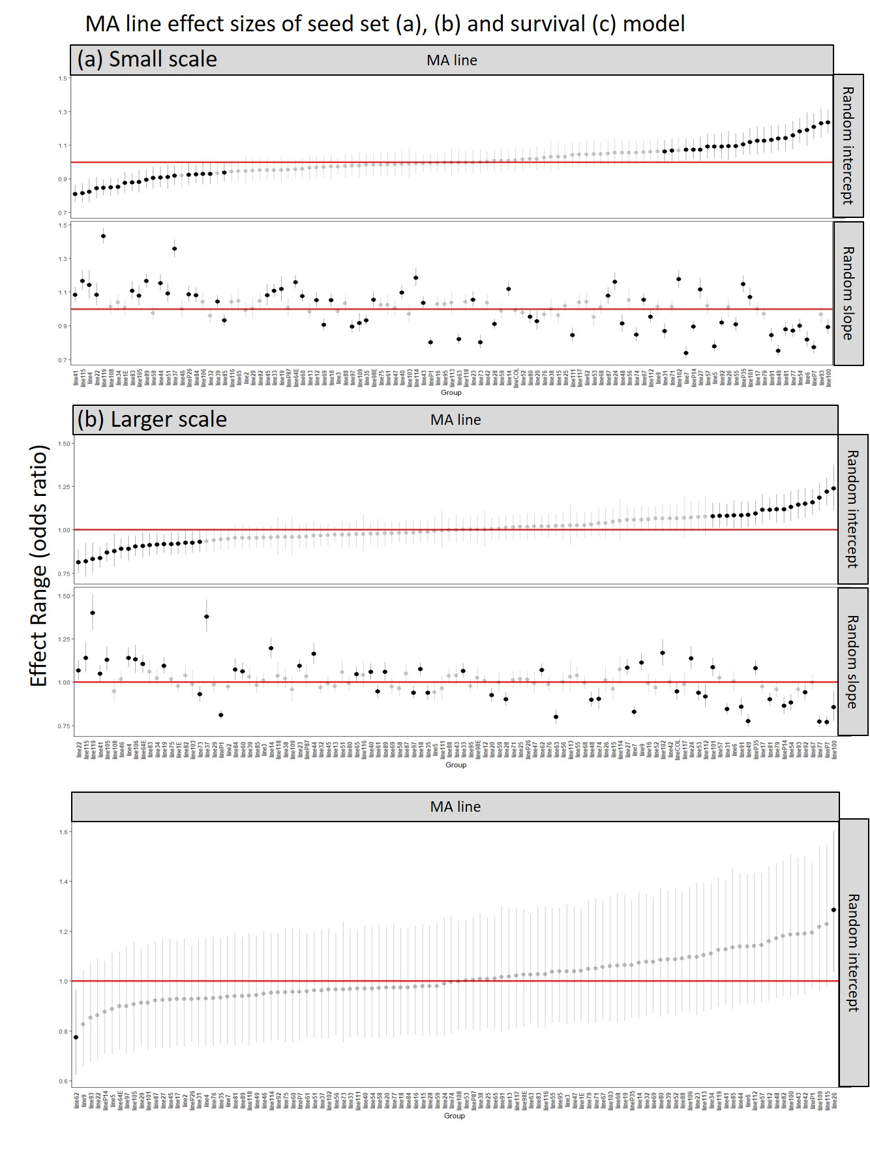
Figure 1. The effect range on seed set (a), (b) and survival (c) computed from eco-evolutionary trait-based neighborhood models shown as odds ratios for year 2005 (a) Shows the hierarchical competitive order of MA lines and founder for the seed set model including range effects of each MA line and founder as random intercepts and the trait proxy biomass as random slopes at small-scale and (b) at large-scale. (c) Shows the hierarchical selective order of MA lines and founder for the survival model including range effects of each MA line and founder as random intercepts at small-scale.

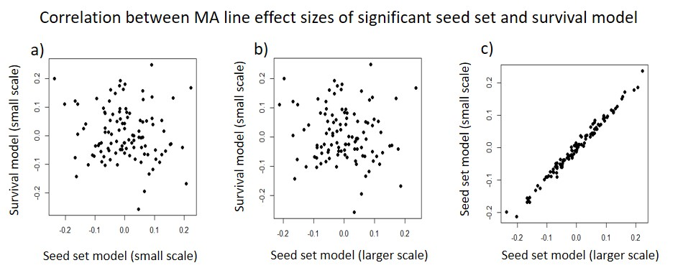
Figure 2. Correlation of the simulated conditional mean represented as odds ratio of same genotypes (MA lines) reducing or increasing the effect sizes of the seed set model and of the survival model at small-scale or large-scale for 2005, respectively. Each point represents different genotypes of A. thaliana. Negative values means lower effect sizes on the survival or seed set and positive values means increasing the effect sizes on the survival or seed set. a) Relationship between survival and seed set model. b) Relationship between survival and seed set model. c) Relationship between small-scale survival and large-scale seed set model. Since we are plotting effect sizes, the positive correlation in panel c reflects a trade-off between competition and facilitation (see results).

Table 1. AIC scores and distance effect of all differential models with trait proxy biomass as neighborhood biomass density and without trait proxy biomass (including only density measurements) to identify adequate models. The distance between focal plants and neighboring plants that influence 50% of the response (survival and seed set) is described as alpha (see S1). Note that survival models always include the density effect of neighboring genotypes.
Model | AIC | Distance of alpha
With trait proxy biomass
2004 Survival model at small scale | NA | NA
2004 Survival model at larger scale | NA | NA
2005 Survival model at small scale | NA | NA
2005 Survival model at larger scale | NA | NA
2004 Seed set model at small scale | 52841 | 12 cm
2004 Seed set model at larger scale | 52939 | 75 cm
2005 Seed set model at small scale | 48393 | 41 cm
2005 Seed set model at larger scale | 49026 | 83 cm
Without trait proxy biomass
2004 Survival model at small scale | 7548 | 44 cm
2004 Survival model at larger scale | 7639 | 48 cm
2005 Survival model at small scale | 9628 | 9 cm
2005 Survival model at larger scale | 9874 | 252 cm
2004 Seed set model at small scale | 52937 | 23 cm
2004 Seed set model at larger scale | 63207 | 73 cm
2005 Seed set model at small scale | 48765 | 17 cm
2005 Seed set model at larger scale | 55059 | 47 cm

