Supplementary materials

Title: Diagnostic and Prognostic Value of Selected MicroRNAs in Patients with Acute Heart Failure

Authors: Seyyed-Reza Sadat-Ebrahimi, Naser Aslanabadi, Milad Asadi, Venus Zafari, Dariush Shanebandi, Habib Zarredar, Elgar Enamzadeh, Hamed Taghizadeh, Reza Badalzadeh

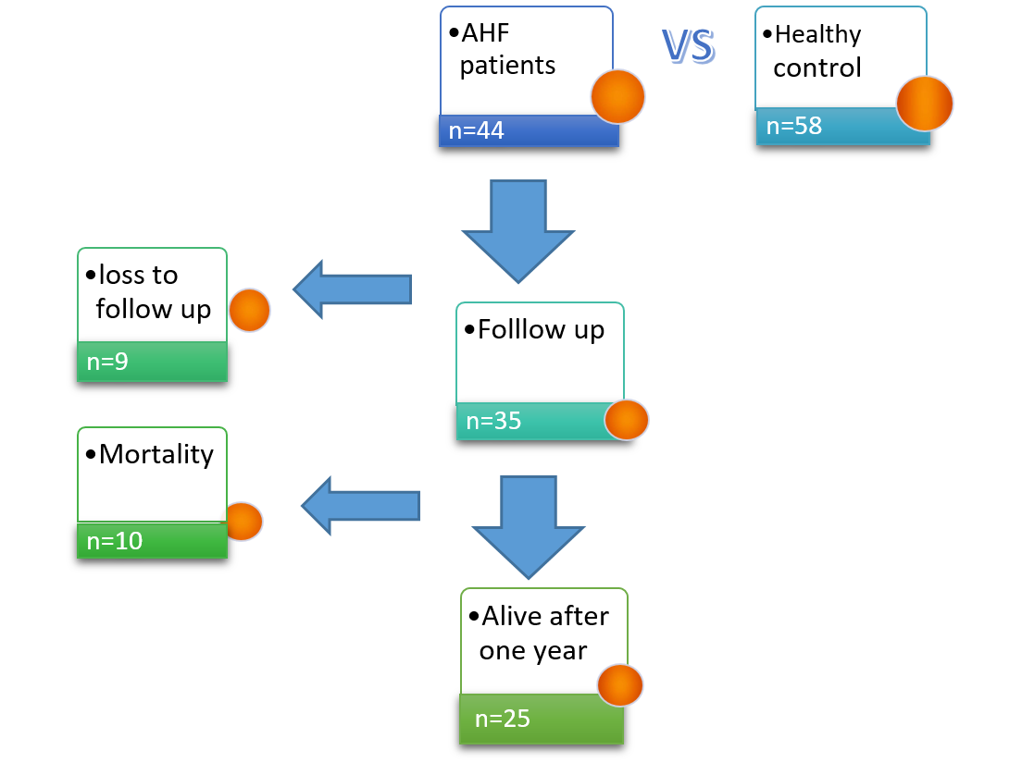
Supplementary figure 1. Inclusion of patients and follow up

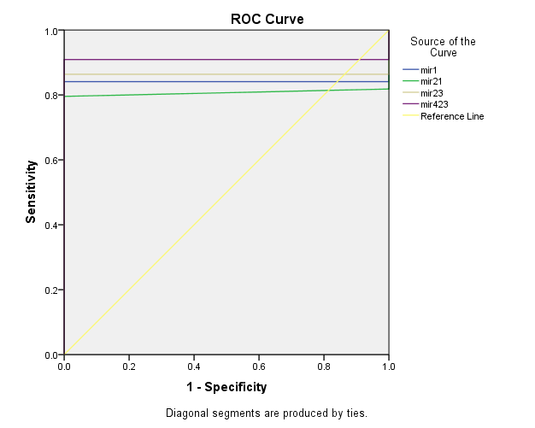

Supplementary figure 2. ROC curve plotted for four selected miRNAs

