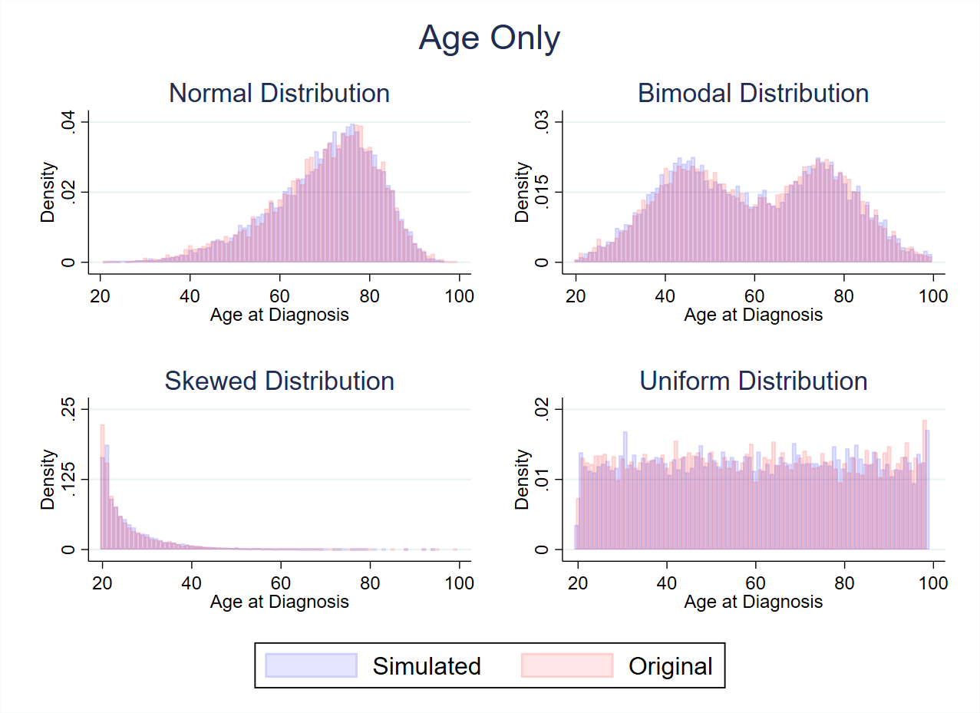
Supplementary Material 2: Simulating Age Distributions
Figure 1: Demonstration of age distribution reconstruction methods for assorted distributions (Normal, Bimodal. Skewed and Uniform) where age is not dependent on other variables

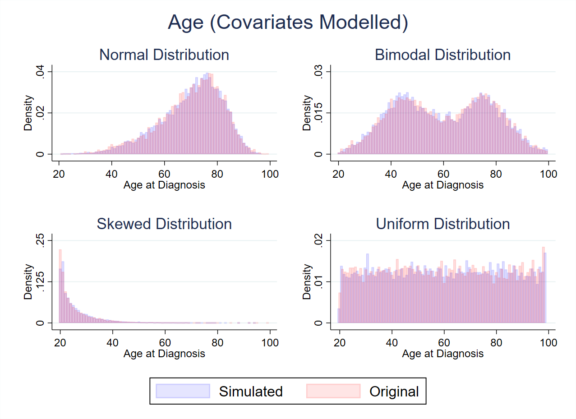
Figure 2: Demonstration of age distribution reconstruction methods for assorted distributions (Normal, Bimodal, Skewed and Uniform) where age is dependent on other variables
Figure 1 provides a visual demonstration of the effectiveness of the inverse-rank-based transformation method to reconstruct an age distribution accurately without incorporating any other covariate information into the regression model for age. Figure 2 shows the methods where other covariates (stage, sex, subsite, year of diagnosis) are included in the predictive regression model. As shown in table 1, both the “age only” and “age (covariates modelled)” do an effective job at recreating the marginal age distribution and key metrics found in the original data, across the assorted distributions being considered.

Table 1: Age distribution comparison details for "age only" and "age (covariate modelled)" for Normal, Bimodal, Skewed and Uniform distributions
 | Obs | Mean | Std. dev. | Min | Max | Skewness | Kurtosis
AGE ONLY
Normal
Original | 9087 | 69.75 | 12.26 | 12 | 99 | -0.736 | 3.40
Simulated | 9087 | 69.86 | 12.35 | 9.88 | 98.51 | -0.754 | 3.49
Bimodal
Original | 9087 | 59.90 | 17.79 | 10.39 | 107.93 | -0.001 | 2.04
Simulated | 9087 | 59.61 | 17.91 | 5.74 | 111.04 | -0.024 | 2.03
Skewed
Original | 9087 | 26.12 | 8.47 | 20 | 106.17 | 2.66 | 12.91
Simulated | 9087 | 26.18 | 8.64 | 19.47 | 105.57 | 2.76 | 13.72
Uniform
Original | 9087 | 59.55 | 22.74 | 20.00 | 98.99 | 0.005 | 1.81
Simulated | 9087 | 59.30 | 22.72 | 20.02 | 99.34 | 0.024 | 1.81
AGE (COVARIATES MODELLED)
Normal
Original | 9087 | 69.75 | 12.26 | 12 | 99 | -0.736 | 3.40
Simulated | 9087 | 69.77 | 12.13 | 13.23 | 103.14 | -0.737 | 3.46
Bimodal
Original | 9087 | 59.91 | 17.86 | 7.23 | 106.07 | 0.018 | 2.05
Simulated | 9087 | 59.87 | 17.81 | 9.25 | 108.18 | 0.025 | 2.04
Skewed
Original | 9087 | 26.08 | 8.57 | 20 | 99.77 | 2.684 | 12.85
Simulated | 9087 | 25.94 | 8.32 | 19.34 | 104.74 | 2.704 | 13.55
Uniform
Original | 9087 | 59.62 | 22.69 | 20.01 | 98.99 | -0.009 | 1.84
Simulated | 9087 | 59.38 | 22.61 | 19.47 | 99.30 | 0.002 | 1.85

Stata Code to Create Simulated Age Distributions:

1 ********************************************************************************
2 ***************************AGE NOT DEPENDENT*************************
3 ********************************************************************************
4 *UNIFORM DISTRIBUTION
5
6 use "https://www.pclambert.net/data/colon", clear
7 keep if year8594==1
8 gen female=sex-1
9
10 replace age=runiform(20,99)
11
12 egen rank = rank(age), unique
13 global N = _N
14 gen InvRankNormAge = invnormal((rank - 0.5)/${N})
15
16 rcsgen InvRankNormAge, df(5) gen(rcs) orthog
17 matrix Rmat=r(R)
18 local knots=r(knots)
19 regress age rcs*
20
21 gen U = rnormal()
22 drop rcs*
23 rcsgen U, knot(`knots') gen(rcs) rmatrix(Rmat)
24 predict agenew
25 gen agenew2 = (rnormal(agenew, `e(rmse)'))
26
27 twoway (hist agenew2, discrete width(1) color(blue%10)) ///
28 (hist age, discrete width(1) color(red%10)), ///
29 graphregion(color(white)) ///
30 title("Uniform Distribution") ///
31 xlabel(20(20)100) xtitle("Age at Diagnosis") ///
32 ylabel(0(0.01)0.02) ///
33 legend(order(1 "Simulated" 2 "Original")) name(uniform_ageonly, replace)
34
35 ********************************************************************************
36 ********************************************************************************
37 ********************************************************************************
38 *BIMODAL DISTRIBUTION
39
40 use "https://www.pclambert.net/data/colon", clear
41 keep if year8594==1
42 gen female=sex-1
43
44 gen p = runiform()<0.5
45 replace age=p*rnormal(45,10) + (1-p)*rnormal(75,10)
46
47 egen rank = rank(age), unique
48 global N = _N
49 gen InvRankNormAge = invnormal((rank - 0.5)/${N})
50
51 rcsgen InvRankNormAge, df(5) gen(rcs) orthog
52 matrix Rmat=r(R)
53 local knots=r(knots)
54 regress age rcs*
55
56 gen U = rnormal()
57 drop rcs*
58 rcsgen U, knot(`knots') gen(rcs) rmatrix(Rmat)
59 predict agenew
60 gen agenew2 = (rnormal(agenew, `e(rmse)'))
61
62 drop if agenew2 > 100
63 drop if agenew2 < 20
64
65 drop if age > 100
66 drop if age < 20
67
68 twoway (hist agenew2, discrete width(1) color(blue%10)) ///
69 (hist age, discrete width(1) color(red%10)), ///
70 graphregion(color(white)) ///
71 title("Bimodal Distribution") ///
72 xlabel(20(20)100) xtitle("Age at Diagnosis") ///
73 ylabel(0(0.015)0.03) ///
74 legend(order(1 "Simulated" 2 "Original")) name(bimod_ageonly, replace)
75
76 ********************************************************************************
77 ********************************************************************************
78 ********************************************************************************
79 *NORMAL DISTRIBUTION
80
81 use "https://www.pclambert.net/data/colon", clear
82 keep if year8594==1
83 gen female=sex-1
84
85 egen rank = rank(age), unique
86 global N = _N
87 gen InvRankNormAge = invnormal((rank - 0.5)/${N})
88
89 rcsgen InvRankNormAge, df(5) gen(rcs) orthog
90 matrix Rmat=r(R)
91 local knots=r(knots)
92 regress age rcs*
93
94 gen U = rnormal()
95 drop rcs*
96 rcsgen U, knot(`knots') gen(rcs) rmatrix(Rmat)
97 predict agenew
98 gen agenew2 = (rnormal(agenew, `e(rmse)'))
99
100 drop if agenew2 > 100
101 drop if agenew2 < 20
102
103 drop if age > 100
104 drop if age < 20
105
106 twoway (hist agenew2, discrete width(1) color(blue%10)) ///
107 (hist age, discrete width(1) color(red%10)), ///
108 graphregion(color(white)) ///
109 title("Normal Distribution") ///
110 xlabel(20(20)100) xtitle("Age at Diagnosis") ///
111 ylabel(0(0.02)0.04) ///
112 legend(order(1 "Simulated" 2 "Original")) name(normal_ageonly, replace)
113
114 ********************************************************************************
115 ********************************************************************************
116 ********************************************************************************
117 *SKEWED DISTRIBUTION
118
119 use "https://www.pclambert.net/data/colon", clear
120 keep if year8594==1
121 gen female=sex-1
122
123 replace age=runiform(20,99)
124
125 replace age = rgamma(0.5,0.012)*1000
126
127 egen rank = rank(age), unique
128 global N = _N
129 gen InvRankNormAge = invnormal((rank - 0.5)/${N})
130
131 rcsgen InvRankNormAge, df(5) gen(rcs) orthog
132 matrix Rmat=r(R)
133 local knots=r(knots)
134 regress age rcs*
135
136 gen U = rnormal()
137 drop rcs*
138 rcsgen U, knot(`knots') gen(rcs) rmatrix(Rmat)
139 predict agenew
140 gen agenew2 = (rnormal(agenew, `e(rmse)'))
141
142
143 gen age2 = age + 20
144 gen agenew3 = agenew2 + 20
145 drop if agenew3 < 20
146 drop if agenew3 > 100
147 drop if age2 > 100
148
149
150 twoway (hist agenew3, discrete width(1) color(blue%10)) ///
151 (hist age2, discrete width(1) color(red%10)), ///
152 graphregion(color(white)) ///
153 title("Skewed Distribution") ///
154 xtitle("Age at Diagnosis") xlabel(20(20)100) ///
155 ylabel(0(0.125)0.25) ///
156 legend(order(1 "Simulated" 2 "Original")) name(skewed_ageonly, replace)
157
158
159 grc1leg normal_ageonly bimod_ageonly skewed_ageonly uniform_ageonly, ///
160 graphregion(color(white)) title("Age Only") name(ageonly_comb, replace)
161
162
163 ********************************************************************************
164 ***********************AGE DEPENDENT ON COVARIATES*************
165 ********************************************************************************
166 *UNIFORM DISTRIBUTION
167
168 use "https://www.pclambert.net/data/colon", clear
169 keep if year8594==1
170 gen female=sex-1
171
172 replace age=runiform(20,99)
173
174 egen rank = rank(age), unique
175 global N = _N
176 gen InvRankNormAge = invnormal((rank - 0.5)/${N})
177
178 rcsgen InvRankNormAge, df(5) gen(rcs) orthog
179 matrix Rmat=r(R)
180 local knots=r(knots)
181 regress age rcs* i.stage##i.female ///
182 i.yydx##i.female i.female##i.subsite ///
183 i.subsite##i.stage i.subsite##i.yydx
184
185 gen U = rnormal()
186 drop rcs*
187 rcsgen U, knot(`knots') gen(rcs) rmatrix(Rmat)
188 predict agenew
189 gen agenew2 = (rnormal(agenew, `e(rmse)'))
190
191 twoway (hist agenew2, discrete width(1) color(blue%10)) ///
192 (hist age, discrete width(1) color(red%10)), ///
193 graphregion(color(white)) ///
194 title("Uniform Distribution") ///
195 xlabel(20(20)100) xtitle("Age at Diagnosis") ///
196 ylabel(0(0.01)0.02) ///
197 legend(order(1 "Simulated" 2 "Original")) name(uniform_agecond, replace)
198
199 ********************************************************************************
200 ********************************************************************************
201 ********************************************************************************
202 *BIMODAL DISTRIBUTION
203
204 use "https://www.pclambert.net/data/colon", clear
205 keep if year8594==1
206 gen female=sex-1
207
208 gen p = runiform()<0.5
209 replace age=p*rnormal(45,10) + (1-p)*rnormal(75,10)
210
211 egen rank = rank(age), unique
212 global N = _N
213 gen InvRankNormAge = invnormal((rank - 0.5)/${N})
214
215 rcsgen InvRankNormAge, df(5) gen(rcs) orthog
216 matrix Rmat=r(R)
217 local knots=r(knots)
218 regress age rcs* i.stage##i.female ///
219 i.yydx##i.female i.female##i.subsite ///
220 i.subsite##i.stage i.subsite##i.yydx
221
222 gen U = rnormal()
223 drop rcs*
224 rcsgen U, knot(`knots') gen(rcs) rmatrix(Rmat)
225 predict agenew
226 gen agenew2 = (rnormal(agenew, `e(rmse)'))
227
228 drop if agenew2 > 100
229 drop if agenew2 < 20
230
231 drop if age > 100
232 drop if age < 20
233
234 twoway (hist agenew2, discrete width(1) color(blue%10)) ///
235 (hist age, discrete width(1) color(red%10)), ///
236 graphregion(color(white)) ///
237 title("Bimodal Distribution") ///
238 xlabel(20(20)100) xtitle("Age at Diagnosis") ///
239 ylabel(0(0.015)0.03) ///
240 legend(order(1 "Simulated" 2 "Original")) name(bimod_agecond, replace)
241
242 ********************************************************************************
243 ********************************************************************************
244 ********************************************************************************
245 *NORMAL DISTRIBUTION
246
247 use "https://www.pclambert.net/data/colon", clear
248 keep if year8594==1
249 gen female=sex-1
250
251 egen rank = rank(age), unique
252 global N = _N
253 gen InvRankNormAge = invnormal((rank - 0.5)/${N})
254
255 rcsgen InvRankNormAge, df(5) gen(rcs) orthog
256 matrix Rmat=r(R)
257 local knots=r(knots)
258 regress age rcs* i.stage##i.female ///
259 i.yydx##i.female i.female##i.subsite ///
260 i.subsite##i.stage i.subsite##i.yydx
261
262 gen U = rnormal()
263 drop rcs*
264 rcsgen U, knot(`knots') gen(rcs) rmatrix(Rmat)
265 predict agenew
266 gen agenew2 = (rnormal(agenew, `e(rmse)'))
267
268 drop if agenew2 > 100
269 drop if agenew2 < 20
270
271 drop if age > 100
272 drop if age < 20
273
274 twoway (hist agenew2, discrete width(1) color(blue%10)) ///
275 (hist age, discrete width(1) color(red%10)), ///
276 graphregion(color(white)) ///
277 title("Normal Distribution") ///
278 xlabel(20(20)100) xtitle("Age at Diagnosis") ///
279 ylabel(0(0.02)0.04) ///
280 legend(order(1 "Simulated" 2 "Original")) name(normal_agecond, replace)
281
282 ********************************************************************************
283 ********************************************************************************
284 ********************************************************************************
285 *SKEWED DISTRIBUTION
286
287 use "https://www.pclambert.net/data/colon", clear
288 keep if year8594==1
289 gen female=sex-1
290
291 replace age=runiform(20,99)
292
293 replace age = rgamma(0.5,0.012)*1000
294
295 egen rank = rank(age), unique
296 global N = _N
297 gen InvRankNormAge = invnormal((rank - 0.5)/${N})
298
299 rcsgen InvRankNormAge, df(5) gen(rcs) orthog
300 matrix Rmat=r(R)
301 local knots=r(knots)
302 regress age rcs* i.stage##i.female ///
303 i.yydx##i.female i.female##i.subsite ///
304 i.subsite##i.stage i.subsite##i.yydx
305
306 gen U = rnormal()
307 drop rcs*
308 rcsgen U, knot(`knots') gen(rcs) rmatrix(Rmat)
309 predict agenew
310 gen agenew2 = (rnormal(agenew, `e(rmse)'))
311
312
313 gen age2 = age + 20
314 gen agenew3 = agenew2 + 20
315 drop if agenew3 < 20
316 drop if agenew3 > 100
317 drop if age2 > 100
318
319
320 twoway (hist agenew3, discrete width(1) color(blue%10)) ///
321 (hist age2, discrete width(1) color(red%10)), ///
322 graphregion(color(white)) ///
323 title("Skewed Distribution") ///
324 xtitle("Age at Diagnosis") xlabel(20(20)100) ///
325 ylabel(0(0.125)0.25) ///
326 legend(order(1 "Simulated" 2 "Original")) name(skewed_agecond, replace)
327
328
329 grc1leg normal_ageonly bimod_ageonly skewed_ageonly uniform_ageonly, ///
330 graphregion(color(white)) title("Age (Covariates Modelled)") ///
331 name(agemod_comb, replace)

