Supporting Information
pH-regulated carbon dots fluorescence sensor array detection of multiple heavy metal ions under stepwise prediction
Yuying Liu ª, Jiao Chenª, Xiyuan Wang ª, Hao Liu ª, Tingting Yuan^{b}, Qingdong Shiª, Zijun Xu^{ac}*, Jianjie Wei^{d}*
ª College of Resources and Environment Sciences, Xin Jiang University, Urumqi 830046, PR China
^{b} Tianjin Geological Engineering Survey and Design Institute Co. LTD
^{c} College of Resources and Environment Sciences, China Agricultural University, Beijing 100193, PR China
^{d} College of Mathematics and System Science, Xinjiang University, Urumqi 830046, China
Address:
College of Resources and Environment Sciences, Xinjiang University, Shengli Road, Tianshan District, Urumqi, China, 830046.
*Corresponding author:
E-mail address: xuzijun511@163.com
Tel: 0991-2111429
EXPERIMENTAL SECTION
1.1 Fluorescence quantum yield measurement. The aqueous solution of quinine sulfate in 0.1 M H₂SO₄ with the about 54% QY were used as reference standard solutions. The corresponding absorbance values (A) of solutions with different concentrations were determined at 370 nm UV light and the A should be no more than 0.05 and greater than 0.01. By scanning the fluorescence spectra of standard reference quinine sulfate and sample solution respectively, the integrated fluorescence intensity (i.e., the area of the fluorescence spectrum) was recorded by the software of the fluorometer. The refractive index of deionized water and 0.1 mol/L H₂SO₄ were tested respectively, and then substituted into the following equation to calculate the QY of CPC-CDs:
Φ_{X}=Φ_{ST} (k_{x} / k_{ST}) (η²_{X} / η²_{ST})
Where: Φ_{ST} is QY of reference material, k_{x} and k_{ST} indicate respectively the slope of the linear fitting line, η_{X} and η_{ST} refer to the refractive index.

List of Figures
Figure. S1. Fluorescence excitation (black line) and emission (red line) spectra of CPC-CDs (Inset: the photographs of CPC solution under irradiation by 370 nm UV light ).
Figure. S2. The ratio of integrated area of fluorescence peak to absorption value :
(A) CPC-CDs; (B) the Quinine sulfate .
Figure. S3. Absorption spectra of four metal chelates （XO-Cr⁶⁺, XO-Fe³⁺, XO-Fe²⁺, XO-Hg²⁺）and fluorescence excitation spectra of CPC-CDs.
Figure. S4. The UV absorption spectrum of CPC-CDs, four metal complexes, CPC-CDs+metal complexes, CPC-CDs and metal complexes and the sum of quantity.
Figure. S5. Fluorescence response of CPC-CDs and CPC-CDs/XO in different pH buffer solutions.
Figure. S6. Fluorescence spectra of CPC-CDs, CPC-CDs/XO and the reacton of CDs/XO with different metal ions（Cr⁶⁺、Fe²⁺、Fe³⁺、Hg²⁺）.
Figure. S7. (a) Fluorescence responses of metal ions reacting with sensor array systems in different pH environments ; (b) Fluorescence responses of Cr⁶⁺ reacting with sensor array systems in different pH environments ; (c) Fluorescence responses of Fe³⁺ reacting with sensor array systems in different pH environments ; (d) Fluorescence responses of Fe²⁺ reacting with sensor array systems in different pH environments ; (e) Fluorescence responses of Hg²⁺ reacting with sensor array systems in different pH environments.
Figure. S8. The fluorescence intensity ratios of the CPC-CDs/XO aqueous solutions in the presence of 10 μM of various anions and metal ions. (pH=7.4).
Figure. S9. Optimization of XO concentration in Tris-HCl buffer solution. (pH=7.4).
Figure. S10. Optimization of reaction time between CPC-CDs and XO in Tris-HCl buffer solution.(pH=7.4).
Figure. S11. Optimization of reaction time between XO/CDs and Cr⁶⁺ in Tris-HCl buffer solution.(pH=7.4).

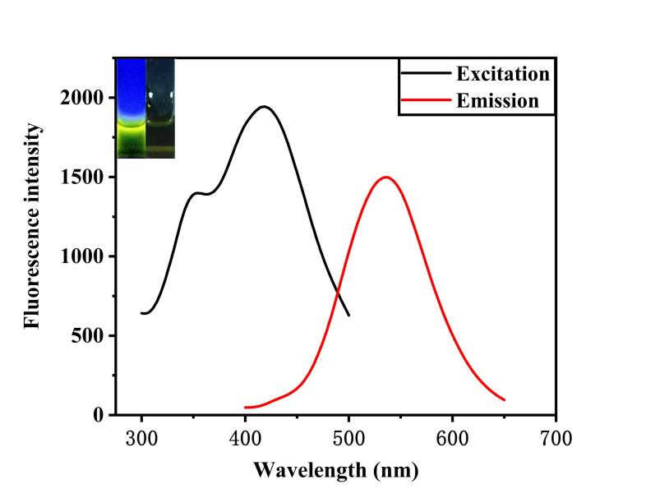
Figure S1. Fluorescence excitation (black line) and emission (red line) spectra of CPC-CDs (Insert: photos of the novel CPC-CDs solution irradiated by natural light (right) and 365 nm ultraviolet light (left)).

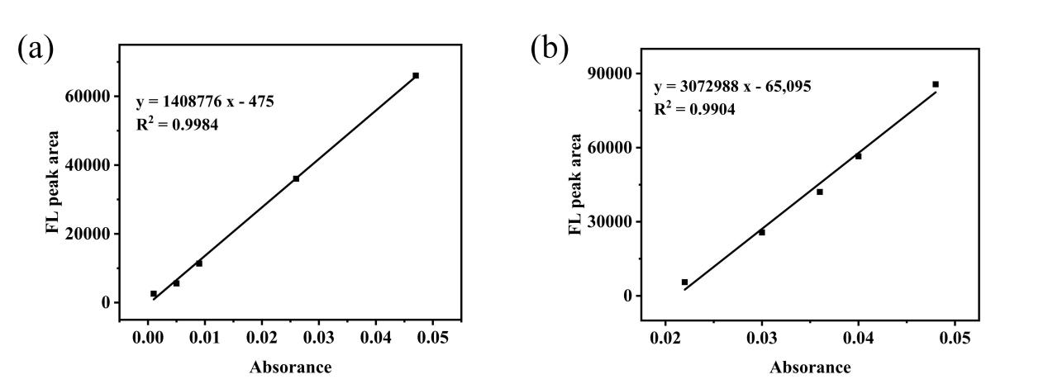
Figure S2. The ratio of integrated area of fluorescence peak to absorption value :
(A) CPC-CDs; (B) the Quinine sulfate .

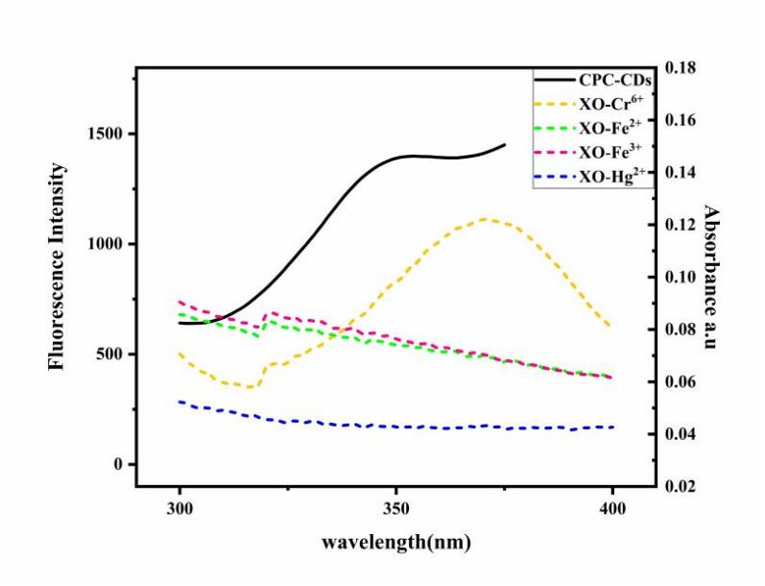
Figure S3. Absorption spectra of four metal chelates（XO-Cr⁶⁺, XO-Fe³⁺, XO-Fe²⁺, XO-Hg²⁺）and fluorescence excitation spectra of CPC-CDs.

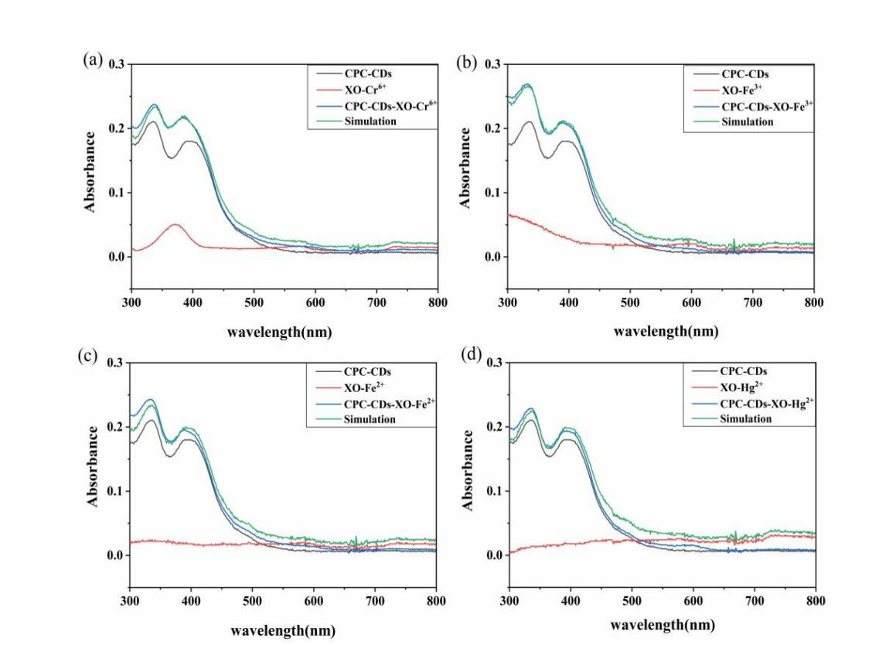
Figure S4. The UV absorption spectrum of CPC-CDs, four metal complexes, CPC-CDs+metal complexes, CPC-CDs and metal complexes and the sum of quantity.

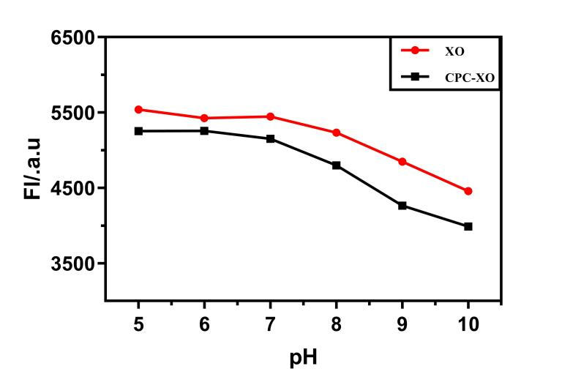
Figure S5. Fluorescence response of CPC-CDs and CPC-CDs/XO in different pH buffer solutions.

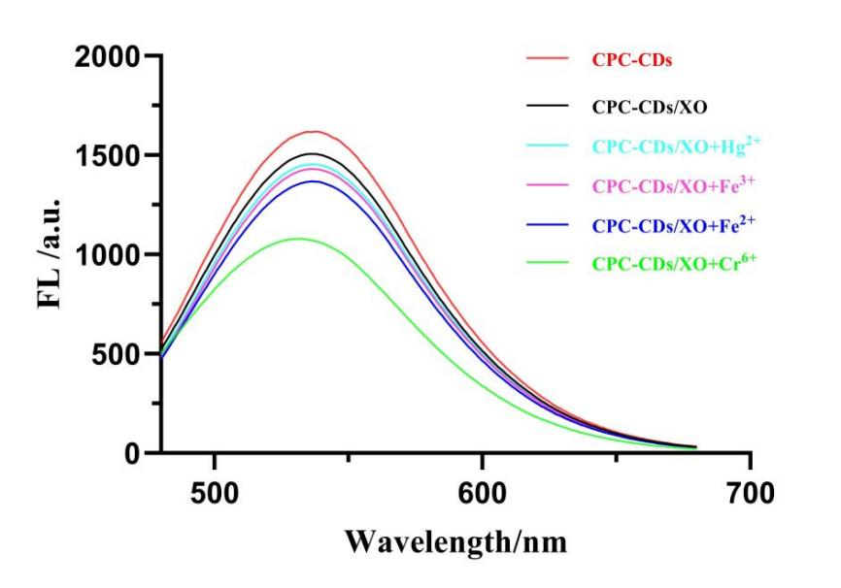
Figure S6. Fluorescence spectra of CPC-CDs, CPC-CDs/XO and the reacton of CPC-CDs/XO with different metal ions（Cr⁶⁺、Fe²⁺、Fe³⁺、Hg²⁺）.

Figure S7. a. Fluorescence responses of metal ions reacting with sensor array systems in different pH environments(pH 7.4 on the left, 8.8 on the right).

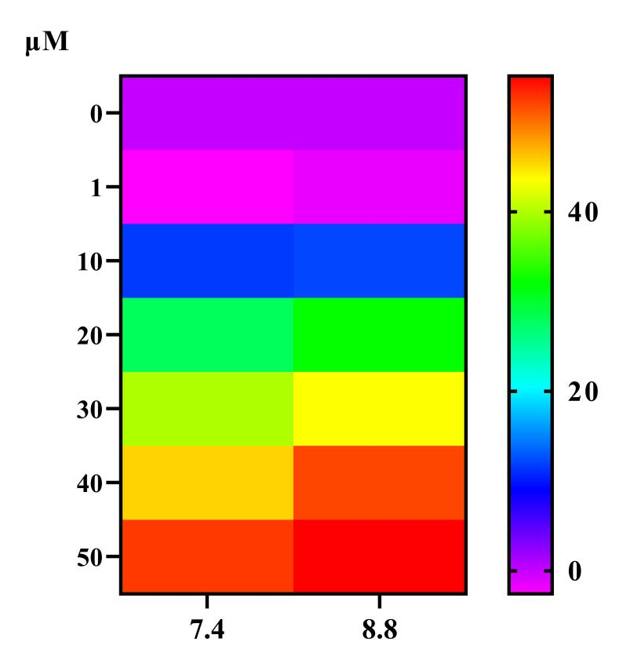
Figure S7. b. Fluorescence responses of Cr⁶⁺ reacting with sensor array systems in different pH environments.

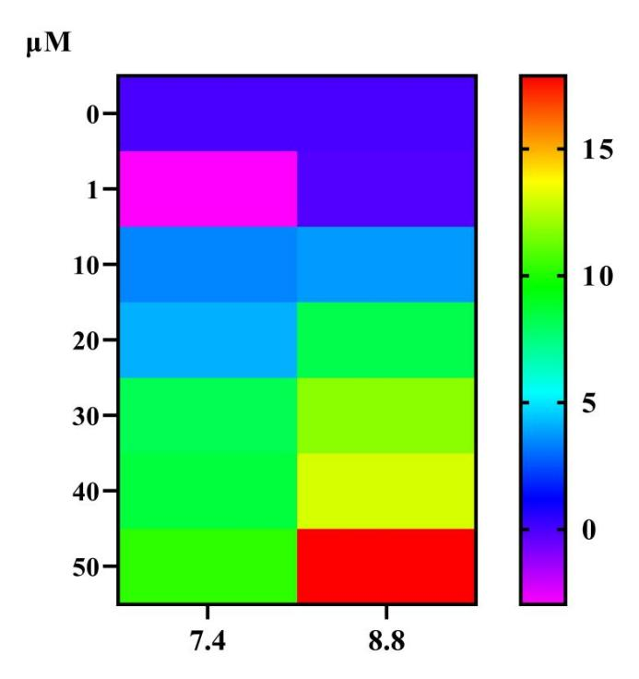
Figure S7. c. Fluorescence responses of Fe³⁺ reacting with sensor array systems in different pH environments.

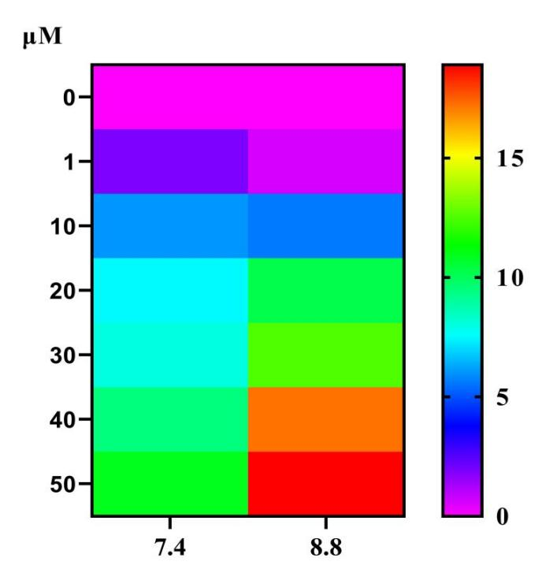
Figure S7. d. Fluorescence responses of Fe²⁺ reacting with sensor array systems in different pH environments.

Figure S7. e. Fluorescence responses of Hg²⁺ reacting with sensor array systems in different pH environments.

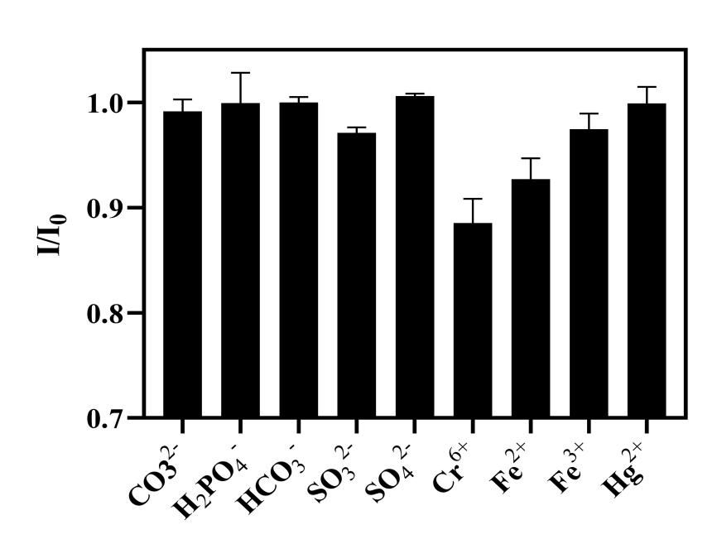

Figure S8. The fluorescence intensity ratios of the CPC-CDs/XO aqueous solutions in the presence of 10 μM of various anions and metal ions.(pH=7.4).

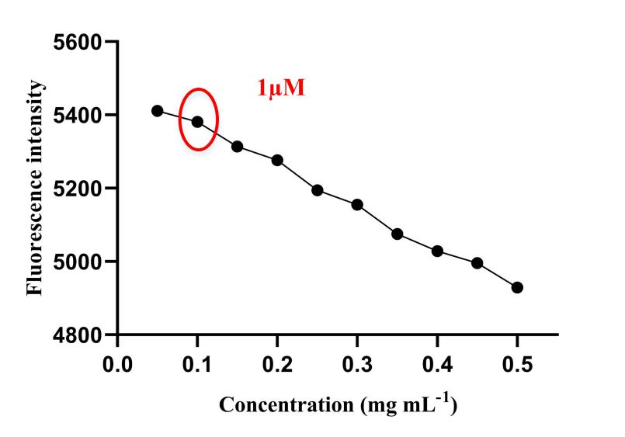

F Figure S9. Optimization of XO concentration in Tris-HCl buffer solution
(pH=7.4).

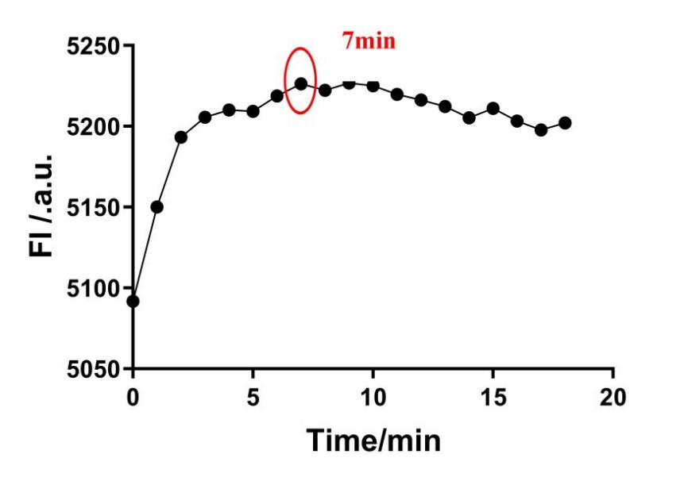
F Figure S10. Optimization of reaction time between CPC-CDs and XO in
Tris-HCl buffer solution.(pH=7.4).

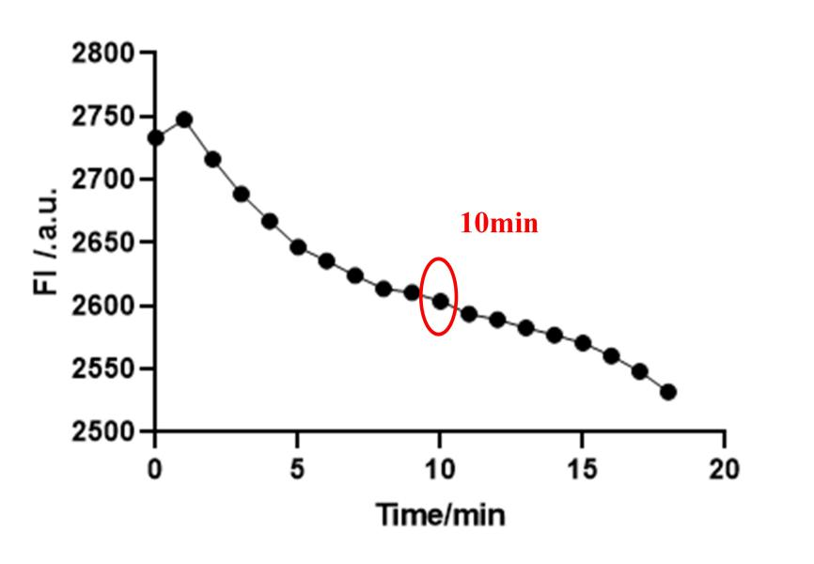

F Figure S11. Optimization of reaction time between CPC-CDs/XO and Cr⁶⁺ in
Tris-HCl buffer solution(pH=7.4).

List of Tables
Table S1. Classification accuracy of four metal ions in deionized water samples for unknown samples
Table S2. Concentration accuracy of four metal ions in deionized water samples for unknown samples
Table S3. Classification accuracy of four metal ions in lake water for unknown samples
Table S4. Concentration accuracy of four metal ions in lake water for unknown samples
Table S5. Classification accuracy of binary mixtures in deionized water sample for unknown samples
Table S6. Concentration accuracy of binary mixtures in deionized water sample for unknown
samples
Table S7. Classification accuracy of binary mixtures in lake water for unknown samples
Table S8. Concentration accuracy of binary mixtures in lake water for unknown samples
Table S9. Detection of Cr⁶⁺ in lake water Using CPC-CDs/XO Sensor Array

Table S1. Classification accuracy of four metal ions in deionized water samples for unknown samples
Data Types Class | Total samples | correct prediction samples | Accuracy
Category Data | 22 | 21 | 95.45%

Table S2. Concentration accuracy of four metal ions in deionized water samples for unknown sample
Data Types Class | Total samples | Accuracy
concentration data | 22 | 100.00%

Table S3. Classification accuracy of four metal ions in lake water for unknown sample.
Data Types Class | Total samples | correct prediction samples | Accuracy
Category Data | 15 | 15 | 100.00%

Table S4. Concentration accuracy of four metal ions in lake water for unknown samples
Data Types Class | Total samples | Accuracy
concentration data | 15 | 100.00%

Data Types Class | Total samples | correct prediction samples | Accuracy
Category Data | 22 | 21 |  | 95.45%
Table S5. Classification accuracy of binary mixtures in deionized water sample for unknown samples

Table S6. Concentration accuracy of binary mixtures in deionized water sample for unknown
Data Types Class | Total samples | Accuracy 1 | Accuracy 2
concentration data | 22 | 100.00% | 100.00%

Table S7. Classification accuracy of binary mixtures in lake water for unknown samples
Data Types Class | Total samples | correct prediction samples | Accuracy
Category Data | 11 | 10 |  | 90.90%

Table S8. Concentration accuracy of binary mixtures in lake water for unknown samples
Data Types Class | Total samples | Accuracy 1 | Accuracy 2
concentration data | 11 | 100.00% | 100.00%

Table S9. Detection of Cr⁶⁺ in lake water Using CPC-CDs/XO Sensor Array

Added (μM) | ICP-MS (μM) | CPC-CDs/XO (μM)
1 | 0.98 | 1
10 | 11.42 | 10

