Supplemental data
Supplemental Figure 1. Schematic of the binary vector used in the genetic transformation. DsRed is the reporter gene, Bar is the herbicide selectable marker gene. RB/LB, right/left border of T-DNA.

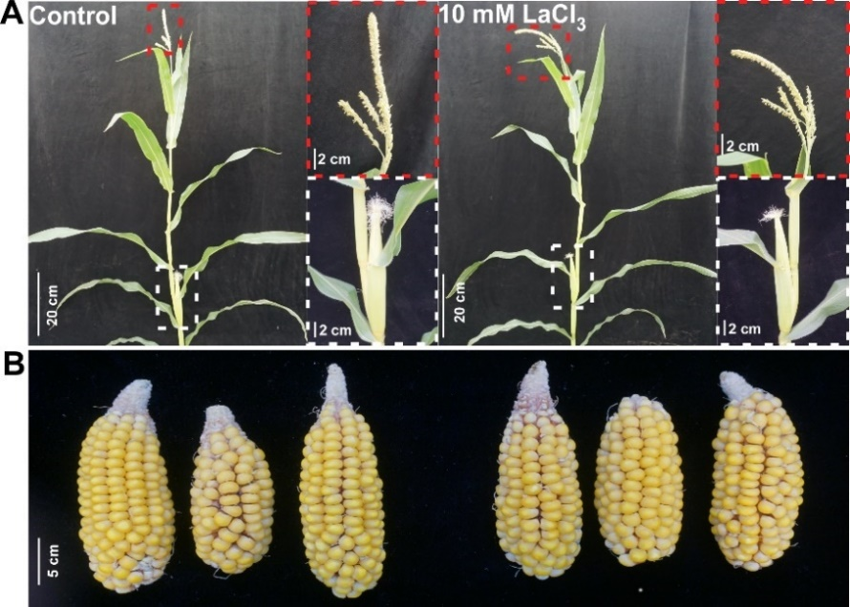
Supplemental Figure 2. Morphology of T₀ generation plants in the control and LaCl₃ pretreatment groups. A. Tassel and silking of the T₀ generation plant. B. Mature ears of the T₀ generation plant.

Supplemental Figure 3. Schematic of test vectors and target genes. A. Sketch map of single-editing target vector and region of target genes with SgRNAs. B. Sketch map of double-editing target vector and region of target genes with SgRNAs. RB/LB, right/left border of T-DNA. OsU3t/p, rice U3 promoter/terminator Cas9, codon-optimized Cas9 in maize. Ubi1p, ubiquitin-1 promoter. Bar is an herbicide-selectable maker gene.

Supplemental Figure 4. Preliminary results of pretreatment of immature embryos with the Ca²⁺ chelators EDTA and EGTA. A. Transformation frequency of EDTA and EGTA treatments in ND101 immature embryos. B. Infection frequency of EDTA and EGTA treatments in ND88 immature embryos. C. Transient expression of RFP in ND88 immature embryos pretreated with EDTA and EGTA after 2 days of co-cultivation.

