Supplementary Figure

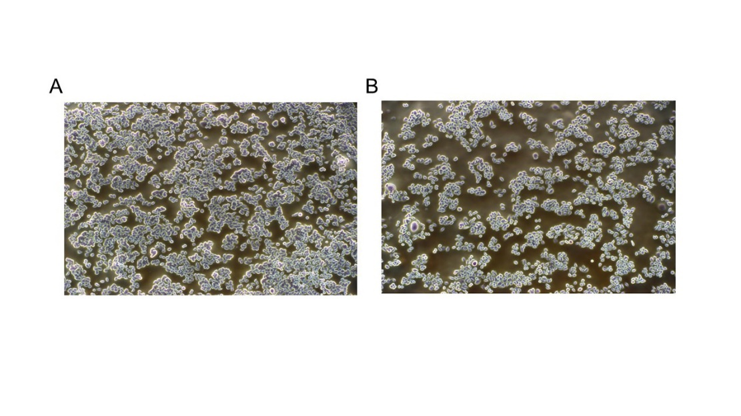
Fig. S1 Effects of NCs on BGC-823 cells growth. NCs were added into the culture medium and cells were observed by inverted microscope (40×) after co-culturing for 48 h. (A) Control group; (B) NCs (300 μg/mL) group exhibited significant growth inhibition of BGC-823 cells.

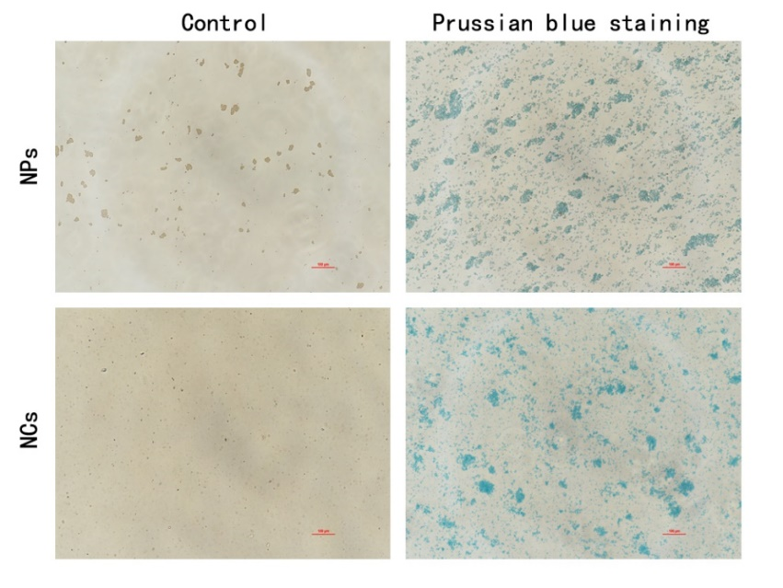
Fig. S2 Prussian blue staining of NPs and NCs. NPs and NCs were incubated with Prussian blue for 12h, then washed and observed. NPs/NCs in the control group (no incubation) showed brownish grey. After incubation with Prussian blue, both NPs and NCs were stained blue (400×).

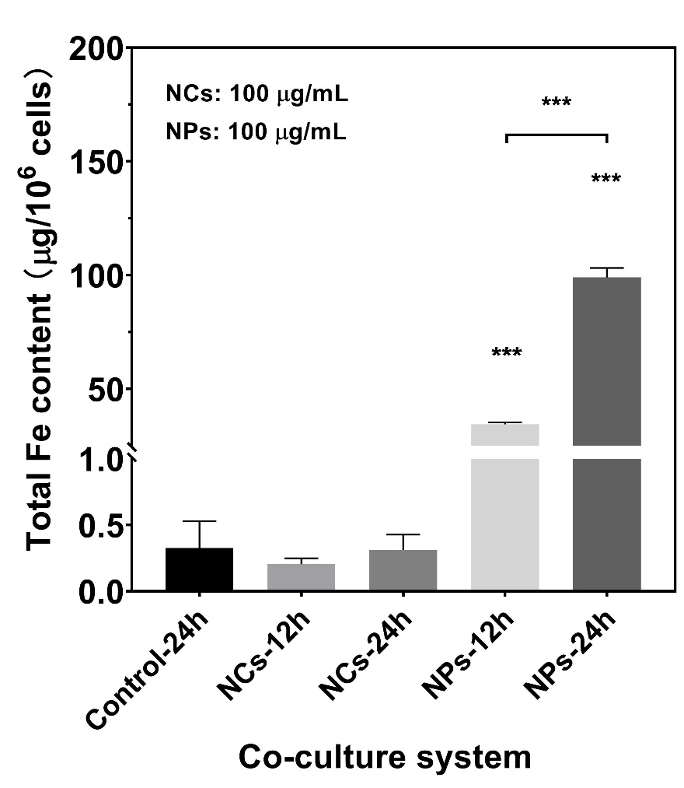
Fig. S3 Cellular uptake of NPs/NCs in co-cultured BGC-823 cells as quantitatively determined by ICP-MS. *** p < 0.001, vs. the control group, n = 3. When co-cultured with NCs, no significant difference was found compared to the control group in Fe content. However, when co-cultured with NPs, a significant increase in Fe content was measured for all exposure time.
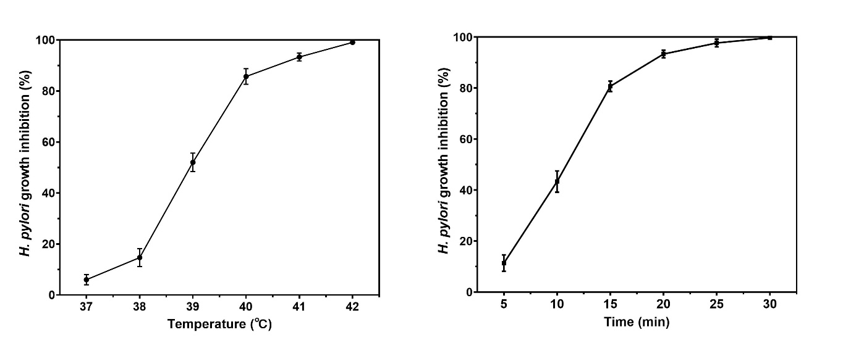
Fig. S4 Effect of Zn_{0.3}Fe_{2.7}O₄ NCs (50 μg/mL) photothermia on H. pylori growth inhibition. Percentage of H. pylori growth inhibition (A) as a function of temperature, t = 20 min; (B) as a function of time, temperature = 41 °C.

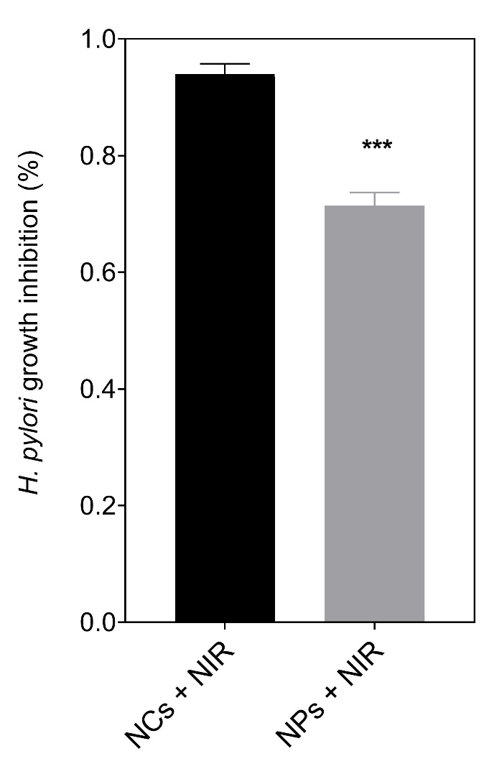
Fig. S5 Comparison of H. pylori NCTC 11637 growth inhibition between NPs and NCs heating. NCs (50 µg/mL) group showed higher growth inhibition rate (%) than NPs (50 µg/mL) group after heating induced by NIR laser to 41℃ for 20 min (n=3).

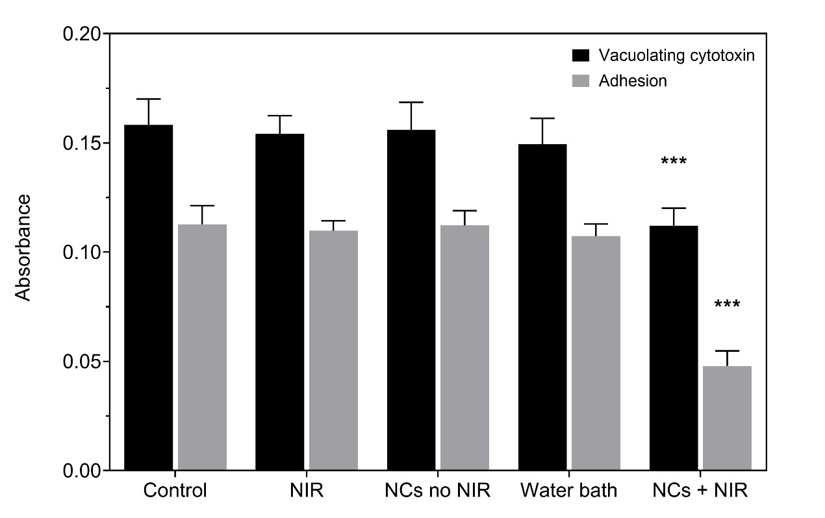
Fig. S6 Effects of NCs heating on H. pylori NCTC 11637 vacuolization and adhesion ability. Under the near-infrared (808nm) irradiation to 41℃ for 20 min, the NCs+heating group showed significant inhibition of vacuolization and adhesion ability, compared with control group (*** P<0.001). The near infrared group, NCs no heating group and water bath (41℃) group showed no difference (n=5).

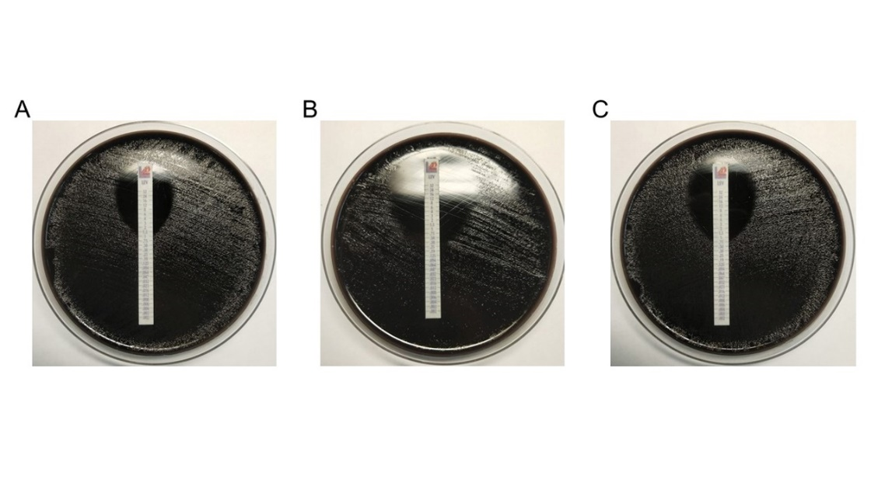
Fig. S7 Changes of H. pylori NCTC 11637 antibiotic susceptibility to levofloxacin. The minimum inhibitory concentration (MIC) for levofloxacin was 1.4 µg/ml in control group (A), 0.3 µg/mL in the NPs heating group (B), and 0.8 µg/mL in the NCs heating group (C).

