Supporting information

Efficiently generate functional hepatic cells from human pluripotent stem cells by complete small-molecule strategy

Tingcai Pan ^{1, 2, †}, Ning Wang ^{2 †}, Jiaye Zhang ^{2 †}, Fan Yang ³, Yan Chen ², Yuanqi Zhuang ², Yingying Xu ², Ji Fang ², Kai You ², Xianhua Lin ², Yang Li ¹, Shao Li ¹, Kangyan Liang ¹, Yin-xiong Li ^{2,} * and Yi Gao ^{1, 4,} *

1 General Surgery Center, Department of Hepatobiliary Surgery II,Guangdong Provincial Research Center for Artificial Organ and Tissue Engineering, Guangzhou Clinical Research and Transformation Center for Artificial Liver, Institute of Regenerative Medicine, Zhujiang Hospital, Southern Medical University, Guangzhou, Guangdong Province, China
2 Key Laboratory of Regenerative Biology, South China Institute for Stem Cell Biology and Regenerative Medicine, Guangdong Provincial Key Laboratory of Biocomputing, Guangzhou Institutes of Biomedicine and Health, Chinese Academy of Sciences, Guangzhou, 510530, China
3 Guangdong Key Laboratory of Non-Human Primate Models, Guangdong-Hongkong-Macau Institute of CNS Regeneration, Jinan University, Guangzhou, Guangdong Province, China
4 State Key Laboratory of Organ Failure Research, Southern Medical University, Guangzhou, China
† These authors contributed equally to this work.
* Correspondence: li_yinxiong_iph@gibh.ac.cn and gaoyi@smu.edu.cn.

Supplementary figures

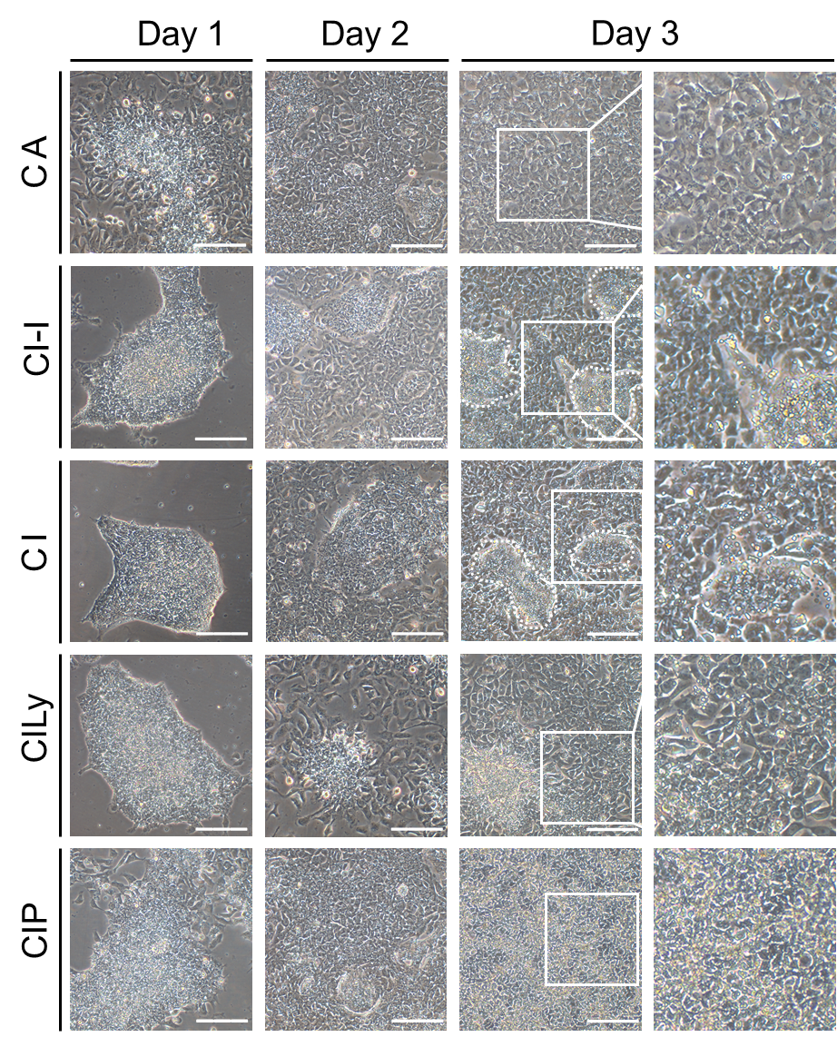
Fig. S1. Small-molecule cocktails induced DE differentiation from hPSCs
Sequential morphologic changes in the differentiation of hPSCs into DE. Scale bars 100 μm. Scale bar 100 μM.

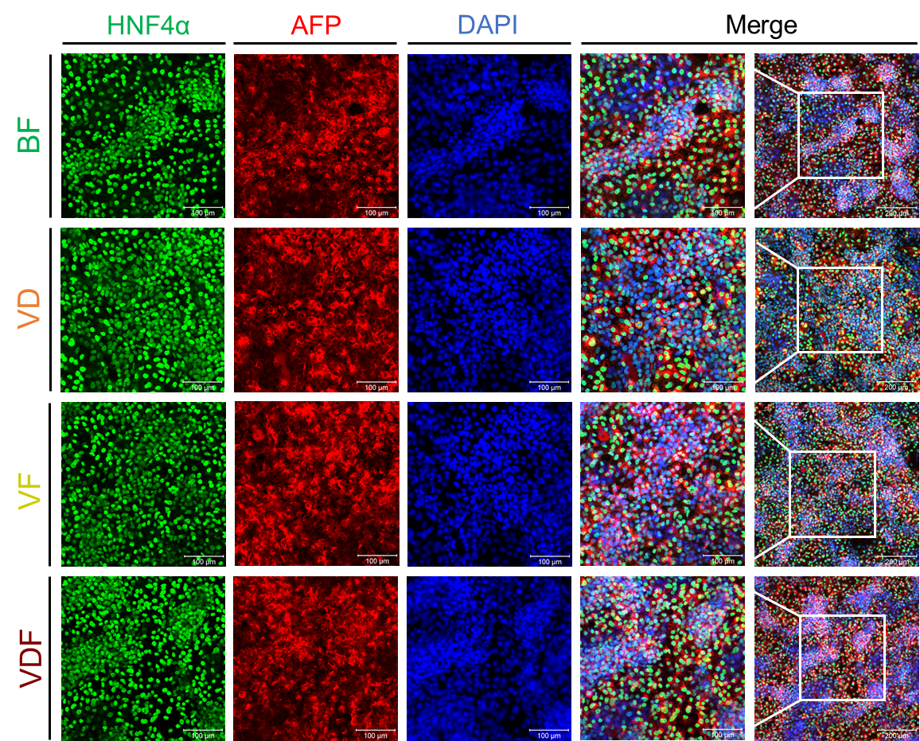
Fig. S2. Small-molecule cocktails directed hepatic specification
Immunostaining analyses of AFP and HNF4α expression after different small molecule cocktails induced. Scale bars 100 μm.

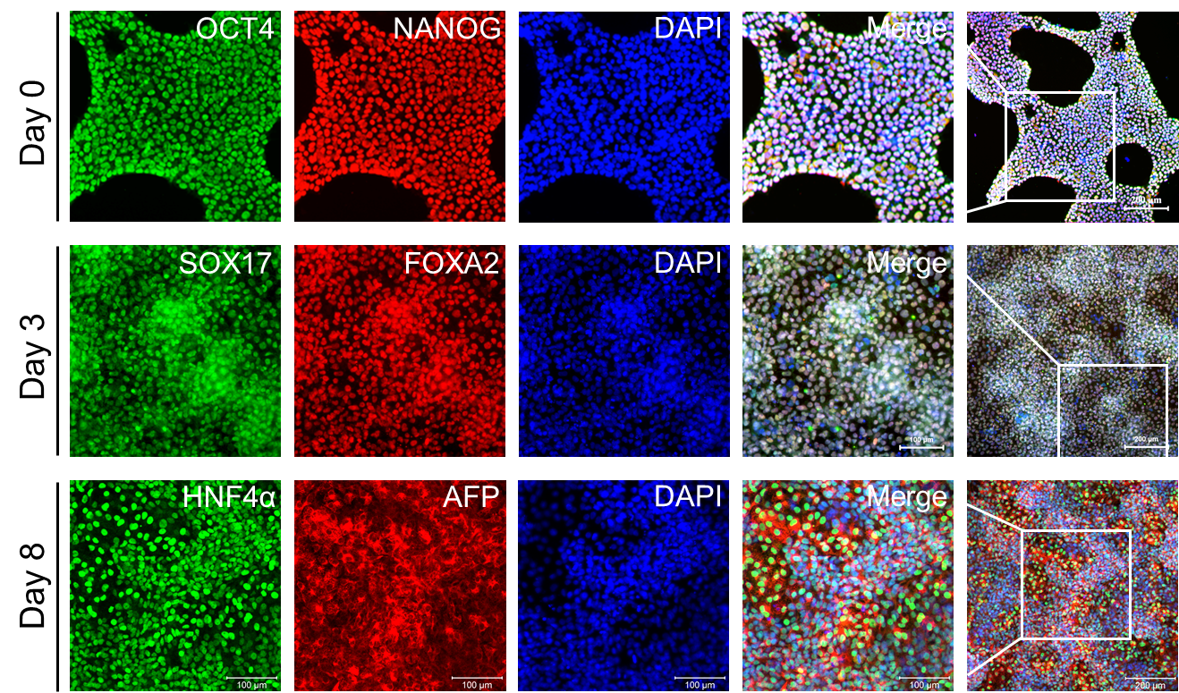
Fig. S3. Generation of HBs from human iPSC line
Immunostaining analyses results showed that human iPSC line (UC15) could sequentially differentiate into DE cells and HBs with high efficiency similarity as previous hESC line H1, and expressed stage specific markers.
Supplementary Tables
Table 1. List of antibodies used in this study
Gene | Primer sequence (forward / reverse; 5' to 3')
OCT4 | CCTCACTTCACTGCACTGTA / CAGGTTTTCTTTCCCTAGCT
NANOG | TGAACCTCAGCTACAAACAG / TGGTGGTAGGAAGAGTAAAG
BRA | TATGAGCCTCGAATCCACATAGT / CCTCGTTCTGATAAGCAGTCAC
Mixl1 | GGCGTCAGAGTGGGAAATCC / GGCAGGCAGTTCACATCTACC
GATA6 | GTGCCCAGACCACTTGCTAT / CCCTGAGGCTGTAGGTTGTG
SOX7 | TCGACGCCCTGGATCAACT / CTGGGAGACCGGAACATGC
SOX17 | GTGGACCGCACGGAATTTG / GGAGATTCACACCGGAGTCA
FOXA2 | GGAGCAGCTACTATGCAGAGC / CGTGTTCATGCCGTTCATCC
WNT3A | GCCCCACTCGGATACTTCTTACT / GAGGAATACTGTGGCCCAACA
FGF8 | GACCCCTTCGCAAAGCTCAT / CCGTTGCTCTTGGCGATCA
BMP2 | ACTACCAGAAACGAGTGGGAA / GCATCTGTTCTCGGAAAACCT
BMP4 | TAGCAAGAGTGCCGTCATTCC / GCGCTCAGGATACTCAAGACC
NODAL | CTGCTTAGAGCGGTTTCAGATG / CGAGAGGTTGGAGTAGAGCATAA
TGF-β1 | CTAATGGTGGAAACCCACAACG / TATCGCCAGGAATTGTTGCTG
TGF-β2 | CCCCGGAGGTGATTTCCATC / GGGCGGCATGTCTATTTTGTAAA
TGF-β3 | ACTTGCACCACCTTGGACTTC / GGTCATCACCGTTGGCTCA
AFP | AGAACCTGTCACAAGCTGTG / GACAGCAAGCTGAGGATGTC
HNF4α | TGTACTCCTGCAGATTTAGCC / CTGTCCTCATAGCTTGACCT
ALB | TGCAACTCTTCGTGAAACCTATG / ACATCAACCTCTGGTCTCACC
CYP3A4 | TTCAGCAAGAAGAACAAGGACAA / GGTTGAAGAAGTCCTCCTAAGC
CYP2C9 | CTACAGATAGGTATTAAGGACA / GCTTCATATCCATGCAGCACCAC
ARG1 | TGGACAGACTAGGAATTGGCA / CCAGTCCGTCAACATCAAAACT
ASS1 | AGGAAAGGGGAACGATCAGGT / GTGTTGCTTTGCGTACTCCA
GAPDH | CAAAGTTGTCATGGATGACC / CCATGGAGAAGGCTGGGG

Table 2. List of primers for real-time PCR
Primary anbibody | Species | Company | Cat Number | Dilution
OCT4 | Mouse | Genetex | GTX627423 | 1:200
Nanog | Rabbit | Genetex | GTX100863 | 1:200
FOXA2 | Goat | R&D systems | AF2400 | 1:200
SOX17 | Mouse | Genetex | GTX83580 | 1:100
SOX17 | Goat | R&D systems | IC1924A | 1:50
BRA | Goat | R&D systems | AF2085 | 1:200
SOX7 | Goat | R&D systems | AF2766 | 1:200
AFP | Mouse | Genetex | GTX84948 | 1:200
HNF4α | Rabbit | Genetex | GTX62347 | 1:200
Ki67 | Rat | Thermo Fisher | 11-5698-82 | 1:100
Ki67 | Rabbit | Genetex | GTX16667 | 1:200
Ep-CAM | Mouse | Invitrogen | 53-8326-42 | 1:100
Ep-CAM | Mouse | Abcam | ab46714 | 1:100
ALB | Goat | R&D systems | MAB1455 | 1:200
ALB | Rabbit | Dako | F0117 | 1:50
SOX9 | Mouse | Abcam | ab76997 | 1:200
E-CAD | Goat | R&D systems | AF648 | 1:200
AAT | Rabbit | Abcam | AB166610 | 1:200
CYP3A4 | Mouse | Genetex | GTX60577 | 1:200
CYP2C9 | Rabbit | Genetex | GTX55583 | 1:200
Second antibody | Species | Company | Cat. Number | Dilution
Anti-Goat IgG Antibody, Alexa Fluor 488 | Donkey | Invitrogen | A-11055 | 1:500
Anti-Goat IgG Antibody, Alexa Fluor 568 | Donkey | Invitrogen | A-11057 | 1:500
Anti-Mouse IgG Antibody, Alexa Fluor 488 | Donkey | Invitrogen | A32766 | 1:500
Anti-Mouse IgG Antibody, Alexa Fluor 568 | Donkey | Invitrogen | A10037 | 1:500
Anti-Rabbit IgG antibody Alexa Fluor 488 | Donkey | Invitrogen | A-21206 | 1:500
Anti-Rabbit IgG antibody Alexa Fluor 568 | Donkey | Invitrogen | A10042 | 1:500

