Local-scale thermal history influences metabolic response of marine invertebrates to warming

Racine E. Rangelª and Cascade J. B. Sorteª
Email address: raciner@uci.edu, csorte@uci.edu
ª Department of Ecology and Evolutionary Biology, University of California - Irvine, 321 Steinhaus Hall Irvine, CA, 92697, USA
Corresponding Author
Racine E. Rangel, raciner@uci.edu

Supplementary Material
Table S1 Tide pool characteristics and species collections. Species collected from each experimental pool are labeled as followed, M. trossulus (M), P. hirsitusculus (H), and L. sitkana (S). Note that * indicate pools that were sampled only in March 2019 due to those pools being used in a field manipulation study during the summer months; others were sampled at all 3 time points
Pool Number |  |  | Volume (L) | Tide Height (m) | Species Collected
 |  | 1 | 4.5 | 2.43 |  | M
 |  | 2 | 4 | 2.10 | H | M
 |  | 3 | 9.5 | 2.16 | H | M | S
 |  | 5* | 8 | 2.46 |  | M
 |  | 6 | 5.5 | 2.16 | H | M | S
 |  | 7 | 28 | 2.63 |  | M
 |  | 8* | 7 | 2.65 |  | M
 |  | 9* | 3 | 2.23 |  | M
 | 10 |  | 5.5 | 2.30 | H | M | S
 | 11* |  | 14 | 2.48 |  | M | S
 | 12 |  | 20 | 2.45 | H
 | 13* |  | 22 | 2.36 | H | M | S
 | 14 |  | 16 | 2.71 | H | M | S
 | 15* |  | 5 | 2.30 | H | M | S
 | 16* |  | 19.5 | 1.99 | H | M
 | 18 |  | 3 | 2.07 | H | M | S
 | 19 |  | 5 | 2.03 | H |  | S
 | 20* |  | 22 | 2.03 | H |  | S
 | 21* |  | 8 | 1.89 |  |  | S
 | 22 |  | 37 | 2.32 | H | M | S
 | 23 |  | 37 | 2.32 | H | M | S
 | 24 |  | 3 | 2.67 | H | M | S
 | 27* |  | 12.5 | 2.87 |  | M | S
 | 28 |  | 3.5 | 2.47 | H | M | S
 | 29* |  | 9 | 2.49 | H
 | 30 |  | 4 | 2.64 |  | M | S
 | 31 |  | 6.5 | 2.86 | H | M | S
 | 32 |  | 15 | 2.94 | H | M
 | 33* |  | 25 | 2.94 |  | M | S
 | 35* |  | 9 | 3.09 |  | M
 | 36* |  | 19.5 | 3.23 |  | M | S

Table S2 Mean (SD) values for tide pool temperature metrics across seasons and thermal histories (TH). Temperature metrics are minimum (Min), maximum (Max), median (Med), variance (Var), standard deviation (SD), 90th percentile (90th), 95th percentile (95th), 10th percentile (10th), daily mean (Dmean), daily maximum (Dmax), daily 90th percentile (D90th), daily 95th percentile (D95th), daily minimum (Dmin), daily range (Drange)
TH | Season | Min | Max | Range | Med | Mean | Var | SD | 90th | 95th | 10th | Dmean | Dmax | D90th | D95th | Dmin | Drange
3-Month | March 2019 | -1.9  (0.8) | 10.9  (1.9) | 12.8  (2.2) | 5.4  (0.5) | 5.1  (0.5) | 4.7  (1.7) | 2.1  (0.4) | 7.3  (0.1) | 7.6  (0.1) | 2.0  (1.2) | 5.1  (0.5) | 6.9  (0.4) | 3.7  (0.6) | 6.8  (0.4) | 3.2  (0.6) | 3.7  (0.6)
3-Month | July 2019 | 4.2  (0.8) | 26.1  (3.8) | 21.9  (4.3) | 12.9  (0.7) | 13.2  (0.7) | 13.8  (3.8) | 3.7  (0.5) | 17.9  (1.4) | 19.5  (1.8) | 8.4  (0.5) | 13.2  (0.7) | 16.7  (1.6) | 11.4  (0.3) | 16.4  (1.5) | 11.1  (0.3) | 5.6  (1.5)
3-Month | Sept 2019 | 10.6  (0.6) | 26.6  (3.6) | 16.1  (3.8) | 15.7  (0.5) | 15.9  (0.7) | 7.1  (2.8) | 2.6  (0.5) | 19.3  (1.5) | 20.9  (1.9) | 12.6  (0.3) | 15.9  (0.7) | 19.4  (1.6) | 14.2  (0.2) | 19.0  (1.5) | 13.9  (0.2) | 5.5  (1.5)
2-Month | March 2019 | -1.9  (0.9) | 10.9  (19) | 12.8  (2.2) | 5.2  (0.5) | 4.8  (0.6) | 5.2  (1.9) | 2.2  (0.4) | 7.1  (0.1) | 7.6  (0.4) | 1.5  (1.2) | 4.8  (0.6) | 6.7  (0.5) | 3.3  (0.7) | 6.5  (0.5) | 2.9  (0.7) | 3.9  (0.7)
2-Month | July 2019 | 8.7  (0.5) | 26.2  (3.8) | 17.4  (3.7) | 14.6  (0.8) | 14.8  (0.8) | 9.4  (3.4) | 3.0  (0.5) | 18.8  (1.7) | 20.3  (2.0) | 11.4  (0.3) | 14.8  (0.8) | 18.6  (1.8) | 13.0  (0.3) | 18.2  (1.7) | 12.7  (0.3) | 5.8  (1.7)
2-Month | Sept  2019 | 10.8  (0.8) | 25.4  (2.9) | 14.6  (3.3) | 16.0  (0.4) | 16.2  (0.6) | 5.8  (2.6) | 2.3  (0.5) | 19.3  (1.4) | 20.7  (1.7) | 13.3  (0.3) | 16.2  (0.6) | 19.6  (1.5) | 14.5  (0.3) | 19.1  (2.2) | 14.3  (0.3) | 5.3  (1.5)
1-Month | March  2019 | 0.4  (1.2) | 10.9  (2.0) | 10.5  (2.3) | 5.9  (0.5) | 5.5  (0.6) | 3.9  (1.8) | 1.9  (0.5) | 7.5  (0.4) | 8.3  (0.9) | 2.6  (1.2) | 5.5  (0.6) | 7.5  (0.8) | 4.2  (0.7) | 7.2  (0.8) | 3.8  (0.7) | 3.6  (0.9)
1-Month | July  2019 | 11.3  (0.3) | 26.2  (3.8) | 14.8  (3.8) | 16.2  (0.5) | 16.6  (0.8) | 7.0  (3.5) | 2.6  (0.6) | 20.2  (2.0) | 21.7  (2.3) | 13.8  (0.9) | 16.6  (0.9) | 20.6  (2.0) | 14.7  (0.3) | 20.2  (1.9) | 14.5  (0.3) | 6.1  (1.8)
1-Month | Sept  2019 | 10.8  (0.8) | 23.5  (2.4) | 12.7  (2.6) | 15.1  (0.5) | 15.5  (0.5) | 6.1  (2.4) | 2.4  (0.5) | 18.8  (1.2) | 20.1  (1.6) | 12.8  (0.2) | 15.5  (0.5) | 18.7  (1.4) | 13.8  (0.4) | 18.2  (1.3) | 13.6  (0.4) | 5.0  (1.4)
1-Week | March  2019 | 5.3  (0.3) | 10.8  (1.9) | 5.6  (1.9) | 7.0  (0.2) | 7.3  (0.4) | 1.5  (1.3) | 1.1  (0.5) | 8.9  (1.3) | 9.7  (1.6) | 6.1  (0.2) | 7.3  (0.4) | 9.5  (1.4) | 6.2  (0.2) | 9.0  (1.3) | 6.0  (0.2) | 3.5  (1.4)
1-Week | July  2019 | 14.3  (0.3) | 22.9  (3.0) | 8.6  (3.1) | 16.1  (0.6) | 16.7  (0.8) | 4.0  (3.2) | 1.9  (0.7) | 19.5  (2.0) | 20.7  (2.3) | 14.8  (0.4) | 16.7  (0.8) | 20.1  (2.0) | 15.2  (0.4) | 19.6  (1.9) | 14.9  (0.3) | 5.1  (1.9)
1-Week | Sept  2019 | 12.5  (0.7) | 20.2  (2.1) | 7.8  (2.3) | 14.7  (0.5) | 15.1  (0.6) | 3.0  (2.1) | 1.6  (0.6) | 17.7  (1.6) | 18.6  (1.8) | 13.5  (0.6) | 15.1  (0.6) | 18.4  (1.6) | 13.5  (0.5) | 17.9  (1.5) | 13.3  (0.5) | 5.0  (1.6)
1-Day | March  2019 | 5.9  (0.6) | 10.7  (2.1) | 4.9  (1.9) | 7.5  (0.8) | 7.8  (0.9) | 2.6  (2.2) | 1.5  (0.6) | 10.1  (2.0) | 10.4  (2.1) | 6.1  (0.6) | 7.8  (0.9) | 10.7  (2.1) | 10.1  (2.0) | 10.4  (2.1) | 5.8  (0.6) | 4.9  (1.9)
1-Day | July  2019 | 14.6  (0.4) | 20.1  (3.3) | 5.5  (3.4) | 16.2  (0.9) | 16.5  (1.1) | 3.5  (4.8) | 1.5  (1.1) | 18.8  (2.8) | 19.4  (3.1) | 14.9  (0.5) | 16.5  (1.1) | 20.1  (3.3) | 18.8  (2.8) | 19.4  (3.1) | 14.6  (0.4) | 5.5  (3.4)
1-Day | Sept  2019 | 13.5  (0.7) | 17.8  (2.4) | 4.4  (2.7) | 14.8  (0.5) | 15.0  (0.7) | 2.1  (2.6) | 1.2  (0.8) | 17.1  (2.0) | 17.5  (2.2) | 13.8  (0.7) | 15.0  (0.7) | 17.8  (2.4) | 17.1  (2.0) | 17.5  (2.2) | 13.5  (0.7) | 4.4  (2.7)

Table S3 Mean (SD) values for dry weight, oxygen consumption (MO₂), and thermal sensitivity (Q₁₀) at experimental temperatures at different seasonal collections
Season | Species | Dry Weight g | Temperature °C | MO₂ mgO₂h⁻¹ | Q₁₀
March 2019 | P. hirsutiusculus N=12 | 0.09 (0.04) | 10 | 0.94 (0.24) | 1.41 (0.22)
March 2019 | P. hirsutiusculus N=12 | 0.09 (0.04) | 18 | 1.19 (0.37) | 1.41 (0.22)
March 2019 | P. hirsutiusculus N=12 | 0.09 (0.04) | 26 | 1.54 (0.35) | 1.41 (0.22)
March 2019 | M. trossulus  N=16 | 0.04 (0.01) | 10 | 0.52 (0.28) | 1.31 (0.29)
March 2019 | M. trossulus  N=16 | 0.04 (0.01) | 18 | 1.23 (0.59) | 1.31 (0.29)
March 2019 | M. trossulus  N=16 | 0.04 (0.01) | 26 | 0.98 (0.49) | 1.31 (0.29)
March 2019 | L. sitkana  N=13 | 0.004 (0.002) | 10 | 0.91 (0.44) | 1.24 (0.22)
March 2019 | L. sitkana  N=13 | 0.004 (0.002) | 18 | 1.34 (0.64) | 1.24 (0.22)
March 2019 | L. sitkana  N=13 | 0.004 (0.002) | 26 | 1.35 (0.65) | 1.24 (0.22)
July 2019 | P. hirsutiusculus N=12 | 0.09 (0.05) | 10 | 0.90 (0.22) | 1.50 (0.27)
July 2019 | P. hirsutiusculus N=12 | 0.09 (0.05) | 18 | 1.29 (0.55) | 1.50 (0.27)
July 2019 | P. hirsutiusculus N=12 | 0.09 (0.05) | 26 | 1.72 (0.56) | 1.50 (0.27)
July 2019 | M. trossulus  N=13 | 0.004 (0.001) | 10 | 1.11 (0.23) | 1.26 (0.34)
July 2019 | M. trossulus  N=13 | 0.004 (0.001) | 18 | 1.80 (0.44) | 1.26 (0.34)
July 2019 | M. trossulus  N=13 | 0.004 (0.001) | 26 | 1.66 (0.85) | 1.26 (0.34)
July 2019 | L. sitkana  N=11 | 0.003 (0.001) | 10 | 0.86 (0.45) | 1.38 (0.39)
July 2019 | L. sitkana  N=11 | 0.003 (0.001) | 18 | 1.32 (0.63) | 1.38 (0.39)
July 2019 | L. sitkana  N=11 | 0.003 (0.001) | 26 | 1.51 (0.57) | 1.38 (0.39)
Sept 2019 | P. hirsutiusculus N=13 | 0.11 (0.05) | 10 | 0.71 (0.26) | 1.67 (0.40)
Sept 2019 | P. hirsutiusculus N=13 | 0.11 (0.05) | 18 | 0.93 (0.33) | 1.67 (0.40)
Sept 2019 | P. hirsutiusculus N=13 | 0.11 (0.05) | 26 | 1.45 (0.48) | 1.67 (0.40)
Sept 2019 | M. trossulus  N=13 | 0.05 (0.002) | 10 | 0.95 (0.18) | 1.22 (0.33)
Sept 2019 | M. trossulus  N=13 | 0.05 (0.002) | 18 | 1.65 (0.36) | 1.22 (0.33)
Sept 2019 | M. trossulus  N=13 | 0.05 (0.002) | 26 | 1.41 (0.79) | 1.22 (0.33)
Sept 2019 | L. sitkana  N=13 | 0.004 (0.002) | 10 | 0.75 (0.68) | 1.72 (0.58)
Sept 2019 | L. sitkana  N=13 | 0.004 (0.002) | 18 | 1.53 (1.32) | 1.72 (0.58)
Sept 2019 | L. sitkana  N=13 | 0.004 (0.002) | 26 | 1.65 (1.39) | 1.72 (0.58)

Table S4 Results from type 3 analysis of variance table calculated with Satterthwaite’s method for the linear mixed effect models of the relationship between thermal sensitivity and the different time intervals (reduced using a PCA analysis; Figure 2)
3-Month Time Interval
Fixed Effects | Num DF | Den DF | F-value | p value
Initial linear mixed effect model (df =21, AIC=152.0)
PC1 | 1 | 34.3 | 0.670 | 0.419
PC2 | 1 | 33.2 | 1.037 | 0.316
Season | 2 | 53.4 | 0.515 | 0.601
Species | 2 | 85.7 | 0.766 | 0.468
Season: PC1 | 2 | 82.1 | 0.538 | 0.586
Season: PC2 | 2 | 51.1 | 1.051 | 0.357
Species: PC1 | 2 | 83.7 | 0.121 | 0.887
Species: PC2 | 2 | 84.4 | 0.209 | 0.812
Species: Season | 4 | 83.2 | 0.113 | 0.978
Random effects | St. Dev
Pool | 0.087
Final linear mixed effect model (df=11, AIC=126.5)
PC1 | 1 | 82.4 | 0.464 | 0.498
PC2 | 1 | 63.5 | 0.340 | 0.562
Season | 2 | 57.2 | 0.663 | 0.519
Species | 2 | 91.2 | 7.521 | 0.001
Species: PC1 | 2 | 89.4 | 3.907 | 0.024
Random effects | St. Dev
Pool | 0.125

2-Month Time Interval
Fixed Effects | Num DF | Den DF | F-value | p value
Initial linear mixed effect model (df=21, AIC=150.2)
PC1 | 1 | 27.3 | 2.830 | 0.104
PC2 | 1 | 27.0 | 3.723 | 0.064
Season | 2 | 78.3 | 0.180 | 0.836
Species | 2 | 85.5 | 2.940 | 0.058
Season: PC1 | 2 | 73.6 | 1.229 | 0.298
Season: PC2 | 2 | 42.4 | 2.311 | 0.112
Species: PC1 | 2 | 83.8 | 0.552 | 0.578
Species: PC2 | 2 | 84.3 | 0.927 | 0.400
Species: Season | 4 | 83.3 | 0.980 | 0.423
Random effects | St. Dev
Pool | 0.054
Final linear mixed effect model (df=13, AIC=123.5)
PC1 | 1 | 77.1 | 0.004 | 0.950
PC2 | 1 | 64.7 | 0.002 | 0.967
Season | 2 | 84.3 | 0.921 | 0.402
Species | 2 | 88.9 | 6.441 | 0.002
Species: Season | 4 | 84.2 | 2.497 | 0.049
Random effects | St. Dev
Pool | 0.121

1-Month Time Interval
Fixed Effects | Num DF | Den DF | F-value | p value
Initial linear mixed effect model (df=21, AIC=149.8)
PC1 | 1 | 27.3 | 2.716 | 0.111
PC2 | 1 | 29.8 | 2.946 | 0.096
Season | 2 | 74.6 | 0.279 | 0.758
Species | 2 | 88.5 | 3.788 | 0.026
Season: PC1 | 2 | 75.0 | 0.902 | 0.410
Season: PC2 | 2 | 50.0 | 2.043 | 0.140
Species: PC1 | 2 | 82.0 | 0.699 | 0.500
Species: PC2 | 2 | 82.5 | 1.065 | 0.349
Species: Season | 4 | 84.4 | 1.583 | 0.186
Random effects | St. Dev
Pool | 0.058
Final linear mixed effect model (df=9, AIC=118.6)
PC1 | 1 | 92.6 | 0.015 | 0.903
PC2 | 1 | 70.2 | 0.028 | 0.868
Season | 2 | 91.2 | 1.409 | 0.250
Species | 2 | 96.4 | 4.965 | 0.009
Random effects | St. Dev
Pool | 0.103

1-Day Time Interval
Fixed Effects | Num DF | Den DF | F-value | p value
Initial linear mixed effect model (df=21, AIC=150.7)
PC1 | 1 | 89.6 | 0.018 | 0.895
PC2 | 1 | 89.9 | 0.106 | 0.746
Season | 2 | 89.8 | 0.022 | 0.978
Species | 2 | 87.8 | 0.448 | 0.641
Season: PC1 | 2 | 90.3 | 0.351 | 0.705
Season: PC2 | 2 | 89.9 | 1.202 | 0.306
Species: PC1 | 2 | 87.8 | 0.334 | 0.717
Species: PC2 | 2 | 87.9 | 0.789 | 0.457
Species: Season | 4 | 86.2 | 0.409 | 0.802
Random effects | St. Dev
Pool | 0.079
Final linear mixed effect model (df=11, AIC=122.2)
PC1 | 1 | 99.4 | 0.006 | 0.941
PC2 | 1 | 99.5 | 0.150 | 0.700
Season | 2 | 93.5 | 1.954 | 0.147
Species | 2 | 98.0 | 4.272 | 0.017
Season: PC1 | 2 | 100.4 | 3.173 | 0.046
Random effects | St. Dev
Pool | 0.094

Table S5 Post hoc tests from simplest linear mixed effect model for each time interval (reduced PCA analysis) to determine which species (Pagurus hirsutiusculus, Littorina sitkana, Mytilus trossulus) statistically differed in their thermal sensitivity. Significant p-values are in bold
3-Month Time Interval
Comparisons | t | p
P. hirsutiusculus– L. sitkana | 0.985 | 0.588
P. hirsutiusculus – M. trossulus | 3.414 | 0.003
L. sitkana – M. trossulus | 2.315 | 0.059

2-Month Time Interval
Comparisons | t | p
 | March 2019
P. hirsutiusculus – L. sitkana | 0.648 | 0.794
P. hirsutiusculus – M. trossulus | 1.724 | 0.202
L. sitkana – M. trossulus | 0.974 | 0.595
 | July 2019
P. hirsutiusculus – L. sitkana | 1.359 | 0.366
P. hirsutiusculus – M. trossulus | 0.811 | 0.697
L. sitkana – M. trossulus | -0.626 | 0.806
 | September 2019
P. hirsutiusculus – L. sitkana | -0.422 | 0.907
P. hirsutiusculus – M. trossulus | 3.512 | 0.002
L. sitkana – M. trossulus | 3.553 | 0.002

1-Month Time Interval
Comparisons | t | p
P. hirsutiusculus – L. sitkana | 1.075 | 0.532
P. hirsutiusculus – M. trossulus | 3.068 | 0.008
L. sitkana – M. trossulus | 1.888 | 0.148

1-Week Time Interval
Comparisons | t | p
P. hirsutiusculus – L. sitkana | 1.021 | 0.566
P. hirsutiusculus – M. trossulus | 2.558 | 0.032
L. sitkana – M. trossulus | 1.279 | 0.411

1-Day Time Interval
Comparisons | t | p
P. hirsutiusculus – L. sitkana | 1.575 | 0.261
P. hirsutiusculus – M. trossulus | 2.891 | 0.013
L. sitkana – M. trossulus | 1.233 | 0.437

Table S6 Results from type 3 analysis of variance table calculated with Satterthwaite’s method for the single thermal metric daily maximum pool temperature linear mixed effect models to analyze the relationship between thermal sensitivity and the different time intervals
3-Month Time Interval
Fixed Effects | Num DF | Den DF | F-value | p value
Initial linear mixed effect model (df =16, AIC=139.4)
Daily Maximum | 1 | 46.0 | 0.766 | 0.386
Season | 2 | 93.3 | 0.144 | 0.866
Species | 2 | 80.0 | 0.192 | 0.826
Daily Max: Season | 2 | 73.6 | 0.281 | 0.756
Daily Max: Species | 2 | 79.7 | 0.052 | 0.950
Season: Species | 4 | 79.6 | 0.636 | 0.639
Random effects | St. Dev
Pool | 0.112
Final linear mixed effect model (df=10, AIC=123.6)
Daily Maximum | 1 | 23.6 | 0.439 | 0.514
Season | 2 | 38.6 | 1.569 | 0.221
Species | 2 | 93.2 | 1.644 | 0.199
Daily Max: Species | 2 | 91.5 | 3.936 | 0.023
Random effects | St. Dev
Pool | 0.116

2-Month Time Interval
Fixed Effects | Num DF | Den DF | F-value | p value
Initial linear mixed effect model (df =16, AIC=140.6)
Daily Maximum | 1 | 39.7 | 0.577 | 0.452
Season | 2 | 79.0 | 0.044 | 0.957
Species | 2 | 79.4 | 0.178 | 0.838
Daily Max: Season | 2 | 76.8 | 0.178 | 0.837
Daily Max: Species | 2 | 79.3 | 0.062 | 0.940
Season: Species | 4 | 79.3 | 0.878 | 0.481
Random effects | St. Dev
Pool | 0.111
Final linear mixed effect model (df=10, AIC=125.0)
Daily Maximum | 1 | 23.8 | 0.582 | 0.453
Season | 2 | 38.6 | 2.028 | 0.145
Species | 2 | 93.8 | 1.225 | 0.299
Daily Max: Species | 2 | 92.0 | 3.239 | 0.044
Random effects | St. Dev
Pool | 0.112

1-Month Time Interval
Fixed Effects | Num DF | Den DF | F-value | p value
Initial linear mixed effect model (df =16, AIC=141.7)
Daily Maximum | 1 | 29.9 | 0.063 | 0.804
Season | 2 | 68.3 | 0.082 | 0.921
Species | 2 | 80.5 | 0.208 | 0.813
Daily Max: Season | 2 | 87.3 | 0.015 | 0.985
Daily Max: Species | 2 | 80.4 | 0.117 | 0.890
Season: Species | 4 | 81.5 | 1.164 | 0.333
Random effects | St. Dev
Pool | 0.111
Final linear mixed effect model (df=8, AIC=113.6)
Daily Maximum | 1 | 29.1 | 0.397 | 0.534
Season | 2 | 46.4 | 2.162 | 0.127
Species | 2 | 97.3 | 5.394 | 0.006
Random effects | St. Dev
Pool | 0.116

1-Week Time Interval
Fixed Effects | Num DF | Den DF | F-value | p value
Initial linear mixed effect model (df =16, AIC=141.9)
Daily Maximum | 1 | 26.8 | 0.000 | 0.993
Season | 2 | 80.8 | 0.515 | 0.600
Species | 2 | 80.8 | 0.448 | 0.641
Daily Max: Season | 2 | 94.5 | 0.366 | 0.695
Daily Max: Species | 2 | 80.7 | 0.212 | 0.809
Season: Species | 4 | 84.6 | 1.680 | 0.162
Random effects | St. Dev
Pool | 0.098
Final linear mixed effect model (df=8, AIC=113.8)
Daily Maximum | 1 | 49.0 | 0.611 | 0.438
Season | 2 | 69.2 | 1.891 | 0.159
Species | 2 | 94.1 | 5.680 | 0.005
Random effects | St. Dev
Pool | 0.116

1-Day Time Interval
Fixed Effects | Num DF | Den DF | F-value | p value
Initial linear mixed effect model (df =16, AIC=142.9)
Daily Maximum | 1 | 67.8 | 0.628 | 0.431
Season | 2 | 90.9 | 2.018 | 0.139
Species | 2 | 90.6 | 0.768 | 0.467
Daily Max: Season | 2 | 92.5 | 1.377 | 0.258
Daily Max: Species | 2 | 89.3 | 0.474 | 0.624
Season: Species | 4 | 88.9 | 0.795 | 0.531
Random effects | St. Dev
Pool | 0.093
Final linear mixed effect model (df=10, AIC=119.9)
Daily Maximum | 1 | 85.0 | 1.442 | 0.233
Season | 2 | 99.1 | 5.761 | 0.004
Species | 2 | 98.0 | 4.485 | 0.014
Daily Max: Species | 2 | 101.4 | 4.230 | 0.017
Random effects | St. Dev
Pool | 0.089

Table S7 Results from type 3 analysis of variance table calculated with Satterthwaite’s method for the single thermal metric daily 95th percentile pool temperature linear mixed effect models to analyze the relationship between thermal sensitivity and the different time intervals
3-Month Time Interval
Fixed Effects | Num DF | Den DF | F-value | p value
Initial linear mixed effect model (df =16, AIC=139.0)
Daily 95 Maximum | 1 | 48.6 | 0.882 | 0.352
Season | 2 | 93.1 | 0.192 | 0.825
Species | 2 | 80.1 | 0.192 | 0.826
Daily 95 Max: Season | 2 | 73.7 | 0.365 | 0.695
Daily 95 Max: Species | 2 | 79.8 | 0.052 | 0.950
Season: Species | 4 | 79.6 | 0.647 | 0.631
Random effects | St. Dev
Pool | 0.112
Final linear mixed effect model (df=10, AIC=123.5)
Daily 95 Maximum | 1 | 24.3 | 0.378 | 0.544
Season | 2 | 39.3 | 1.508 | 0.234
Species | 2 | 93.2 | 1.629 | 0.202
Daily 95 Max: Species | 2 | 91.4 | 3.922 | 0.023
Random effects | St. Dev
Pool | 0.117

2-Month Time Interval
Fixed Effects | Num DF | Den DF | F-value | p value
Initial linear mixed effect model (df =16, AIC=139.0)
Daily 95 Maximum | 1 | 42.4 | 0.644 | 0.427
Season | 2 | 77.2 | 0.066 | 0.936
Species | 2 | 79.5 | 0.182 | 0.834
Daily 95 Max: Season | 2 | 77.0 | 0.239 | 0.788
Daily 95 Max: Species | 2 | 79.4 | 0.068 | 0.935
Season: Species | 4 | 79.4 | 0.902 | 0.467
Random effects | St. Dev
Pool | 0.111
Final linear mixed effect model (df=10, AIC=124.9)
Daily 95 Maximum | 1 | 24.6 | 0.520 | 0.478
Season | 2 | 39.4 | 1.976 | 0.152
Species | 2 | 93.8 | 1.201 | 0.305
Daily 95 Max: Species | 2 | 91.9 | 3.217 | 0.045
Random effects | St. Dev
Pool | 0.113

1-Month Time Interval
Fixed Effects | Num DF | Den DF | F-value | p value
Initial linear mixed effect model (df =16, AIC=141.1)
Daily 95 Maximum | 1 | 32.8 | 0.056 | 0.814
Season | 2 | 69.7 | 0.086 | 0.918
Species | 2 | 80.5 | 0.208 | 0.813
Daily 95 Max: Season | 2 | 86.4 | 0.019 | 0.981
Daily 95 Max: Species | 2 | 80.5 | 0.124 | 0.884
Season: Species | 4 | 81.5 | 1.172 | 0.329
Random effects | St. Dev
Pool | 0.112
Final linear mixed effect model (df=8, AIC=113.6)
Daily 95 Maximum | 1 | 29.5 | 0.357 | 0.555
Season | 2 | 46.5 | 2.130 | 0.130
Species | 2 | 97.3 | 5.403 | 0.006
Random effects | St. Dev
Pool | 0.098

1-Week Time Interval
Fixed Effects | Num DF | Den DF | F-value | p value
Initial linear mixed effect model (df =16, AIC=141.1)
Daily 95 Maximum | 1 | 27.8 | 0.041 | 0.841
Season | 2 | 80.7 | 0.448 | 0.641
Species | 2 | 80.3 | 0.383 | 0.683
Daily 95 Max: Season | 2 | 94.1 | 0.364 | 0.696
Daily 95 Max: Species | 2 | 80.2 | 0.181 | 0.835
Season: Species | 4 | 86.3 | 1.580 | 0.187
Random effects | St. Dev
Pool | 0.099
Final linear mixed effect model (df=8, AIC=113.1)
Daily 95 Maximum | 1 | 56.7 | 1.316 | 0.256
Season | 2 | 73.6 | 2.098 | 0.130
Species | 2 | 93.4 | 5.727 | 0.005
Random effects | St. Dev
Pool | 0.122

1-Day Time Interval
Fixed Effects | Num DF | Den DF | F-value | p value
Initial linear mixed effect model (df =16, AIC=141.9)
Daily 95 Maximum | 1 | 74.9 | 0.868 | 0.355
Season | 2 | 92.8 | 2.442 | 0.093
Species | 2 | 89.1 | 0.819 | 0.444
Daily 95 Max: Season | 2 | 93.2 | 1.748 | 0.180
Daily 95 Max: Species | 2 | 88.2 | 0.543 | 0.583
Season: Species | 4 | 88.6 | 0.810 | 0.522
Random effects | St. Dev
Pool | 0.096
Final linear mixed effect model (df=10, AIC=119.3)
Daily 95 Maximum | 1 | 89.6 | 1.524 | 0.220
Season | 2 | 98.3 | 6.029 | 0.003
Species | 2 | 98.6 | 4.759 | 0.011
Daily 95 Max: Species | 2 | 100.4 | 4.640 | 0.012
Random effects | St. Dev
Pool | 0.095

Table S8 Results from type 3 analysis of variance table calculated with Satterthwaite’s method for the single thermal metric range of pool temperatures linear mixed effect models to analyze the relationship between thermal sensitivity and the different time intervals
3-Month Time Interval
Fixed Effects | Num DF | Den DF | F-value | p value
Initial linear mixed effect model (df =16, AIC=148.6)
Range | 1 | 26.6 | 0.200 | 0.658
Season | 2 | 95.6 | 1.713 | 0.186
Species | 2 | 79.2 | 0.963 | 0.386
Range: Season | 2 | 90.7 | 0.863 | 0.425
Range: Species | 2 | 77.8 | 0.621 | 0.540
Season: Species | 4 | 80.3 | 2.331 | 0.063
Random effects | St. Dev
Pool | 0.120
Final linear mixed effect model (df=12, AIC=120.6)
Range | 1 | 19.1 | 0.123 | 0.729
Season | 2 | 61.0 | 4.005 | 0.023
Species | 2 | 90.6 | 6.810 | 0.002
Season: Species | 2 | 85.2 | 2.566 | 0.044
Random effects | St. Dev
Pool | 0.117

2-Month Time Interval
Fixed Effects | Num DF | Den DF | F-value | p value
Initial linear mixed effect model (df =16, AIC=148.8)
Range | 1 | 28.4 | 0.203 | 0.656
Season | 2 | 95.5 | 0.816 | 0.445
Species | 2 | 79.0 | 1.165 | 0.317
Range: Season | 2 | 95.0 | 0.286 | 0.752
Range: Species | 2 | 77.8 | 0.404 | 0.669
Season: Species | 4 | 80.2 | 2.331 | 0.063
Random effects | St. Dev
Pool | 0.119
Final linear mixed effect model (df=12, AIC=120.6)
Range | 1 | 24.7 | 0.288 | 0.596
Season | 2 | 93.0 | 4.013 | 0.021
Species | 2 | 89.9 | 6.910 | 0.002
Season: Species | 2 | 84.1 | 2.574 | 0.043
Random effects | St. Dev
Pool | 0.125

1-Month Time Interval
Fixed Effects | Num DF | Den DF | F-value | p value
Initial linear mixed effect model (df =16, AIC=148.8)
Range | 1 | 35.2 | 0.001 | 0.982
Season | 2 | 92.4 | 2.063 | 0.133
Species | 2 | 83.7 | 1.040 | 0.358
Range: Season | 2 | 95.6 | 1.176 | 0.313
Range: Species | 2 | 82.4 | 0.249 | 0.780
Season: Species | 4 | 81.9 | 1.901 | 0.118
Random effects | St. Dev
Pool | 0.113
Final linear mixed effect model (df=10, AIC=124.6)
Range | 1 | 35.5 | 0.001 | 0.970
Season | 2 | 98.7 | 3.814 | 0.025
Species | 2 | 94.4 | 5.525 | 0.005
Range: Season | 2 | 101.7 | 2.725 | 0.070
Random effects | St. Dev
Pool | 0.108

1-Week Time Interval
Fixed Effects | Num DF | Den DF | F-value | p value
Initial linear mixed effect model (df =16, AIC=145.9)
Range | 1 | 29.9 | 0.349 | 0.559
Season | 2 | 91.2 | 0.867 | 0.424
Species | 2 | 82.0 | 1.223 | 0.300
Range: Season | 2 | 94.3 | 0.319 | 0.728
Range: Species | 2 | 81.9 | 0.179 | 0.837
Season: Species | 4 | 84.9 | 2.162 | 0.080
Random effects | St. Dev
Pool | 0.104
Final linear mixed effect model (df=8, AIC=114.5)
Range | 1 | 52.6 | 0.756 | 0.389
Season | 2 | 103.8 | 2.306 | 0.105
Species | 2 | 93.5 | 5.812 | 0.004
Random effects | St. Dev
Pool | 0.116

1-Day Time Interval
Fixed Effects | Num DF | Den DF | F-value | p value
Initial linear mixed effect model (df =16, AIC=140.2)
Range | 1 | 67.8 | 0.716 | 0.401
Season | 2 | 95.4 | 4.494 | 0.014
Species | 2 | 92.6 | 2.237 | 0.113
Range: Season | 2 | 93.1 | 2.626 | 0.078
Range: Species | 2 | 89.6 | 0.881 | 0.418
Season: Species | 4 | 88.9 | 0.463 | 0.763
Random effects | St. Dev
Pool | 0.079
Final linear mixed effect model (df=10, AIC=124.6)
Range | 1 | 85.1 | 0.826 | 0.366
Season | 2 | 101.9 | 7.509 | 0.001
Species | 2 | 97.6 | 3.705 | 0.028
Range: Season | 2 | 101.9 | 5.132 | 0.008
Random effects | St. Dev
Pool | 0.076

Table S9 Post hoc tests from simplest linear mixed effect model for each time interval (for single thermal metric analyses) to determine which species (Pagurus hirsutiusculus, Littorina sitkana, Mytilus trossulus) statistically differed in their thermal sensitivity. Only models that had a significant species result are included below. Significant p-values are in bold
Daily Maximum Pool Temperatures
1-Month Time Interval
Comparisons | t | p
P. hirsutiusculus– L. sitkana | 1.150 | 0.486
P. hirsutiusculus – M. trossulus | 3.215 | 0.005
L. sitkana – M. trossulus | 1.914 | 0.140

1-Week Time Interval
Comparisons | t | p
P. hirsutiusculus – L. sitkana | 1.054 |  | 0.545
P. hirsutiusculus – M. trossulus | 3.270 |  | 0.004
L. sitkana – M. trossulus | 2.085 |  | 0.099
 | 1-Day Time Interval
Comparisons | t |  | p
P. hirsutiusculus – L. sitkana | 0.448 |  | 0.895
P. hirsutiusculus – M. trossulus | 2.807 |  | 0.017
L. sitkana – M. trossulus | 2.256 |  | 0.067
Daily 95th Percentile Pool Temperatures
 | 1-Month Time Interval
P. hirsutiusculus – L. sitkana | 1.150 |  | 0.486
P. hirsutiusculus – M. trossulus | 3.217 |  | 0.005
L. sitkana – M. trossulus | 1.915 |  | 0.140

1-Week Time Interval
Comparisons | t | p
P. hirsutiusculus – L. sitkana | 1.054 | 0.545
P. hirsutiusculus – M. trossulus | 3.282 | 0.004
L. sitkana – M. trossulus | 2.101 | 0.095

1-Day Time Interval
Comparisons | t | p
P. hirsutiusculus – L. sitkana | 0.468 | 0.886
P. hirsutiusculus – M. trossulus | 2.661 | 0.025
L. sitkana – M. trossulus | 2.131 | 0.089

Range of Pool Temperatures
3-Month Time Interval
Season: July
Comparisons | t |  | p
P. hirsutiusculus – L. sitkana | 0.678 |  | 0.777
P. hirsutiusculus – M. trossulus | 1.765 |  | 0.188
L. sitkana – M. trossulus | 1.004 |  | 0.576
Season: March
P. hirsutiusculus – L. sitkana | 1.318 |  | 0.389
P. hirsutiusculus – M. trossulus | 0.850 |  | 0.673
L. sitkana – M. trossulus | -0.563 |  | 0.840
 | Season: September
P. hirsutiusculus – L. sitkana | -0.421 |  | 0.907
P. hirsutiusculus – M. trossulus | 3.571 |  | 0.002
L. sitkana – M. trossulus | 3.624 |  | 0.001
2-Month Time Interval
Season: July
Comparisons | t |  | p
P. hirsutiusculus – L. sitkana | 0.684 |  | 0.773
P. hirsutiusculus – M. trossulus | 1.771 |  | 0.186
L. sitkana – M. trossulus | 1.003 |  | 0.577
Season: March
P. hirsutiusculus – L. sitkana | 1.284 | 0.408
P. hirsutiusculus – M. trossulus | 0.858 | 0.668
L. sitkana – M. trossulus | -0.522 | 0.861
 | Season: September
P. hirsutiusculus – L. sitkana | -0.425 | 0.905
P. hirsutiusculus – M. trossulus | 3.597 | 0.002
L. sitkana – M. trossulus | 3.651 | 0.001
1-Month Time Interval
Comparisons | t | p
P. hirsutiusculus – L. sitkana | 1.256 | 0.424
P. hirsutiusculus – M. trossulus | 3.276 | 0.004
L. sitkana – M. trossulus | 1.847 | 0.160
1-Week Time Interval
Comparisons | t | p
P. hirsutiusculus – L. sitkana | 1.172 | 0.473
P. hirsutiusculus – M. trossulus | 3.328 | 0.004
L. sitkana – M. trossulus | 2.027 | 0.111
1-Day Time Interval
Comparisons | t | p
P. hirsutiusculus – L. sitkana | 1.596 | 0.252
P. hirsutiusculus – M. trossulus | 2.687 | 0.023
L. sitkana – M. trossulus | 1.046 | 0.550

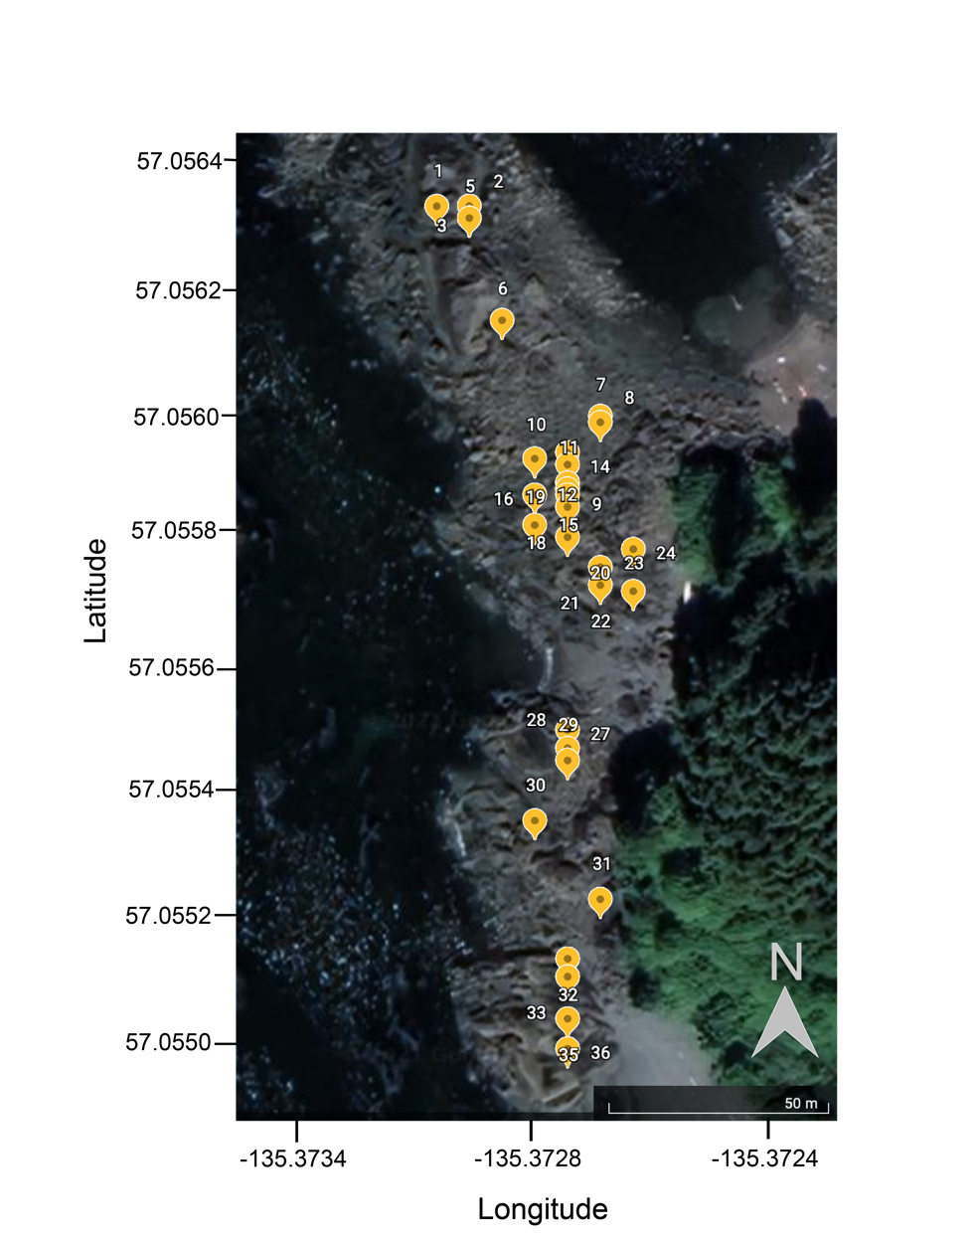
Fig. S1 Ariel view of the field site at John Brown’s Beach, Japonski Island, Sitka, Alaska. Yellow markers and numbers indicate location of the tide pools (n = 31) used in this study. Maps Data: Google, 2021 © 2021 Imagery data: 2/13/21-newer / Maxar Technologies

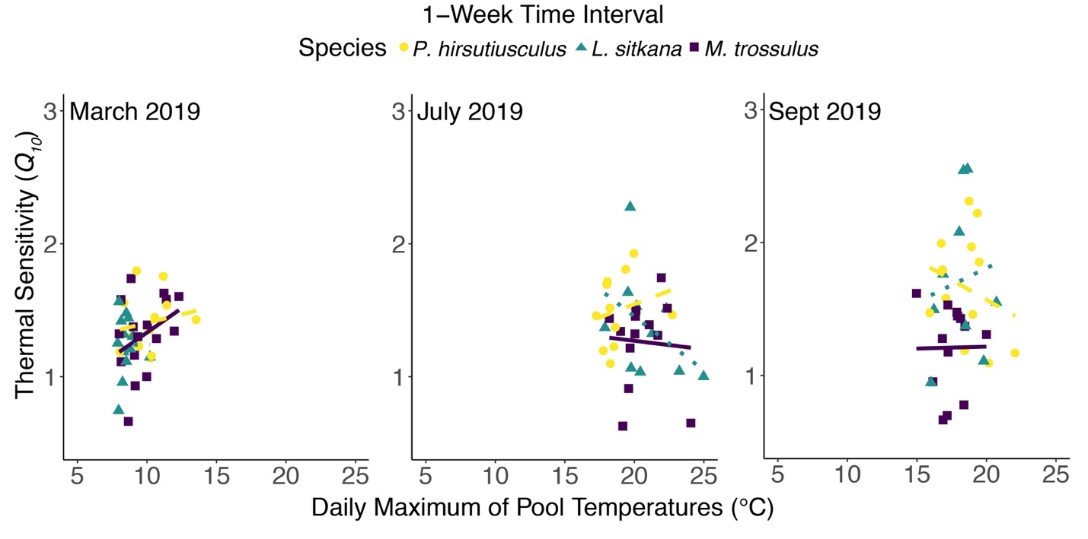
Fig. S2 Relationship between thermal sensitivity (Q₁₀) and the daily maximum of pool temperatures experienced 1-week prior to collection. Each point represents a single individual of Pagurus hirsutiusculus (circle), Littorina sitkana (triangles), and Mytilus trossulus (squares). Colored lines are individual species trendlines across seasons, hermit crabs (yellow dashed), snails (green dotted), and mussels (purple solid)

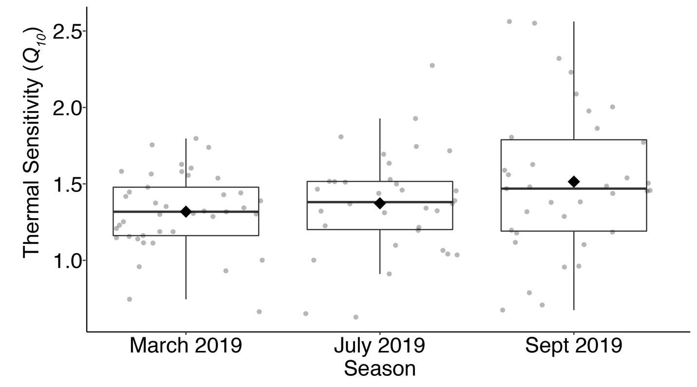
Fig. S3 Q₁₀ values across seasons. The boxes include data within the 25th to the 75th percentile, with the middle solid line representing the median, and the whiskers show both the highest and lowest values within 1.5-fold of the 25th and 75th percentile range. Transparent dots represent all data points within and outside of this range from the 1-week time interval for all three species. Mean values for each season are indicated by the black diamond

