Supplementary Table S1. Risk rankings of the probability of different treatment regimens for system or organ-specific irAEs
System or Organ Immune-Related Adverse Events | Treatment combination regimens,  median risk
System or Organ Immune-Related Adverse Events | ICI-ICI | ICI | ICI-CT | ICI-ICI-CT | CT
Endocrine irAEs | 2 | 3 | 4 | 1 | 5
Gastrointestinal irAEs | 1 | 2 | 2 | 2 | 5
Hepatic irAEs | 1 | 3 | 4 | 1 | 5
Infusion reactions | 2 | 2 | 2 | 1 | 5
Pneumonitis | 1 | 2 | 4 | 3 | 5
Renal irAEs | 3 | 4 | 1 | 2 | 5
Dermatologic irAEs | 2 | 3 | 4 | 1 | 5

Supplementary Table S2A Treatment comparisons using a node-splitting model for any TRAEs
Comparison | p value | CrI
CT vs. ICI | 0.63
Direct |  | -1.3 (-1.7, -0.96)
Indirect |  | -1.0 (-2.4, 0.33)
Network |  | -1.3 (-1.6, -0.93)
CT vs. ICI-ICI | 0.81
Direct |  | -0.61 (-1.2, 0.015)
Indirect |  | -0.47 (-1.5, 0.55)
Network |  | -0.68 (-1.1, -0.25)
CT vs. ICI-ICI-CT | 0.41
Direct |  | 0.47 (-0.49, 1.4)
Indirect |  | -0.093 (-1.2, 1.0)
Network |  | 0.23 (-0.48, 0.94)
ICI vs. ICI-ICI | 0.22
Direct |  | 0.45 (-0.058, 0.99)
Indirect |  | 1.0 (0.16, 1.8)
Network |  | 0.61 (0.16, 1.1)
ICI-CT vs. ICI-ICI | 0.66
Direct |  | -1.4 (-2.4, -0.41)
Indirect |  | -1.1 (-1.7, -0.52)
Network |  | -1.2 (-1.7, -0.62)
ICI-ICI vs. ICI-ICI-CT | 0.41
Direct |  | 0.63 (-0.35, 1.6)
Indirect |  | 1.2 (0.12, 2.3)
Network |  | 0.91 (0.19, 1.6)

Supplementary Table S2B Treatment comparisons using a node-splitting model for grade 3-5 TRAEs
Comparison | p value | CrI
CT vs. ICI | 0.67
Direct |  | -1.1 (-1.3, -0.87)
Indirect |  | -0.92 (-1.6, -0.24)
Network |  | -1.1 (-1.2, -0.87)
CT vs. ICI-ICI | 0.7
Direct |  | -0.30 (-0.61, 0.00028)
Indirect |  | -0.41 (-0.88, 0.10)
Network |  | -0.39 (-0.63, -0.15)
CT vs. ICI-ICI-CT | 0.21
Direct |  | 0.37 (-0.10, 0.86)
Indirect |  | -0.23 (-1.1, 0.59)
Network |  | 0.23 (-0.21, 0.63)
ICI vs. ICI-ICI | 0.81
Direct |  | 0.63 (0.33, 0.92)
Indirect |  | 0.70 (0.19, 1.2)
Network |  | 0.67 (0.42, 0.92)
ICI-CT vs. ICI-ICI | 0.11
Direct |  | -1.2 (-1.8, -0.67)
Indirect |  | -0.72 (-1.0, -0.42)
Network |  | -0.82 (-1.1, -0.54)
ICI-ICI vs. ICI-ICI-CT | 0.19
Direct |  | 0.18 (-0.59, 0.96)
Indirect |  | 0.80 (0.27, 1.3)
Network |  | 0.61 (0.15, 1.0)

Supplementary Table S2C Treatment comparisons using a node-splitting model for any irAEs
Comparison | p value | CrI
CT vs. ICI | 0.96
Direct |  | 2.4 (1.2, 3.7)
Indirect |  | 2.5 (1.2, 3.8)
Network |  | 2.5 (1.8, 3.3)

Supplementary Table S2D Treatment comparisons using a node-splitting model for grade 3-5 irAEs
Comparison | p value | CrI
CT vs. ICI | 0.62
Direct |  | 2.8 (1.5, 4.5)
Indirect |  | 3.3 (2.1, 4.7)
Network |  | 3.1 (2.4, 4.1)

Supplementary Figure S1: Flow diagram of study identification.
Supplementary Figure S2: Risk of bias graph: review authors' judgement about the risk of bias for each item presented as percentages across all included studies.
Supplementary Figure S3: Number needed to treat (benefit or harm) for treatment combination regimens on any TRAEs and grade 3-5 TRAEs.
Supplementary Figure S4: Number needed to treat (harm) for different treatment regimens on any irAEs and grade 3-5 irAEs.

Supplementary Figure S1
Supplementary Figure S2

Supplementary Figure S3.
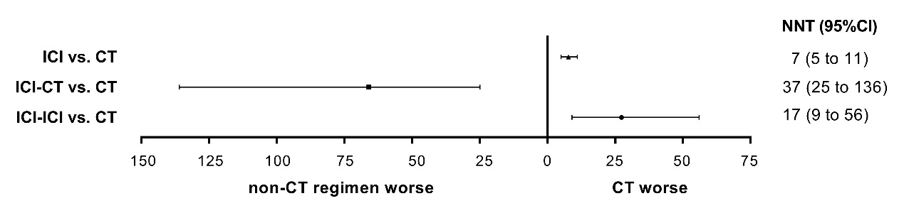
Supplementary Figure S4
