Supporting information

A recycling alternative for expanded polystyrene residues using natural esters

Luisa V. García-Barrera^{a,b}, Dafne L. Ortega-Solís^{b}, Gabriela Soriano-Giles^{b}, Nazario López^{c}, Fernando Romero-Romero^{a,b}, Eric Reinheminerd^{d}, Victor Varela-Guerrero^{a,b*}, María F. Ballesteros-Rivas^{a,b*}
ª Universidad Autónoma del Estado de México. Facultad de Química. Paseo Colón esq. Paseo Tollocan s/n, 50120, Toluca, México, CP 50120, México
^{b} Centro Conjunto de Investigación en Química Sustentable UAEM-UNAM, Carretera Toluca-Atlacomulco km 14.5, 50200, Mexico
^{c} Centro de Investigaciones Químicas, IICBA, Universidad Autónoma del Estado de Morelos, Av. Universidad 1001, Col. Chamilpa, Cuernavaca, Morelos 62209, Mexico

^{d}Rigaku Americas Corporation. 9009 New Trails Drive. The Woodlands, TX 77381. USA

*Corresponding authors at: Centro Conjunto de Investigación en Química Sustentable UAEM-UNAM, Carretera Toluca-Atlacomulco km 14.5, 50200, Mexico.
E-mail addresses: vvarelag@uaemex.mx (V. Varela-Guerrero), mfballesterosr@uaemex.mx (M.F. Ballesteros-Rivas).

Contents
Table S1. Time required to dissolve WEP
Table S2. Main bands of the esters
Table S3. Characteristic bands of WEP compared to WEP recovered from esters
Fig.S1. Infrared spectroscopy of omega-3
Fig.S2. Infrared spectroscopy of glyceryl tributyrate
Fig.S3. Infrared spectroscopy of ethyl butyrate
Fig.S4. FTIR of esters: (a) omega-3, (b) glyceryl tributyrate and (c) ethyl butyrate
Fig.S5. Differential Scanning Calorimetry of untreated WEP
Fig.S6. Differential Scanning Calorimetry at 50% WEP solution using omega-3
Fig.S7. Differential Scanning Calorimetry at 50% WEP solution using glyceryl tributyrate
Fig.S8. Differential Scanning Calorimetry at 50% WEP solution using ethyl butyrate
Fig.S9. Thermogravimetric analysis of untreated WEP
Fig.S10. Thermogravimetric analysis at a 50% solution of WEP using omega-3
Fig.S11. Thermogravimetric Analysis at 50% WEP solution using glyceryl tributyrate
Fig.S12. Thermogravimetric analysis at a 50% solution of WEP using ethyl butyrate
Fig.S13. Degree of advance α for the calculation of the activation energy of the WEP without treatment using the Friedman model with heating rate β = 20°C/min (293.15 K / min)
Fig.S14. Linear regression for the calculation of the activation energy of the WEP without treatment using the Friedman model with heating rate β=20°C/min (293.15 K/min)
Fig.S15. Degree of advancement α for the calculation of the activation energy of the WEP recovered with omega-3 using the Friedman model with heating rate β=20°C/min (293.15 K/min)
Fig.S16. Linear regression for the calculation of the activation energy of the WEP recovered with omega-3 using the Friedman model with heating rate β=20°C/min (293.15 K/min)
Fig.S17. Degree of advancement α for the calculation of the activation energy of the WEP recovered with glyceryl tributyrate using the Friedman model with heating rate β=20°C/min (293.15 K/min)
Fig.S18. Linear regression for the calculation of the activation energy of the WEP recovered with glyceryl tributyrate using the Friedman model with heating rate β=20°C/min (293.15 K/min)
Fig.S19. Degree of advancement α for the calculation of the activation energy of the WEP recovered with ethyl butyrate using the Friedman model with heating rate β=20°C/min (293.15 K/min)
Fig.S20. Linear regression for the calculation of the activation energy of the WEP recovered with ethyl butyrate using the Friedman model with heating rate β=20°C/min (293.15 K/min)
Fig.S21. Scanning electron micrograph of untreated WEP (a) outer layer (b) inner layer
Fig.S22. Experimentation process for WEP recycling a) WEP-Omega 3 mixing, b) and c) WEP dissolution process, d) WEP precipitation, e) and f) recovered WEP

Omega-3 |  | Glyceryl tributyrate |  | Ethyl butyrate
Co (w/w) | Time (min) | Co (w/w) | Time (min) | Co (w/w) | Time (min)
10.123 | 4.21111 | 10.08558 | 4.41667 | 10.02133 | 0.86667
20.02485 | 6.09444 | 20.00796 | 8.15833 | 19.9277 | 2
30.0033 | 6.56111 | 30.04303 | 11.73333 | 30.00269 | 2.31111
39.99868 | 7.2 | 40.03082 | 17.25 | 39.97742 | 2.44445
49.96054 | 7.94445 | 50.02479 | 24.325 | 50.01294 | 2.46667
59.97404 | 10.05 | 60.02682 | 30.44167 | 59.98019 | 3.32222
69.96818 | 15.30833 | 70.00197 | 40.65833 | 70.1271 | 3.48889
79.99804 | 24.05 | 79.97312 | 52.84167 | 80.1 | 3.59
89.97957 | 28.05 | 90.02584 | 73.5 | 90.02312 | 3.96667
99.9967 | 31.23333 | 100.00497 | 130.5 | 100.14142 | 7.40556
Table S1. Time required to dissolve WEP

Table S2. Main bands of the esters

Omega-3 |  |  |  |  | Glyceryl tributyrate |  |  |  |  | Ethyl Butyrate
Vibration | Frequency (cm⁻¹) | Intensity | Shape |  | Vibration | Frequency (cm⁻¹) | Intensity | Shape |  | Vibration | Frequency (cm⁻¹) | Intensity | Shape
= C-H  (of the unsaturations present in the chain) | 3011 | w | Narrow |  | C-H | 2965 2936 2877 | w | Narrow |  | C-H | 2964 2937 2877 | w | Narrow
C-H | 2959 2926 2855 | m | Narrow |  | C = O (from the ester) | 1735 | s | Acute |  | C = O (from the ester) | 1735 | s | Acute
C = O  (from the ester) | 1735 | s | Acute |  | C-O (from alkyl ester) | 1164 | m | Narrow-Acute |  | C-O (from alkyl ester) | 1161 | m | Narrow-Acute
C-O  (from alkyl ester) | 1177 1161 | m | Narrow |  | - | - | - | - |  | - | - | - | -

Table S3. Characteristic bands of WEP compared to WEP recovered from esters
WEP untreated |  |  |  | RE-OME3 |  |  | RE-GT |  |  | RE-EB
Vibration | Frequency (cm⁻¹) | Intensity |  | Frequency (cm⁻¹) | Intensity |  | Frequency (cm⁻¹) | Intensity |  | Frequency (cm⁻¹) | Intensity
= C-H (from the aromatic ring) | 3026 | w |  | 3026 | w |  | 3026 | w |  | 3026 | w
-CH₂- | 2921  2849 | m |  | 2922  2849 | m |  | 2925  2850 | m |  | 2923  2849 | m
-C = C- (from the aromatic ring) | 1601  1493  1450 | m |  | 1600  1494  1452 | m |  | 1601  1493  1452 | m |  | 1601  1493  1452 | m
= C-H oop  (out-of-plane twist) | 752  695 | s |  | 754  693 | s |  | 756  695 | s |  | 755  695 | s

WEP: Waste Expanded Polystyrene
RE-OME3: WEP recovered from Omega 3
RE-GT: WEP recovered from Glyceryl Tributyrate
RE-EB: WEP recovered from Ethyl Butyrate

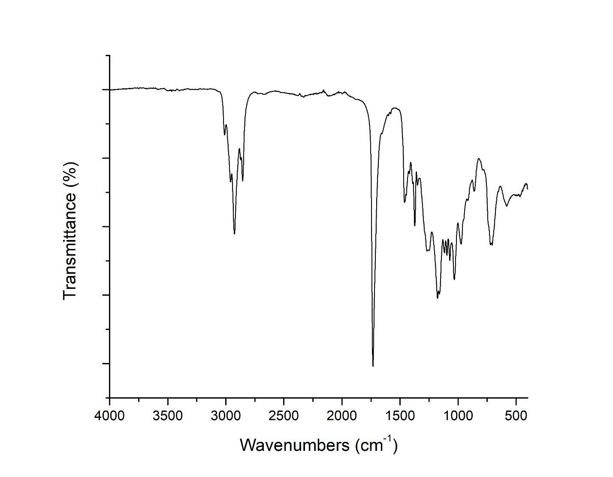
Fig.S1 Infrared spectroscopy of omega-3
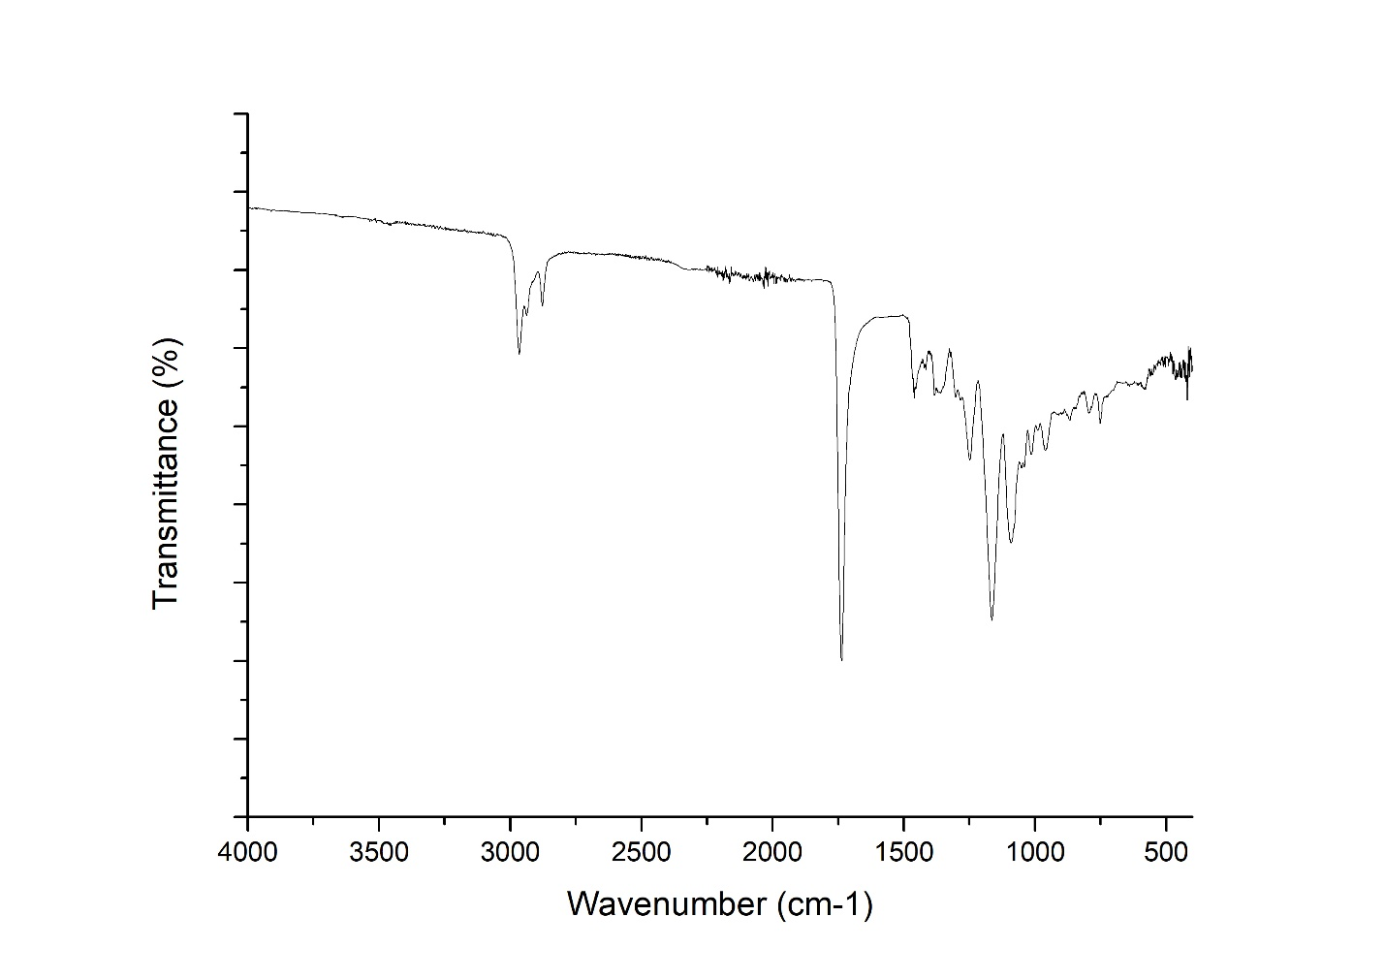
Fig.S2 Infrared spectroscopy of glyceryl tributyrate
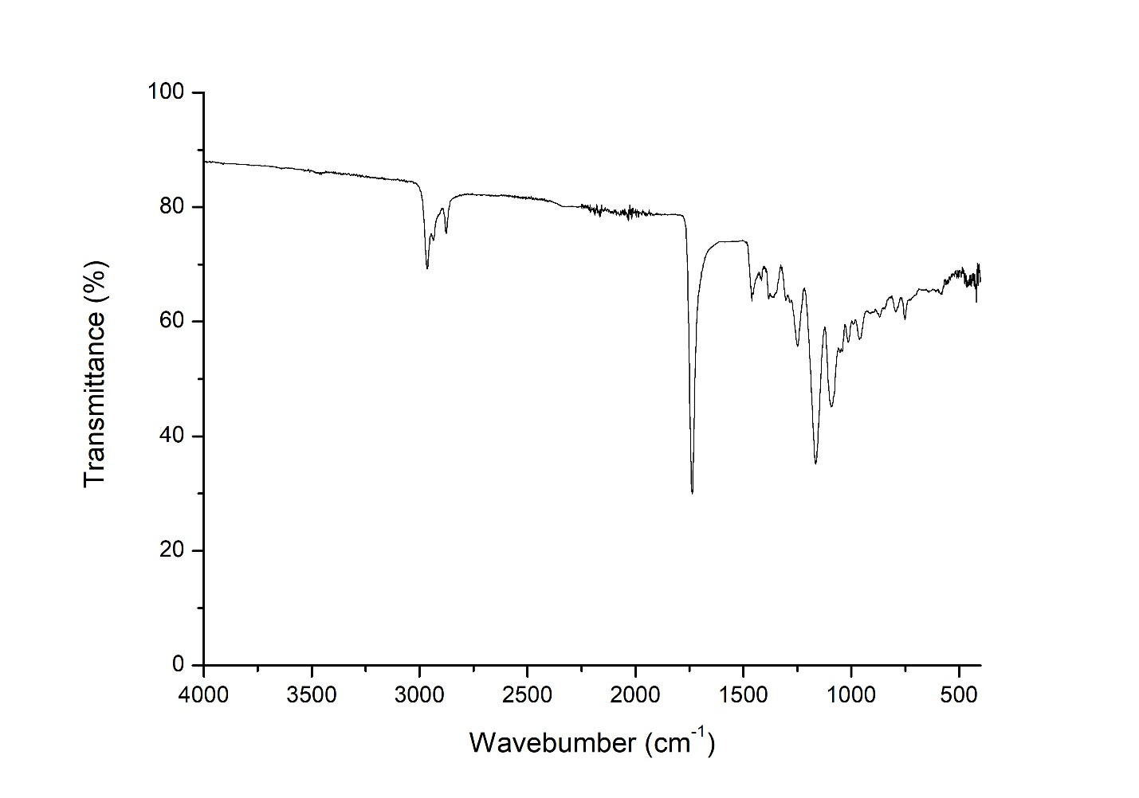
Fig.S3 Infrared spectroscopy of ethyl butyrate
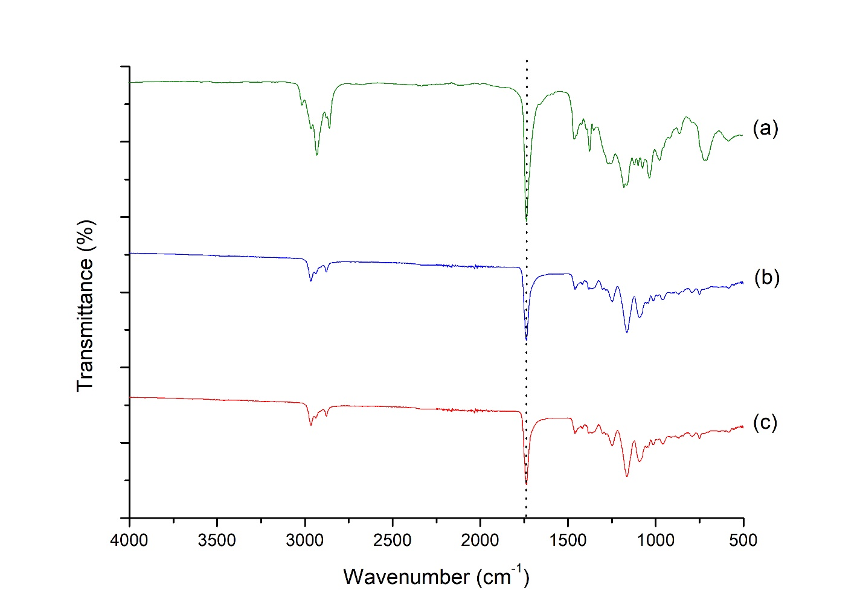
Fig.S4 FTIR of esters: (a) omega-3, (b) glyceryl tributyrate and (c) ethyl butyrate
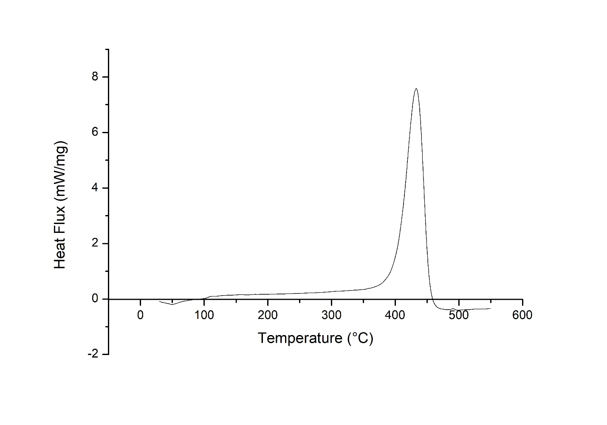
Fig.S5 Differential Scanning Calorimetry of untreated WEP
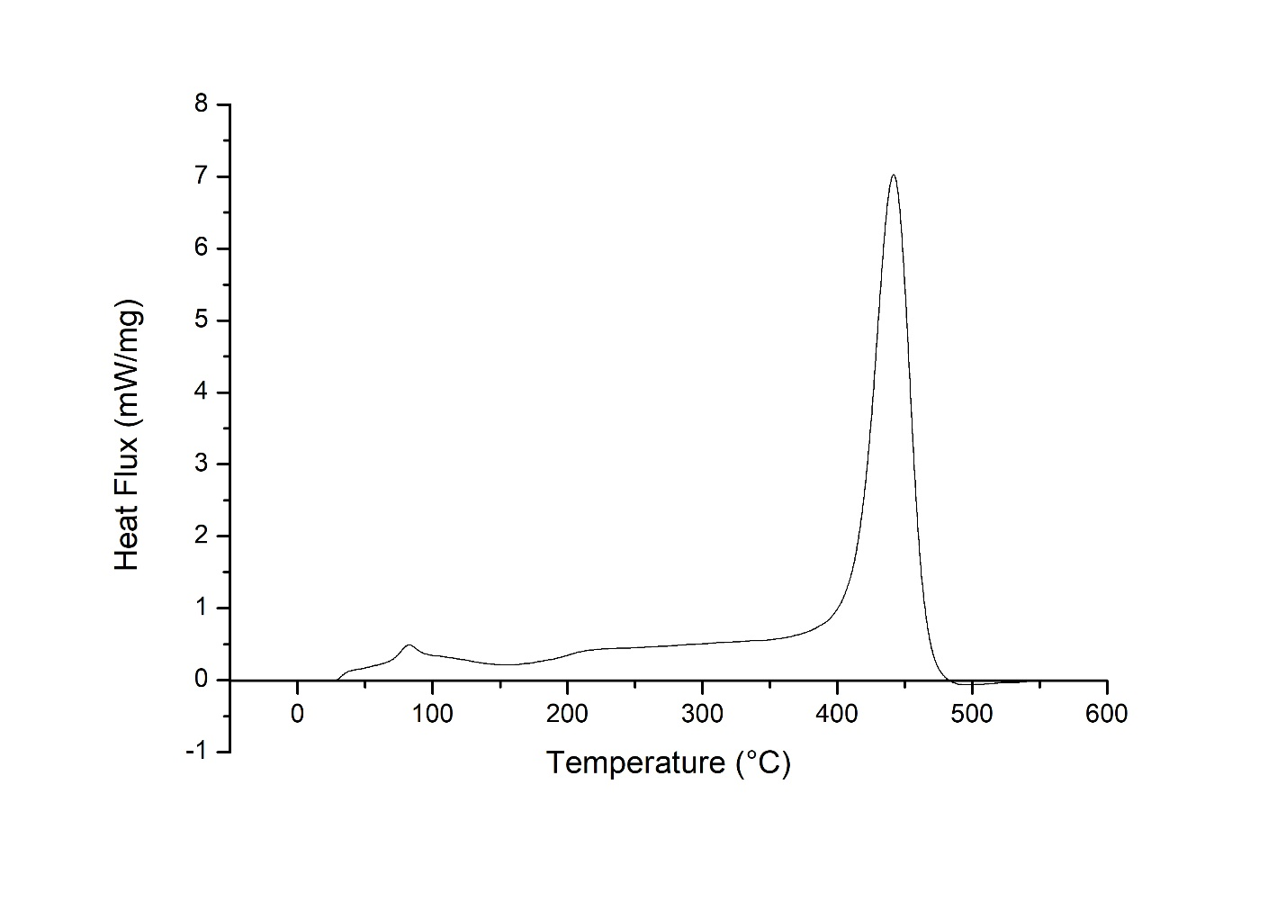
Fig.S6 Differential Scanning Calorimetry at 50% WEP solution using omega-3
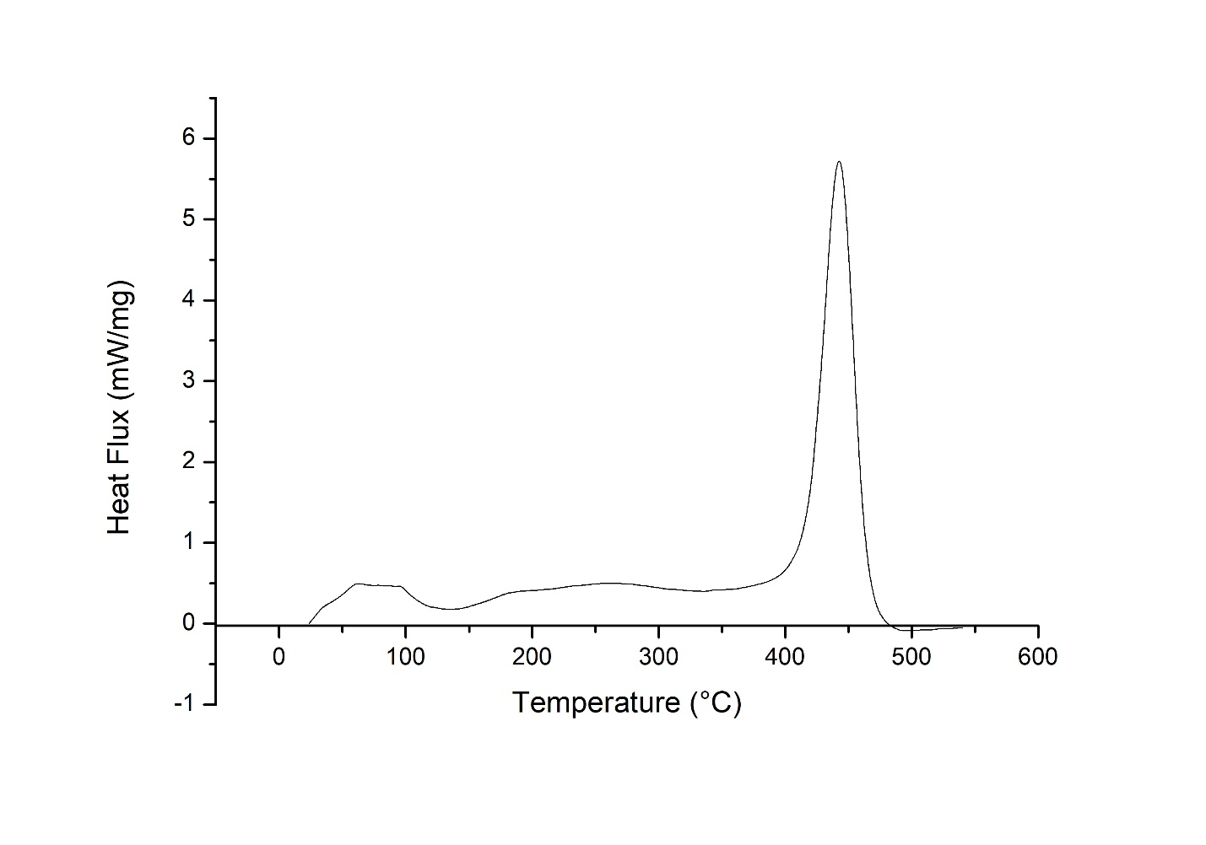
Fig.S7 Differential Scanning Calorimetry at 50% WEP solution using glyceryl tributyrate
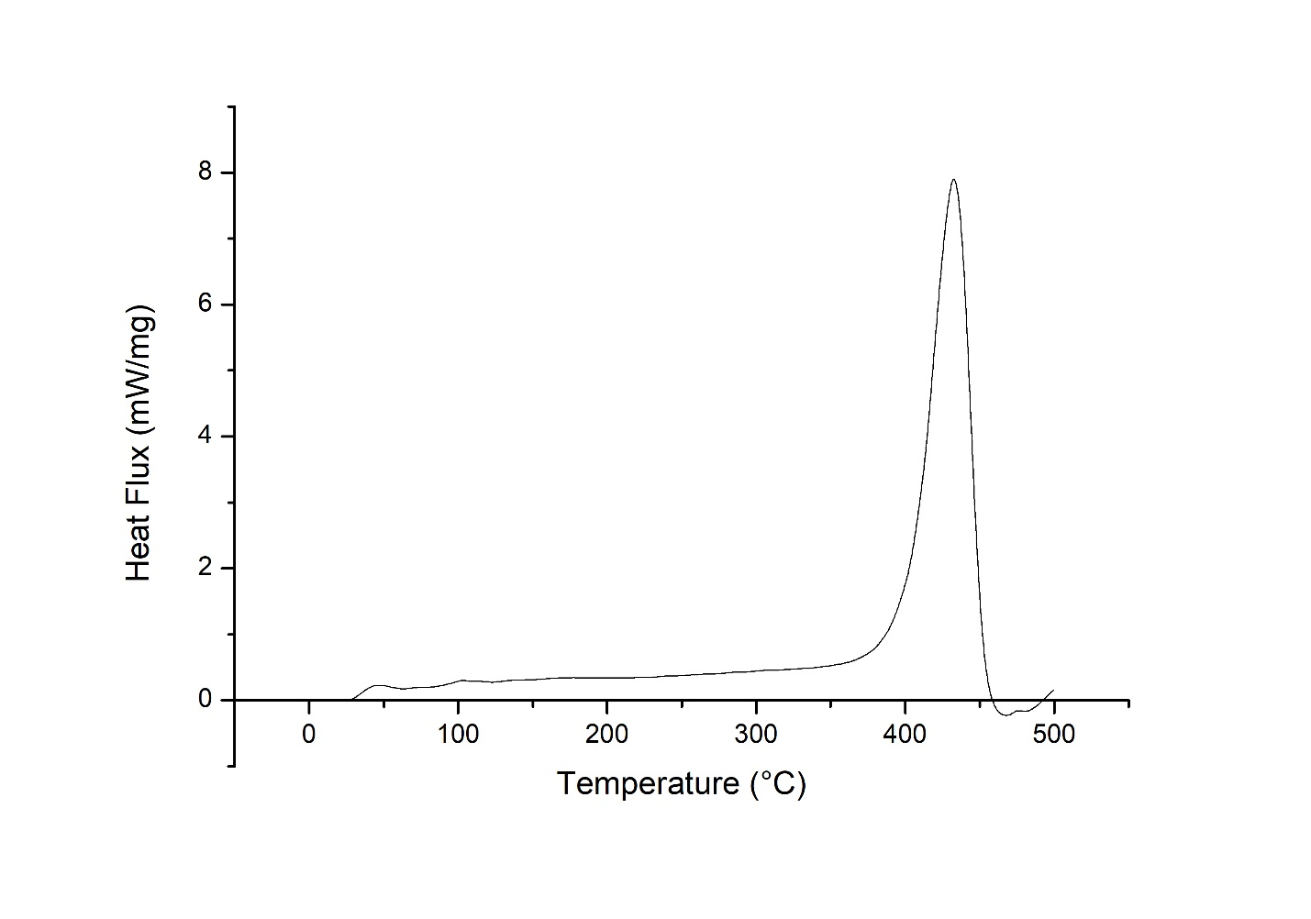
Fig.S8 Differential Scanning Calorimetry at 50% WEP solution using ethyl butyrate
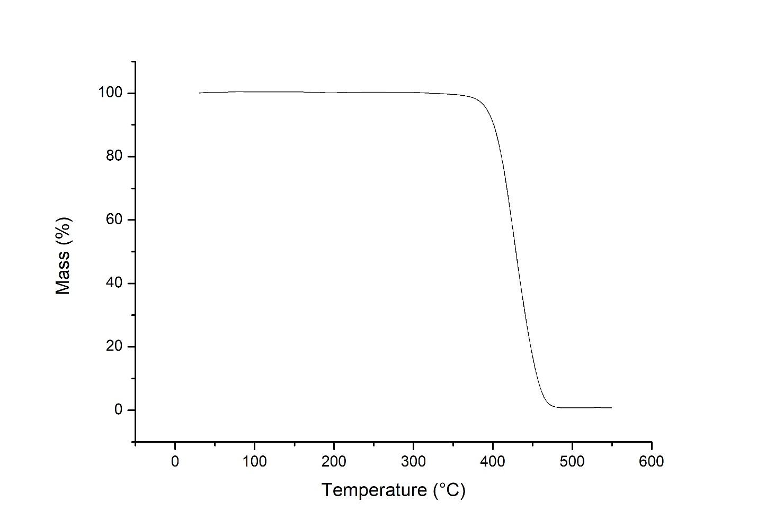
Fig.S9 Thermogravimetric analysis of untreated WEP
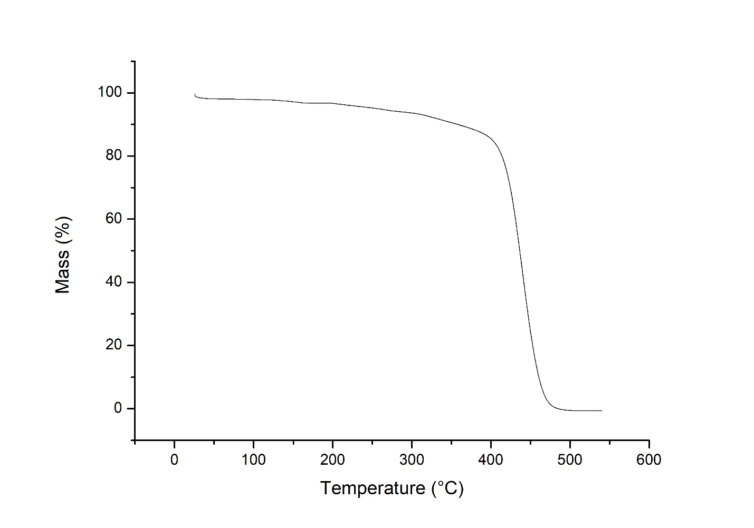
Fig.S10 Thermogravimetric analysis at a 50% solution of WEP using omega-3
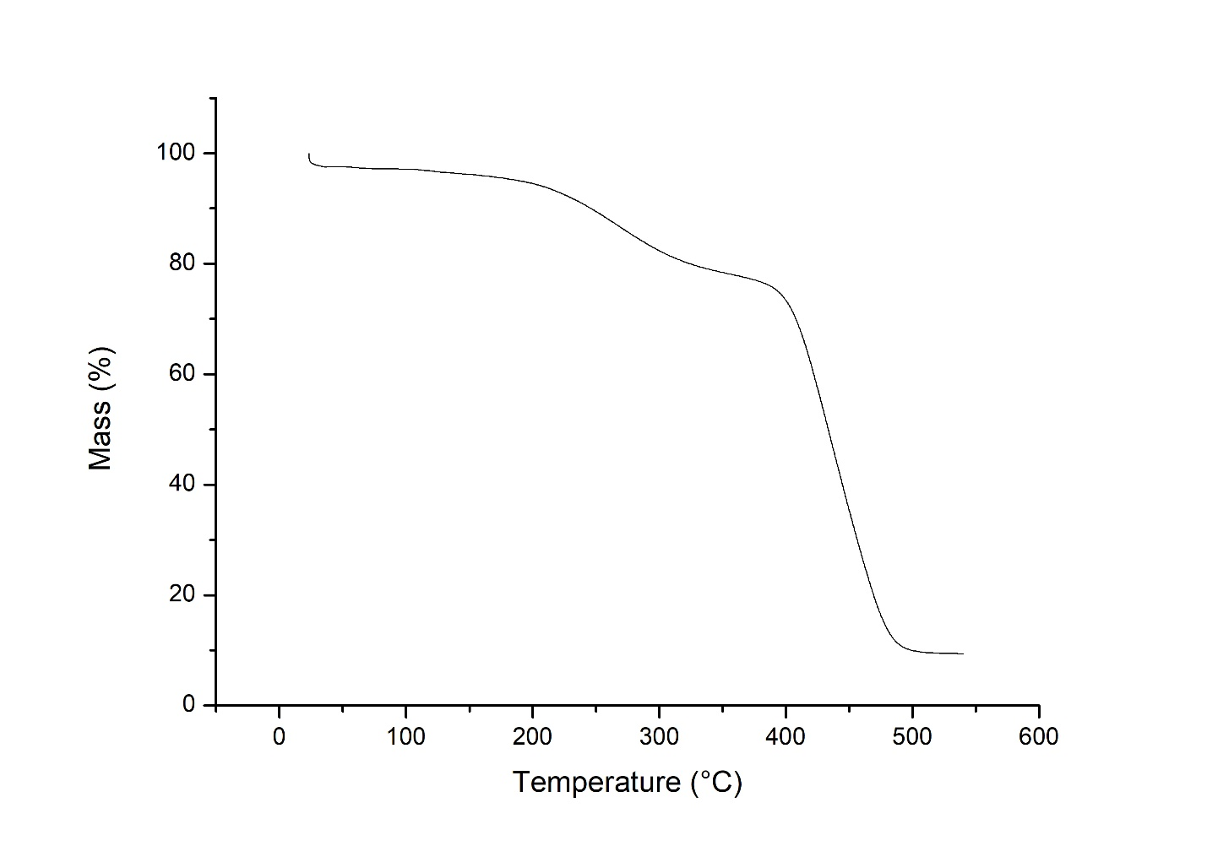
Fig.S11 Thermogravimetric Analysis at 50% WEP solution using glyceryl tributyrate
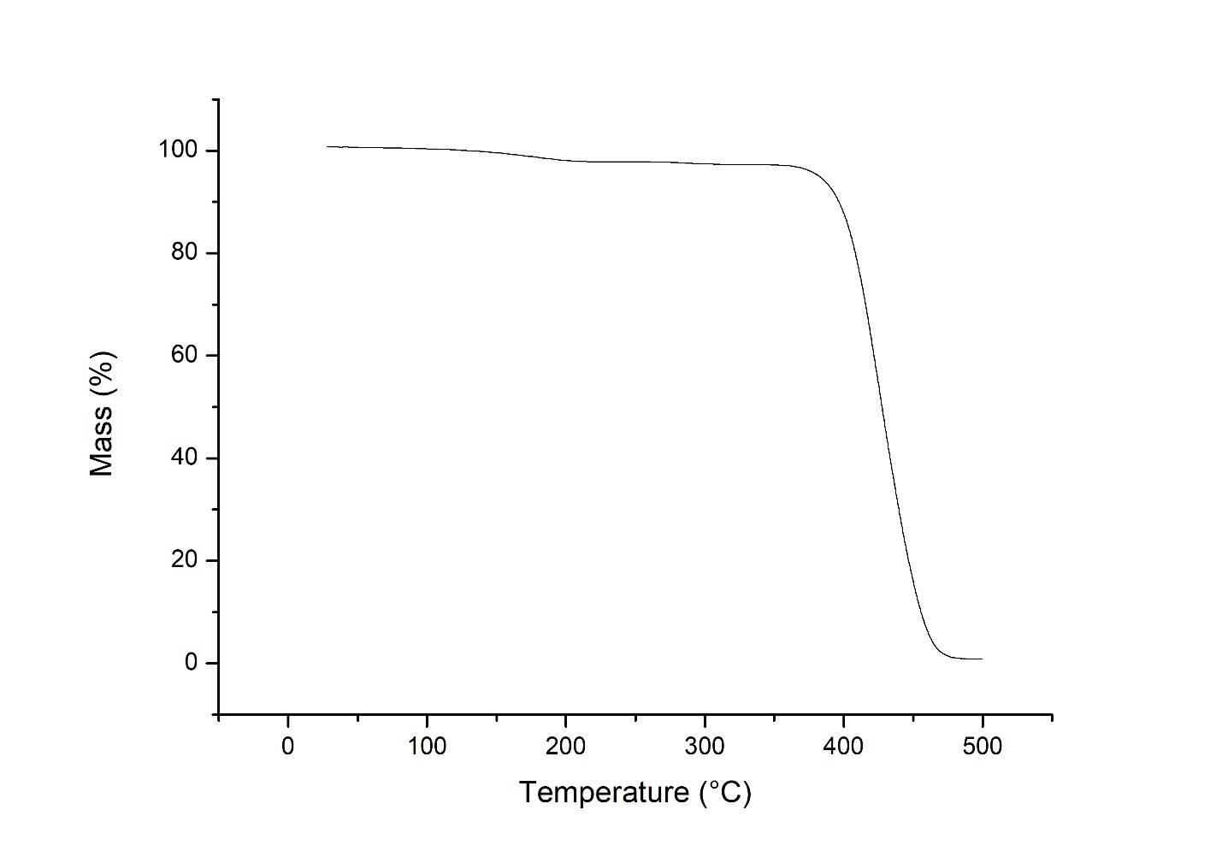
Fig.S12 Thermogravimetric analysis at a 50% solution of WEP using ethyl butyrate
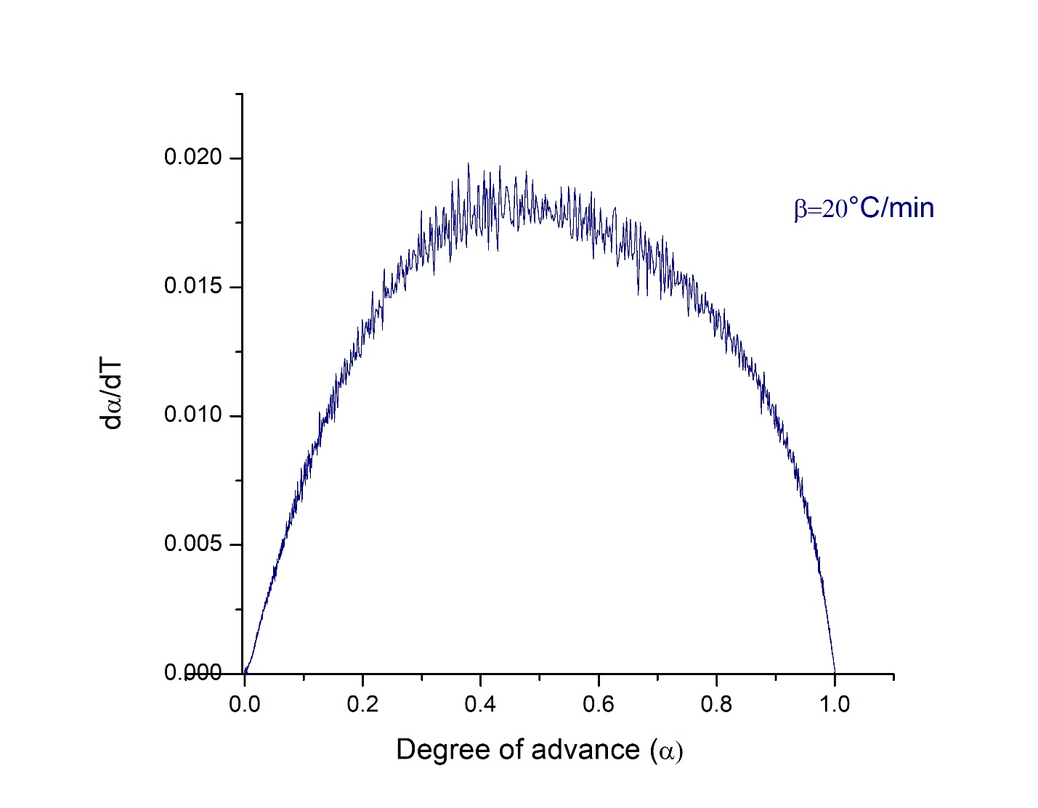
Fig.S13 Degree of advance α for the calculation of the activation energy of the WEP without treatment using the Friedman model with heating rate β = 20°C/min (293.15 K / min)
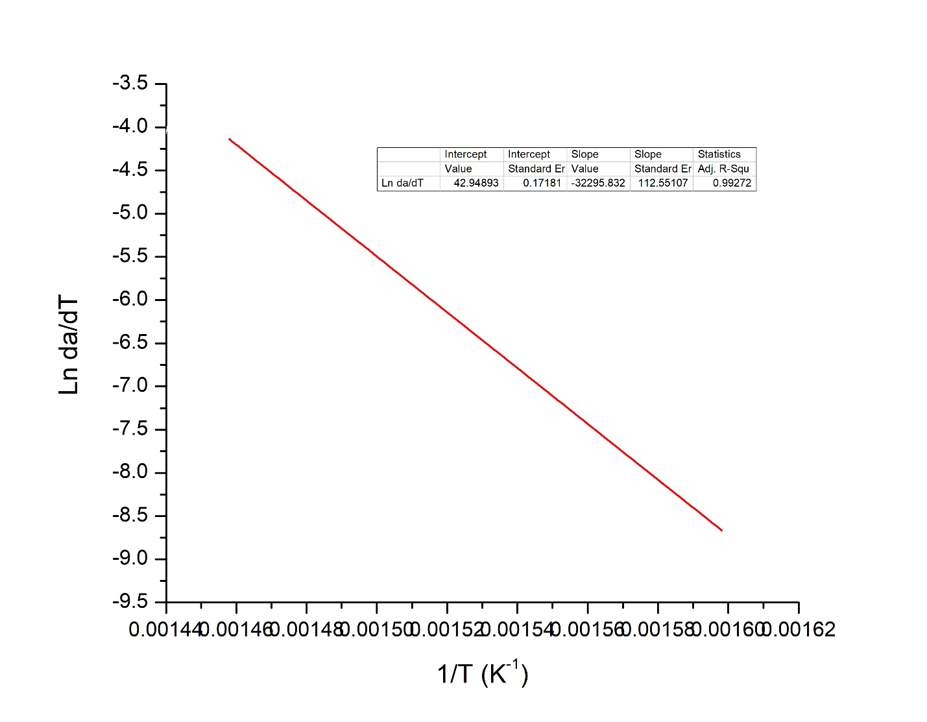
Fig.S14 Linear regression for the calculation of the activation energy of the WEP without treatment using the Friedman model with heating rate β=20°C/min (293.15 K/min)
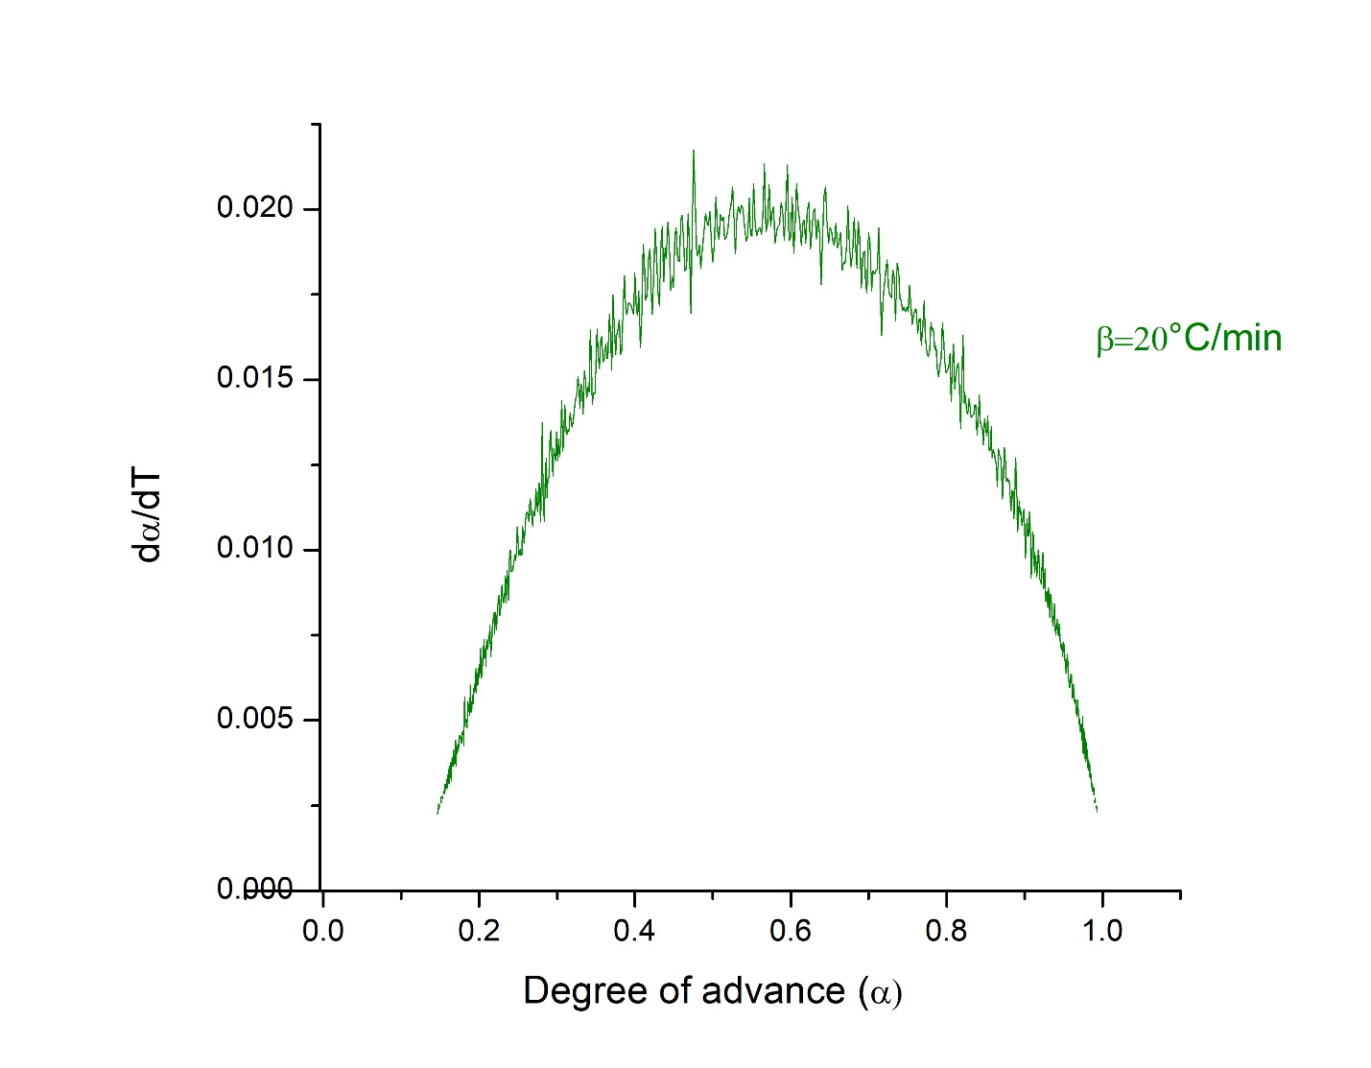
Fig.S15 Degree of advancement α for the calculation of the activation energy of the WEP recovered with omega-3 using the Friedman model with heating rate β=20°C/min (293.15 K/min)
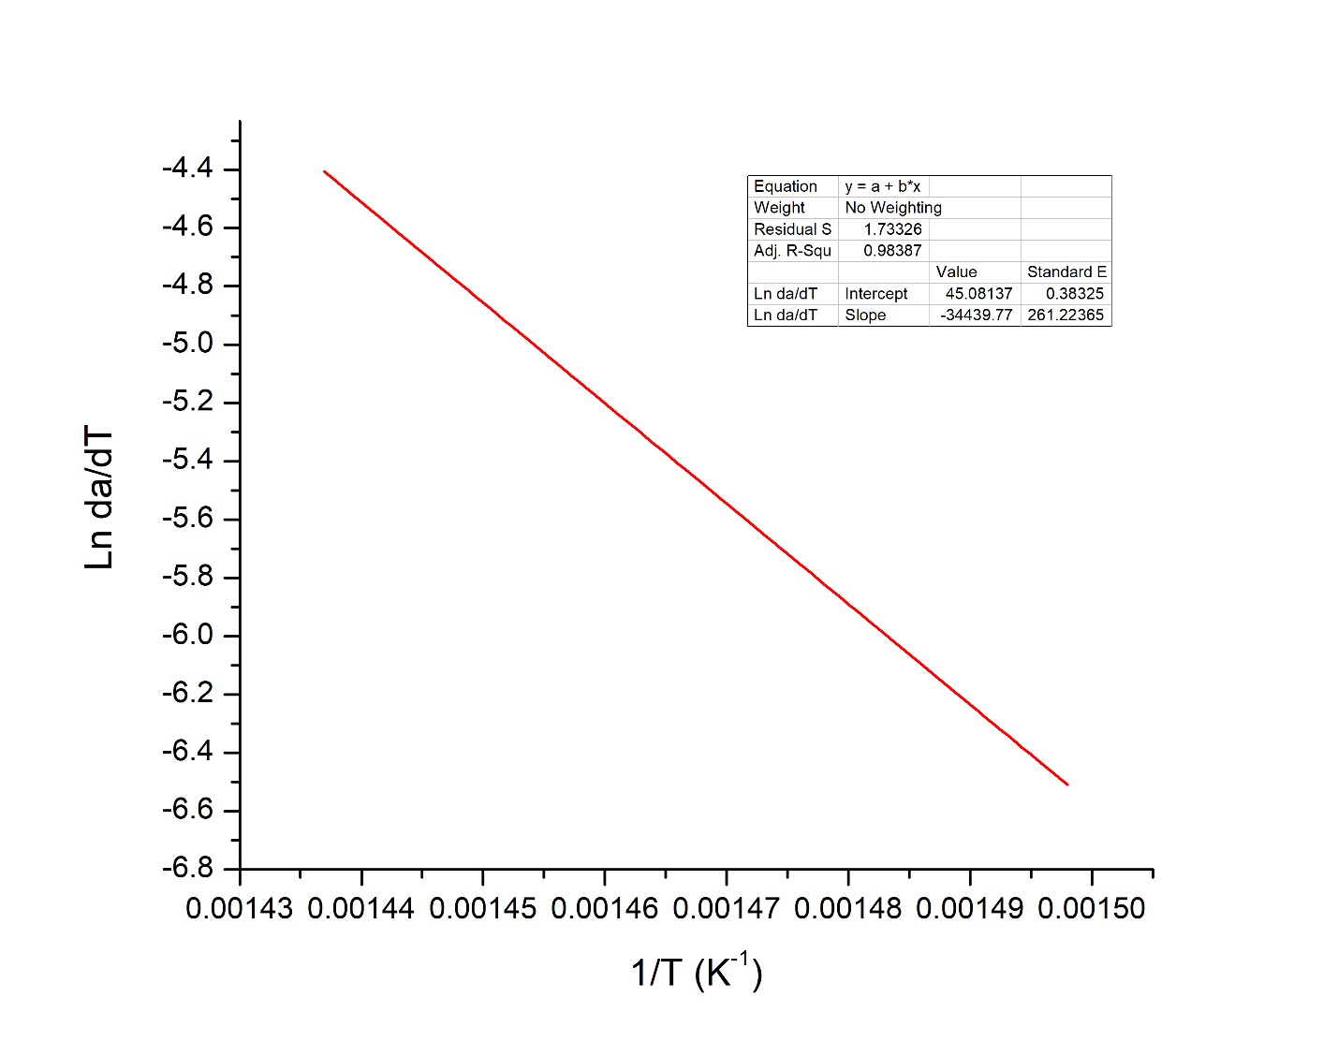
Fig.S16 Linear regression for the calculation of the activation energy of the WEP recovered with omega-3 using the Friedman model with heating rate β=20°C/min (293.15 K/min)
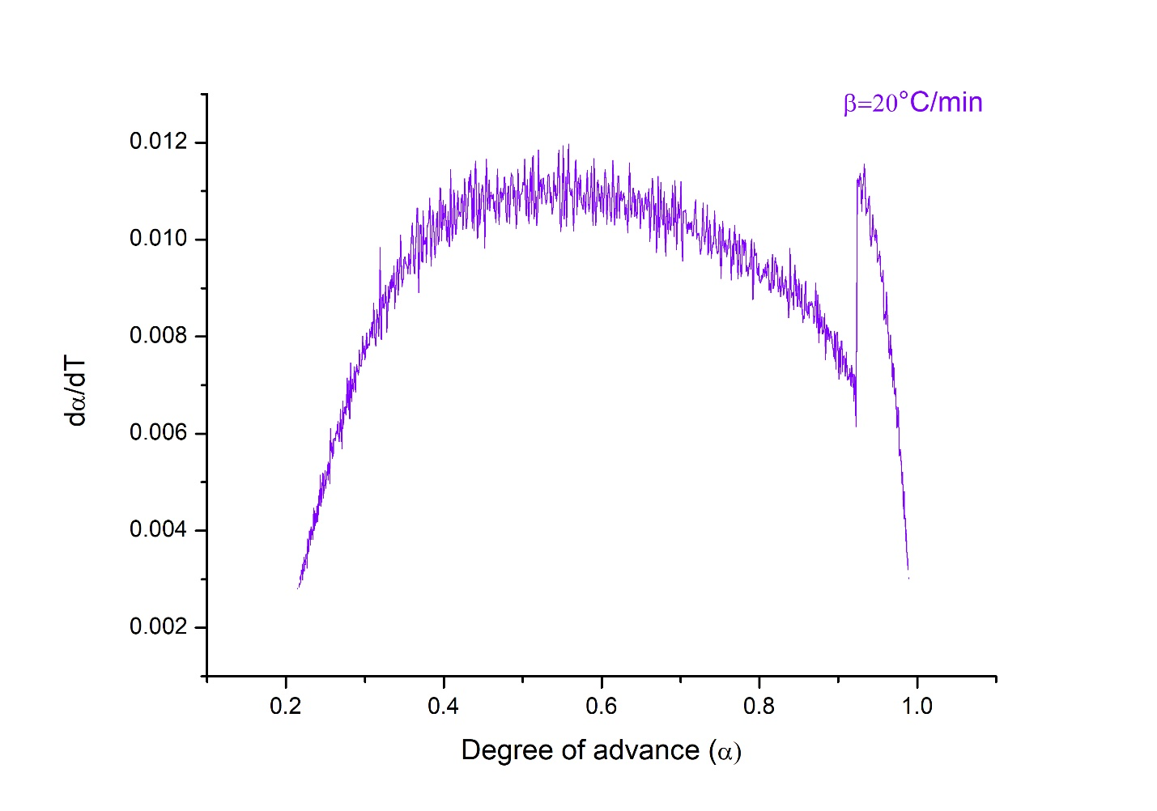
Fig.S17 Degree of advancement α for the calculation of the activation energy of the WEP recovered with glyceryl tributyrate using the Friedman model with heating rate β=20°C/min (293.15 K/min)
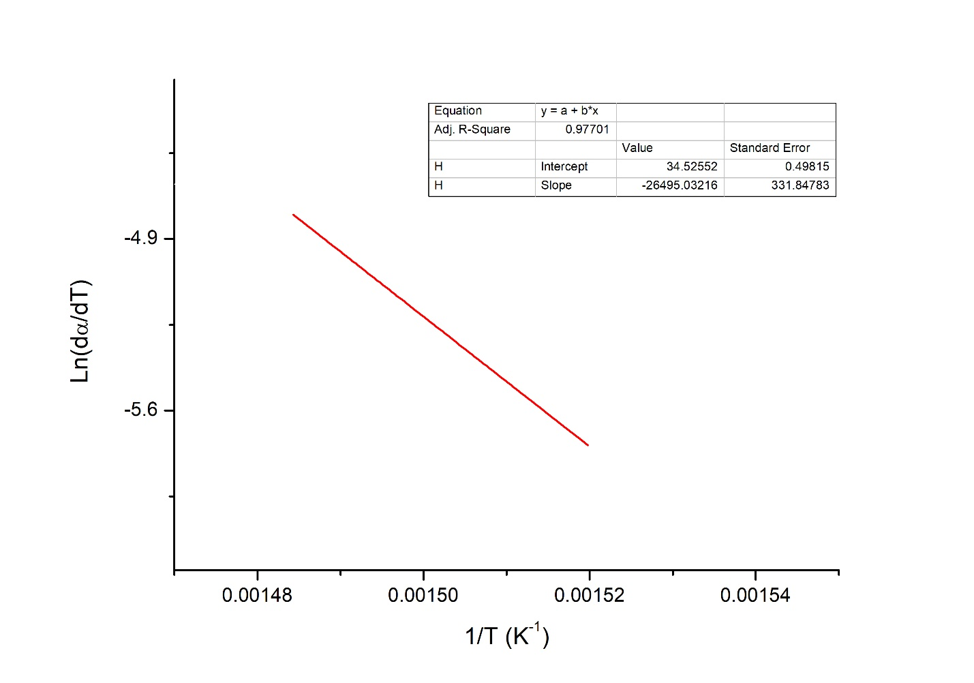
Fig.S18 Linear regression for the calculation of the activation energy of the WEP recovered with glyceryl tributyrate using the Friedman model with heating rate β=20°C/min (293.15 K/min)
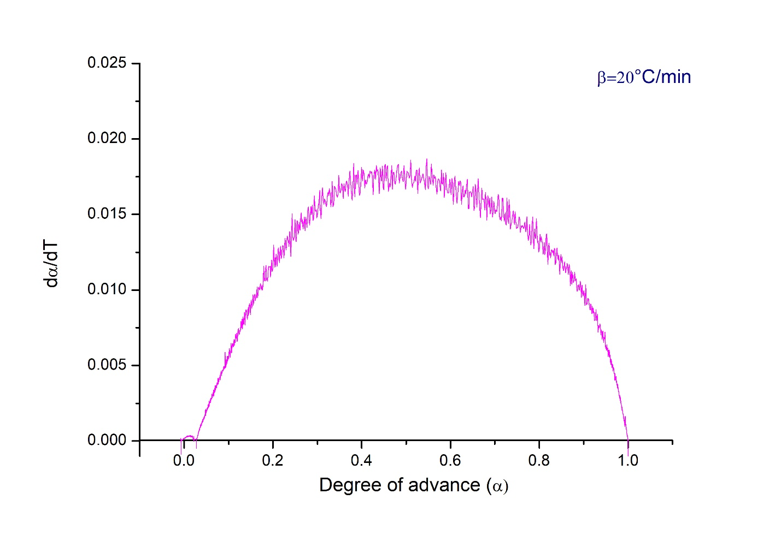
Fig.S19 Degree of advancement α for the calculation of the activation energy of the WEP recovered with ethyl butyrate using the Friedman model with heating rate β=20°C/min (293.15 K/min)
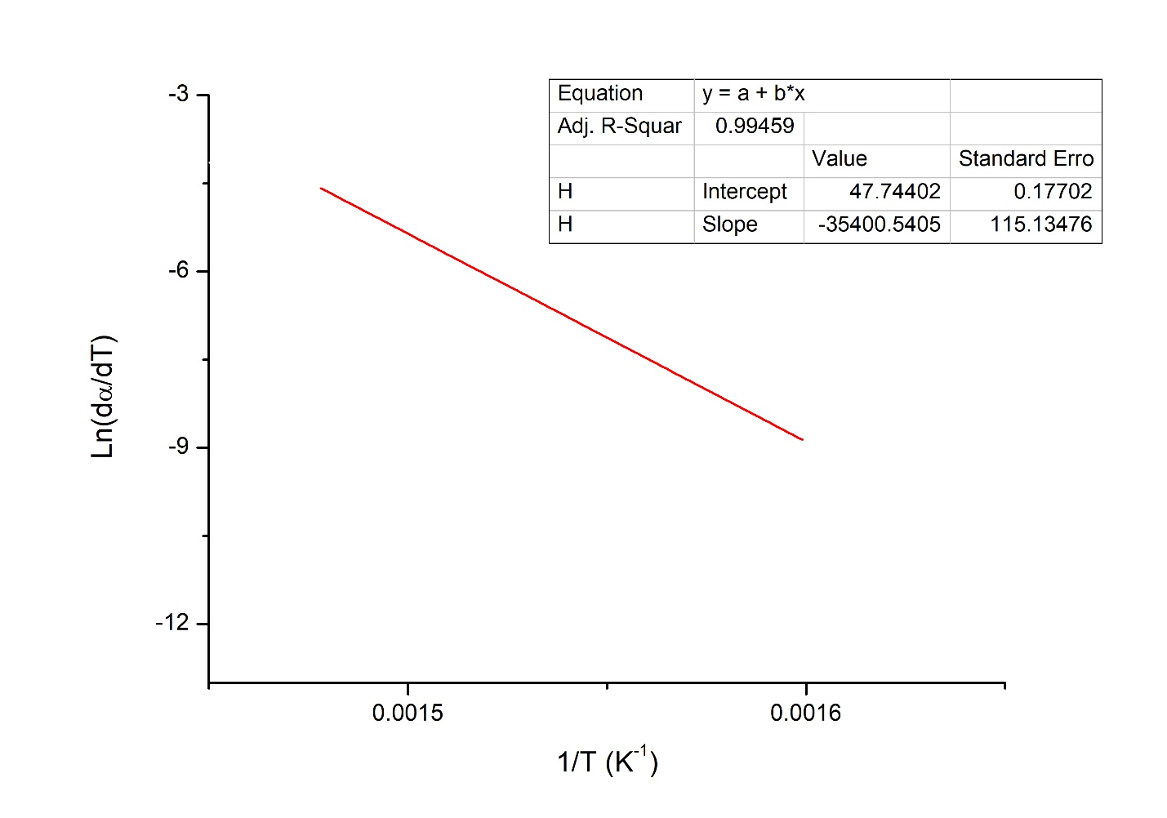
Fig.S20 Linear regression for the calculation of the activation energy of the WEP recovered with ethyl butyrate using the Friedman model with heating rate β=20°C/min (293.15 K/min)
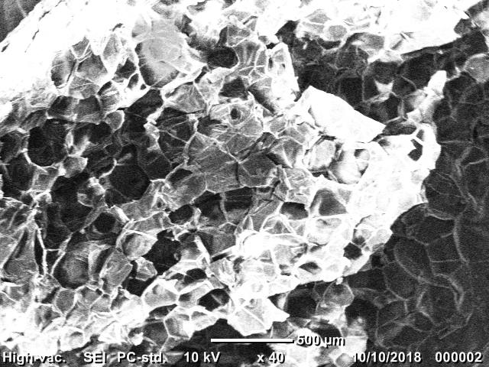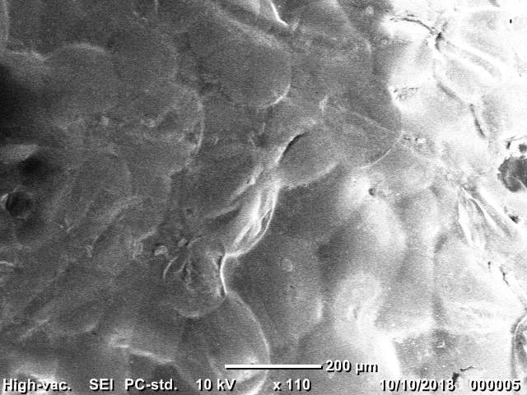
(b)
(a)
Fig.S21 Scanning electron micrograph of untreated WEP (a) outer layer (b) inner layer

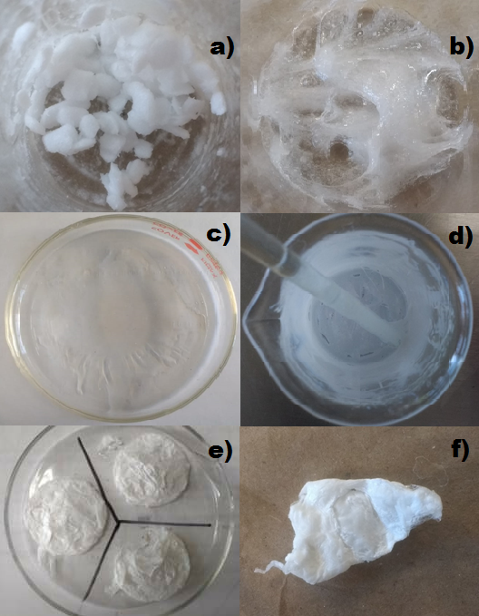
Fig.S22 Experimentation process for WEP recycling a) WEP-Omega 3 mixing, b) and c) WEP dissolution process, d) WEP precipitation, e) and f) recovered WEP

