International Archives of Occupational and Environmental HealthSupplementary material
Examining the Short-term Effect of Moderate Level Air Pollution on Multi-department Outpatient Visits in Xi’an, China
Qingnan Wang, PhDª, Zhuo Chen, PhD^{d,e}, Wei Huang, PhD^{b,a}, Bo Kou, PhD^{c, *}, Jingwei Li, PhD^{f}
ªDepartment of Information Management, School of Management, Xi’an Jiaotong University, Xi’an 710049, China; wqingnan1118@gmail.com
^{b}College of Business, Southern University of Science and Technology, Shenzhen 518055, China; waynehw@qq.com
^{c}Department of Otolaryngology, the First Afﬁliated Hospital of Xi’an Jiaotong University, Xi’an 710049, China; bobiekou@163.com
^{d} College of Public Health, University of Georgia, Athens, GA 30602, USA; zchen1@uga.edu
^{e}School of Economics, University of Nottingham Ningbo China, Ningbo 315000, China
^{f}Department of Information Management, School of Management, Xi’an Jiaotong University, Xi’an 710049, China; li.jing.wei123@stu.xjtu.edu.cn
*Correspondence: bobiekou@163.com, No.28, Xianning West Road, Xi’an, Shaanxi, 710049, P.R. China

Figures

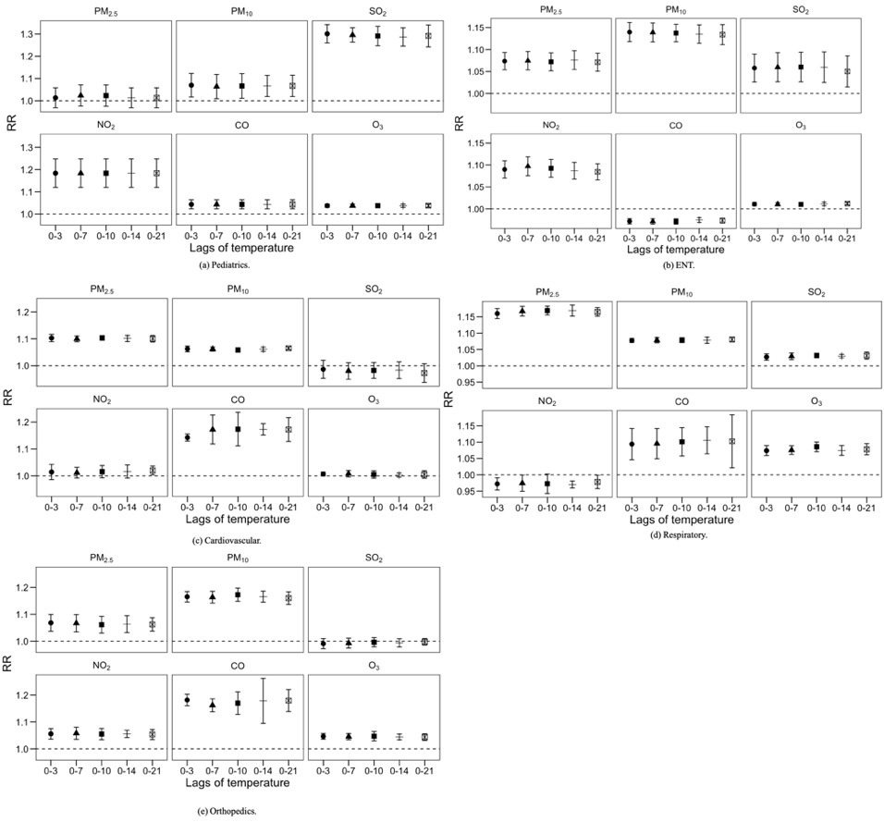
Fig.S1 Associations of air pollutants with department visits using different lags of temperature.
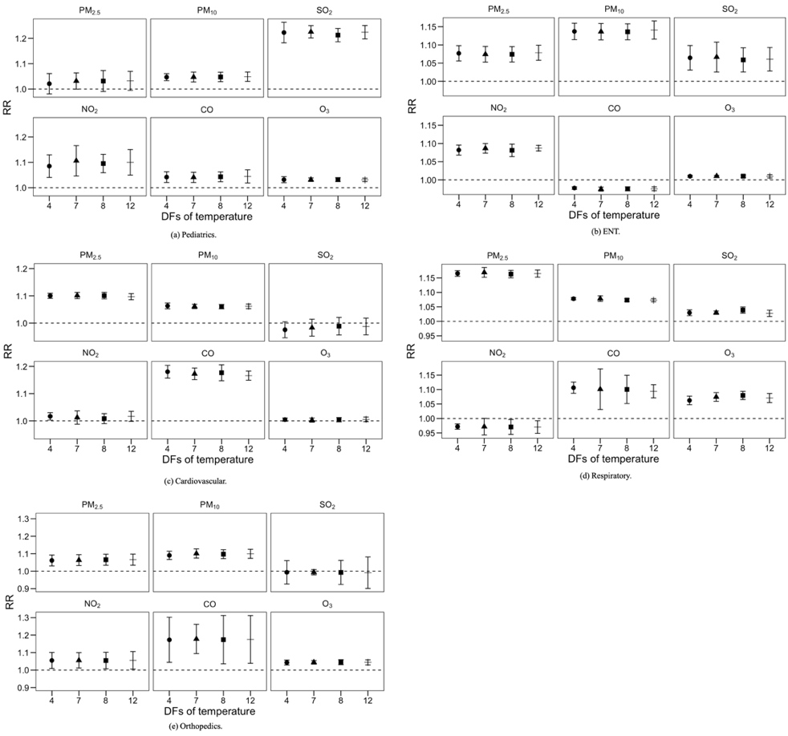
Fig.S2 Associations of air pollutants with department visits using different degrees of freedom for time trends.
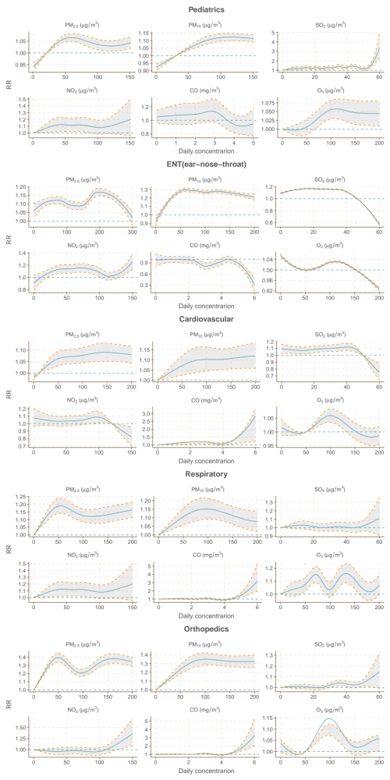
Figure S3. Concentration-response relationship curves for the associations between short-term exposure to air pollutants (cumulative lags from 0 to 3 days) and outpatient visits of different departments.
Tables
Table S1. Spearman's correlation coefficients between daily air pollutant concentrations and meteorological conditions in Xi'an, 2016-2018.
 | $$PM_{10}$$ | $$SO_{2}$$ | $$NO_{2}$$ | $$CO$$ | $$O_{3}$$ | Temperature | RH
$$PM_{2.5}$$ | 0.93** | 0.78** | 0.86** | 0.74** | -0.50** | -0.59** | 0.01
$$PM_{10}$$ |  | 0.80** | 0.77** | 0.76&& | -0.41** | 0.52** | -0.16**
$$SO_{2}$$ |  |  | 0.77** | 0.82** | -0.49** | -0.70** | -0.28**
$$NO_{2}$$ |  |  |  | 0.71** | -0.39** | -0.51** | -0.18**
$$CO$$ |  |  |  |  | -0.58** | -0.64** | 0.08**
$$O_{3}$$ |  |  |  |  |  | 0.81** | -0.36**
Temperature |  |  |  |  |  |  | -0.02
RH: relative humidity.
**: p value<0.01.

Table S2. Correlation coefficients between daily air pollutant concentrations in Xi'an, 2016-2018.
$R^{2}$ | $PM_{10}$ | $SO_{2}$ | $NO_{2}$ | $CO$ | $O_{3}$
$PM_{2.5}$ | 0.85 | 0.61 | 0.74 | 0.55 | 0.26
$PM_{10}$ |  | 0.66 | 0.61 | 0.61 | 0.17
$SO_{2}$ |  |  | 0.59 | 0.67 | 0.23
$NO_{2}$ |  |  |  | 0.50 | 0.32
$CO$ |  |  |  |  | 0.14

Table S3. Relative risks of outpatient visits with a 10-unit increase in air pollutant concentrations (cumulative lags from 0 to 3 days) in single- and two-pollutant models.
Model | $$PM_{2.5}$$ | $$PM_{10}$$ | $$SO_{2}$$ | $$NO_{2}$$ | $$CO$$ | $$O_{3}$$
Pediatrics
Single | 1.032 (0.998, 1.064)** | 1.047 (1.028, 1.067)** | 1.226 (1.201, 1.250)** | 1.105 (1.090, 1.121)** | 1.044 (1.025, 1.064)* | 1.032 (1.026, 1.039)
+$PM_{2.5}$ | - | 1.026 (0.991, 1.062)** | 1.207 (1.151, 1.264)* | 1.084 (1.051, 1.117)* | 0.992 (0.871, 1.114) | 1.019 (1.004, 1.034)*
+$PM_{10}$ | 1.044 (0.980, 1.109)** | - | 1.233 (1.153, 1.313)* | 1.094 (1.052, 1.136) | 0.927 (0.817, 1.037) | 1.017 (1.003, 1.032)
+$SO_{2}$ | 1.054 (1.007, 1.101)* | 0.985 (0.948, 1.022) | - | 1.057 (1.032, 1.081) | 1.011 (0.906, 1.115) | 1.001 (0.993, 1.009)
+$NO_{2}$ | 1.033 (0.985, 1.082) | 0.982 (0.939, 1.025)* | 1.191 (1.152, 1.230) | - | 1.132 (0.911, 1.354) | 1.021 (1.009, 1.033)*
+$CO$ | 1.081 (1.068, 1.093)** | 0.981 (0.941, 1.021)* | 1.214 (1.167, 1.261)* | 1.090 (1.067, 1.113)* | - | 1.015 (1.008, 1.022)*
+$O_{3}$ | 1.019 (0.970, 1.069)** | 1.015 (0.968, 1.063) | 1.241 (1.206, 1.275)* | 0.943 (0.919, 0.967)* | 1.060 (0.985, 1.134) | -
ENT
Single | 1.074 (1.053, 1.096)* | 1.136 (1.114, 1.159)** | 1.061 (1.021, 1.102) | 1.086 (1.067, 1.106) | 0.975 (0.917, 1.032) | 1.011 (1.007, 1.015)**
+$PM_{2.5}$ | - | 0.963 (0.952, 0.974)* | 1.062 (1.024, 1.100)** | 0.991 (1.946, 1.035)* | 0.931 (0.912, 0.949) | 1.082 (1.061, 1.102)
+$PM_{10}$ | 0.958 (0.920, 0.996) | - | 1.134 (1.088, 1.181)** | 1.087 (0.991, 1.183) | 0.975 (0.947, 1.003)* | 1.142 (1.118, 1.167)*
+$SO_{2}$ | 1.135 (1.103, 1.166)* | 1.248 (1.216, 1.281) | - | 1.095 (1.075, 1.115)** | 1.067 (1.003, 1.131)* | 1.113 (1.091, 1.134)*
+$NO_{2}$ | 1.188 (1.149, 1.227) | 1.156 (1.134, 1.179) | 1.145 (1.098, 1.193) | - | 1.040 (0.998, 1.082) | 1.037 (1.022, 1.052)
+$CO$ | 1.010 (1.006, 1.015)* | 1.006 (1.003, 1.009)* | 1.084 (1.048, 1.121)* | 1.114 (1.059, 1.170)* | - | 1.053 (1.035, 1.073)
+$O_{3}$ | 1.155 (1.124, 1.186) | 1.129 (1.109, 1.312)** | 1.086 (1.049, 1.124) | 1.145 (1.054, 1.238) | 1.046 (0.992, 1.100)* | -
Cardiovascular
Single | 1.101 (1.090, 1.113)** | 1.061 (1.053, 1.069)* | 1.050 (1.027, 1.073) | 1.015 (0.974, 1.022) | 1.187 (1.212, 1.350)** | 1.014 (1.006, 1.022)
+$PM_{2.5}$ | - | 1.035 (1.005, 1.065) | 1.027 (0.973, 1.080)** | 0.990 (0.961, 1.019)* | 1.005 (0.985, 1.025)** | 1.002 (0.986, 1.019)
+$PM_{10}$ | 1.021 (1.003, 1.044)** | - | 1.069 (1.000, 1.137)* | 0.966 (0.909, 1.023) | 1.135 (1.111, 1.159)* | 1.020 (1.004, 1.036)
+$SO_{2}$ | 0.982 (0.965, 1.000)** | 1.177 (1.120, 1.234)** | - | 1.082 (1.034, 1.129)* | 1.002 (0.961, 1.043)** | 1.027 (1.013, 1.040)
+$NO_{2}$ | 1.101 (1.084, 1.118)* | 1.144 (1.095, 1.193)* | 1.016 (0.957, 1.076) | - | 1.007 (0.986, 1.029)** | 1.009 (0.998, 1.020)*
+$CO$ | 1.056 (1.042, 1.071)* | 1.125 (1.081, 1.170)* | 1.026 (0.965, 1.087) | 1.042 (0.996, 1.087) | - | 1.004 (0.993, 1.015)
+$O_{3}$ | 1.080 (1.063, 1.096)* | 1.111 (1.074, 1.148)* | 0.957 (0.903, 1.011) | 0.960 (0.898, 1.022)* | 1.106 (1.083, 1.129)* | -
Respiratory
Single | 1.169 (1.152, 1.186)** | 1.078 (1.069, 1.088) | 1.030 (1.024, 1.035)* | 0.970 (0.961, 0.981)* | 1.101 (1.031, 1.171)* | 1.074 (1.059, 1.089)*
+$PM_{2.5}$ | - | 0.965 (0.954, 0.976) | 1.069 (1.017, 1.122) | 0.990 (0.901, 1.080)** | 1.112 (1.095, 1.128) | 1.082 (1.061, 1.102)
+$PM_{10}$ | 0.988 (0.963, 1.013) | - | 1.033 (0.986, 1.080) | 1.041 (1.006, 1.067) | 1.066 (1.023, 1.110) | 1.056 (1.043, 1.069)*
+$SO_{2}$ | 1.011 (0.983, 1.039)* | 1.248 (1.216, 1.281)* | - | 1.095 (1.075, 1.115)* | 1.024 (0.961, 1.087)* | 1.113 (1.091, 1.134)
+$NO_{2}$ | 1.188 (1.149, 1.227) | 1.156 (1.134, 1.179)* | 1.084 (1.032, 1.136) | - | 1.161 (1.110, 1.212) | 1.037 (1.022, 1.052)*
+$CO$ | 1.172 (1.140, 1.204)* | 1.188 (1.160, 1.216)* | 1.073 (1.023, 1.122)* | 1.045 (1.003, 1.088)** | - | 1.054 (1.035, 1.073)*
+$O_{3}$ | 1.155 (1.124, 1.186) | 1.130 (1.109, 1.150)* | 1.031 (1.006, 1.057) | 1.051 (1.039, 1.064) | 1.096 (1.034, 1.158)* | -
Orthopedics
Single | 1.063 (1.032, 1.095)** | 1.166 (1.145, 1.186) | 1.029 (1.021, 1.038) | 1.055 (1.011, 1.101)** | 1.178 (1.095, 1.262) | 1.044 (1.031, 1.058)
+$PM_{2.5}$ | - | 1.093 (1.065, 1.121)** | 1.092 (1.044, 1.140) | 0.906 (0.874, 0.939)** | 1.172 (1.119, 1.225)* | 0.980 (0.952, 1.007)
+$PM_{10}$ | 1.015 (0.976, 1.054)** | - | 1.016 (0.975, 1.058)** | 1.034 (0.980, 1.089)** | 1.140 (1.079, 1.202)* | 1.003 (0.974, 1.031)*
+$SO_{2}$ | 0.994 (0.973, 1.016) | 1.092 (1.069, 1.114)** | - | 1.049 (1.027, 1.071)** | 1.138 (1.068, 1.208)* | 1.029 (1.006, 1.052)
+$NO_{2}$ | 1.002 (0.985, 1.018) | 1.104 (1.075, 1.133)** | 1.074 (1.025, 1.123)* | - | 0.950 (0.905, 0.995)** | 1.009 (0.998, 1.020)*
+$CO$ | 0.979 (0.961, 0.996)* | 1.056 (1.030, 1.081)** | 1.047 (1.003, 1.091)* | 1.084 (1.017, 1.150)** | - | 1.016 (1.005, 1.028)*
+$O_{3}$ | 0.982 (0.962, 1.003)* | 1.081 (1.060, 1.103)* | 1.030 (0.991, 1.069) | 1.054 (0.979, 1.130)** | 0.922 (0.899, 0.946)* | -

