Supplementary Table 1. Effect of the sampling time on the in vitro rumen fermentation.
 | Sampling time |  |  |  |  |  |  | SEM | P value
 | 12h | 36h | 60h | 84h | 108h | 132h | 156h | SEM | Saliva | Time | SxT
pH | 6.44 | 6.62 | 6.63 | 6.68 | 6.69 | 6.68 | 6.62 | 0.00549 | 0.432 | <0.001 | 0.106
Gas volume, mL/12h | 14.3a | 6.86c | 8.03b | 8.41b | 6.59c | 8.08b | 8.19b | 0.155 | 0.203 | <0.001 | 0.038
Total VFA, mM | 70.8a | 69.6ab | 67.6bc | 68.7abc | 66.1c | 63.2d | 58.5e | 0.599 | 0.017 | <0.001 | 0.013
Acetate, % | 60.3 | 59.3 | 60.4 | 62.1 | 63.7 | 64.6 | 64.4 | 0.242 | 0.409 | <0.001 | 0.066
Propionate, % | 27.4a | 26.8a | 25.4b | 23.8c | 22.8cd | 22.3d | 22.9cd | 0.280 | 0.012 | <0.001 | 0.030
Isobutyrate, % | 1.18 | 1.35 | 1.32 | 1.31 | 1.53 | 1.36 | 1.24 | 0.0219 | 0.598 | 0.162 | 0.469
Butyrate, % | 9.02ab | 9.44a | 9.44a | 9.19a | 8.58bc | 8.19c | 8.17c | 0.105 | 0.264 | <0.001 | 0.016
Isovalerate, % | 1.13d | 1.51c | 1.69ab | 1.81a | 1.74a | 1.82a | 1.67bc | 0.0257 | 0.103 | <0.001 | 0.025
Valerate, % | 0.963d | 1.56c | 1.69b | 1.81a | 1.74ab | 1.82a | 1.67bc | 0.0321 | 0.217 | <0.001 | 0.022
Ac/Pro | 2.26d | 2.26d | 2.41c | 2.63b | 2.81a | 2.91a | 2.82a | 0.368 | 0.061 | <0.001 | 0.047
Within a row, means with different letters differ (P < 0.05).

Supplementary Table 2. Abundance of the rumen prokaryotic taxa when incubated incubated with autoclaved (AUT), own, goat or sheep saliva.
Prokaryotic taxa, % sequences | AUT | OWN | GOAT | SHEEP | SEM | P-Value
p_Actinobacteria | 2.03^{b} | 2.41^{ab} | 3.44ª | 3.04ª | 0.196 | 0.0385
f_Atopobiaceae, g_Atopobium | 0.499^{b} | 0.761^{ab} | 0.948ª | 0.724^{ab} | 0.0559 | 0.023
f_Coriobacteriaceae, g_Olsenella | 1.81^{b} | 1.99^{ab} | 2.96ª | 2.81ª | 0.187 | 0.013
f_Eggerthellaceae | 0.139 | 0.142 | 0.155 | 0.123 | 0.00962 | 0.463
p_Bacteroidetes | 51.7 | 52.7 | 52.1 | 54.0 | 0.865 | 0.837
f_Bacteroidaceae, g_Bacteroides | 3.53ª | 3.01ª | 1.58^{b} | 1.82^{b} | 0.192 | 0.001
f_Bacteroidales BS11 gut group | 0.421 | 0.395 | 0.442 | 0.449 | 0.0652 | 0.413
f_Bacteroidales RF16 group | 0.182ª | 0.0767^{c} | 0.101^{bc} | 0.134^{ab} | 0.0127 | 0.013
f_Bacteroidales UCG-001 | 0.364 | 0.543 | 0.431 | 0.468 | 0.0346 | 0.210
f_F082 | 4.14^{b} | 6.77ª | 5.85ª | 6.01ª | 0.397 | 0.031
g_Bacteroidales bacterium Bact_22 | 1.09 | 1.88 | 1.22 | 0.333 | 0.311 | 0.461
f_Muribaculaceae | 0.115 | 0.356 | 0.185 | 0.207 | 0.0503 | 0.127
f_p-251-o5 | 0.137 | 0.177 | 0.260 | 0.156 | 0.0245 | 0.381
f_Prevotellaceae | 22.8^{b} | 27.0ª | 27.9ª | 27.7ª | 0.571 | <0.001
g_Prevotella 1 | 19.5^{b} | 22.3ª | 23.9ª | 23.8ª | 0.489 | 0.001
g_Prevotellaceae Ga6A1 group | 0.577 | 0.761 | 0.844 | 0.631 | 0.0483 | 0.226
g_Prevotellaceae UCG-001 | 0.738^{b} | 1.164ª | 1.138ª | 0.999^{ab} | 0.0525 | 0.022
g_Prevotellaceae UCG-003 | 4.85ª | 3.80^{bc} | 3.36^{c} | 4.36^{ab} | 0.147 | 0.001
f_Rikenellaceae | 19.8ª | 14.9^{b} | 15.3^{b} | 17.1^{ab} | 0.618 | 0.003
g_Rikenellaceae RC9 gut group | 19.2 | 15.5 | 15.5 | 16.8 | 0.719 | 0.193
p_Chloroflexi, f_Anaerolineaceae | 0.118 | 0.184 | 0.135 | 0.184 | 0.0126 | 0.121
p_Cyanobacteria | 0.124 | 0.0458 | 0.0733 | 0.137 | 0.0209 | 0.630
f_Endomicrobiaceae | 0.0315^{b} | 0.0187^{b} | 0.0447^{b} | 0.434ª | 0.0519 | <0.001
p_Elusimicrobia | 0.244ª | 0.0920^{b} | 0.0475^{b} | 0.426ª | 0.0523 | <0.001
p_Euryarchaeota | 0.699 | 0.672 | 0.753 | 0.884 | 0.0607 | 0.801
f_Methanobacteriaceae, g_Methanobrevibacter | 0.780 | 0.698 | 0.818 | 0.978 | 0.0627 | 0.916
p_Fibrobacteres | 0.644 | 0.964 | 0.886 | 0.695 | 0.0683 | 0.403
f_Fibrobacteraceae, g_Fibrobacter | 0.794 | 1.21 | 1.09 | 0.866 | 0.0683 | 0.060
p_Firmicutes | 31.7 | 29.4 | 30.9 | 28.2 | 0.818 | 0.434
f_Acidaminococcaceae, g_Succiniclasticum | 1.98 | 2.17 | 2.09 | 2.11 | 0.0792 | 0.974
f_Christenellaceae, g_Christensenellaceae R-7 group | 8.41 | 7.27 | 7.45 | 6.96 | 0.275 | 0.307
f_Clostridiales vadimbb60 group | 0.271 | 0.342 | 0.260 | 0.260 | 0.0150 | 0.229
f_Erysipelotrichaceae | 0.889 | 0.784 | 1.01 | 0.831 | 0.0490 | 0.223
f_Family XIII | 1.51ª | 1.32^{ab} | 1.11^{b} | 1.12^{b} | 0.0526 | 0.035
g_Family XIII AD3011 group | 0.592 | 0.746 | 0.629 | 0.523 | 0.0383 | 0.639
f_Lachnospiraceae | 8.75 | 7.43 | 6.70 | 7.68 | 0.497 | 0.063
g_[Eubacterium] oxidoreducens group | 1.51ª | 0.997^{c} | 0.817^{bc} | 1.25^{ab} | 0.159 | 0.004
g_Butyrivibrio 2 | 1.15ª | 0.954^{ab} | 0.725^{b} | 0.873^{b} | 0.0567 | 0.021
g_Lachnospiraceae XPB1014 group | 0.784^{ab} | 0.694^{b} | 0.954ª | 0.751^{b} | 0.0333 | 0.044
f_Ruminococcaceae | 6.70 | 6.23 | 5.79 | 6.24 | 0.125 | 0.093
g_Ruminococcaceae NK4A214 group | 1.47 | 1.49 | 1.50 | 1.70 | 0.0608 | 0.213
g_Ruminococcaceae UCG-010 | 0.783 | 0.871 | 0.727 | 0.769 | 0.0250 | 0.593
g_Ruminococcaceae UCG-014 | 1.18 | 1.13 | 0.858 | 1.22 | 0.107 | 0.056
g_Ruminococcus 1 | 0.773 | 0.737 | 0.765 | 0.605 | 0.0424 | 0.416
f_Streptococcaceae, g_Streptococcus | 1.43^{b} | 1.95^{b} | 5.07ª | 2.11^{ab} | 0.424 | 0.020
f_Veillonellaceae | 3.75ª | 3.60ª | 3.68ª | 2.76^{b} | 0.134 | 0.002
g_Anaerovibrio | 1.38 | 1.23 | 1.45 | 1.51 | 0.0829 | 0.644
g_Quinella | 0.920ª | 1.01ª | 0.792ª | 0.0898^{b} | 0.100 | <0.001
g_Veillonellaceae UCG-001 | 1.55 | 1.68 | 1.75 | 1.38 | 0.0661 | 0.060
p_Kiritimatiellaeota | 0.201^{c} | 0.668ª | 0.397^{ab} | 0.330^{bc} | 0.0472 | 0.001
p_Lentisphaerae | 0.0742 | 0.0755 | 0.0475 | 0.0587 | 0.00565 | 0.435
p_Patescibacteria | 0.792 | 0.752 | 0.956 | 1.522 | 0.130 | 0.127
f_Saccharimonadaceae, g_Candidatus Saccharimonas | 0.881^{b} | 0.926^{b} | 1.16^{b} | 1.87ª | 0.124 | 0.009
p_Planctomycetes | 0.0409 | 0.0782 | 0.0502 | 0.0547 | 0.00681 | 0.300
p_Proteobacteria | 7.47^{ab} | 8.08ª | 6.03^{b} | 5.95^{b} | 0.321 | 0.036
f_Desulfovibrionaceae, g_Desulfovibrio | 0.695 | 0.784 | 0.856 | 0.751 | 0.0353 | 0.596
f_Succinivibrionaceae | 6.96^{ab} | 7.37ª | 5.18^{bc} | 5.12^{c} | 0.331 | 0.031
g_Ruminobacter | 4.29 | 5.35 | 3.14 | 4.31 | 0.332 | 0.213
g_Succinivibrio | 1.36 | 1.27 | 1.15 | 0.961 | 0.0938 | 0.158
g_Succinivibrionaceae UCG-002 | 2.18 | 2.04 | 1.72 | 0.796 | 0.232 | 0.075
p_Spirochaetes, f_Spirochaetaceae | 1.42 | 1.36 | 1.36 | 1.54 | 0.117 | 0.749
g_Treponema 2 | 1.29 | 1.32 | 1.30 | 1.44 | 0.112 | 0.729
p_Synergistetes, f_Synergistaceae | 1.71 | 1.39 | 1.59 | 1.75 | 0.119 | 0.065
g_Fretibacterium | 1.18 | 1.29 | 1.49 | 1.50 | 0.0969 | 0.429
p_Tenericutes | 0.931 | 0.966 | 1.16 | 1.21 | 0.0973 | 0.639
f_Anaeroplasmataceae, g_Anaeroplasma | 0.684 | 0.766 | 1.21 | 1.06 | 0.0845 | 0.193
p_Verrucomicrobia | 0.0809 | 0.109 | 0.0893 | 0.107 | 0.0139 | 0.971
p_unidentified | 0.0364 | 0.0458 | 0.0293 | 0.0071 | 0.00618 | 0.136
Within a row, means with different letters differ (P < 0.05).

Supplementary Table 3. Detected metabolites when goat rumen fluid is incubated with autoclaved (AUT), own, goat or sheep saliva.
Metabolites, mTIC | AUT | OWN | GOAT | SHEEP | SEM | P-Value
(10R)-2,8-dihydroxy-[…]10H-anthracen-9-one | 74 | 8556 | 31769 | 130 | 5664 | 0.395
(3-Carboxypropyl)trimethylammonium cation | 12703 | 23513 | 15115 | 26276 | 2287 | 0.054
15-Ketoprostaglandin E1 | 55802 | 60253 | 69154 | 56449 | 3029 | 0.392
1-Phenylethanol | 8140 | 11334 | 13970 | 12088 | 1517 | 0.431
2,2'-Dithiobis(benzothiazole) | 26^{b} | 542^{ab} | 1085ª | 367^{ab} | 146 | 0.042
2-Mercaptobenzothiazole | 61 | 8217 | 16321 | 2189 | 2513 | 0.037
Dibutyl sebacate | 1457 | 1799 | 2053 | 1940 | 115 | 0.137
Dimethyl sulfoxide | 1191 | 1681 | 2643 | 1848 | 228 | 0.163
Ethyldiethanolamine | 84738ª | 51507^{ab} | 45690^{ab} | 3647^{b} | 9902 | 0.012
Gabapentin related compound D | 10807 | 13399 | 15949 | 14736 | 819 | 0.089
Monoethyl phthalate | 887 | 461 | 602 | 548 | 95.6 | 0.423
Nicotinamide | 1086^{b} | 1709^{ab} | 1661^{ab} | 2185ª | 150 | 0.038
N-Methyl-2-pyrrolidone | 37945 | 36997 | 62211 | 42600 | 4480 | 0.205
Norsufentanil | 11620ª | 640a^{b} | 56^{b} | 80^{b} | 1474 | 0.010
Spermidine | 11023 | 19473 | 19498 | 18089 | 1448 | 0.084
Stearamide | 730^{b} | 7142^{ab} | 21626ª | 1235^{ab} | 3152 | 0.011
Tri(3-chloropropyl) phosphate | 23630^{ab} | 12505^{ab} | 35530ª | 6972^{b} | 3270 | 0.010
Tryptamine | 14953 | 20035 | 23434 | 23087 | 1700 | 0.229
Tyramine | 3624^{b} | 6475^{ab} | 6136^{ab} | 9718ª | 743 | 0.020
Within a row, means with different letters differ (P < 0.05).

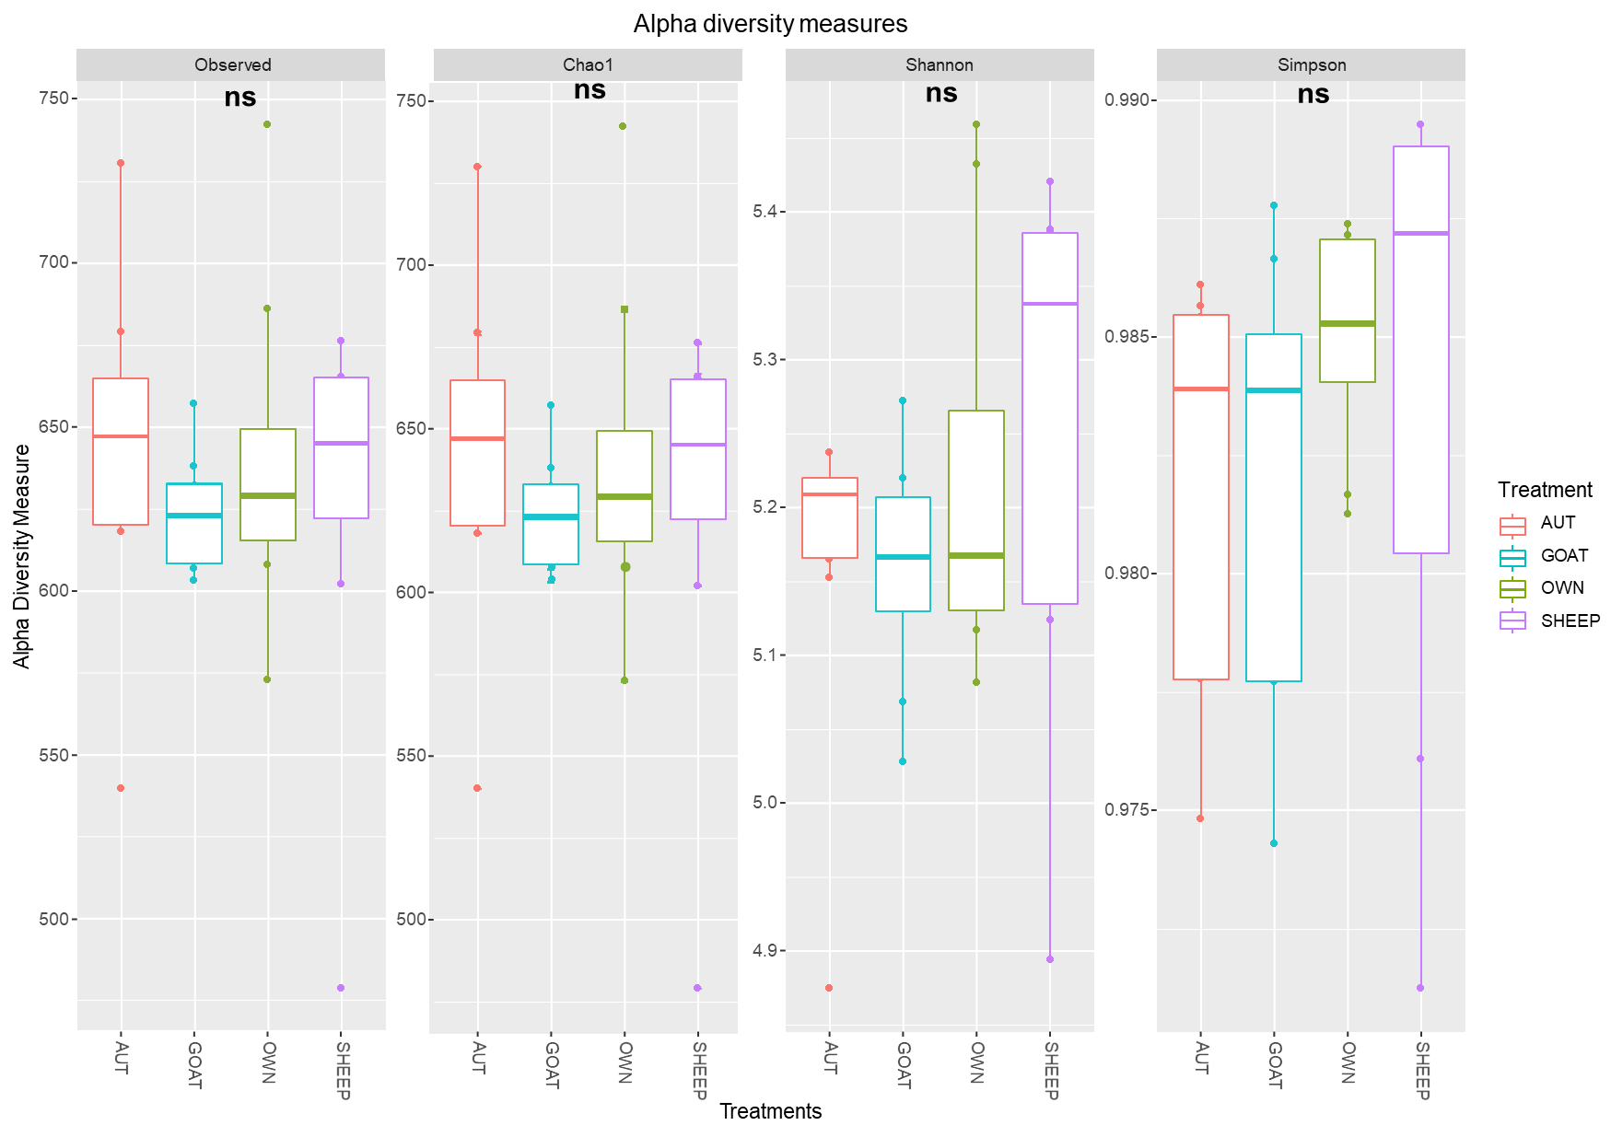
Supplementary Figure 1. Boxplots indicating the rumen prokaryotic alpha-diversity in terms of observed ASVs, Chao1, Shannon and Simpson indexes.

