Table (1): patients’ characteristics.
ID | Sex | age | Age  Cat. | LDL  chol | LDL  Cat | Homa  2-IR | Homa  Cat | BMI | BMI  cat | Sys  pre | Sys  cat | Dias  pre | Dias  cat
1 | 0 | 27 | 1 | 59.89 | 1 | 0.49 | 1 | 20.30 | 1 | 123.40 | 1 | 70.00 | 1
2 | 0 | 27 | 1 | 62.18 | 1 | 0.63 | 1 | 20.39 | 1 | 124.18 | 1 | 70.96 | 1
3 | 0 | 29 | 1 | 63.65 | 1 | 0.65 | 1 | 22.21 | 1 | 125.90 | 1 | 71.78 | 1
4 | 0 | 29 | 1 | 65.81 | 1 | 0.84 | 1 | 22.50 | 1 | 126.18 | 1 | 71.91 | 1
5 | 0 | 30 | 1 | 69.79 | 1 | 1.05 | 1 | 23.14 | 1 | 130.08 | 2 | 73.52 | 1
6 | 0 | 31 | 1 | 70.11 | 2 | 1.06 | 1 | 23.18 | 1 | 130.43 | 2 | 73.89 | 1
7 | 0 | 31 | 1 | 70.60 | 2 | 1.08 | 1 | 23.35 | 1 | 132.98 | 2 | 74.24 | 1
8 | 0 | 32 | 1 | 71.74 | 2 | 1.09 | 1 | 23.36 | 1 | 133.19 | 2 | 74.61 | 1
9 | 1 | 33 | 1 | 74.00 | 2 | 1.13 | 1 | 23.52 | 1 | 135.13 | 2 | 74.70 | 1
10 | 0 | 34 | 1 | 74.63 | 2 | 1.19 | 1 | 23.70 | 1 | 135.27 | 2 | 75.54 | 1
11 | 0 | 34 | 1 | 74.72 | 2 | 1.29 | 2 | 23.85 | 1 | 135.50 | 2 | 76.49 | 1
12 | 0 | 34 | 1 | 75.17 | 2 | 1.32 | 2 | 24.18 | 1 | 135.66 | 2 | 76.52 | 1
13 | 0 | 34 | 1 | 75.18 | 2 | 1.34 | 2 | 24.23 | 1 | 136.00 | 2 | 77.16 | 1
14 | 0 | 34 | 1 | 75.23 | 2 | 1.42 | 2 | 24.29 | 1 | 136.10 | 2 | 79.35 | 1
15 | 0 | 34 | 1 | 75.62 | 2 | 1.43 | 2 | 24.36 | 1 | 136.90 | 2 | 79.74 | 1
16 | 0 | 35 | 1 | 76.18 | 2 | 1.45 | 2 | 24.44 | 1 | 137.08 | 2 | 80.02 | 1
17 | 0 | 35 | 1 | 76.24 | 2 | 1.45 | 2 | 24.54 | 1 | 137.09 | 2 | 80.16 | 1
18 | 0 | 35 | 1 | 76.30 | 2 | 1.46 | 2 | 24.61 | 1 | 137.56 | 2 | 80.75 | 1
19 | 0 | 35 | 1 | 76.70 | 2 | 1.46 | 2 | 24.62 | 1 | 138.07 | 2 | 80.85 | 1
20 | 0 | 35 | 1 | 77.59 | 2 | 1.51 | 2 | 24.64 | 1 | 138.32 | 2 | 82.06 | 1
21 | 0 | 35 | 1 | 77.71 | 2 | 1.54 | 2 | 24.91 | 1 | 138.59 | 2 | 82.10 | 1
22 | 0 | 35 | 1 | 77.95 | 2 | 1.54 | 2 | 24.92 | 1 | 139.01 | 2 | 82.32 | 1
23 | 0 | 36 | 2 | 78.06 | 2 | 1.59 | 2 | 25.06 | 2 | 139.18 | 2 | 82.49 | 1
24 | 0 | 36 | 2 | 78.26 | 2 | 1.62 | 2 | 25.10 | 2 | 139.42 | 2 | 82.77 | 1
25 | 0 | 36 | 2 | 78.44 | 2 | 1.62 | 2 | 25.12 | 2 | 139.89 | 2 | 83.11 | 1
26 | 0 | 36 | 2 | 79.18 | 2 | 1.63 | 2 | 25.13 | 2 | 139.91 | 2 | 83.43 | 1
27 | 0 | 36 | 2 | 79.34 | 2 | 1.64 | 2 | 25.18 | 2 | 140.56 | 2 | 83.54 | 1
28 | 0 | 36 | 2 | 79.90 | 2 | 1.64 | 2 | 25.29 | 2 | 140.70 | 2 | 83.81 | 1
29 | 0 | 36 | 2 | 80.23 | 2 | 1.65 | 2 | 25.61 | 2 | 140.72 | 2 | 83.84 | 1
30 | 0 | 36 | 2 | 80.54 | 2 | 1.65 | 2 | 25.70 | 2 | 141.08 | 2 | 84.51 | 1
31 | 0 | 36 | 2 | 80.79 | 2 | 1.67 | 2 | 25.71 | 2 | 141.14 | 2 | 84.66 | 1
32 | 0 | 36 | 2 | 80.95 | 2 | 1.67 | 2 | 25.73 | 2 | 141.30 | 2 | 84.77 | 1
33 | 0 | 36 | 2 | 81.40 | 2 | 1.68 | 2 | 25.80 | 2 | 141.74 | 2 | 84.94 | 1
34 | 0 | 36 | 2 | 81.52 | 2 | 1.69 | 2 | 25.83 | 2 | 142.02 | 2 | 85.05 | 2
35 | 0 | 36 | 2 | 81.63 | 2 | 1.69 | 2 | 25.96 | 2 | 142.14 | 2 | 85.08 | 2
36 | 0 | 36 | 2 | 81.64 | 2 | 1.71 | 2 | 25.98 | 2 | 142.27 | 2 | 85.97 | 2
37 | 0 | 37 | 2 | 81.8 | 2 | 1.73 | 2 | 26.03 | 2 | 142.75 | 2 | 86.08 | 2
38 | 0 | 37 | 2 | 82.10 | 2 | 1.73 | 2 | 26.05 | 2 | 142.88 | 2 | 86.34 | 2
39 | 0 | 37 | 2 | 82.73 | 2 | 1.74 | 2 | 26.20 | 2 | 143.64 | 2 | 86.78 | 2
40 | 0 | 37 | 2 | 83.19 | 2 | 1.78 | 2 | 26.25 | 2 | 143.65 | 2 | 87.11 | 2
41 | 0 | 37 | 2 | 83.51 | 2 | 1.78 | 2 | 26.35 | 2 | 143.84 | 2 | 87.38 | 2
42 | 0 | 37 | 2 | 83.88 | 2 | 1.82 | 2 | 26.36 | 2 | 143.90 | 2 | 87.50 | 2
43 | 0 | 37 | 2 | 83.91 | 2 | 1.83 | 2 | 26.44 | 2 | 144.10 | 2 | 88.10 | 2
44 | 0 | 37 | 2 | 84.40 | 2 | 1.86 | 2 | 26.65 | 2 | 144.15 | 2 | 88.17 | 2
45 | 0 | 37 | 2 | 85.18 | 2 | 1.87 | 2 | 26.67 | 2 | 144.35 | 2 | 88.77 | 2
46 | 0 | 38 | 2 | 86.24 | 2 | 1.87 | 2 | 26.78 | 2 | 144.51 | 2 | 88.78 | 2
47 | 0 | 38 | 2 | 86.42 | 2 | 1.92 | 2 | 26.81 | 2 | 144.52 | 2 | 89.01 | 2
48 | 0 | 38 | 2 | 86.97 | 2 | 1.92 | 2 | 26.96 | 2 | 144.74 | 2 | 89.32 | 2
49 | 0 | 38 | 2 | 87.03 | 2 | 1.93 | 2 | 27.11 | 2 | 145.11 | 2 | 89.34 | 2
50 | 0 | 38 | 2 | 87.21 | 2 | 1.94 | 2 | 27.11 | 2 | 145.17 | 2 | 89.38 | 2
51 | 1 | 38 | 2 | 87.60 | 2 | 1.94 | 2 | 27.13 | 2 | 145.63 | 2 | 89.50 | 2
52 | 1 | 38 | 2 | 87.65 | 2 | 1.95 | 2 | 27.31 | 2 | 145.78 | 2 | 89.53 | 2
ID | Sex | age | Age  Cat. | LDL-chol | LDL Cat. | HOMA2-IR | Homa Cat. | BMI | BMI Cat. | Sys. Pre. | Sys.  Cat. | Dias.  Pre. | Dias  Cat.
53 | 1 | 38 | 2 | 88.22 | 2 | 1.95 | 2 | 27.31 | 2 | 145.84 | 2 | 89.56 | 2
54 | 1 | 39 | 2 | 88.34 | 2 | 1.96 | 2 | 27.34 | 2 | 145.85 | 2 | 89.82 | 2
55 | 1 | 39 | 2 | 88.74 | 2 | 1.96 | 2 | 27.36 | 2 | 145.95 | 2 | 89.95 | 2
56 | 1 | 39 | 2 | 89.00 | 2 | 1.99 | 2 | 27.42 | 2 | 146.00 | 2 | 90.18 | 2
57 | 1 | 39 | 2 | 89.31 | 2 | 2.03 | 2 | 27.43 | 2 | 146.44 | 2 | 90.34 | 2
58 | 1 | 39 | 2 | 90.06 | 2 | 2.03 | 2 | 27.45 | 2 | 146.60 | 2 | 90.87 | 2
59 | 1 | 39 | 2 | 90.42 | 2 | 2.05 | 2 | 27.51 | 2 | 146.73 | 2 | 90.92 | 2
60 | 1 | 39 | 2 | 90.67 | 2 | 2.07 | 2 | 27.54 | 2 | 146.74 | 2 | 91.06 | 2
61 | 1 | 39 | 2 | 90.92 | 2 | 2.08 | 2 | 27.64 | 2 | 146.88 | 2 | 91.07 | 2
62 | 1 | 39 | 2 | 91.45 | 2 | 2.10 | 2 | 27.76 | 2 | 146.91 | 2 | 91.12 | 2
63 | 1 | 39 | 2 | 91.74 | 2 | 2.12 | 2 | 27.78 | 2 | 147.31 | 2 | 91.30 | 2
64 | 1 | 39 | 2 | 92.51 | 2 | 2.13 | 2 | 27.79 | 2 | 147.39 | 2 | 91.32 | 2
65 | 1 | 39 | 2 | 92.73 | 2 | 2.15 | 2 | 27.80 | 2 | 147.39 | 2 | 91.45 | 2
66 | 1 | 40 | 2 | 92.90 | 2 | 2.15 | 2 | 27.85 | 2 | 147.77 | 2 | 91.50 | 2
67 | 1 | 40 | 2 | 92.90 | 2 | 2.16 | 2 | 27.87 | 2 | 148.11 | 2 | 91.60 | 2
68 | 1 | 40 | 2 | 93.15 | 2 | 2.17 | 2 | 28.02 | 2 | 148.21 | 2 | 91.61 | 2
69 | 1 | 40 | 2 | 93.18 | 2 | 2.19 | 2 | 28.02 | 2 | 148.23 | 2 | 91.67 | 2
70 | 1 | 40 | 2 | 93.54 | 2 | 2.19 | 2 | 28.11 | 2 | 148.27 | 2 | 91.70 | 2
71 | 1 | 40 | 2 | 93.57 | 2 | 2.20 | 2 | 28.28 | 2 | 148.37 | 2 | 92.01 | 2
72 | 1 | 40 | 2 | 93.97 | 2 | 2.21 | 2 | 28.32 | 2 | 148.85 | 2 | 92.04 | 2
73 | 1 | 40 | 2 | 94.15 | 2 | 2.23 | 2 | 28.35 | 2 | 149.01 | 2 | 92.99 | 2
74 | 1 | 40 | 2 | 94.27 | 2 | 2.24 | 2 | 28.36 | 2 | 149.08 | 2 | 93.62 | 2
75 | 1 | 40 | 2 | 94.57 | 2 | 2.25 | 2 | 28.38 | 2 | 149.38 | 2 | 93.99 | 2
76 | 1 | 40 | 2 | 94.68 | 2 | 2.28 | 2 | 28.42 | 2 | 149.44 | 2 | 94.15 | 2
77 | 1 | 40 | 2 | 94.73 | 2 | 2.29 | 2 | 28.45 | 2 | 149.69 | 2 | 94.28 | 2
78 | 1 | 40 | 2 | 94.81 | 2 | 2.30 | 2 | 28.45 | 2 | 149.96 | 2 | 94.65 | 2
79 | 1 | 40 | 2 | 95.22 | 2 | 2.31 | 2 | 28.49 | 2 | 149.98 | 2 | 94.68 | 2
80 | 1 | 41 | 2 | 95.32 | 2 | 2.33 | 2 | 28.61 | 2 | 150.00 | 2 | 94.95 | 2
81 | 1 | 41 | 2 | 95.81 | 2 | 2.33 | 2 | 28.61 | 2 | 150.03 | 2 | 95.50 | 2
82 | 1 | 41 | 2 | 95.88 | 2 | 2.36 | 2 | 28.62 | 2 | 150.47 | 2 | 95.68 | 2
83 | 1 | 41 | 2 | 96.00 | 2 | 2.36 | 2 | 28.62 | 2 | 150.63 | 2 | 95.72 | 2
84 | 1 | 41 | 2 | 96.11 | 2 | 2.37 | 2 | 28.67 | 2 | 150.76 | 2 | 95.92 | 2
85 | 1 | 41 | 2 | 96.40 | 2 | 2.39 | 2 | 28.71 | 2 | 150.84 | 2 | 96.07 | 2
86 | 1 | 41 | 2 | 96.77 | 2 | 2.39 | 2 | 28.76 | 2 | 150.86 | 2 | 96.34 | 2
87 | 1 | 41 | 2 | 96.81 | 2 | 2.40 | 2 | 28.81 | 2 | 150.91 | 2 | 96.48 | 2
88 | 1 | 41 | 2 | 96.90 | 2 | 2.41 | 2 | 28.92 | 2 | 150.92 | 2 | 96.52 | 2
89 | 1 | 41 | 2 | 96.91 | 2 | 2.42 | 2 | 28.99 | 2 | 151.06 | 2 | 96.61 | 2
90 | 1 | 41 | 2 | 97.55 | 2 | 2.43 | 2 | 29.10 | 2 | 151.58 | 2 | 96.78 | 2
91 | 1 | 41 | 2 | 97.58 | 2 | 2.46 | 2 | 29.11 | 2 | 151.69 | 2 | 97.16 | 2
92 | 1 | 41 | 2 | 97.82 | 2 | 2.47 | 2 | 29.14 | 2 | 152.01 | 2 | 97.39 | 2
93 | 1 | 41 | 2 | 98.19 | 2 | 2.51 | 2 | 29.17 | 2 | 152.49 | 2 | 97.51 | 2
94 | 1 | 41 | 2 | 98.65 | 2 | 2.54 | 2 | 29.18 | 2 | 152.54 | 2 | 97.58 | 2
95 | 1 | 42 | 2 | 98.68 | 2 | 2.56 | 2 | 29.34 | 2 | 153.38 | 2 | 98.40 | 2
96 | 1 | 42 | 2 | 99.00 | 2 | 2.58 | 2 | 29.37 | 2 | 153.46 | 2 | 98.42 | 2
97 | 1 | 42 | 2 | 99.47 | 2 | 2.58 | 2 | 29.41 | 2 | 153.50 | 2 | 98.49 | 2
98 | 1 | 42 | 2 | 99.57 | 2 | 2.59 | 2 | 29.41 | 2 | 153.63 | 2 | 98.93 | 2
99 | 1 | 42 | 2 | 100.28 | 3 | 2.61 | 2 | 29.60 | 2 | 153.91 | 2 | 99.20 | 2
100 | 1 | 42 | 2 | 100.57 | 3 | 2.64 | 2 | 29.72 | 2 | 153.94 | 2 | 99.39 | 2
101 | 1 | 42 | 2 | 100.60 | 3 | 2.65 | 2 | 29.80 | 2 | 154.46 | 2 | 99.72 | 2
102 | 1 | 42 | 2 | 101.85 | 3 | 2.68 | 2 | 29.94 | 2 | 154.56 | 2 | 99.74 | 2
ID | Sex | age | Age  Cat. | LDL  chol | LDL  Cat. | Homa  2-IR | Homa  Cat. | BMI | BMI  Cat. | Sys  Pre. | Sys  Cat. | Dias  Pre. | Dias  Cat.
103 | 1 | 42 | 2 | 101.95 | 3 | 2.69 | 2 | 29.97 | 2 | 154.82 | 2 | 100.16 | 3
104 | 1 | 42 | 2 | 102.25 | 3 | 2.70 | 3 | 29.97 | 2 | 154.84 | 2 | 100.45 | 3
105 | 1 | 43 | 2 | 102.91 | 3 | 2.71 | 3 | 29.97 | 2 | 155.02 | 2 | 100.54 | 3
106 | 1 | 43 | 2 | 103.48 | 3 | 2.72 | 3 | 30.00 | 3 | 155.03 | 2 | 100.95 | 3
107 | 1 | 43 | 2 | 104.09 | 3 | 2.72 | 3 | 30.03 | 3 | 155.41 | 2 | 100.98 | 3
108 | 1 | 43 | 2 | 104.37 | 3 | 2.74 | 3 | 30.11 | 3 | 155.50 | 2 | 101.08 | 3
109 | 1 | 43 | 2 | 104.39 | 3 | 2.75 | 3 | 30.15 | 3 | 155.57 | 2 | 101.08 | 3
110 | 1 | 43 | 2 | 104.58 | 3 | 2.76 | 3 | 30.18 | 3 | 155.59 | 2 | 101.14 | 3
111 | 0 | 43 | 2 | 104.66 | 3 | 2.77 | 3 | 30.28 | 3 | 155.63 | 2 | 101.34 | 3
112 | 0 | 43 | 2 | 104.72 | 3 | 2.77 | 3 | 30.34 | 3 | 155.96 | 2 | 101.66 | 3
113 | 0 | 44 | 2 | 104.85 | 3 | 2.78 | 3 | 30.35 | 3 | 155.97 | 2 | 101.66 | 3
114 | 0 | 44 | 2 | 104.92 | 3 | 2.79 | 3 | 30.36 | 3 | 156.53 | 2 | 101.77 | 3
115 | 0 | 44 | 2 | 105.04 | 3 | 2.79 | 3 | 30.42 | 3 | 156.62 | 2 | 101.84 | 3
116 | 0 | 44 | 2 | 105.77 | 3 | 2.81 | 3 | 30.46 | 3 | 156.97 | 2 | 101.87 | 3
117 | 0 | 44 | 2 | 106.05 | 3 | 2.82 | 3 | 30.52 | 3 | 157.23 | 2 | 102.14 | 3
118 | 0 | 44 | 2 | 106.32 | 3 | 2.84 | 3 | 30.54 | 3 | 157.36 | 2 | 102.32 | 3
119 | 0 | 44 | 2 | 106.36 | 3 | 2.86 | 3 | 30.55 | 3 | 157.53 | 2 | 102.93 | 3
120 | 0 | 44 | 2 | 106.50 | 3 | 2.87 | 3 | 30.63 | 3 | 157.67 | 2 | 103.46 | 3
121 | 0 | 44 | 2 | 106.60 | 3 | 2.87 | 3 | 30.74 | 3 | 158.72 | 2 | 103.61 | 3
122 | 0 | 44 | 2 | 108.32 | 3 | 2.87 | 3 | 31.00 | 3 | 158.92 | 2 | 103.73 | 3
123 | 0 | 45 | 2 | 108.59 | 3 | 2.88 | 3 | 31.12 | 3 | 159.14 | 2 | 103.75 | 3
124 | 0 | 45 | 2 | 108.82 | 3 | 2.91 | 3 | 31.18 | 3 | 159.54 | 2 | 104.41 | 3
125 | 0 | 45 | 2 | 108.92 | 3 | 2.94 | 3 | 31.19 | 3 | 159.60 | 2 | 104.98 | 3
126 | 0 | 45 | 2 | 109.36 | 3 | 2.95 | 3 | 31.24 | 3 | 159.73 | 2 | 105.40 | 3
127 | 0 | 45 | 2 | 109.44 | 3 | 2.99 | 3 | 31.34 | 3 | 159.83 | 2 | 105.58 | 3
128 | 0 | 45 | 2 | 110.00 | 3 | 3.03 | 3 | 31.35 | 3 | 160.49 | 3 | 105.80 | 3
129 | 0 | 45 | 2 | 111.71 | 3 | 3.04 | 3 | 31.35 | 3 | 161.40 | 3 | 106.17 | 3
130 | 0 | 45 | 2 | 112.73 | 3 | 3.05 | 3 | 31.39 | 3 | 161.58 | 3 | 106.43 | 3
131 | 1 | 45 | 2 | 112.96 | 3 | 3.05 | 3 | 31.47 | 3 | 161.62 | 3 | 106.51 | 3
132 | 1 | 46 | 3 | 113.07 | 3 | 3.06 | 3 | 31.51 | 3 | 161.78 | 3 | 107.06 | 3
133 | 1 | 46 | 3 | 113.08 | 3 | 3.08 | 3 | 31.56 | 3 | 162.26 | 3 | 108.16 | 3
134 | 1 | 47 | 3 | 113.50 | 3 | 3.08 | 3 | 31.67 | 3 | 162.37 | 3 | 108.61 | 3
135 | 1 | 47 | 3 | 113.97 | 3 | 3.13 | 3 | 31.75 | 3 | 162.53 | 3 | 109.79 | 3
136 | 1 | 47 | 3 | 115.21 | 3 | 3.13 | 3 | 31.94 | 3 | 163.57 | 3 | 110.16 | 3
137 | 1 | 47 | 3 | 116.16 | 3 | 3.21 | 3 | 32.18 | 3 | 163.78 | 3 | 110.53 | 3
138 | 1 | 47 | 3 | 116.90 | 3 | 3.24 | 3 | 32.20 | 3 | 164.47 | 3 | 110.68 | 3
139 | 1 | 47 | 3 | 118.37 | 3 | 3.33 | 3 | 32.31 | 3 | 164.93 | 3 | 112.09 | 3
140 | 1 | 47 | 3 | 118.75 | 3 | 3.36 | 3 | 32.71 | 3 | 164.93 | 3 | 112.44 | 3
141 | 1 | 48 | 3 | 121.35 | 3 | 3.36 | 3 | 32.87 | 3 | 165.41 | 3 | 113.56 | 3
142 | 1 | 48 | 3 | 123.60 | 3 | 3.36 | 3 | 32.91 | 3 | 165.96 | 3 | 114.21 | 3
143 | 1 | 49 | 3 | 123.70 | 3 | 3.45 | 3 | 33.17 | 3 | 167.51 | 3 | 114.27 | 3
144 | 1 | 49 | 3 | 124.69 | 3 | 3.52 | 3 | 33.73 | 3 | 168.68 | 3 | 114.77 | 3
145 | 1 | 49 | 3 | 124.96 | 3 | 3.60 | 3 | 33.93 | 3 | 169.07 | 3 | 115.36 | 3
146 | 1 | 50 | 3 | 127.56 | 3 | 3.65 | 3 | 34.29 | 3 | 170.23 | 3 | 117.39 | 3
147 | 1 | 51 | 3 | 127.83 | 3 | 3.70 | 3 | 34.59 | 3 | 173.73 | 3 | 117.88 | 3
148 | 1 | 51 | 3 | 131.57 | 3 | 3.78 | 3 | 34.95 | 3 | 175.61 | 3 | 118.11 | 3
149 | 1 | 51 | 3 | 131.89 | 3 | 3.82 | 3 | 35.09 | 3 | 175.59 | 3 | 119.27 | 3
150 | 1 | 53 | 3 | 133.13 | 3 | 4.36 | 3 | 35.16 | 3 | 175.75 | 3 | 124.04 | 3
The following table are the actual data used in Stata 14 software, not the above rounded values. The above values are only used for the space to demonstrate all the variables and corresponding category each participant belong to.
patient_ID | LDL_chol | HOMA2_IR | BMI | sysBloodPr | diastBloodPressure
1 | 59.88626253 | 0.486660227 | 20.30083374 | 123.4009178 | 69.99634935
2 | 62.17804017 | 0.625517898 | 20.38539827 | 124.1760587 | 70.95836483
3 | 63.65385754 | 0.648810155 | 22.20504654 | 125.8975997 | 71.77720889
4 | 65.80681914 | 0.835501959 | 22.50371191 | 126.1787116 | 71.90626924
5 | 69.79260909 | 1.048423757 | 23.13687005 | 130.0785608 | 73.51626359
6 | 70.10500285 | 1.063198485 | 23.18066959 | 130.4312855 | 73.89087266
7 | 70.5951389 | 1.082373227 | 23.34615748 | 132.9771952 | 74.24442658
8 | 71.73608315 | 1.09242144 | 23.3553593 | 133.1941031 | 74.60984969
9 | 73.99519667 | 1.129448668 | 23.51913306 | 135.1296929 | 74.69569464
10 | 74.63244092 | 1.189798489 | 23.7000037 | 135.2716671 | 75.54314352
11 | 74.71785909 | 1.29368181 | 23.84731358 | 135.4981258 | 76.48721248
12 | 75.17096758 | 1.324724984 | 24.18061722 | 135.6569022 | 76.52476289
13 | 75.18235196 | 1.335093535 | 24.23270373 | 136.0038509 | 77.16186785
14 | 75.23138391 | 1.422111938 | 24.28506674 | 136.0953597 | 79.34849803
15 | 75.61753709 | 1.432224008 | 24.36230869 | 136.9038556 | 79.73530992
16 | 76.18401022 | 1.453228249 | 24.44359033 | 137.0809407 | 80.01683653
17 | 76.24358806 | 1.453815821 | 24.53815568 | 137.0869254 | 80.15864331
18 | 76.29881294 | 1.456305613 | 24.61359837 | 137.5649291 | 80.74565456
19 | 76.69659462 | 1.464666603 | 24.61722818 | 138.0735912 | 80.85114089
20 | 77.58989329 | 1.51356061 | 24.64186842 | 138.3241151 | 82.05654214
21 | 77.70521508 | 1.536136161 | 24.9131702 | 138.5853047 | 82.1038819
22 | 77.94998599 | 1.544577706 | 24.92131773 | 139.008886 | 82.31728002
23 | 78.05838748 | 1.586554018 | 25.06314382 | 139.181514 | 82.48948116
24 | 78.25702966 | 1.617951836 | 25.09951711 | 139.4240568 | 82.76779198
25 | 78.4403701 | 1.619881 | 25.11813044 | 139.889396 | 83.11299612
26 | 79.17897107 | 1.626478279 | 25.13316489 | 139.9072013 | 83.42940556
27 | 79.34469678 | 1.639802471 | 25.17546941 | 140.5566385 | 83.53598548
28 | 79.90002937 | 1.640401777 | 25.28627577 | 140.7048667 | 83.80597309
29 | 80.23286431 | 1.650270486 | 25.60867263 | 140.7248329 | 83.83555089
30 | 80.53759625 | 1.651985736 | 25.70466017 | 141.0786766 | 84.5109185
31 | 80.78692327 | 1.665993018 | 25.71210314 | 141.1392888 | 84.6618672
32 | 80.95179537 | 1.666095395 | 25.73388846 | 141.3048354 | 84.77066523
33 | 81.39997551 | 1.676923007 | 25.80137142 | 141.7431129 | 84.94485471
34 | 81.5230473 | 1.694165523 | 25.83013284 | 142.0180379 | 85.04737784
35 | 81.6333478 | 1.694587966 | 25.95726452 | 142.1419579 | 85.08232589
36 | 81.63910707 | 1.7096777 | 25.9830848 | 142.2669347 | 85.9701009
37 | 81.79551762 | 1.728720127 | 26.03356639 | 142.7497928 | 86.07727811
38 | 82.09730138 | 1.732354693 | 26.05377139 | 142.8777895 | 86.33759816
39 | 82.72673203 | 1.738136697 | 26.19980058 | 143.6355794 | 86.78184428
40 | 83.19282441 | 1.775434606 | 26.25343572 | 143.6518685 | 87.11256427
41 | 83.51015721 | 1.780812997 | 26.35494787 | 143.8440352 | 87.37727918
42 | 83.87801001 | 1.821641325 | 26.3591208 | 143.904684 | 87.49567067
43 | 83.90994145 | 1.831844486 | 26.44070213 | 144.0988788 | 88.0956395
44 | 84.40043839 | 1.862877807 | 26.65017692 | 144.1541475 | 88.16578459
45 | 85.17501733 | 1.86912154 | 26.66541993 | 144.3474132 | 88.76568544
46 | 86.24150134 | 1.872825229 | 26.78361722 | 144.509008 | 88.7825505
47 | 86.41587725 | 1.916601042 | 26.812301 | 144.5242085 | 89.0125243
48 | 86.96738711 | 1.92222757 | 26.96295086 | 144.7370245 | 89.31527986
49 | 87.02828486 | 1.932907728 | 27.11405208 | 145.1060697 | 89.33794082
50 | 87.21342521 | 1.939328867 | 27.11442109 | 145.1690792 | 89.38452095
51 | 87.59738179 | 1.941058513 | 27.12546756 | 145.6324734 | 89.5019489
52 | 87.65253761 | 1.951682018 | 27.30688699 | 145.7802001 | 89.5308856

53 | 88.21762356 | 1.952190865 | 27.30755139 | 145.8370062 | 89.55774174
54 | 88.34186837 | 1.958971905 | 27.34284662 | 145.8501257 | 89.81576935
55 | 88.7409777 | 1.962141305 | 27.36056248 | 145.9489973 | 89.95193185
56 | 88.99684398 | 1.989914501 | 27.42257654 | 145.9993347 | 90.17512035
57 | 89.31278846 | 2.02697825 | 27.43065895 | 146.4363352 | 90.33968778
58 | 90.05869996 | 2.033050053 | 27.45034168 | 146.6040765 | 90.86615116
59 | 90.42098152 | 2.052561065 | 27.50839688 | 146.7290227 | 90.91646661
60 | 90.66844195 | 2.065170296 | 27.54237172 | 146.7365686 | 91.06059405
61 | 90.91962854 | 2.082371342 | 27.63616749 | 146.8836997 | 91.07330339
62 | 91.45092179 | 2.098034701 | 27.75959177 | 146.9104233 | 91.12413523
63 | 91.73729771 | 2.1191684 | 27.78172501 | 147.3086787 | 91.29977663
64 | 92.51302825 | 2.132822463 | 27.79279514 | 147.3877559 | 91.32199752
65 | 92.73033242 | 2.147590744 | 27.7992254 | 147.3889239 | 91.44767437
66 | 92.90181516 | 2.15186423 | 27.84995994 | 147.7746667 | 91.49574549
67 | 92.90450229 | 2.159333468 | 27.86907689 | 148.1125105 | 91.60054843
68 | 93.15072278 | 2.170694946 | 28.01690012 | 148.2112376 | 91.61239313
69 | 93.18080864 | 2.187319216 | 28.01932658 | 148.2342406 | 91.66833284
70 | 93.53782288 | 2.190678916 | 28.11007119 | 148.2676521 | 91.69940127
71 | 93.5737695 | 2.196355685 | 28.28004598 | 148.3681924 | 92.00989498
72 | 93.96977742 | 2.211907172 | 28.31709791 | 148.8537684 | 92.04176836
73 | 94.14544773 | 2.226152678 | 28.34828762 | 149.0057149 | 92.99337843
74 | 94.26851067 | 2.240807892 | 28.36225579 | 149.0833154 | 93.62273135
75 | 94.57093547 | 2.250136361 | 28.37706409 | 149.3803847 | 93.98582303
76 | 94.68147986 | 2.276625971 | 28.42003727 | 149.4410218 | 94.14513547
77 | 94.73162406 | 2.291658478 | 28.44672231 | 149.6870214 | 94.28270759
78 | 94.8091201 | 2.300868336 | 28.45466819 | 149.9554549 | 94.64978228
79 | 95.22476536 | 2.307544036 | 28.4938252 | 149.9772856 | 94.67519469
80 | 95.31849196 | 2.326027215 | 28.6073615 | 150.0036963 | 94.95138569
81 | 95.80827063 | 2.332456523 | 28.60853748 | 150.0317356 | 95.504466
82 | 95.87960534 | 2.35945621 | 28.62039083 | 150.4667957 | 95.68060593
83 | 96.00168055 | 2.359833761 | 28.62136969 | 150.6259156 | 95.72396957
84 | 96.10649581 | 2.373084069 | 28.67169603 | 150.7608258 | 95.92103971
85 | 96.40483791 | 2.387931316 | 28.70849209 | 150.8378482 | 96.06573604
86 | 96.76889879 | 2.390069935 | 28.76101083 | 150.8610255 | 96.34116959
87 | 96.80646738 | 2.399277902 | 28.80966656 | 150.905197 | 96.47836375
88 | 96.90122271 | 2.411984544 | 28.92018631 | 150.9217811 | 96.51952908
89 | 96.90967787 | 2.4218036 | 28.9943167 | 151.0591804 | 96.60639678
90 | 97.54518517 | 2.425332347 | 29.10458361 | 151.5783406 | 96.78398633
91 | 97.57532315 | 2.464533455 | 29.11393665 | 151.6895192 | 97.16179582
92 | 97.82240849 | 2.472015524 | 29.14182311 | 152.0147919 | 97.38518017
93 | 98.19383152 | 2.512852519 | 29.17354849 | 152.4897552 | 97.50577044
94 | 98.65168935 | 2.538669397 | 29.17974603 | 152.5383571 | 97.583515
95 | 98.67628649 | 2.557198677 | 29.33804648 | 153.3760363 | 98.40263236
96 | 99.000552 | 2.579092668 | 29.37220989 | 153.4606462 | 98.42450822
97 | 99.47036072 | 2.583321929 | 29.40508095 | 153.4953371 | 98.4857294
98 | 99.56796044 | 2.589431917 | 29.40925322 | 153.6290617 | 98.93001208
99 | 100.2809094 | 2.610692002 | 29.60369794 | 153.9099293 | 99.20391047
100 | 100.5717195 | 2.636885226 | 29.71572889 | 153.9424972 | 99.38911282
101 | 100.6047924 | 2.651751393 | 29.79977925 | 154.4560393 | 99.71821712
102 | 101.8494775 | 2.678843061 | 29.93617461 | 154.558702 | 99.7448965

103 | 101.9492914 | 2.69069223 | 29.96661684 | 154.8245324 | 100.1596441
104 | 102.2515504 | 2.698054556 | 29.96835067 | 154.837513 | 100.4489565
105 | 102.9114573 | 2.708479035 | 29.96957974 | 155.019825 | 100.5387061
106 | 103.4806938 | 2.71543582 | 30.00466141 | 155.0302859 | 100.9490535
107 | 104.0881578 | 2.720640069 | 30.03225126 | 155.4068362 | 100.9756056
108 | 104.3713252 | 2.736640518 | 30.10960076 | 155.4976388 | 101.0822111
109 | 104.3914483 | 2.748266639 | 30.14865929 | 155.5674547 | 101.0830179
110 | 104.5798686 | 2.758139944 | 30.18347007 | 155.5914364 | 101.1394993
111 | 104.6607348 | 2.768605796 | 30.27695636 | 155.6261913 | 101.3435673
112 | 104.7238725 | 2.772175859 | 30.33694066 | 155.9660494 | 101.6553383
113 | 104.8524726 | 2.784769065 | 30.34647086 | 155.972805 | 101.6564651
114 | 104.9203266 | 2.788978027 | 30.35791172 | 156.5262548 | 101.7654722
115 | 105.0374154 | 2.792846389 | 30.42338805 | 156.623788 | 101.8369263
116 | 105.7708525 | 2.813543425 | 30.45991065 | 156.9746708 | 101.8745766
117 | 106.0526701 | 2.8216319 | 30.52013788 | 157.2333107 | 102.1438818
118 | 106.3224205 | 2.836471693 | 30.54321084 | 157.3606742 | 102.3191044
119 | 106.3588698 | 2.86156774 | 30.54610609 | 157.5349887 | 102.9303476
120 | 106.4972799 | 2.870049811 | 30.62901275 | 157.6709272 | 103.4613788
121 | 106.604525 | 2.870113146 | 30.7433647 | 158.7207682 | 103.6144469
122 | 108.3227542 | 2.874031357 | 30.99738238 | 158.9222397 | 103.7258609
123 | 108.5904841 | 2.87941575 | 31.12302385 | 159.1374886 | 103.7531646
124 | 108.8231986 | 2.906358239 | 31.18244663 | 159.5381187 | 104.4083546
125 | 108.9212838 | 2.944579876 | 31.19197902 | 159.599158 | 104.9786418
126 | 109.3646854 | 2.946595176 | 31.24239694 | 159.7268598 | 105.3992209
127 | 109.443203 | 2.985029147 | 31.34270287 | 159.830625 | 105.5849072
128 | 110.0035342 | 3.027057171 | 31.34638621 | 160.4869579 | 105.8003815
129 | 111.7142213 | 3.0415236 | 31.35100678 | 161.3990233 | 106.1653939
130 | 112.727007 | 3.045917418 | 31.39241181 | 161.5790007 | 106.4294163
131 | 112.9599582 | 3.054332948 | 31.4744049 | 161.620505 | 106.5062134
132 | 113.0742184 | 3.059351383 | 31.51252628 | 161.7783022 | 107.0606273
133 | 113.0811469 | 3.080270062 | 31.56477963 | 162.2555993 | 108.1639294
134 | 113.5011891 | 3.082093216 | 31.6663631 | 162.3732048 | 108.6064678
135 | 113.9678215 | 3.12902167 | 31.74508879 | 162.5259587 | 109.7874429
136 | 115.2098298 | 3.133993 | 31.93917448 | 163.5672102 | 110.1637194
137 | 116.1608298 | 3.212666172 | 32.18283095 | 163.7750487 | 110.5316899
138 | 116.8971631 | 3.239904042 | 32.19956838 | 164.4663885 | 110.6818642
139 | 118.3710727 | 3.331810851 | 32.31424866 | 164.9260434 | 112.0894894
140 | 118.750906 | 3.361332552 | 32.70754103 | 164.9274447 | 112.4385468
141 | 121.3539927 | 3.361957484 | 32.86909366 | 165.4101566 | 113.5642057
142 | 123.6046089 | 3.363641715 | 32.90902767 | 165.9629702 | 114.2073523
143 | 123.6953321 | 3.44841049 | 33.17015687 | 167.5063644 | 114.2730905
144 | 124.6863766 | 3.520206957 | 33.72790263 | 168.6830254 | 114.7742868
145 | 124.9633003 | 3.600924971 | 33.9273159 | 169.066132 | 115.3553829
146 | 127.5631494 | 3.652359416 | 34.29045674 | 170.229292 | 117.3937688
147 | 127.8271221 | 3.697602312 | 34.58909385 | 173.7274296 | 117.8790236
148 | 131.5713536 | 3.782653123 | 34.95279071 | 175.6065684 | 118.1096726
149 | 131.8938225 | 3.815486059 | 35.0914694 | 175.5867168 | 119.268837
150 | 133.1308799 | 4.361195597 | 35.16374084 | 175.7543407 | 124.037896
Table (6): transition counts for each patient.
ID | 0→1 | 1→2 | 2→3 | 3→4 | 1→0 | 2→1 | 3→2 | 2→0 | 3→1
1 | 0 | 0 | 0 | 0 | 0 | 0 | 0 | 0 | 0
2 | 0 | 0 | 0 | 0 | 0 | 0 | 0 | 0 | 0
3 | 0 | 0 | 0 | 0 | 0 | 0 | 0 | 0 | 0
4 | 0 | 0 | 0 | 0 | 0 | 0 | 0 | 0 | 0
5 | 0 | 0 | 0 | 0 | 0 | 0 | 0 | 0 | 0
6 | 0 | 0 | 0 | 0 | 0 | 0 | 0 | 0 | 0
7 | 0 | 0 | 0 | 0 | 0 | 0 | 0 | 0 | 0
8 | 0 | 0 | 0 | 0 | 0 | 0 | 0 | 0 | 0
9 | 0 | 0 | 0 | 0 | 0 | 0 | 0 | 0 | 0
10 | 0 | 0 | 0 | 0 | 0 | 0 | 0 | 0 | 0
11 | 0 | 0 | 0 | 0 | 0 | 0 | 0 | 0 | 0
12 | 0 | 0 | 0 | 0 | 0 | 0 | 0 | 0 | 0
13 | 0 | 0 | 0 | 0 | 0 | 0 | 0 | 0 | 0
14 | 0 | 0 | 0 | 0 | 0 | 0 | 0 | 0 | 0
15 | 0 | 0 | 0 | 0 | 0 | 0 | 0 | 0 | 0
16 | 0 | 0 | 0 | 0 | 0 | 0 | 0 | 0 | 0
17 | 0 | 0 | 0 | 0 | 0 | 0 | 0 | 0 | 0
18 | 0 | 0 | 0 | 0 | 0 | 0 | 0 | 0 | 0
19 | 0 | 0 | 0 | 0 | 0 | 0 | 0 | 0 | 0
20 | 0 | 0 | 0 | 0 | 0 | 0 | 0 | 0 | 0
21 | 0 | 0 | 0 | 0 | 0 | 0 | 0 | 0 | 0
22 | 0 | 0 | 0 | 0 | 0 | 0 | 0 | 0 | 0
23 | 0 | 0 | 0 | 0 | 0 | 0 | 0 | 0 | 0
24 | 0 | 0 | 0 | 0 | 0 | 0 | 0 | 0 | 0
25 | 0 | 0 | 0 | 0 | 0 | 0 | 0 | 0 | 0
26 | 0 | 0 | 0 | 0 | 0 | 0 | 0 | 0 | 0
27 | 0 | 0 | 0 | 0 | 0 | 0 | 0 | 0 | 0
28 | 0 | 0 | 0 | 0 | 0 | 0 | 0 | 0 | 0
29 | 0 | 0 | 0 | 0 | 0 | 0 | 0 | 0 | 0
30 | 0 | 0 | 0 | 0 | 0 | 0 | 0 | 0 | 0
31 | 0 | 0 | 0 | 0 | 0 | 0 | 0 | 0 | 0
32 | 0 | 0 | 0 | 0 | 0 | 0 | 0 | 0 | 0
33 | 0 | 0 | 0 | 0 | 0 | 0 | 0 | 0 | 0
34 | 0 | 0 | 0 | 0 | 0 | 0 | 0 | 0 | 0
35 | 0 | 0 | 0 | 0 | 0 | 0 | 0 | 0 | 0
36 | 0 | 0 | 0 | 0 | 0 | 0 | 0 | 0 | 0
37 | 0 | 0 | 0 | 0 | 0 | 0 | 0 | 0 | 0
38 | 0 | 0 | 0 | 0 | 0 | 0 | 0 | 0 | 0
39 | 0 | 0 | 0 | 0 | 0 | 0 | 0 | 0 | 0
40 | 0 | 0 | 0 | 0 | 0 | 0 | 0 | 0 | 0
41 | 0 | 0 | 0 | 0 | 0 | 0 | 0 | 0 | 0
42 | 0 | 0 | 0 | 0 | 0 | 0 | 0 | 0 | 0
43 | 0 | 0 | 0 | 0 | 0 | 0 | 0 | 0 | 0
44 | 0 | 0 | 0 | 0 | 0 | 0 | 0 | 0 | 0
45 | 0 | 0 | 0 | 0 | 0 | 0 | 0 | 0 | 0
46 | 0 | 0 | 0 | 0 | 0 | 0 | 0 | 0 | 0
47 | 0 | 0 | 0 | 0 | 0 | 0 | 0 | 0 | 0
48 | 0 | 0 | 0 | 0 | 0 | 0 | 0 | 0 | 0
49 | 0 | 0 | 0 | 0 | 0 | 0 | 0 | 0 | 0
50 | 0 | 0 | 0 | 0 | 0 | 0 | 0 | 0 | 0
51 | 0 | 0 | 0 | 0 | 0 | 0 | 0 | 0 | 0
52 | 0 | 0 | 0 | 0 | 0 | 0 | 0 | 0 | 0
53 | 0 | 0 | 0 | 0 | 0 | 0 | 0 | 0 | 0
ID | 0→1 | 1→2 | 2→3 | 3→4 | 1→0 | 2→1 | 3→2 | 2→0 | 3→1
54 | 0 | 0 | 0 | 0 | 0 | 0 | 0 | 0 | 0
55 | 0 | 0 | 0 | 0 | 0 | 0 | 0 | 0 | 0
56 | 0 | 0 | 0 | 0 | 0 | 0 | 0 | 0 | 0
57 | 0 | 0 | 0 | 0 | 0 | 0 | 0 | 0 | 0
58 | 0 | 0 | 0 | 0 | 0 | 0 | 0 | 0 | 0
59 | 0 | 0 | 0 | 0 | 0 | 0 | 0 | 0 | 0
60 | 0 | 0 | 0 | 0 | 0 | 0 | 0 | 0 | 0
61 | 0 | 0 | 0 | 0 | 0 | 0 | 0 | 0 | 0
62 | 0 | 0 | 0 | 0 | 0 | 0 | 0 | 0 | 0
63 | 0 | 0 | 0 | 0 | 0 | 0 | 0 | 0 | 0
64 | 1 | 0 | 0 | 0 | 0 | 0 | 0 | 0 | 0
65 | 1 | 0 | 0 | 0 | 0 | 0 | 0 | 0 | 0
66 | 1 | 0 | 0 | 0 | 0 | 0 | 0 | 0 | 0
67 | 1 | 0 | 0 | 0 | 0 | 0 | 0 | 0 | 0
68 | 1 | 0 | 0 | 0 | 0 | 0 | 0 | 0 | 0
69 | 1 | 0 | 0 | 0 | 0 | 0 | 0 | 0 | 0
70 | 1 | 0 | 0 | 0 | 0 | 0 | 0 | 0 | 0
71 | 1 | 0 | 0 | 0 | 0 | 0 | 0 | 0 | 0
72 | 1 | 0 | 0 | 0 | 0 | 0 | 0 | 0 | 0
73 | 1 | 0 | 0 | 0 | 0 | 0 | 0 | 0 | 0
74 | 1 | 0 | 0 | 0 | 0 | 0 | 0 | 0 | 0
75 | 1 | 0 | 0 | 0 | 0 | 0 | 0 | 0 | 0
76 | 1 | 0 | 0 | 0 | 0 | 0 | 0 | 0 | 0
77 | 1 | 0 | 0 | 0 | 0 | 0 | 0 | 0 | 0
78 | 1 | 0 | 0 | 0 | 0 | 0 | 0 | 0 | 0
79 | 1 | 0 | 0 | 0 | 0 | 0 | 0 | 0 | 0
80 | 1 | 0 | 0 | 0 | 0 | 0 | 0 | 0 | 0
81 | 1 | 0 | 0 | 0 | 0 | 0 | 0 | 0 | 0
82 | 1 | 0 | 0 | 0 | 0 | 0 | 0 | 0 | 0
83 | 1 | 0 | 0 | 0 | 0 | 0 | 0 | 0 | 0
84 | 1 | 0 | 0 | 0 | 0 | 0 | 0 | 0 | 0
85 | 1 | 0 | 0 | 0 | 0 | 0 | 0 | 0 | 0
86 | 1 | 0 | 0 | 0 | 0 | 0 | 0 | 0 | 0
87 | 1 | 0 | 0 | 0 | 0 | 0 | 0 | 0 | 0
88 | 1 | 0 | 0 | 0 | 0 | 0 | 0 | 0 | 0
89 | 1 | 0 | 0 | 0 | 0 | 0 | 0 | 0 | 0
90 | 1 | 0 | 0 | 0 | 0 | 0 | 0 | 0 | 0
91 | 1 | 0 | 0 | 0 | 0 | 0 | 0 | 0 | 0
92 | 1 | 0 | 0 | 0 | 0 | 0 | 0 | 0 | 0
93 | 1 | 0 | 0 | 0 | 0 | 0 | 0 | 0 | 0
94 | 1 | 0 | 0 | 0 | 0 | 0 | 0 | 0 | 0
95 | 1 | 0 | 0 | 0 | 0 | 0 | 0 | 0 | 0
96 | 1 | 0 | 0 | 0 | 0 | 0 | 0 | 0 | 0
97 | 1 | 1 | 0 | 0 | 0 | 0 | 0 | 0 | 0
98 | 1 | 1 | 0 | 0 | 0 | 0 | 0 | 0 | 0
99 | 1 | 1 | 0 | 0 | 0 | 0 | 0 | 0 | 0
100 | 1 | 1 | 0 | 0 | 0 | 0 | 0 | 0 | 0
101 | 1 | 1 | 0 | 0 | 0 | 0 | 0 | 0 | 0
102 | 1 | 1 | 0 | 0 | 0 | 0 | 0 | 0 | 0
103 | 1 | 1 | 0 | 0 | 0 | 0 | 0 | 0 | 0
104 | 1 | 1 | 0 | 0 | 0 | 0 | 0 | 0 | 0
105 | 1 | 1 | 0 | 0 | 0 | 0 | 0 | 0 | 0
106 | 1 | 1 | 0 | 0 | 0 | 0 | 0 | 0 | 0
107 | 1 | 1 | 0 | 0 | 0 | 0 | 0 | 0 | 0
108 | 1 | 1 | 0 | 0 | 0 | 0 | 0 | 0 | 0
ID | 0→1 | 1→2 | 2→3 | 3→4 | 1→0 | 2→1 | 3→2 | 2→0 | 3→1
109 | 1 | 1 | 0 | 0 | 0 | 0 | 0 | 0 | 0
110 | 1 | 1 | 0 | 0 | 0 | 0 | 0 | 0 | 0
111 | 1 | 1 | 0 | 0 | 0 | 0 | 0 | 0 | 0
112 | 1 | 1 | 0 | 0 | 0 | 0 | 0 | 0 | 0
113 | 1 | 1 | 0 | 0 | 0 | 0 | 0 | 0 | 0
114 | 1 | 1 | 0 | 0 | 0 | 0 | 0 | 0 | 0
115 | 1 | 1 | 0 | 0 | 0 | 0 | 0 | 0 | 0
116 | 1 | 1 | 0 | 0 | 0 | 0 | 0 | 0 | 0
117 | 1 | 1 | 0 | 0 | 0 | 0 | 0 | 0 | 0
118 | 1 | 1 | 0 | 0 | 0 | 0 | 0 | 0 | 0
119 | 1 | 1 | 0 | 0 | 0 | 0 | 0 | 0 | 0
120 | 1 | 1 | 0 | 0 | 0 | 0 | 0 | 0 | 0
121 | 1 | 1 | 0 | 0 | 0 | 0 | 0 | 0 | 0
122 | 2 | 1 | 1 | 0 | 1 | 0 | 0 | 0 | 0
123 | 2 | 1 | 1 | 0 | 1 | 0 | 0 | 0 | 0
124 | 2 | 1 | 1 | 0 | 1 | 0 | 0 | 0 | 0
125 | 2 | 1 | 1 | 0 | 1 | 0 | 0 | 0 | 0
126 | 2 | 1 | 1 | 0 | 1 | 0 | 0 | 0 | 0
127 | 2 | 1 | 1 | 0 | 1 | 0 | 0 | 0 | 0
128 | 2 | 1 | 1 | 0 | 1 | 1 | 0 | 0 | 0
129 | 2 | 1 | 1 | 1 | 1 | 1 | 0 | 0 | 0
130 | 2 | 1 | 1 | 1 | 1 | 1 | 0 | 0 | 0
131 | 2 | 1 | 1 | 1 | 1 | 1 | 1 | 0 | 0
132 | 2 | 1 | 1 | 1 | 1 | 1 | 1 | 0 | 0
133 | 2 | 1 | 1 | 1 | 1 | 1 | 1 | 0 | 0
134 | 2 | 1 | 1 | 1 | 1 | 1 | 1 | 0 | 0
135 | 2 | 1 | 1 | 1 | 1 | 1 | 1 | 0 | 0
136 | 2 | 1 | 1 | 1 | 1 | 1 | 1 | 0 | 0
137 | 2 | 1 | 1 | 1 | 1 | 1 | 1 | 0 | 0
138 | 2 | 1 | 1 | 1 | 1 | 1 | 1 | 0 | 0
139 | 2 | 1 | 1 | 1 | 1 | 1 | 1 | 1 | 0
140 | 2 | 2 | 1 | 1 | 1 | 1 | 1 | 1 | 1
141 | 2 | 2 | 1 | 1 | 1 | 1 | 1 | 1 | 1
142 | 2 | 2 | 1 | 1 | 1 | 1 | 1 | 1 | 1
143 | 2 | 2 | 1 | 1 | 1 | 1 | 1 | 1 | 1
144 | 2 | 2 | 1 | 1 | 1 | 1 | 1 | 1 | 1
145 | 2 | 3 | 2 | 1 | 1 | 2 | 1 | 1 | 1
146 | 2 | 2 | 2 | 1 | 2 | 2 | 1 | 1 | 1
147 | 3 | 2 | 2 | 1 | 2 | 2 | 1 | 1 | 1
148 | 3 | 2 | 2 | 1 | 2 | 2 | 2 | 1 | 1
149 | 3 | 2 | 3 | 1 | 3 | 2 | 2 | 1 | 2
150 | 3 | 3 | 3 | 1 | 3 | 3 | 2 | 2 | 2

Table(8): time line for each patient. First column is the patient’s ID.
1 | 0 | 0 | 0 | 0 | 0 | 0 | 0 | 0 | 0 | 0 | 0 | 0 | 0 | 0 | 0 | 0 | 0 | 0 | 0 | 0 | 0 | 0 | 0 | 0 | 0 | 0 | 0 | 0 | 0
2 | 0 | 0 | 0 | 0 | 0 | 0 | 0 | 0 | 0 | 0 | 0 | 0 | 0 | 0 | 0 | 0 | 0 | 0 | 0 | 0 | 0 | 0 | 0 | 0 | 0 | 0 | 0 | 0 | 0
3 | 0 | 0 | 0 | 0 | 0 | 0 | 0 | 0 | 0 | 0 | 0 | 0 | 0 | 0 | 0 | 0 | 0 | 0 | 0 | 0 | 0 | 0 | 0 | 0 | 0 | 0 | 0 | 0 | 0
4 | 0 | 0 | 0 | 0 | 0 | 0 | 0 | 0 | 0 | 0 | 0 | 0 | 0 | 0 | 0 | 0 | 0 | 0 | 0 | 0 | 0 | 0 | 0 | 0 | 0 | 0 | 0 | 0 | 0
5 | 0 | 0 | 0 | 0 | 0 | 0 | 0 | 0 | 0 | 0 | 0 | 0 | 0 | 0 | 0 | 0 | 0 | 0 | 0 | 0 | 0 | 0 | 0 | 0 | 0 | 0 | 0 | 0 | 0
6 | 0 | 0 | 0 | 0 | 0 | 0 | 0 | 0 | 0 | 0 | 0 | 0 | 0 | 0 | 0 | 0 | 0 | 0 | 0 | 0 | 0 | 0 | 0 | 0 | 0 | 0 | 0 | 0 | 0
7 | 0 | 0 | 0 | 0 | 0 | 0 | 0 | 0 | 0 | 0 | 0 | 0 | 0 | 0 | 0 | 0 | 0 | 0 | 0 | 0 | 0 | 0 | 0 | 0 | 0 | 0 | 0 | 0 | 0
8 | 0 | 0 | 0 | 0 | 0 | 0 | 0 | 0 | 0 | 0 | 0 | 0 | 0 | 0 | 0 | 0 | 0 | 0 | 0 | 0 | 0 | 0 | 0 | 0 | 0 | 0 | 0 | 0 | 0
9 | 0 | 0 | 0 | 0 | 0 | 0 | 0 | 0 | 0 | 0 | 0 | 0 | 0 | 0 | 0 | 0 | 0 | 0 | 0 | 0 | 0 | 0 | 0 | 0 | 0 | 0 | 0 | 0 | 0
10 | 0 | 0 | 0 | 0 | 0 | 0 | 0 | 0 | 0 | 0 | 0 | 0 | 0 | 0 | 0 | 0 | 0 | 0 | 0 | 0 | 0 | 0 | 0 | 0 | 0 | 0 | 0 | 0 | 0
11 | 0 | 0 | 0 | 0 | 0 | 0 | 0 | 0 | 0 | 0 | 0 | 0 | 0 | 0 | 0 | 0 | 0 | 0 | 0 | 0 | 0 | 0 | 0 | 0 | 0 | 0 | 0 | 0 | 0
12 | 0 | 0 | 0 | 0 | 0 | 0 | 0 | 0 | 0 | 0 | 0 | 0 | 0 | 0 | 0 | 0 | 0 | 0 | 0 | 0 | 0 | 0 | 0 | 0 | 0 | 0 | 0 | 0 | 0
13 | 0 | 0 | 0 | 0 | 0 | 0 | 0 | 0 | 0 | 0 | 0 | 0 | 0 | 0 | 0 | 0 | 0 | 0 | 0 | 0 | 0 | 0 | 0 | 0 | 0 | 0 | 0 | 0 | 0
14 | 0 | 0 | 0 | 0 | 0 | 0 | 0 | 0 | 0 | 0 | 0 | 0 | 0 | 0 | 0 | 0 | 0 | 0 | 0 | 0 | 0 | 0 | 0 | 0 | 0 | 0 | 0 | 0 | 0
15 | 0 | 0 | 0 | 0 | 0 | 0 | 0 | 0 | 0 | 0 | 0 | 0 | 0 | 0 | 0 | 0 | 0 | 0 | 0 | 0 | 0 | 0 | 0 | 0 | 0 | 0 | 0 | 0 | 0
16 | 0 | 0 | 0 | 0 | 0 | 0 | 0 | 0 | 0 | 0 | 0 | 0 | 0 | 0 | 0 | 0 | 0 | 0 | 0 | 0 | 0 | 0 | 0 | 0 | 0 | 0 | 0 | 0 | 0
17 | 0 | 0 | 0 | 0 | 0 | 0 | 0 | 0 | 0 | 0 | 0 | 0 | 0 | 0 | 0 | 0 | 0 | 0 | 0 | 0 | 0 | 0 | 0 | 0 | 0 | 0 | 0 | 0 | 0
18 | 0 | 0 | 0 | 0 | 0 | 0 | 0 | 0 | 0 | 0 | 0 | 0 | 0 | 0 | 0 | 0 | 0 | 0 | 0 | 0 | 0 | 0 | 0 | 0 | 0 | 0 | 0 | 0 | 0
19 | 0 | 0 | 0 | 0 | 0 | 0 | 0 | 0 | 0 | 0 | 0 | 0 | 0 | 0 | 0 | 0 | 0 | 0 | 0 | 0 | 0 | 0 | 0 | 0 | 0 | 0 | 0 | 0 | 0
20 | 0 | 0 | 0 | 0 | 0 | 0 | 0 | 0 | 0 | 0 | 0 | 0 | 0 | 0 | 0 | 0 | 0 | 0 | 0 | 0 | 0 | 0 | 0 | 0 | 0 | 0 | 0 | 0 | 0
21 | 0 | 0 | 0 | 0 | 0 | 0 | 0 | 0 | 0 | 0 | 0 | 0 | 0 | 0 | 0 | 0 | 0 | 0 | 0 | 0 | 0 | 0 | 0 | 0 | 0 | 0 | 0 | 0 | 0
22 | 0 | 0 | 0 | 0 | 0 | 0 | 0 | 0 | 0 | 0 | 0 | 0 | 0 | 0 | 0 | 0 | 0 | 0 | 0 | 0 | 0 | 0 | 0 | 0 | 0 | 0 | 0 | 0 | 0
23 | 0 | 0 | 0 | 0 | 0 | 0 | 0 | 0 | 0 | 0 | 0 | 0 | 0 | 0 | 0 | 0 | 0 | 0 | 0 | 0 | 0 | 0 | 0 | 0 | 0 | 0 | 0 | 0 | 0
24 | 0 | 0 | 0 | 0 | 0 | 0 | 0 | 0 | 0 | 0 | 0 | 0 | 0 | 0 | 0 | 0 | 0 | 0 | 0 | 0 | 0 | 0 | 0 | 0 | 0 | 0 | 0 | 0 | 0
25 | 0 | 0 | 0 | 0 | 0 | 0 | 0 | 0 | 0 | 0 | 0 | 0 | 0 | 0 | 0 | 0 | 0 | 0 | 0 | 0 | 0 | 0 | 0 | 0 | 0 | 0 | 0 | 0 | 0
26 | 0 | 0 | 0 | 0 | 0 | 0 | 0 | 0 | 0 | 0 | 0 | 0 | 0 | 0 | 0 | 0 | 0 | 0 | 0 | 0 | 0 | 0 | 0 | 0 | 0 | 0 | 0 | 0 | 0
27 | 0 | 0 | 0 | 0 | 0 | 0 | 0 | 0 | 0 | 0 | 0 | 0 | 0 | 0 | 0 | 0 | 0 | 0 | 0 | 0 | 0 | 0 | 0 | 0 | 0 | 0 | 0 | 0 | 0
28 | 0 | 0 | 0 | 0 | 0 | 0 | 0 | 0 | 0 | 0 | 0 | 0 | 0 | 0 | 0 | 0 | 0 | 0 | 0 | 0 | 0 | 0 | 0 | 0 | 0 | 0 | 0 | 0 | 0
29 | 0 | 0 | 0 | 0 | 0 | 0 | 0 | 0 | 0 | 0 | 0 | 0 | 0 | 0 | 0 | 0 | 0 | 0 | 0 | 0 | 0 | 0 | 0 | 0 | 0 | 0 | 0 | 0 | 0
30 | 0 | 0 | 0 | 0 | 0 | 0 | 0 | 0 | 0 | 0 | 0 | 0 | 0 | 0 | 0 | 0 | 0 | 0 | 0 | 0 | 0 | 0 | 0 | 0 | 0 | 0 | 0 | 0 | 0
31 | 0 | 0 | 0 | 0 | 0 | 0 | 0 | 0 | 0 | 0 | 0 | 0 | 0 | 0 | 0 | 0 | 0 | 0 | 0 | 0 | 0 | 0 | 0 | 0 | 0 | 0 | 0 | 0 | 0
32 | 0 | 0 | 0 | 0 | 0 | 0 | 0 | 0 | 0 | 0 | 0 | 0 | 0 | 0 | 0 | 0 | 0 | 0 | 0 | 0 | 0 | 0 | 0 | 0 | 0 | 0 | 0 | 0 | 0
33 | 0 | 0 | 0 | 0 | 0 | 0 | 0 | 0 | 0 | 0 | 0 | 0 | 0 | 0 | 0 | 0 | 0 | 0 | 0 | 0 | 0 | 0 | 0 | 0 | 0 | 0 | 0 | 0 | 0
34 | 0 | 0 | 0 | 0 | 0 | 0 | 0 | 0 | 0 | 0 | 0 | 0 | 0 | 0 | 0 | 0 | 0 | 0 | 0 | 0 | 0 | 0 | 0 | 0 | 0 | 0 | 0 | 0 | 0
35 | 0 | 0 | 0 | 0 | 0 | 0 | 0 | 0 | 0 | 0 | 0 | 0 | 0 | 0 | 0 | 0 | 0 | 0 | 0 | 0 | 0 | 0 | 0 | 0 | 0 | 0 | 0 | 0 | 0
36 | 0 | 0 | 0 | 0 | 0 | 0 | 0 | 0 | 0 | 0 | 0 | 0 | 0 | 0 | 0 | 0 | 0 | 0 | 0 | 0 | 0 | 0 | 0 | 0 | 0 | 0 | 0 | 0 | 0
37 | 0 | 0 | 0 | 0 | 0 | 0 | 0 | 0 | 0 | 0 | 0 | 0 | 0 | 0 | 0 | 0 | 0 | 0 | 0 | 0 | 0 | 0 | 0 | 0 | 0 | 0 | 0 | 0 | 0
38 | 0 | 0 | 0 | 0 | 0 | 0 | 0 | 0 | 0 | 0 | 0 | 0 | 0 | 0 | 0 | 0 | 0 | 0 | 0 | 0 | 0 | 0 | 0 | 0 | 0 | 0 | 0 | 0 | 0
39 | 0 | 0 | 0 | 0 | 0 | 0 | 0 | 0 | 0 | 0 | 0 | 0 | 0 | 0 | 0 | 0 | 0 | 0 | 0 | 0 | 0 | 0 | 0 | 0 | 0 | 0 | 0 | 0 | 0
40 | 0 | 0 | 0 | 0 | 0 | 0 | 0 | 0 | 0 | 0 | 0 | 0 | 0 | 0 | 0 | 0 | 0 | 0 | 0 | 0 | 0 | 0 | 0 | 0 | 0 | 0 | 0 | 0 | 0
41 | 0 | 0 | 0 | 0 | 0 | 0 | 0 | 0 | 0 | 0 | 0 | 0 | 0 | 0 | 0 | 0 | 0 | 0 | 0 | 0 | 0 | 0 | 0 | 0 | 0 | 0 | 0 | 0 | 0
42 | 0 | 0 | 0 | 0 | 0 | 0 | 0 | 0 | 0 | 0 | 0 | 0 | 0 | 0 | 0 | 0 | 0 | 0 | 0 | 0 | 0 | 0 | 0 | 0 | 0 | 0 | 0 | 0 | 0
43 | 0 | 0 | 0 | 0 | 0 | 0 | 0 | 0 | 0 | 0 | 0 | 0 | 0 | 0 | 0 | 0 | 0 | 0 | 0 | 0 | 0 | 0 | 0 | 0 | 0 | 0 | 0 | 0 | 0
44 | 0 | 0 | 0 | 0 | 0 | 0 | 0 | 0 | 0 | 0 | 0 | 0 | 0 | 0 | 0 | 0 | 0 | 0 | 0 | 0 | 0 | 0 | 0 | 0 | 0 | 0 | 0 | 0 | 0
45 | 0 | 0 | 0 | 0 | 0 | 0 | 0 | 0 | 0 | 0 | 0 | 0 | 0 | 0 | 0 | 0 | 0 | 0 | 0 | 0 | 0 | 0 | 0 | 0 | 0 | 0 | 0 | 0 | 0
46 | 0 | 0 | 0 | 0 | 0 | 0 | 0 | 0 | 0 | 0 | 0 | 0 | 0 | 0 | 0 | 0 | 0 | 0 | 0 | 0 | 0 | 0 | 0 | 0 | 0 | 0 | 0 | 0 | 0
47 | 0 | 0 | 0 | 0 | 0 | 0 | 0 | 0 | 0 | 0 | 0 | 0 | 0 | 0 | 0 | 0 | 0 | 0 | 0 | 0 | 0 | 0 | 0 | 0 | 0 | 0 | 0 | 0 | 0
48 | 0 | 0 | 0 | 0 | 0 | 0 | 0 | 0 | 0 | 0 | 0 | 0 | 0 | 0 | 0 | 0 | 0 | 0 | 0 | 0 | 0 | 0 | 0 | 0 | 0 | 0 | 0 | 0 | 0
49 | 0 | 0 | 0 | 0 | 0 | 0 | 0 | 0 | 0 | 0 | 0 | 0 | 0 | 0 | 0 | 0 | 0 | 0 | 0 | 0 | 0 | 0 | 0 | 0 | 0 | 0 | 0 | 0 | 0
50 | 0 | 0 | 0 | 0 | 0 | 0 | 0 | 0 | 0 | 0 | 0 | 0 | 0 | 0 | 0 | 0 | 0 | 0 | 0 | 0 | 0 | 0 | 0 | 0 | 0 | 0 | 0 | 0 | 0
51 | 0 | 0 | 0 | 0 | 0 | 0 | 0 | 0 | 0 | 0 | 0 | 0 | 0 | 0 | 0 | 0 | 0 | 0 | 0 | 0 | 0 | 0 | 0 | 0 | 0 | 0 | 0 | 0 | 0
52 | 0 | 0 | 0 | 0 | 0 | 0 | 0 | 0 | 0 | 0 | 0 | 0 | 0 | 0 | 0 | 0 | 0 | 0 | 0 | 0 | 0 | 0 | 0 | 0 | 0 | 0 | 0 | 0 | 0
53 | 0 | 0 | 0 | 0 | 0 | 0 | 0 | 0 | 0 | 0 | 0 | 0 | 0 | 0 | 0 | 0 | 0 | 0 | 0 | 0 | 0 | 0 | 0 | 0 | 0 | 0 | 0 | 0 | 0
54 | 0 | 0 | 0 | 0 | 0 | 0 | 0 | 0 | 0 | 0 | 0 | 0 | 0 | 0 | 0 | 0 | 0 | 0 | 0 | 0 | 0 | 0 | 0 | 0 | 0 | 0 | 0 | 0 | 0
55 | 0 | 0 | 0 | 0 | 0 | 0 | 0 | 0 | 0 | 0 | 0 | 0 | 0 | 0 | 0 | 0 | 0 | 0 | 0 | 0 | 0 | 0 | 0 | 0 | 0 | 0 | 0 | 0 | 0
56 | 0 | 0 | 0 | 0 | 0 | 0 | 0 | 0 | 0 | 0 | 0 | 0 | 0 | 0 | 0 | 0 | 0 | 0 | 0 | 0 | 0 | 0 | 0 | 0 | 0 | 0 | 0 | 0 | 0
57 | 0 | 0 | 0 | 0 | 0 | 0 | 0 | 0 | 0 | 0 | 0 | 0 | 0 | 0 | 0 | 0 | 0 | 0 | 0 | 0 | 0 | 0 | 0 | 0 | 0 | 0 | 0 | 0 | 0
58 | 0 | 0 | 0 | 0 | 0 | 0 | 0 | 0 | 0 | 0 | 0 | 0 | 0 | 0 | 0 | 0 | 0 | 0 | 0 | 0 | 0 | 0 | 0 | 0 | 0 | 0 | 0 | 0 | 0
59 | 0 | 0 | 0 | 0 | 0 | 0 | 0 | 0 | 0 | 0 | 0 | 0 | 0 | 0 | 0 | 0 | 0 | 0 | 0 | 0 | 0 | 0 | 0 | 0 | 0 | 0 | 0 | 0 | 0
60 | 0 | 0 | 0 | 0 | 0 | 0 | 0 | 0 | 0 | 0 | 0 | 0 | 0 | 0 | 0 | 0 | 0 | 0 | 0 | 0 | 0 | 0 | 0 | 0 | 0 | 0 | 0 | 0 | 0
61 | 0 | 0 | 0 | 0 | 0 | 0 | 0 | 0 | 0 | 0 | 0 | 0 | 0 | 0 | 0 | 0 | 0 | 0 | 0 | 0 | 0 | 0 | 0 | 0 | 0 | 0 | 0 | 0 | 0
62 | 0 | 0 | 0 | 0 | 0 | 0 | 0 | 0 | 0 | 0 | 0 | 0 | 0 | 0 | 0 | 0 | 0 | 0 | 0 | 0 | 0 | 0 | 0 | 0 | 0 | 0 | 0 | 0 | 0
63 | 0 | 0 | 0 | 0 | 0 | 0 | 0 | 0 | 0 | 0 | 0 | 0 | 0 | 0 | 0 | 0 | 0 | 0 | 0 | 0 | 0 | 0 | 0 | 0 | 0 | 0 | 0 | 0 | 0
64 | 0 | 1 | 1 | 1 | 1 | 1 | 1 | 1 | 1 | 1 | 1 | 1 | 1 | 1 | 1 | 1 | 1 | 1 | 1 | 1 | 1 | 1 | 1 | 1 | 1 | 1 | 1 | 1 | 1
65 | 0 | 1 | 1 | 1 | 1 | 1 | 1 | 1 | 1 | 1 | 1 | 1 | 1 | 1 | 1 | 1 | 1 | 1 | 1 | 1 | 1 | 1 | 1 | 1 | 1 | 1 | 1 | 1 | 1
66 | 0 | 1 | 1 | 1 | 1 | 1 | 1 | 1 | 1 | 1 | 1 | 1 | 1 | 1 | 1 | 1 | 1 | 1 | 1 | 1 | 1 | 1 | 1 | 1 | 1 | 1 | 1 | 1 | 1
67 | 0 | 1 | 1 | 1 | 1 | 1 | 1 | 1 | 1 | 1 | 1 | 1 | 1 | 1 | 1 | 1 | 1 | 1 | 1 | 1 | 1 | 1 | 1 | 1 | 1 | 1 | 1 | 1 | 1
68 | 0 | 1 | 1 | 1 | 1 | 1 | 1 | 1 | 1 | 1 | 1 | 1 | 1 | 1 | 1 | 1 | 1 | 1 | 1 | 1 | 1 | 1 | 1 | 1 | 1 | 1 | 1 | 1 | 1
69 | 0 | 1 | 1 | 1 | 1 | 1 | 1 | 1 | 1 | 1 | 1 | 1 | 1 | 1 | 1 | 1 | 1 | 1 | 1 | 1 | 1 | 1 | 1 | 1 | 1 | 1 | 1 | 1 | 1
70 | 0 | 1 | 1 | 1 | 1 | 1 | 1 | 1 | 1 | 1 | 1 | 1 | 1 | 1 | 1 | 1 | 1 | 1 | 1 | 1 | 1 | 1 | 1 | 1 | 1 | 1 | 1 | 1 | 1
71 | 0 | 1 | 1 | 1 | 1 | 1 | 1 | 1 | 1 | 1 | 1 | 1 | 1 | 1 | 1 | 1 | 1 | 1 | 1 | 1 | 1 | 1 | 1 | 1 | 1 | 1 | 1 | 1 | 1
72 | 0 | 1 | 1 | 1 | 1 | 1 | 1 | 1 | 1 | 1 | 1 | 1 | 1 | 1 | 1 | 1 | 1 | 1 | 1 | 1 | 1 | 1 | 1 | 1 | 1 | 1 | 1 | 1 | 1
73 | 0 | 1 | 1 | 1 | 1 | 1 | 1 | 1 | 1 | 1 | 1 | 1 | 1 | 1 | 1 | 1 | 1 | 1 | 1 | 1 | 1 | 1 | 1 | 1 | 1 | 1 | 1 | 1 | 1
74 | 0 | 1 | 1 | 1 | 1 | 1 | 1 | 1 | 1 | 1 | 1 | 1 | 1 | 1 | 1 | 1 | 1 | 1 | 1 | 1 | 1 | 1 | 1 | 1 | 1 | 1 | 1 | 1 | 1
75 | 0 | 1 | 1 | 1 | 1 | 1 | 1 | 1 | 1 | 1 | 1 | 1 | 1 | 1 | 1 | 1 | 1 | 1 | 1 | 1 | 1 | 1 | 1 | 1 | 1 | 1 | 1 | 1 | 1
76 | 0 | 1 | 1 | 1 | 1 | 1 | 1 | 1 | 1 | 1 | 1 | 1 | 1 | 1 | 1 | 1 | 1 | 1 | 1 | 1 | 1 | 1 | 1 | 1 | 1 | 1 | 1 | 1 | 1
77 | 0 | 1 | 1 | 1 | 1 | 1 | 1 | 1 | 1 | 1 | 1 | 1 | 1 | 1 | 1 | 1 | 1 | 1 | 1 | 1 | 1 | 1 | 1 | 1 | 1 | 1 | 1 | 1 | 1
78 | 0 | 1 | 1 | 1 | 1 | 1 | 1 | 1 | 1 | 1 | 1 | 1 | 1 | 1 | 1 | 1 | 1 | 1 | 1 | 1 | 1 | 1 | 1 | 1 | 1 | 1 | 1 | 1 | 1
79 | 0 | 1 | 1 | 1 | 1 | 1 | 1 | 1 | 1 | 1 | 1 | 1 | 1 | 1 | 1 | 1 | 1 | 1 | 1 | 1 | 1 | 1 | 1 | 1 | 1 | 1 | 1 | 1 | 1
80 | 0 | 1 | 1 | 1 | 1 | 1 | 1 | 1 | 1 | 1 | 1 | 1 | 1 | 1 | 1 | 1 | 1 | 1 | 1 | 1 | 1 | 1 | 1 | 1 | 1 | 1 | 1 | 1 | 1
81 | 0 | 1 | 1 | 1 | 1 | 1 | 1 | 1 | 1 | 1 | 1 | 1 | 1 | 1 | 1 | 1 | 1 | 1 | 1 | 1 | 1 | 1 | 1 | 1 | 1 | 1 | 1 | 1 | 1
82 | 0 | 1 | 1 | 1 | 1 | 1 | 1 | 1 | 1 | 1 | 1 | 1 | 1 | 1 | 1 | 1 | 1 | 1 | 1 | 1 | 1 | 1 | 1 | 1 | 1 | 1 | 1 | 1 | 1
83 | 0 | 1 | 1 | 1 | 1 | 1 | 1 | 1 | 1 | 1 | 1 | 1 | 1 | 1 | 1 | 1 | 1 | 1 | 1 | 1 | 1 | 1 | 1 | 1 | 1 | 1 | 1 | 1 | 1
84 | 0 | 1 | 1 | 1 | 1 | 1 | 1 | 1 | 1 | 1 | 1 | 1 | 1 | 1 | 1 | 1 | 1 | 1 | 1 | 1 | 1 | 1 | 1 | 1 | 1 | 1 | 1 | 1 | 1
85 | 0 | 1 | 1 | 1 | 1 | 1 | 1 | 1 | 1 | 1 | 1 | 1 | 1 | 1 | 1 | 1 | 1 | 1 | 1 | 1 | 1 | 1 | 1 | 1 | 1 | 1 | 1 | 1 | 1
86 | 0 | 1 | 1 | 1 | 1 | 1 | 1 | 1 | 1 | 1 | 1 | 1 | 1 | 1 | 1 | 1 | 1 | 1 | 1 | 1 | 1 | 1 | 1 | 1 | 1 | 1 | 1 | 1 | 1
87 | 0 | 1 | 1 | 1 | 1 | 1 | 1 | 1 | 1 | 1 | 1 | 1 | 1 | 1 | 1 | 1 | 1 | 1 | 1 | 1 | 1 | 1 | 1 | 1 | 1 | 1 | 1 | 1 | 1
88 | 0 | 1 | 1 | 1 | 1 | 1 | 1 | 1 | 1 | 1 | 1 | 1 | 1 | 1 | 1 | 1 | 1 | 1 | 1 | 1 | 1 | 1 | 1 | 1 | 1 | 1 | 1 | 1 | 1
89 | 0 | 1 | 1 | 1 | 1 | 1 | 1 | 1 | 1 | 1 | 1 | 1 | 1 | 1 | 1 | 1 | 1 | 1 | 1 | 1 | 1 | 1 | 1 | 1 | 1 | 1 | 1 | 1 | 1
90 | 0 | 1 | 1 | 1 | 1 | 1 | 1 | 1 | 1 | 1 | 1 | 1 | 1 | 1 | 1 | 1 | 1 | 1 | 1 | 1 | 1 | 1 | 1 | 1 | 1 | 1 | 1 | 1 | 1
91 | 0 | 1 | 1 | 1 | 1 | 1 | 1 | 1 | 1 | 1 | 1 | 1 | 1 | 1 | 1 | 1 | 1 | 1 | 1 | 1 | 1 | 1 | 1 | 1 | 1 | 1 | 1 | 1 | 1
92 | 0 | 1 | 1 | 1 | 1 | 1 | 1 | 1 | 1 | 1 | 1 | 1 | 1 | 1 | 1 | 1 | 1 | 1 | 1 | 1 | 1 | 1 | 1 | 1 | 1 | 1 | 1 | 1 | 1
93 | 0 | 1 | 1 | 1 | 1 | 1 | 1 | 1 | 1 | 1 | 1 | 1 | 1 | 1 | 1 | 1 | 1 | 1 | 1 | 1 | 1 | 1 | 1 | 1 | 1 | 1 | 1 | 1 | 1
94 | 0 | 1 | 1 | 1 | 1 | 1 | 1 | 1 | 1 | 1 | 1 | 1 | 1 | 1 | 1 | 1 | 1 | 1 | 1 | 1 | 1 | 1 | 1 | 1 | 1 | 1 | 1 | 1 | 1
95 | 0 | 1 | 1 | 1 | 1 | 1 | 1 | 1 | 1 | 1 | 1 | 1 | 1 | 1 | 1 | 1 | 1 | 1 | 1 | 1 | 1 | 1 | 1 | 1 | 1 | 1 | 1 | 1 | 1
96 | 0 | 1 | 1 | 1 | 1 | 1 | 1 | 1 | 1 | 1 | 1 | 1 | 1 | 1 | 1 | 1 | 1 | 1 | 1 | 1 | 1 | 1 | 1 | 1 | 1 | 1 | 1 | 1 | 1
97 | 0 | 1 | 2 | 2 | 2 | 2 | 2 | 2 | 2 | 2 | 2 | 2 | 2 | 2 | 2 | 2 | 2 | 2 | 2 | 2 | 2 | 2 | 2 | 2 | 2 | 2 | 2 | 2 | 2
98 | 0 | 1 | 2 | 2 | 2 | 2 | 2 | 2 | 2 | 2 | 2 | 2 | 2 | 2 | 2 | 2 | 2 | 2 | 2 | 2 | 2 | 2 | 2 | 2 | 2 | 2 | 2 | 2 | 2
99 | 0 | 1 | 2 | 2 | 2 | 2 | 2 | 2 | 2 | 2 | 2 | 2 | 2 | 2 | 2 | 2 | 2 | 2 | 2 | 2 | 2 | 2 | 2 | 2 | 2 | 2 | 2 | 2 | 2
100 | 0 | 1 | 2 | 2 | 2 | 2 | 2 | 2 | 2 | 2 | 2 | 2 | 2 | 2 | 2 | 2 | 2 | 2 | 2 | 2 | 2 | 2 | 2 | 2 | 2 | 2 | 2 | 2 | 2
101 | 0 | 1 | 2 | 2 | 2 | 2 | 2 | 2 | 2 | 2 | 2 | 2 | 2 | 2 | 2 | 2 | 2 | 2 | 2 | 2 | 2 | 2 | 2 | 2 | 2 | 2 | 2 | 2 | 2
102 | 0 | 1 | 2 | 2 | 2 | 2 | 2 | 2 | 2 | 2 | 2 | 2 | 2 | 2 | 2 | 2 | 2 | 2 | 2 | 2 | 2 | 2 | 2 | 2 | 2 | 2 | 2 | 2 | 2
103 | 0 | 1 | 2 | 2 | 2 | 2 | 2 | 2 | 2 | 2 | 2 | 2 | 2 | 2 | 2 | 2 | 2 | 2 | 2 | 2 | 2 | 2 | 2 | 2 | 2 | 2 | 2 | 2 | 2
104 | 0 | 1 | 2 | 2 | 2 | 2 | 2 | 2 | 2 | 2 | 2 | 2 | 2 | 2 | 2 | 2 | 2 | 2 | 2 | 2 | 2 | 2 | 2 | 2 | 2 | 2 | 2 | 2 | 2
105 | 0 | 1 | 2 | 2 | 2 | 2 | 2 | 2 | 2 | 2 | 2 | 2 | 2 | 2 | 2 | 2 | 2 | 2 | 2 | 2 | 2 | 2 | 2 | 2 | 2 | 2 | 2 | 2 | 2
106 | 0 | 1 | 2 | 2 | 2 | 2 | 2 | 2 | 2 | 2 | 2 | 2 | 2 | 2 | 2 | 2 | 2 | 2 | 2 | 2 | 2 | 2 | 2 | 2 | 2 | 2 | 2 | 2 | 2
107 | 0 | 1 | 2 | 2 | 2 | 2 | 2 | 2 | 2 | 2 | 2 | 2 | 2 | 2 | 2 | 2 | 2 | 2 | 2 | 2 | 2 | 2 | 2 | 2 | 2 | 2 | 2 | 2 | 2
108 | 0 | 1 | 2 | 2 | 2 | 2 | 2 | 2 | 2 | 2 | 2 | 2 | 2 | 2 | 2 | 2 | 2 | 2 | 2 | 2 | 2 | 2 | 2 | 2 | 2 | 2 | 2 | 2 | 2
109 | 0 | 1 | 2 | 2 | 2 | 2 | 2 | 2 | 2 | 2 | 2 | 2 | 2 | 2 | 2 | 2 | 2 | 2 | 2 | 2 | 2 | 2 | 2 | 2 | 2 | 2 | 2 | 2 | 2
110 | 0 | 1 | 2 | 2 | 2 | 2 | 2 | 2 | 2 | 2 | 2 | 2 | 2 | 2 | 2 | 2 | 2 | 2 | 2 | 2 | 2 | 2 | 2 | 2 | 2 | 2 | 2 | 2 | 2
111 | 0 | 1 | 2 | 2 | 2 | 2 | 2 | 2 | 2 | 2 | 2 | 2 | 2 | 2 | 2 | 2 | 2 | 2 | 2 | 2 | 2 | 2 | 2 | 2 | 2 | 2 | 2 | 2 | 2
112 | 0 | 1 | 2 | 2 | 2 | 2 | 2 | 2 | 2 | 2 | 2 | 2 | 2 | 2 | 2 | 2 | 2 | 2 | 2 | 2 | 2 | 2 | 2 | 2 | 2 | 2 | 2 | 2 | 2
113 | 0 | 1 | 2 | 2 | 2 | 2 | 2 | 2 | 2 | 2 | 2 | 2 | 2 | 2 | 2 | 2 | 2 | 2 | 2 | 2 | 2 | 2 | 2 | 2 | 2 | 2 | 2 | 2 | 2
114 | 0 | 1 | 2 | 2 | 2 | 2 | 2 | 2 | 2 | 2 | 2 | 2 | 2 | 2 | 2 | 2 | 2 | 2 | 2 | 2 | 2 | 2 | 2 | 2 | 2 | 2 | 2 | 2 | 2
115 | 0 | 1 | 2 | 2 | 2 | 2 | 2 | 2 | 2 | 2 | 2 | 2 | 2 | 2 | 2 | 2 | 2 | 2 | 2 | 2 | 2 | 2 | 2 | 2 | 2 | 2 | 2 | 2 | 2
116 | 0 | 1 | 2 | 2 | 2 | 2 | 2 | 2 | 2 | 2 | 2 | 2 | 2 | 2 | 2 | 2 | 2 | 2 | 2 | 2 | 2 | 2 | 2 | 2 | 2 | 2 | 2 | 2 | 2
117 | 0 | 1 | 2 | 2 | 2 | 2 | 2 | 2 | 2 | 2 | 2 | 2 | 2 | 2 | 2 | 2 | 2 | 2 | 2 | 2 | 2 | 2 | 2 | 2 | 2 | 2 | 2 | 2 | 2
118 | 0 | 1 | 2 | 2 | 2 | 2 | 2 | 2 | 2 | 2 | 2 | 2 | 2 | 2 | 2 | 2 | 2 | 2 | 2 | 2 | 2 | 2 | 2 | 2 | 2 | 2 | 2 | 2 | 2
119 | 0 | 1 | 2 | 2 | 2 | 2 | 2 | 2 | 2 | 2 | 2 | 2 | 2 | 2 | 2 | 2 | 2 | 2 | 2 | 2 | 2 | 2 | 2 | 2 | 2 | 2 | 2 | 2 | 2
120 | 0 | 1 | 2 | 2 | 2 | 2 | 2 | 2 | 2 | 2 | 2 | 2 | 2 | 2 | 2 | 2 | 2 | 2 | 2 | 2 | 2 | 2 | 2 | 2 | 2 | 2 | 2 | 2 | 2
121 | 0 | 1 | 2 | 2 | 2 | 2 | 2 | 2 | 2 | 2 | 2 | 2 | 2 | 2 | 2 | 2 | 2 | 2 | 2 | 2 | 2 | 2 | 2 | 2 | 2 | 2 | 2 | 2 | 2

122 | 0 | 1 | 1 | 1 | 1 | 1 | 2 | 3 | 0 | 0 | 0 | 0 | 0 | 1 | 0 | 0 | 0 | 0 | 0 | 0 | 0 | 0 | 0 | 0 | 0 | 0 | 0 | 0 | 0
123 | 0 | 1 | 1 | 1 | 1 | 1 | 2 | 3 | 0 | 0 | 0 | 0 | 0 | 1 | 0 | 0 | 0 | 0 | 0 | 0 | 0 | 0 | 0 | 0 | 0 | 0 | 0 | 0 | 0
124 | 0 | 1 | 1 | 1 | 1 | 1 | 2 | 3 | 0 | 0 | 0 | 0 | 0 | 1 | 0 | 0 | 0 | 0 | 0 | 0 | 0 | 0 | 0 | 0 | 0 | 0 | 0 | 0 | 0
125 | 0 | 1 | 1 | 1 | 1 | 1 | 2 | 3 | 0 | 0 | 0 | 0 | 0 | 1 | 0 | 0 | 0 | 0 | 0 | 0 | 0 | 0 | 0 | 0 | 0 | 0 | 0 | 0 | 0
126 | 0 | 1 | 1 | 1 | 1 | 1 | 2 | 3 | 0 | 0 | 0 | 0 | 0 | 1 | 0 | 0 | 0 | 0 | 0 | 0 | 0 | 0 | 0 | 0 | 0 | 0 | 0 | 0 | 0
127 | 0 | 1 | 1 | 1 | 1 | 1 | 2 | 3 | 0 | 0 | 0 | 0 | 0 | 1 | 0 | 0 | 0 | 0 | 0 | 0 | 0 | 0 | 0 | 0 | 0 | 0 | 0 | 0 | 0
128 | 0 | 1 | 1 | 1 | 1 | 1 | 2 | 3 | 0 | 2 | 2 | 2 | 2 | 1 | 0 | 0 | 0 | 1 | 1 | 1 | 1 | 1 | 1 | 1 | 1 | 1 | 3 | 3 | 3
129 | 0 | 1 | 1 | 1 | 1 | 1 | 2 | 3 | 0 | 2 | 2 | 2 | 2 | 1 | 0 | 0 | 0 | 1 | 1 | 1 | 1 | 1 | 1 | 1 | 1 | 1 | 3 | 3 | 4
130 | 0 | 1 | 1 | 1 | 1 | 1 | 2 | 3 | 0 | 2 | 2 | 2 | 2 | 1 | 0 | 0 | 0 | 1 | 1 | 1 | 1 | 1 | 1 | 1 | 1 | 1 | 3 | 3 | 4
131 | 0 | 1 | 1 | 1 | 1 | 1 | 2 | 3 | 2 | 2 | 2 | 2 | 2 | 1 | 0 | 0 | 0 | 1 | 1 | 1 | 1 | 1 | 1 | 1 | 1 | 1 | 3 | 3 | 4
132 | 0 | 1 | 1 | 1 | 1 | 1 | 2 | 3 | 2 | 2 | 2 | 2 | 2 | 1 | 0 | 0 | 0 | 1 | 1 | 1 | 1 | 1 | 1 | 1 | 1 | 1 | 3 | 3 | 4
133 | 0 | 1 | 1 | 1 | 1 | 1 | 2 | 3 | 2 | 2 | 2 | 2 | 2 | 1 | 0 | 0 | 0 | 1 | 1 | 1 | 1 | 1 | 1 | 1 | 1 | 1 | 3 | 3 | 4
134 | 0 | 1 | 1 | 1 | 1 | 1 | 2 | 3 | 2 | 2 | 2 | 2 | 2 | 1 | 0 | 0 | 0 | 1 | 1 | 1 | 1 | 1 | 1 | 1 | 1 | 1 | 3 | 3 | 4
135 | 0 | 1 | 1 | 1 | 1 | 1 | 2 | 3 | 2 | 2 | 2 | 2 | 2 | 1 | 0 | 0 | 0 | 1 | 1 | 1 | 1 | 1 | 1 | 1 | 1 | 1 | 3 | 3 | 4
136 | 0 | 1 | 1 | 1 | 1 | 1 | 2 | 3 | 2 | 2 | 2 | 2 | 2 | 1 | 0 | 0 | 0 | 1 | 1 | 1 | 1 | 1 | 1 | 1 | 1 | 1 | 3 | 3 | 4
137 | 0 | 1 | 1 | 1 | 1 | 1 | 2 | 3 | 2 | 2 | 2 | 2 | 2 | 1 | 0 | 0 | 0 | 1 | 1 | 1 | 1 | 1 | 1 | 1 | 1 | 1 | 3 | 3 | 4
138 | 0 | 1 | 1 | 1 | 1 | 1 | 2 | 3 | 2 | 2 | 2 | 2 | 2 | 1 | 0 | 0 | 0 | 1 | 1 | 1 | 1 | 1 | 1 | 1 | 1 | 1 | 3 | 3 | 4
139 | 0 | 1 | 1 | 1 | 3 | 3 | 3 | 3 | 2 | 3 | 3 | 1 | 2 | 1 | 0 | 2 | 0 | 1 | 1 | 1 | 1 | 1 | 1 | 1 | 1 | 1 | 3 | 3 | 4
140 | 0 | 1 | 1 | 1 | 3 | 3 | 3 | 3 | 2 | 3 | 3 | 1 | 2 | 1 | 0 | 0 | 0 | 1 | 1 | 1 | 1 | 1 | 1 | 1 | 2 | 0 | 3 | 3 | 4
141 | 0 | 1 | 1 | 1 | 3 | 3 | 3 | 3 | 2 | 3 | 3 | 1 | 2 | 1 | 0 | 0 | 0 | 1 | 1 | 1 | 1 | 1 | 1 | 1 | 2 | 0 | 3 | 3 | 4
142 | 0 | 1 | 1 | 1 | 3 | 3 | 3 | 3 | 2 | 3 | 3 | 1 | 2 | 1 | 0 | 0 | 0 | 1 | 1 | 1 | 1 | 1 | 1 | 1 | 2 | 0 | 3 | 3 | 4
143 | 0 | 1 | 1 | 1 | 3 | 3 | 3 | 3 | 2 | 3 | 3 | 1 | 2 | 1 | 0 | 0 | 0 | 1 | 1 | 1 | 1 | 1 | 1 | 1 | 2 | 0 | 3 | 3 | 4
144 | 0 | 1 | 1 | 1 | 3 | 3 | 3 | 3 | 2 | 3 | 3 | 1 | 2 | 1 | 0 | 0 | 0 | 1 | 1 | 1 | 1 | 1 | 1 | 1 | 2 | 0 | 3 | 3 | 4
145 | 0 | 1 | 0 | 1 | 1 | 3 | 3 | 3 | 2 | 3 | 3 | 1 | 2 | 1 | 2 | 2 | 2 | 2 | 2 | 2 | 2 | 2 | 2 | 1 | 2 | 0 | 2 | 3 | 4
146 | 0 | 1 | 0 | 1 | 0 | 0 | 0 | 3 | 2 | 3 | 3 | 1 | 2 | 1 | 3 | 0 | 2 | 1 | 1 | 1 | 1 | 1 | 1 | 1 | 2 | 0 | 2 | 3 | 4
147 | 0 | 1 | 0 | 1 | 0 | 2 | 1 | 3 | 2 | 3 | 3 | 1 | 2 | 1 | 3 | 0 | 0 | 1 | 1 | 1 | 1 | 1 | 1 | 1 | 2 | 0 | 2 | 3 | 4
148 | 0 | 1 | 0 | 1 | 0 | 2 | 1 | 3 | 2 | 3 | 3 | 1 | 2 | 1 | 3 | 2 | 0 | 1 | 1 | 1 | 1 | 1 | 1 | 1 | 2 | 2 | 2 | 3 | 4
149 | 0 | 1 | 0 | 1 | 0 | 2 | 1 | 3 | 2 | 3 | 3 | 1 | 2 | 1 | 3 | 2 | 0 | 1 | 0 | 0 | 0 | 2 | 3 | 1 | 2 | 2 | 2 | 3 | 4
150 | 0 | 1 | 0 | 1 | 0 | 2 | 1 | 3 | 2 | 3 | 3 | 1 | 2 | 1 | 3 | 2 | 0 | 1 | 0 | 2 | 0 | 2 | 3 | 1 | 2 | 1 | 2 | 3 | 4
The first column in the above table is the ID, the next column (year index) is t=0 and the last column is t=28
The distribution of the transition counts is Poisson as illustrated in the following figures using the Statgraphics-19 software.
Figure 4: For transition from 0 to 1: 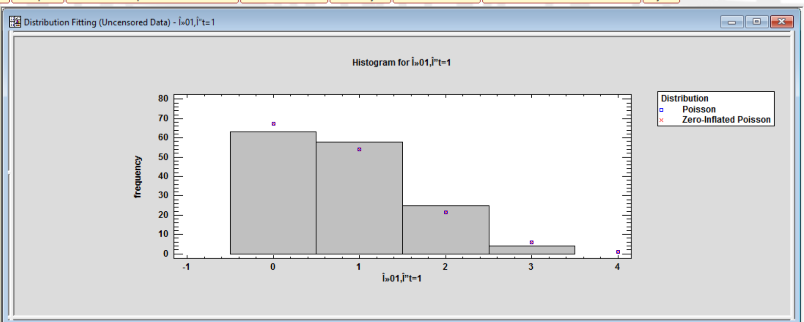

Figure 5: For transition from 1 to 2: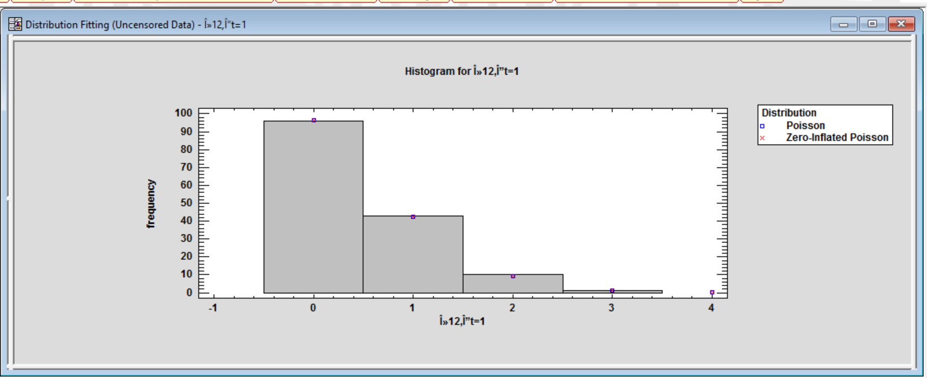
Figure 6 : For transition from 2 to 3: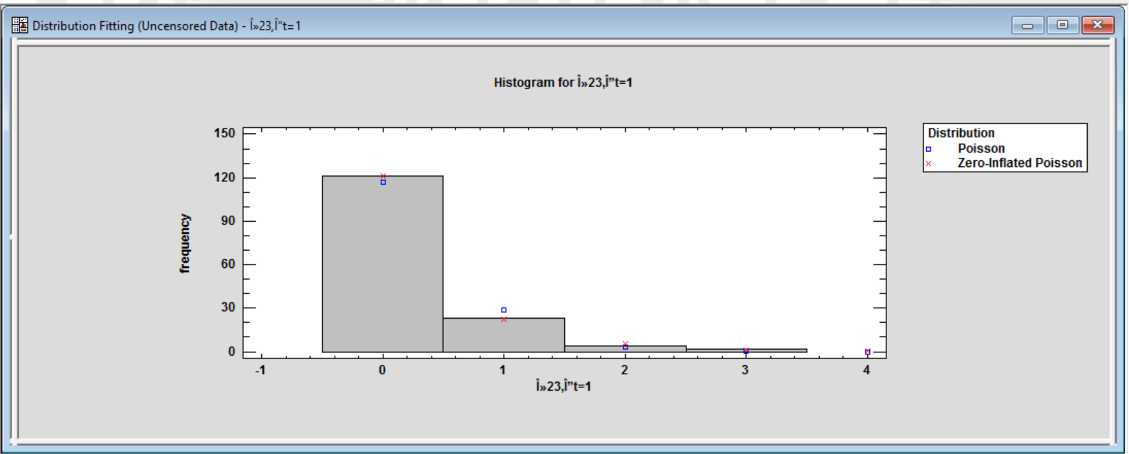
Figure 7 : For transition from 3 to 4: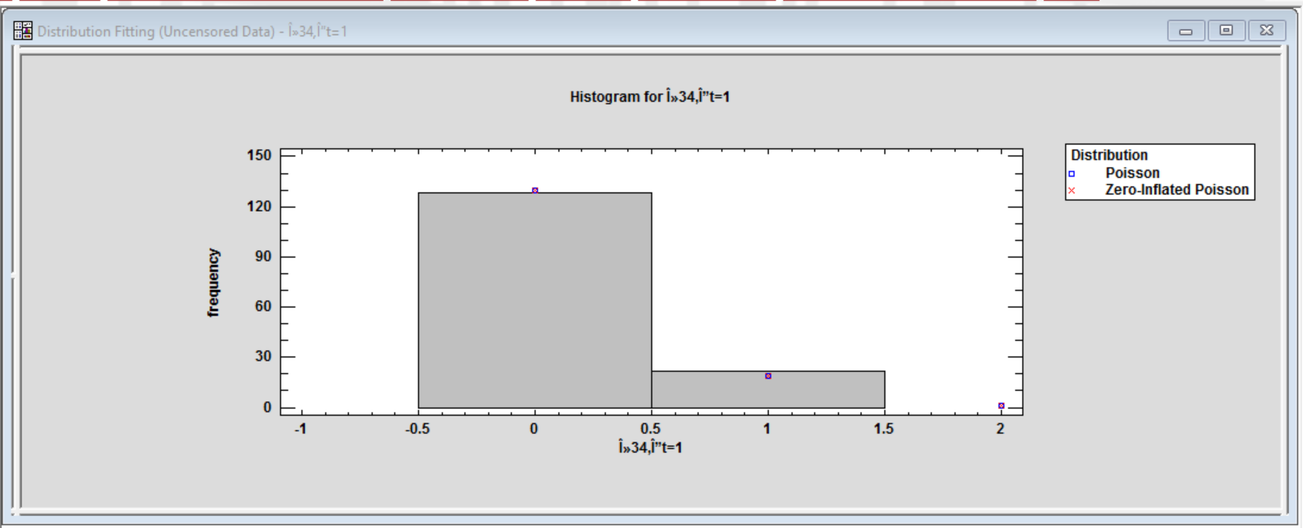

Figure 8 : For transition from 1 to 0 :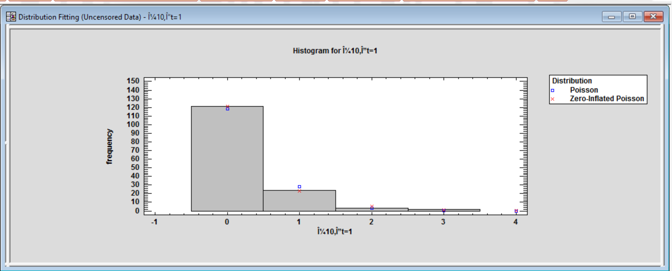
Figure 9 : For transition from 2 to 1: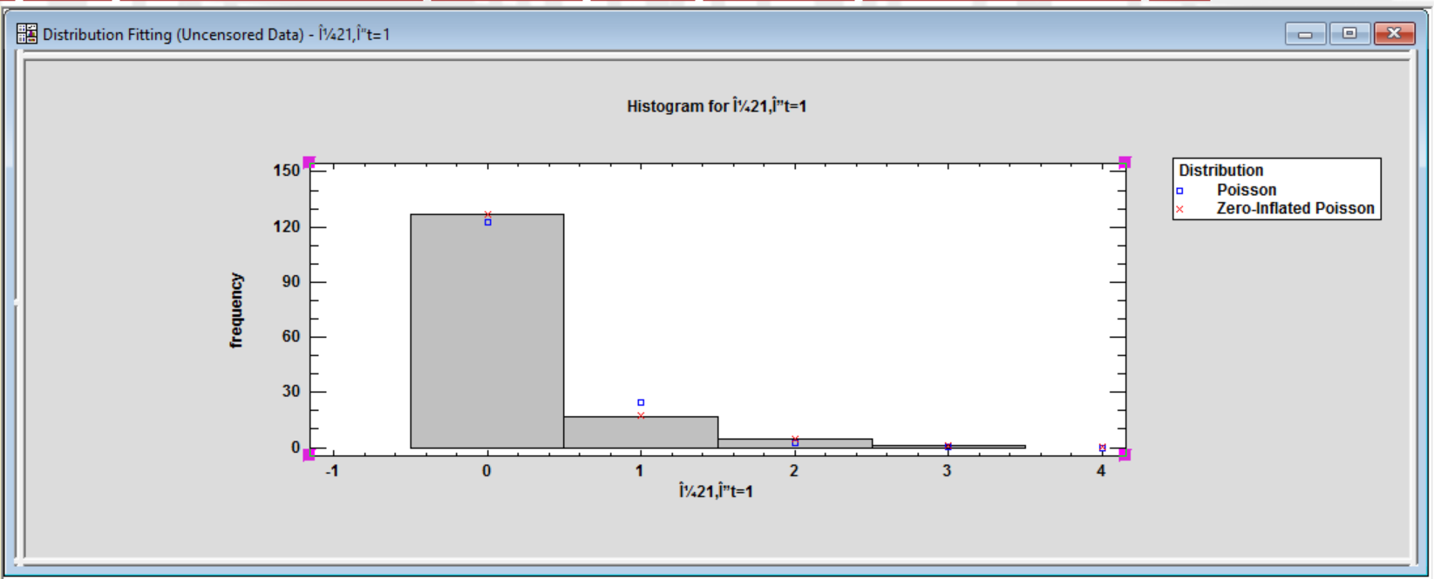
Figure 10 ( a then b ): For transition from 3 to 2: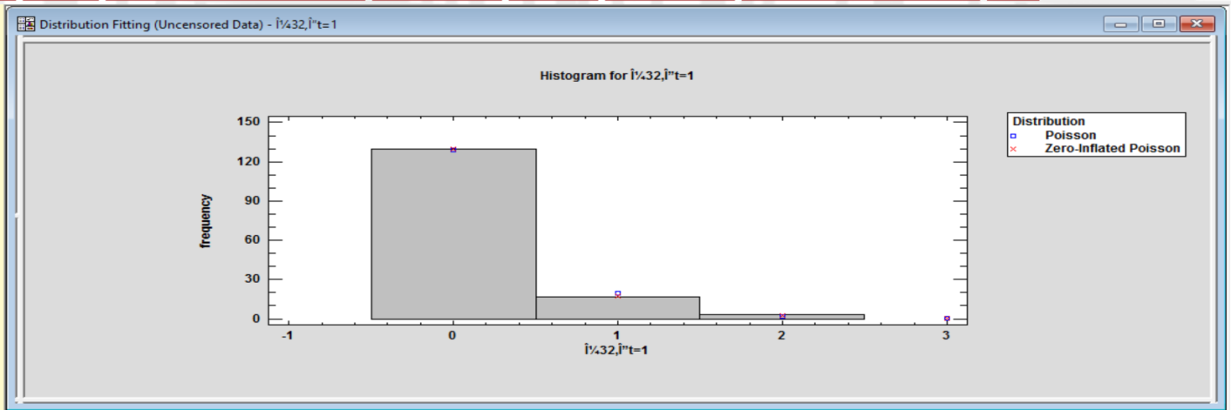
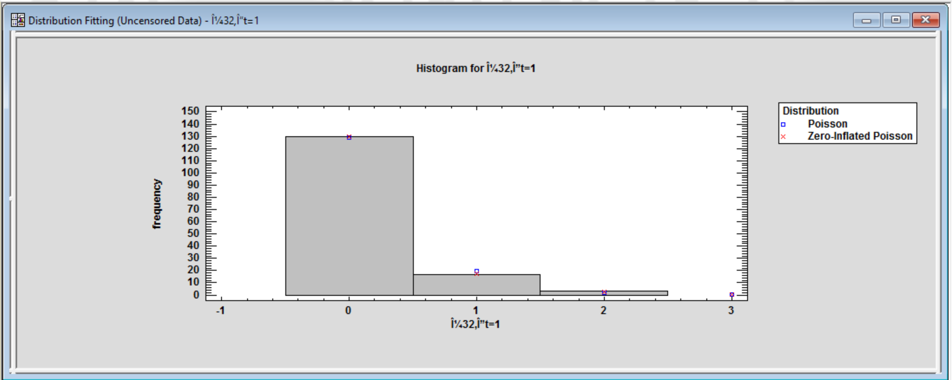
Figure 11 :For transition from 2 to 0: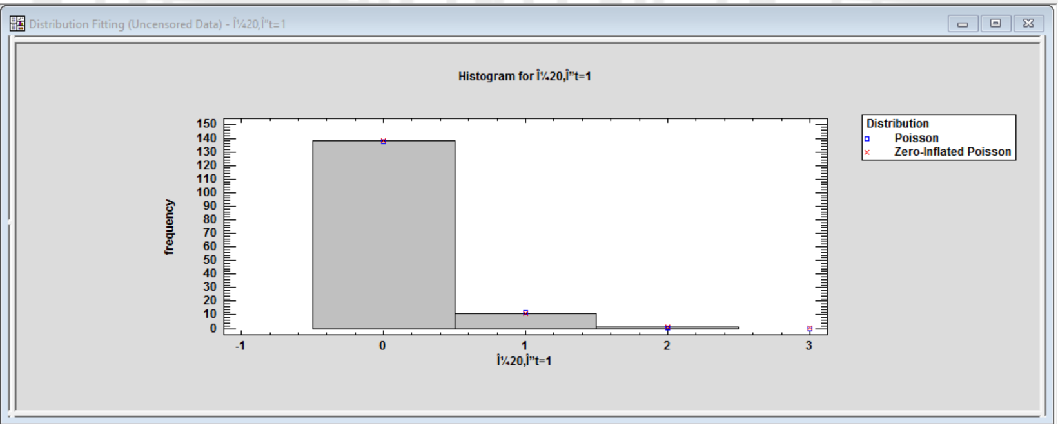
Figure 12 : For transition from 3 to 1: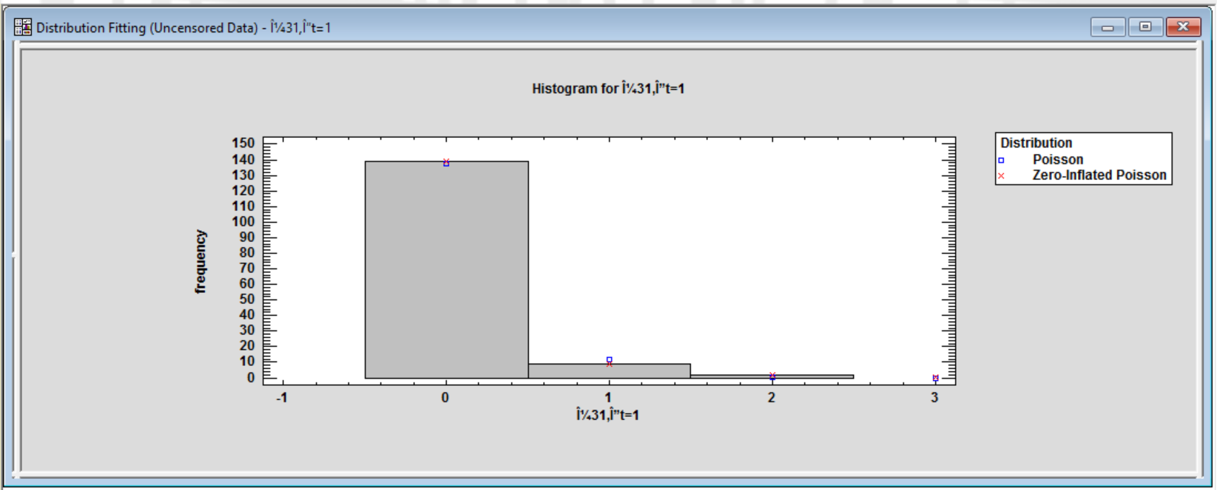
The following figures show the Lowess smoother for each observed response rate to each of the 7 predictors:
Figure 13 : Transition 0 to 1:
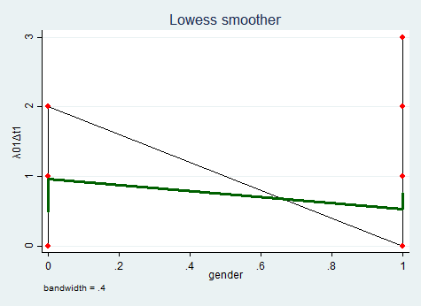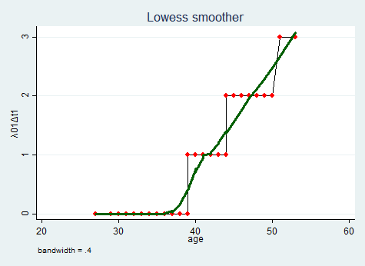
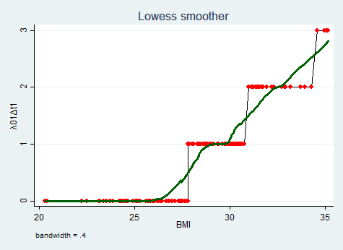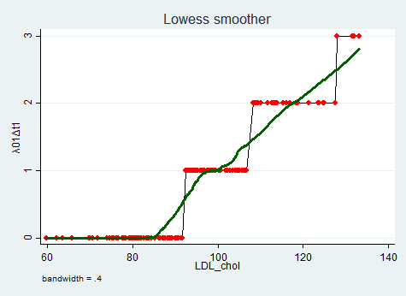
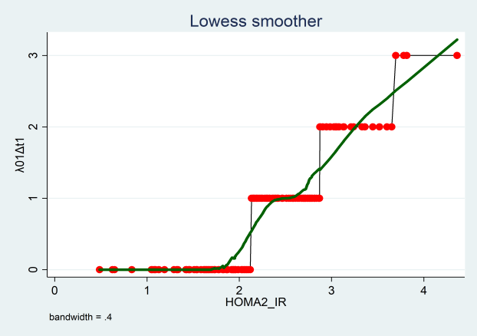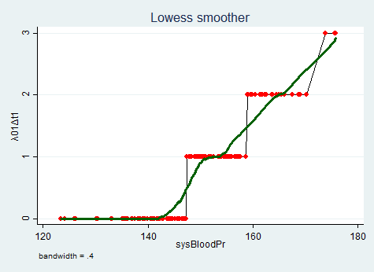
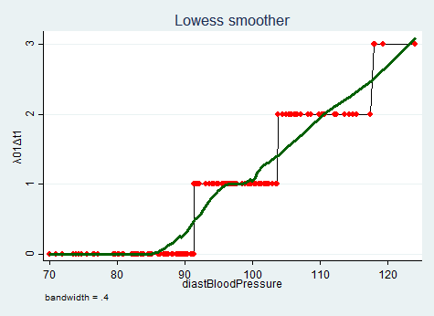
Figure 14: Transition 1 to 2:
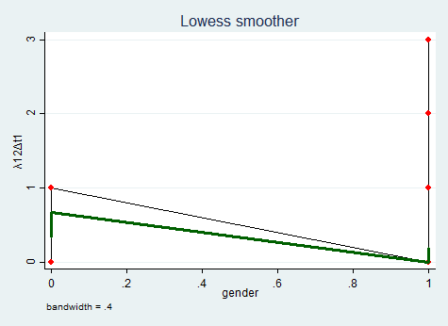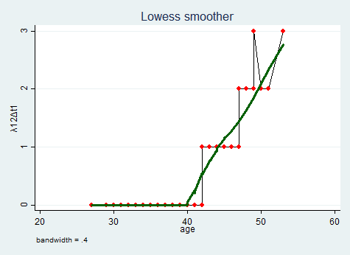
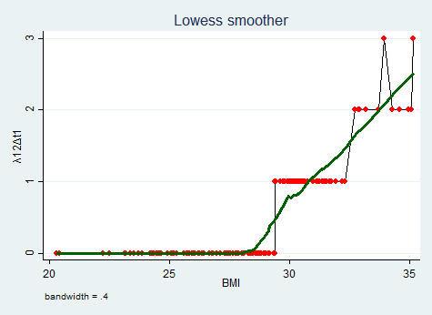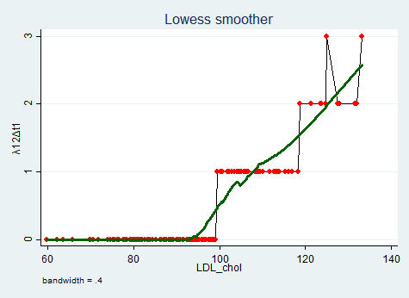
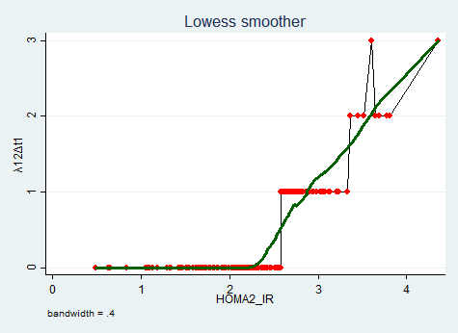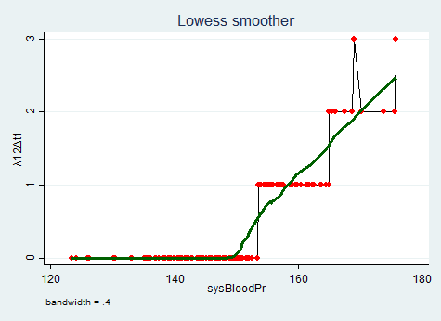
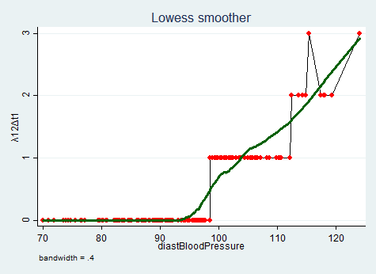
Figure 15 : Transition 2 to 3:
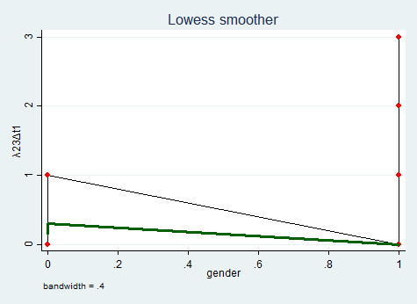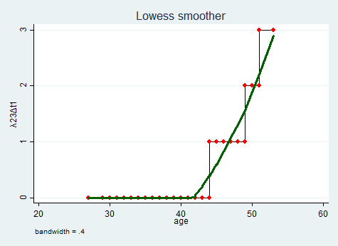
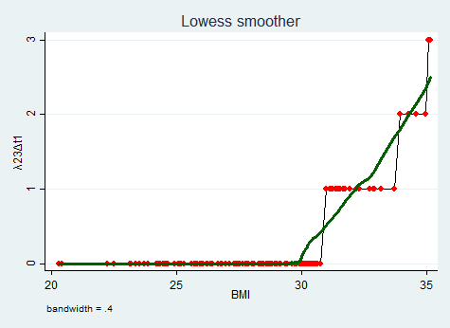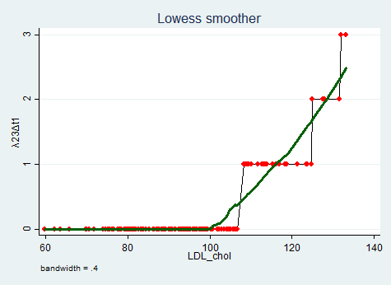
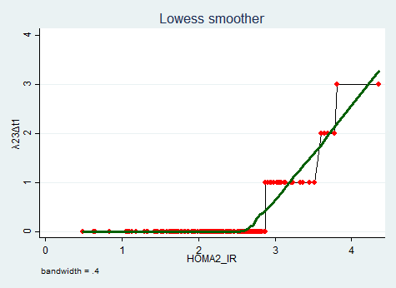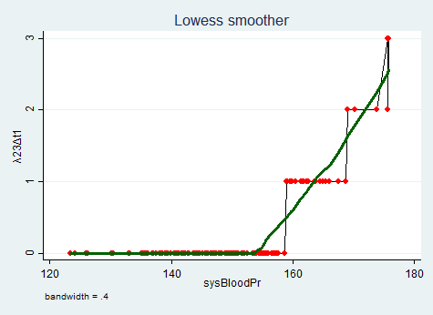
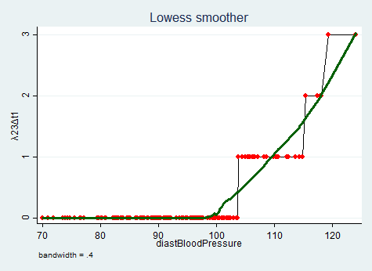
Figure 16: Transition 3 to 4:
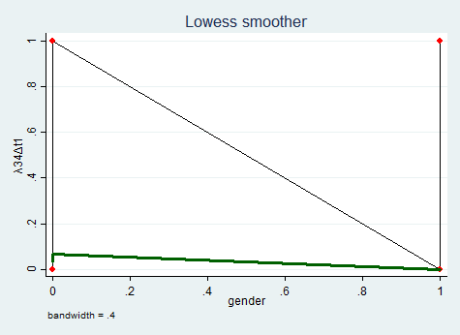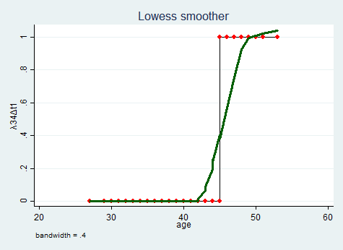
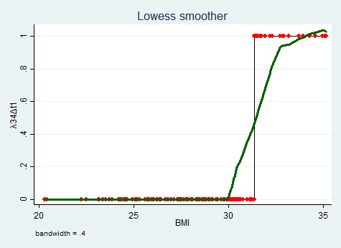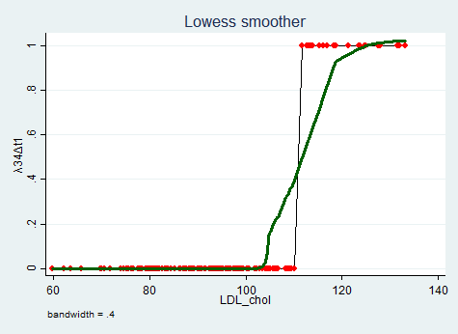
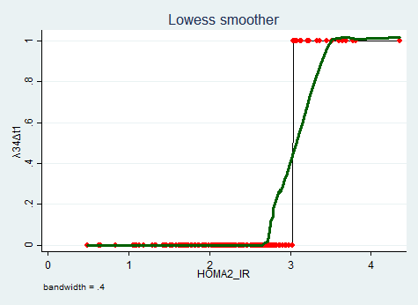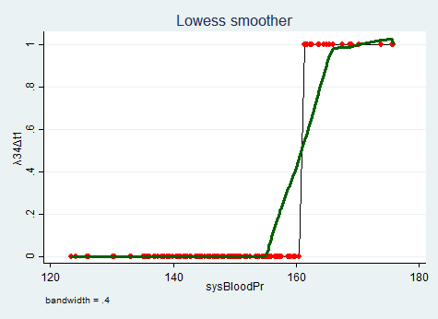
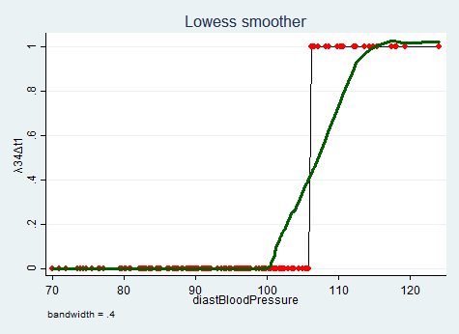
Figure 17 : Transition 1 to 0:
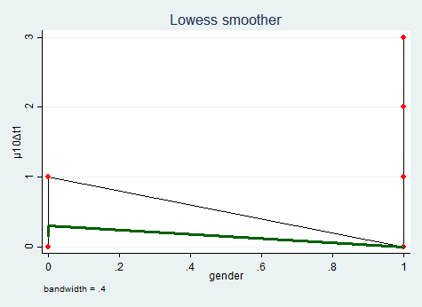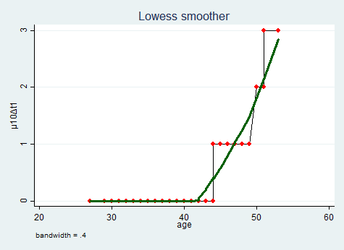
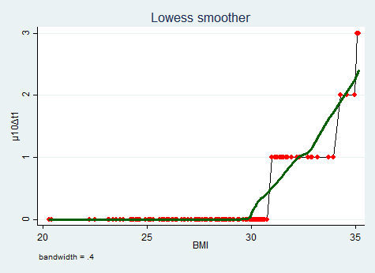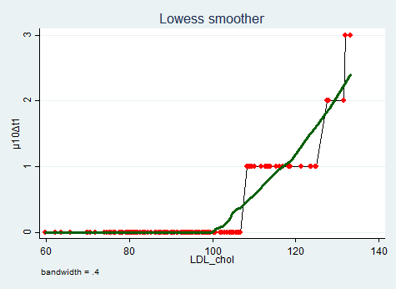
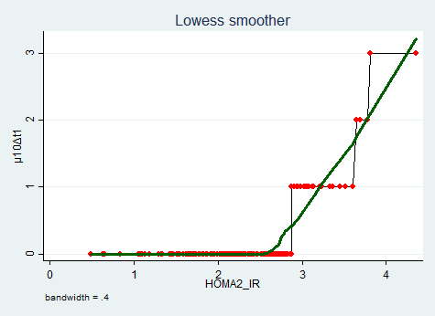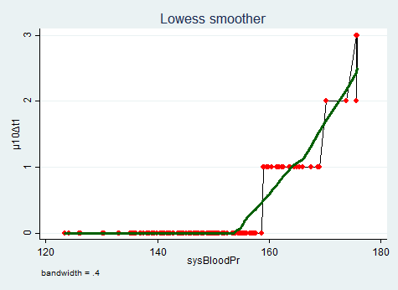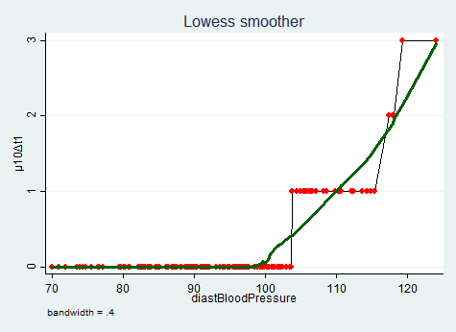
Figure 18 : Transition 2 to 1:
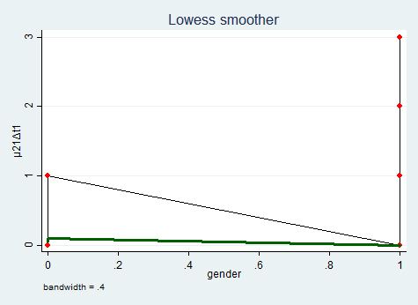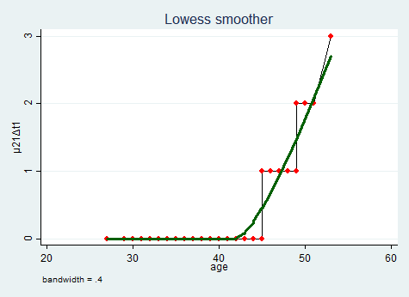
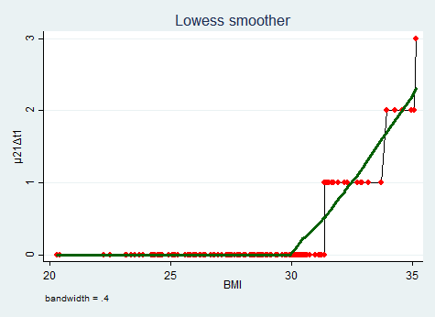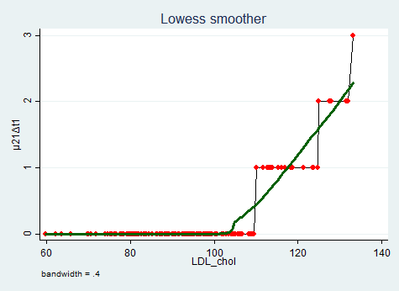
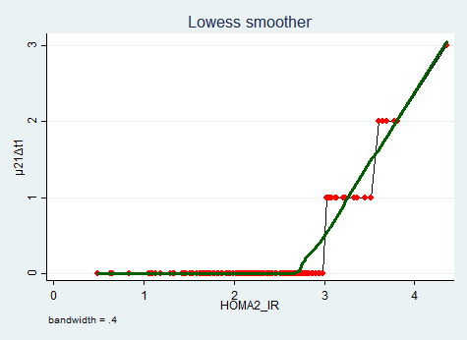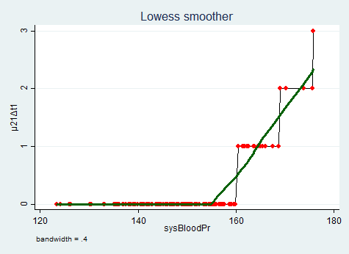
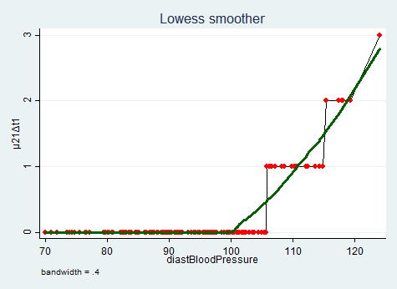
Figure 19 : Transition 3 to 2 :
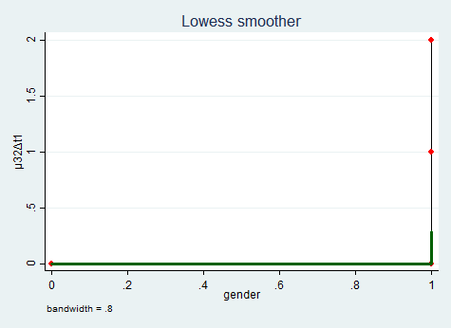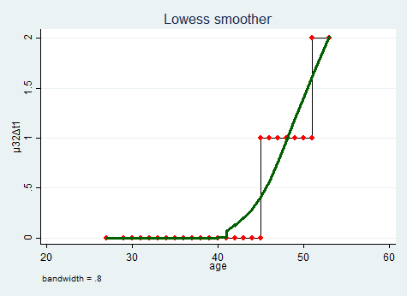
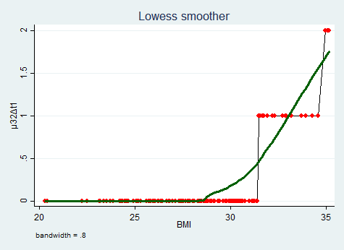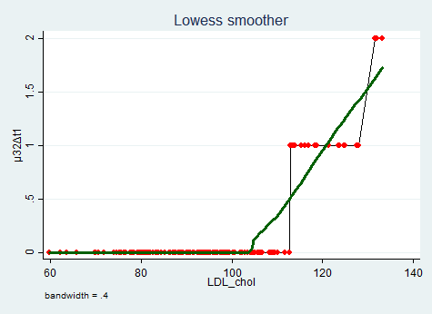
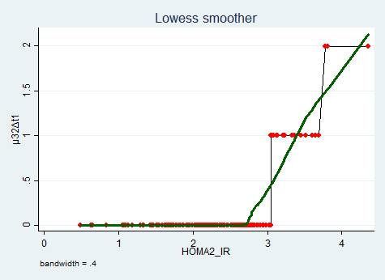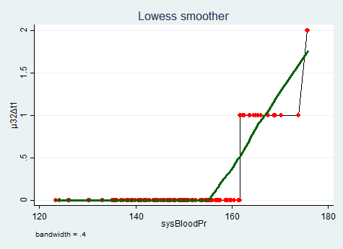
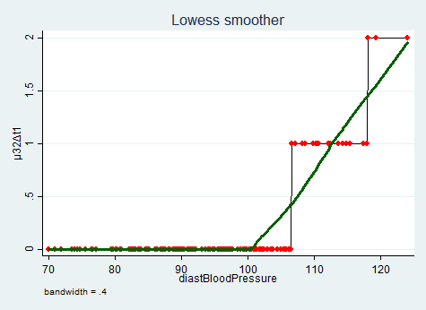
Figure 20 : Transition 2 to 0 :
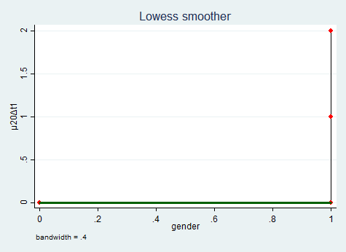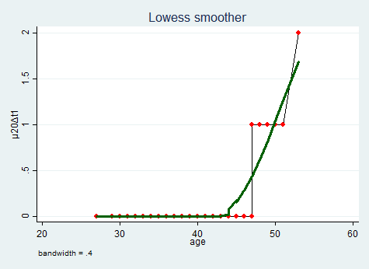
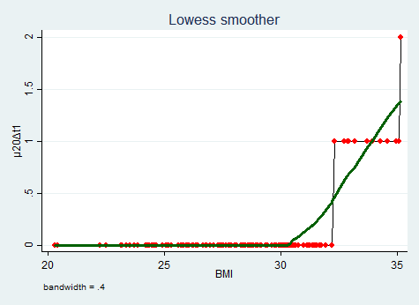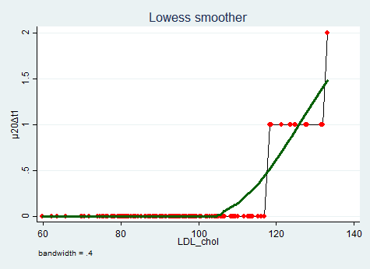
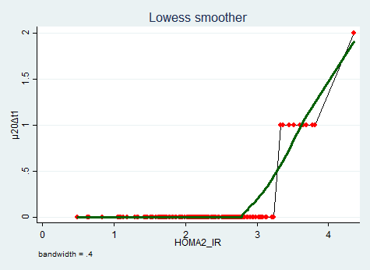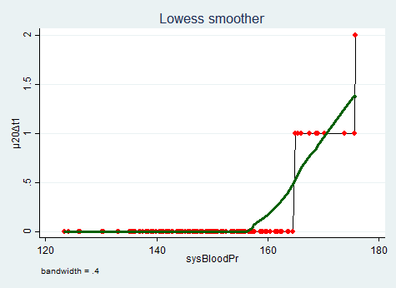
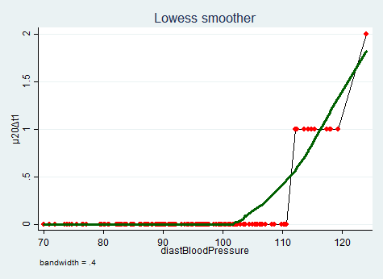
Figure 21: Transition 3 to 1:
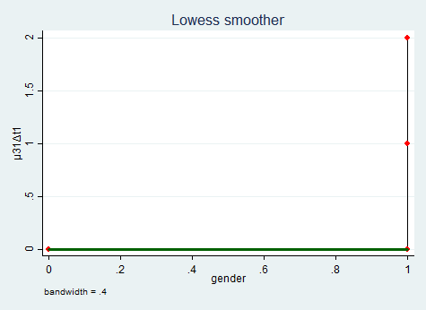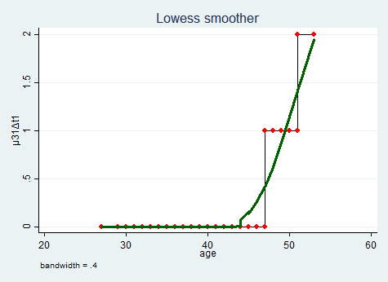
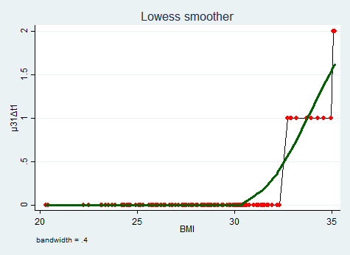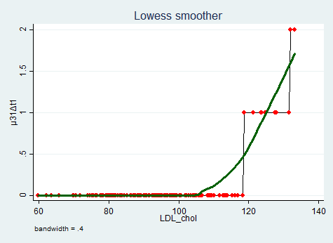
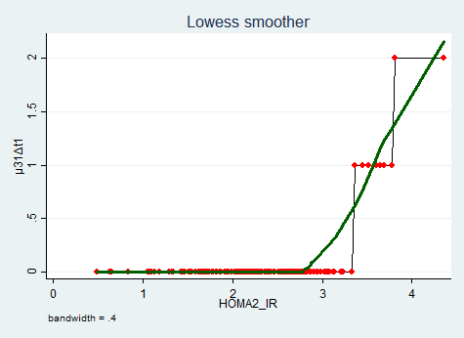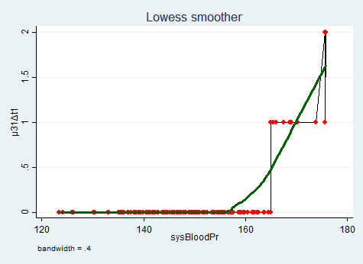
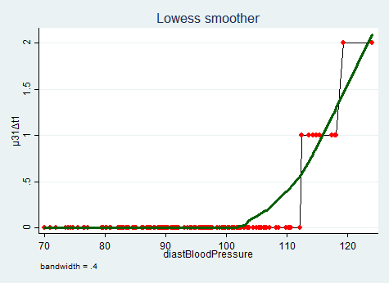
Table (14): results for transitions from state 0 to state 1:
 | Coefficient | Robust  Std.dev. | z | p>|z| | 95%CI for  B coeff. | IRR | Robust  Std.dev. | 95%CI for  IRR
LDLsp2 | 0.523 | 0.243 | 2.149 | 0.032 | (0.046 , 1.000) | 1.687 | 0.411 | (1.047 , 2.718)
HOMAsp1 | 4.096 | 0.328 | 12.470 | 0.000 | (3.452 , 4.740) | 60.097 | 19.739 | (31.569 , 114.403)
sysSP2 | -0.628 | 0.347 | -1.809 | 0.070 | (-1.308 , 0.052) | 0.534 | 0.185 | (0.270 , 1.054)
c.LDLsp2#  c.HOMAsp1 | -0.179 | 0.070 | -2.540 | 0.011 | (-0.317 , -0.041) | 0.836 | 0.059 | (0.728 , 0.960)
c.LDLsp2#  c.sysSP2 | 0.003 | 0.000 | 8.144 | 0.000 | (0.002 , 0.003) | 1.003 | 0.000 | (1.002 , 1.003)
c.sysSP2#  c.HOMAsp1 | 0.151 | 0.098 | 1.547 | 0.122 | (-0.040 , 0.342) | 1.163 | 0.113 | (0.960 , 1.408)
cons | -9.510 | 0.725 | -13.122 | 0.000 | (-10.930 , -8.089) | 0.000 | 0.000 | (0.000 , 0.000)
Log pseudolikelihood = -110.43 |  |  |  |  | Pseudo R² = .355
Wald chi2(6) = 535.34 |  |  |  |  | Prob>chi2 =.000
Deviance gof = 27.55 |  |  |  |  | Prob>chi2(143) = 1
Pearson gof = 24.458 |  |  |  |  | Prob>chi2(143) = 1
Log pseudolikelihood(full model ) = -110.43 |  |  |  |  | Log pseudolikelihood(null model ) = -171.273
DF = 7 |  |  | AIC = 234.86 |  |  | BIC = 255.935
Using the above results to predict the $\ln{λ_{01}}=x_{i}^{'}B$ then calculating $E\left[y_{i} | x_{i}\right]=λ_{01}=e^{x_{i}^{'}B}$
where $λ_{01}$ denotes the transition counts from state 0 to state 1 and as the time for the follow up is equal to all patients. The estimated counts for the transition from state 0 to state 1 are 120 transitions and the observed count is 120. The expected increase in log count for one-unit increase in transformed LDL cholesterol is (0.523), which is not highly statistically significant (P=0.032), and for one-unit increase in transformed HOMA is (4.096), which is highly statistically significant (P=0.000), as both are considered risk factors for NAFLD to progress from F0 to F1. The expected decrease in log count for one-unit increase in transformed systolic blood pressure is (0.628) which is not statistically significant (P=0.07). For every unit increase in transformed LDL, the incident rate ratio is increased (increase in transition counts) by 68.7%; while, for transformed HOMA, it is increased by 5909.7%, with 95% confidence that this increase is between 3056.9% and 11340.3%. The expected decrease in log count for one unit increase in interaction between the transformed LDL and transformed HOMA is (0.179) with high statistical significance (P=0.11), in other word, the rise in one predictor variable decreases the rising effect of the other on the response variable (expected log count) but not reverse it. And for every unit increase in this interaction, the incident rate ratio is decreased (i.e. decrease in transition counts) by 16.4%, with 95% confidence, that this decrease lies between 4% and 27.2%. While, the expected increase in log count for one unit increase in interaction between the transformed systolic blood pressure and transformed LDL is (0.003) with high statistical significance (P=0.000), and this increase in log count for one unit increase in interaction between transformed systolic blood pressure and transformed HOMA is (0.151) which is not statistically significant (P=0.122), in other word, the rise in one predictor variable increases the rising effect of the other on the response variable (expected log count).However, for every unit increase in the first interaction, the incident rate ratio is only increased (i.e. increase in transition counts) by 0.3%, with 95% confidence, that this increase lies between .2% and .31% , while for the second interaction; the IRR is increased by 16.3%. Poisson model fits the data as goodness of fit is not statistically significant (P=1).
Table (15): results for transitions from state 1 to state 2:
 | Coefficient | Robust  Std.dev. | z | p>|z| | 95%CI for  B coeff. | IRR | Robust  Std.dev. | 95%CI for  IRR
LDLsp2 | 0.311 | 0.396 | 0.785 | 0.432 | (-0.465 , 1.086) | 1.364 | 0.540 | (0.628 , 2.962)
HOMAsp1 | 5.486 | 0.571 | 9.599 | 0.000 | (4.366 , 6.606) | 241.179 | 137.821 | (78.690 , 739.192)
sysSP2 | -0.314 | 0.545 | -0.577 | 0.564 | (-1.383 , 0.754) | 0.730 | 0.398 | (0.251 , 2.126)
c.LDLsp2#  c.HOMAsp1 | -0.105 | 0.116 | -0.902 | 0.367 | (-0.332 , 0.123) | 0.901 | 0.105 | (0.717 , 1.131)
c.sysSP2#  c.HOMAsp1 | 0.079 | 0.158 | 0.502 | 0.616 | (-0.231 , 0.389) | 1.083 | 0.171 | (0.794 , 1.476)
cons | -14.884 | 1.363 | -10.923 | 0.000 | (-17.555 , -12.213) | 0.000 | 0.000 | (0.000 , 0.000)
Log pseudolikelihood = -67.887 |  |  |  |  | Pseudo R² = 0.481
Wald chi2(6) = 284.3 |  |  |  |  | Prob>chi2 = 0.000
Deviance gof = 20.27 |  |  |  |  | Prob>chi2(144) = 1
Pearson gof = 18.12 |  |  |  |  | Prob>chi2(144) = 1
Log pseudolikelihood( full model ) = -67.887 |  |  |  |  | Log pseudolikelihood( null model ) = -130.82
DF = 6 |  |  | AIC = 147.77 |  |  | BIC = 165.84
Using the above results to predict the $\ln{λ_{12}}=x_{i}^{'}B$ then calculating $E\left[y_{i} | x_{i}\right]=λ_{12}=e^{x_{i}^{'}B}$
where $λ_{12}$ denotes the transition counts from state 1 to state 2 and as the time for the follow up is equal to all patients the estimated counts for the transition from state 1 to state 2 are 64 transitions with while the observed count is 67 transitions . The expected increase in log count for one-unit increase in transformed LDL cholesterol is (0.311), which is not highly statistically significant (P=0.432), and for one-unit increase in transformed HOMA is (5.486), which is highly statistically significant (P=0.000), as both are considered risk factors for NAFLD to progress from F1 to F2. The expected decrease in log count for one-unit increase in transformed systolic blood pressure is (0.314), which is not statistically significant (P= 0.564). For every unit increase in transformed LDL the incident rate ratio is increased (increase in transition counts) by 36.4%; while, for transformed HOMA it is increased by 24017.9%, with 95% confidence that this increase is between 7769% and 73819.2%. The expected decrease in log count for one unit increase in interaction between the transformed LDL and transformed HOMA is (0.105) with no statistical significance (P=0.367), in other word, the rise in one predictor variable decreases the rising effect of the other on the response variable (expected log count) but not reverse it. While, the expected increase in log count for one unit increase in interaction between the transformed systolic blood pressure and transformed HOMA is (0.079) with no statistical significance (P=0.616). Poisson model fits the data as goodness of fit is not statistically significant (P=1).

Table (16): results for transitions from state 2 to state 3:
 | Coefficient | Robust  Std.dev. | z | p>|z| | 95%CI for  B coeff. | IRR | Robust  Std.dev. | 95%CI for  IRR
LDLsp2 | -1.480 | 0.685 | -2.159 | 0.031 | (-2.823 , -0.137) | 0.228 | 0.156 | (0.059 , 0.872)
HOMAsp1 | 6.174 | 3.093 | 1.996 | 0.046 | (0.112 , 12.237) | 480.318 | 1485.815 | (1.118 , 2.06e+5)
sysSP2 | 2.497 | 0.967 | 2.583 | 0.010 | (0.602 , 4.391) | 12.143 | 11.738 | (1.826 , 80.754)
c.LDLsp2#  c.HOMAsp1 | 0.390 | 0.192 | 2.032 | 0.042 | (0.014 , 0.766) | 1.477 | 0.283 | (1.014 , 2.151)
c.LDLsp2#  c.sysSP2 | -0.001 | 0.002 | -0.403 | 0.687 | (-0.005 , 0.004) | 0.999 | 0.002 | (0.995 , 1.004)
c.sysSP2#  c.HOMAsp1 | -0.655 | 0.274 | -2.392 | 0.017 | (-1.191 , -0.118) | 0.520 | 0.142 | (0.304 , 0.889)
cons | -20.866 | 7.293 | -2.861 | 0.004 | (-35.160 , -6.572) | 0.000 | 0.000 | (0.000 , 0.001)
Log pseudolikelihood = -37.87 |  |  |  |  | Pseudo R² = 0.6020
Wald chi2(6) = 191.48 |  |  |  |  | Prob>chi2 = 0.000
Deviance gof = 13.29 |  |  |  |  | Prob>chi2(143) = 1
Pearson gof = 12.42 |  |  |  |  | Prob>chi2(143) = 1
Log pseudolikelihood(full model ) = -37.87 |  |  |  |  | Log pseudolikelihood(null model ) = -95.15
DF = 7 |  |  | AIC = 89.73 |  |  | BIC = 110.81
Using the above results to predict the $\ln{λ_{23}}=x_{i}^{'}B$ then calculating $E\left[y_{i} | x_{i}\right]=λ_{23}=e^{x_{i}^{'}B}$
Where $λ_{23}$ denotes the transition counts from state 2 to state 3 and as the time for the follow up is equal to all patients the estimated counts for the transition from state 2 to state 3 are 35 transitions with good fit of the model while the observed count is 37 transitions . The expected decrease in log count for one-unit increase in transformed LDL cholesterol is (1.48) which is not highly statistically significant (P=0.031). This effect is not explainable. The expected increase in log count for one-unit increase in transformed HOMA is (6.174) which is not highly statistically significant (P=0.046), and for one-unit increase in transformed systolic blood pressure is (2.497) which is statistically significant (P=0.01), as both are considered risk factors for NAFLD to progress from F2 to F3. For every unit increase in transformed systolic blood pressure, the incident rate ratio is increased (increase in transition counts) by 1114.3%, with 95% confidence that this increase is between 82.6% and 7975.4%. The expected increase in log count for one unit increase in interaction between the transformed LDL and transformed HOMA is (0.39) with no high statistical significance (P=0.042), in other word, the rise in one predictor variable increases the rising effect of the other on the response variable (expected log count). While, the expected decrease in log count for one unit increase in interaction between the transformed systolic blood pressure and transformed LDL is (0.001) with no statistical significance (P=0.687), and this decrease in log count for one unit increase in interaction between transformed systolic blood pressure and transformed HOMA is (0.655) which is highly statistically significant (P=0.017), in other word, the rise in one predictor variable decreases the rising effect of the other on the response variable (expected log count) but not reverse it. However, for every unit increase in the first interaction, the incident rate ratio is only decreased (i.e. decrease in transition counts) by 0.1%, and for the second interaction; the IRR is decreased by 48%, with 95% confidence that this decrease is between 11.1% and 69.6%. Poisson model fits the data as goodness of fit is not statistically significant.

Table (17): results for transitions from state 3 to state 4:
 | Coefficient | Robust  Std.dev. | z | p>|z| | 95%CI for  B coeff. | IRR | Robust  Std.dev. | 95%CI for  IRR
LDLsp2 | 0.452 | 0.055 | 8.278 | 0.000 | (0.345 , 0.559) | 1.571 | 0.086 | (1.412 , 1.748)
HOMAsp1 | 10.866 | 1.402 | 7.753 | 0.000 | (8.119 , 13.613) | 52375.984 | 73411.34 | (3357.9 , 8.17e+5)
sysSP2 | 0.073 | 0.050 | 1.472 | 0.141 | (-0.024 , 0.171) | 1.076 | 0.054 | (0.976 , 1.187)
c.LDLsp2#  c.HOMAsp1 | -0.166 | 0.018 | -9.320 | 0.000 | (-0.201 , -0.131) | 0.847 | 0.015 | (0.818 , 0.877)
cons | -34.034 | 3.865 | -8.806 | 0.000 | (-41.608 , -26.459) | 0.000 | 0.000 | (0.000 , 0.000)
Log pseudolikelihood = -26.97 |  |  |  |  | Pseudo R² = 0.58
Wald chi2(6) = 122.33 |  |  |  |  | Prob>chi2 = 0.000
Deviance gof = 9.94 |  |  |  |  | Prob>chi2(145) = 1
Pearson gof = 8.96 |  |  |  |  | Prob>chi2(145) = 1
Log pseudolikelihood(full model ) = -26.97 |  |  |  |  | Log pseudolikelihood(null model ) = -64.23
DF = 5 |  |  | AIC = 63.94 |  |  | BIC = 78.99
Using the above results to predict the $\ln{λ_{34}}=x_{i}^{'}B$ then calculating $E\left[y_{i} | x_{i}\right]=λ_{34}=e^{x_{i}^{'}B}$
Where $λ_{34}$ denotes the transition counts from state 3 to state 4 and as the time for the follow up is equal to all patients the estimated counts for the transition from state 3 to state 4 are 20 transitions with good fit of the model while the observed count is 22 transitions . The expected increase in log count for one-unit increase in transformed LDL cholesterol is (0.452) which is highly statistically significant (P=0.000), this expected increase in log count for one-unit increase in transformed HOMA is (10.866) which is also highly statistically significant (P=0.000), and it is for one-unit increase in transformed systolic blood pressure is (0.073) which is not statistically significant (P=0.141), as all are considered risk factors for NAFLD to progress from F3 to F4. For every unit increase in transformed LDL, the incident rate ratio is increased (increase in transition counts) by 57.1%, with 95% confidence that this increase is between 41.2% and 74.8%. Furthermore, for every unit increase in transformed HOMA, the incident rate ratio is increased (increase in transition counts) by 5237498.4%, with 95% confidence that this increase is between 335691.1% and 81.7e+6%. For every unit increase in this interaction, the incident rate ratio is decreased (i.e. decrease in transition counts) by 15.3%, with 95% confidence that this decrease is between 12.3% and 18.2%. Poisson model fits the data as goodness of fit is not statistically significant (P=1).

Table (18): results for transitions from state 1 to state 0 :
 | Coefficient | Robust  Std.dev. | z | p>|z| | 95%CI for  B coeff. | IRR | Robust  Std.dev. | 95%CI for  IRR
LDLsp2 | -0.454 | 0.244 | -1.862 | 0.063 | (-0.932 , 0.024) | 0.635 | 0.155 | (0.394 , 1.024)
HOMAsp2 | -4.489 | 2.962 | -1.515 | 0.130 | (-10.294 , 1.316) | 0.011 | 0.033 | (0.000 , 3.730)
sysSP2 | 1.340 | 0.312 | 4.301 | 0.000 | (0.729 , 1.951) | 3.820 | 1.190 | (2.074 , 7.034)
c.LDLsp2#  c.HOMAsp2 | 0.290 | 0.096 | 3.029 | 0.002 | (0.102 , 0.478) | 1.337 | 0.128 | (1.108 , 1.612)
c.LDLsp2#  c.sysSP2 | -0.010 | 0.004 | -2.789 | 0.005 | (-0.017 , - 0.003) | 0.990 | 0.004 | (0.983 , 0.997)
c.sysSP2#  c.HOMAsp2 | -0.286 | 0.145 | -1.974 | 0.048 | (-0.571 , -0.002) | 0.751 | 0.109 | (0.565 , 0.998)
cons | -5.916 | 0.508 | -11.651 | 0.000 | (-6.912 , -4.921) | 0.003 | 0.001 | (0.001 , 0.007)
Log pseudolikelihood = -38.14 |  |  |  |  | Pseudo R² = 0.59
Wald chi2(6) = 331.08 |  |  |  |  | Prob>chi2 = 0.000
Deviance gof = 14.46 |  |  |  |  | Prob>chi2(143) = 1
Pearson gof = 13.55 |  |  |  |  | Prob>chi2(143) = 1
Log pseudolikelihood(full model ) = -38.14 |  |  |  |  | Log pseudolikelihood(null model ) = -93.04
DF = 7 |  |  | AIC = 90.29 |  |  | BIC = 111.36
Using the above results to predict the $\ln{μ_{10}}=x_{i}^{'}B$ then calculating $E\left[y_{i} | x_{i}\right]=μ_{10}=e^{x_{i}^{'}B}$
Where $μ_{10}$ denotes the transition counts from state 1 to state 0 and as the time for the follow up is equal to all patients the estimated counts for the transition from state1 to state 0 are 36 transitions with good fit of the model while the observed count is 36 transitions. The expected decrease in log count for one-unit increase in transformed LDL cholesterol is (0.454), which is not highly statistically significant (P= 0.063), and the expected decrease in log count for one-unit increase in transformed HOMA is (4.489), which is not statistically significant (P= 0.13). As better management for both of these risk factors enhance the transition from F1 to F0. While the expected increase in log count for one-unit increase in transformed systolic blood pressure is (1.34), which is highly statistically significant (p=0.000). For every unit increase in transformed systolic blood pressure, the incident rate ratio is increased (increase in transition counts) by 282%, with 95% confidence that this increase is between 107.4% and 603.4%. This effect is not really explainable and further studies are needed to evaluate such effect as there may be some confounder substances that could induce such effect. The expected increase in log count for one unit increase in interaction between the transformed LDL and transformed HOMA is (0.29) with high statistical significance (p=0.002), in other word, the rise in one predictor variable increases the effect of the other on the response variable (expected log count). For every unit increase of this interaction, the incident rate ratio is increased (increase in transition counts) by 33.7%, with 95% confidence that this increase is between 10.8% and 61.2%. While, the expected decrease in log count for one unit increase in interaction between the transformed systolic blood pressure and transformed LDL is (0.01) with high statistical significance (p=0.005), and this decrease in log count for one unit increase in interaction between transformed systolic blood pressure and transformed HOMA is (0.286) which is not highly statistically significant (p=0.048), in other word, the rise in one predictor variable decreases the effect of the other on the response variable (expected log count). However, for every unit increase in the first interaction, the incident rate ratio is only decreased (i.e. decrease in transition counts) by 1%, with 95% confidence that this decrease is between 0.3% and 1.7%. Moreover, for the second interaction; the IRR is decreased by 24.9%. Poisson model fits the data as goodness of fit is not statistically significant (P=1).
Table (19): results for transitions from state 2 to state 1:
 | Coefficient | Robust  Std.dev. | z | p>|z| | 95%CI for  B coeff. | IRR | Robust  Std.dev. | 95%CI for  IRR
LDLsp2 | -0.128 | 0.189 | -0.675 | 0.499 | (-0.499 , 0.243) | 0.880 | 0.167 | (0.607 , 1.275)
HOMAsp2 | -3.288 | 2.812 | -1.169 | 0.242 | (-8.800 , 2.224) | 0.037 | 0.105 | (0.000 , 9.244)
sysSP2 | 0.913 | 0.201 | 4.546 | 0.000 | (0.519 , 1.307) | 2.492 | 0.501 | (1.681 , 3.694)
c.LDLsp2#  c.HOMAsp2 | 0.152 | 0.066 | 2.288 | 0.022 | (0.022 , 0.282) | 1.164 | 0.077 | (1.022 , 1.326)
c.LDLsp2#  c.sysSP2 | -0.010 | 0.003 | -2.950 | 0.003 | (-0.017 , -0.003) | 0.990 | 0.003 | (0.983 , 0.997)
c.sysSP2#  c.HOMAsp2 | -0.114 | 0.114 | -1.001 | 0.317 | (-0.338 , 0.109) | 0.892 | 0.102 | (0.713 , 1.116)
cons | -7.666 | 0.617 | -12.426 | 0.000 | (-8.875 , -6.457) | 0.000 | 0.000 | (0.000 , 0.002)
Log pseudolikelihood = -29.96 |  |  |  |  | Pseudo R² = 0.64
Wald chi2(6) = 304.94 |  |  |  |  | Prob>chi2 = 0.000
Deviance gof = 9.86 |  |  |  |  | Prob>chi2(143) = 1
Pearson gof = 8.97 |  |  |  |  | Prob>chi2(143) = 1
Log pseudolikelihood(full model ) = -29.96 |  |  |  |  | Log pseudolikelihood(null model ) = -83.54
DF = 7 |  |  | AIC = 73.92 |  |  | BIC = 94.99
Using the above results to predict the $\ln{μ_{21}}=x_{i}^{'}B$ then calculating $E\left[y_{i} | x_{i}\right]=μ_{21}=e^{x_{i}^{'}B}$
Where $μ_{21}$ denotes the transition counts from state 2 to state 1 and as the time for the follow up is equal to all patients the estimated counts for the transition from state2 to state1 are 26 transitions with good fit of the model while the observed count is 30 transitions. The expected decrease in log count for one-unit increase in transformed LDL cholesterol is (0.128) which is not statistically significant(P=0.499), and the expected decrease in log count for one-unit increase in transformed HOMA is (3.288) which is not statistically significant (P=0.242). As better management of both of these risk factors, enhances the transition from F2 to F1. While the expected increase in log count for one-unit increase in transformed systolic blood pressure is (0.913) which is highly statistically significant (P=0.000). For every unit increase in transformed systolic blood pressure, the incident rate ratio is increased (increase in transition counts) by 149.2%, with 95% confidence that this increase is between 68.1% and 269.4%. This effect is not really explainable and further studies are needed to evaluate such effect as there may be some confounder substances that could induce such effect. The expected increase in log count for one unit increase in interaction between the transformed LDL and transformed HOMA is (0.152) with high statistical significance (P=0.022), in other word, the rise in one predictor variable increases the effect of the other on the response variable (expected log count). For every unit increase of this interaction, the incident rate ratio is increased (increase in transition counts) by 16.4%, with 95% confidence that this increase is between 2.2% and 32.6%. While, the expected decrease in log count for one unit increase in interaction between the transformed systolic blood pressure and transformed LDL is (0.01) with high statistical significance (P=0.003), and this decrease in log count for one unit increase in interaction between transformed systolic blood pressure and transformed HOMA is (0.114) which is not statistically significant (P=0.317), in other word, the rise in one predictor variable decreases the effect of the other on the response variable (expected log count) but not reverse it. However, for every unit increase in the first interaction, the incident rate ratio is only decreased (i.e. decrease in transition counts) by 1%, with 95% confidence that this decrease is between 0.3% and 1.7%. Moreover, for the second interaction; the IRR is decreased by 10.8%. Poisson model fits the data as goodness of fit is not statistically significant .
Table (20): results for transitions from state 3 to state 2:
 | Coefficient | Robust  Std.dev. | z | p>|z| | 95%CI for  B coeff. | IRR | Robust  Std.dev. | 95%CI for  IRR
LDLsp2 | .302 | .211 | 1.427 | .154 | (-.113 , 0.716) | 1.352 | .286 | (0.893 , 2.047)
HOMAsp2 | -5.214 | 3.196 | -1.631 | .103 | (-11.478 , 1.05) | .005 | .017 | (0.000 , 2.859)
sysSP2 | .422 | .288 | 1.467 | .142 | (-0.142 , .987) | 1.526 | .439 | (.868 , 2.683)
c.LDLsp2#  c.HOMAsp2 | .002 | .102 | .019 | .984 | (-.198 , .202) | 1.002 | .102 | (.821 , 1.223)
c.LDLsp2#  c.sysSP2 | -.012 | .004 | -2.749 | .006 | (-.02 ,- .003) | 0.998 | .004 | (0.98 , .997)
c.sysSP2#  c.HOMAsp2 | .132 | .149 | 0.888 | .375 | (-0.16 , .425) | 1.142 | .17 | (.852 , 1.529)
cons | -7.363 | .761 | -9.671 | .000 | (-8.855 , -5.871) | .001 | .000 | (.000 , .003)
Log pseudolikelihood = -26.37 |  |  |  |  | Pseudo R² = .61
Wald chi2(6) = 175.47 |  |  |  |  | Prob>chi2 =.000
Deviance gof = 10.89 |  |  |  |  | Prob>chi2(143) = 1
Pearson gof = 9.77 |  |  |  |  | Prob>chi2(143) = 1
Log pseudolikelihood(full model ) = -26.37 |  |  |  |  | Log pseudolikelihood(null model ) = -68.21
DF = 7 |  |  | AIC = 66.74 |  |  | BIC = 87.81
Using the above results to predict the $\ln{μ_{32}}=x_{i}^{'}B$ then calculating $E\left[y_{i} | x_{i}\right]=μ_{32}=e^{x_{i}^{'}B}$
Where $μ_{32}$ denotes the transition counts from state 3 to state 2 and as the time for the follow up is equal to all patients the estimated counts for the transition from state 3 to state 2 are 19 transitions with good fit of the model while the observed count is 23 transitions . The expected increase in log count for one-unit increase in transformed LDL cholesterol is (0.302) which is not statistically significant (P=0.154), and the expected increase in log count for one-unit increase in transformed systolic blood pressure is (0.422) which is not statistically significant (P=0.142). These effects are not really explainable and further studies are needed to evaluate such effects as there may be some confounder substances that could induce such effects. While the expected decrease in log count for one-unit increase in transformed HOMA is (5.214) which is not statistically significant (P=0.103). As better management of HOMA, enhances the transition from F3 to F2. The expected increase in log count for one unit increase in interaction between the transformed LDL and transformed HOMA is (0.002) with no high statistical significance (P=0.984), and this expected increase for one unit increase in interaction between transformed HOMA and transformed systolic blood pressure is (0.132), which is not statistically significant (P=0.375), in other word, the rise in one predictor variable increases the effect of the other on the response variable (expected log count). While, the expected decrease in log count for one unit increase in interaction between the transformed systolic blood pressure and transformed LDL is (.012) with high statistical significance (P=0.006), in other word, the rise in one predictor variable decreases the effect of the other on the response variable (expected log count) but not reverse it. For every unit increase in this interaction, the incident rate ratio is deceased (decrease in transition counts) by 1.2%, with 95% confidence that this decrease is between .3% and 2%. Poisson model fits the data as goodness of fit is not statistically significant.

Table (21): results for transitions from state 2 to state 0:
 | Coefficient | Robust  Std.dev. | z | p>|z| | 95%CI for  B coeff. | IRR | Robust  Std.dev. | 95%CI for  IRR
LDLsp2 | 0.076 | 0.079 | 0.965 | 0.335 | (-0.079 , 0.231) | 1.079 | 0.085 | (0.924 , 1.260)
HOMAsp2 | -2.713 | 0.709 | -3.829 | 0.000 | (-4.102 , -1.324) | 0.066 | 0.047 | (0.017 , 0.266)
sysSP2 | -0.123 | 0.047 | -2.593 | 0.010 | (-0.216 , -0.030) | 0.884 | 0.042 | (0.806 , 0.970)
DiasSP2 | 0.358 | 0.110 | 3.266 | 0.001 | (0.143 , 0.573) | 1.430 | 0.157 | (1.154 , 1.773)
cons | -7.034 | 0.501 | -14.052 | 0.000 | (-8.015 , -6.053) | 0.001 | 0.000 | (0.000 , 0.002)
Log pseudolikelihood = -15.63 |  |  |  |  | Pseudo R² = 0.656
Wald chi2(6) = 263.12 |  |  |  |  | Prob>chi2 = 0.000
Deviance gof = 6.65 |  |  |  |  | Prob>chi2(145) = 1
Pearson gof = 7.36 |  |  |  |  | Prob>chi2(145) = 1
Log pseudolikelihood(full model ) = -15.63 |  |  |  |  | Log pseudolikelihood(null model ) = -45.49
DF = 5 |  |  | AIC = 41.26 |  |  | BIC = 56.31
Using the above results to predict the $\ln{μ_{20}}=x_{i}^{'}B$ then calculating $E\left[y_{i} | x_{i}\right]=μ_{20}=e^{x_{i}^{'}B}$
Where $μ_{20}$ denotes the transition counts from state 2 to state 0 and as the time for the follow up is equal to all patients the estimated counts for the transition from state2 to state 0 are 12 transitions with good fit of the model while the observed count is 13 transitions . The expected increase in log count for one-unit increase in transformed LDL cholesterol is (0.076) which is not statistically significant (P=0.335), and the expected increase in log count for one-unit increase in transformed diastolic blood pressure is (0.358) which is highly statistically significant (P=0.001). These effects are not really explainable and further studies are needed to evaluate such effects as there may be some confounder substances that could induce such effects. For every unit increase of diastolic blood pressure, the incident rate ratio is increased (increase in transition counts) by 43%, with 95% confidence that this increase is between 15.4% and 77.3%. While the expected decrease in log count for one-unit increase in transformed HOMA is (2.713) which is highly statistically significant (P=0.000), and the expected decrease in log count for one-unit increase in transformed systolic blood pressure is (0.123) which is highly statistically significant (P=0.01). As better management of these risk factors, enhances the transition from F2 to F0. For every unit increase of transformed HOMA, the incident rate ratio is decreased (decrease in transition counts) by 93.4%, with 95% confidence that this decrease is between 73.4% and 98.3%. For every unit increase of transformed systolic blood pressure, the incident rate ratio is decreased (decrease in transition counts) by 11.6%, with 95% confidence that this decrease is between 3% and 19.4%. Poisson model fits the data as goodness of fit is not statistically significant (P=1).

Table (22): results for transitions from state 3 to state 1:
 | Coefficient | Robust  Std.dev. | z | p>|z| | 95%CI for  B coeff. | IRR | Robust  Std.dev. | 95%CI for  IRR
LDLsp2 | 0.145 | 0.070 | 2.079 | 0.038 | (0.008 , 0.282) | 1.156 | 0.081 | (1.008 , 1.326)
HOMAsp2 | -2.476 | 0.660 | -3.754 | 0.000 | (-3.769 , -1.183) | 0.084 | 0.055 | (0.023 , 0.306)
sysSP2 | -0.129 | 0.045 | -2.899 | 0.004 | (-0.216 , -0.042) | 0.879 | 0.039 | (0.805 , 0.959)
DiasSP2 | 0.276 | 0.093 | 2.962 | 0.003 | (0.093 , 0.459) | 1.318 | 0.123 | (1.098 , 1.582)
cons | -7.584 | 0.688 | -11.017 | 0.000 | (-8.934 , -6.235) | 0.001 | 0.000 | (0.000 , 0.002)
Log pseudolikelihood = -14.18 |  |  |  |  | Pseudo R² = 0.693
Wald chi2(6) = 202.29 |  |  |  |  | Prob>chi2 = 0.000
Deviance gof = 5.14 |  |  |  |  | Prob>chi2(145) = 1
Pearson gof = 6.09 |  |  |  |  | Prob>chi2(145) = 1
Log pseudolikelihood(full model ) = -14.18 |  |  |  |  | Log pseudolikelihood(null model ) = -46.18
DF = 5 |  |  | AIC = 38.36 |  |  | BIC = 53.42

Using the above results to predict the $\ln{μ_{31}}=x_{i}^{'}B$ then calculating $E\left[y_{i} | x_{i}\right]=μ_{31}=e^{x_{i}^{'}B}$
Where $μ_{31}$ denotes the transition counts from state 3 to state 1 and as the time for the follow up is equal to all patients the estimated counts for the transition from state 3 to state 1 are 13 transitions with good fit of the model while the observed count is 14 transitions. The expected increase in log count for one-unit increase in transformed LDL cholesterol is (0.145) which is not highly statistically significant (P=.038), and the expected increase in log count for one-unit increase of transformed diastolic blood pressure is (0.276) which is highly statistically significant (P=0.003). These effects are not really explainable and further studies are needed to evaluate such effects as there may be some confounder substances that could induce such effects. For every unit increase in diastolic blood pressure, the incident rate ratio is increased (increase in transition counts) by 31.8%, with 95% confidence that this increase is between 9.8% and 58.2%. While the expected decrease in log count for one-unit increase in transformed HOMA is (2.476) which is highly statistically significant (P= 0.000), and the expected decrease in log count for one-unit increase in transformed systolic blood pressure is (0.129) which is highly statistically significant (P=0.004). As better management of these risk factors, enhances the transition from F3 to F1. For every unit increase of transformed HOMA, the incident rate ratio is decreased (decrease in transition counts) by 91.6%, with 95% confidence that this decrease is between 69.4% and 97.7%. Furthermore, for every unit increase in transformed systolic blood pressure, the incident rate ratio is decreased (decrease in transition counts) by 12.1%, with 95% confidence that this decrease is between 4.1% and 19.5%. Poisson model fits the data as goodness of fit is not statistically significant (P=1).

Table (23): comparison of the summary between the distribution of the response rates and estimated mean response rate
 |  | Observed  response count | Estimated mean  response count
0→1 | Mean | .8 | .8
0→1 | Variance | .658 | .619
0→1 | Std.dev. | .811 | .787
1→2 | Mean | .45 | .45
1→2 | Variance | .45 | .45
1→2 | Std.dev. | .671 | .671
2→3 | Mean | .25 | .25
2→3 | Variance | .32 | .318
2→3 | Std.dev. | .567 | .564
3→4 | Mean | .15 | .15
3→4 | Variance | .126 | .126
3→4 | Std.dev. | .355 | .355
1→0 | Mean | .24 | .24
1→0 | Variance | .305 | .314
1→0 | Std.dev. | .552 | .56
2→1 | Mean | .2 | .2
2→1 | Variance | .268 | .284
2→1 | Std.dev. | .518 | .533
3→2 | Mean | .15 | .15
3→2 | Variance | .171 | .173
3→2 | Std.dev. | .413 | .416
2→0 | Mean | .09 | .09
2→0 | Variance | .093 | .101
2→0 | Std.dev. | .305 | .318
3→1 | Mean | .09 | .09
3→1 | Variance | .106 | .11
3→1 | Std.dev. | .326 | .336

