Linking omega-3 polyunsaturated fatty acids in natural diet with brain size of wild consumers

Libor Závorka1*, Magnus Lovén Wallerius2, Martin J. Kainz1†, Johan Höjesjö2†

Supplementary information 2 – PCA of brain regions volume

A principal component analysis (PCA) was used to identify independent axes of variation in the volume of individual brain regions (Lê et al. 2008). To control for the allometric effect in the brain morphology (i.e., the size of brain regions), we used residuals of a linear regression between log-transformed volume of the brain region and the volume of the whole brain minus the volume of the brain region of interest (Pike et al. 2018). The PCA was based on the multivariate correlation matrix (Fig. S2.1), with all variables being scaled and centred. Bartlett's test of sphericity and the KMO-test of the correlation matrix met the minimum criteria, following Budaev (2010) (Bartlett’s sphericity test χ2 = 34.13; p < 0.0001; KMO = 0.49). The analysis yielded two components with an eigenvalue above the Kaiser-Guttman threshold of 1.0, summarizing in total 56 % of the variation in brain morphology. Loading of the brain region volumes to PCs (Table S2.1) suggest that PC1 was positively related to the volume of olfactory bulb, and hypothalamus and negatively to cerebellum and optic tectum (Fig. S2.2). PC2 was positively related to the volume of telencephalon (Fig. S2.2).

Table S2.1. Loadings of two dominant PCs
Brain region | PC 1 Loadings | PC 2 Loadings
Olfactory bulb | 0.47 | 0.49
Telencephalon | 0.15 | 0.77
Optic Tectum | -0.53 | 0.30
Cerebellum | -0.50 | 0.22
Hypothalamus | 0.47 | -0.17

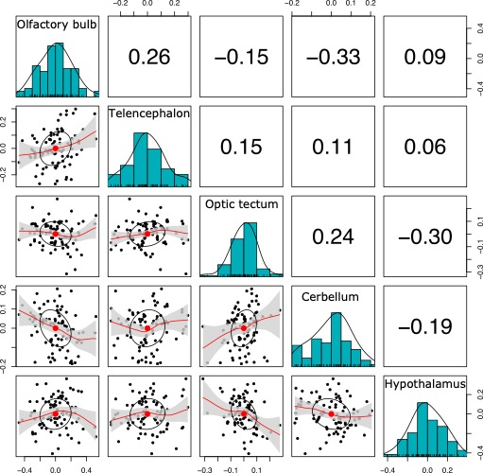
Figure S2.1 – Correlation matrix of volumes of the brain regions. Values indicate the spearman correlation.

Figure S2.2 – Two dominant principal component of PCA. Ellipses in PCA indicate 95 % CI around the mean around AF – allopatric females (black), AM – allpaptric males (red), SF – sympatric females (green), and SM – sympatric females (blue). Mean of groups are indicated by purple square.

References
Budaev, S. 2010. Using principal components and factor analysis in animal behaviour research: Caveats and guidelines. Ethology 116: 472-480. https://doi.org/10.1111/j.1439-0310.2010.01758.x
Lê, S., Josse, J. and Husson, F. 2008. FactoMineR: an R package for multivariate analysis. Journal of Statistical Software 25: 1–18. https://doi.org/10.18637/jss.v025.i01
Pike, T.W., Ramsey, M., and Wilkinson, A. 2018. Environmentally induced changes to brain morphology predict cognitive performance. Philos. Trans. R. Soc. Lond., B, Biol. Sci., 373(1756), 20170287. https://doi.org/10.1098/rstb.2017.0287

