Supplementary information
Supplementary figures 1-7

Supplementary Fig.1
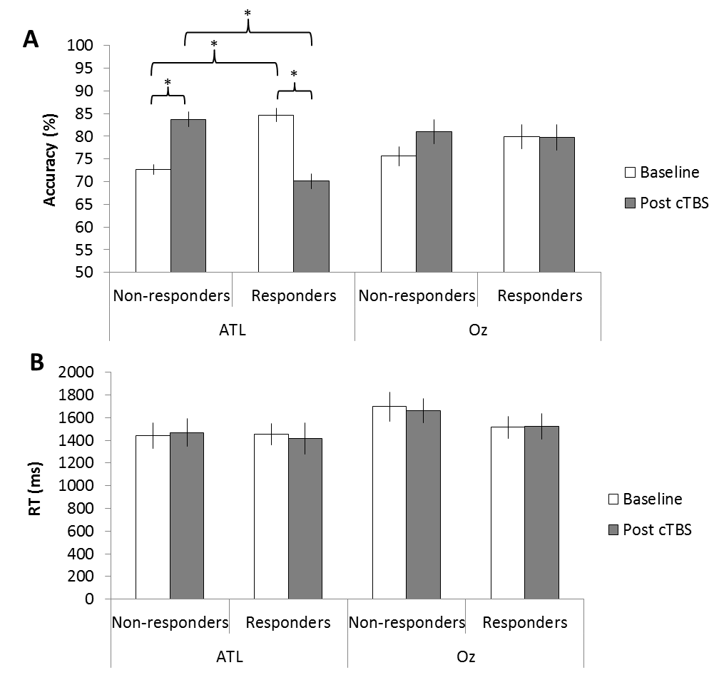
Figure S1 Summary of task performance during a semantic task. After ATL stimulation, non-responders showed increased accuracy compared to responders, who showed decreased accuracy. However, at baseline, responders showed better semantic task accuracy compared to non-responders. White bars represent the baseline block and grey bars represent the post cTBS block. Error bars represent the standard error. * p < 0.05

Supplementary Fig.2
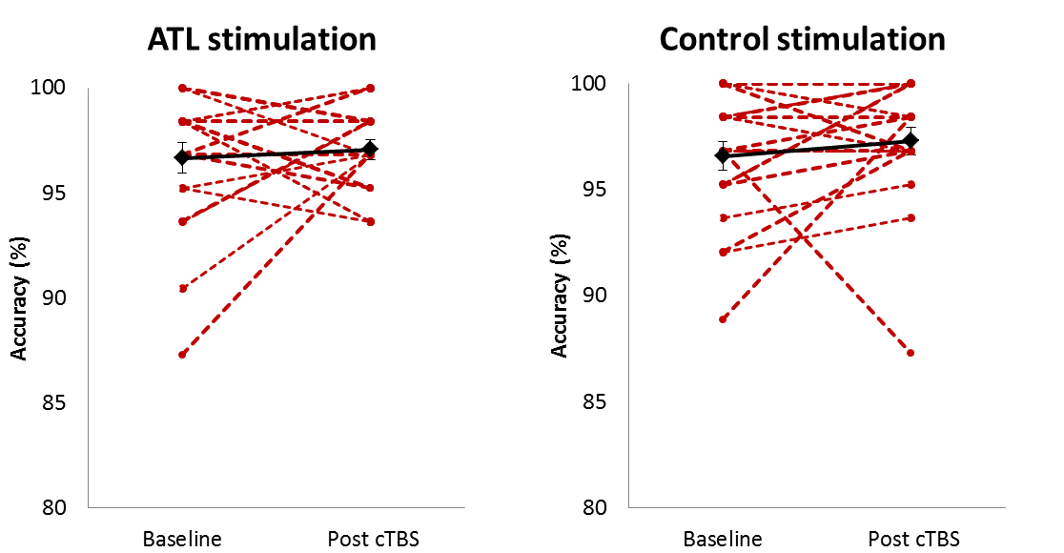
Figure S2 Individual task performance during a picture matching task (control task). Red dot represents each individual and the block diamond indicates the average of task accuracy.
Supplementary Fig. 3
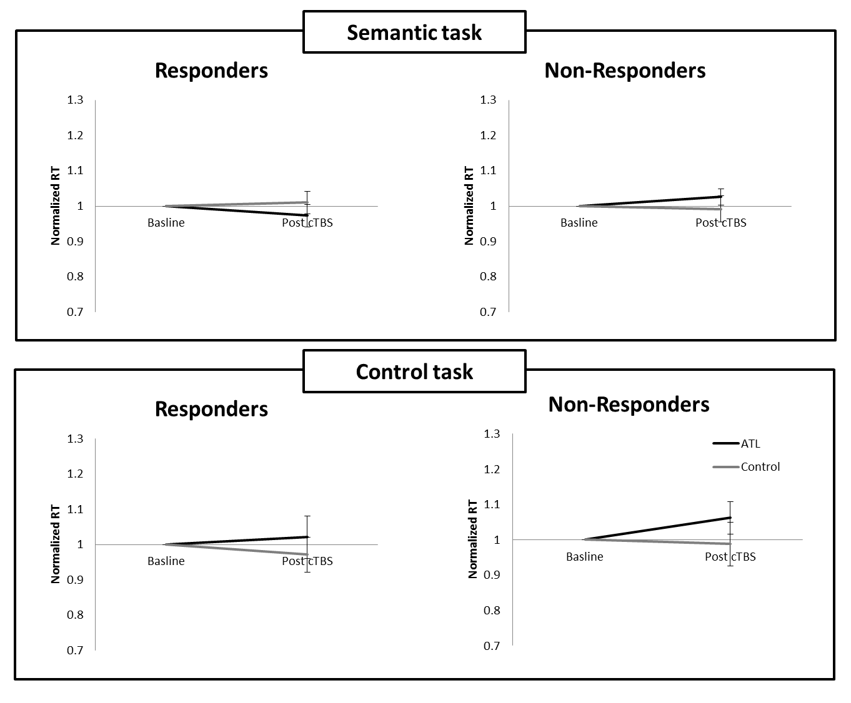Figure S3 Normalized reaction time (RT). No significant effects of TMS on RT. Black line represents the ATL stimulation. Grey line represents the control stimulation. Error bars indicate standard errors.
Supplementary Fig. 4
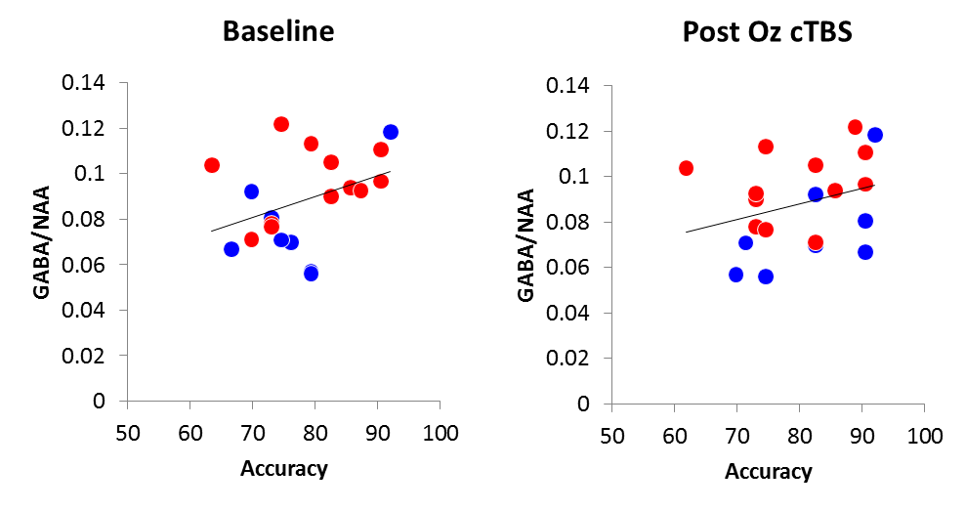
Figure S4 The relationship between semantic task accuracy and ATL GABA concentration with and without occipital pole (Oz) stimulation. Partial correlation analysis revealed a positive relationship between the ATL GABA concentration and semantic task accuracy regardless of Oz stimulation (baseline: r = 0.42, p _{FDR-corrected} < 0.05, Post Oz cTBS: r = 0.43, p _{FDR-corrected} < 0.05). Red circles represent responders and blue circles, non-responders.
Supplementary Fig. 5
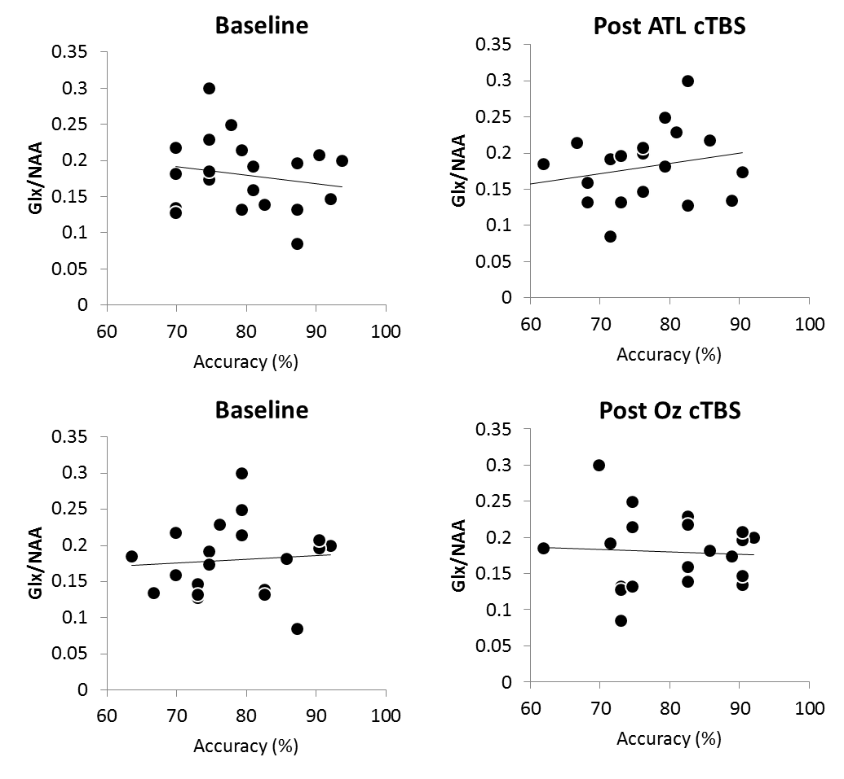
Figure S5 The relationship between semantic task accuracy and ATL glutamate + glutamine (Glx) concentration expressed as a ratio to N-acetylaspartate (NAA) with and without cTBS. Partial correlation analysis revealed no significant relationship between ATL Glx concentration and semantic task accuracy (ps > 0.05).
Supplementary Fig. 6
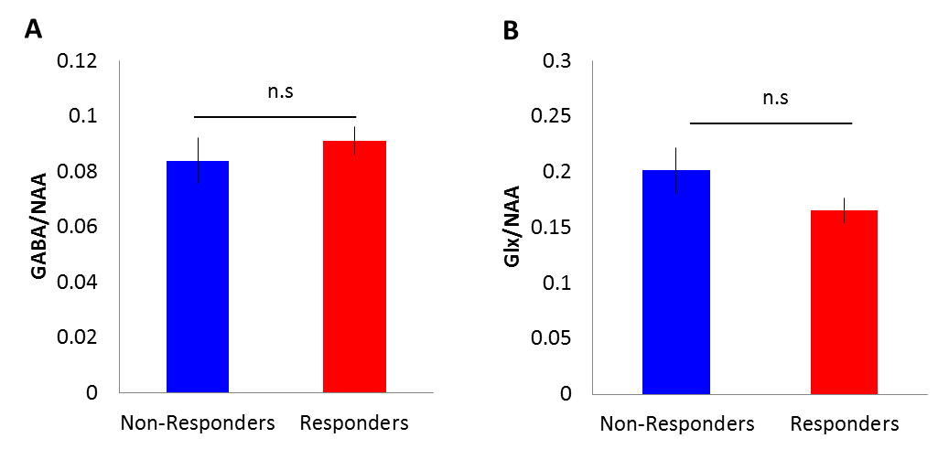
Figure S6 GABA and glutamate + glutamine (Glx) concentrations relative to N-acetylaspartate (NAA) for responders (red) and non-responders (blue). Error bars indicate standard errors.
Supplementary Fig. 7
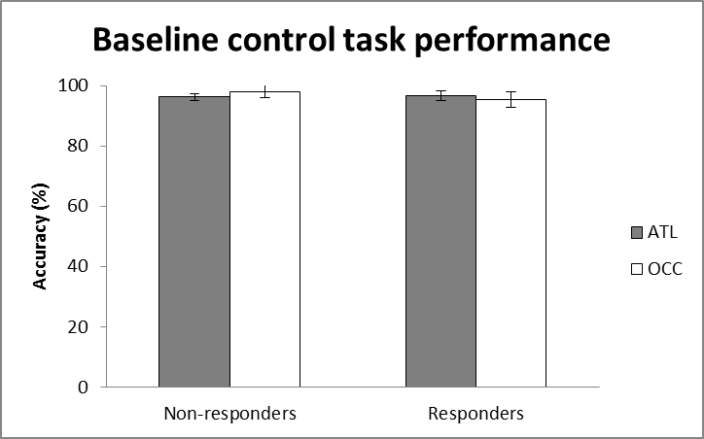
Figure S7 Baseline control task performance. There was no difference between the groups. Grey bars indicate the ATL stimulation. White bars represent the control stimulation. Error bars indicate standard errors.

