Supporting Information

Spatial assessment of tap water safety in China and associated health impacts

Mengjie Liu^{a,b}, Nigel Graham^{c}, Wenyu Wangª, Renzun Zhao^{d}, Yonglong Lu^{e}, Menachem Elimelech^{f*}, Wenzheng Yu^{a*}

ª State Key Laboratory of Environmental Aquatic Chemistry, Key Laboratory of Drinking Water Science and Technology, Research Center for Eco-Environmental Sciences, Chinese Academy of Sciences, Beijing 100085, China. (wzyu@rcees.ac.cn)
^{b} University of Chinese Academy of Sciences, Beijing100049, China
^{c} Department of Civil and Environmental Engineering, Imperial College London, South Kensington Campus, London, SW7 2AZ, UK. (n.graham@imperial.ac.uk)
^{d} Department of Civil, Architectural and Environmental Engineering, North Carolina Agricultural and Technical State University, Greensboro, North Carolina, USA 27411(rzhao@ncat.edu)
^{e} State Key Laboratory of Marine Environmental Science and Key Laboratory of the Ministry of Education for Coastal Wetland Ecosystems, College of the Environment and Ecology, Xiamen University, Fujian 361102, China (yllu@xmu.edu.cn, or yllu@rcees.ac.cn)
^{f} Department of Chemical and Environmental Engineering, Yale University, New Haven, CT, 06520–8286, USA (menachem.elimelech@yale.edu)

Text S1: Chemical standards for DBP calibration
The chemical standards were as follows: a THM mixture certified reference material (100 mg/L of each component in methanol, TanMo Quality Inspection Technology Co., Ltd (China)), a HAA mixture certified reference material (1000 mg/L of each component in methanol, Sigma-Aldrich (USA)), and a N-DBPs mixture certified reference material (5000 mg/L of each component in acetone, AccuStandard, (USA)). Detailed information about DBPs were in Table S7.

Text S2: DBP extraction
For the extraction of THMs and N-DBPs, 4 mL methyl tert-butyl ether (MTBE) and 8 g Na₂SO₄ were added to 20 mL water samples. After shaking the water samples for 2 min and standing them for 20 min, the supernatant was drawn to the GC-vial, and compounds subsequently determined by GC-ECD.
For HAAs, 20 mL water samples were adjusted to pH ≤ 0.5 with 1 mL concentrated sulfuric acid. Na₂SO₄ was then added and the sample was immediately shaken until all the solid had dissolved. After that, MTBE was added and the sample was shaken vigorously for 2 min. The supernatant containing HAAs were then methylated by adding acidic methanol (containing 10%wt H₂SO₄) followed by water bath heating for 2 h at 50 ⁰C. Finally, the methylated HAAs were separated by adding NaSO₄ (150 g/L), and neutralized with NaHCO₃ before determination by GC-ECD.

Text S3: Relative position of sample point
The indexes ‘north’ and ‘east’ were used to describe the relative position of a sample point. For a city with latitude of x and longitude of y, the calculation of ‘north’ and ‘east’ were as follows:
$$north=\frac{x-x_{min}}{x_{max}-x_{min}}$$
$$east=\frac{y-y_{min}}{y_{max}-y_{min}}$$
The x_{min} and x_{max} are the latitude of the southernmost and northernmost location of China (3°51′N and 53°33′N). The y_{min} and y_{max} are the longitude of the westernmost and easternmost location of China (73°33′E and 135°05′E).

Table S1. The Environmental Quality Standards for Surface Water in mg/L (MEP, 1997)
No. | parameters/standards’ value/classification | I. | II. | III. | IV. | V.
1 | Water temperature ℃ | The water temperature variations caused by human activities should be controlled within: The maximum average weekly temperature rise in summer≤1; The maximum average weekly temperature drop ≤2;
2 | pH | 6.5~8.5 |  |  |  | 6~9
3 | Sulfate (by SO₄²⁻) <= | Lower than 250 | 250 | 250 | 250 | 250
4 | Chloride (by Cl⁻) <= | Lower than 250 | 250 | 250 | 250 | 250
5 | Soluble Fe <= | Lower than 0.3 | 0.3 | 0.5 | 0.5 | 1
6 | Total Manganese (Mn) <= | Lower than 0.1 | 0.1 | 0.1 | 0.5 | 1
7 | Total Copper <= | Lower than 0.01 | 1.0 (fishery 0.01) | 1.0 (fishery 0.01) | 1 | 1
8 | Total Zine <= | 0.05 | 1.0 (fishery0.1) | 1.0 (fishery 0.1) | 2 | 2
9 | Nitrate (by N) <= | Lower than 10 | 10 | 20 | 20 | 25
10 | Nitrite (by N) <= | 0.06 | 0.1 | 0.15 | 1 | 1
11 | Non-ionic Nitrogen <= | 0.02 | 0.02 | 0.02 | 0.2 | 0.2
12 | Kjeldahl Nitrogen <= | 0.5 | 0.5 | 1 | 2 | 2
13 | Total Phosphorus (by P) <= | 0.02 | 0.1  (lakes, reservoirs 0.025) | 0.1  (lakes, reservoirs 0.05) | 0.2 | 0.2
14 | Permanganate Index <= | 2 | 4 | 6 | 8 | 10
15 | Soluble Oxygen <= | Percentage of saturation 90% | 6 | 5 | 3 | 2
16 | Chemical Oxygen Demand (COD_{Cr}) <= | Lower than 15 | Lower than 15 | 15 | 20 | 25
17 | Biochemical Oxygen Demand (BOD₅) <= | Lower than 3 | 3 | 4 | 6 | 10
18 | Fluoride (F⁻) <= | Lower than 1.0 | 1 | 1 | 1.5 | 1.5
19 | Selenium (four) <= | Lower than 0.01 | 0.01 | 0.01 | 0.02 | 0.02
20 | Total Arsenic <= | 0.05 | 0.05 | 0.05 | 0.1 | 0.1
21 | Total Mercury <= | 0.00005 | 0.00005 | 0.0001 | 0.001 | 0.001
22 | Total Cadmium <= | 0.001 | 0.005 | 0.005 | 0.005 | 0.01
23 | Total Chromium (six) <= | 0.01 | 0.05 | 0.05 | 0.05 | 0.1
24 | Total Lead <= | 0.01 | 0.05 | 0.05 | 0.05 | 0.1
25 | Total Cyanide <= | 0.005 | 0.05 (fishery 0.005) | 0.2 (fishery 0.005) | 0.2 | 0.2
26 | Volatile Phenol <= | 0.002 | 0.002 | 0.005 | 0.01 | 0.1
27 | Oil Category <= | 0.05 | 0.05 | 0.05 | 0.5 | 1
28 | Anionic Surface-active Agent <= | Lower than 0.2 | 0.2 | 0.2 | 0.3 | 0.3
29 | Total Coliform Group Bacteria (/L) <= | 1000
30 | Benzo(a)pyrene (ug/L) <= | 0.0025 | 0.0025 | 0.0025
Note:This standard is hereby formulated for implementing the Environmental Protection Law and Law of Water Pollution Prevention and Control of People’s Republic of China, and to control water pollution and to protect water resources. This standard is applicable to the surface water bodies of rivers, lakes and reservoirs within the territory of the People’s Republic of China.
The water bodies are divided into five classes according to the utilization purposes and protection objectives:
Class I is mainly applicable to the water from pristine sources, and the national nature reserves.
Class II is mainly applicable to first class of protected areas for centralized sources of drinking water, the protected areas for rare fish, and the spawning fields of fishes and shrimps.
Class III is mainly applicable to second class of protected areas for centralized sources of drinking water, protected areas for the common fishes and swimming areas.
Class IV is mainly applicable to the water areas for industrial use and entertainment which is not directly touched by human bodies.
Class V is mainly applicable to the water bodies for agricultural use and landscape requirement.）

Table S2. Cancer incidence indexes
City number | Bladder cancer |  |  | Rectal and colon cancers |  |  | DBPs
City number | M.ASRª | F.ASR^{b} | ASR^{c} | M.ASR | F.ASR | ASR | DBPs
1 | 8.25 | 0.80 | 4.60 | 17.83 | 10.19 | 14.10 | 57.06
2 | 6.15 | 2.29 | 4.24 | 17.93 | 10.25 | 14.13 | 186.05
3 | 9.54 | 2.54 | 6.05 | 21.09 | 12.17 | 16.63 | 176.30
4 | 5.27 | 2.62 | 3.99 | 26.07 | 18.36 | 22.34 | 107.23
5 | 8.01 | 2.82 | 5.42 | 24.99 | 16.76 | 20.88 | 154.14
6 | 5.36 | 2.33 | 3.84 | 29.17 | 25.41 | 27.29 | 56.84
7 | 5.36 | 0.77 | 3.04 | 17.87 | 14.02 | 15.93 | 16.31
8 | 4.18 | 0.67 | 2.41 | 25.84 | 16.18 | 20.96 | 46.84
9 | 2.35 | 1.09 | 1.71 | 24.27 | 17.49 | 20.83 | 115.09
10 | 4.41 | 3.16 | 3.79 | 11.94 | 6.77 | 9.37 | 26.18
11 | 6.14 | 2.40 | 4.33 | 26.08 | 17.70 | 22.02 | 118.40
12 | 4.06 | 2.28 | 3.17 | 23.48 | 20.16 | 21.81 | 93.93
13 | 10.90 | 2.63 | 6.72 | 34.36 | 19.98 | 27.08 | 137.06
14 | 8.27 | 3.39 | 5.76 | 37.03 | 17.58 | 27.05 | 217.40
15 | 2.44 | 0.81 | 1.67 | 12.48 | 10.05 | 11.33 | 97.70
16 | 5.72 | 1.41 | 3.60 | 28.19 | 14.87 | 21.62 | 64.61
17 | 3.30 | 0.22 | 1.81 | 15.87 | 16.05 | 15.96 | 17.53
18 | 5.43 | 1.26 | 3.35 | 32.78 | 23.24 | 27.99 | 125.64
19 | 6.04 | 1.35 | 3.75 | 28.60 | 18.96 | 23.90 | 136.95
20 | 6.74 | 2.02 | 4.32 | 30.07 | 15.59 | 22.65 | 89.61
21 | 5.27 | 1.37 | 3.32 | 23.85 | 16.96 | 20.40 | 70.75
22 | 8.17 | 2.19 | 5.21 | 26.81 | 17.42 | 22.16 | 184.14
23 | 5.44 | 1.56 | 3.48 | 21.13 | 12.64 | 16.83 | 73.83
24 | 4.54 | 1.40 | 2.95 | 29.69 | 17.90 | 23.74 | 105.62
25 | 6.92 | 0.95 | 3.95 | 22.66 | 17.76 | 20.22 | 212.35
26 | 4.26 | 0.49 | 2.39 | 17.97 | 13.90 | 15.94 | 13.67
27 | 5.17 | 0.00 | 5.17 | 14.06 | 10.56 | 12.38 | 75.30
28 | 1.10 | 0.00 | 1.10 | 7.43 | 1.93 | 4.76 | 14.03
29 | 6.74 | 1.91 | 4.55 | 29.49 | 18.13 | 24.35 | 69.74
30 | 5.57 | 2.10 | 3.88 | 14.98 | 12.96 | 14.00 | 268.04
31 | 5.36 | 0.70 | 2.98 | 28.14 | 19.07 | 23.51 | 72.16
32 | 5.58 | 0.00 | 5.58 | 19.32 | 32.31 | 25.47 | 48.41
33 | 3.75 | 0.48 | 2.15 | 40.62 | 20.86 | 30.98 | 63.98
34 | 11.53 | 2.77 | 7.18 | 34.66 | 21.76 | 28.26 | 99.64
35 | 7.77 | 2.35 | 5.03 | 29.60 | 21.86 | 25.68 | 7.38
36 | 5.33 | 1.47 | 3.37 | 16.91 | 12.84 | 14.85 | 152.74
37 | 5.35 | 1.01 | 3.15 | 22.75 | 16.35 | 19.50 | 84.63
38 | 8.12 | 2.68 | 5.34 | 33.87 | 20.23 | 26.90 | 95.37
39 | 15.51 | 3.19 | 9.88 | 67.80 | 45.90 | 57.77 | 117.10
40 | 7.68 | 1.69 | 4.69 | 21.35 | 14.74 | 18.05 | 93.66
41 | 2.54 | 0.29 | 1.42 | 10.70 | 6.79 | 8.76 | 18.02
42 | 2.48 | 1.50 | 1.99 | 24.49 | 12.81 | 18.66 | 80.32
43 | 8.28 | 1.84 | 5.09 | 24.39 | 17.74 | 21.10 | 125.37
44 | 7.36 | 1.84 | 4.54 | 19.79 | 14.17 | 16.92 | 78.97
45 | 5.61 | 1.47 | 3.57 | 21.97 | 8.52 | 15.34 | 114.95
46 | 5.56 | 1.04 | 3.26 | 35.53 | 20.60 | 27.96 | 97.18
47 | 6.15 | 1.27 | 3.66 | 27.09 | 18.22 | 22.57 | 32.33
48 | 4.24 | 0.47 | 2.37 | 17.58 | 14.28 | 15.94 | 12.92
49 | 4.48 | 1.66 | 3.07 | 20.80 | 11.88 | 16.34 | 99.07
50 | 8.50 | 1.79 | 5.13 | 28.52 | 19.09 | 23.79 | 145.34
51 | 6.75 | 2.99 | 4.84 | 25.47 | 16.06 | 20.69 | 53.71
52 | 6.49 | 1.62 | 4.03 | 28.53 | 18.02 | 23.22 | 126.73
national average | 6.36 | 1.66 | 3.93 | 24.04 | 16.25 | 20.05
a. male age standard rate
b. female age standard rate
c. age standard rate

Table S3. Abbreviations for water quality indexes
Abbreviations | Indexes
TOC | total organic carbon
R1 | volume integral of Tyrosine-like aromatic protein region in EEM: Ex: 200-250 nm; Em: 280-330 nm
R2 | volume integral of Tryptophan-like aromatic protein region in EEM: Ex: 200-250 nm; Em: 330-380 nm
R3 | volume integral of Fulvic acid-like matter region in EEM: Ex: 200-250 nm; Em: 380-550 nm
R4 | volume integral of Soluble microbial byproduct-like matter region in EEM: Ex: 250-400 nm; Em: 280-380 nm
R5 | volume integral of Humic acid-like matter region in EEM: Ex: 250-400 nm; Em: 380-550 nm
BIX | biological index: (Ex=310; Em=380)/(Ex=310; Em=430)
B | fluorescent peak: Em=305; Ex=275
T | fluorescent peak: Em=340; Ex=275
A | fluorescent peak: Em=400-460; Ex=260
M | fluorescent peak: Em=370-410; Ex=290-310
C | fluorescent peak: Em=420-460; Ex=320-360;
TF | total fluorescence
FI | fluorescence index: (Ex=370; Em=470)/(Ex=370; Em=520)
HIX | humification index: (Ex=254; Em=435-480)/[(Ex=254; Em=435-480)]
A254 | absorbance at 254 nm
A300 | absorbance at 300 nm
E2:E3 | the ratio of absorbance at 250 nm to 365 nm
E4:E6 | the ratio of absorbance at 465 nm to 665 nm
S275/295 | the first derivative of the natural logarithmic spectrum at 275-295nm
S350/400 | the first derivative of the natural logarithmic spectrum at 350-400nm
S300/700 | the first derivative of the natural logarithmic spectrum at 300-700nm
SR | the ratio of S275_295 to S350_390
SUVA | the ratio of A254 to TOC

Table S4. Definitions and sources of data for PLS-PM analysis
Latent variables | Manifest variables | Abbreviation | Features | Source of statistics | Pearson coefficientª | p-value
Natural factors | annual precipitation | N1 | Average of the sampled cities in each province (2019) | http://data.cma.cn/ | -0.52 (conductivity) | **
Natural factors | forest coverage | N2 | provincial forest coverage in 2019 | https://data.stats.gov.cn/ | -0.42 (conductivity) | *
Anthropogenic factors | Total Land Area of Administrative region | A1 | provincal value in 2019 | https://data.stats.gov.cn/ | 0.53 | **
Anthropogenic factors | Gross Domestic Product (GDP) | A2 | provincal value in 2019 | https://data.stats.gov.cn/ | 0.5 | **
Anthropogenic factors | Nitrogen Oxides Emission | A3 | provincal value in 2018 | China Statistical Yearbook on Environment (2019) | 0.49 | **
Anthropogenic factors | Industrial Nitrogen Oxides Emission | A4 | provincal value in 2018 | China Statistical Yearbook on Environment (2019) | 0.5 | **
Anthropogenic factors | Motor vehicle Nitrogen Oxides Emission | A5 | provincal value in 2018 | China Statistical Yearbook on Environment (2019) | 0.45 | *
Anthropogenic factors | Hazardous Wastes Generated | A6 | provincal value in 2018 | China Statistical Yearbook on Environment (2019) | 0.45 | *
Anthropogenic factors | Hazardous Wastes Utilized and Disposed | A7 | provincal value in 2018 | China Statistical Yearbook on Environment (2019) | 0.46 | **
Anthropogenic factors | Annual Expenditure of Industrial Whste Gas Treatment Facilities | A8 | provincal value in 2018 | China Statistical Yearbook on Environment (2019) | 0.58 | ***
Anthropogenic factors | Annual Expenditure of Industrial Waste Water Treatment Facilities | A9 | provincal value in 2018 | China Statistical Yearbook on Environment (2019) | 0.58 | ***
Anthropogenic factors | Industry COD Discharged | A10 | provincal value in 2018 | China Statistical Yearbook on Environment (2019) | 0.54 | **
DOM | TOC | D1 | Average of the sampled cities in each province | measured
DOM | TF | D2 | Average of the sampled cities in each province | measured
DOM | A254 | D3 | Average of the sampled cities in each province | measured
Cl-DBPs | TCM | C1 | Average of the sampled cities in each province | measured
Cl-DBPs | DCAA | C2 | Average of the sampled cities in each province | measured
Cl-DBPs | DCAN | C3 | Average of the sampled cities in each province | measured
Cl-DBPs | TCAN | C4 | Average of the sampled cities in each province | measured
Cl-DBPs | TCAA | C5 | Average of the sampled cities in each province | measured
Cl-DBPs | CDBA | C6 | Average of the sampled cities in each province | measured
Br-DBPs | TBAA | B1 | Average of the sampled cities in each province | measured
Br-DBPs | BCAA | B2 | Average of the sampled cities in each province | measured
Br-DBPs | BDCM | B3 | Average of the sampled cities in each province | measured
Br-DBPs | BCAN | B4 | Average of the sampled cities in each province | measured
Br-DBPs | BDCA | B5 | Average of the sampled cities in each province | measured
Br-DBPs | DBCM | B6 | Average of the sampled cities in each province | measured
Br-DBPs | DBAA | B7 | Average of the sampled cities in each province | measured
Br-DBPs | TBM | B8 | Average of the sampled cities in each province | measured
 | DBAN | B9 | Average of the sampled cities in each province | measured
conductivity | conductivity | con | Average of the sampled cities in each province | measured
total toxicity | total toxicity | tox | Average of the sampled cities in each province | measured
a. if not noted in the bracket, representing the pearson coefficient with DBP toxicity

Table S5. Properties of nanofiltration membranes
Membranes | Zeta potential  (mV) | Contact angle (degree) | Flux of deionized water  L/(h·m²·bar)
NF270 | -39.2 ± 2.2 | 32.2 ± 3.3 | 11.0 ± 0.5
NF90 | -32.7 ± 1.9 | 54.3 ± 5.3 | 5.8 ± 0.3

TableS6：Detailed information of DBPs
Type | Name | Acronyms | Molecular formula/structure | Molecular weight (g/mol) | CHO LC₅₀ (M) ª
THMs | trichloromethane | TCM | 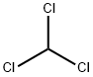 | 119.38 | 9.62 × 10⁻³
THMs | bromodichloromethane | BDCM | 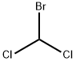 | 163.83 | 1.15 × 10⁻²
THMs | dibromochloromethane | DBCM | 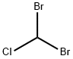 | 208.28 | 5.36 × 10-3
THMs | tribromomethane | TBM | 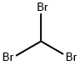 | 252.73 | 3.96 × 10⁻³
HAAs | bromochloroacetic acid | BCAA | 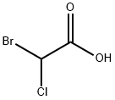 | 173.39 | 7.78 × 10⁻⁴
HAAs | chlorodibromoacetic acid | CDBA | 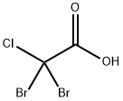 | 252.29 | 2.02 × 10⁻⁴
HAAs | bromodichloroacetic acid | BDCA | 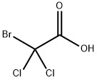 | 207.84 | 6.85 × 10⁻⁴
HAAs | tribromoacetic acid | TBAA | 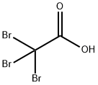 | 296.74 | 8.50 × 10⁻⁵
HAAs | monochloroacetic acid | MCAA | 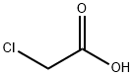 | 94.5 | 8.10×10⁻⁴
HAAs | dichloroaceticacid | DCAA | 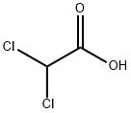 | 128.94 | 7.30 × 10⁻³
HAAs | trichloroacetic acid | TCAA | 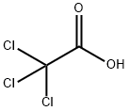 | 163.39 | 2.40 × 10⁻³
HAAs | monobromoacetic acid | MBAA | 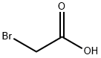 | 138.95 | 9.6×10⁻⁶
HAAs | dibromoacetic acid | DBAA | 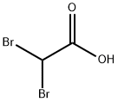 | 217.84 | 5.90 × 10⁻⁴
N-DBPs | bromochloroacetonitrile | BCAN | 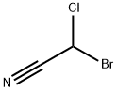 | 154.39 | 8.46 × 10⁻⁶
N-DBPs | dibromoacetonitrile | DBAN | 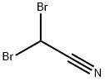 | 198.84 | 2.85 × 10⁻⁶
N-DBPs | dichloroacetonitrile | DCAN | 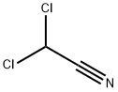 | 109.94 | 5.73 × 10⁻⁵
N-DBPs | trichloroacetonitrile | TCAN | 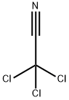 | 144.39 | 1.60÷10⁻⁴
N-DBPs | trichloronitromethane | TCNM | 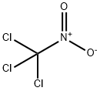 | 164.39 | 5.36 × 10⁻⁴
a. CHO LC50 values from ref.(1)

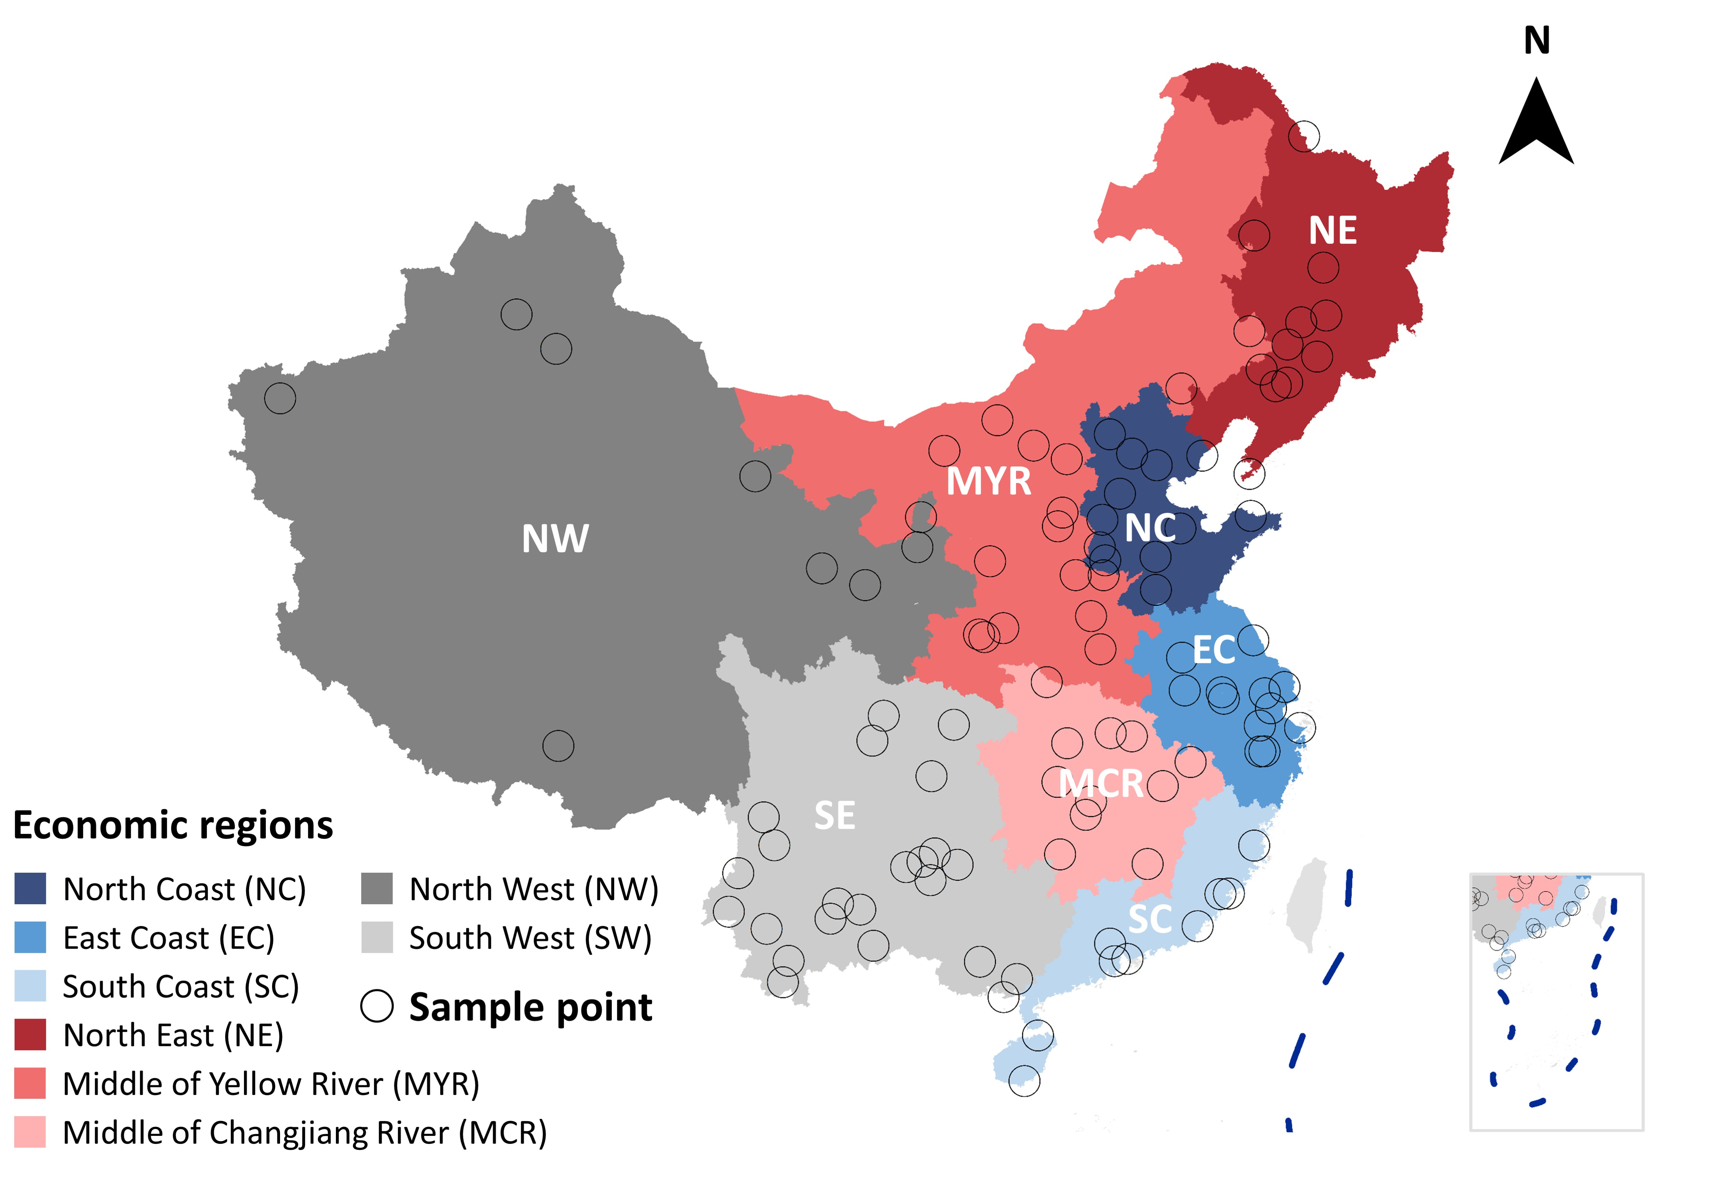

Figure S1. Map showing the 103 sample points from 31 provinces, excluding Hong Kong, Macao, and Taiwan due to sample unavailability. The 31 provinces were grouped into eight regions: North East (NE), North Coast (NC), East Coast (EC), South Coast (SC), Middle of Yellow River (MYR), Middle of Changjiang River (MCR), North West (NW) and South West (SW).

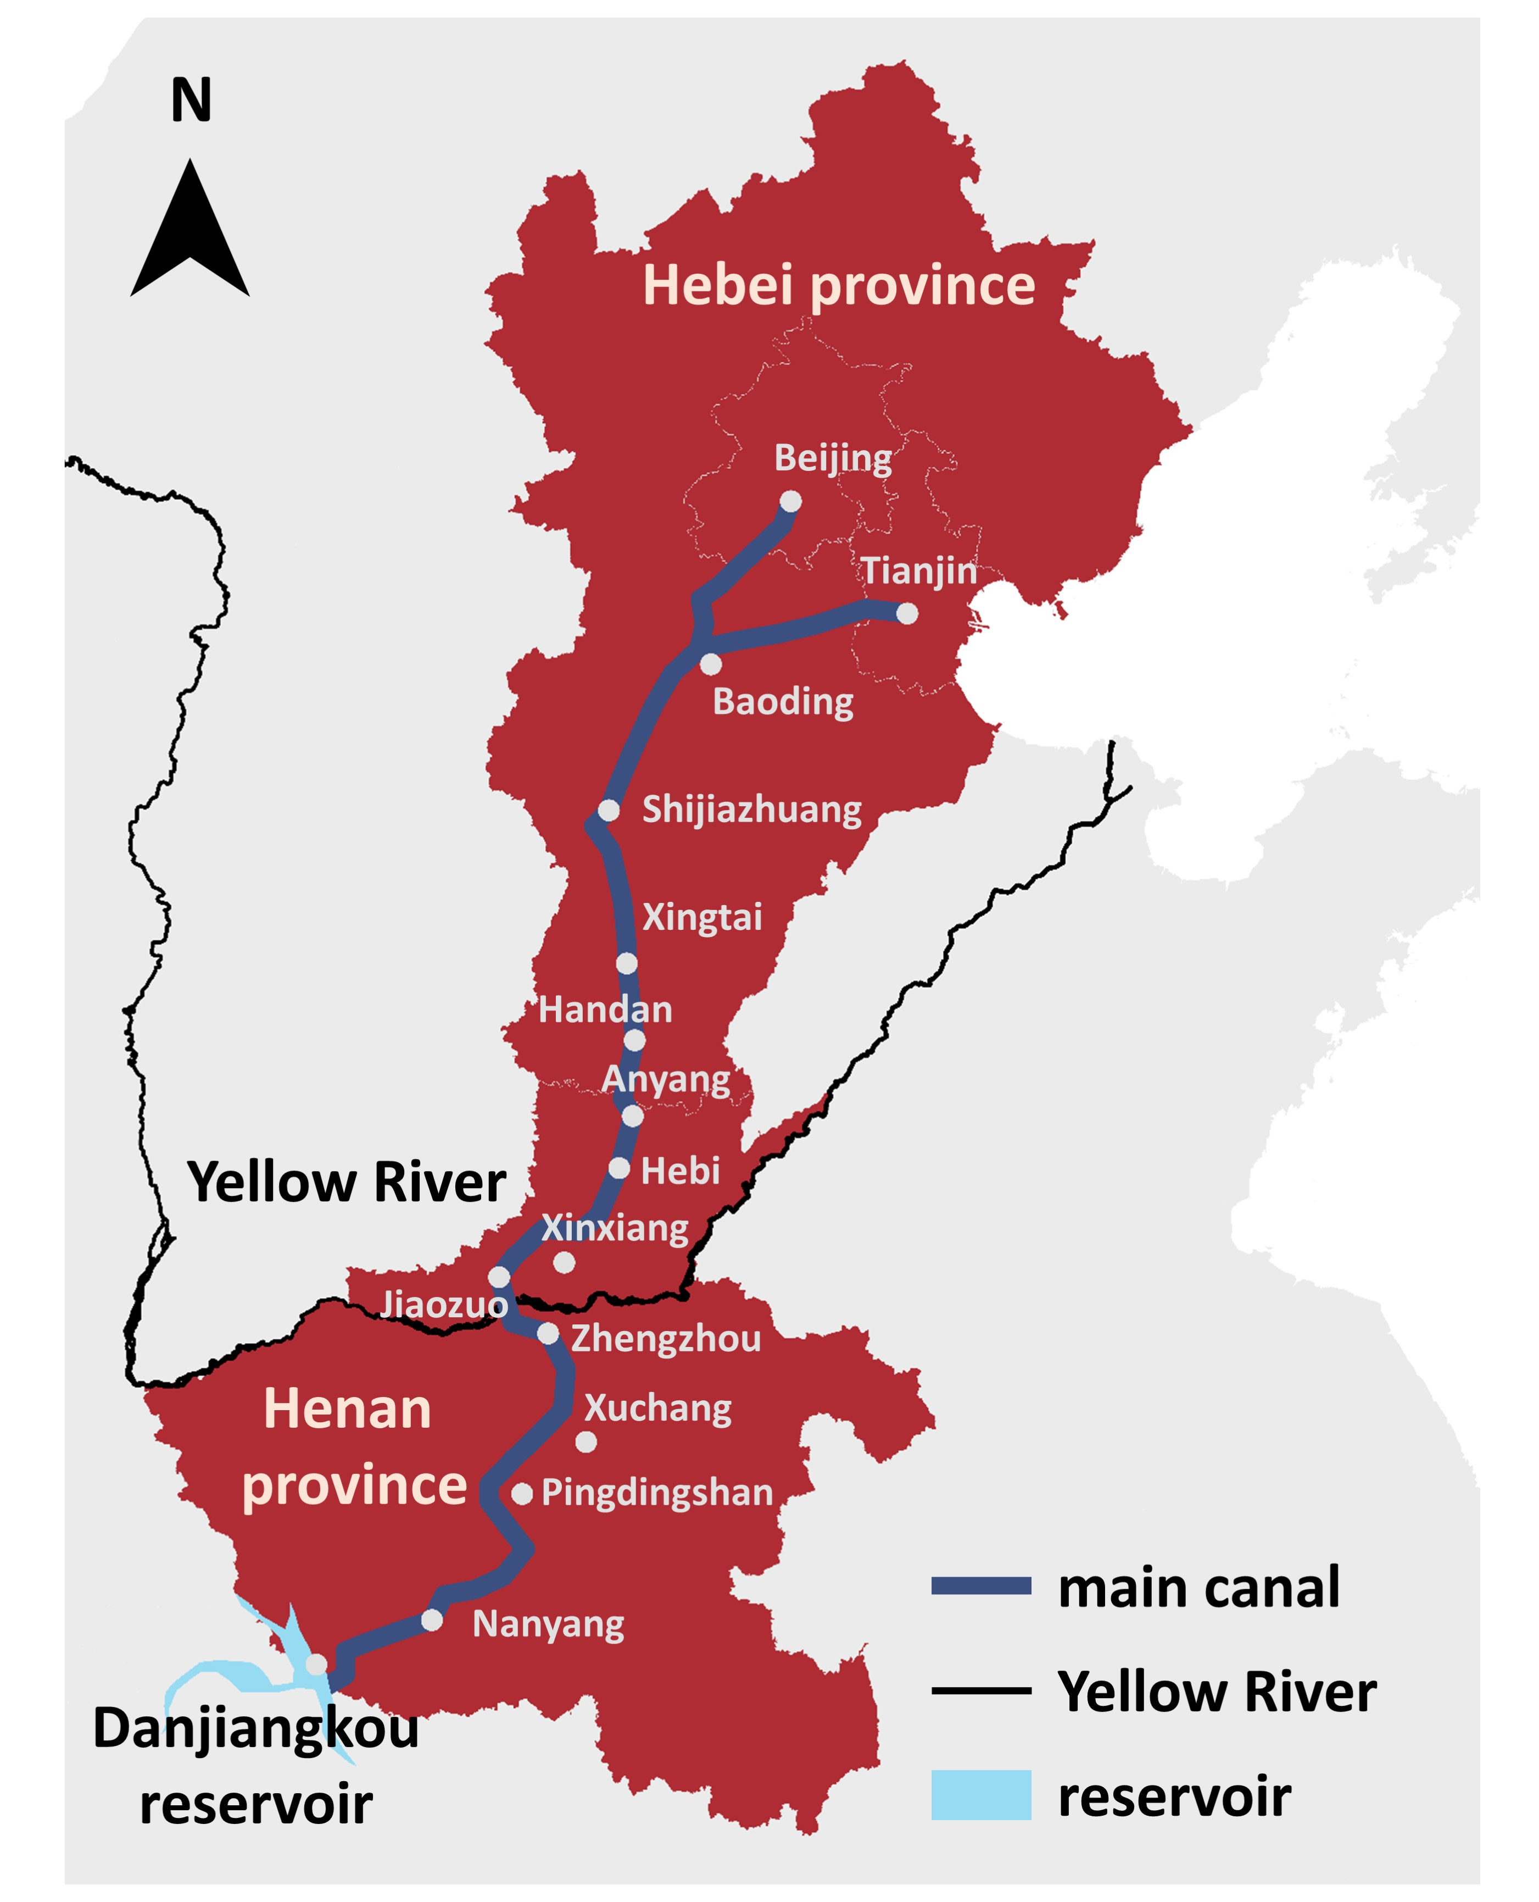

Figure S2. Roadmap of the middle route of the South-to-North Water Diversion Project. It was reported that the middle route of the South-to-North Water Diversion project supplied 8.3 billion cubic meters of water for Beijing, Tianjin as well as more than 20 large and medium-sized cities in Henan and Hebei in 2020.

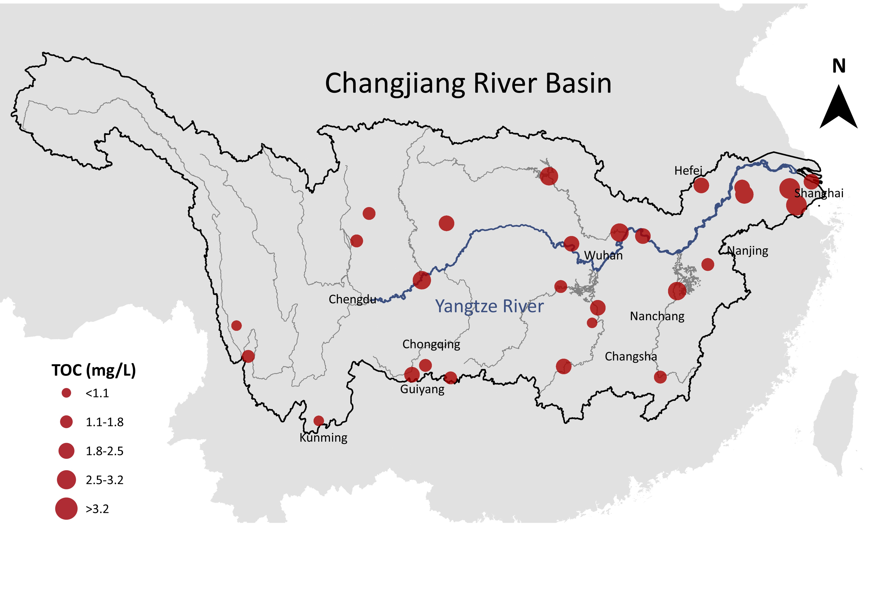

Figure S3. TOC of sample cities in Yangtze River Basin. The TOC (point size) gradually increases along the mainstream of Yangtze River.

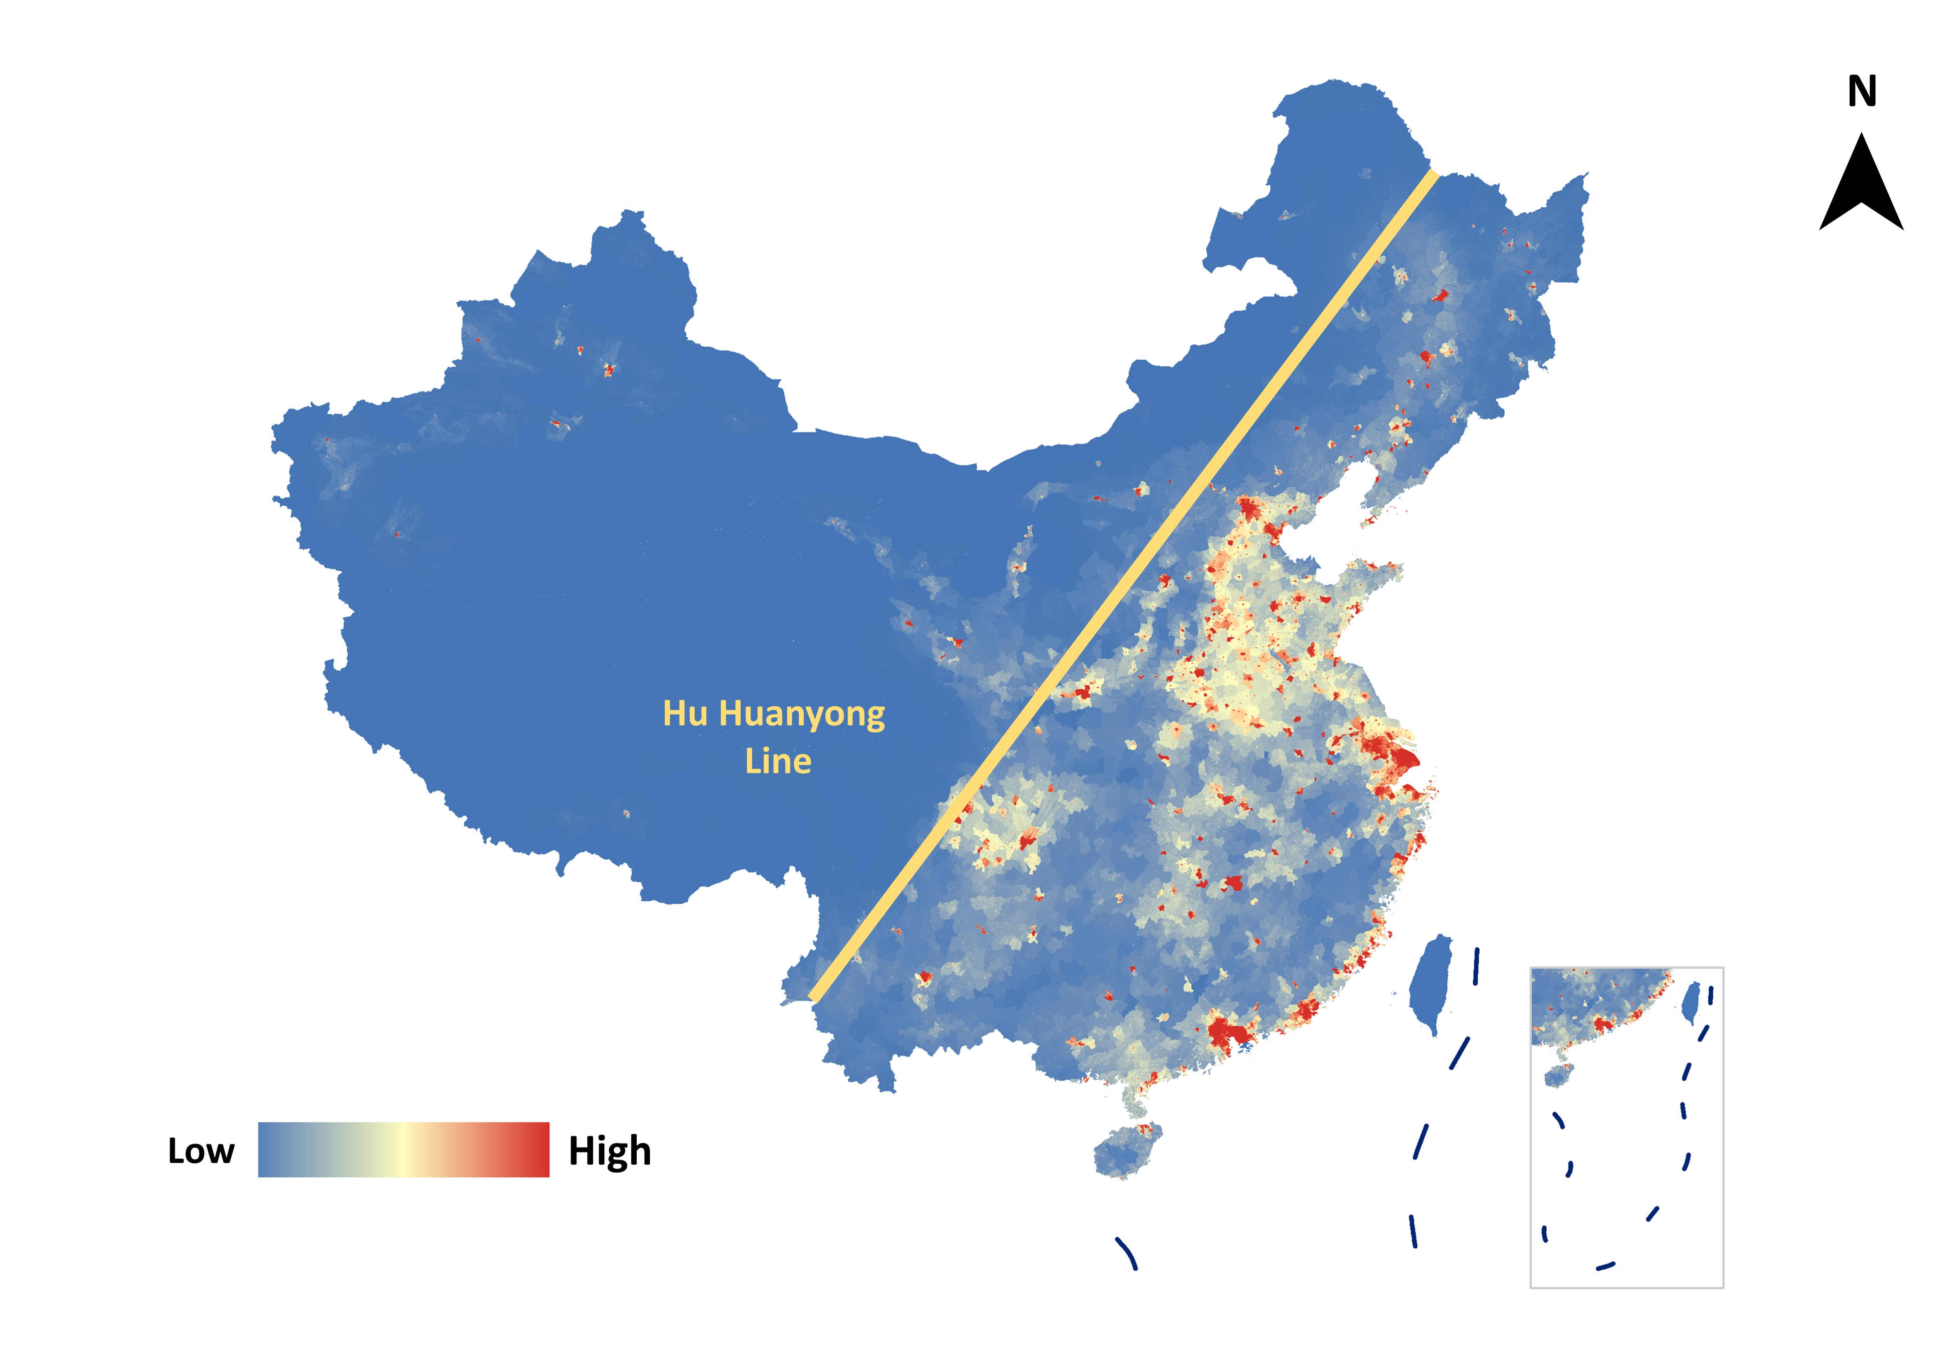

Figure S4. Population distribution of China in 2015. The Hu Huanyong Line is used as a geographic boundary between the highly developed and densely populated Eastern region and the less-developed and sparsely populated Western region in China. There is a clear and substantial difference in population density between eastern and western China (known as the Hu Huanyong Line), which is driven by historical and geographical factors, and is amplified by modern economic development (2).

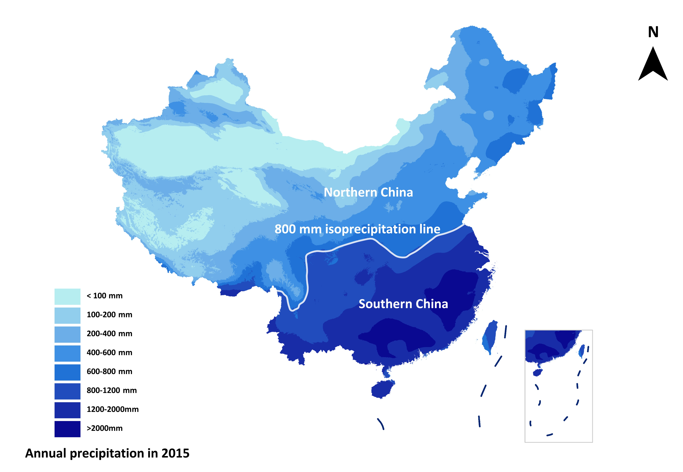

Figure S5. Annual precipitation in China in 2015, where the 800 mm iso-precipitation line coincides with the north-south boundary (Qinglin-Huaihe line).

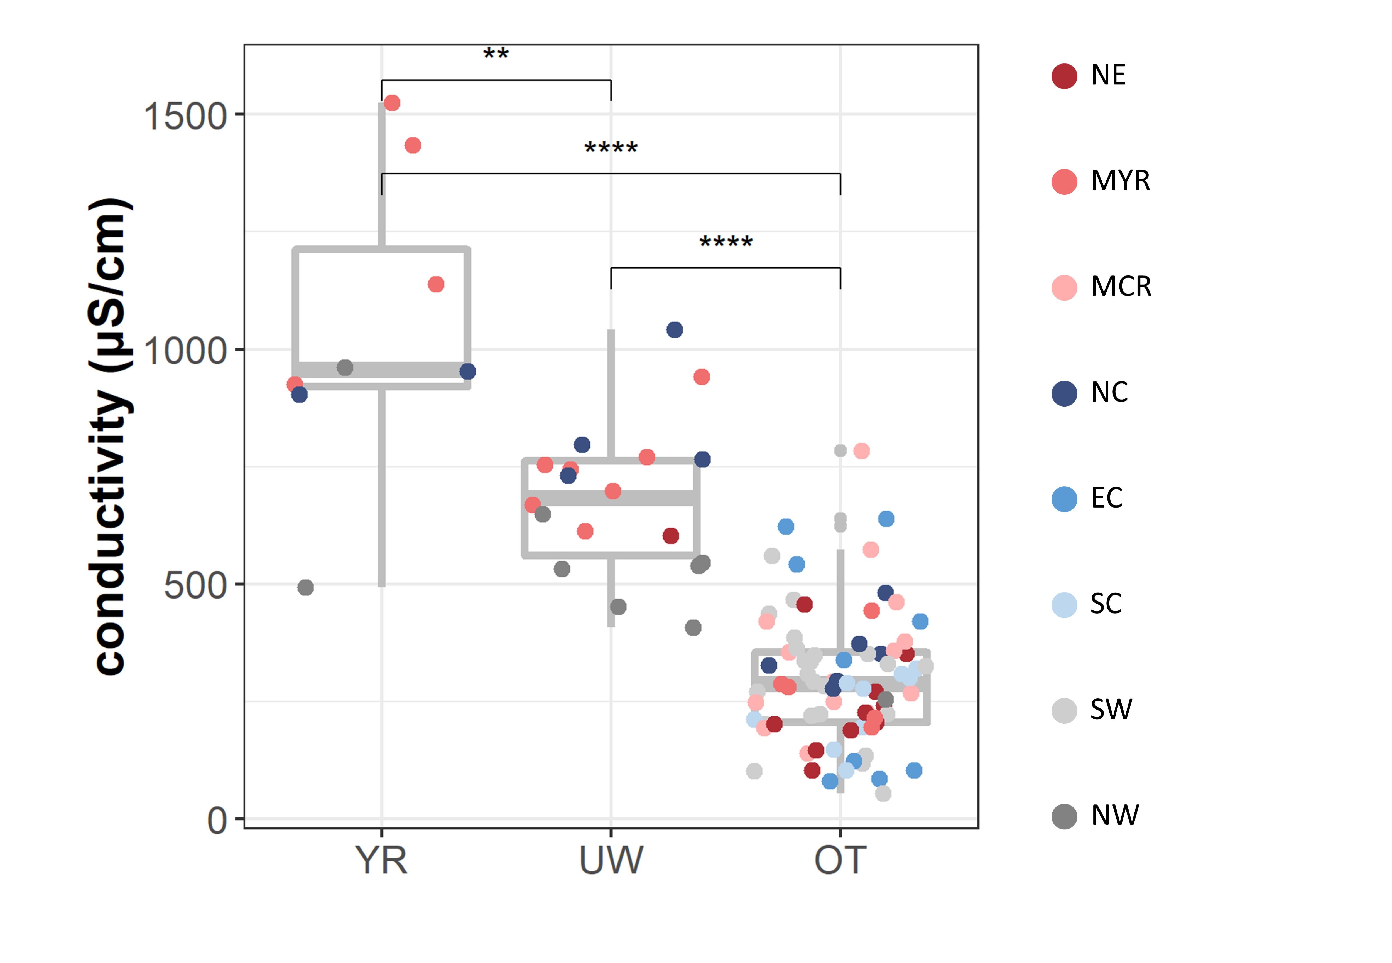

Figure S6. Boxplot of conductivity in tap water from different water sources: Yellow River (YR), underground water (UW) and others (OT), where the color indicates eight economic regions. Results of Wilcoxon tests showed significant differences (P < 0.0001) between group YR and OT, UW and OT, while the difference between YR and UW was not significant (ns, p>0.05)

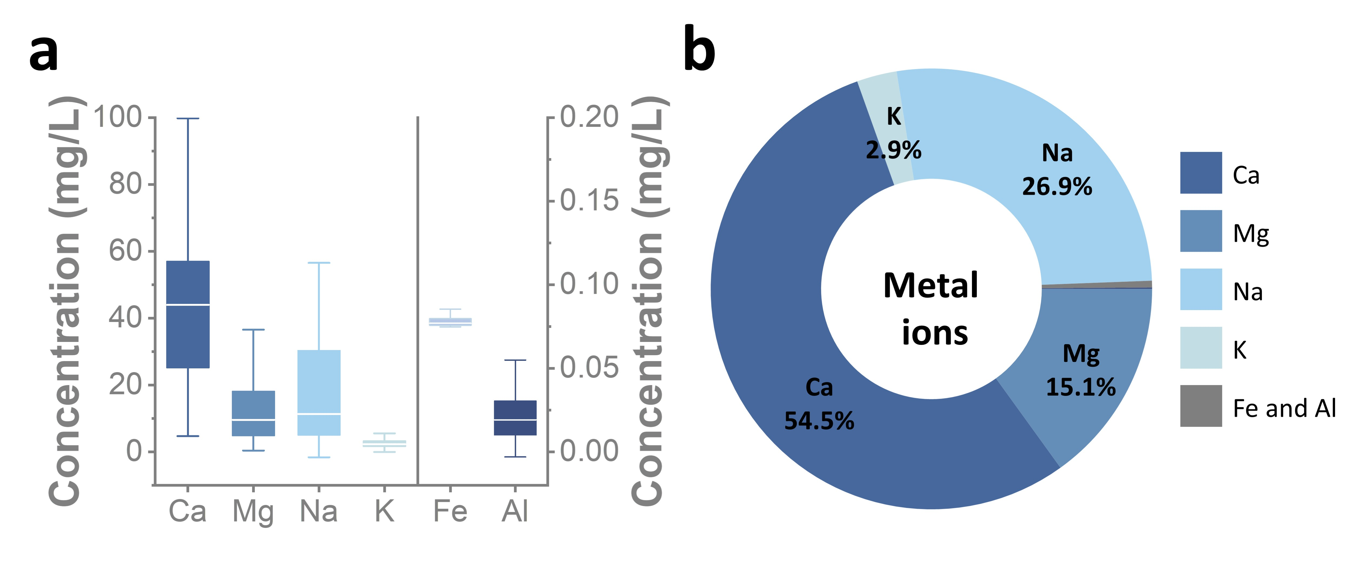Figure S7. Cations in tap water samples. (a) Concentrations of six cations in tap water. (b) Average concertation weights of six cations in tap water.

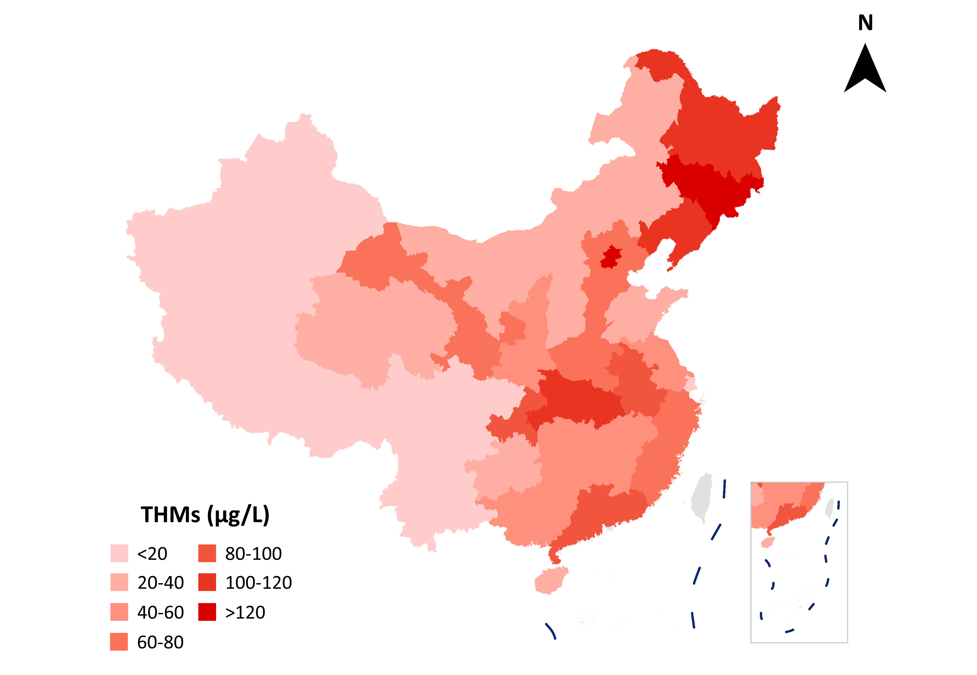

Figure S8. Spatial distribution of total THMs (averaged by province) in China.
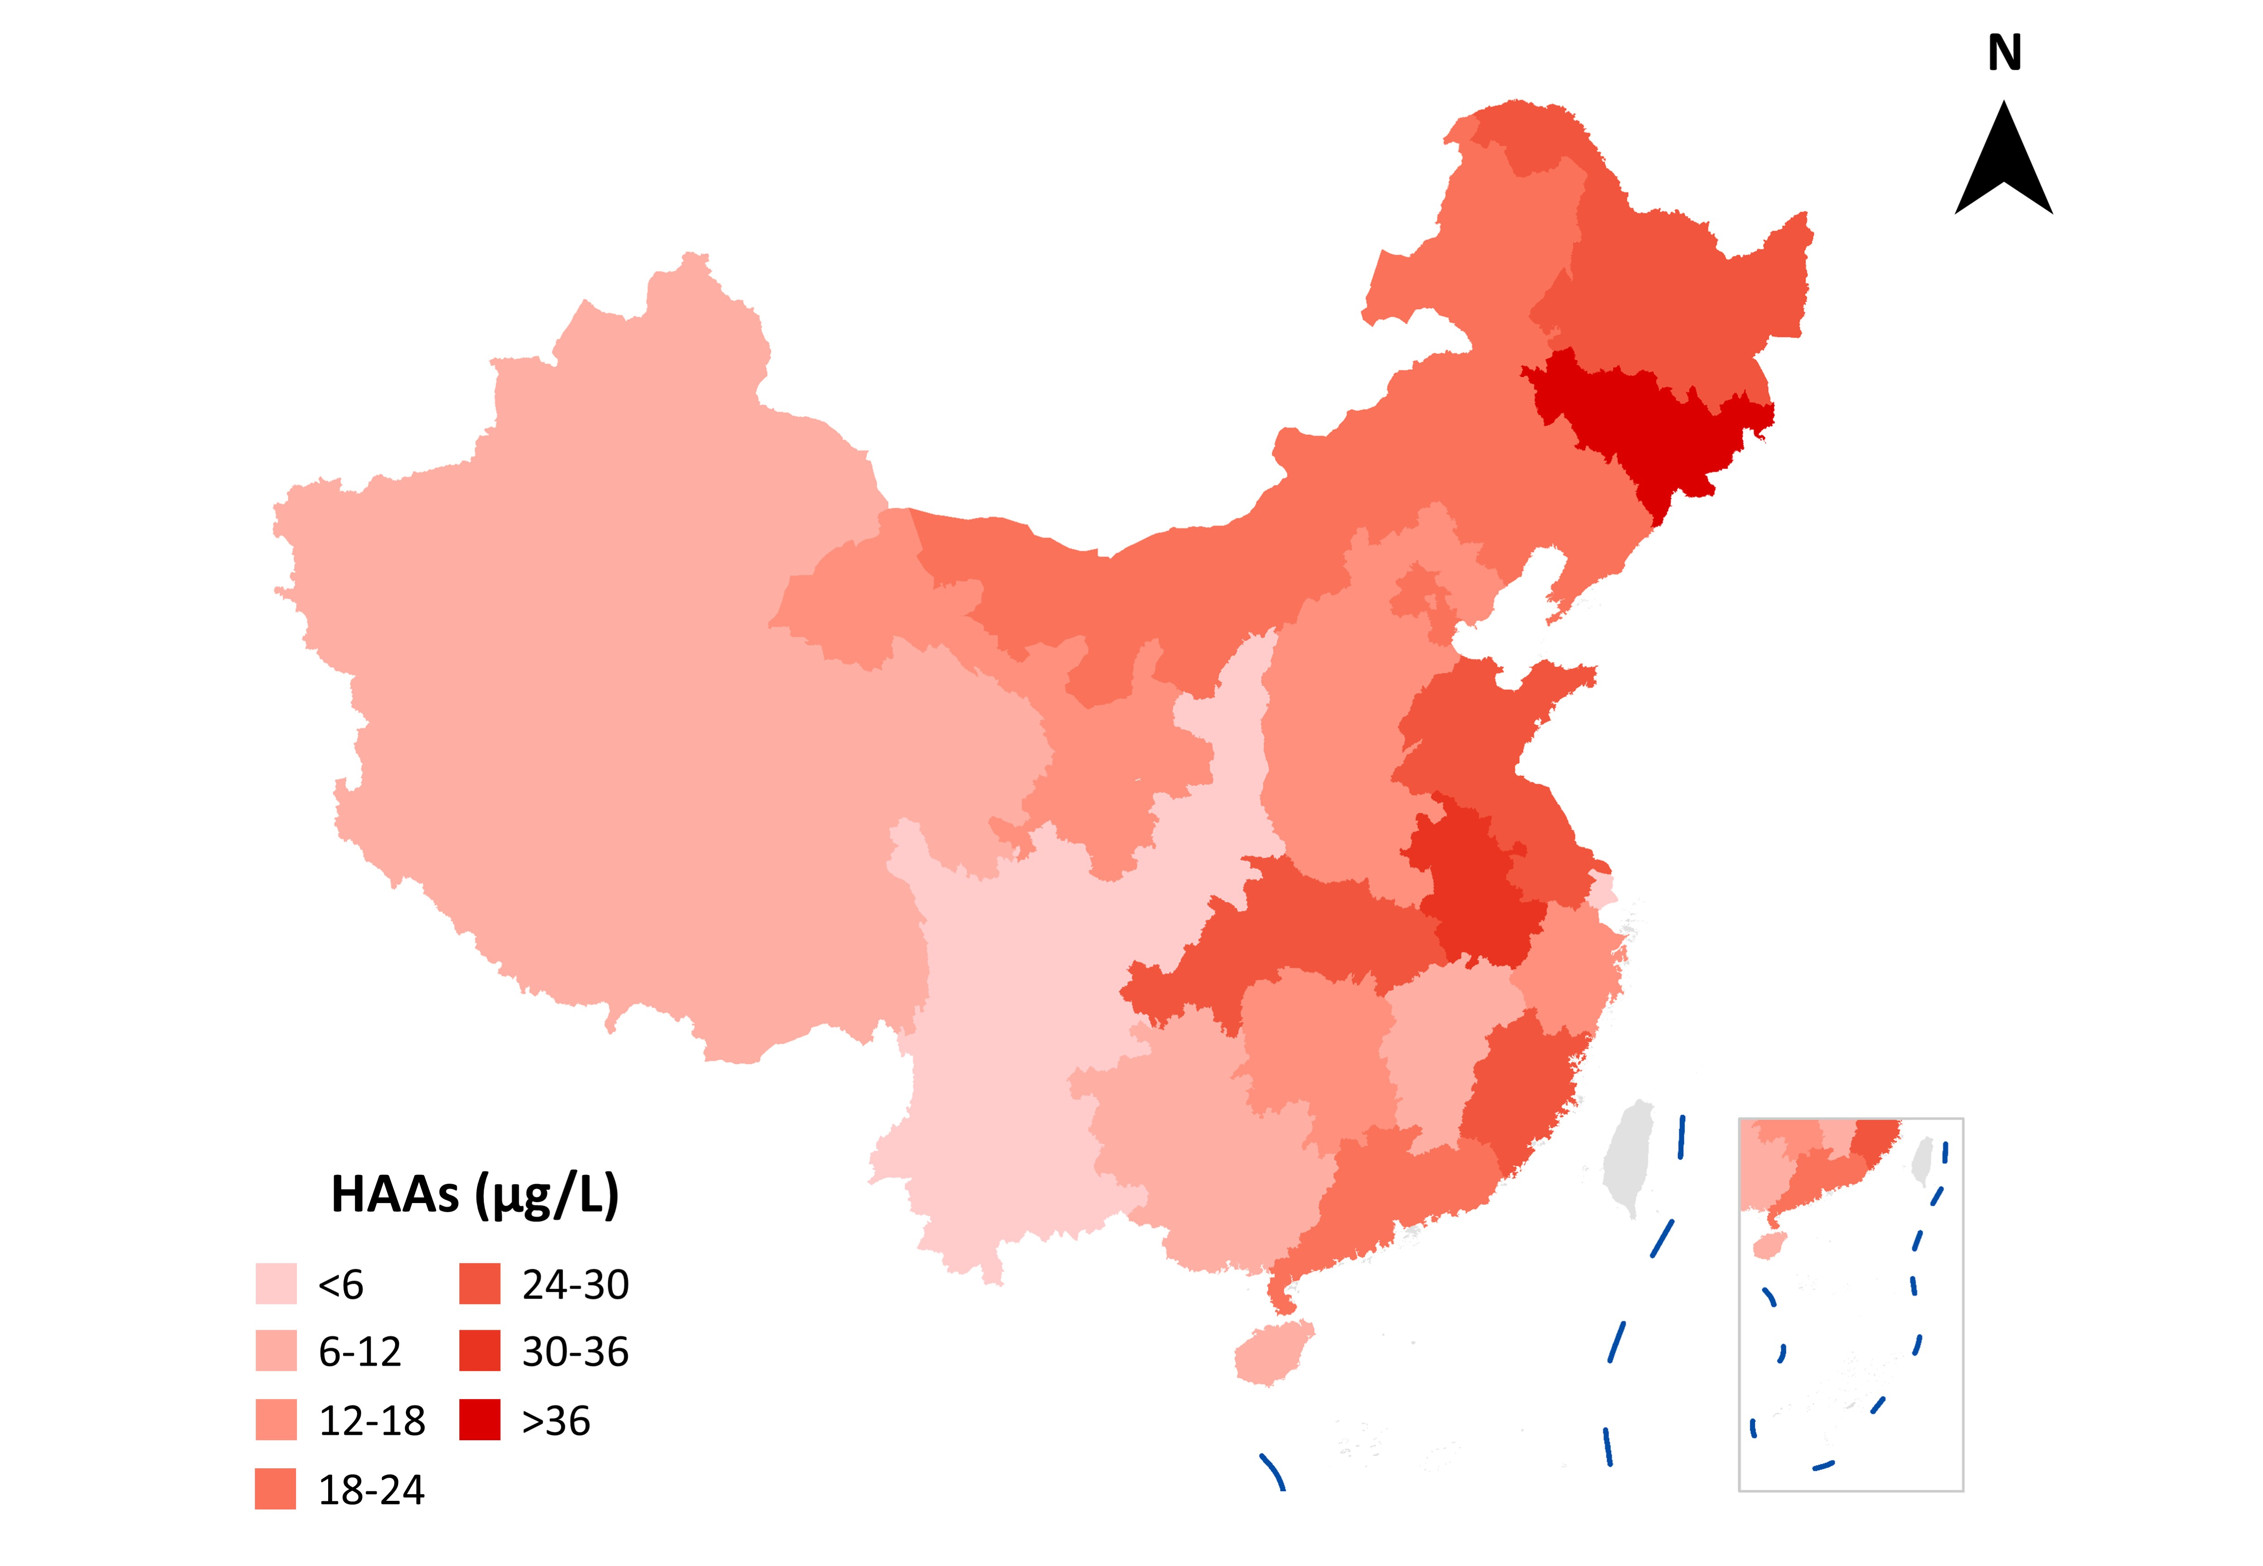

Figure S9. Spatial distribution of total HAAs (averaged by province) in China.

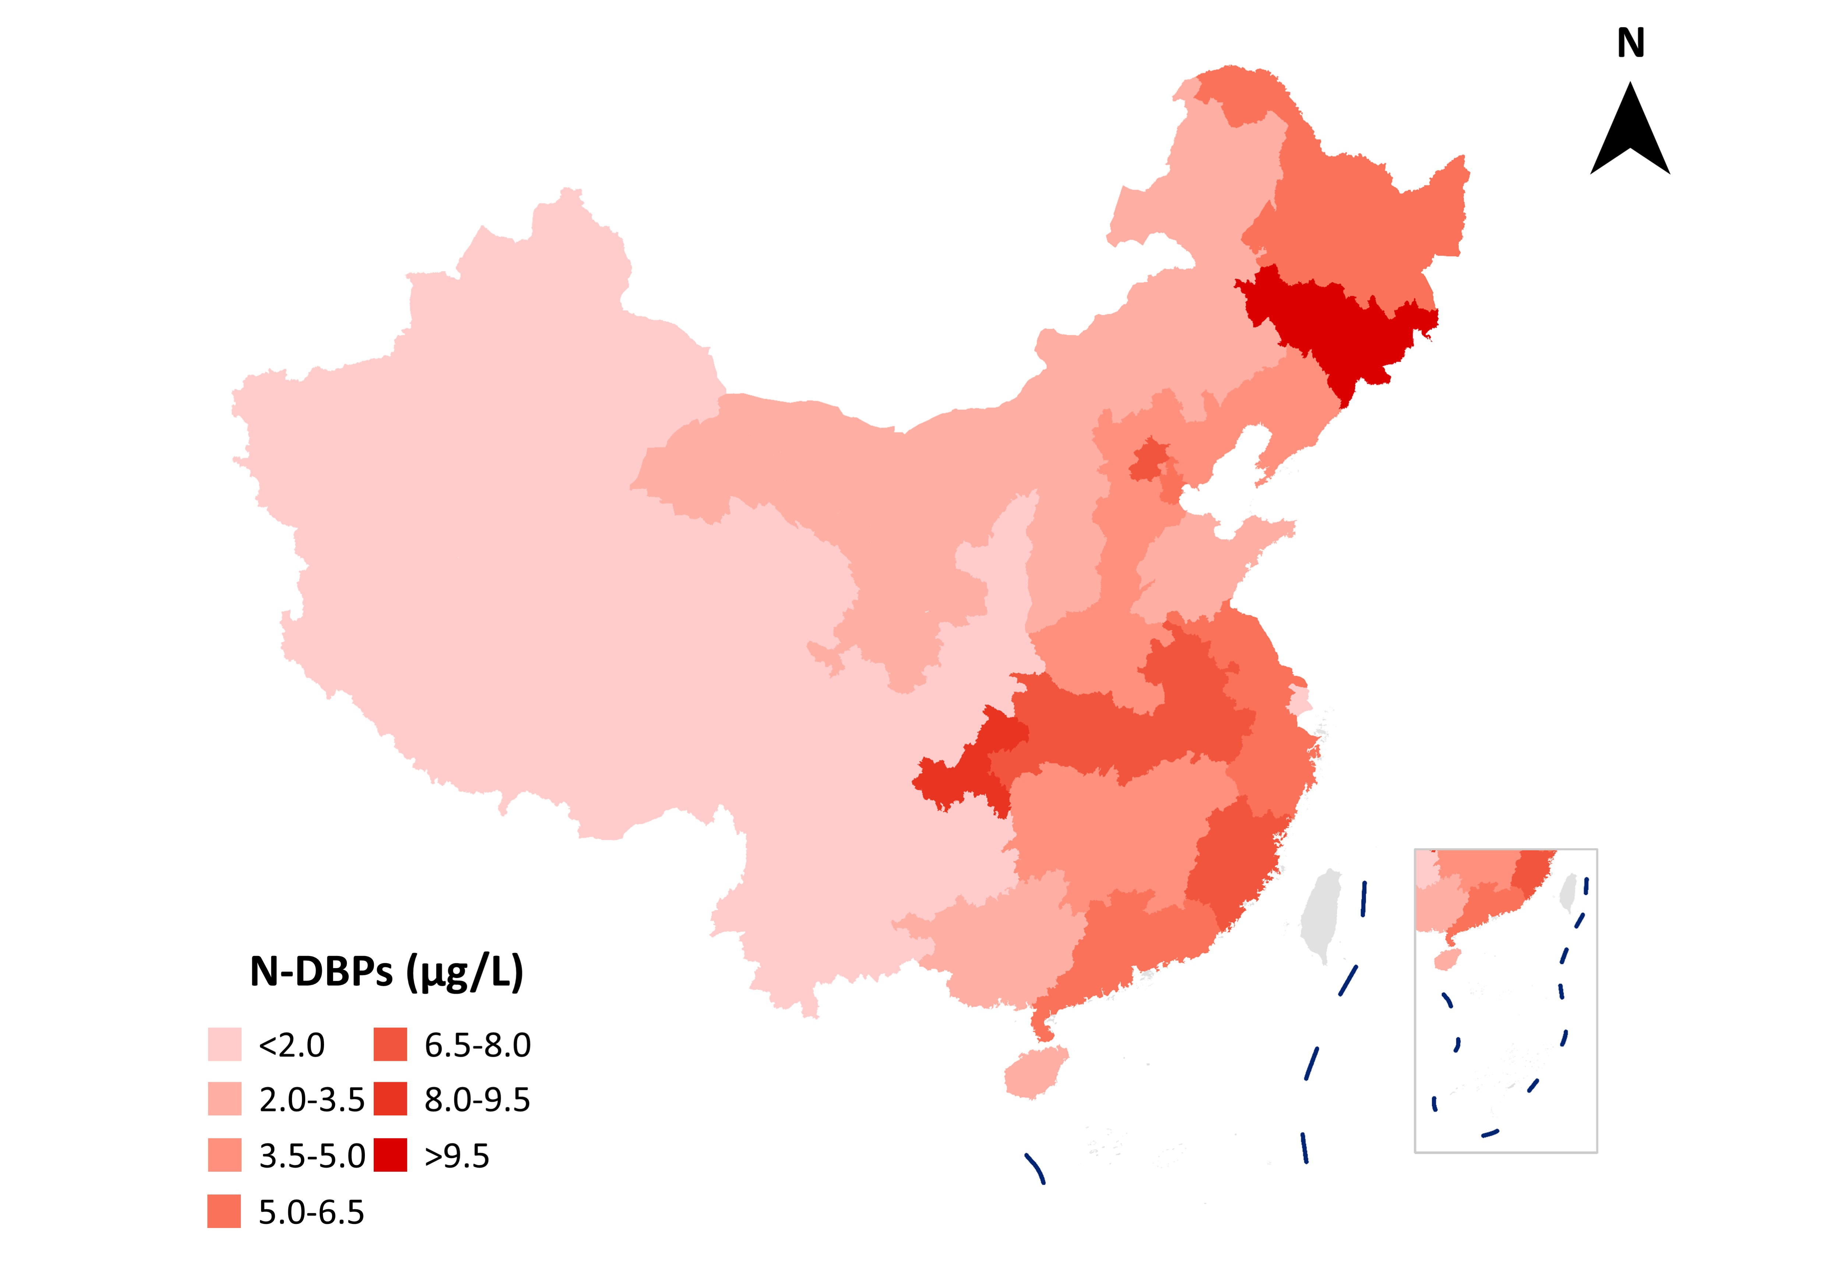

Figure S10. Spatial distribution of total N-DBPs (averaged by province) in China.
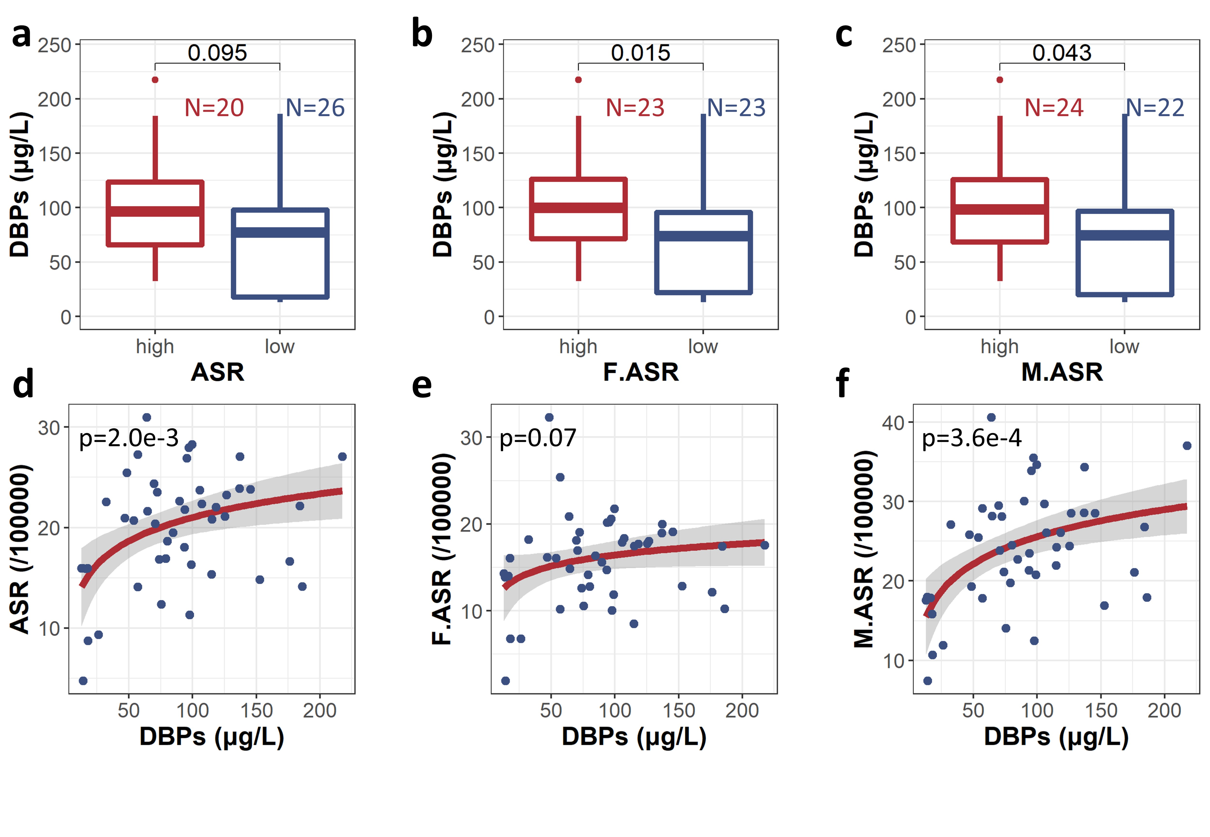

Figure S11. (a-c) Comparison of DBP concentrations for cities with colon and rectal cancer rate higher (high group) or lower (low group) than national average: (a) all gender, (b) female, (c) male. Results by Wilcox tests showed significant differences (p < 0.05) between high group and low group. Details of cancer rates in 46 cities were provided in Table S3; (d-f) Scatter plot showing the correlation between colon and rectal cancer indexes and DBP concentration, where the red line is the logarithmic linear fitting of results: (d) all gender, (e) female, (f) male. The cancer indexes are: ASR-age standardized rate, F.ASR-female age standardized rate, M.ASR-male age standardized rate.

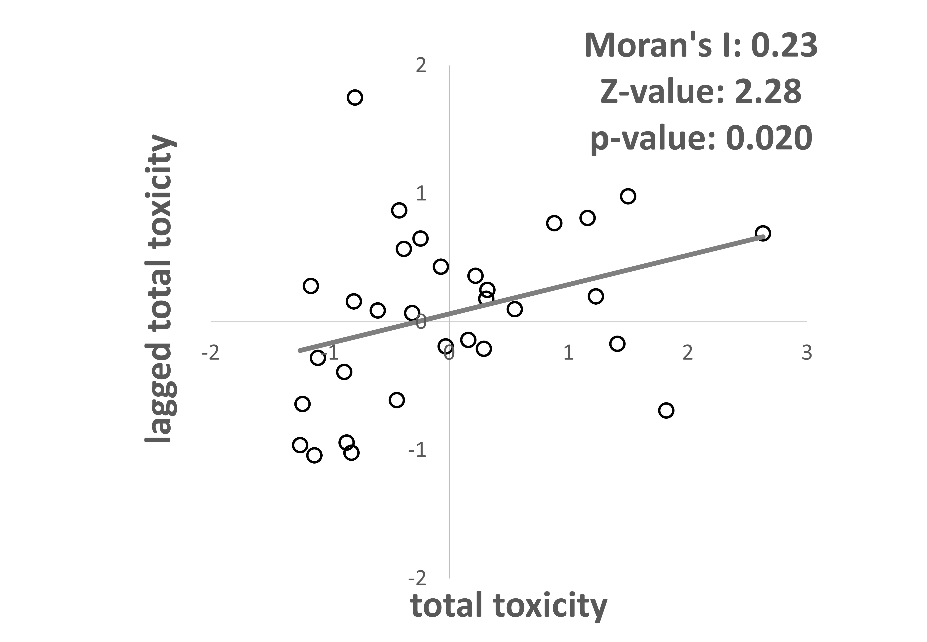

Figure S12. Moran scatter plot of total toxicity (averaged by province)

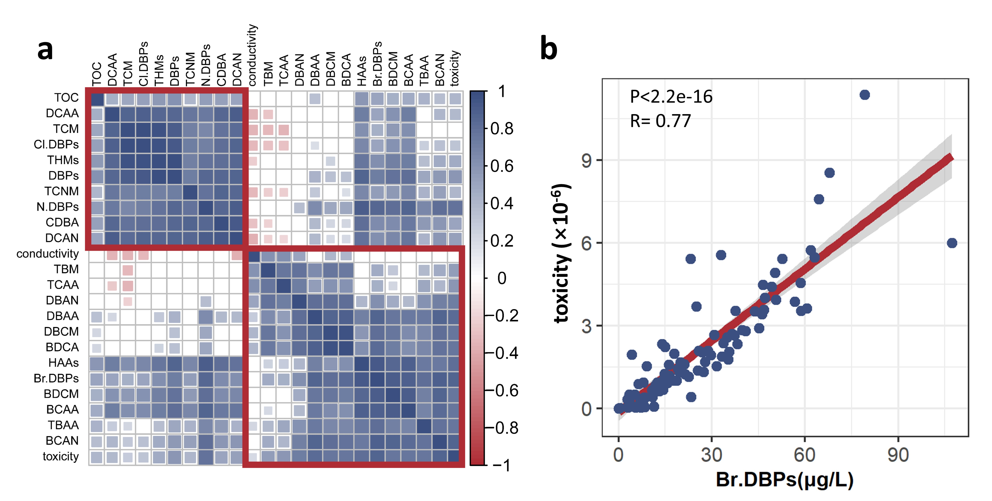

Figure S13. (a) Heatmap showing the Pearson coefficients between each two water quality indexes. (b) Correlation between Br.DBPs and toxicity. The red line is the linear fitting.

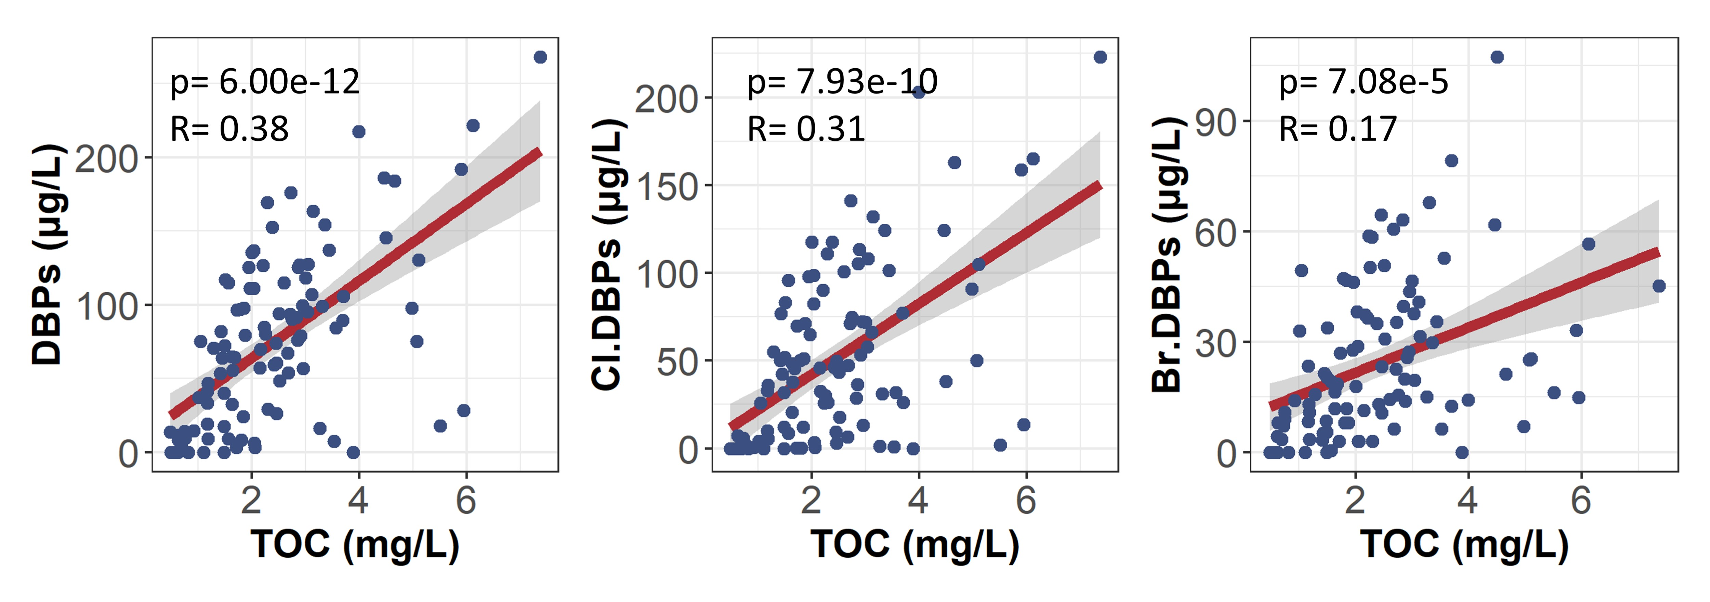

Figure S14. Correlation between TOC and DBP concentrations: (a) total DBPs, (b) non-brominated DBPs, and (c) brominated DBPs. The red line is the linear fitting.

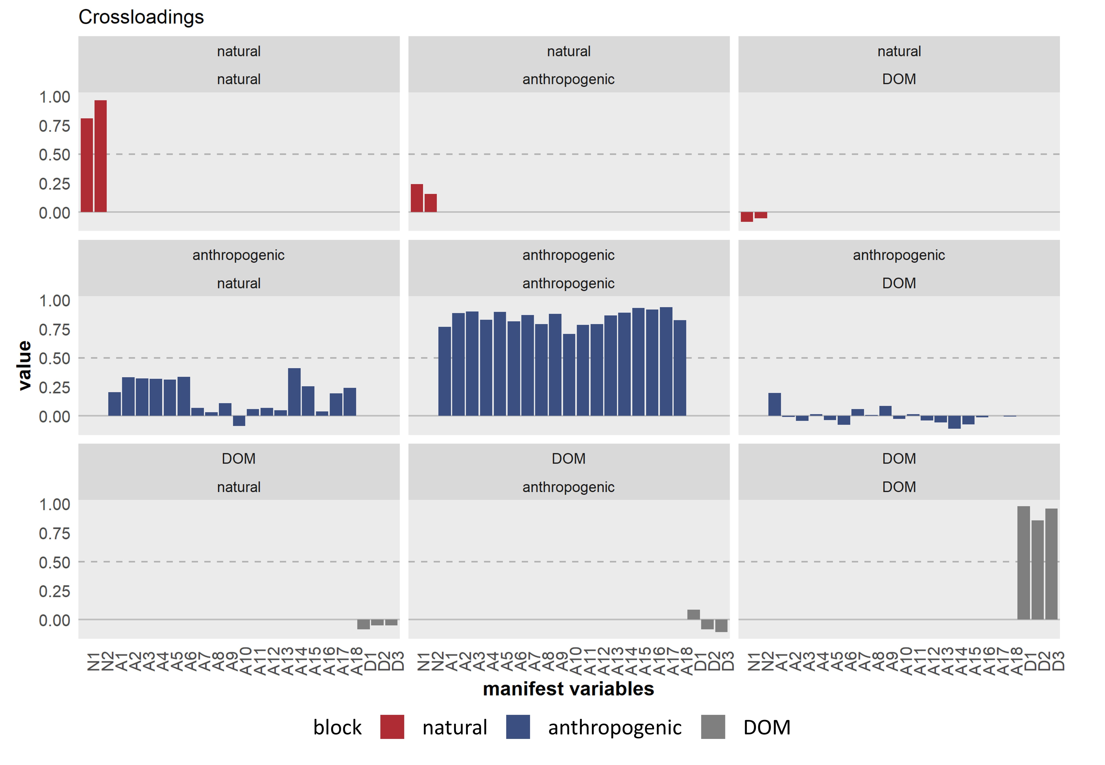

Figure S15. Bar-charts showing the loadings of each manifest variable with latent variables. The full name of manifest variables is listed in Table S2.

Reference
1. S. S. Lau et al., Assessing Additivity of Cytotoxicity Associated with Disinfection Byproducts in Potable Reuse and Conventional Drinking Waters. Environmental Science & Technology 54, 5729-5736 (2020).
2. Y. Lu et al., Forty years of reform and opening up: China’s progress toward a sustainable path. Science Advance 5, eaau9413 (2019).

