Supplementary Information: A generative network model of neurodevelopment

Danyal Akarca^{1*}, Petra E Vértes^{2,3}, Edward T Bullmore^{2,4}, the CALM team¹, & Duncan E Astle¹

¹MRC Cognition and Brain Sciences Unit, University of Cambridge, Cambridge, UK
²Department of Psychiatry, University of Cambridge, Cambridge, UK
³The Alan Turing Institute, London, UK
⁴Department of Clinical Neurosciences, Wolfson Brain Imaging Centre, University of Cambridge, Cambridge, UK

*danyal.akarca@mrc-cbu.cam.ac.uk

Supplementary Figures
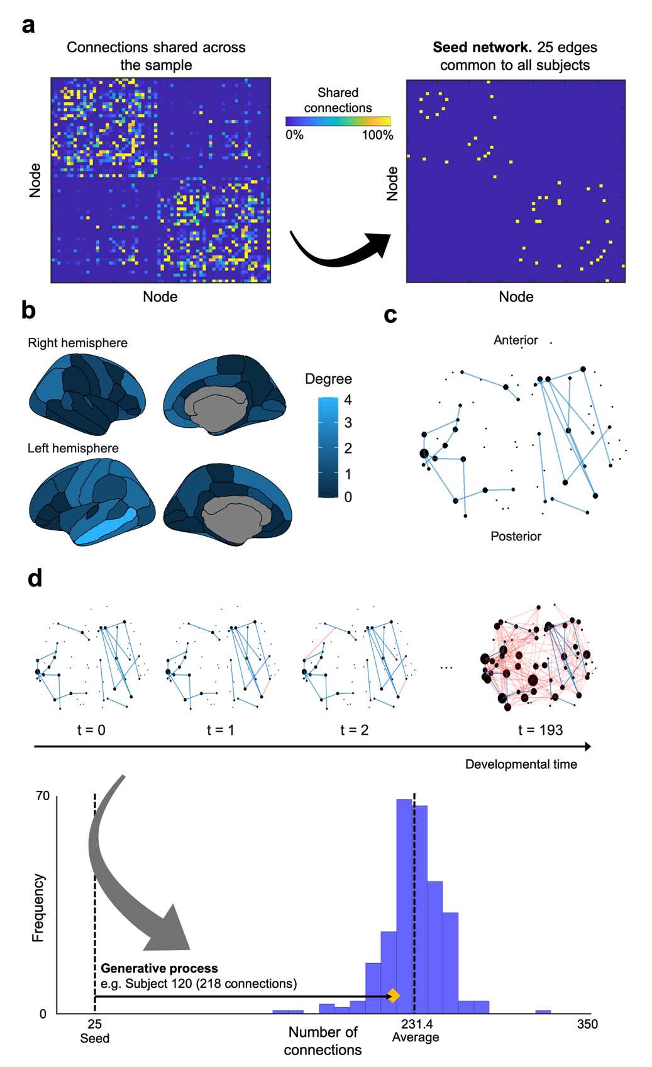
Supplementary Fig. 1 Seed network construction and generative model overview. a The seed network was constructed by taking connections that were shared across 100% of the sample, as in Betzel, R.F. et al²⁵. This left 25 bidirectional connections that were common across all subjects. b The degree distribution of the seed network c An edge-wise view of the seed network. Node size relates to degree. d A schematic illustration of how generative models aim to uncover the wiring rules that give rise to an observed brain network. Starting from the seed network (10.8% density of the average observed network), edges are added to the network according to parameterized costs and value (i.e. rule) terms until it reaches the same number of edges as observed. For this illustration, subject 120 is shown, where 193 edges are added to the seed’s 25 edges, leaving 218 edges in the final network. The distribution of number of observed edges are shown, with a mean of 231.4 edges and standard deviation of 19.1.

Rule |  |  | Energy |  | η |  | γ
Name | Class | K_{i,j} | Mean | SD | Mean | SD | Mean | SD
Spatial | Spatial | 1 | 0.337 | 0.020 | -3.940 | 0.397 | n/a | n/a
Neighbours | Homophily | ∑_{w}a_{iw}a_{wj} | 0.165 | 0.020 | -1.995 | 0.483 | 0.338 | 0.045
Matching | Homophily | $$\frac{|Γi\backslash j∩Γj\backslash i|}{|Γi\backslash j∪Γj\backslash i|}$$ | 0.141 | 0.021 | -1.647 | 0.490 | 0.357 | 0.022
C-Average | Cluster | $$\frac{Ci}{2}+\frac{Cj}{2}$$ | 0.181 | 0.016 | -3.070 | 0.378 | -6.203 | 0.735
C-Minimum | Cluster | min(C_{i},C_{j}) | 0.252 | 0.020 | -3.626 | 0.396 | -6.131 | 0.795
C-Maximum | Cluster | max(C_{i},C_{j}) | 0.182 | 0.014 | -3.095 | 0.387 | -6.153 | 0.735
C-Difference | Cluster | |C_{i}-C_{j}| | 0.322 | 0.025 | -6.193 | 0.744 | -3.480 | 2.012
C-Product | Cluster | C_{i}C_{j} | 0.223 | 0.024 | -3.401 | 0.393 | -5.964 | 0.926
D-Average | Degree | $$\frac{ki}{2}+\frac{kj}{2}$$ | 0.221 | 0.019 | -3.516 | 0.502 | 2.419 | 0.332
D-Minimum | Degree | min(k_{i},k_{j}) | 0.279 | 0.016 | -4.749 | 0.749 | 0.474 | 0.010
D-Maximum | Degree | max(k_{i},k_{j}) | 0.216 | 0.019 | -3.557 | 0.602 | 2.255 | 0.332
D-Difference | Degree | |k_{i}-k_{j}| | 0.229 | 0.018 | -3.836 | 0.669 | 1.689 | 0.577
D-Product | Degree | k_{i}k_{j} | 0.277 | 0.018 | -4.605 | 0.738 | 0.399 | 0.082

Supplementary Table 1 Generative rules, their formulae and descriptive statistics across the broad parameter space. Descriptive statistics of the η and γ parameters required to achieve the best performing network for each subject, across each of the generative rules over the space defined (-7 ≤ η ≤ 7, -7 ≤ γ ≤ 7) for 10,000 simulations.

Matching: Narrow energy window
Averaged over top N networks | Energy |  | η |  | γ
Averaged over top N networks | Mean | SD | Mean | SD | Mean | SD
N = 1 | 0.090 | 0.010 | -1.565 | 0.327 | 0.349 | 0.033
N = 10 | 0.101 | 0.011 | -1.579 | 0.334 | 0.352 | 0.036
N = 100 | 0.116 | 0.013 | -1.614 | 0.372 | 0.355 | 0.038
N = 500 | 0.1326 | 0.015 | -1.658 | 0.427 | 0.357 | 0.040

Supplementary Table 2 Descriptive statistics of high performing wiring parameters η and γ, and the energy of the networks they produce. Parameters were selected using the matching generative rule with 50,000 simulations, evenly spaced across the narrow window -3.606 ≤ η ≤ 0.354 and 0.212 ≤ γ ≤ 0.495. Parameters were averaged across a variable N number of high performing wiring combinations to determine stability.
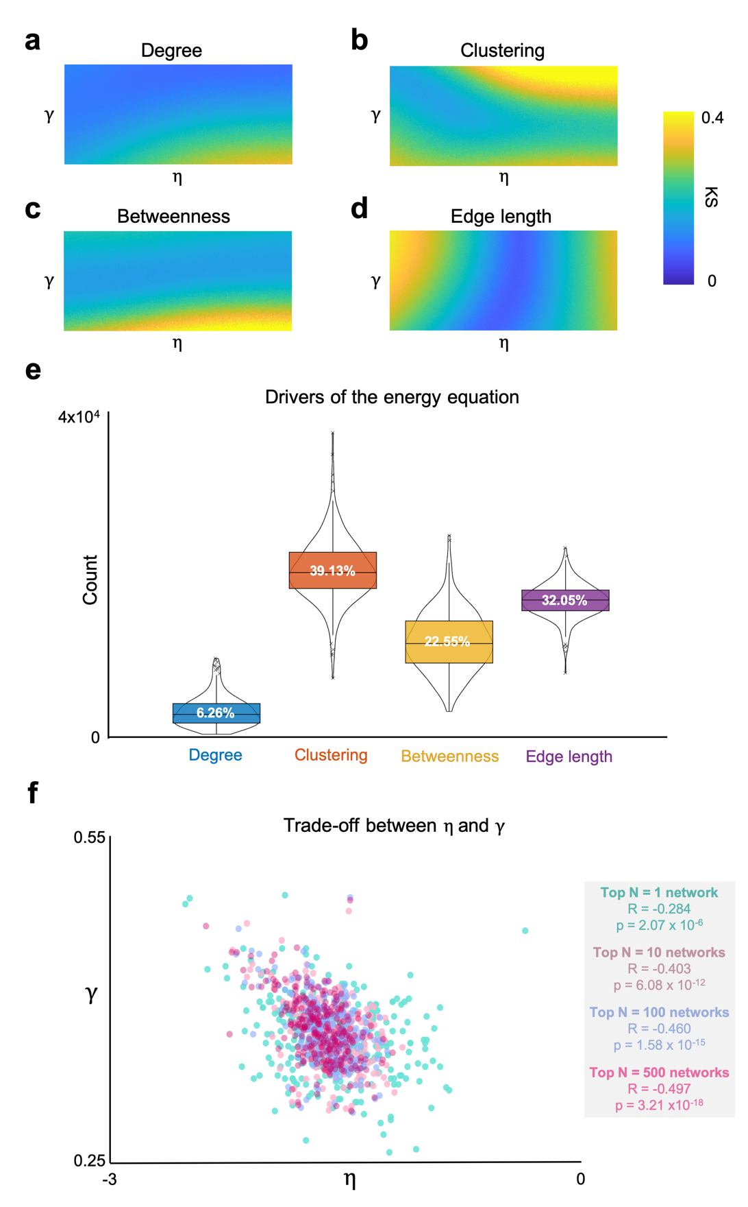

Supplementary Fig. 2 Exploration of the energy and KS statistics, and the resultant parameter combination relationships. a Visualisation of group-averaged degree KS statistics in the window b Clustering coefficient KS statistics c Betweenness-centrality KS statistics d Edge length statistics. e The KS statistics which were “maxed” as to produce the energy statistic, across all subjects and simulations in the narrow parameter window (in total, 270 x 50,000 = 13,500,00 simulations). On average, the energy equation was driven by clustering 39.13% of the time, followed by edge length at 32.05%, followed by betweenness at 22.55% and degree at 6.26%. f Within the narrow window, η and γ trade-off such that subjects with a larger γ have a greater preponderance to have a larger magnitude negative η.
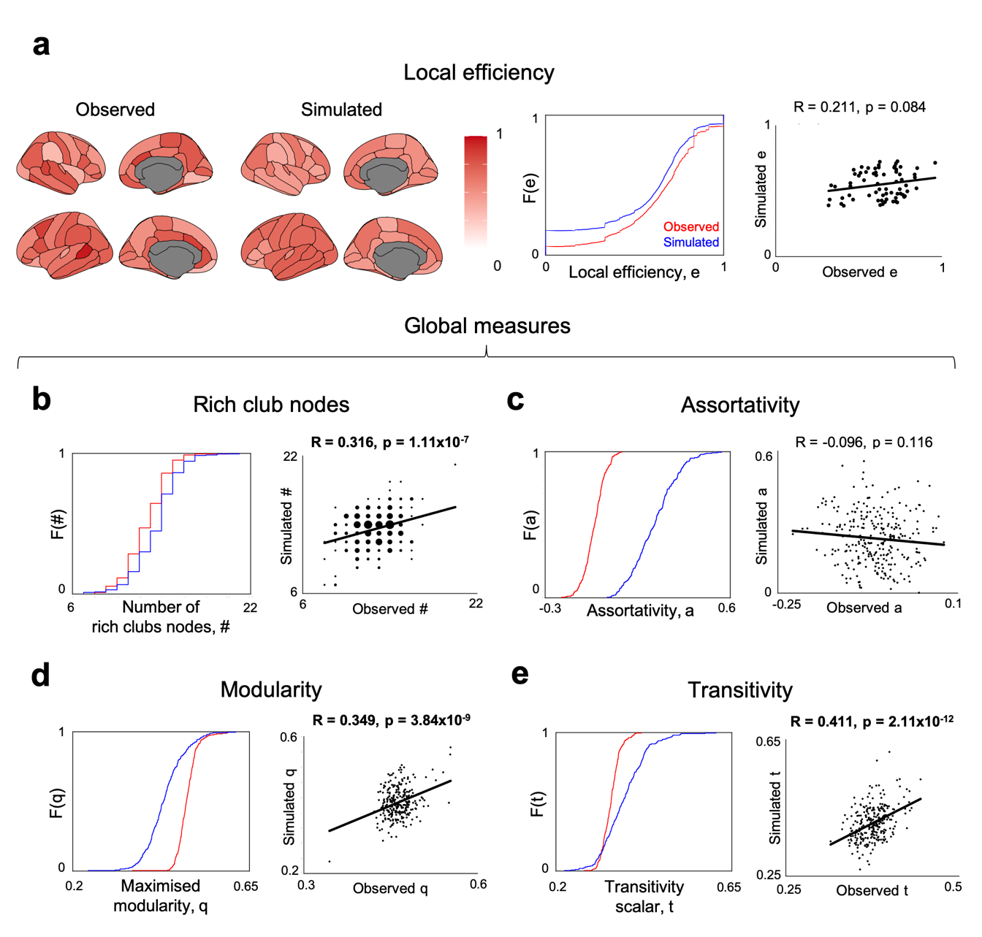

Supplementary Fig. 3 Out-of-sample network measures, not included in the energy equation, and their relationships between simulated and observed measures. Local efficiency is the only local measure, and thus, as in Figure 3, each point in the scatter plot reflects the across-subject average nodal measure from observed and optimal simulated networks. All other measures are global and therefore each point in the scatter represents a subject in the sample. (a) Local efficiency between observed and simulated networks are not significantly correlated (R = 0.211, p = 0.084). (b) The number of rich club nodes between observed and simulated networks are significantly positively correlated (R = 0.316, p = 1.11 x 10⁻⁷) (c) Assortativity between observed and simulated networks are not significantly correlated (R = -0.096, p = 0.116) (d) Modularity between observed and simulated networks are significantly positively correlated (R = 0.349, p = 3.84 x 10⁻⁹) (e) Transitivity between observed and simulated networks are significantly positively correlated (R = 0.411, p = 2.11 x 10⁻¹²). Boldened values are significant correlations at p < 0.05.

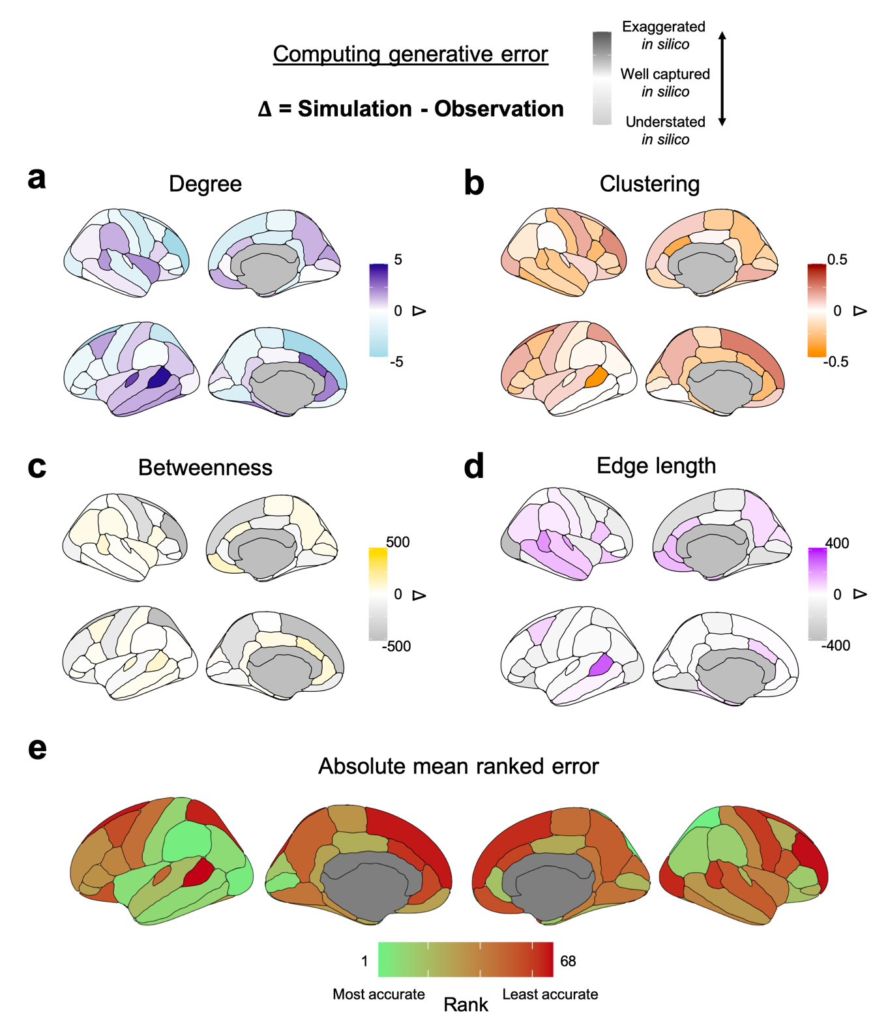
Supplementary Fig. 4 Computing the generative mismatch between low energy simulated networks and those observed. a. Degree generative errors. b Clustering generative errors c Betweenness centrality generative errors. d Edge length generative errors. e Visualisation of the absolute mean ranked error across the four measures, indicating the accuracy to which regions are approximated via the optimised homophily generative models.
 | η |  |  |  |  |  |  |  | γ
Global measures | Top N=1  simulated network |  | Top N=10  simulated networks |  | Top N=100  simulated networks |  | Top N=500 simulated networks |  | Top N=1  simulated network |  | Top N=10  simulated networks |  | Top N=100  simulated networks |  | Top N=500  simulated networks
Global measures | R | p | R | p | R | p | R | p | R | p | R | p | R | p | R | p
Degree | 0.0623 | 0.3074 | -0.0828 | 0.1748 | -0.1209 | 0.0472 | -0.1845 | 0.0023 | 0.3215 | 6.5867x10⁻⁸ | 0.5765 | 2.5715x10⁻²⁵ | 0.5860 | 2.7400x10⁻²⁶ | 0.5947 | 3.2074x10⁻²⁷
Clustering coefficient | -0.2424 | 5.7241x10⁻⁵ | -0.4312 | 1.1915x10⁻¹³ | -0.5754 | 3.3105x10⁻²⁵ | -0.6338 | 9.7869x10⁻³² | 0.5879 | 1.7144x10⁻²⁶ | 0.7878 | 2.3807x10⁻⁵⁸ | 0.8314 | 2.4001x10⁻⁷⁰ | 0.8285 | 1.8709x10⁻⁶⁹
Betweenness centrality | -0.1595 | 0.0087 | -0.1128 | 0.0641 | -0.1741 | 0.0041 | -0.1391 | 0.0223 | -0.2194 | 2.8060x10⁻⁴ | -0.4125 | 1.6248x10⁻¹² | -0.4225 | 4.0817x10⁻¹³ | -0.4424 | 2.2968x10⁻¹⁴
Edge length | 0.3415 | 8.4813x10⁻⁹ | 0.4752 | 1.2926x10⁻¹⁶ | 0.5477 | 1.5660x10⁻²² | 0.4925 | 6.6608x10⁻¹⁸ | 0.1168 | 0.0553 | 0.2094 | 5.3257x10⁻¹⁴ | 0.2287 | 1.5018x10⁻⁴ | 0.2491 | 3.4712x10⁻⁵
Efficiency | 0.1049 | 0.0854 | 0.041 | 0.5020 | 0.0154 | 0.8005 | -0.0460 | 0.4516 | 0.2070 | 6.2060x10⁻⁴ | 0.3988 | 9.9888x10⁻¹² | 0.4158 | 1.0312x10⁻¹² | 0.4340 | 7.8898x10⁻¹⁴
Number of rich club nodes | 0.0861 | 0.1581 | 0.0177 | 0.7718 | 0.0090 | 0.8827 | 0.0206 | 0.7360 | 0.2041 | 7.4004x10⁻⁴ | 0.3560 | 1.7377x10⁻⁹ | 0.3832 | 7.1277x10⁻¹¹ | 0.4001 | 8.4373x10⁻¹²
Assortativity | 0.0130 | 0.8313 | 0.0358 | 0.5578 | 0.0311 | 0.6104 | 0.0531 | 0.3845 | -0.1850 | 0.0023 | -0.1964 | 0.0012 | -0.1564 | 0.0101 | -0.1602 | 0.0083
Transitivity scalar | -0.2548 | 2.2667x10⁻⁵ | -0.3989 | 9,7813x10⁻¹² | -0.5281 | 8.5927x10⁻²¹ | -0.5767 | 2.4941x10⁻²⁵ | 0.4863 | 1.9646x10⁻¹⁷ | 0.6383 | 2.6553x10⁻³² | 0.6792 | 7.0291x10⁻³⁸ | 0.6689 | 2.1791x10⁻³⁶
Maximised modularity | -0.2249 | 1.9449x10⁻⁴ | -0.1747 | 0.0040 | -0.2626 | 1.234x10⁻⁵ | -0.2374 | 8.1647x10⁻⁵ | -0.1052 | 0.0844 | -0.2291 | 1.4583x10⁻⁴ | -0.2432 | 5.3864x10⁻⁵ | -0.2543 | 2.3398x10⁻⁵
Number of vertices | 0.0061 | 0.9207 | -0.0950 | 0.1196 | -0.1461 | 0.0163 | -0.1627 | 0.0074 | 0.1329 | 0.0291 | 0.2214 | 2.4517x10⁻⁴ | 0.2141 | 3.9639x10⁻⁴ | 0.2081 | 5.7950x10⁻⁴
Surface area | -0.0040 | 0.9482 | -0.1048 | 0.0856 | -0.1644 | 0.0068 | -0.1799 | 0.0030 | 0.1492 | 0.0141 | 0.2363 | 8.8556x10⁻⁵ | 0.2278 | 1.5917x10⁻⁴ | 0.2217 | 2.4095x10⁻⁴
Grey volume | -0.0331 | 0.5885 | -0.0909 | 0.1362 | -0.1730 | 0.0044 | -0.1979 | 0.0011 | 0.1262 | 0.0382 | 0.2058 | 6.6834x10⁻⁴ | 0.1938 | 0.0014 | 0.1871 | 0.0020
Mean thickness | -0.0603 | 0.3236 | 0.0323 | 0.5976 | -0.0100 | 0.8698 | -0.0296 | 0.6283 | 0.0026 | 0.9661 | -0.0025 | 0.9676 | -0.0137 | 0.8222 | -0.0146 | 0.7697
Std thickness | -0.1031 | 0.0909 | -0.1570 | 0.0098 | -0.1682 | 0.0056 | -0.1685 | 0.0055 | 0.0828 | 0.1747 | 0.0137 | 0.8231 | -0.0115 | 0.8508 | -0.0146 | 0.8112
Mean curvature | -0.0435 | 0.4770 | -0.1378 | 0.0235 | -0.1510 | 0.0130 | -0.1259 | 0.0387 | 0.0508 | 0.4061 | 0.0447 | 0.4642 | 0.0294 | 0.6306 | 0.0222 | 0.7167
Gaussian curvature | -0.0222 | 0.7170 | -0.0560 | 0.3593 | 0.0035 | 0.9543 | 0.0012 | 0.9842 | 0.0344 | 0.5740 | -0.0809 | 0.1848 | -0.0780 | 0.2015 | -0.0861 | 0.1582
Folding index | 0.0396 | 0.5172 | -0.0683 | 0.2635 | -0.1281 | 0.0354 | -0.1110 | 0.0686 | 0.0531 | 0.3852 | 0.0670 | 0.2727 | 0.0637 | 0.2974 | 0.0519 | 0.3954

Supplementary Table 3 Correlational statistics between η and γ and observed global network and graphical measures. Global measures were calculated by averaging across the cortex. Parameters were averaged across a variable N number of best performing networks to determine how this influences associations. Rows 1 – 4 (blue) correspond to measures minimised within the energy equation (2). Rows 5 – 9 (green) correspond to measures not included in the energy equation. Rows 10 – 17 (yellow) are cortical morphology measures which were not included in the energy equation. Boldened values represent associations which are significant at p < 0.05.
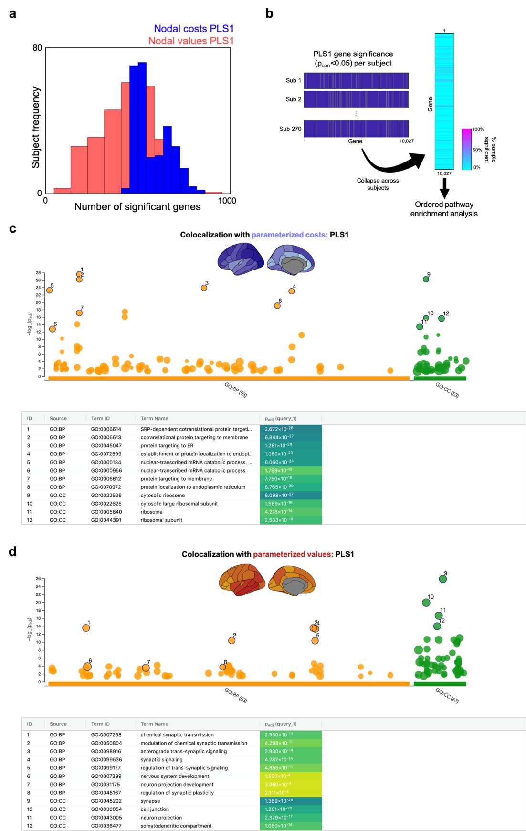

Supplementary Fig. 5 Gene loading analysis and pathway enrichment. a Distributions of significant genes (p_{corr} < 0.05) for the nodal-costs and nodal-values PLS1, which provided an average of 581.5 significant genes and 437.6 significant respectively across the sample. b To collapse across subjects, we ranked genes according to the number of subjects for which each gene was significant and submitted genes above 10% to an ordered pathway enrichment analysis, using g:Profiler. Pathway enrichment analysis summarises large gene sets as a smaller list of more easily interpretable pathways that can be visualised to identify main biological themes. c Parameterized costs pathway enrichment analysis, for biological processes and cellular components, and d Parameterized values.
PLS | Response | # Genes | Gene Ontology | Link
PLS1 | Parametrised costs | 1427 | Biological processes and cellular components | https://biit.cs.ut.ee/gplink/l/TYGoJHihSs
PLS1 | Parameterised values | 1584 | Biological processes and cellular components | https://biit.cs.ut.ee/gplink/l/H_gK8UIVR1
Supplementary Table 4 Gene queries submitted to g:Profiler. Ordered gene lists were computed by taking subject-specific significant (p_{corr} <0.05) genes according to their frequency across the sample, up to 10% of the sample.

N | Age (months) |  | Sex |  | Referral status
N | Mean | SD | Male | Female | Referred | Non-referred
270 | 117.8 | 25.8 | 178 | 92 | 192 | 78
Supplementary Table 5 Demographic information of the sample.

