SUPPLEMENTARY INFORMATION FOR

Flexible material formulations for 3D printing of porous beds with applications in bioprocess engineering

Simone Dimartino^{1,}*, Giuseppe Rafael Galindo-Rodriguez¹, Ursula Simon¹, Mariachiara Conti¹, Sulaiman Sarwar¹, Selva Athi Narayanan¹, Qihao Jiang¹, Nick Christofi²,

¹ Institute for Bioengineering, School of Engineering, The University of Edinburgh, Edinburgh, EH9 3DW, UK

² Recircle Ltd, NINE BioQuarter, 9 Little France Road, Edinburgh, EH16 4UX, UK

Chemicals
[2-(Acryloyloxy)ethyl]trimethylammonium chloride (AETAC), 2-carboxyethyl acrylate (CEA), 2-Hydroxyethyl methacrylate (HEMA), [2-(Methacryloyloxy)ethyl]trimethylammonium chloride (MAETAC), di(ethylene glycol) ethyl ether acrylate (DEGEEA), hexamethyldisilazane (HMDS), Gibbs reagent (2,6 dichloroquinone-4-chloroimide) and TRIZMA HCl were purchased from Sigma-Aldrich. Cyclohexanol, 1- dodecanol, isopropanol (IPA), bovine serum albumin (BSA, protease-free powder), lysozyme, trypsin, sodium phosphate (mono and dibasic), N-α-benzoyl-L-arginine ethyl ester hydrochloride (BAEE) and PierceTM bicinchoninic acid (BCA) assay kit were purchased from Thermo Fisher Scientific. 1-Ethyl-3-(3’-dimethylaminopropyl)carbodiimide HCl (EDC) was purchased from Novabiochem. The salts used in the preparation of mineral salts medium (MSM) were sourced from VWR Chemicals (GPR RECTAPUR® grade). Benzothiophene (BT) was purchased from Alfa Aesar, UK. The isotonic diluent Ringer’s solution tablets were purchased from Oxoid, UK. Ethylene glycol dimethacrylate (EDMA), poly(ethylene glycol) diacrylate (PEGDA) and alkoxylated pentaerythrioltetraacrylate (SR494) were kindly donated by Arkema-Sartomer (Colombes, France). Omnirad 819 was donated from IGM resins (Waalwijk, The Netherlands). Tinuvin 326 was donated from BASF (Ludwigshafen, Germany). All buffers were prepared using deionized water (EuRO10 Reverse Osmosis System, EvoquaWater Technologies, Pittsburgh, PA, USA).

Porous microstructure
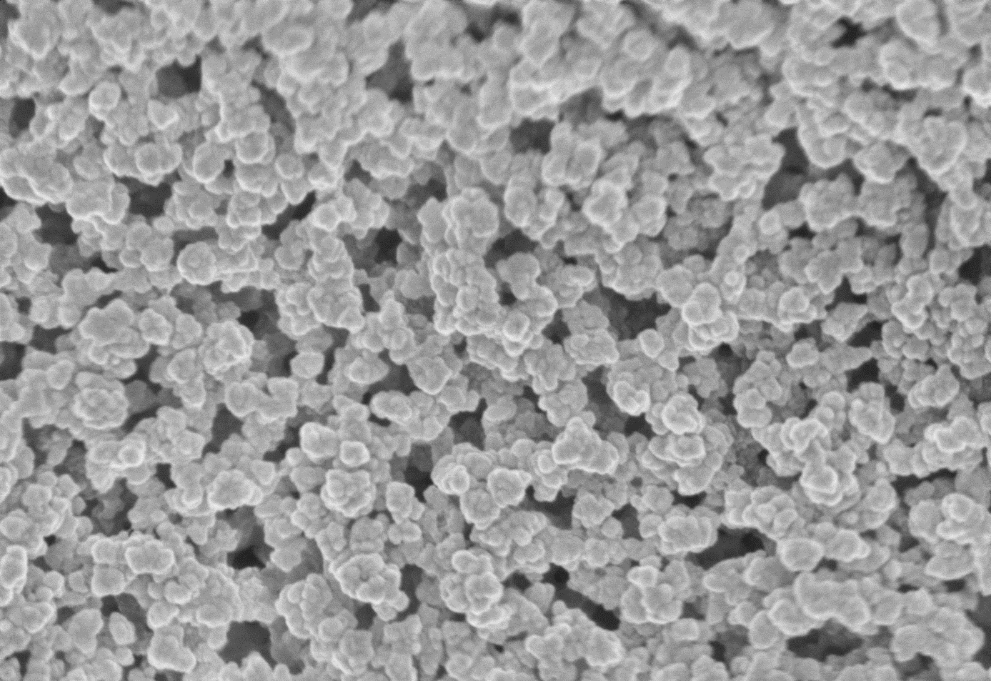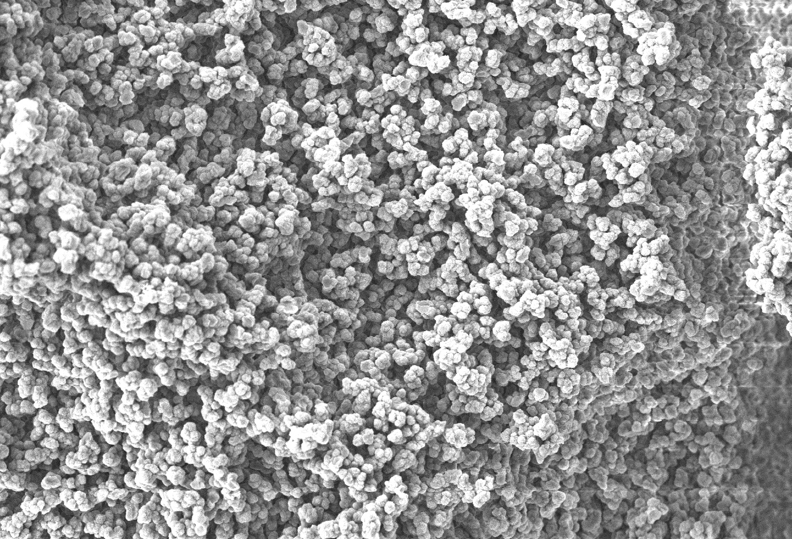
(a)
(b)
500 nm
5 μm
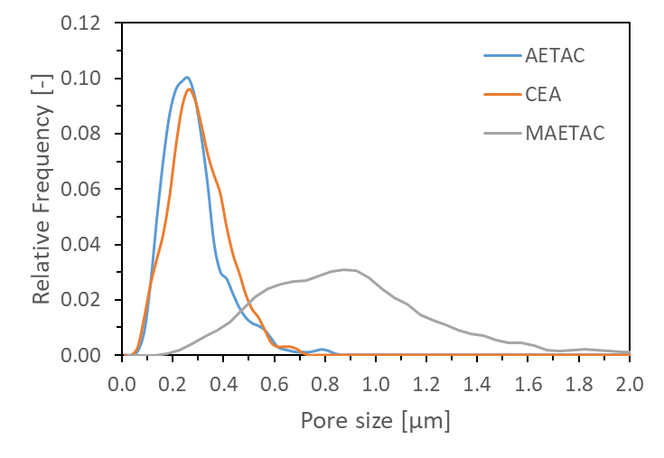
3 μm
(c)
(d)
Figure S1. SEM images of (a) CEA, (b) AETAC and (c) MAETAC polymers together with their pore size distribution (d).

