Table 1 The general characteristics of the included articles.

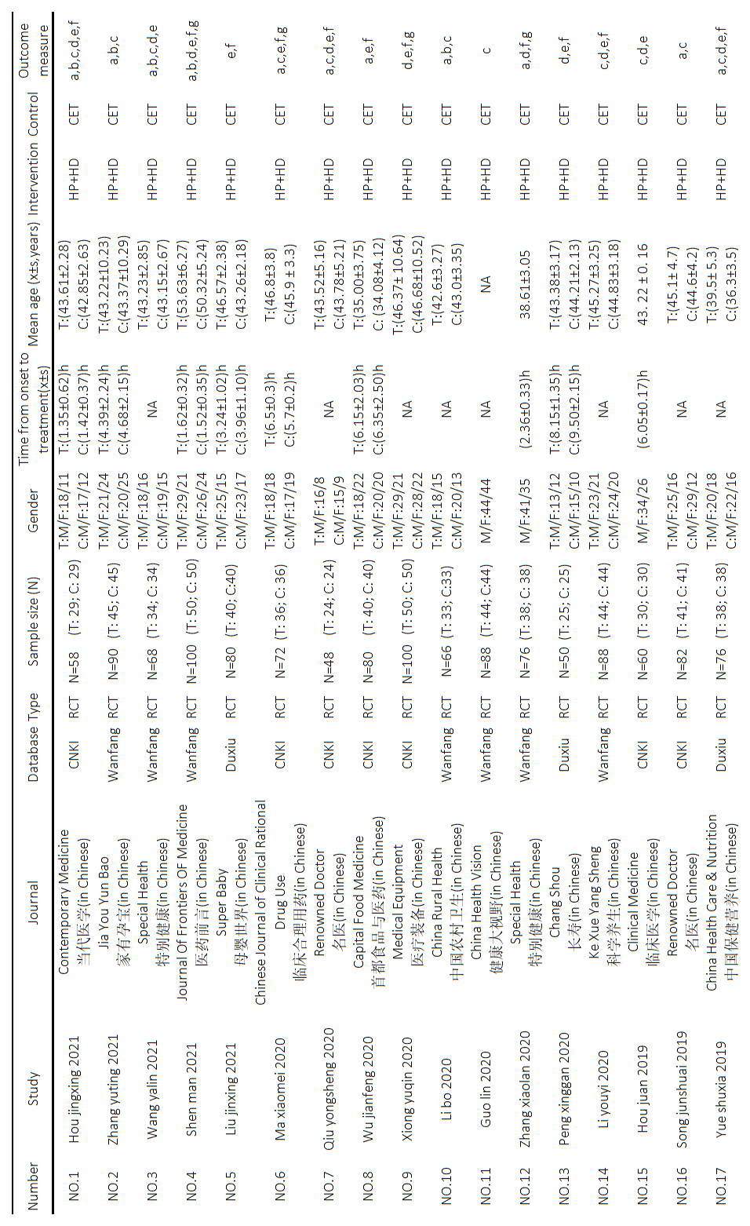
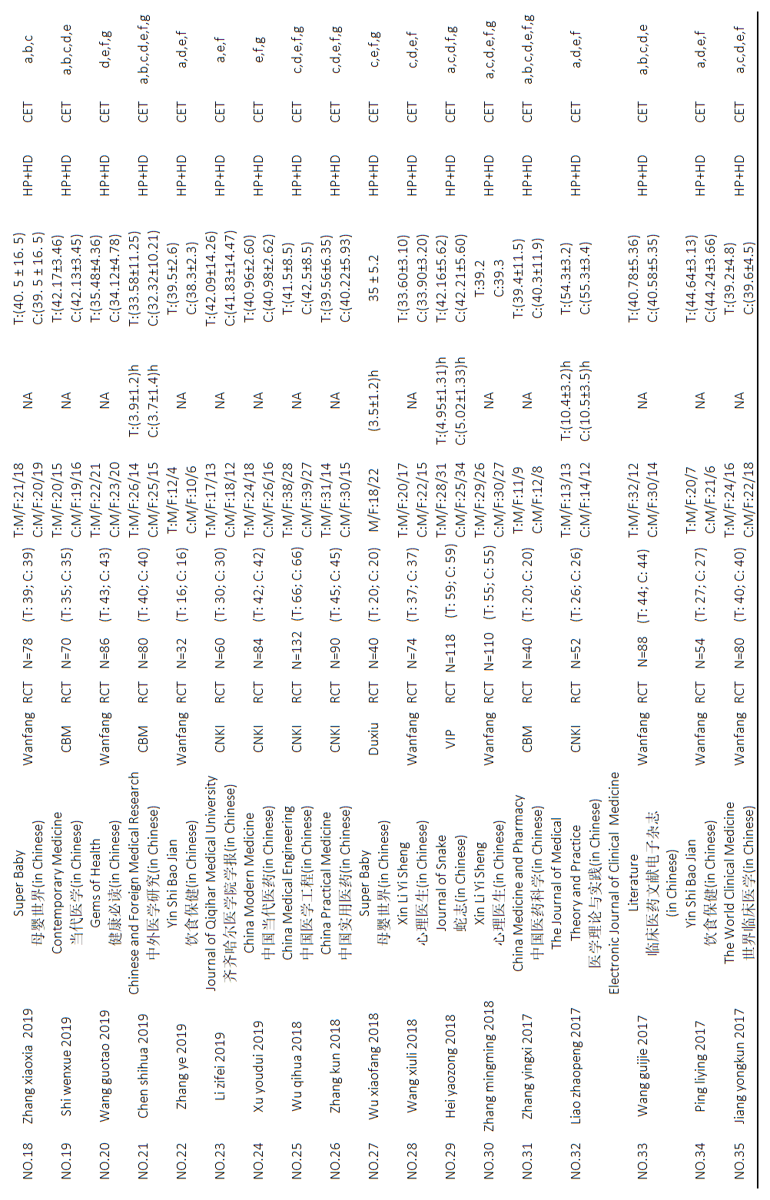

T, treatment group; C, control group; M, male; F, female, HP+HD: Hemoperfusion+Hemodialysis; CET: conventional emergency treatment, NA, not applicable; a, Cure rate; b, Efficacy; c, Incidence of complications d, time for cholinesterase level to return to normal; e, coma time; f, time of hospitalization; g, atropine dosage.

