Organic-sulfonate functionalized graphene as a high temperature lubricant for efficient antifriction and antiwear in water-based drilling fluid
Xiao Tian，Ningning Song*, Guangbin Yang, Changhua Zhou,
Shengmao Zhang*, Pingyu Zhang
National & Local Joint Engineering Research Center for Applied Technology of Hybrid Nanomaterials, Henan University, Kaifeng, 475004, PR China
*Dr. Ningning Song: Phone: (+86)371-25152066, Fax: (86)371-25152066, E-mail: songning@henu.edu.cn
*Dr. Shengmao Zhang: Phone: (+86)371-25152066, Fax: (86)371-25152066, Email: zsm@vip.henu.edu.cn
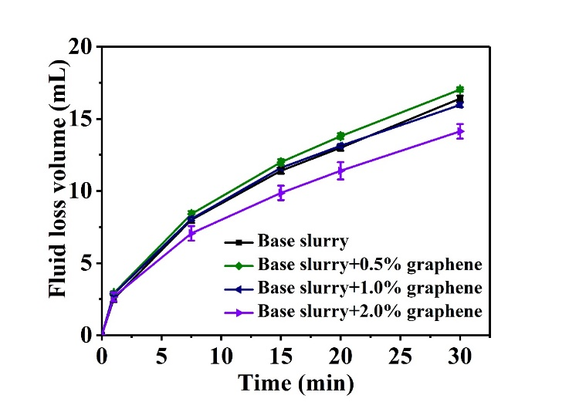
Fig.S1 Filtration volume of drilling fluid at different concentrations graphene

a
b
c
d
Fig.S2 Plots of fluid loss volume versus time for base slurry and base slurry + 1 wt.% graphene after aging at different temperatures:(a) 180 ℃, (b) 230 ℃, (c) 240 ℃, (d) 250 ℃

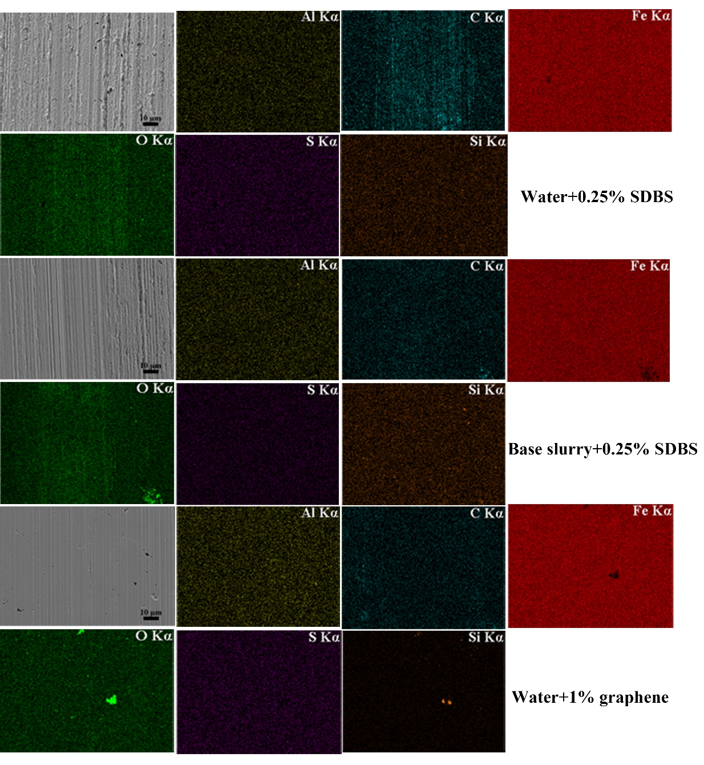
Fig.S3 The SEM and typical element distribution diagram of the tribofilms of the samples aging at room temperature of 25 ℃

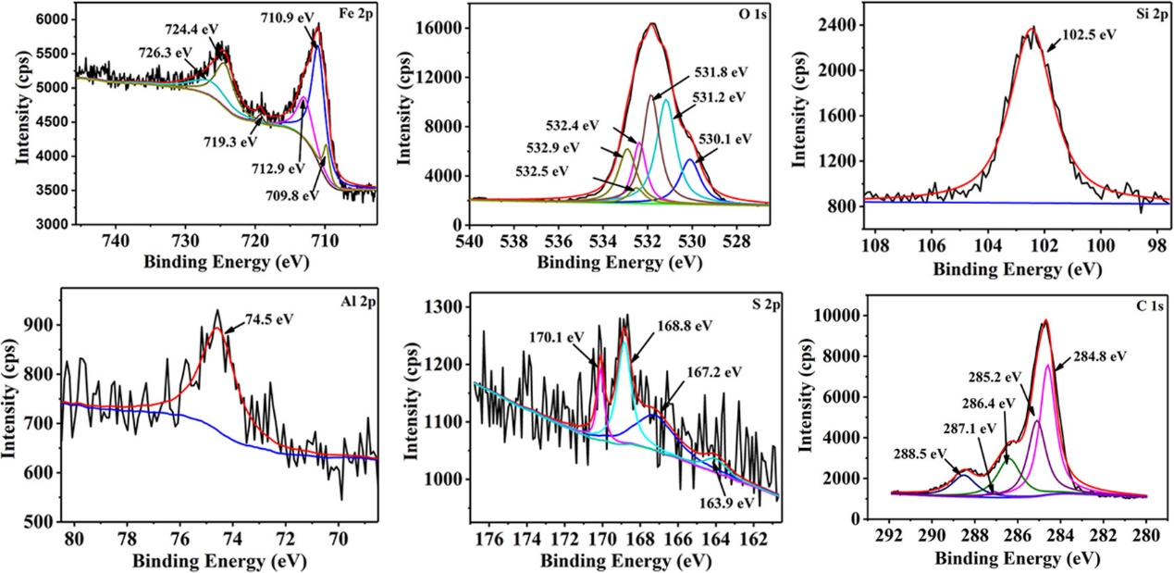
Fig.S4 The XPS spectra of steel black wear scar of the drilling fluid with 1% graphene after aging at room temperature

