Supplementary information
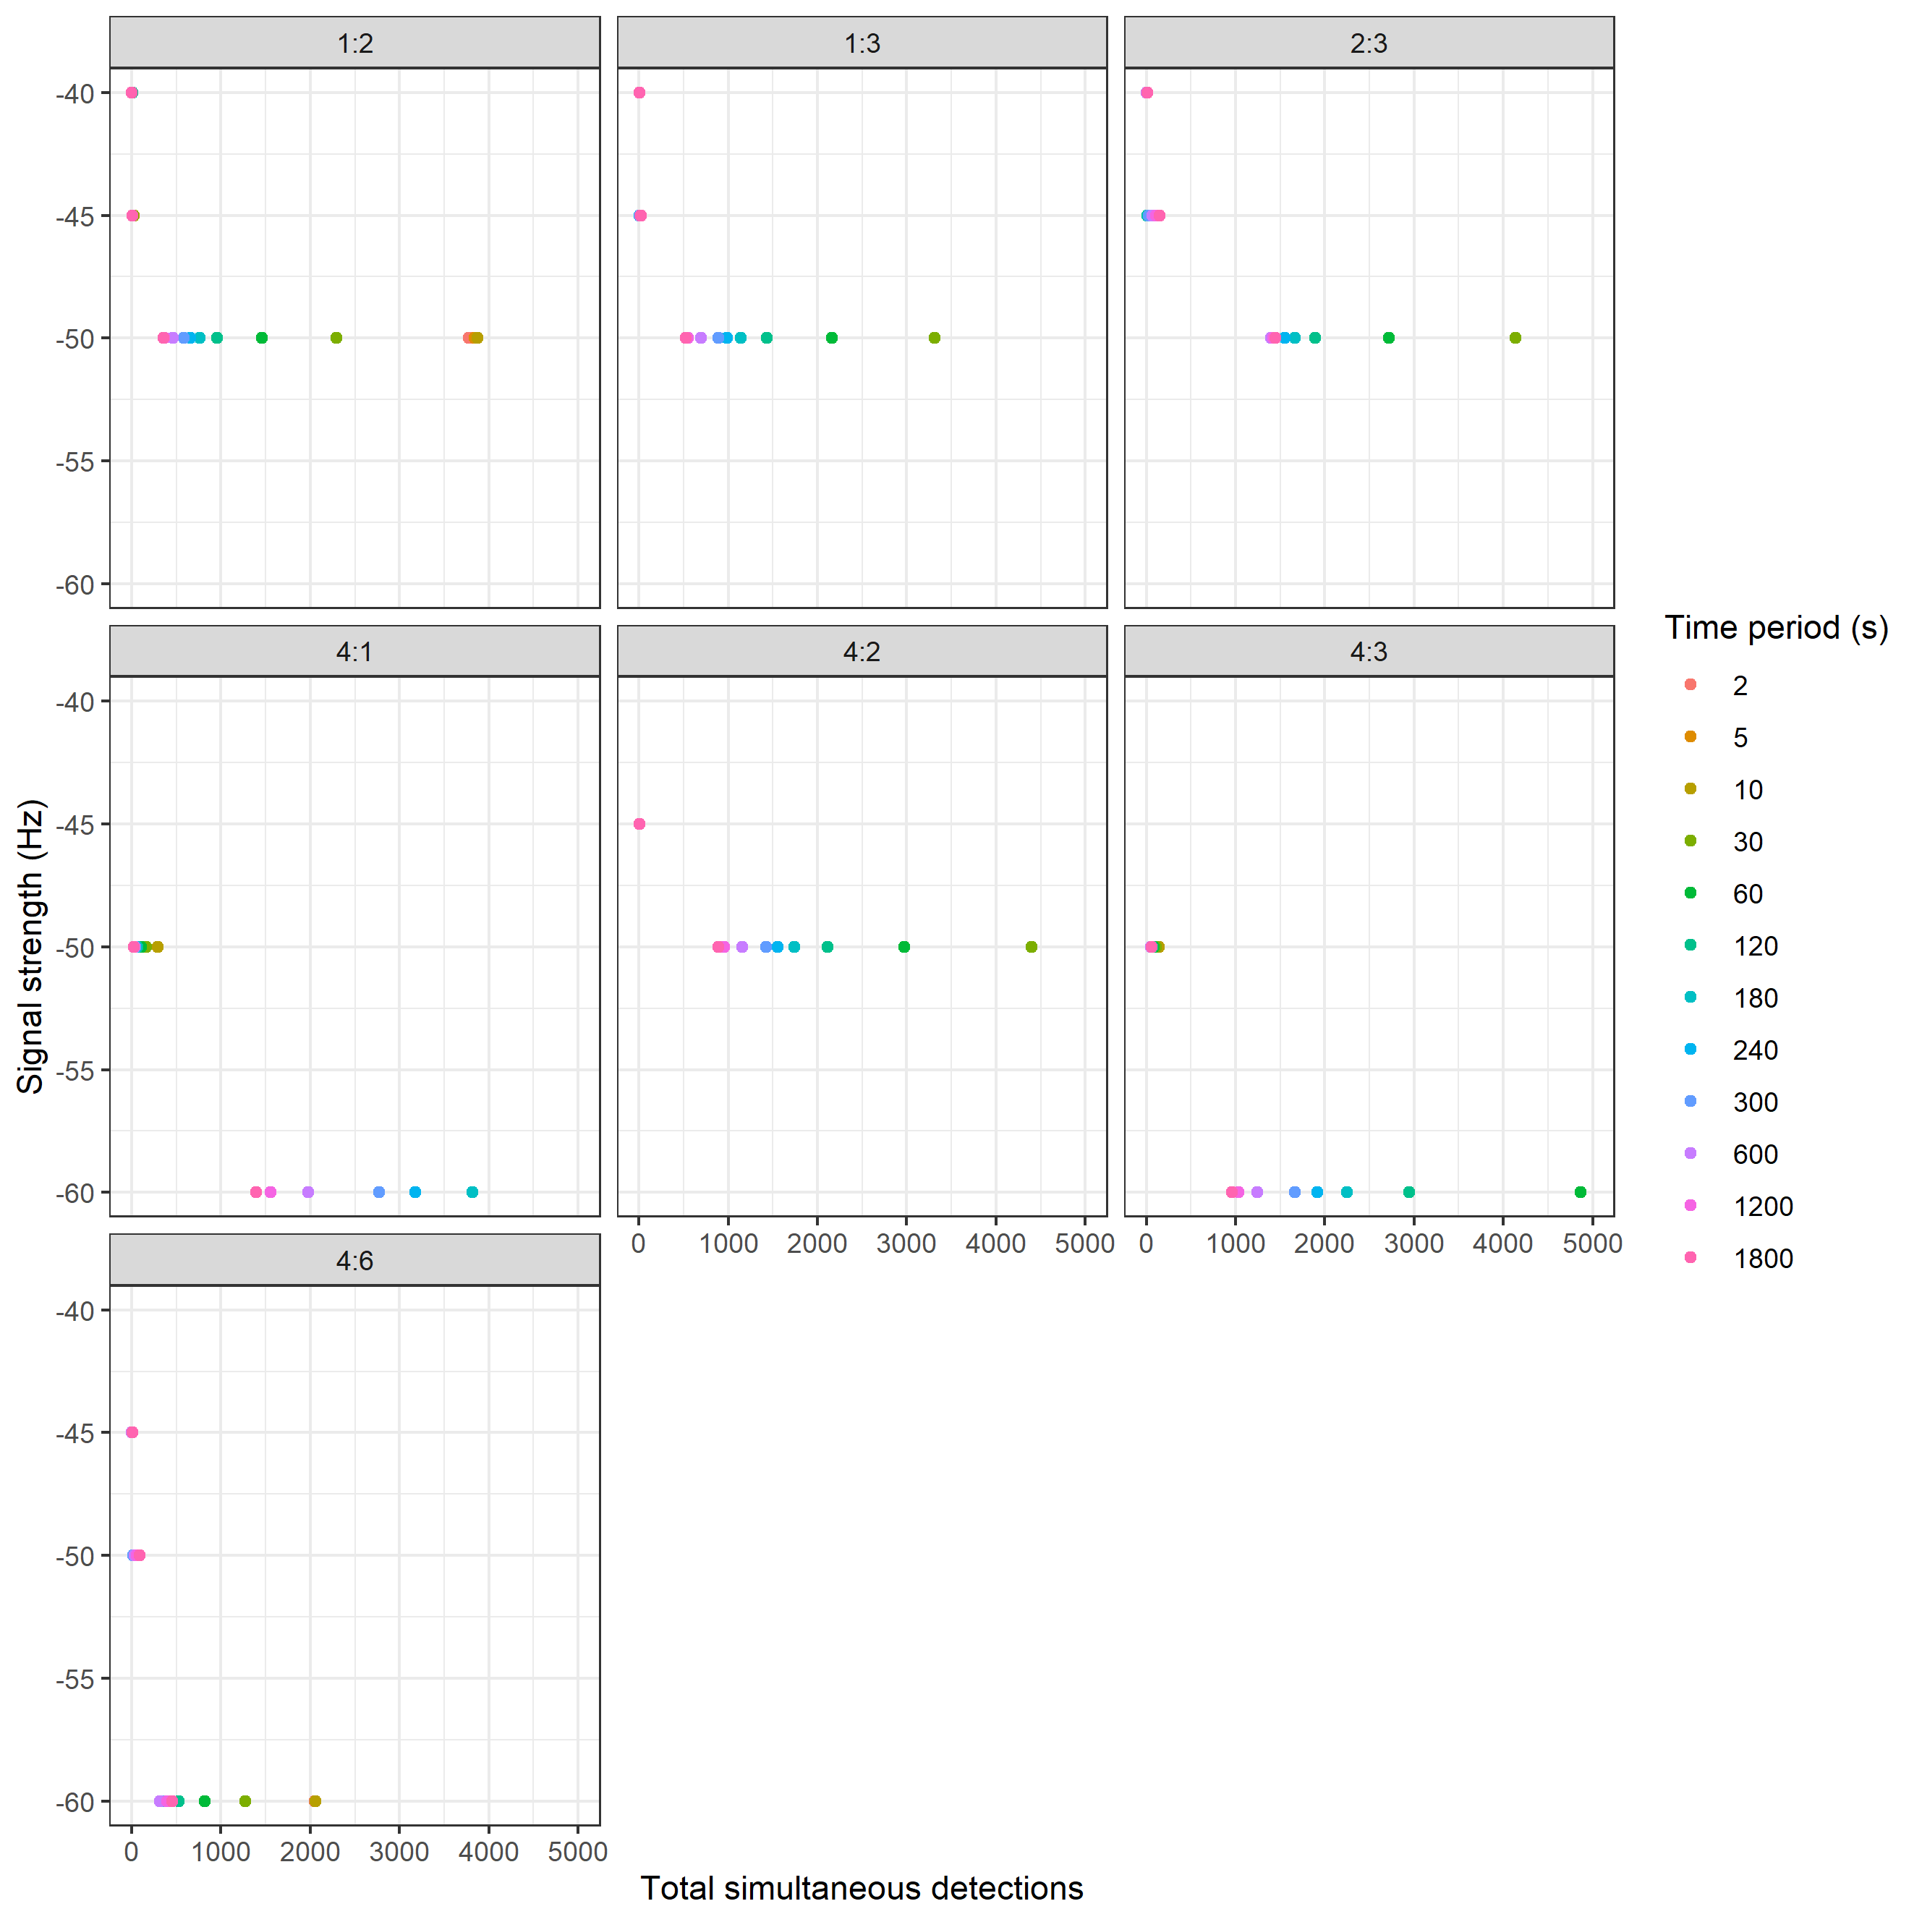
Figure 1. Number of simultaneous detections between pairs of receivers 1-6 at a given signal strengths for a given time period at which a detection is considered simultaneous.
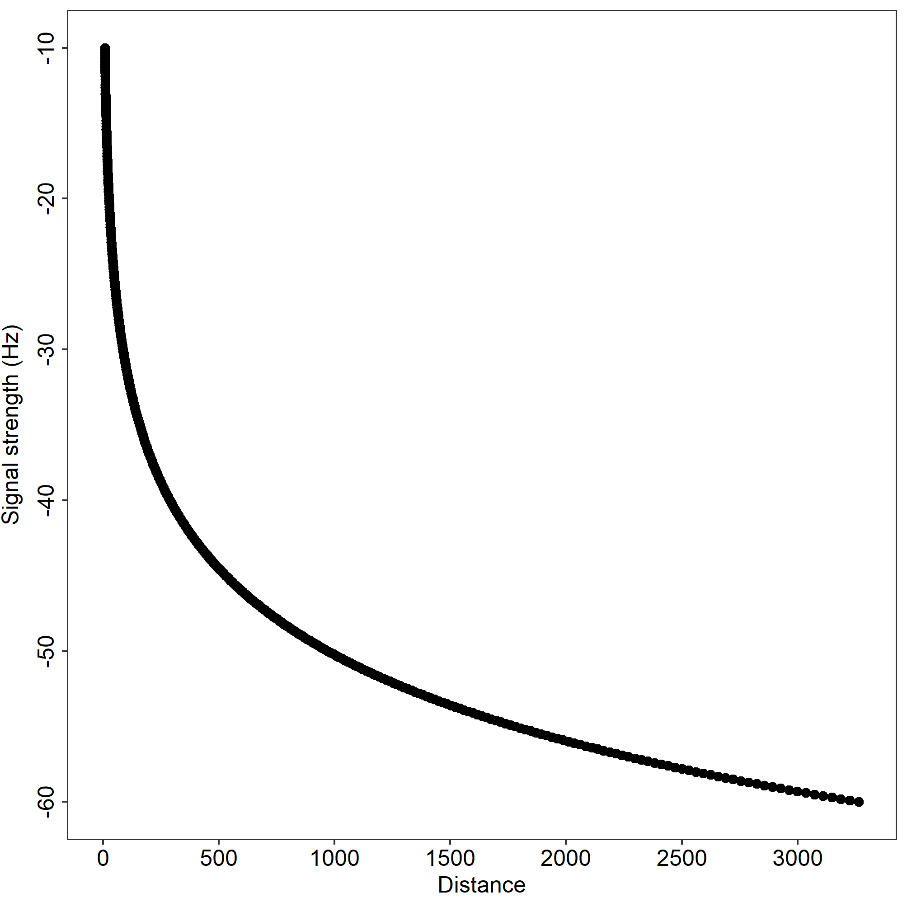
Figure 2. Mean detection radius for a given signal strength at any given receiver in the array

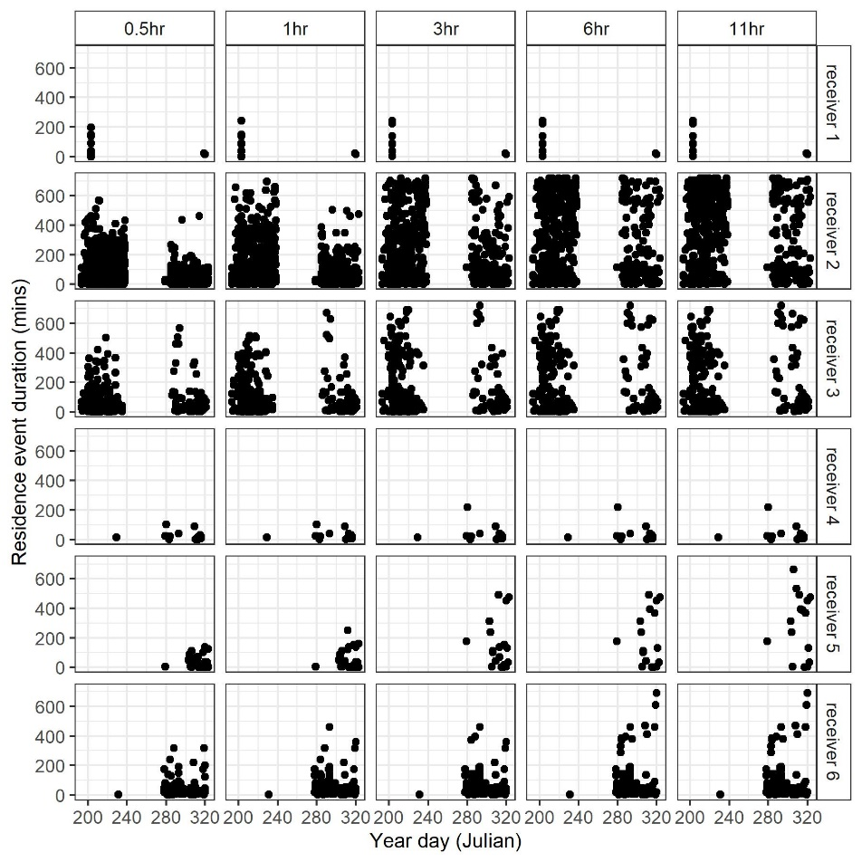
Figure 3. Duration of a residence event at different time out thresholds (0.5 - 11hrs) at each receiver (1-6) in VTrack.

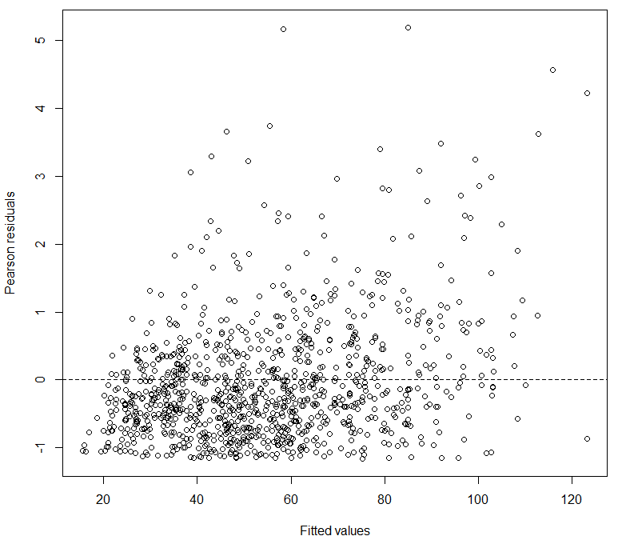
Figure 4. Pearson residuals vs. Fitted values for the final gamma model for mean residence event duration.
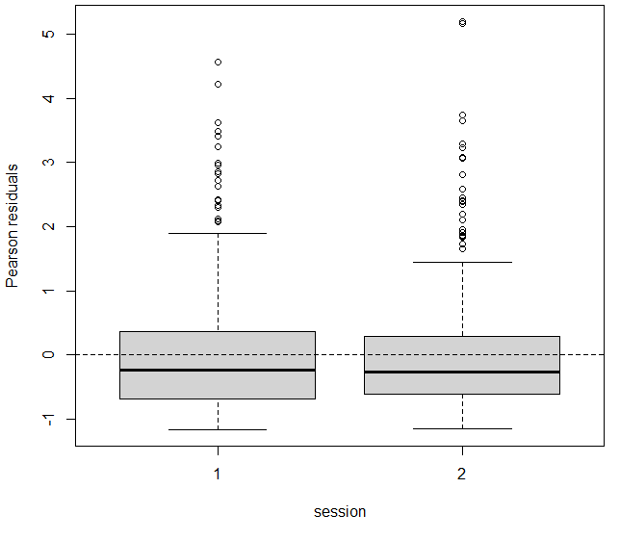
Figure 5. Pearson residuals vs. session for the final gamma model for mean residence event duration
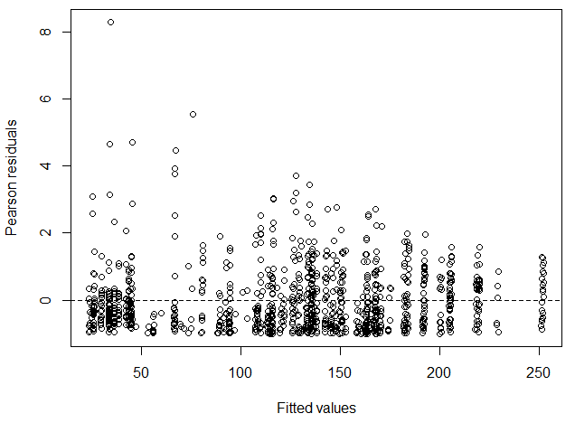
Figure 6. Pearson residuals vs. fitted values for the final gamma model for total duration of residence events.

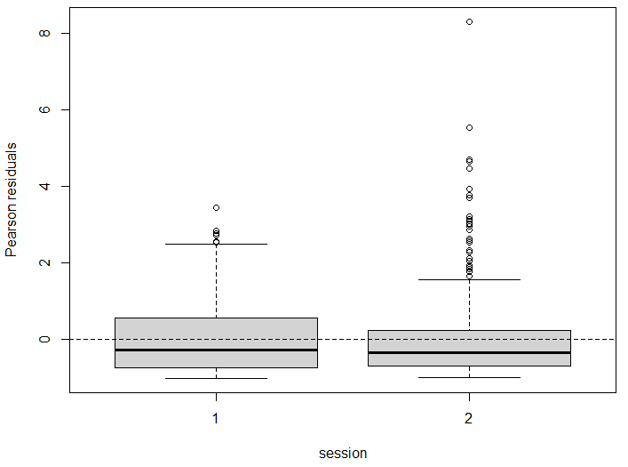
Figure 7. Pearson residuals vs. session for the final gamma model for total residence event duration

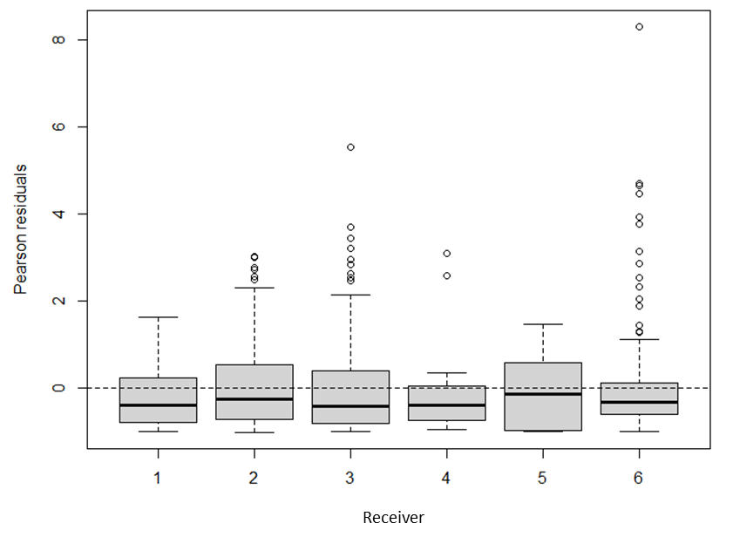
Figure 8. Pearson residuals vs. Receiver for the final gamma model for total residence event duration

Table 1 Trapping effort summary at each release site (A or B) and session (1 or 2).
 | Session 1 |  | Session 2 |  | Both sessions
 | Trapping effort (days) | No. birds | Trapping effort (days) | No. birds | Total trapping effort (days) | Total no. birds
Site A | 3 | 19 | 4 | 9 | 7 | 28
Site B | 5 | 0 | 4 | 10 | 9 | 10
Total | 8 | 19 | 8 | 19 | 16 | 38

Table 2 Detection information for 35 radio-tagged Gouldian finches (E. gouldiae), caught in either session 1 (July-August) or 2 (October-November), at either site A or site B.
Tag number + Motus deployment ID | Session | Release site | Life stage | Tracking duration (d) | No. receivers | No. residence events | Mean duration of residence event (mins) | Cumulative daily total residence time (mins)
156.2417 | 1 | Site A | Juvenile | 20 | 2 | 52 | 150.21 | 1043.97
160.2417 | 1 | Site A | Juvenile | 35 | 3 | 117 | 161.77 | 1594.61
161.2418 | 1 | Site A | Juvenile | 4 | 2 | 9 | 122.18 | 1160.75
167.2444 | 1 | Site A | Juvenile | 28 | 2 | 103 | 154.45 | 1533.42
168.2418 | 1 | Site A | Juvenile | 10 | 3 | 33 | 137.97 | 1283.17
169.2444 | 1 | Site A | Adult | 37 | 3 | 138 | 156.59 | 1781.76
172.2417 | 1 | Site A | Adult | 33 | 3 | 106 | 152.57 | 1521.04
173.2418 | 1 | Site A | Juvenile | 1 | 1 | 2 | 126.86 | 888.00
181.2444 | 1 | Site A | Juvenile | 2 | 2 | 3 | 34.86 | 209.17
186.2444 | 1 | Site A | Juvenile | 35 | 2 | 107 | 152.87 | 1415.16
194.2444 | 1 | Site A | Juvenile | 16 | 3 | 63 | 142.86 | 1732.14
195.2444 | 1 | Site A | Juvenile | 38 | 2 | 107 | 168.68 | 1407.16
200.2445 | 1 | Site A | Juvenile | 39 | 2 | 149 | 205.33 | 2011.16
203.2445 | 1 | Site A | Juvenile | 36 | 2 | 106 | 199.70 | 1669.69
204.2445 | 1 | Site A | Adult | 38 | 3 | 124 | 128.12 | 1358.70
206.2444 | 1 | Site A | Adult | 14 | 2 | 30 | 125.11 | 938.32
207.2445 | 1 | Site A | Adult | 13 | 3 | 48 | 163.90 | 1865.96
208.2445 | 1 | Site A | Juvenile | 39 | 2 | 138 | 189.85 | 1835.26
216.2445 | 1 | Site A | Juvenile | 24 | 3 | 93 | 206.68 | 2402.63
227.2679 | 2 | Site A | Juvenile | 11 | 2 | 17 | 66.31 | 391.82
228.2679 | 2 | Site A | Juvenile | 25 | 3 | 63 | 111.64 | 803.84
242.2678 | 2 | Site A | Juvenile | 18 | 2 | 61 | 174.08 | 1479.66
244.2675 | 2 | Site B | Adult | 22 | 1 | 27 | 54.41 | 291.86
249.2673 | 2 | Site B | Juvenile | 33 | 2 | 44 | 57.84 | 326.01
254.2674 | 2 | Site B | Adult | 25 | 2 | 31 | 34.43 | 187.32
256.2677 | 2 | Site B | Juvenile | 29 | 3 | 34 | 34.71 | 187.92
258.2674 | 2 | Site A | Juvenile | 1 | 1 | 2 | 62.07 | 434.50
261.2679 | 2 | Site A | Adult | 35 | 2 | 128 | 154.65 | 1586.31
262.2679 | 2 | Site A | Adult | 25 | 2 | 65 | 121.10 | 978.46
263.2679 | 2 | Site A | Adult | 8 | 1 | 22 | 144.34 | 1118.67
265.2671 | 2 | Site B | Juvenile | 25 | 3 | 29 | 34.53 | 200.27
267.2679 | 2 | Site A | Adult | 30 | 3 | 89 | 136.91 | 1318.86
268.2679 | 2 | Site A | Adult | 31 | 2 | 79 | 155.03 | 1190.21
270.2678 | 2 | Site B | Adult | 14 | 1 | 18 | 44.62 | 235.86
271.2678 | 2 | Site B | Juvenile | 10 | 1 | 12 | 50.72 | 263.77
272.2678 | 2 | Site B | Juvenile | 26 | 2 | 37 | 92.65 | 538.10
273.2678 | 2 | Site B | Adult | 25 | 1 | 25 | 21.83 | 109.17
274.2678 | 2 | Site B | Adult | 18 | 1 | 23 | 38.13 | 207.61
Mean residence time is the mean duration of a residence event. Total residence time is the mean daily cumulative duration for the tracking period residences

Table 3 Models tested and ranked by ∆DIC for mean and total duration of residence events per individual/day
Metric | Model | DIC | ∆DIC
Mean duration of residence event day/individual/receiver (minutes) | Session | 10215.03 | 0.00
 | Session + Life stage | 10215.06 | 0.03
 | Session*Life stage | 10215.49 | 0.46
 | Session*Release site | 10215.69 | 0.66
 | Session + Release site | 10215.89 | 0.86
 | Session + Life stage + Release site | 10215.97 | 0.95
 | Life stage | 10216.77 | 1.74
 | Release site | 10218.46 | 3.44
 | Life stage + Release site | 10218.79 | 3.76
 | Session + Receiver | 10219.09 | 4.06
 | session + Life stage + Receiver | 10219.12 | 4.09
 | Session + Receiver + Release site | 10221.41 | 6.38
 | Session + Life stage + Receiver + Release site | 10221.62 | 6.59
 | Receiver | 10221.84 | 6.81
 | Life stage + Receiver | 10222.25 | 7.23
 | Life stage + Receiver + Release site | 10224.32 | 9.29
Total duration of residence events/day/individual/receiver (minutes) | Life stage | 11649.29 | 0
 | Session | 11649.9 | 0.611697
 | Session + Life stage + Receiver | 11649.93 | 0.636675
 | Session + Life stage | 11650.12 | 0.830925
 | Session * Life stage | 11650.35 | 1.058068
 | Session + Receiver | 11650.44 | 1.152467
 | Receiver | 11651.21 | 1.920348
 | Life stage + Receiver | 11651.52 | 2.224688
 | Session * Release site | 11652.31 | 3.022676
 | Session + Release site | 11652.32 | 3.025283
 | Release site | 11652.47 | 3.17464
 | Session + Life stage + Release site | 11652.54 | 3.252541
 | Life stage + Release site | 11653.4 | 4.104933
 | Session + Receiver + Release site | 11653.6 | 4.310995
 | Session + Life stage + Receiver + Release site | 11653.63 | 4.337567
 | Life stage + Receiver + Release site | 11654.28 | 4.987795

Table 4 Proportional time spent and eigenvector centrality of receivers (nodes) in the array (network) between session 1 (July-August) and session 2 (October-November).
 | Session 1 |  | Session 2
Receiver | Proportion | Eigenvector centrality | Proportion | Eigenvector centrality
1 | 0.02 | 0.06 | 0.01 | 0.07
2 | 0.77 | 1.00 | 0.71 | 1.00
3 | 0.27 | 1.00 | 0.29 | 1.00
4 | 0.00 | 0.00 | 0.01 | 0.00
5 | NA | NA | 0.21 | 0.02
6 | 0.04 | 0.00 | 0.95 | 0.00
Proportion is the proportion of time spent within the detection range of any one receiver compared to the whole array across all tagged birds. Eigenvector centrality is a measure of a receiver’s connectedness within the array and is out of a possible score 1 (most connected).
Table 5 Number of connections (frequency of movement) between pairs of receivers in session 1 (July-August) and session 2 (October-November)
Session 1
Receiver from/to | 1 | 2 | 3 | 4 | 5 | 6
1 | N/A | 1 | 6 | 0 | 0 | 0
2 | 0 | N/A | 111 | 1 | 0 | 0
3 | 7 | 112 | N/A | 0 | 0 | 1
4 | 0 | 0 | 0 | N/A | 0 | 0
5 | 0 | 0 | 0 | 0 | N/A | 0
6 | 0 | 0 | 0 | 0 | 0 | N/A
Session 2
Receiver from/to | 1 | 2 | 3 | 4 | 5 | 6
1 | N/A | 1 | 1 | 0 | 0 | 0
2 | 0 | N/A | 31 | 0 | 1 | 0
3 | 2 | 29 | N/A | 0 | 0 | 0
4 | 0 | 0 | 0 | N/A | 1 | 10
5 | 0 | 0 | 0 | 9 | N/A | 1
6 | 0 | 0 | 0 | 10 | 1 | N/A

