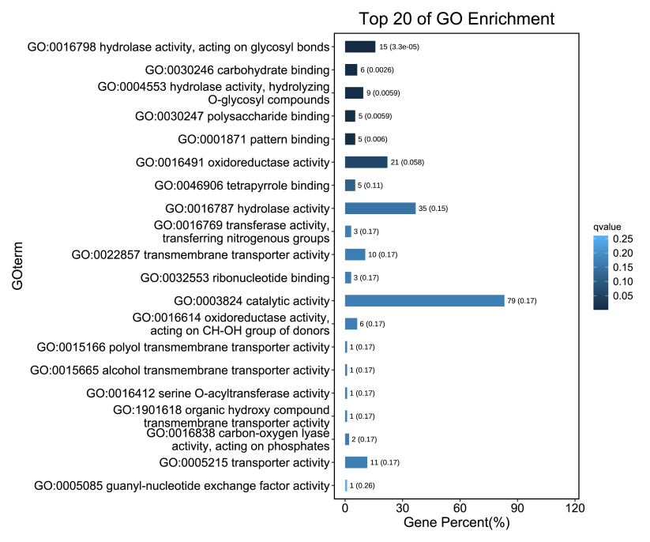
Figure S1. Top 20 of GO Enrichment for 215 different genes.
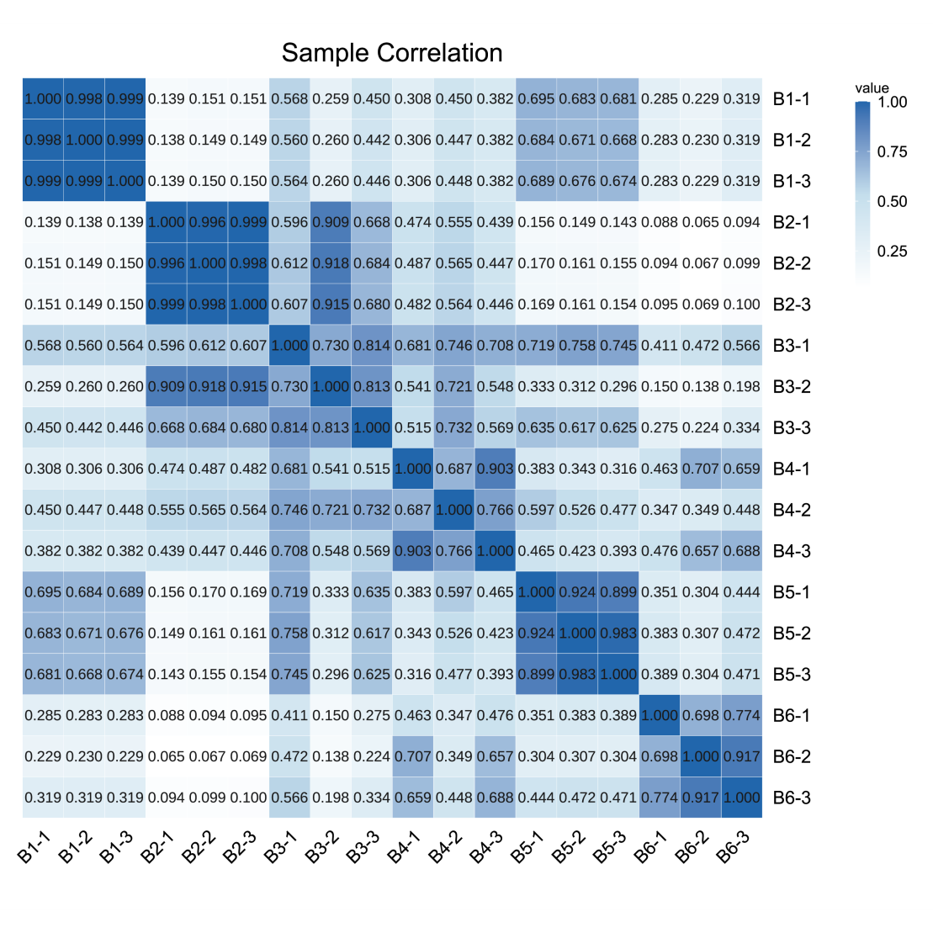
Figure S2. Pearson correlation between samples.

