Supplementary information
Figure
Fig.1 Optimized geometries (of IM and TS) for the first step reaction mechanism of CS₂ hydrolysis (bond distances in Å).
Fig.2 The summary of the potential energy surface for the reaction CS₂ hydrolysis was calculated at the B3LYP-D3/6-311+G* level.
Fig.3 NBO analysis of donor-acceptor interaction for the TS2 and TS2′ are from B3LYP-D3/6-311+G* calculations. Values are the second-order stabilization energies
Fig.4 Optimized geometries (of IM and TS) for the second step reaction mechanism of CS₂ hydrolysis (bond distances in Å).
Fig.5 The summary of the potential energy surface for the reaction COS hydrolysis calculated at the B3LYP-D3/6-311+G* level including the B3LYP zero-point vibrational energies. The relative energies are in kJ/mol.
Fig.6 NBO analysis of donor-acceptor interaction for the TS4, TS4′, TS5 and TS5′′ are from B3LYP-D3/6-311+G* calculations. Values are the second-order stabilization energies
Fig.7 the activation enthalpy, activation entropy , activation and the rate constant energy of each step of elementary reaction at 298.15~1000K

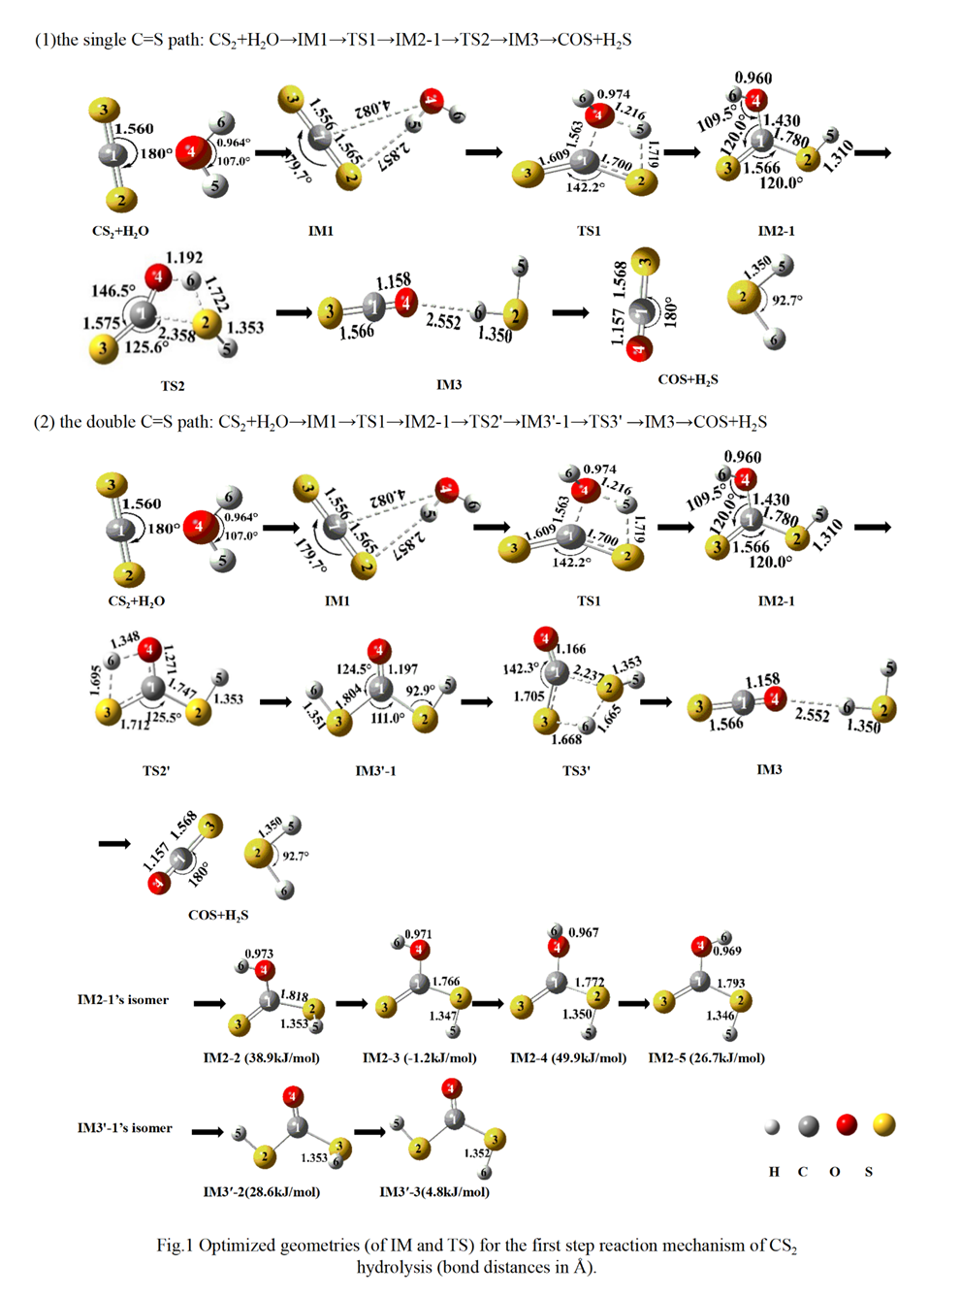
Fig.1 Optimized geometries (of IM and TS) for the first step reaction mechanism of CS₂ hydrolysis (bond distances in Å).

Fig.2 The summary of the potential energy surface for the reaction CS₂ hydrolysis was calculated at the B3LYP-D3/6-311+G* level.
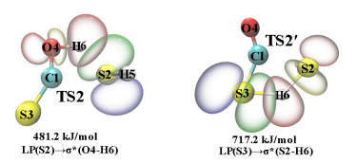
481.2 kJ/mol 717.2 kJ/mol
LP(S2) →σ* (O4-H6) LP(S3) →σ* (S2-H6)

Fig.3 NBO analysis of donor-acceptor interaction for the TS2 and TS2′ are from B3LYP/6-311+G* calculations. Values are the second-order stabilization energies.

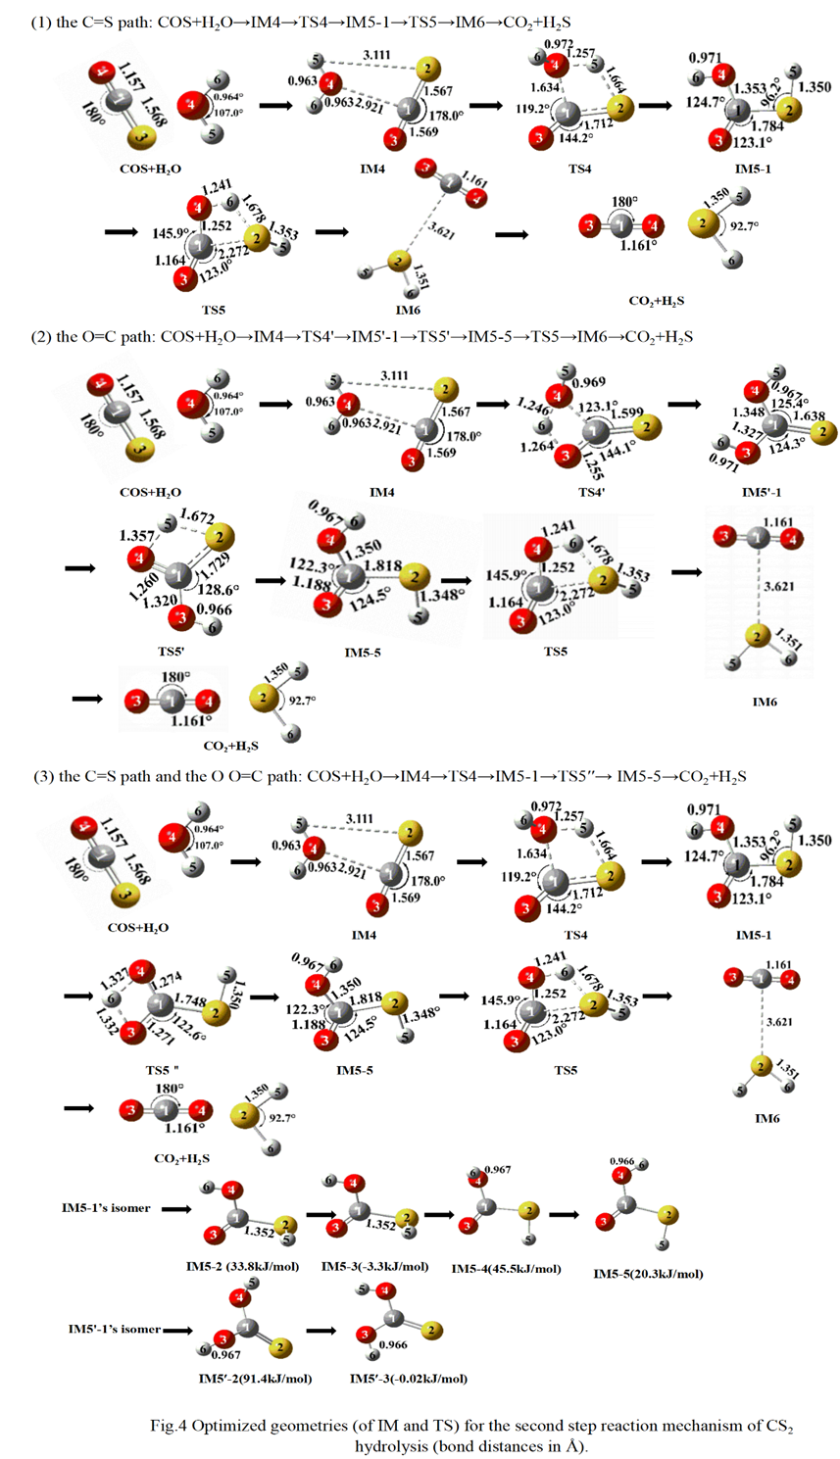
Fig.4 Optimized geometries (of IM and TS) for the second step reaction mechanism of CS₂ hydrolysis (bond distances in Å).

Fig.5 The summary of the potential energy surface for the reaction COS hydrolysis calculated at the B3LYP-D3/6-311+G* level.
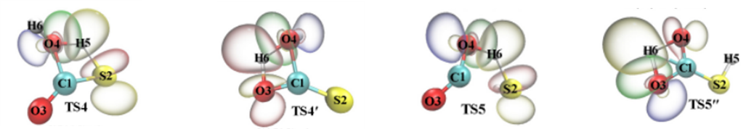
527.2 kJ/mol 500.7 kJ/mol 594.6 kJ/mol 457.5 kJ/mol
LP(O4) →σ* (S2-H5) LP(O4) →σ* (O3-H6) LP(O4) →σ* (S2-H6) LP(O3) →σ* (O4-H6)
Fig.6 NBO analysis of donor-acceptor interaction for the TS4, TS4′, TS5 and TS5′′ are from B3LYP-D3/6-311+G* calculations. Values are the second-order stabilization energies.

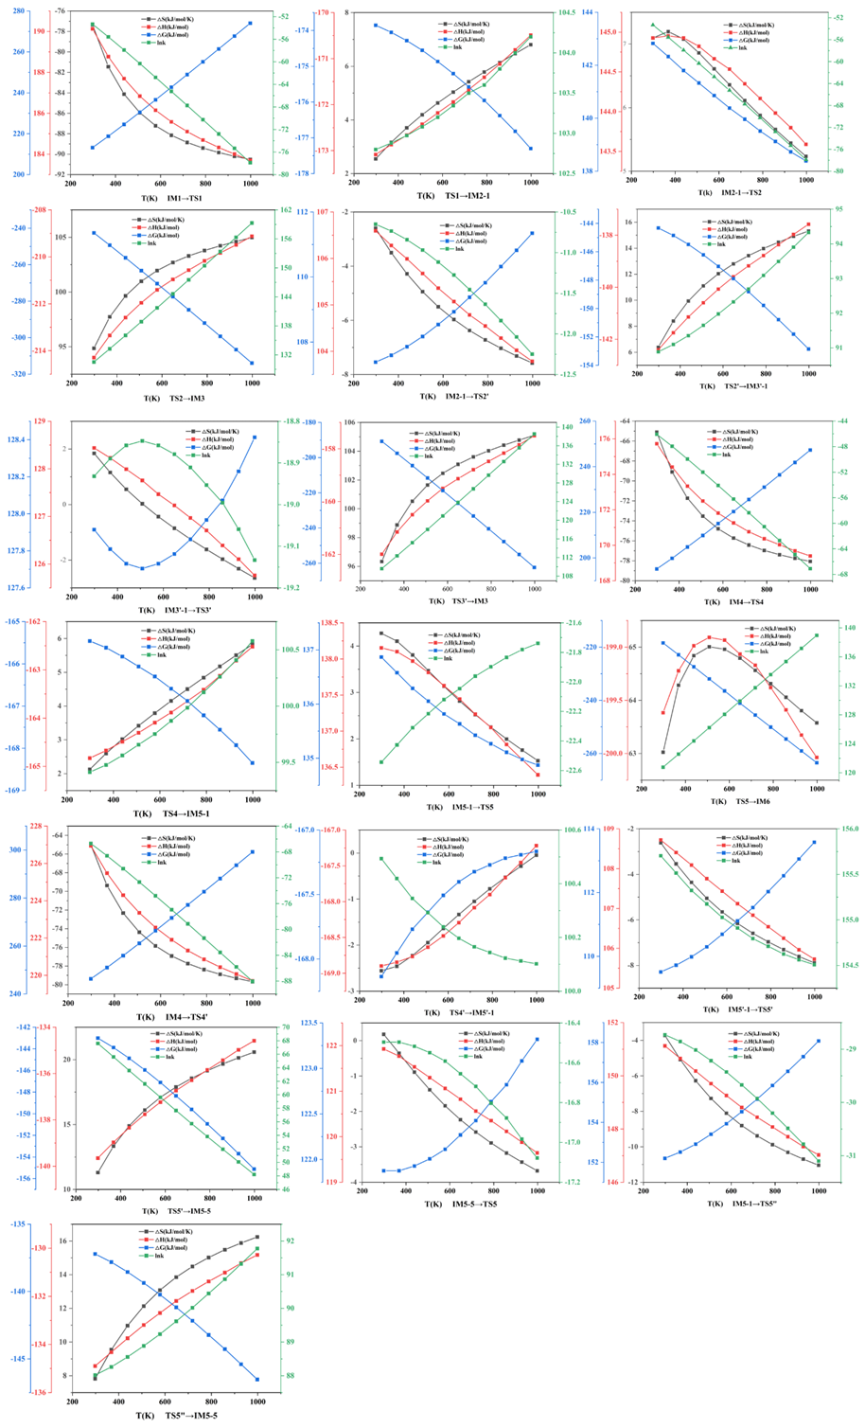
Fig.7 the activation enthalpy, activation entropy , activation and the rate constant energy of each step of elementary reaction at 298.15~1000K
Table
Table 1. Imaginary frequency of each transition state and the bonds corresponding to relative normal vibrations for the hydrolysis of CS₂
Table 2. Imaginary frequency of each transition state and the bonds corresponding to relative normal vibrations for the hydrolysis of COS

Table 1. Imaginary frequency of each transition state and the bonds corresponding to relative normal vibrations for the hydrolysis of CS₂

Transition state | Imaginary frequency (i/cm) | Bonds corresponding to normal vibrations
TS1 | -1573.61 | H5-O4-S2; O4-C1
TS2 | -1712.30 | H6-O4-S2; S2-C1
TS2′ | -1755.11 | H6-O4-S3; S3-C1
TS3′ | -1317.63 | S3-S2-H6; S2-C1

Table 2. Imaginary frequency of each transition state and the bonds corresponding to relative normal vibrations for the hydrolysis of COS

Transition state | Imaginary frequency (cm⁻¹) | Bonds corresponding to normal vibrations
TS4 | -1592.47 | H5-O4-S2; O4-C1
TS5 | -1752.28 | H6-O4-S2; S2-C1
TS4′ | -1887.88 | H6-O3-O4; O4-C1
TS5′ | -1755.12 | H5-O4-S2; S2-C1
TS5″ | -1956.90 | H6-O3-O4; O3-C1

