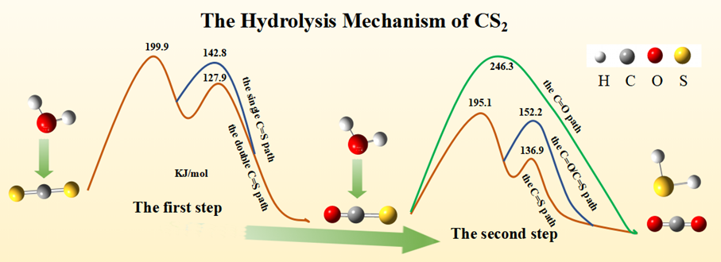
Graphical Abstract
This picture vividly presented the two-step hydrolysis mechanism of CS₂ by using density functional theory at the B3LYP-D3(BJ)/6-311+G* level of theory. In the first step of the reaction, the rate-determining step in both the single C=S path and the double C=S path has a higher barrier of 199.9 kJ/mol, but the 127.9 kJ/mol barrier in the double C=S path has a lower barrier of 142.8 kJ/mol in the single C=S path. So the double C=S path is more favorable than the single C=S path. Similarly, the order of the barriers for the three paths in the second reaction is: C=S path < C=S path and C=O path < C=O path. So the C=S path is more favorable than the C=O path and the C=S, O=C path.

