The effect of early treatment with ivermectin on viral load, symptoms and humoral response in patients with mild COVID-19: a pilot, double-blind, placebo-controlled, randomized clinical trial.

Table S1. Viral loads during follow up by study arm 2
Figure S1: Cycle threshold evolution 3
Figure S2: Compliance with symptoms diary 4
Table S2: Summary statistics of viral load profiles 5
Figure S3: Reported fever, headache, general malaise, nasal congestion, gastrointestinal, shortness of breath 6
Figure S4: Reports of symptoms potentially associated with ivermectin 7
Table S3. Vital signs during visits by study arm 8
Table S4. Laboratory parameters during follow up by study arm 9
Figure S5: Symptoms’ predicted probability by study arm. 10
Figure S6: Anosmia/hyposmia by sex and treatment group 11

Table S1. Viral loads during follow up by study arm

 | Day
 | 1 | 4 | 7 | 14 | 21
Viral load (gene E)
Ivermectin | 1.7·10⁷ (5.9·10⁶- 3.9·10⁸) | 1.6·10⁵ (2820-8.8·10⁵) | 1018 (92-15445) | 7 (0- 42) | 1 (0- 9)
Placebo | 2.7·10⁷ (8.3·10⁵- 4.2·10⁸) | 4.9·10⁵ (1.0·10⁵-9.9·10⁶) | 23550 (709-2.3·10⁵) | 30 (1- 50) | 0 (0- 16)
Cycle threshold (gene E)
Ivermectin | 20 (17- 22) | 27 (25- 31) | 33 (30- 35) | 36 (35- 41) | 38 (36- 41)
Placebo | 21 (18- 23) | 26 (22- 28) | 30 (28- 32) | 35 (35- 37) | 41 (37- 41)
Viral load (gene N)
Ivermectin | 3.7·10⁸ (1.8·10⁷- 9.3·10⁹) | 2.7·10⁵ (1885-1.0·10⁶) | 2255 (938-34650) | 86 (0- 1235) | 0 (0- 67)
Placebo | 3.3·10⁸ (5.8·10⁷- 6.7·10⁹) | 2.2·10⁶ (73150-3.7·10⁷) | 36800 (4510-6.3·10⁵) | 75 (24- 710) | 107 (0- 183)
Cycle threshold (gene N)
Ivermectin | 20 (16- 22) | 27 (24- 31) | 32 (30- 34) | 36 (33- 41) | 41 (35- 41)
Placebo | 21 (17- 22) | 25 (22- 27) | 29 (27- 31) | 35 (33- 35) | 35 (35- 39)
Number of subjects per day and study arm is 12. IQR: interquartile range.

Figure S1: Cycle threshold evolution

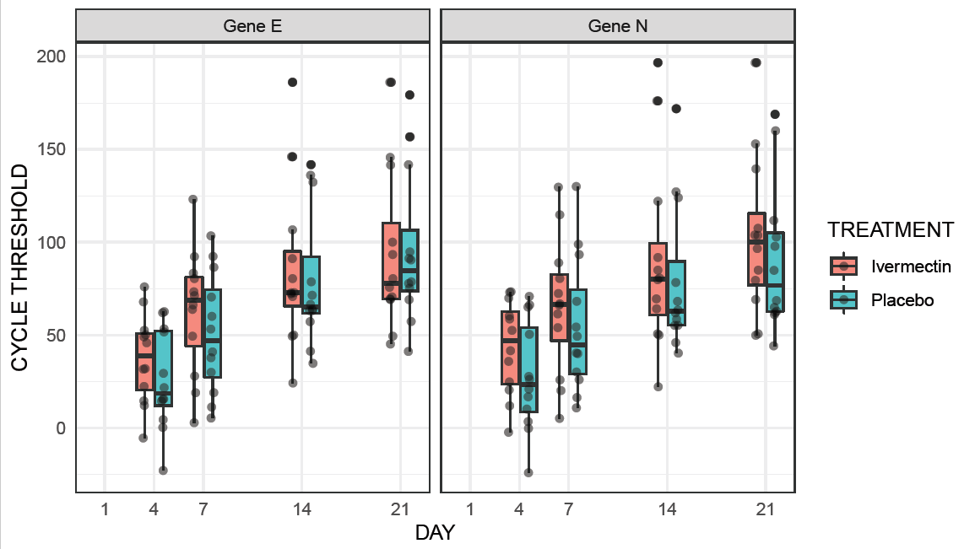
The boxes show the median and interquartile range (IQR). The whiskers extend +/-1.5 times the IQR. Dots represent each individual value.

Figure S2: Compliance with symptoms diary

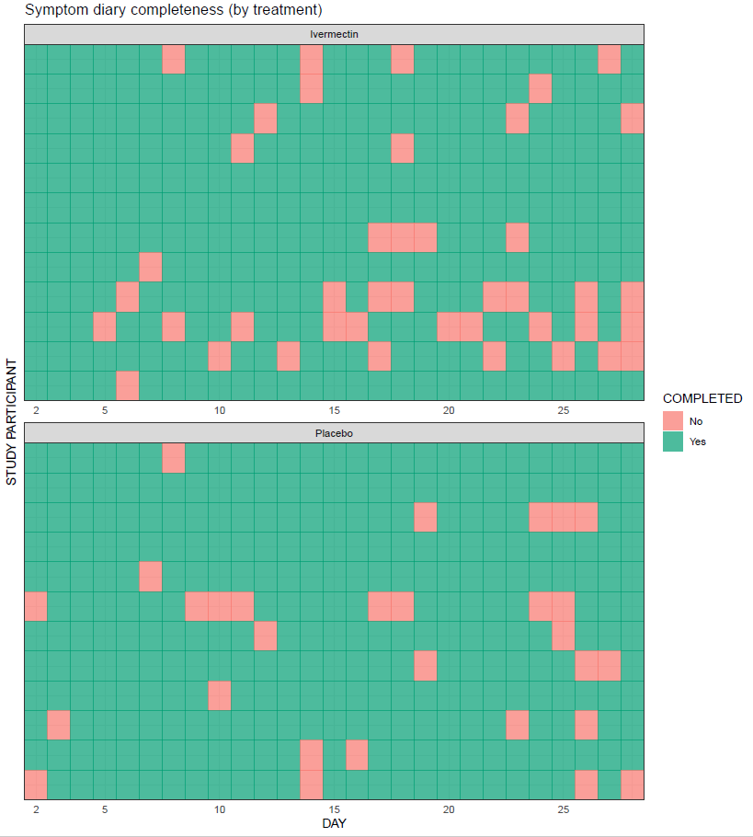
The symptoms diary had to be completed each day from days two to 28. Each row represents a study participant. Highlighted in red are those cases where the diary was not completed.

Table S2: Summary statistics of viral load profiles
 | Ivermectin | Placebo | p value
Peak viral load (Cmax), median (IQR) [range], cycles | 19.63 (15.87 - 21.19) [13.82 - 27.22] | 20.48 (17.36 - 21.14) [12.94 - 22.77] | 0.5846
Time to peak viral load (Cmax), median (IQR) [range], d | 6.00 (6.00 - 7.00) [5.75-10.00] | 7.00 (6.75 - 7.00) [6 - 11] | 0.2637
Time from start to end of positivity threshold of 35 cycles (duration),  median (IQR) [range], d | 18.00 (12.80 - 21.05) [11 – 27.7] | 20.10 (18.53 - 25.52) [11.8 - 28.9] | 0.1017
AUCobs, median (IQR) [range], cp/mL*d | 3.36*10⁸ (3.74*10⁷ - 1.9*10¹⁰) [4.19*10⁵-1.45*10¹¹] | 8.24*10⁸ (2.51*10⁸ - 1.02*10¹⁰) [2.08*10⁷ - 1.70*10¹²] | 0.4764
IQR: interquartile range; AUCobs: area under the viral load curve. Statistical significance was assessed using a two-tailed unpaired t test with (AUCobs) or without (Cmax duration) logarithmic transformation and the Wilcoxon rank sum test (Tmax).

Figure S3: Reported fever, headache, general malaise, nasal congestion, gastrointestinal, shortness of breath
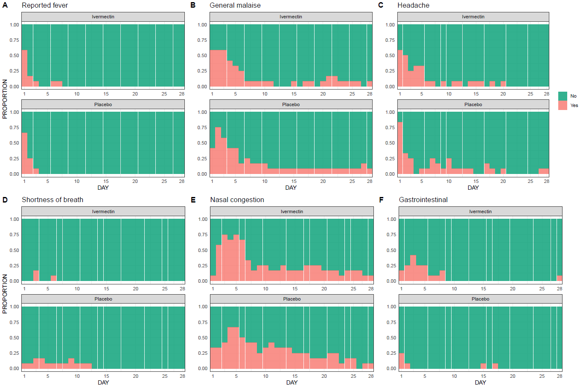
Each individual graph represents the daily proportion of individuals (n/N) who suffered from each symptom in the corresponding study arm for a 28 day follow up.

Figure S4: Reports of symptoms potentially associated with ivermectin

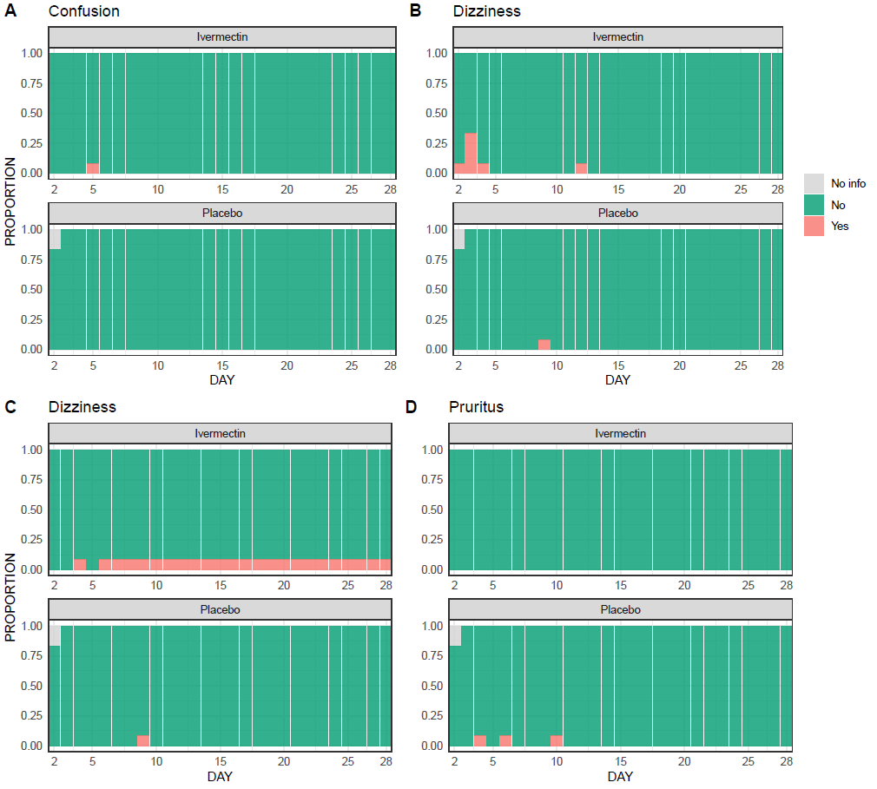
Each individual graph represents the daily proportion of individuals (n/N) who suffered from each potential side effect in the corresponding study arm for a 28 day follow up. Note that these data come from the symptom diary, which was completed from day two to day 28. Missing information was carried over from the last data available. There is some gray area on day two because there were two participants who did not complete the symptom diary on that day and no previous information existed.

Table S3. Vital signs during visits by study arm

 | Day
 | 1 | 7 | 14 | 21 | 28
Systolic blood pressure, median (IQR), mmHg
Ivermectin | 114 (113- 117) | 108 (99- 116) | 106 (102- 112) | 112 (103- 122) | 113 (108- 122)
Placebo | 129 (116- 134) | 119 (110- 123) | 114 (108- 126) | 114 (104- 121) | 122 (117- 131)
Diastolic blood pressure, median (IQR), mmHg
Ivermectin | 76 (72- 80) | 71 (66- 76) | 69 (68- 72) | 73 (70- 78) | 75 (69- 78)
Placebo | 79 (77- 85) | 76 (72- 80) | 73 (68- 78) | 73 (70- 77) | 79 (75- 85)
Heart rate, median (IQR), bpm
Ivermectin | 83 (77- 99) | 75 (68- 77) | 74 (67- 84) | 84 (74- 91) | 75 (65- 87)
Placebo | 90 (81- 100) | 78 (75- 94) | 80 (72- 89) | 83 (74- 93) | 92 (76- 97)
Respiratory rate, median (IQR), breaths per minute
Ivermectin | 14 (12- 17) [11] | 12 (12- 14) | 14 (12- 15) | 14 (12- 14) | 12 (12- 14)
Placebo | 14 (12- 15) | 14 (12- 14) | 14 (13- 15) | 12 (12- 14) | 14 (12- 14)
Temperature, median (IQR), ºC
Ivermectin | 36.8 (36.4-37.0) | 36.4 (36.0-36.5) | 36.4 (36.0-36.7) | 36.5 (36.0-36.6) | 36.5 (36.4-36.6)
Placebo | 36.9 (36.5-37.0) | 36.5 (36.2-36.7) | 36.5 (36.3-36.6) | 36.4 (36.2-36.8) | 36.5 (36.1-36.9)
Oxygen saturation, median (IQR), %
Ivermectin | 97 (96- 98) | 97 (96- 99) | 97 (96- 97) | 96 (96- 98) | 97 (96- 98)
Placebo | 98 (97- 100) | 98 (97- 98) | 98 (97- 98) | 97 (96- 98) | 97 (96- 98)
Number of subjects per day and study arm is 12, otherwise indicated in brackets.
IQR: interquartile range; bpm: beats per minute.

Table S4. Laboratory parameters during follow up by study arm
Variable | Day |  |  | Normal range
Variable | 1 | 7 | 14 | Normal range
Blood creatinine, median (IQR), mg/dL
Ivermectin | 0.9 (0.8- 1.1) | 0.8 (0.8- 0.9) | 0.8 (0.8- 1.0) | 0.7-1.2
Placebo | 0.9 (0.6- 1.1) | 0.8 (0.7- 1.0) | 0.8 (0.7- 1.0) [11] | 0.7-1.2
Urea blood, median (IQR), mg/dL
Ivermectin | 28 (22- 34) | 29 (27- 36) | 30 (26- 35) | 16.6-48.5
Placebo | 27 (26- 35) | 33 (27- 41) | 30 (27- 38) [11] | 16.6-48.5
LDH, median (IQR), Ul/L
Ivermectin | 231 (192- 251) [11] | 223 (202- 264) | 235 (217- 250) | 135-225
Placebo | 217 (207- 255) | 217 (191- 227) | 224 (204- 232) [11] | 135-225
CRP, median (IQR), mg/dL
Ivermectin | 0.35 (0.16-0.81) | 0.10 (0.03-0.16) | 0.08 (0.06-0.10) | <0.5
Placebo | 0.30 (0.19-0.60) | 0.11 (0.06-0.21) | 0.06 (0.04-0.12) [11] | <0.5
Procalcitonin, median (IQR), ng/mL
Ivermectin | 0.07 (0.04-0.10) | 0.03 (0.02-0.03) | 0.03 (0.02-0.03) | <0.5
Placebo | 0.05 (0.04-0.06) | 0.03 (0.02-0.03) | 0.02 (0.02-0.04) [11] | <0.5
Sodium, median (IQR), mEq/L
Ivermectin | 139 (136- 142) | 141 (140- 142) | 141 (140- 141) | 136-145
Placebo | 139 (139- 141) | 141 (140- 141) | 141 (139- 143) [11] | 136-145
Potassium, median (IQR), mEq/L
Ivermectin | 4.1 (3.8- 4.1) | 3.9 (3.8- 4.0) | 4.0 (4.0- 4.1) | 3.5-5.0
Placebo | 4.1 (3.9- 4.3) | 4.0 (3.8- 4.3) | 3.9 (3.8- 4.2) [11] | 3.5-5.0
Chlorine, median (IQR), mEq/L
Ivermectin | 97 (95- 100) | 100 (98- 102) | 99 (98- 102) | 98-107
Placebo | 99 (98- 101) | 100 (99- 101) | 101 (98- 103) [11] | 98-107
Bicarbonate, median (IQR), mEq/L
Ivermectin | 24.2 (22.6-26.1) | 24.8 (23.6-26.1) [11] | 24.3 (22.6-25.4) | 22-29
Placebo | 24.5 (22.4-26.1) | 24.9 (23.0-26.4) | 24.5 (22.2-26.1) [11] | 22-29
Remaining anion, median (IQR), mEq/L
Ivermectin | 16.7 (15.2-19.3) | 15.1 (14.7-19.8) [11] | 15.8 (15.1-17.5) | 8-16
Placebo | 16.6 (12.7-18.1) | 15.4 (14.7-17.4) | 16.5 (13.5-19.2) [11] | 8-16
Ferritin, median (IQR), ng/mL
Ivermectin | 165.0 (95.8-241.3) | 125.0 (79.5-343.4) | 152.0 (69.4-305.3) | 30-400
Placebo | 156.1 (103.1-223.0) | 198.7 (109.5-248.2) | 145.2 (132.4-196.1) [11] | 30-400
CPK, median (IQR), Ul/L
Ivermectin | 98 (79- 131) | 64 (47- 100) | 106 (63- 160) | <190
Placebo | 66 (59- 113) | 47 (41- 76) | 55 (52- 114) [11] | <190
IL-6, median (IQR), pg/mL
Ivermectin | 6.5 (5.1- 9.6) | 4.3 (3.8- 5.2) [11] | 2.7 (1.5- 4.4) | <7
Placebo | 4.5 (3.0- 6.5) [11] | 4.2 (3.5- 4.9) [11] | 2.1 (1.5- 4.7) [11] | <7
D-Dimer, median (IQR), ng/mL
Ivermectin | 295 (270- 420) | 295 (270- 435) | 270 (270- 340) | 150-500
Placebo | 280 (270- 315) | 270 (270- 310) | 270 (270- 330) [11] | 150-500
Number of subjects per day and study arm is 12, otherwise indicated in brackets.
IQR: interquartile range.

Figure S5: Symptoms’ predicted probability by study arm.
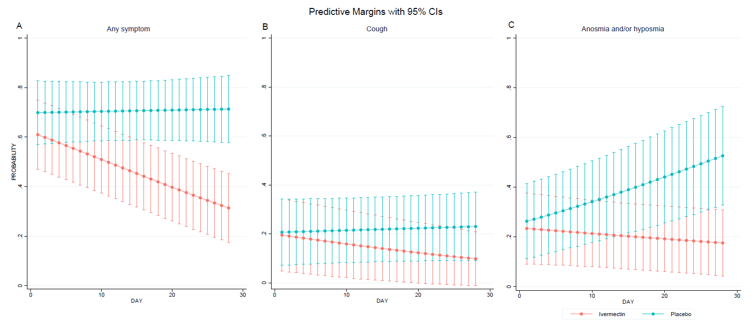
For each symptom, the graph shows the evolution by study arm of its probability during follow up. It was estimated based on mixed effects logistic regression models with subject as a random intercept. These models were adjusted by day of follow up (as symptoms are expected to disappear over time), duration of symptoms before enrolment (as a proxy of disease onset) and the interaction between study arm and day of follow up.

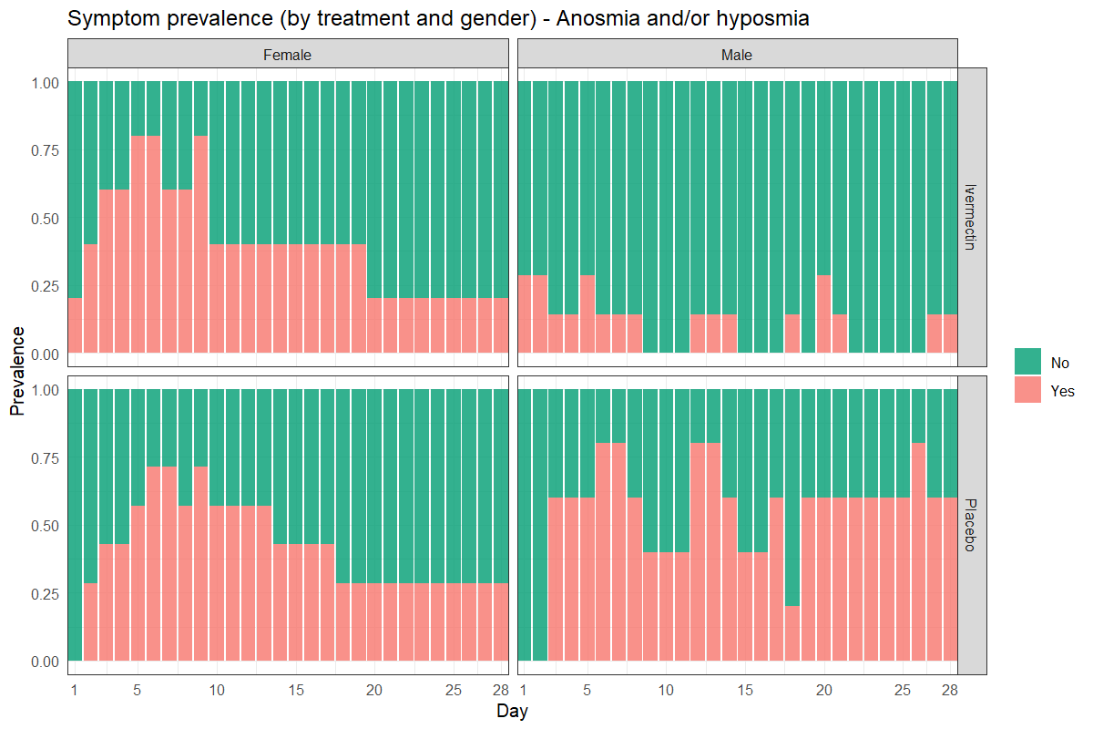
Figure S6: Anosmia/hyposmia by sex and treatment group
Each individual graph represents the daily proportion of individuals (n/N) who suffered from anosmia/hyposmia in the corresponding study arm for a 28 day follow up.

