Supplementary material 5-a. Correlation between anti-S IgM antibody titers and anti-S IgG antibody titers
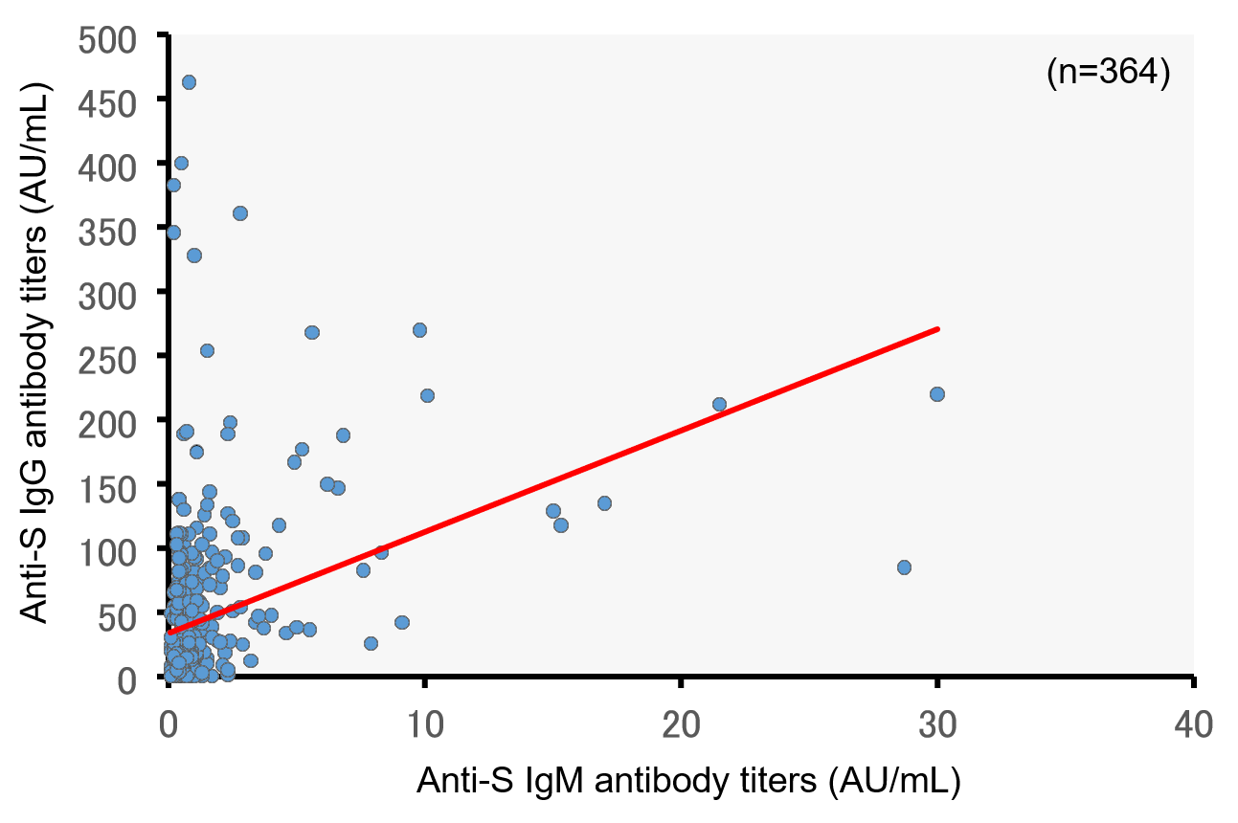
ρ=0.674, p<0.001 Spearman’s test.

Supplementary material 5-b. Correlation between anti-S IgM antibody titers and anti-S IgG antibody titers (correlation between the maximums of both titers)
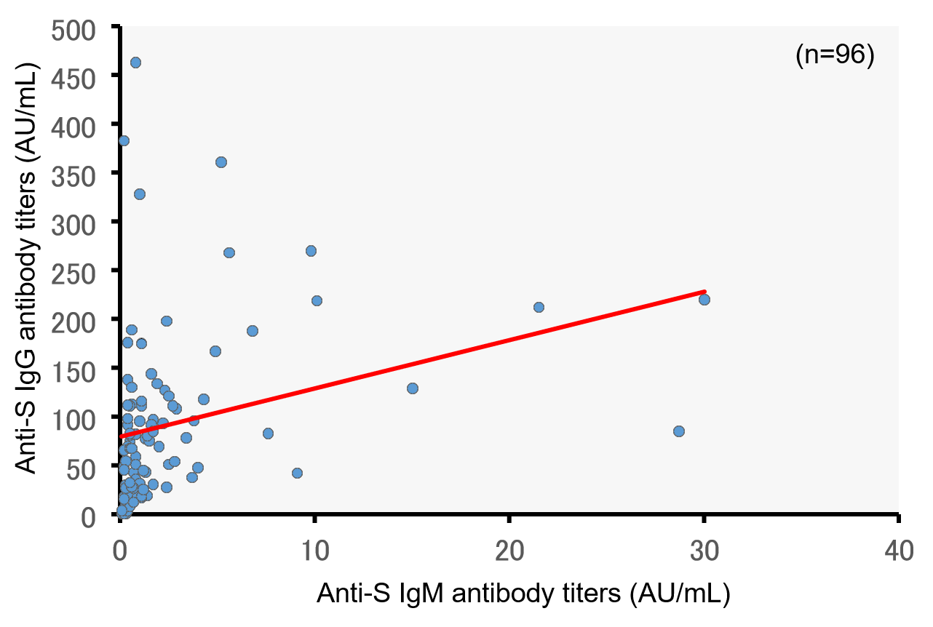
ρ=0.458, p<0.001 Spearman’s test

