Supplementary material 2-a. Changes in anti-S IgG antibody titers from the day of the first dose
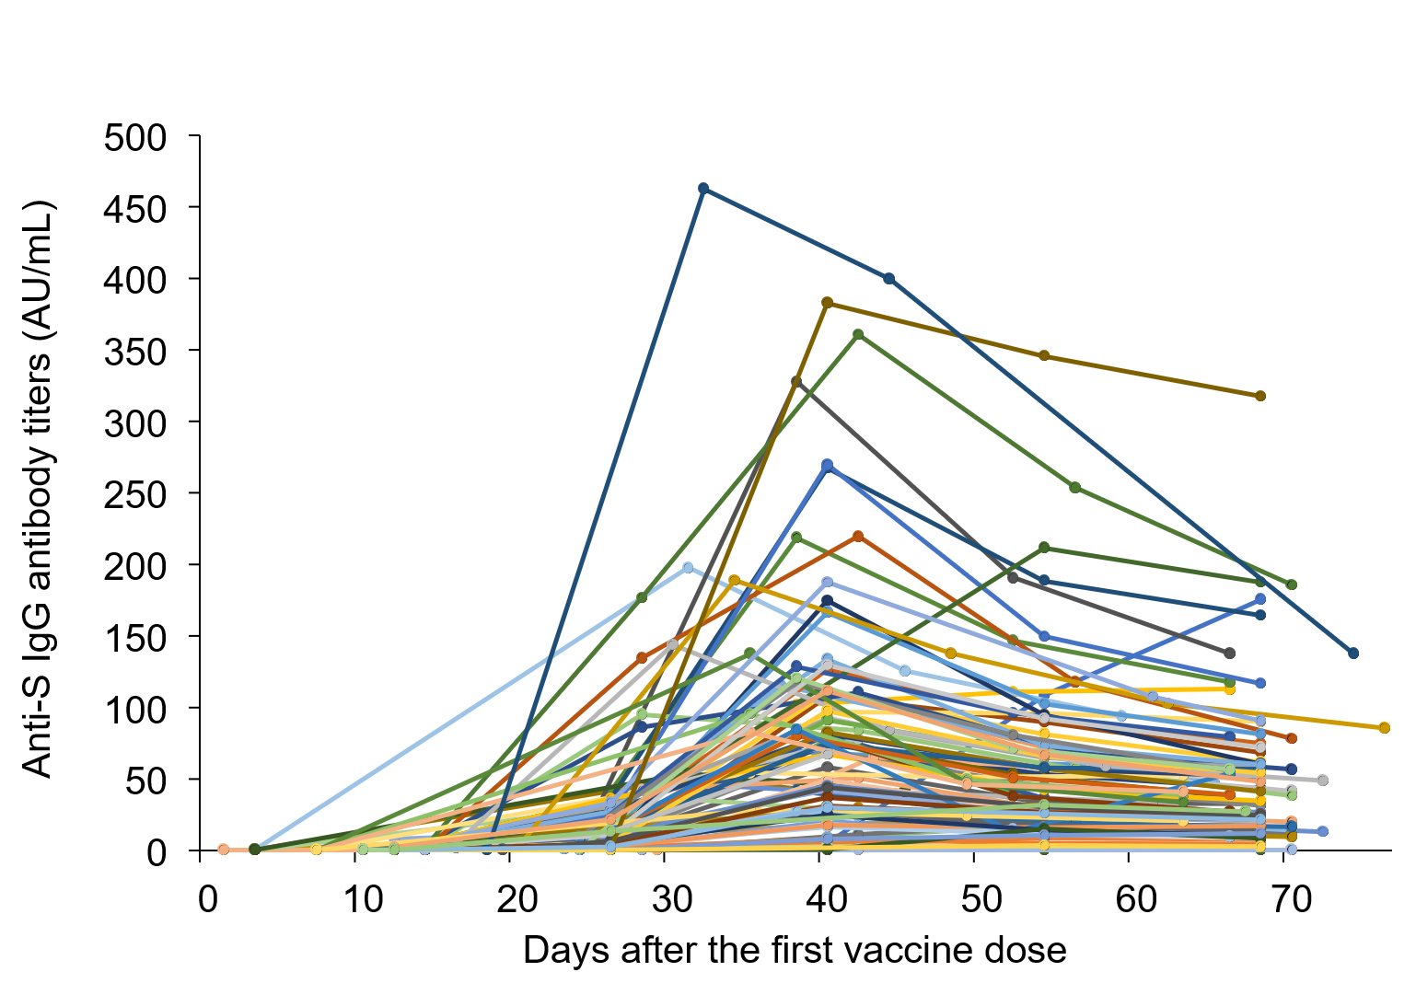
Supplementary material 2-b. Changes in anti-S IgG antibody titers from the day of the second dose
