Supplementary material 7. Correlation between ant-S IgG antibody titers (Fujirebio) and Anti-spike protein antibody titers (Roche)
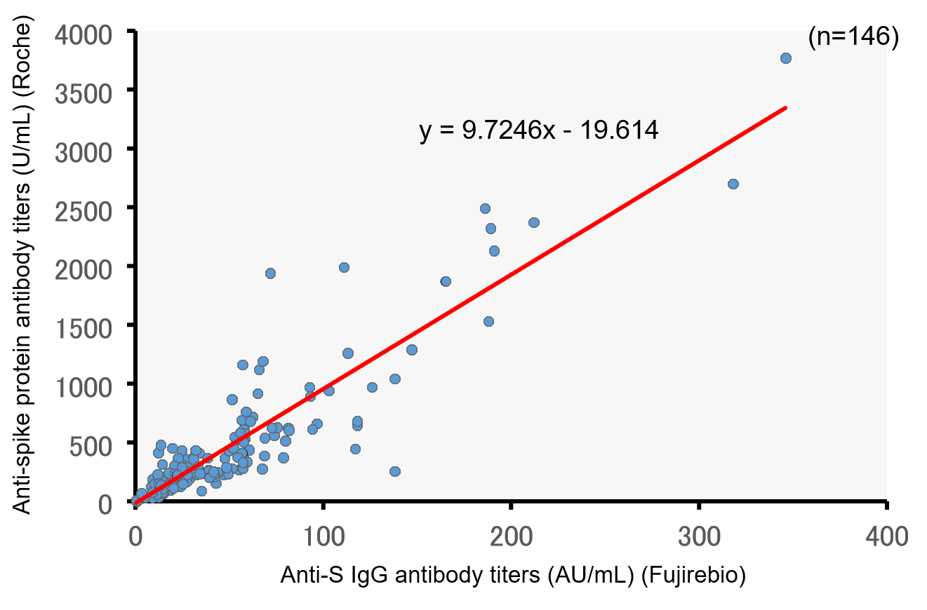
ρ=0.864, p<0.001 Spearman’s test.
ρ=0.900, p<0.001 Pearson’s test.
The results from the parametric test are also indicated due to conversion based on the derived linear regression formula.

