An efficient 2-aminothiazolesalicylaldehyde fluorescent chemosensor for Fe²⁺ ion detection and potential inhibitor of NUDT5 signaling hormone for breast cancer cell and molecular keypad lock application
Summaya Banu Bashaª, Immanuel David Charles^{b}, Nandhakumar Raju^{b,}*, Sakthivel Manokaran^{c} , Hemalatha Kuzhandaivel^{a,}*
ªDepartment of Chemistry, Coimbatore Institute of Technology, Affiliated to Anna University, Coimbatore - 641 014, India. E-mail: hemalathakv@cit.edu.in Orcid ID: 0000-0003-4082-1156.
^{b}Department of Chemistry, Karunya Institute of Technology and Sciences (Deemed-to-be University),Karunya Nagar,Coimbatore-641114,India, E-mail: nandhakumar@karunya.edu
^{c}Intergrated Bio Computing laboratory, Department of Bioinformatics, Bharathiar University, Coimbatore – 641046

ENTRY | TITLE | PAGE NO.
1 | FTIR Spectra of receptor1 | S1
2 | ¹H NMR Spectra of receptor1 | S2
3 | ¹³C NMR Spectra of receptor1 | S2
4 | Fluorescence spectra of determination of Fe²⁺ ion | S3

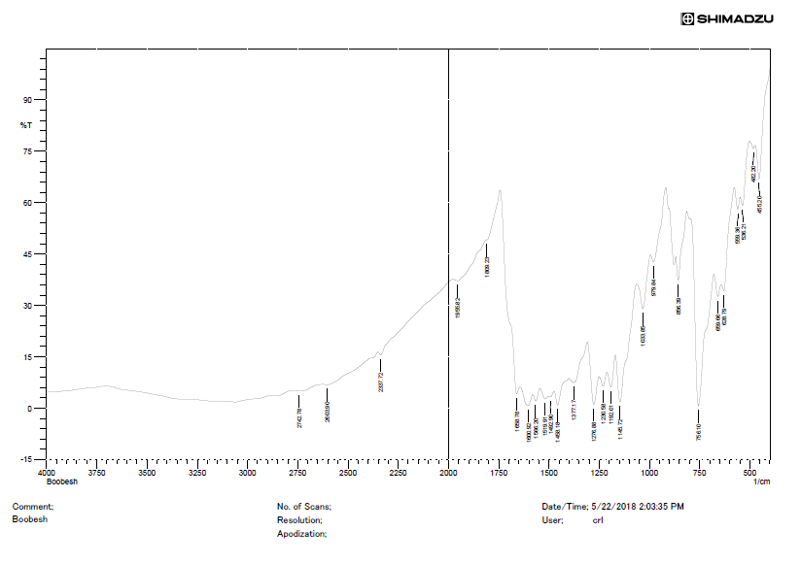
Fig. S1. FTIR spectra of receptor1

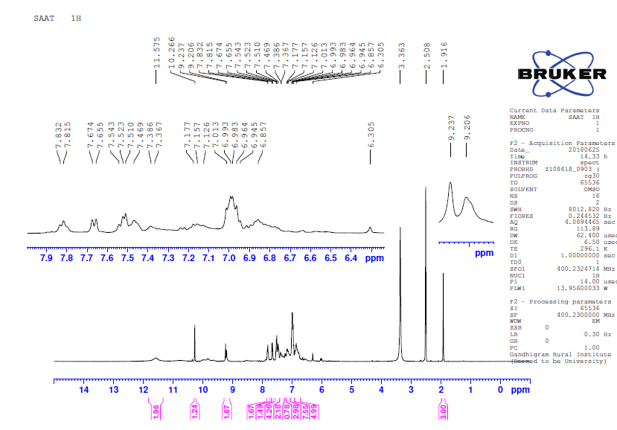
Fig. S2. ¹H NMR Spectra of receptor1

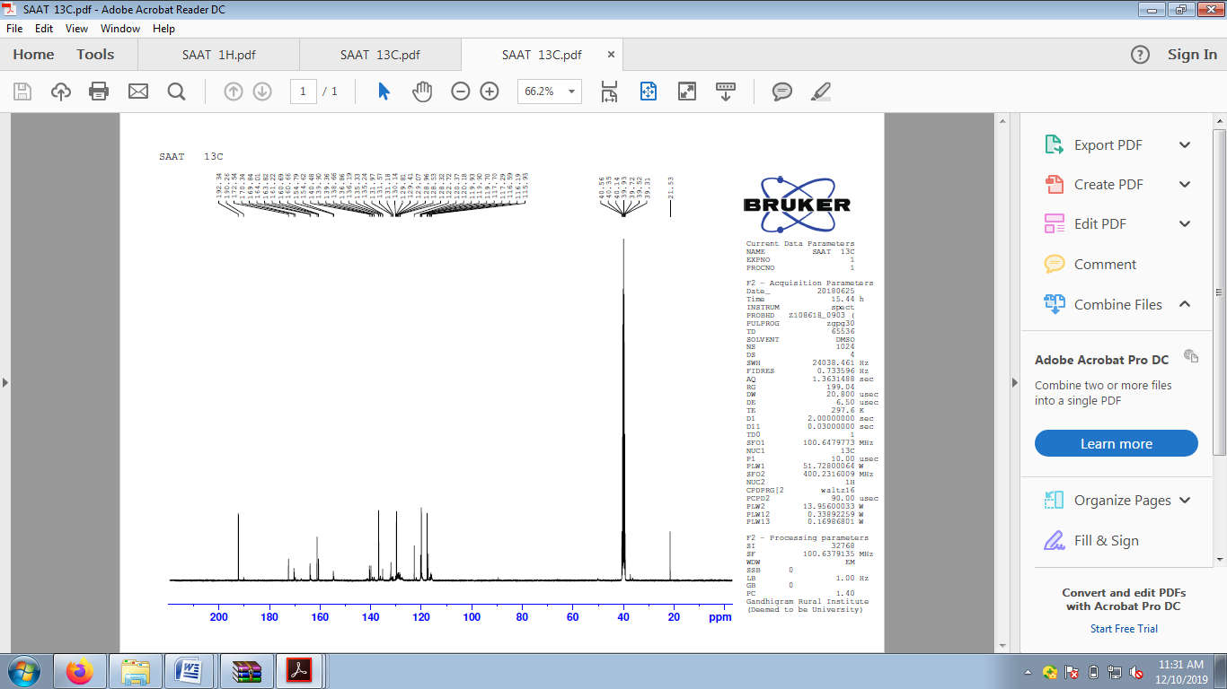
Fig. S3. ¹³C NMR Spectra of receptor1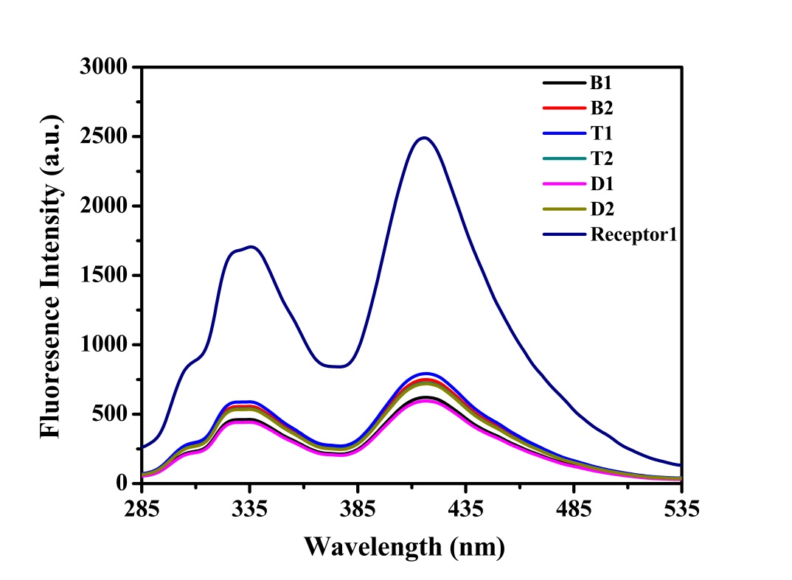
Fig. S4. Fluorescence spectra of determination of Fe²⁺ ion in real water sample.
- B1-Borewell water spiked with 3 µM Fe²⁺ ion, B2- Borewell water spiked with 6 µM Fe²⁺ ion.
- T1-Tap water spiked with 3 µM Fe²⁺ ion, T2-Tap water spiked with 6 µM Fe²⁺ ion.
- D1- RO drinking water spiked with 3 µM Fe²⁺ ion, D1- RO drinking water spiked with 6 µM Fe²⁺ ion.

