Supporting information
Gadolinium-based nanoparticles combined with checkpoint blockade amplify radiation-induced abscopal effect and cancer immunotherapy
Huijuan Songª, Ningning Heª, Chang Xuª, Yan Wangª, Liqing Duª, Yang Liuª, Qin Wangª, Kaihua Jiª, Jinhan Wangª, Manman Zhangª, Yeqing Guª, Yumin Zhangª, Weiwei Wang^{b}*, Olivier Tillement^{c}, Li Feng^{d}，Qiang Liuª*
ª Institute of Radiation Medicine, Chinese Academy of Medical Sciences & Peking Union Medical College, Tianjin 300192, China.
^{b} Tianjin Key Laboratory of Biomaterial Research, Institute of Biomedical Engineering, Chinese Academy of Medical Sciences and Peking Union Medical College, Tianjin 300192, China.
^{c} NH TherAguix, NH TherAguix SAS, Villeurbanne, France.
^{d} Department of Ultrasound, The First Affiliated Hospital of Shandong First Medical University & Shandong Provincial Qianfoshan Hospital, Jinan 250014, China.

Materials. Fluorochrome-conjugated anti-mouse monoclonal antibodies specific for anti-CD16/32 (clone 93), CD3ε (clone 145-2C11), CD4 (clone GK1.5), CD8 (clone 53-6.7), Foxp3 (clone FJK-16s), NK1.1 (clone PK136), Gr-1 (clone RB6-8C5), CD11b (clone M1/70), CD11c (clone N418), CD86 (clone GL-1) were acquired from BioLegend (San Diego, CA, USA). Alexa Fluor 647-conjugated anti-Calreticulin antibody (Catalog: ab196159) was purchased from Abcam (Cambridge, United Kingdom), The mouse regulatory T cell staining kit (clone FJK-16s) was obtained from eBioscience (San Diego, CA, USA). Mouse HMGB-1 (Catalog: SEKM-0145) ELISA kits were received from Beijing Solarbio Science & Technology Co., Ltd. (Beijing, China). The reactive oxygen species assay kit was purchased from Thermo Fisher Scientific (USA). The FITC Annexin V apoptosis detection kit was acquired from BD pharmingen (San Diego, CA, USA). Anti-CD4 (GK1.5), anti-CD8 (OKT-8), or mouse IgG (C1.18.4) antibodies were purchased from BioXCell, USA.
Cell lines and culture. B16 tumor cells (ATCC) were purchased from the Cell Bank at the Chinese Academy of Sciences, and upon receipt, cells were cultured in RPMI 1640 (Gibcol, Grand Island, NY) containing 10% fetal bovine serum (Gibcol, Grand Island, NY), 100 units/mL penicillin and 100 mg/mL streptomycin (Life Technologies, Inc.).

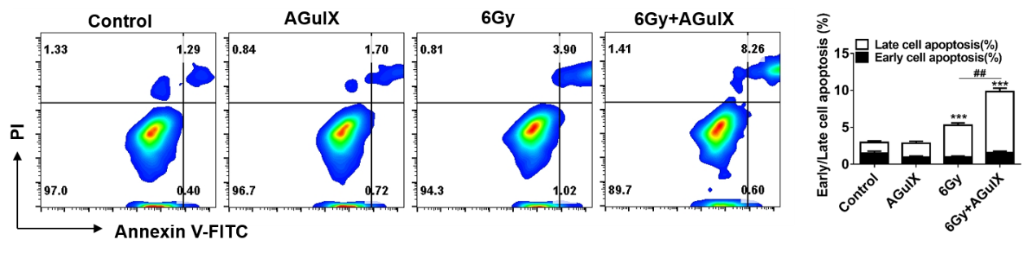
Figure S1. Annexin V/PI analysis of B16 cells. Qualitative flow cytometry data plot showing the increased apoptosis caused by the AGuIX nanoparticles under irradiation, 6 h postirradiation.

Figure S2. Mouse body weight growth curve.

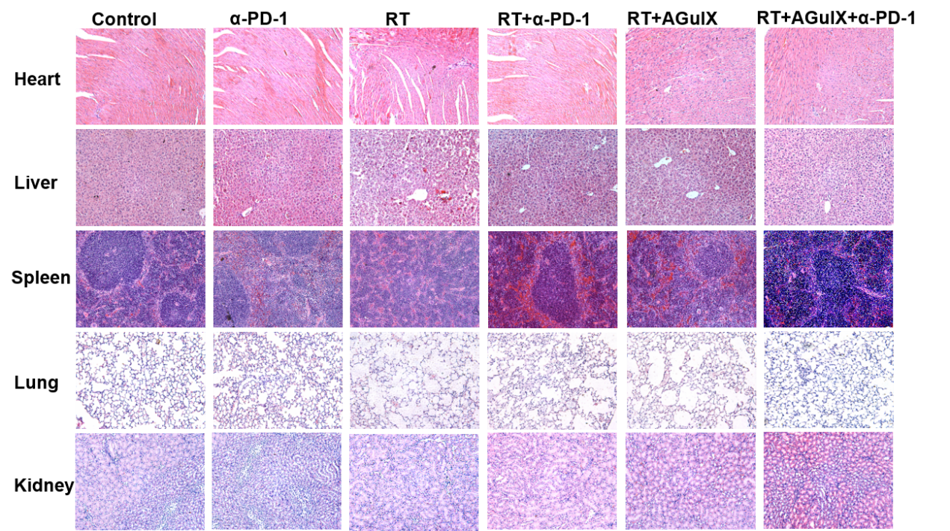
Figure S3. H&E staining of the collected organs from different groups.

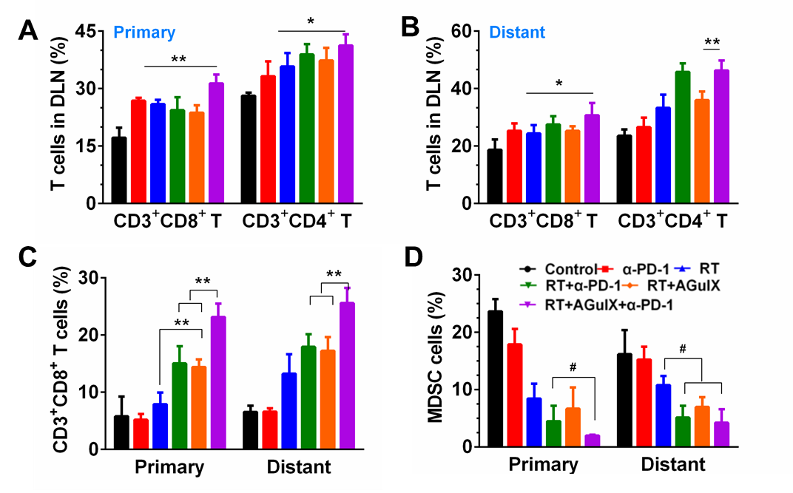
Figure S3. The increasing systemic anti-tumor T-cell immune response and weakening of tumor immunosuppressive microenvironment by the combination of RT and immunotherapy. Flow cytometric analysis of CD3⁺CD8⁺ and CD3⁺CD4⁺ T cells in primary (A) and distant (B) draining lymph nodes (DLN), and CD3⁺CD8⁺ T cells (C) and MDSC cells (D)in primary and distant tumors. Data represent mean ± SD (n=5).

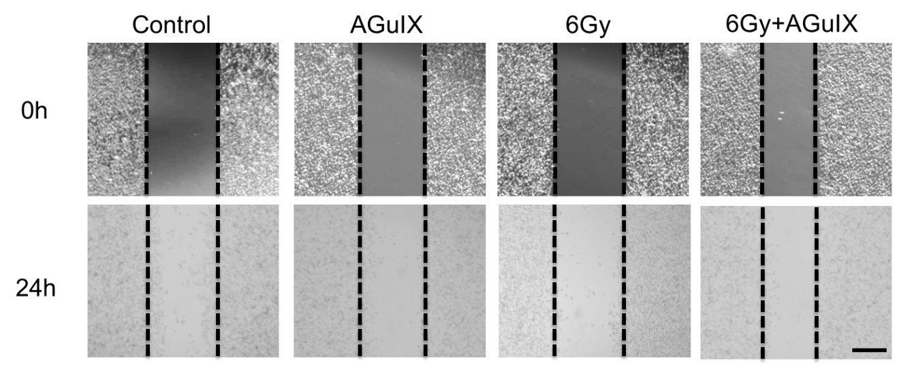
Figure S4. Representative photographs of wound-healing assays of B16 cells treated with AGuIX and 6 Gy irradiation. The scale bar represents 100 μm.

