Title
Multi-omics analysis of oral bacterial biofilm on titanium oxide nanostructure modified implant surface: in vivo sequencing-based pilot study in Beagle dogs

Authors
Hanyu Sun ª, Yuki Chan ^{b}, Xuan Li ^{b}, Ruogu Xu ª, Zhengchuan Zhang ª, Feilong Deng ^{a†}, Xiaolin Yu ^{a†}

ª Department of Oral Implantology, Hospital of Stomatology, Guanghua School of Stomatology, Guangdong Provincial Key Laboratory of Stomatology, Sun Yat-sen University, Guangzhou, Guangdong, PR China
^{b} Faculty of Dentistry, The University of Hong Kong, Hong Kong SAR, PR China

†Co-corresponding authors:
Xiaolin Yu ^{a†}, DDS, PhD,
ª Department of Oral Implantology, Hospital of Stomatology, Guanghua School of Stomatology, Guangdong Provincial Key Laboratory of Stomatology, Sun Yat-sen University, 56 Lingyuan Xi Road, Guangzhou, Guangdong, 510055, PR China
E-mail: yuxlin3@mail.sysu.edu.cn
Tel: +86 20 8386 2537
Fax: +86 20 8382 2807

Feilong Deng ^{a†}, DDS, PhD, Professor
ª Department of Oral Implantology, Hospital of Stomatology, Guanghua School of Stomatology, Guangdong Provincial Key Laboratory of Stomatology, Sun Yat-sen University, 56 Lingyuan Xi Road, Guangzhou, Guangdong, 510055, PR China
E-mail: dengfl@mail.sysu.edu.cn
Tel: +86 20 8386 2537
Fax: +86 20 8382 2807
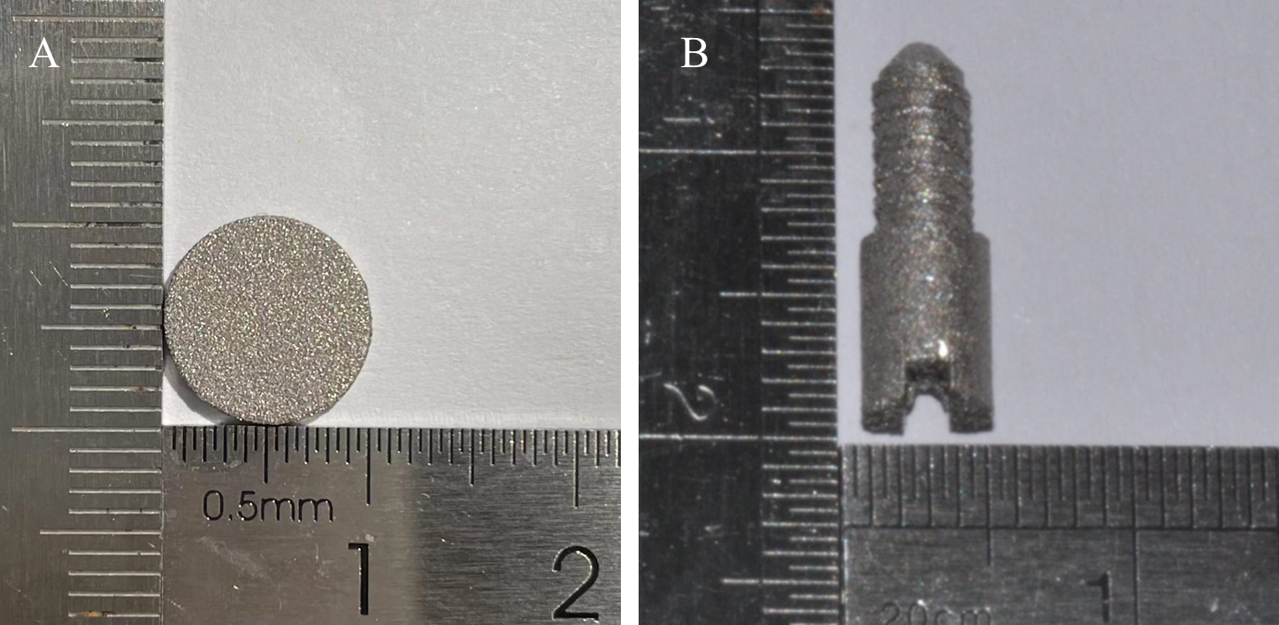
Fig. S1 SLM Titanium specimens.
(A) SLM Titanium round discs; (B) SLM Titanium implant screws.

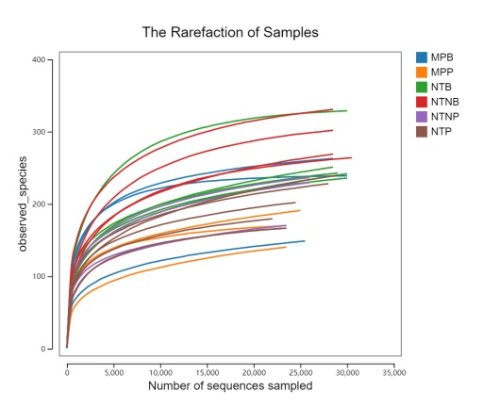

Fig. S2 The rarefaction curve of the observed OTUs in all samples.
The X-axis indicates the respective number of sequences in each sample; the Y-axis indicates the observed OTUs. The curves appear to approach asymptotes, which indicate high levels of coverage.

