Appendix 1. Meta-analysis by outcomes

- Muscular strength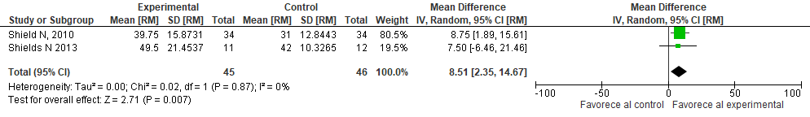
Figure a. Neuromuscular exercise with mechanotherapy equipment versus control, outcome: 1.1 Chest muscle strength (measuring instrument: [MR] maximal resistance).
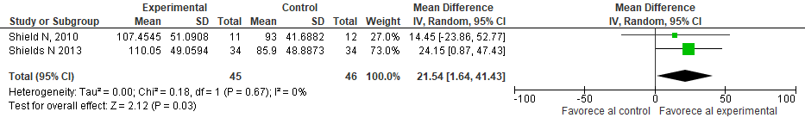
Figure b. Neuromuscular exercise with mechanotherapy equipment versus control. Outcome: 1.2 Leg muscle strength (measuring instrument: [MR] maximal endurance).
Figure c. Neuromuscular exercise with isokinetic training versus conventional physiotherapy outcome: 1.3 Lower limb muscle strength.
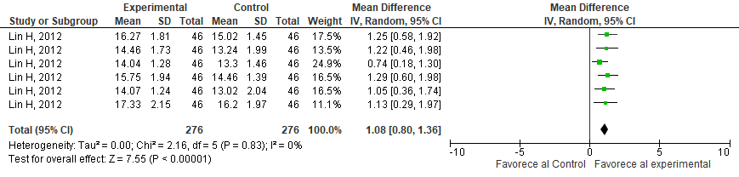
Figure d. Neuromuscular exercise using treadmill and Nintendo Wii versus control, outcome: 1.4 hip and knee muscle strength.
Figure e. Neuromuscular exercise by isometric training versus control. Outcome: 1.5 Knee muscle strength. Figure f. Neuromuscular exercise by therapeutic vibration plus conventional therapy versus conventional therapy. Outcome: 1.6. knee muscle strength.
Balance Figure g. Neuromuscular exercise by conventional physiotherapy and isokinetic training/core stability exercises versus conventional therapy. Outcome: 2.1: Balance.
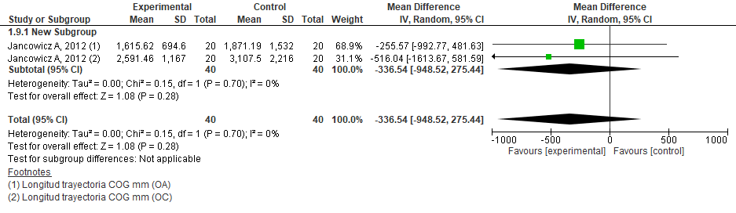
Figure h. Neuromuscular exercise using unstable surfaces and balls versus control. Outcome: 2.2. Balance.
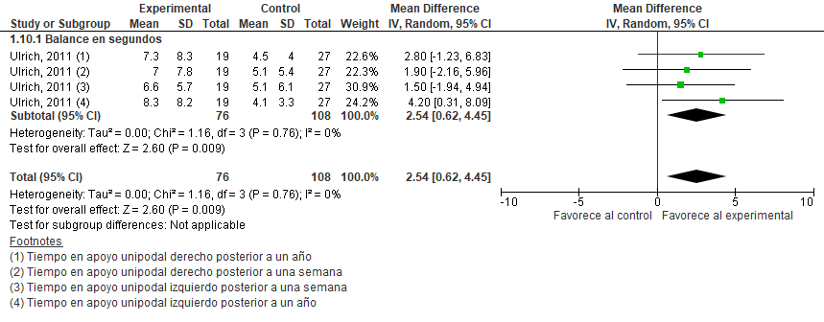
Figure i. Neuromuscular exercise through isometric training and unipodal balance versus control. Outcome: 2.3 Unipodal balance.

