Radical Nephrectomy Provides a Worse Prognosis than Partial Nephrectomy in T3aN0M0 Renal Cancer of Small (≤4 cm) Size and No Invasion of Perisinus Fat
Shiliang Liu ª, Zhixian Wang ª, Chang Liu ^{b, *}
ª Department of Urology, Tongji Hospital, Tongji Medical College, Huazhong University of Science and Technology, Wuhan, 430030, China
^{b} Department of intergrated medical services, Tongji Hospital, Tongji Medical College, Huazhong University of Science and Technology, Wuhan, 430030, China
*Correspondence
Dr. Chang Liu,
Department of intergrated medical services, Tongji Hospital, Tongji Medical College, Huazhong University of Science and Technology, Wuhan, 430030, China.
E-mail: liuchangtjh@163.com

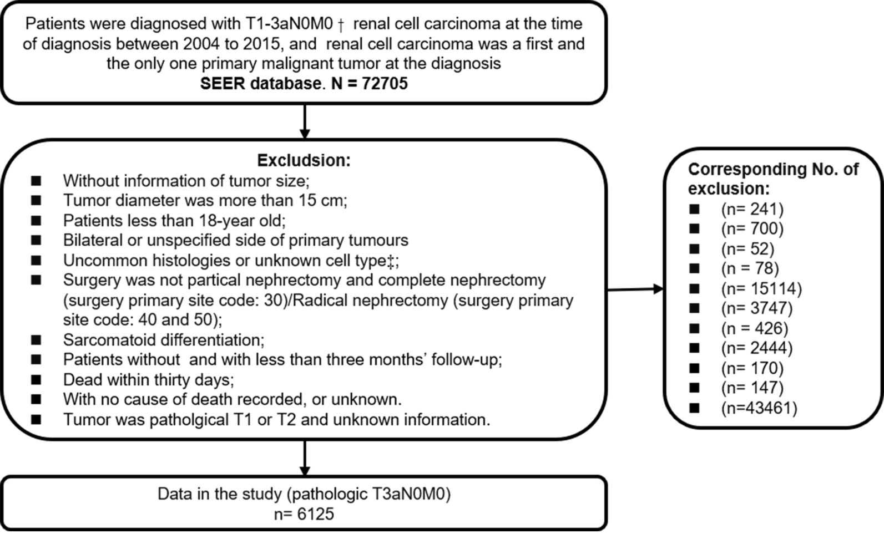
Supplementary Figure 1. A flowchart showing data selection for patients with pT3a renal cell carcinoma from the Surveillance, Epidemiology, and End Results (SEER) database (2004 and 2015).
†, TNM staging was based on the edition of the AJCC TNM staging system in place at the time of diagnosis. Between 2004 and 2010, patients were diagnosed with pT3a RCC in accordance with the 6th edition of the AJCC TNM staging system. Between 2010 and 2015, the SEER database used the 7th edition of the AJCC TNM staging system for the diagnosis of kidney cancer.
‡, In SEER cohort, we identified three common histological types included clear cell (code 8310/3), papillary (code 8260/3), and chromophobe (code 8317/3) types.

